Use-case Diagram & Use-case Specification Diagram: Client Relationship Management and Retention Framework

Prepared by: Nikhil H. Mali (Business Analyst)

Date: 16 August 2025

Use Case Diagram

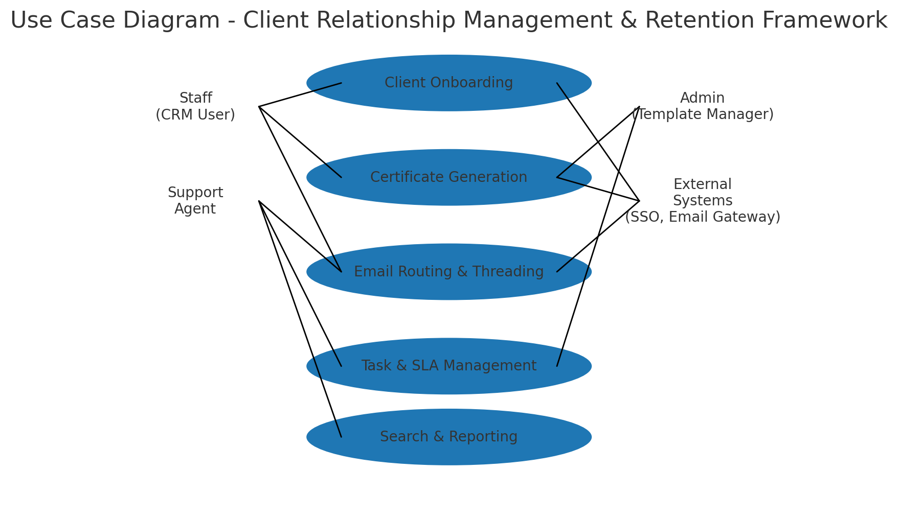

Activity Diagram
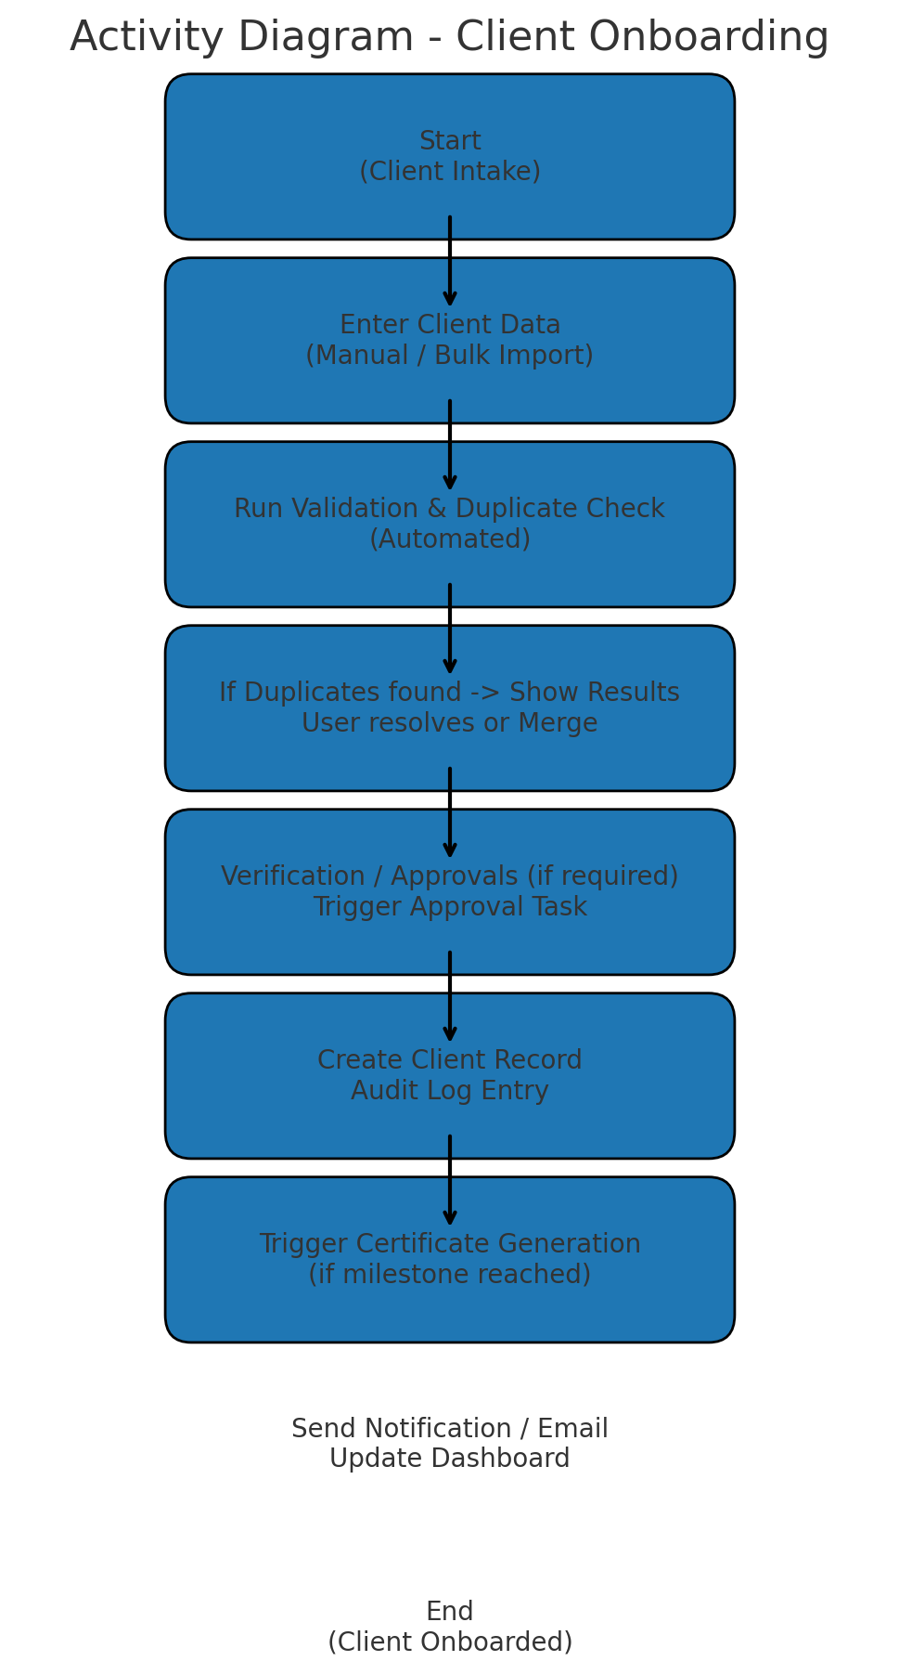

Use Case Specifications:
Use Case Name: Client Onboarding
Description: Create a new client record via manual entry or bulk import, validate data, resolve duplicates, and create initial tasks and certificates as applicable.
Actors: Primary Actors: Staff (CRM User), System (Data Importer)
Secondary Actors: Admin, Support Agent, External Systems (SSO, Billing)
Basic Flow:
1. Staff opens 'Create Client' form or uploads bulk import file.
2. System validates required fields and runs duplicate detection.
3. If duplicates not found or resolved, system saves client record and creates audit log.
4. System creates any required onboarding tasks and SLAs.
5. If onboarding milestone met, trigger certificate generation and notification.
6. System updates dashboards and notifies assigned owners.

Alternate Flows:
1. Staff saves a draft and returns later to complete data.
2. Bulk import produces a validation report; staff reviews failed rows and re-uploads corrected data.
3. Duplicate detected and staff chooses to merge, link or create a separate record after review.
Exceptional Flows:
1. Validation failures block save and show inline errors.
2. Import job fails due to malformed file — system emails the uploader and logs the error.
3. Approval required but approver not available — system queues the approval task and sends reminders.
Pre-Conditions:
- Staff is authenticated and authorised (RBAC).
- Template and mandatory field definitions configured by Admin.
- Bulk import files follow the prescribed schema.
Post-Conditions:
- Client record exists with unique client_id and audit trail.
- Onboarding tasks (if any) are created and assigned.
- Certificate issued if milestone conditions met; notification sent.
Assumptions:
- SMEs provide required template and field definitions prior to onboarding.
- Legacy data mapping availability for bulk migration.
- Email gateway reachable for notifications.
Constraints:
- RBAC restrictions apply to who can create/merge records.
- Bulk import file size and format limits.
- Waterfall delivery—changes to onboarding after sign-off require CR.
Dependencies:
- SSO service for authentication.
- Email gateway for notifications.
- Template engine for certificate generation.
Inputs and Outputs:
Inputs: Client profile data (name, contact, identifiers), documents, import CSV/Excel files
Outputs: Client record, audit log entry, onboarding tasks, notification emails, (optional) certificate PDF
Business Rules:
- Mandatory fields must be present before record creation.
- Duplicates must be reviewed before creating a new record.
- Only users with 'Admin' role may change template definitions.
Miscellaneous Information:
- UAT should include positive and negative test cases for imports and duplicate handling.
- Retention policy applies to client records as per compliance rules.

Use Case Name: Certificate Generation
Description: Automatically or manually generate a certificate PDF for a client when specific milestone conditions are met. Certificates use templates and data from client records.
Actors: Primary Actors: System (Certificate Engine), Staff (initiator)
Secondary Actors: Admin (Template Manager), External PDF Service
Basic Flow:
1. Triggered by onboarding milestone or manual request from Staff.
2. System selects appropriate template based on client type and context.
3. System populates template placeholders with client data and generates PDF.
4. System stores the certificate against client record and creates an audit log.
5. System sends certificate by email to client and notifies staff.

Alternate Flows:
1. Staff previews certificate and requests template changes (Admin reviews and updates template).
2. Bulk certificate generation for a batch of clients initiated by Admin.

Exceptional Flows:
1. Template contains missing placeholders — generation fails and system logs error.
2. Email delivery fails — certificate remains stored and a retry/sent-to-queue is marked.
Pre-Conditions:
- Template version exists and is active.
- Client record has all required data fields populated.
Post-Conditions:
- Certificate PDF saved and linked to client record.
- Notification sent; audit log recorded and certificate history updated.
Assumptions:
- Template content reviewed and approved by business SMEs.
- PDF service supports required fonts and encoding.
Constraints:
- Template edits require Admin privileges and maintain version history.
- Certificate generation performance limited by PDF service throughput.
Dependencies:
- Template engine / CMS
- Email gateway
- Storage service for attachments
Inputs and Outputs:
Inputs: Client data, selected template, generation trigger (event or manual)
Outputs: PDF certificate stored and emailed, audit log, notification
Business Rules:
- Only approved template versions are used for certificate generation.
- All certificates must include a unique cert_id and issue date.
Miscellaneous Information:
- Consider watermarking certificates in staging environments.
- Retention of certificates follows data retention policy.

Use Case Name: Email Routing & Threading
Description: Centralize incoming and outgoing client emails, link to client records, and maintain conversation threads within the CRM.
Actors: Primary Actors: Support Agent, Staff
Secondary Actors: System (Email Gateway), External Email Provider
Basic Flow:
1. Incoming email received by Email Gateway and forwarded to CRM.
2. CRM parses email, identifies client via email address or reference, and links to client timeline.
3. Email thread created or appended to existing thread; attachments stored.
4. Support Agent views thread in client timeline and replies using templates.
5. Outgoing replies are sent via Email Gateway and recorded in CRM.
Alternate Flows:
1. Unrecognized sender — system creates a new prospect record or flags for manual review.
2. High-priority email triggers SLA task creation and escalations.
Exceptional Flows:
1. Email parsing fails — email stored in quarantine for manual review.
2. Attachment exceeds size limits — attachment stored via link and reference added.
Pre-Conditions:
- Email gateway integration configured and authorised.
- Clients have registered contact emails.
Post-Conditions:
- Email stored against client; thread visible in timeline; attachments saved.
- SLA tasks created if required; notifications to assigned owners.
Assumptions:
- Email addresses are unique per client or mapping rules exist.
- Templates for common replies are maintained by Admin.
Constraints:
- Email retention policies and storage quotas.
- Parsing accuracy depends on email headers and consistent formats.
Dependencies:
- Email Gateway
- Client contact data accuracy
Inputs and Outputs:
Inputs: Incoming/outgoing emails, attachments, mapping rules
Outputs: Email threads, attachments stored, linked client timeline, SLA tasks
Business Rules:
- All client-related correspondence must be recorded within the CRM.
- Sensitive attachments must be redacted or stored in encrypted storage per policy.
Miscellaneous Information:
- Consider threaded view performance for clients with long histories.
- Provide opt-out for marketing communications per compliance rules.

