Assignment 1 - Question 1 - Business Requirement Document

Inventory & Delivery Management System (IDMS)
Version 2.0
Prepared By: CR Barath Narayanan

1. Document Revisions

Date | Version Number | Document Changes
04-Oct-2025 | v1.0 | Initial draft created for IDMS project
06-Oct-2025 | v1.1 | Added Assumptions, Constraints, and Risks
08-Oct-2025 | v1.2 | Documented AS-IS and TO-BE business process overview
10-Oct-2025 | v1.3 | Added detailed functional and non-functional requirements
12-Oct-2025 | v2.0 | Finalized BRD and submitted for review and approval

2. Approvals

Role | Name | Title | Signature | Date
Project Sponsor | Mr. Suresh Iyer | Director – Supply Chain |  | 12-Oct-2025
Business Owner | Ms. Priya Nair | Chief Operating Officer |  | 12-Oct-2025
Project Manager | Mr. Barath Narayanan | Senior Project Manager |  | 12-Oct-2025
System Architect | Mr. Rajat Mehta | IT Systems Architect |  | 12-Oct-2025
Development Lead | Mr. Ankit Bansal | Lead Developer |  | 12-Oct-2025
QA Lead | Ms. Kavitha Reddy | Quality Assurance Manager |  | 12-Oct-2025
UX Lead | Mr. Vignesh Kumar | User Experience Designer |  | 12-Oct-2025

3. RASCI Chart for This Document

Codes Used in RASCI Chart:
- * - Authorize
- R - Responsible
- A - Accountable
- S - Supports
- C - Consulted
- I - Informed

Name | Position | * | R | A | S | C | I
Barath Narayanan | Lead Business Analyst |  | ✔ | ✔
Suresh Iyer | Project Sponsor | ✔ |  |  |  |  | ✔
Priya Nair | Business Owner |  |  | ✔ |  | ✔
Rajat Mehta | System Architect |  |  |  | ✔ | ✔
Ankit Bansal | Development Lead |  |  |  | ✔
Kavitha Reddy | QA Lead |  |  |  | ✔
Vignesh Kumar | UX Lead |  |  |  | ✔

4. Introduction

4.1 Business Goals
The organization aims to modernize its supply chain operations by implementing a unified digital platform that enables efficient inventory management and ensures fastest product delivery to customers.

Key goals include:
- Real-time visibility of stock levels across plants and warehouses
- Automated stock replenishment and batch tracking
- Optimized route planning for deliveries to minimize spoilage and delay
- Data-driven insights for production and logistics decisions
- Integration between manufacturing, warehouse, and distribution units

4.2 Business Objectives

To design and implement a centralized software system that:
- Tracks production output, warehouse stock, and delivery routes in real-time
- Automates replenishment alerts and low-stock notifications
- Enables efficient order allocation based on proximity and stock availability
- Reduces turnaround time for dispatch and delivery
- Provides dashboards for management to monitor efficiency and wastage

The system will provide the following modules:
- Inventory Management – Batch tracking, stock updates, expiry alerts
- Warehouse Operations – Inward, outward, transfer, and stock reconciliation
- Delivery Management – Vehicle assignment, route optimization, and delivery status tracking
- Customer Order Management – Order creation, prioritization, and status visibility
- Reporting & Analytics – Demand forecasting, stock aging, and performance reports
- Admin Module – Role-based access, master data control, and configuration

4.3 Business Rules
- Batch Control: Each batch of ice cream or milk must have a unique batch ID with manufacturing and expiry dates.
- Temperature Compliance: Products can only be shipped if the assigned delivery vehicle meets required temperature standards.
- FIFO Principle: Warehouses must follow First In First Out for dispatches.
- Stock Visibility: Warehouse staff cannot modify batch data manually; system updates are automated based on scanning.
- Delivery SLA: All customer deliveries must be completed within 24 hours of order placement in metro cities and 48 hours in non-metro regions.
- Role Restrictions: Only warehouse managers can authorize inter-warehouse transfers.
- Real-time Sync: All data (inventory, vehicle status, delivery confirmation) must sync every 5 minutes with the central server.

4.4 Background
The company operates multiple manufacturing plants and warehouses across India, producing ice cream, milk, and related products. Currently, inventory is tracked manually via spreadsheets, and deliveries are managed using phone coordination and paper logs.

Challenges include:
- Lack of visibility on stock levels and expiry dates
- Frequent delays due to poor route coordination
- Overstocking or understocking in regional warehouses
- Inability to trace spoilage or returns accurately
A modernized system is required to unify operations and ensure smooth coordination from production to customer delivery.

4.5 Project Objective
The project aims to design and deploy a centralized Inventory & Delivery Management System (IDMS) to streamline production, warehousing, and logistics operations.

Key Deliverables:
- Real-time stock tracking
- Automated reorder suggestions
- Vehicle and route optimization for timely deliveries
- Integration of manufacturing and dispatch data
- Comprehensive dashboards for operations and management

4.6 Project Scope

In-Scope Functionality
- Inventory tracking by batch, product type, and warehouse
- Order allocation based on proximity and stock
- Route optimization using integrated maps
- Delivery vehicle tracking with GPS
- Expiry and spoilage alerts
- Automated restocking notifications
- Role-based dashboards
- Mobile interface for drivers and warehouse staff
- Integration with barcode/RFID scanners

Out-of-Scope Functionality
- Integration with third-party ERP in Phase 1
- Customer-facing mobile app (Phase 2)
- AI-based demand forecasting (Phase 2)
- Payment processing or invoicing module
- Offline functionality without internet

5. Assumptions
- All plants and warehouses have reliable internet connectivity.
- Staff will be trained to use the system.
- GPS-enabled delivery vehicles are available.
- Stock data from existing systems will be migrated using standard templates.
- Temperature and compliance data will be entered manually in Phase 1.

6. Constraints
- Project completion deadline: 6 months.
- Fixed budget with no provision for third-party licenses.
- Phase 1 covers domestic distribution only.
- Mobile app will be web-based, not native.
- Integration with ERP to be considered later.

7. Risks
This section outlines potential risks that may impact the success of the IDMS project. Each risk is categorized and includes its likelihood, impact, and mitigation plan.

Category | Risk ID | Description | Likelihood | Impact | Mitigation / Response Plan
Technological Risks | T001 | GPS tracking may fail in remote areas with weak connectivity | Medium | High | Allow manual confirmation and offline caching for delivery updates
Technological Risks | T002 | Server downtime or sync delay could affect real-time visibility | Low | High | Host on AWS with auto-backup and redundant servers
Technological Risks | T003 | Barcode or RFID scanners may not integrate properly | Medium | Medium | Test compatibility and use industry-standard APIs
Technological Risks | T004 | Data corruption due to power or network failure during sync | Low | High | Enable transaction logs and periodic auto-backups
Skill Risks | S001 | Warehouse and delivery staff unfamiliar with digital devices | High | Medium | Conduct hands-on training and provide visual user guides
Skill Risks | S002 | IT support team lacks knowledge in logistics systems | Medium | Medium | Provide domain training and involve consultants during setup
Skill Risks | S003 | High employee turnover may reduce user adoption | Medium | High | Maintain continuous onboarding and refresher sessions
Requirements Risks | R001 | Change in business policies during development | Medium | High | Follow change control and stakeholder review process
Requirements Risks | R002 | Incomplete or unclear requirements from regional warehouses | High | Medium | Conduct workshops and confirm via sign-off sessions
Requirements Risks | R003 | Conflicts between manufacturing and logistics priorities | Medium | Medium | Regular steering meetings to align functional priorities
Requirements Risks | R004 | Scope creep from management requesting new features mid-phase | Medium | High | Apply strict version control and CR documentation
Operational Risks | O001 | Inaccurate data migration from legacy Excel files | High | Medium | Validate with test uploads and standardized templates
Operational Risks | O002 | Delay in delivery due to unplanned vehicle downtime | Medium | High | Enable maintenance scheduling and backup vehicle assignment
Operational Risks | O003 | Temperature control failure leading to spoilage | Medium | High | Add manual override and condition alerts from vehicle logs
Operational Risks | O004 | Power or connectivity failure in warehouses | Low | High | Provide UPS backup and mobile data alternatives

8. Business Process Overview

AS-IS
- Inventory recorded manually using Excel
- Orders assigned via phone
- No real-time view of vehicle locations
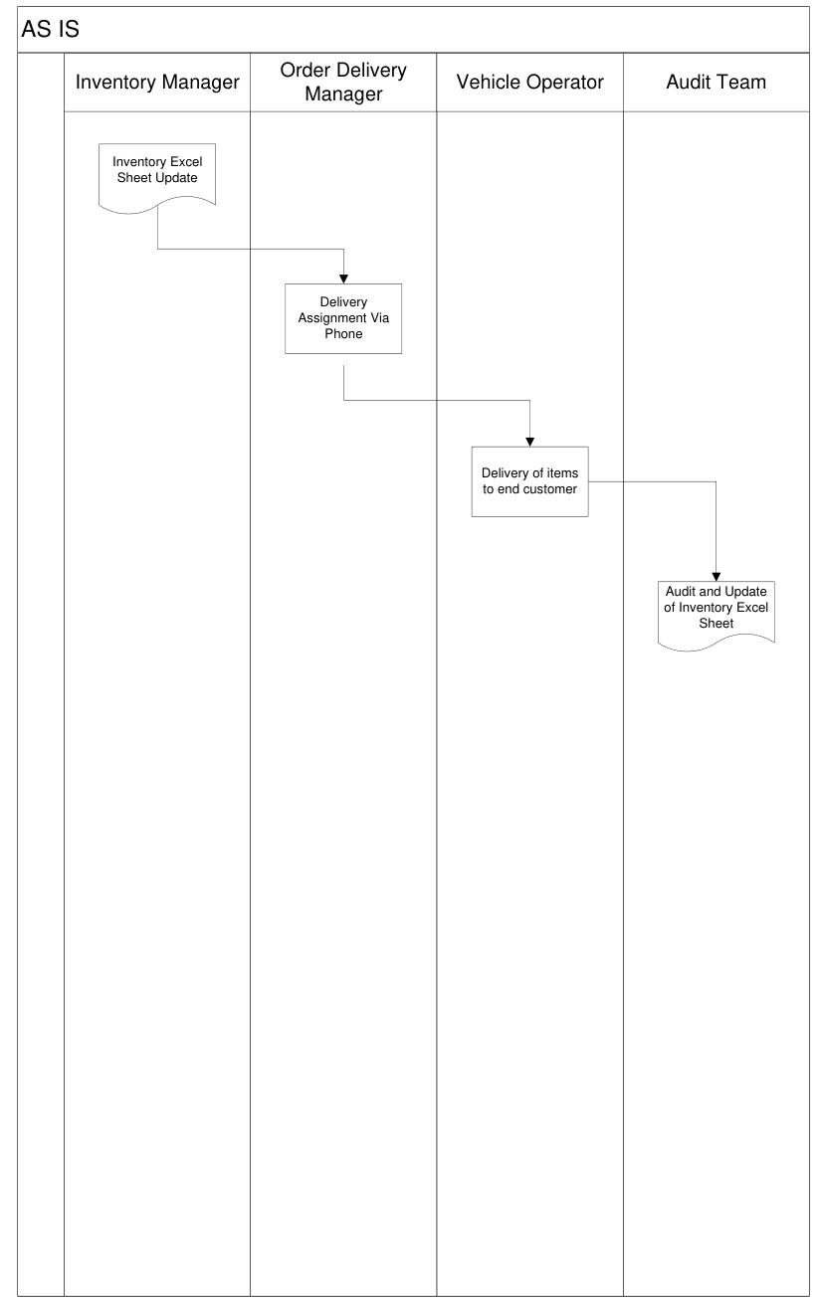
- Stock discrepancies discovered only during audits

TO BE
- Unified system linking production, warehouses, and deliveries
- Automatic batch and expiry tracking
- Route planning based on proximity
- Real-time dashboards and alerts
- Centralized reporting for management
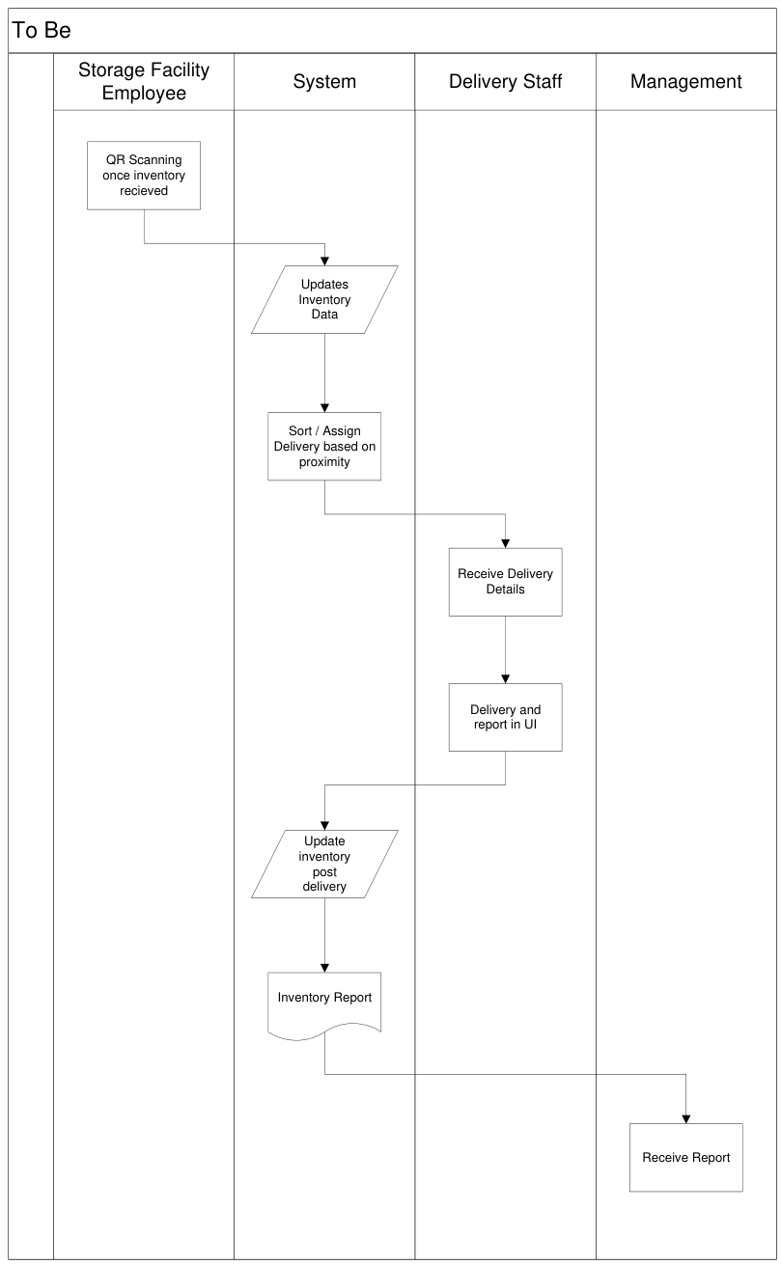

9. Business Requirements
The following requirements were elicited from production, warehouse, logistics, and IT stakeholders.
Each requirement is categorized as Functional (FR) or Non-Functional (NFR) and assigned a priority (1–10).

Functional Requirements
Req ID | Requirement | Priority | Type | Use Case Ref
FR0001 | Record production batches with manufacturing and expiry details | 10 | Functional | UC-001
FR0002 | Track stock levels by product, batch, and warehouse | 10 | Functional | UC-002
FR0003 | Auto-generate replenishment alerts for low stock | 9 | Functional | UC-003
FR0004 | Manage delivery orders and assign nearest warehouse | 9 | Functional | UC-004
FR0005 | Optimize route using integrated maps for fastest delivery | 9 | Functional | UC-005
FR0006 | Allow drivers to update delivery status in real-time via mobile | 9 | Functional | UC-006
FR0007 | Notify warehouse teams for upcoming expiry or spoilage | 8 | Functional | UC-007
FR0008 | Generate daily, weekly, and monthly stock reports | 8 | Functional | UC-008
FR0009 | Enable batch recall functionality for defective items | 8 | Functional | UC-009
FR0010 | Manage inter-warehouse transfers with approval workflow | 9 | Functional | UC-010
FR0011 | Allow scanning of barcodes or RFID tags for inventory updates | 10 | Functional | UC-011
FR0012 | Provide dashboard view for plant, warehouse, and delivery metrics | 9 | Functional | UC-012
FR0013 | Enable order prioritization for premium customers | 8 | Functional | UC-013
FR0014 | Record vehicle temperature compliance at dispatch | 9 | Functional | UC-014
FR0015 | Send automated ETA (Estimated Time of Arrival) alerts to customers | 8 | Functional | UC-015
FR0016 | Provide route reassignment option for delayed deliveries | 7 | Functional | UC-016
FR0017 | Capture proof of delivery (photo/signature) | 9 | Functional | UC-017
FR0018 | Maintain audit trail for all inventory movements | 10 | Functional | UC-018
FR0019 | Enable role-based access control for all modules | 10 | Functional | UC-019
FR0020 | Allow export of all reports to Excel and PDF formats | 7 | Functional | UC-020
Non-Functional Requirements
Req ID | Requirement | Priority | Type | Use Case Ref
NFR0001 | System must support 99.9% uptime | 10 | Non-Functional | NFR-001
NFR0002 | Real-time data sync every 5 minutes | 9 | Non-Functional | NFR-002
NFR0003 | Mobile dashboard must load within 4 seconds | 8 | Non-Functional | NFR-003
NFR0004 | Application must scale to handle 10,000 daily transactions | 9 | Non-Functional | NFR-004
NFR0005 | Must comply with ISO 27001 security standards | 9 | Non-Functional | NFR-005
NFR0006 | Support barcode and RFID integrations via APIs | 8 | Non-Functional | NFR-006
NFR0007 | Database response time for queries < 3 seconds | 9 | Non-Functional | NFR-007
NFR0008 | Role-based dashboards should refresh dynamically | 8 | Non-Functional | NFR-008
NFR0009 | All uploads (e.g., proof of delivery) should support JPG, PNG, PDF | 8 | Non-Functional | NFR-009
NFR0010 | Must support responsive design across all devices | 9 | Non-Functional | NFR-010
NFR0011 | Transaction logs must be stored for a minimum of 5 years | 8 | Non-Functional | NFR-011
NFR0012 | User authentication through strong password policy and OTP | 9 | Non-Functional | NFR-012
NFR0013 | Backup and disaster recovery every 24 hours | 9 | Non-Functional | NFR-013
NFR0014 | System should support both dark and light UI modes | 6 | Non-Functional | NFR-014
NFR0015 | Alerts should be sent within 30 seconds of triggering event | 8 | Non-Functional | NFR-015
NFR0016 | Application latency must be <200 ms for internal network | 9 | Non-Functional | NFR-016
NFR0017 | Ensure compliance with data privacy laws (DPDP/ GDPR) | 9 | Non-Functional | NFR-017
NFR0018 | Must allow concurrent login of up to 500 users | 8 | Non-Functional | NFR-018
NFR0019 | Use modular architecture for easy feature updates | 8 | Non-Functional | NFR-019
NFR0020 | Enable audit log export with user ID and timestamp | 9 | Non-Functional | NFR-020

10. Appendices

List of Acronyms

Acronym | Full Form
IDMS | Inventory & Delivery Management System
BRD | Business Requirement Document
FIFO | First In First Out
GPS | Global Positioning System
SLA | Service Level Agreement
UAT | User Acceptance Testing

Glossary of Terms

Term | Definition
Batch ID | Unique code for each production batch
Route Optimization | Calculation of fastest path for delivery
Stock Reconciliation | Verification of system vs physical stock
Reorder Level | Minimum stock before auto-alert
Dashboard | Visual interface for monitoring KPIs

Related Documents

Document | Version | Description
Project Charter – IDMS | v1.0 | Defines project initiation and ownership
Use Case Specifications | v1.0 | Detailed use cases for modules
RTM | v1.0 | Requirements Traceability Matrix
Risk Register | v1.0 | Detailed risk assessment

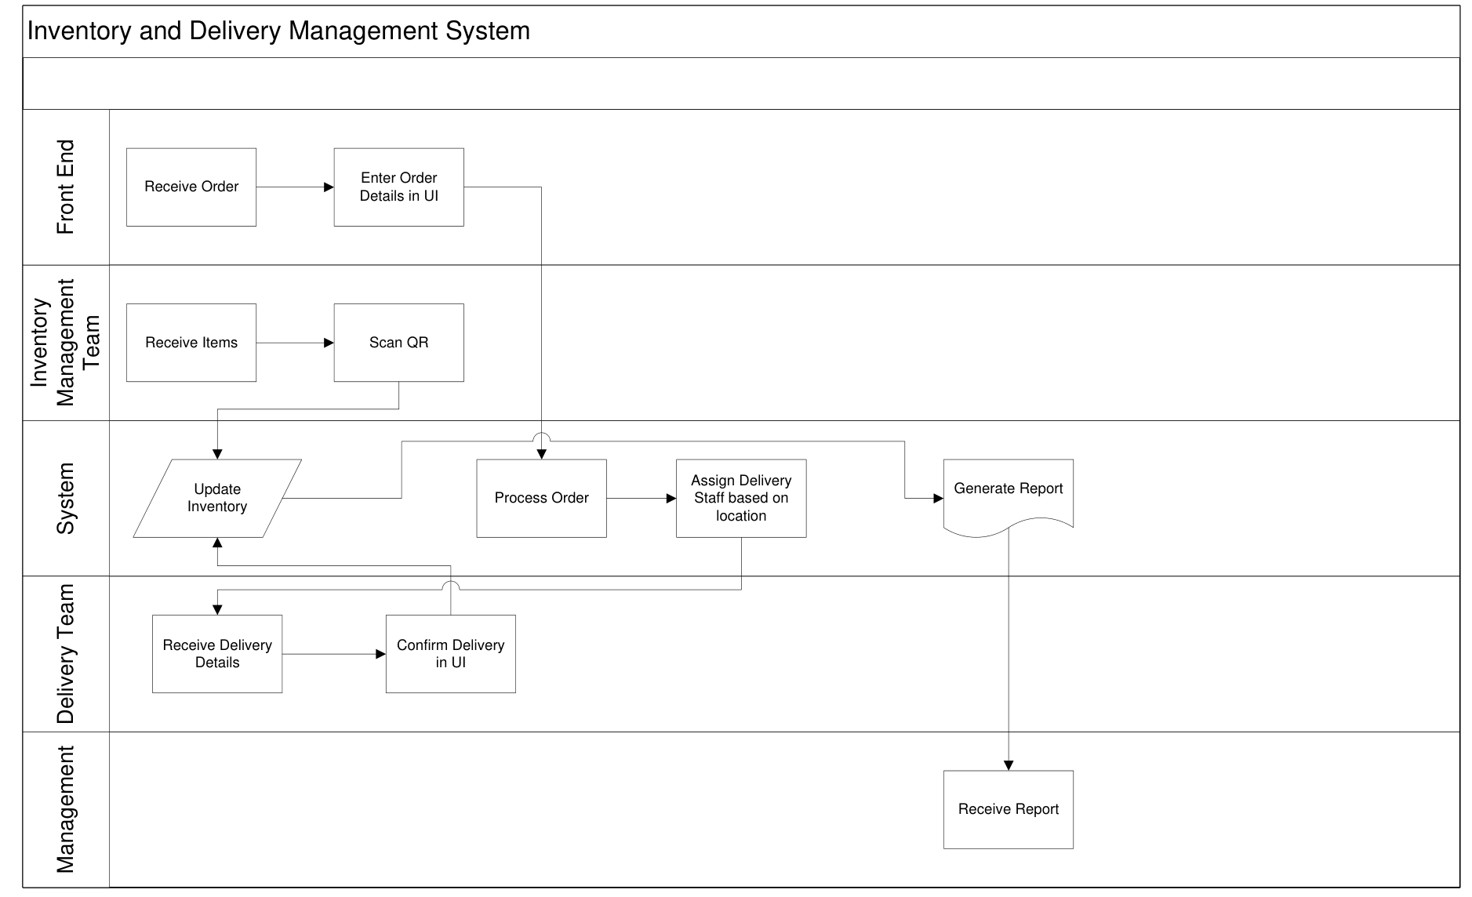
Assignment 1 - Question 2 - Process Flow Diagram

Assignment 2 - Question 1

Subject: Introduction – Business Analyst for Inventory and Delivery Management System

Dear Client,

I hope this letter finds you well.

My name is CR Barath Narayanan, and I have been assigned as the Business Analyst for the Inventory and Delivery Management System engagement. I will be your primary point of contact for all activities related to the business understanding and requirement gathering phase of the project.

My responsibility will be to work closely with you and your team to gain a comprehensive understanding of your business processes, objectives, and system requirements. This will ensure that our proposed solution is aligned with your strategic goals and operational needs. I will also be coordinating discussions, documentation reviews, and requirement validation sessions throughout this phase to maintain clarity and transparency at every step.

Our immediate next step will be to initiate the business discovery process, where we will outline the current workflows, identify key challenges, and define measurable outcomes for the project. I will be reaching out shortly to schedule a detailed kickoff meeting at your convenience.

I look forward to a productive collaboration and to ensuring that this project delivers optimal value to your organization.

Kind regards,
CR Barath Narayanan
Business Analyst - XYZ Technologies
Email - barath.BA@XYZ.in
Phone - 9123456789

Assignment 2 - Question 2
Business requirement document

Ticketing management system
Version 2.0
Prepared By: CR Barath Narayanan, Business Analyst

1. Document Revisions

Date | Version | Description
04-Oct-2025 | v1.0 | Initial draft for Ticketing Management System
06-Oct-2025 | v1.1 | Added functional and non-functional requirements
08-Oct-2025 | v2.0 | Finalized version for client approval

2. Approvals

Role | Name | Title | Date
Project Sponsor | Mr. Suresh Iyer | Director – Operations | 08-Oct-2025
Business Owner | Ms. Priya Nair | Chief Operating Officer | 08-Oct-2025
Project Manager | Mr. Barath Narayanan | Senior Project Manager | 08-Oct-2025
System Architect | Mr. Rajat Mehta | IT Systems Architect | 08-Oct-2025
QA Lead | Ms. Kavitha Reddy | Quality Assurance Manager | 08-Oct-2025
UX Lead | Mr. Vignesh Kumar | User Experience Designer | 08-Oct-2025

3. RASCI Chart for This Document

Codes Used in RASCI Chart:
- * Authorize — Has final signing authority
- R Responsible — Creates or delivers the work item
- A Accountable — Ensures task completion and accuracy
- S Supports — Provides assistance or input
- C Consulted — Offers subject matter expertise
- I Informed — Kept updated on progress or changes

Name | Position | * | R | A | S | C | I
Barath Narayanan | Lead Business Analyst |  | ✔ | ✔
Suresh Iyer | Project Sponsor | ✔ |  |  |  |  | ✔
Priya Nair | Business Owner |  |  | ✔ |  | ✔
Rajat Mehta | System Architect |  |  |  | ✔ | ✔
Ankit Bansal | Development Lead |  |  |  | ✔
Kavitha Reddy | QA Lead |  |  |  | ✔
Vignesh Kumar | UX Lead |  |  |  | ✔

4. Introduction

4.1 Business Goal
The Ticketing Management System (TMS) aims to provide a unified digital platform to manage, track, and resolve customer and internal support requests efficiently. It will centralize ticket handling, improve visibility across teams, and enhance SLA compliance and customer satisfaction.

4.2 Business Objectives
- Automate ticket creation, categorization, and routing.
- Provide SLA-based alerts and escalation workflows.
- Offer real-time dashboards for performance tracking.
- Facilitate seamless communication between customers, support agents, and managers.
- Generate insights through reports and analytics.

5. Project Scope

5.1 In-Scope
- Ticket creation via web form and email.
- Automatic ticket categorization and assignment.
- SLA timer and escalation alerts.
- Role-based dashboards for agents and managers.
- Ticket history and communication logs.
- Reporting and analytics module.
- Knowledge base integration for article suggestions.
- Mobile-responsive web interface.

5.2 Out-of-Scope
- Chatbot integration (Phase 2).
- AI-driven automated ticket resolution (Phase 3).
- Deep CRM integration in Phase 1.
- Voice-based ticket creation.

6. Assumptions
- All users will have stable internet access.
- SLA policies and ticket categories will be defined before development.
- Email servers and endpoints required for integration will be accessible.
- Necessary stakeholder availability for UAT and sign-off will be provided.

7. Risks

Category | Risk ID | Description | Likelihood | Mitigation / Response Plan
Technological | T001 | Email parsing failures leading to missed tickets | Medium | Early integration testing and fallback manual ticket creation
Technological | T002 | Server downtime affecting ticket access | Low | Cloud hosting with redundancy and auto-recovery strategies
Technological | T003 | Security breach exposing customer data | Low | Implement HTTPS, RBAC, encryption, and regular security audits
Technological | T004 | Third-party API (email/SMS) rate limits causing delays | Medium | Use throttling, retry logic, and alternative providers
Skill | S001 | Support agents unfamiliar with ticketing workflows | High | Structured training, SOPs, and quick reference guides
Skill | S002 | Admins not proficient in configuring SLA policies | Medium | Admin training workshops and guided setup templates
Skill | S003 | Insufficient technical support for post-launch maintenance | Medium | Assign dedicated technical team and knowledge transfer sessions
Requirements | R001 | Ambiguous or changing SLA definitions | High | Freeze SLAs prior to development and use change control
Requirements | R002 | Incomplete requirement gathering from departments | Medium | Conduct workshops and requirement validation sessions
Requirements | R003 | Conflicting priorities between customer support and IT | Medium | Steering committee meetings to align priorities
Requirements | R004 | Scope creep due to new feature requests | Medium | Strict CR process with impact analysis
Operational | O001 | Surge in ticket volume post-launch overloads system | High | Load testing, queue management, and phased rollout
Operational | O002 | Delays due to manual processes or human dependency | Medium | Automate routine tasks and implement escalation rules
Operational | O003 | Power/connectivity outages at key locations | Low | Enable cloud access, remote work, and contingency plans
Operational | O004 | Data inconsistency from legacy imports | Medium | Data validation templates and staged migration with QA

8. Business Process Overview

8.1 AS-IS
- Tickets and support requests tracked via fragmented channels such as email and spreadsheets.
- No automatic routing, SLA timers, or escalation workflows.
- Limited visibility for management and manual reporting.

8.2 TO-BE
- Centralized ticketing portal with automated categorization and routing.
- SLA-based timers and escalation mechanisms with notifications.
- Real-time dashboards for agents and management with reporting capabilities.

9. Business Requirements
The following requirements are categorized as Functional (FR) or Non-Functional (NFR) and prioritized (1-10).

9.1 Functional Requirements

Req ID | Requirement | Priority
FR0001 | Allow customers to log tickets through web portal | 10
FR0002 | Support ticket creation via email integration | 10
FR0003 | Auto-generate unique ticket ID for each request | 10
FR0004 | Categorize tickets automatically by issue type | 9
FR0005 | Route tickets to relevant agents based on workload | 9
FR0006 | Enable agents to update ticket status (Open, In-Progress, Closed) | 10
FR0007 | Allow attachment uploads (PDF, images, documents) | 9
FR0008 | Implement SLA timers for response and resolution | 10
FR0009 | Send email/SMS alerts for SLA breaches | 9
FR0010 | Allow ticket reassignment between agents/departments | 8
FR0011 | Maintain communication thread between customer and agent | 9
FR0012 | Provide dashboards for agents, managers, and admins | 10
FR0013 | Enable keyword and filter-based search for tickets | 8
FR0014 | Generate analytical reports (SLA performance, backlog, trends) | 9
FR0015 | Include ticket prioritization (High, Medium, Low) | 8
FR0016 | Allow internal-only comments for agents | 9
FR0017 | Provide customer satisfaction feedback form on closure | 8
FR0018 | Support templates for recurring issues | 7
FR0019 | Offer role-based permissions and access control | 10
FR0020 | Export ticket data and reports in PDF/Excel | 8

9.2 Non-Functional Requirements

Req ID | Requirement | Priority
NFR0001 | Ensure 99.9% system uptime | 10
NFR0002 | Ticket creation should be processed within 3 seconds | 9
NFR0003 | Dashboard must load in under 4 seconds | 9
NFR0004 | Handle up to 10,000 concurrent tickets | 9
NFR0005 | Encrypt all data at rest and in transit | 10
NFR0006 | Support responsive UI for mobile and tablet | 9
NFR0007 | Comply with ISO 27001 security standards | 9
NFR0008 | Daily backups with 30-day restore capability | 8
NFR0009 | Provide detailed audit trails for all user actions | 9
NFR0010 | Multi-browser compatibility (Chrome, Edge, Safari) | 8
NFR0011 | Store closed tickets for a minimum of 5 years | 8
NFR0012 | Support concurrent access for 500 users | 9
NFR0013 | Allow SLA timer customization | 7
NFR0014 | Application latency < 200ms on internal network | 8
NFR0015 | Provide role-based access control (RBAC) | 10
NFR0016 | Allow localization (English, Hindi) | 7
NFR0017 | Generate alerts within 30 seconds of event | 9
NFR0018 | Support failover and disaster recovery | 8
NFR0019 | Modular architecture for scalability and updates | 8
NFR0020 | Allow integration with third-party reporting tools via APIs | 7

10. Appendices

10.1 List of Acronyms

Acronym | Full Form
TMS | Ticketing Management System
SLA | Service Level Agreement
API | Application Programming Interface
UI | User Interface
UAT | User Acceptance Testing
RBAC | Role-Based Access Control

10.2 Glossary of Terms
- Ticket: A digital record of a customer issue or request
- SLA: Predefined response/resolution time limit
- Agent: A user responsible for handling and resolving tickets
- Escalation: Process of elevating a ticket to higher authority based on SLA breach
- Queue: Category or department grouping of tickets

10.3 Related Documents

Document | Version
Project Charter – TMS | v1.0
Use Case Specifications | v1.0
Requirements Traceability Matrix | v1.0
Risk Register | v1.0

SOFTWARE REQUIREMENTS SPECIFICATION (SRS)

For Ticketing Management System (TMS)
Version 2.0
Prepared By: CR Barath Narayanan,
Business Analyst

1. Document Control

Date | Version | Description
10-Oct-2025 | v1.0 | Initial draft of SRS for TMS
12-Oct-2025 | v1.1 | Added detailed functional decomposition
14-Oct-2025 | v2.0 | Finalized after stakeholder review

2. Introduction

2.1 Purpose
The purpose of this SRS document is to specify the functional and non-functional requirements for the Ticketing Management System (TMS). This document provides a detailed description of the system behavior, interfaces, and performance criteria to ensure all stakeholders have a common understanding of the solution before development.

2.2 Scope
The TMS aims to provide a centralized platform for managing and tracking customer support tickets. The software will automate ticket assignment, enable SLA tracking, send escalation alerts, and provide dashboards for agents and managers.

The solution will:

- Improve customer service response times.
- Increase transparency in issue handling.
- Enhance operational efficiency and reporting.

2.3 Intended Audience
- Business Owners: For validating business needs and deliverables.
- Developers: For coding and implementing required functionalities.
- Testers: For designing and executing test cases.
- Testers: For designing and executing test cases.
- End Users: For feedback during UAT.

2.4 Definitions, Acronyms, and Abbreviations

Term | Definition
TMS | Ticketing Management System
SLA | Service Level Agreement
UI | User Interface
UAT | User Acceptance Testing
API | Application Programming Interface

3. Overall Description

3.1 Product Perspective
The TMS is a standalone web-based application that integrates with company email servers to automatically generate and route tickets. It is designed for internal customer service departments and can be extended to external customers in later phases.

3.2 Product Features
- Centralized ticket logging (manual and automated).
- Categorization and prioritization of tickets.
- SLA-based alerts and escalations.
- Multi-level access (agent, manager, admin).
- Analytics and performance reports.
- Communication thread between agent and customer.

3.3 User Classes and Characteristics

User Role | Description | Technical Proficiency
Customer | Creates tickets and receives updates | Low
Support Agent | Manages and resolves tickets | Medium
Manager | Monitors SLA compliance and performance | Medium
Admin | Configures system parameters, roles, SLAs | High

3.4 Operating Environment
- Web-based application accessible on Chrome, Edge, and Safari.
- Server hosted on AWS or Azure cloud infrastructure.
- Database: MySQL or PostgreSQL.
- Backend: Node.js / Java Spring Boot.
- Frontend: React or Angular framework.

3.5 Design and Implementation Constraints
- Must comply with organizational IT security policies.
- Should support data backup and disaster recovery mechanisms.
- Integration limited to corporate email and SMS gateways in Phase 1.

3.6 Assumptions and Dependencies
- Users will have stable internet connectivity.
- Email and SMS APIs will be available and authenticated.
- Browser-based system—no desktop application required.
- Future integration with CRM and chatbots planned in Phase 2.

4. System Features
Each system feature describes functionality, inputs, outputs, and associated requirements.

4.1 Ticket Creation

Description:
Users can create a new ticket via a web form or by sending an email.
Inputs: Issue description, category, priority, and attachments.
Outputs: Unique ticket ID and confirmation email.
Functional Requirements:
- FR0001, FR0002, FR0003

4.2 Ticket Assignment
Description:
System automatically assigns tickets based on issue category, SLA, and available agents.
Functional Requirements: FR0004, FR0005, FR0010

4.3 Ticket Management
Description:
Agents can view, update, and close tickets. Each ticket tracks complete communication and history.
Functional Requirements: FR0006, FR0007, FR0011, FR0016

4.4 SLA and Escalations
Description:
Each ticket has SLA timers for response and resolution. When breached, automatic escalations are triggered.
Functional Requirements: FR0008, FR0009, FR0015

4.5 Reporting and Analytics
Description:
Managers can generate real-time reports on ticket volumes, SLA compliance, and performance trends.
Functional Requirements: FR0012, FR0014, FR0020

4.6 User Roles and Access Control
Description:
Role-based authentication ensures secure access and activity segregation.
Functional Requirements: FR0019, NFR0015

4.7 Communication and Feedback
Description:
System maintains a complete thread of all interactions per ticket. Customers can provide closure feedback.
Functional Requirements: FR0011, FR0017

5. External Interface Requirements

5.1 User Interface
- Modern web UI compatible with desktop, tablet, and mobile.
- Dashboard with tabs for Tickets, Reports, Settings, and User Profile.
- Color-coded indicators for SLA breaches.

5.2 Hardware Interfaces
- No specialized hardware required.
- Compatible with standard PCs, laptops, and tablets.

5.3 Software Interfaces
- Email server integration via SMTP/IMAP.
- SMS gateway integration for notifications.
- API endpoints for external reporting tools.

5.4 Communication Interfaces
- HTTPS protocol for secure communication.
- Encrypted REST APIs.
- WebSocket for real-time ticket updates.

6. Non-Functional Requirements

Req ID | Requirement | Priority
NFR0001 | Ensure 99.9% system uptime | 10
NFR0002 | Ticket creation should be processed within 3 seconds | 9
NFR0003 | Dashboard must load in under 4 seconds | 9
NFR0004 | Handle up to 10,000 concurrent tickets | 9
NFR0005 | Encrypt all data at rest and in transit | 10
NFR0006 | Support responsive UI for mobile and tablet | 9
NFR0007 | Comply with ISO 27001 security standards | 9
NFR0008 | Daily backups with 30-day restore capability | 8
NFR0009 | Provide detailed audit trails for all user actions | 9
NFR0010 | Multi-browser compatibility (Chrome, Edge, Safari) | 8
NFR0011 | Store closed tickets for a minimum of 5 years | 8
NFR0012 | Support concurrent access for 500 users | 9
NFR0013 | Allow SLA timer customization | 7
NFR0014 | Application latency < 200ms on internal network | 8
NFR0015 | Provide role-based access control (RBAC) | 10
NFR0016 | Allow localization (English, Hindi) | 7
NFR0017 | Generate alerts within 30 seconds of event | 9
NFR0018 | Support failover and disaster recovery | 8
NFR0019 | Modular architecture for scalability and updates | 8
NFR0020 | Allow integration with third-party reporting tools via APIs | 7

7. System Architecture Overview
- Presentation Layer: Web UI built with React or Angular.
- Application Layer: Business logic implemented using Java Spring Boot or Node.js.
- Database Layer: MySQL or PostgreSQL for persistent storage.
- Integration Layer: REST APIs for email and SMS services.

8. Security Requirements
- All communication must use HTTPS.
- Passwords stored using salted hashing (SHA-256 or better).
- Automatic logout after 15 minutes of inactivity.
- Audit logs maintained for all user actions.
- Role-based data visibility restrictions.

9. System Flow Overview
Process Flow:
- Customer submits ticket (via web/email).
- System categorizes and assigns ticket.
- Agent receives and updates progress.
- SLA timers track deadlines and trigger escalations if needed.
- Customer receives notifications on updates.
- Ticket is resolved and closed.
- Reports generated for management review.

10. Appendices

10.1 References
- Business Requirement Document – TMS (v2.0)
- Company IT Security Policy
- UI Wireframes and Mockups
- Database Schema Design

10.2 Glossary

Term | Definition
Ticket | A recorded request or issue submitted by a customer.
SLA | Agreed timeframe for response or resolution.
Escalation | Raising a ticket to a higher authority when SLA breached.
Dashboard | UI section showing summaries and KPIs.

Assignment 2 - Question 3 - ERD
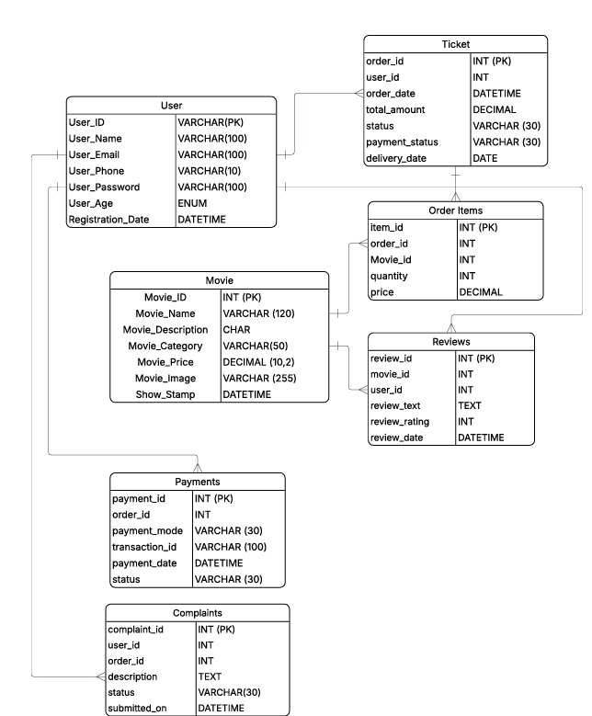

User Stories for shopping from ecommerce

User story No | Tasks | Priority | Value statement | BV | CP | Acceptance criteria
1 | Search for products | High | As a shopper, I want to search for products using keywords so that I can quickly find what I'm looking for. | 9 | 4 | Search results display relevant products.  Suggestions appear as I type.  Search works across product names and descriptions.
2 | View product details | High | As a shopper, I want to view detailed product information (images, description, price, stock) so that I can make an informed purchasing decision. | 10 | 3 | Product images are high-resolution and zoomable.  Technical specifications are clearly listed.  Inventory status (In stock/Out of stock) is visible.
3 | Add product to cart | High | As a shopper, I want to add a product to my shopping cart so that I can continue browsing and buy it later. | 10 | 2 | A confirmation pop-up/message is shown.  The cart icon updates with the new item count.  The item remains in the cart when I navigate away.
4 | Checkout as a guest | High | As a first-time shopper, I want to check out without creating an account so that I can complete my purchase quickly. | 8 | 5 | I can enter shipping and billing details on a single screen.  I receive an order confirmation email.  My information is not saved for future use.
5 | Apply a discount code | High | As a shopper, I want to apply a promotional or discount code during checkout so that I can save money on my purchase. | 8 | 4 | A field for the coupon code is visible in the cart/checkout.  The discount is reflected in the total immediately  An error message is shown for invalid or expired codes.
6 | Choose a shipping method | High | As a shopper, I want to select from different shipping options (e.g., standard, express) so that I can choose the delivery speed that meets my needs. | 9 | 5 | Estimated delivery dates are displayed for each option.  The shipping cost is clearly added to the total.  I can change the shipping option before final payment.
7 | Pay with a credit/debit card | High | As a shopper, I want to pay for my order using a credit or debit card so that I can securely complete my transaction. | 10 | 6 | The payment process is secured  I receive immediate confirmation of a successful payment.  The system accepts all major card types.
8 | View and track an order | High | As a registered shopper, I want to view my current and past orders and track the shipping status so that I know where my package is. | 9 | 5 | Order history is accessible from my account dashboard.  A link to the carrier's tracking website is provided.  Order status (e.g., Processing, Shipped, Delivered) is up-to-date.
9 | Filter product listings | Medium | As a shopper, I want to filter products by attributes like size, color, and price range so that I can narrow down my search results. | 8 | 5 | Filters can be applied and removed easily.  The product count updates after a filter is applied.  Multiple filters can be active at once.
10 | Save items to a wishlist | Medium | As a registered shopper, I want to save products to a personal wishlist so that I can review them later without adding them to my main cart. | 7 | 4 | I can add an item to the wishlist from the product page.  I can move an item from the wishlist to the cart.  I can view and manage the wishlist from my account.
11 | Review a product | Medium | As a shopper, I want to write a review and give a star rating for a purchased product so that I can share my experience with other shoppers. | 7 | 5 | Only verified purchasers can submit a review.  Reviews are moderated before public display.  The average star rating is displayed on the product page.
12 | Reset a forgotten password | Medium | As a registered shopper, I want to reset my password if I forget it so that I can regain access to my account. | 8 | 3 | A "Forgot Password" link is available on the login screen.  A password reset link is sent to my registered email.  The reset link expires after a set time (e.g., 24 hours).
13 | Receive order confirmation | High | As a shopper, I want to receive an immediate order confirmation via email and on-screen so that I know my order has been successfully placed. | 9 | 2 | The confirmation includes a unique order number.  The full breakdown of items, costs, and shipping is included.  The confirmation is sent within 5 minutes of placing the order.
14 | Edit cart item quantity | Medium | As a shopper, I want to easily change the quantity of an item in my cart so that I can adjust my purchase before checkout. | 7 | 3 | The total price in the cart updates automatically when the quantity changes.  I can enter a number or use '+' and '-' buttons to change the quantity.  An alert appears if the requested quantity exceeds stock.
15 | View related products | Medium | As a shopper, I want to see suggestions for related or complementary products so that I can discover items I might also want to buy. | 6 | 4 | Customers Also Bought" or "Recommended" section appears on the product page.  Suggestions are based on the current item or my browsing history.  I can add suggested products directly to the cart.
16 | Subscribe to a newsletter | Low | As a visitor, I want to subscribe to the company's email newsletter so that I can stay informed about new products and promotions. | 5 | 2 | A clear opt-in form is available (e.g., in the footer).  A double opt-in confirmation email is sent for verification.  A confirmation message appears after successful sign-up.
17 | Save multiple addresses | Medium | As a registered shopper, I want to save multiple shipping addresses to my account so that I don't have to re-enter them for gifts or different locations. | 6 | 4 | I can label saved addresses (e.g., "Home," "Work").  I can select a saved address during checkout with one click.  I can edit or delete a saved address at any time.
18 | View a product video | Low | As a shopper, I want to watch a video demonstration of a product so that I can better understand its features and how it looks in real life. | 5 | 3 | A clickable video thumbnail is present on the product page.  The video loads and plays without leaving the page.  The video is optimized for mobile viewing.
19 | Receive stock notification | Low | As a shopper, I want to sign up for an email alert for an out-of-stock item so that I am notified when it becomes available again. | 6 | 4 | A "Notify Me" button replaces the "Add to Cart" button for OOS items.  I receive an email notification when the item is back in stock.  I can easily unsubscribe from the notification.
20 | Choose payment installment plan | Low | As a shopper, I want to choose a payment installment option (e.g., "Pay in 4") so that I can split my purchase into smaller, manageable payments. | 7 | 7 | The payment provider's terms are clearly displayed.  The total payment amount remains the same as the product price.  The option is visible on the product page and at checkout.

