1.Document: Definition of Done
Checklist for DOD
Ans checklist for DOD:
1.Produced code for presumed functionalities
Code address to coding standards
Code follows best practices
Code is modular and maintainable
2.Assumptions of User Story met
User Story is well-defined and understood
Assumptions documented and validated
3.Project builds without errors
Build process is automated
Build arti facts are versioned and tagged
4.Unit tests written and passing
Code coverage meets project standards
Test cases cover edge cases and common scenarios
5.Project deployed on the test environment identical to the production platform
Configuration consistency between environments
Data in the test environment is representative of production data
6.Tests on devices/browsers listed in the project assumptions passe
Cross-browser testing performed
Compatibility with different devices and screen sizes ensured
7.Feature ok-ed by UX designer
Design consistency across the application
Usability testing conducted
8.QA performed & issues resolved
Comprehensive testing, including functional, performance, and security testing
All identified issues are documented and addressed
9.Feature is tested against acceptance criteria
Acceptance criteria are clear and met
Any deviations documented and justified
10.Feature ok-ed by Product Owner
Product Owner has reviewed and approved the implemented feature
Any feedback or changes addressed
11.Refactoring completed
Code refactoring adheres to coding standards
Refactoring improves code quality and maintainability
12.Any configuration or build changes documented
Changes to configuration files documented
Build process changes documented and communicated
13.Documentation updated
README files are updated
User documentation is revised
14.Peer Code Review performed
Code reviews are documented
Feedback addressed and acknowledged
Document 2-Product Vision
Scrum project name
Venue
Date |  | Start time | End time | Duration
Client
Stake holder list
 |  | Scrum team
Scrum master
Scrum developer 1
Scrum developer 2
Scrum developer 2
Scrum developer 3
Scrum developer 4
Scrum developer 5
Vision: what is your vision, your overarching goal for creating the product
Target group  Which market segment does the product address?  Who are the target users and customers? | Needs  What problems does the product solve?  Which benefit does it provide? | Product  What product it is?  What make it desirable and special?  Is it feasible to develop the product? | Value  How is the product going to benefit the company?  What are the business goals?  What is the business model?

Ans: project vision document
Scrum project name | Retail management system
Venue | Hyderabad
Date | Start time  24/08/2024 | End time  27/04/2025 | Duration  8 months
Client | Palak
Stakeholder list | Project stakeholders  Project manager  Development team  Testing team  UI designer | Business stakeholders  Project manger  Business owner  Project sponsor  Subject matter expert | 3rd party stakeholders  Auditors  Vendor  Manufacturer  Legal team
Scrum master | Abhinaya
Scrum developer1 | Sravani
Scrum developer2 | Mokshith
Scrum developer3 | Ayyappa
Scrum developer4 | Bhanu
Scrum developer5 | Akash
UI designer | Kiran
Tester | Chaitanya
Business analyst | Shravani

Vision
Vision: to globalize the retail management system
Target group  To attract more customers to buy products online | Needs  Customers can buy products online, make payment to save their time | Product  Retail management world target the national and international customers retail management system | Value  Avoid the issue of losing customer to increase the customers internationally  To create an user friendly product world website to help the business

Document 3- User Stories
Ans: user stories
User story no 1 | Task 1 | Priority high
As a customer, I want to register with my details so that I can shop online
BV 20 | CP 4
Acceptance criteria
• Registration form includes name, email, phone, and password.
• Duplicate emails are not allowed.
• Confirmation email is sent

User story no 2 | Task 1 | Priority high
As a customer, I want to log in securely so that I can access my account
BV 200 | CV 5
Acceptance criteria
• Login requires valid email & password.
• Invalid credentials show error.
• Session timeout after inactivity

User story no 3 | Task 2 | Priority high
As a customer, I want to view all available products so that I can choose items to purchase.
BV 10 | CV 5
Acceptance criteria
• Displays product name, price, and stock availability.
• Pagination enabled

User story no 4 | Task 1 | Priority medium
As a customer, I want to search for products by name/category so that I can quickly find what I need.
BV 50 | CV 3
Acceptance criteria
• Search supports partial matches.
• Results are displayed instantly

User story no 5 | Task 1 | Priority high
As a customer, I want to filter products by price, brand, and rating so that I can refine my selection.
BV 200 | CV 5
Acceptance criteria
• Search supports partial matches.
• Results are displayed instantly

User story no 6 | Task 1 | Priority high
As a customer
As a customer, I want to view product details so that I can decide before purchasing.
BV 500 | CV 6
Acceptance criteria
• Shows description, price, images, stock.
• Add-to-cart button available.

User story no 7 | Task 1 | Priority medium
As a customer
As a customer, I want to add items to my cart so that I can buy them later.
BV 100 | CV 4
Acceptance criteria
• Cart updates in real time.
• Quantity can be adjusted.

User story no 8 | Task 1 | Priority high
As an owner
As a customer, I want to view my shopping cart so that I can review my items before checkout.
BV 100 | CV 6
Acceptance criteria
• Displays product list, quantity, total cost.
• Option to remove items.

User story no 9 | Task 1 | Priority high
As a delivery partner
As a customer, I want to checkout securely so that I can complete my purchase.
BV 500 | CV 5
Acceptance criteria
• Requires shipping and payment details.
• Order summary is displayed.

User story no 10 | Task 1 | Priority medium
As a customer
As a customer, I want to pay via credit/debit card, UPI, or wallet so that I can complete my purchase.

BV 100 | CV 7
Acceptance criteria
• Supports multiple payment gateways.
• Payment confirmation is displayed.

User story no 11 | Task 1 | Priority medium
As a customer
As a customer, I want to track my order status so that I know when to expect delivery.
BV 200 | CV 4
Acceptance criteria
• Status updates: Pending, Shipped, Delivered.
• Tracking ID provided.

User story no 12 | Task 1 | Priority medium
As a customer
As a customer, I want an invoice for my order so that I have proof of purchase.
BV 50 | CV 6
Acceptance criteria
• Auto-generated invoice PDF.
• Sent via email.

User story no 13 | Task 1 | Priority high
As a customer
As an admin, I want to update stock levels so that inventory is accurate.
BV 50 | CV 5
Acceptance criteria
• Admin can add/update/delete stock.
• Stock auto-reduces after purchase.

User story no 14 | Task 1 | Priority low
As a customer, I want to apply discount coupons so that I can save money.
BV 20 | CV 3
Acceptance criteria
• System validates coupon code.
• Discounts apply to total price

User story no 15 | Task 1 | Priority medium
As a customer, I want to earn loyalty points so that I get benefits on future purchases.
BV 100 | CV 5
Acceptance criteria
• Points calculated per order.
• Redeemable during checkout

User story no 16 | Task 1 | Priority medium
As a customer, I want to update my profile so that my details stay current.
BV 100 | CV 8
Acceptance criteria
• Editable name, email, phone, address.
Changes reflected immediately.

User story no 17 | Task 1 | Priority medium
As a customer, I want to add products to my wishlist so that I can buy them later.
BV 50 | CV 6
Acceptance criteria
• Items remain in wishlist until removed.
• Add-to-cart option available from wishlist

User story no 18 | Task 2 | Priority medium
As a customer, I want to give reviews so that others can benefit from my experience.
BV 100 | CV 6
Acceptance criteria
• Star rating + text review.
• Only verified buyers can review.

User story no 19 | Task 1 | Priority medium
As an admin, I want a dashboard so that I can see sales and inventory overview.
BV 200 | CV 6
Acceptance criteria
• Displays sales, orders, inventory graph.
• Filters by date range.

User story no 20 | Task 2 | Priority high
As an admin, I want sales reports so that I can analyze revenue  BV 300 | CV 8
Acceptance criteria
• Reports downloadable in Excel/PDF.
• Daily, weekly, monthly options.

User story no 21 | Task 2 | Priority medium
As an admin, I want to manage employees so that I can assign system access.
BV 100 | CV 6
Acceptance criteria
• Add/remove employees.
• Role-based access control.

User story no 22 | Task 2 | Priority high
As an admin, I want role-based permissions so that only authorized users access sensitive data.
BV 100 | CV 7
Acceptance criteria
• Roles: Admin, Manager, Cashier.
• Each role has specific permissions.

User story no 23 | Task 2 | Priority medium
As a cashier, I want barcode scanning so that I can quickly process sales.
BV 100 | CV 6
Acceptance criteria
• System recognizes product via barcode.
• Adds item to POS bill.

User story no 24 | Task 2 | Priority medium
As a cashier, I want POS billing so that I can generate receipts quickly.
BV 200 | CV 7
Acceptance criteria
• Auto tax calculation.
• Prints receipt.

User story no 25 | Task 2 | Priority medium
As a customer, I want refunds for returned items so that I get my money back.
BV 200 | CV 6
Acceptance criteria
• Refund processed only for eligible orders.
• Refund amount credited back

User story no 26 | Task 2 | Priority medium
As an admin, I want to manage suppliers so that I can ensure timely stock replenishment.
BV 200 | CV 7
Acceptance criteria
• Add supplier details.
• Track deliveries.

User story no 27 | Task 2 | Priority medium
As an admin, I want stock alerts so that I know when items are running low.
BV 100 | CV 7
Acceptance criteria
• Threshold-based alerts.
• Notification sent to admin.

User story no 28 | Task 2 | Priority low
As an admin, I want to manage multiple stores so that I can track sales across locations.
BV 20 | CV 6
Acceptance criteria
• Separate store-wise data.
• Consolidated reporting.

User story no 29 | Task 2 | Priority medium
As a customer, I want chat support so that I can resolve issues quickly.
BV 10 | CV 5
Acceptance criteria
• Live chat or chatbot available.
• Query tickets generated.

User story no 30 | Task 2 | Priority high
As an admin, I want automated data backups so that I don’t lose critical business data.
BV 20 | CV 6
Acceptance criteria
• Daily/weekly backup schedule.
• Recovery tested successfully.

User story no 31 | Task 2 | Priority high
As a customer
I want to add my bank details
So that I can get my refund
BV 100 | CV 5
Acceptance criteria
Login to website
Go to my account page
Add bank details
Get refund

User story no 32 | Task 2 | Priority medium
As a customer
I want to receive e mail or SMS notifications
So that I can able to receive the order
BV 100 | CV 3
Acceptance criteria
Allow users to option for notification during booking
Send reminders before the day of delivery

User story no 33 | Task 2 | Priority low
As a customer
I want to order bulk of products at a time
So that I can get the delivery same day
BV 50 | CV 6
Acceptance criteria
Select group booking option

User story no 34 | Task 2 | Priority medium
As an owner
I want to set up and manage discount promotions
So that I can attract more customers
BV 100 | CV 5
Acceptance criteria
Admin interface for creating and managing promotions.
Defne promotion periods and conditions

User story no 35 | Task 2 | Priority medium
As a customer
I want to view the alternative products
So that I can order products
BV 150 | CV 3
Acceptance criteria
Display similar products

User story no 36 | Task 2 | Priority high
As a user
I want to have a mobile friendly interface for booking products
So that I can book kurthis any where
BV:100 | CV 6
Acceptance criteria
Responsive design for various devices
Easy navigation on mobile screen

User story no 37 | Task 2 | Priority: low
As a customer
I want to have option for booking my friend
So that I can buy kurthis for my friends
BV 100 | CV 5
Acceptance criteria
Booking option for friends during payment session
Choose to buy for friends

User story no 38 | Task | Priority medium
As an admin
I want to set and mange preferences such as colour, size and availability
So that customer can have personalized options
BV 50 | CV 7
Acceptance criteria
Admin interface for configuring kurthi preferences
Display kurthi options based on preferences during booking

User story no 39 | Task 02 | Priority medium
As a customer
I want to have multi language support option
So that I can use the system in my preferred language
BV: 100 | CV 3
Acceptance criteria
Language selection option in the user profile
Translate interface elements based on user’s language preference

User story no 40 | Task 2 | Priority: high
As a user
I want to reset my password
So that I can regain access to my account
BV 200 | CV 4
Acceptance criteria
Provide forgot password link
Send password reset email with instructions

Document 4: Agile PO Experience
Ans: Agile PO Experience
The Product Owner has a vision of the product keeping the domain/industry experience and the market need.
Following are the responsibilities of PO in a project
Market Analysis -Market analysis isa detailed assessment of your business's target market and the competitive landscape within a specific industry. This analysis lets you project the success you can expect when you introduce your brand and its products to consumers within the market.
Enterprise Analysis -Enterprise Analysis is the identification of business opportunities, development and maintenance of a business architecture, and the determination of optimum project investment. The most significant result that can come from effective enterprise analysis would be a business meeting its strategic goals
Product Vision and Roadmap “Product Vision specifies the What and Why of the product, while Product Strategy elaborates how to realize the vision with a specific approach, and provides a roadmap showing a timeline for executing the strategy.
Managing Product Features
- Market research & user research.
- Idea management.
- Technical specifications.
- Road mapping.
- Prioritization.
- Product development.
- MVP release and customer feedback collection and iterations.
Managing Product Backlog
Review the backlog before the iteration planning meeting to ensure that the prioritization of tasks is correct and that the previous feedback has been implemented.
When the backlog gets larger, you must categorize the backlog items in to short-term/ near-term and long-term.
Delete items that aren’t required and keep the ones that aren’t ready to beo the backlog.
Do not add tasks unless planned.
Make prioritization of the backlog tasks a priority!
Managing Overall Iteration Progress
An iteration manager manages the work done by one team within an iteration, although there might be some coordination with other teams. An iteration manager helps to optimize the efficiency of the team. People on software development teams tend to like to focus on their tasks
Set iteration goals. The culture iteration's goal or a new feature may come from a user request, from the customer, or a priority order/list.
Estimate user stories.
Establish capacity.
Planning steps – internal priority.
From stories to tasks.
From this project I have learned how to handle sprint meetings such as
Sprint planning meeting
Which requirements to be undertaken and can be delivered withing the scrum me framework
Daily scrum meeting
- This usually lasts for less than 10 min where each team member in forms what they did and what they are working on.
Sprint review meeting
- Finished work is shown to the stakeholders, customers and or the users who provide the feedback. Based on the response to the finished work, the product owner will add, remove or adjust prioritises o product backlog items. (Scrum master, Product owner, development team)
Sprint retrospective meeting
- Ensure team gathers in a room and discusses the burndown chart and what went right and what went wrong
Backlog refinement meeting
- During this meeting, the product owner and the Scrum team look at the remaining product backlog items. The product owner may re-prioritize product backlog items. Scrum team members then plan a new sprint based on which item is at the top o the list.
Also, User stories creation and what things will be included in user stories such as
1.User Story
As a [type of user], I want [an action or feature] So that [benefit or value].
For example:
As a website visitor, I want to be able to reset my password, So that I can regain access to my account.
2.Task
List of specific tasks required to complete the user story. These are the individual steps or actions that need to be taken to implement the feature.
For example:
Implement "Forgot Password" button on login page Create a secure password reset mechanism Send confirmation email to the user
3.Priority
Indicates the importance or urgency of the user story in the context of the overall project. Priorities are usually categorized as high, medium, or low.
For example:
High priority: Critical for the next release
Medium priority: Important but can wait for the next iteration
Low priority: Nice to have, can be considered later
4.Acceptance Criteria
A set of conditions or criteria that must be met for the user story to be considered complete. These criteria help ensure that the implemented feature meets the user's expectations.
For example:
User receives a password reset email Clicking the reset link takes the user to a secure page User can successfully set a new password
5.Business Value
Describes the value that the user story brings to the business or end-user. It helps prioritize features based on their impact.
For example:
High business value: Increases user engagement and satisfaction
Medium business value: Adds a useful feature but not critical
Low business value: Nice-to-have, minimal impact on users
6.Complexity Points
An estimation of the complexity or difficulty of implementing the user story. Complexity points are often used in Agile methodologies or capacity planning and sprint commitments
For example:
1-3 points: Low complexity, straightforward implementation5-8 points: Medium complexity, may require some effort13+ points: High complexity, may involve significant challenges
In Scrum, a product owner serves as the liaison between multiple areas of an organization. This person communicates with business stakeholders and collaborates closely with Scrum teams to keep all areas of the business informed on a project's development.
The product owner develops a vision of a product's function and operation, which in turn allows this Scrum team member to define product features and break those features into product backlog items
Document 5: Product and sprint backlog and product and sprint burndown charts Product backlog:
User story  ID | User story | Tasks | priority | BV | CP | Sprint

Sprint backlog: Sprint
User story  ID | User story | Tasks | Owner | Status | Estimated effort

Ans: product backlog:
A product backlog is a list of the new features, changes to existing features, bug fixes, infra structure changes, or other activities that a team may deliver in order to achieve a specific outcome.
It should be cheap and fast to add a product backlog item to the product backlog, and it should be equally as easy to remove a product backlog item that does not result in direct progress to achieving the desired outcome or enable progress toward the outcome.
Product backlog items take a variety of formats, with user stories being the most common. The team using the product backlog determines the format they chose to use and looks to the backlog items as reminders of the aspects of a solution they may work on.
User story ID | User story | Tasks | Priority | BV | CP | Sprint
USO1 | As a user  I want to register  So that I can create account | Enter personal details like name, email, password | High | 400 | 4 | 1
USO2 | As a customer  I want to search for producrs  So that I can make orders | Open website  Go to kurthis page  Search for kurthis | High | 200 | 5 | 1
US03 | As a customer  I want to add my address  So that I can receive order at my place | Login to website  Go to my account page  Add address  Address added successfully | High | 100 | 5 | 1
US04 | As a customer  I want to add contact number  So that I can get calls regarding orders | Login to website  Go to my account  Add contact details | Medium | 50 | 3 | 2
US05 | As a customer  I want to view price  So that I can buy | Search for kurthis  Price displayed at product menu list | High | 200 | 5 | 1
US06 | As a customer  I want to view payment methods  So that I can choose payment mode to pay | Login to website  Show payment methods  Choose payment mode  Make payment  Payment done successfully | High | 500 | 7 | 2
US07 | As a customer  I want to add my bank details  So that I can buy and get refund of kurthis | Login to website  Go to my account page  Add bank details  Bank details added successfully | High | 100 | 6 | 3
US08 | As an owner  I want to add product details  so that customer can get to know about RMS | Login to website  Provide details about the kurthis at down of product menu list | Medium | 50 | 6 | 2
US09 | As a delivery partner  I want to register  So that I can choose products to deliver | Go to website  Click on register  Enter personal details like mail name and password  Registered successfully | High | 500 | 5 | 3
US10 | As a delivery partner  I want to contact details  So that I can call the customers | Login website  Go to my account page  Enter contact details  Contact details added successfully | Medium | 150 | 7 | 1

Product burndown chart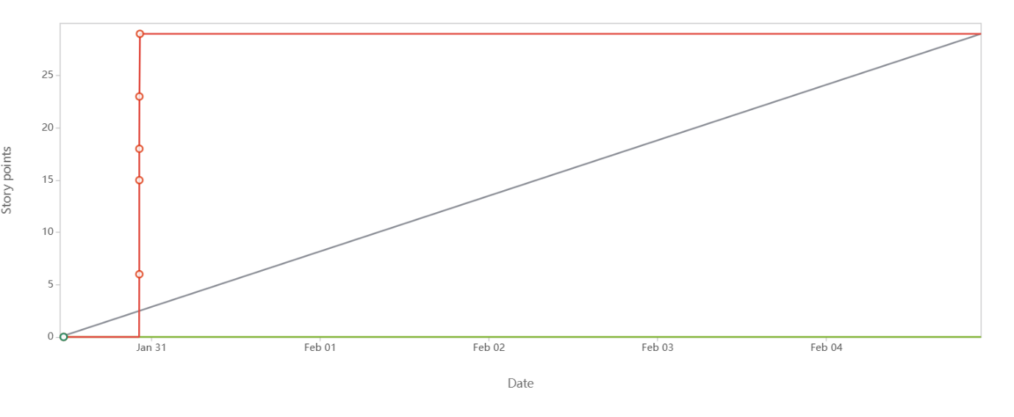Sprint backlog:
The Sprint Backlog is composed of the Sprint Goal (why), the set of Product Backlog items selected for the Sprint (what), as well as an actionable plan for delivering the Increment(how).
The Sprint Backlog is a plan by and for the Developers. It is a highly visible, real-time picture of the work that the Developers plan to accomplish during the Sprint in order to achieve the Sprint Goal. Consequently, the Sprint Backlog is updated throughout the Sprint as more is learned. It should have enough detail that they can inspect their progress in the Daily Scrum
User story ID | User story | Tasks | Owner | Status | Estimated effort
US01 | As a customer  I want to sign up  So that I can create new account | Design and implement sign-up page  Validate and store user registration information  Connect UI and backend for sign-up functionality | Chaitanya | Done | 6
US02 | As a customer  I want to login  So that I can view my ID | Create a login page UI  Implement backend authentication logic  Connect UI and backend for login functionality | Bhanu | Done | 7
US03 | As a customer  I want to recover my password  So that I can regain my account | 1.implement password recovery functionality  2.Design and implement password recovery UI  3.Ensure security measures for password recovery | Ayyappa | Done | 7
USO4 | As a customer  I want to view my order history  So that I can track my order | Create a booking history page UI  Retrieve and display user's booking history  Ensure the information is up-to-date and accurate | Kiran | Pending | 6
USO5 | As a customer  I want to logout  So that I can securely delete my account | Implement logout functionality  Design and add  logout option in the UI  Ensure user session is properly terminated | Sravani | Pending | 6
US06 | As a customer  I want to view available kurthis  So that I can buy kurthis of my choice | Design a page to display available kurthis  Fetch and display kurthis data from the backend | Karthik | Done | 5
US07 | As a user  I want to select payment mode  So that I can choose payment mode according to my option | Design a page to display payment modes  Implement payment gateway | Athul | Pending | 5
US08 | As a customer  I want to make payment  So that I can confirm my order | implement payment gateway integration.  Ensure secure handling of payment information | Akash | Done | 7
US09 | As a customer  I want to add bank details  So that I can get refund to my account | Develop the user interface for entering and editing bank details.  Set up integration with the refund process to retrieve and use the bank details. | Ashwini | Done | 6
US10 | As a customer  I want to contact customer support  So that I can clarify my doubts | Build the Contact Support Page with all required methods (chat, email, phone, etc.).  Integrate backend functionality for Automated responses or acknowledgment. | Rahul | Pending | 8

Sprint burndown chart
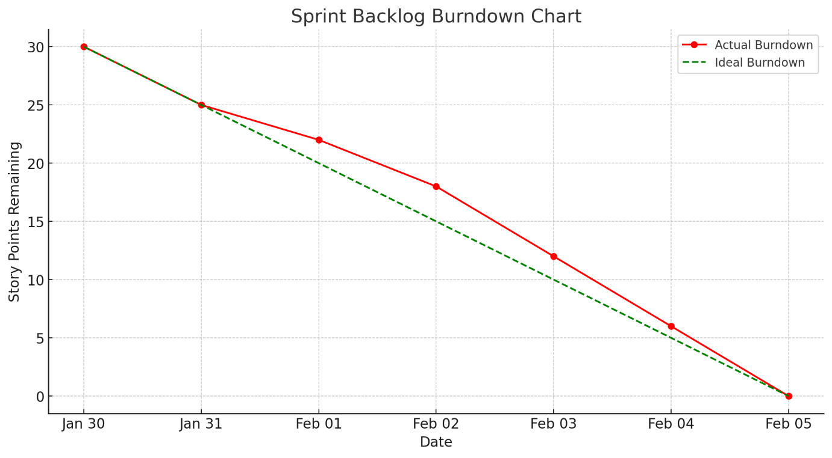
Document 6: Sprint meetings
Meeting Type 1: Sprint Planning meeting
Date | 28/08/2025
Time | 11.00am to 4.00pm
Location | Hyderabad
Prepared by | Srikanth
Attendees | Bhanu (scrum master)  Palak (product owner)  Bhanu (developer)  Sravani (developer)  Shravani (BA)  Kiran (Tester)  Chaitanya (tester)

Agenda topics:
Topic | Presenter | Time allotted
Scopes | Srikanth | 11.00 am to 11.30 am
Strategy & planning | SM, BA, PO | 11.30 am to 12.00 pm
Resource management | Scrum master | 12.00 pm to 1.00 pm
Billing & in voices | BA | 2.00 pm o 3.00 pm
GD | Product owner | 3.00 pm to 3.30 pm

Observers | Testing team, scrum master
Resources | Time: 6months  Budget: 8 lacs  People: BA, scrum master, developers, testing team, project manager  Others: jira technology used for creating burn down charts
Special notes | Clients would be onboarded virtually from legacy tool
Meeting type 2: sprint review meeting
Date | 03-01-2025
Time | 11.00 am to 4.00pm
Location | Hyderabad
Prepared by | Srikanth
Attendees | Bhanu (scrum master)  Palak (product owner)  Bhanu (developer)  Karthik (developer)  Kiran (developer)  Chaitanya (tester)  Sony (tester)

Sprint status | Things to demo | Quick updates | What’s Next
Done | Login screen for RMS searching for products, booking items | All features are enabled | Deploy in live environment

Meeting type 3: sprint retrospective meeting
Date | 8-01-2025
Time | 11.00 am to 4.00pm
Location | Hyderabad
Prepared by | Srikanth
Attendees | Bhanu (scrum master)  Palak (product owner)  Bhanu (developer)  Karthik (developer)  Chaitanya (developer)  Sony (developer)

Agenda | What went well | What didn’t go well | Questions | Reference
Sprint analysis | All the sprint backlog covered in time  sign-off taken from first iteration | Had an issue while approval module code | UAT and unit testing has to complete | SME, PO

Meeting type: Daily standup meeting
Question | Name/role | Week “X” (from dd-mm-yyyy to dd-mm-yyyy)
Question | Name/role | Mon | Tue | Wed | Thurs | Fri | Sat | Sun
What did you do yesterday? | Developer 1 | Have worked in login page | Completed login page | Login page completed | Completed searching page | Search option completed | - | -
What did you do yesterday? | Developer 2
What did you do yesterday? | Developer 3
What will you do today | Developer 1 | Have to complete by today | Recoding login has some errors | Code on searching kurthis | Recoding error codes | Booking kurthis option | - | -
What will you do today | Developer 2
What will you do today | Developer 3
What will you do tomorrow | Developer 1 | Few bugs | Nope | Few bugs | Nope | Few bugs | - | -
What will you do tomorrow | Developer 2
What will you do tomorrow | Developer 3

