Waterfall Project2 – Part -2/2

Geethu gopakumar
Document 6- Please prepare a use case diagram, activity diagram and a use case specification document.
Use case diagram :
Login
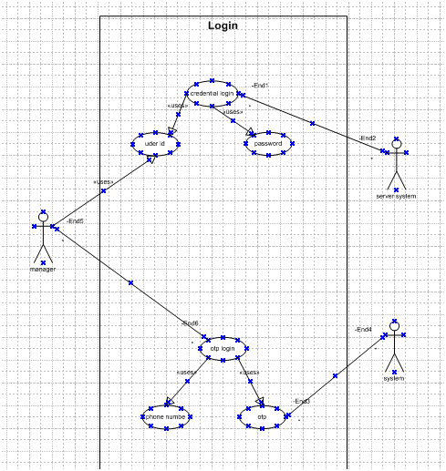
Procurement
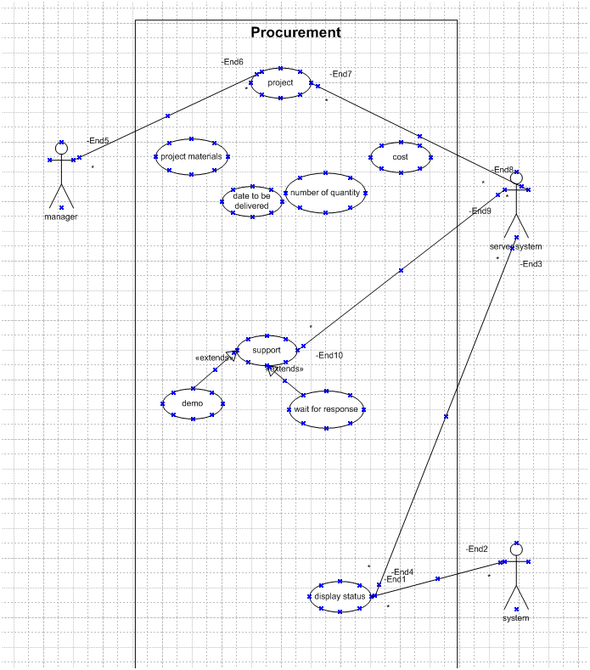
Generate quote

Activity diagram :
Login page
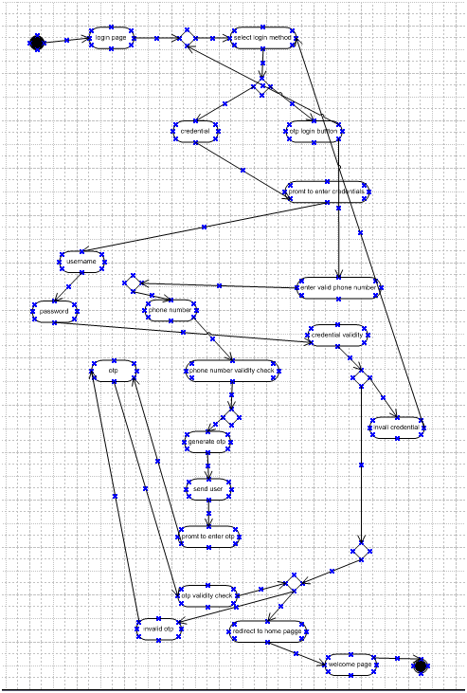
Vendor details
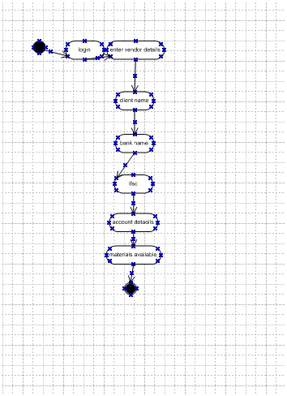

Procurement
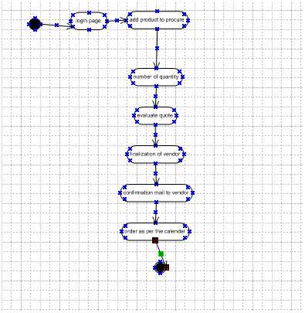
Acceptace
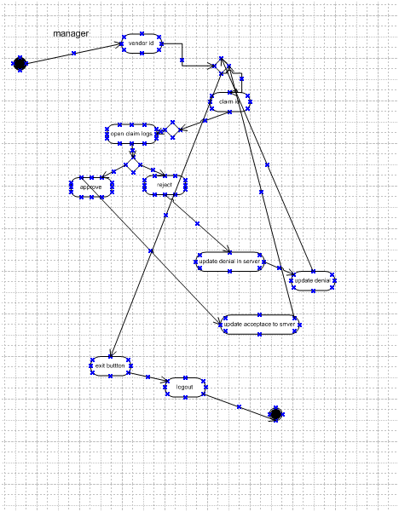

use case specification document.
UC-IMS-001 — Manage Stock Inward (Stock-In)
Use Case Name | Manage Stock Inward (Stock-In)
Use Case ID | UC-IMS-001
Created By | Geethu Gopakumar
Date Created | 15 November 2025
Last Updated | 15 November 2025
Priority | High
Status | Final
Use Case Description: | This use case describes recording incoming goods into inventory, verifying quantities, scanning barcodes, performing quality checks, updating stock levels, and generating Goods Received Notes.
Actors:
Primary Actor | Warehouse Staff / Storekeeper
Supporting Actors | System, Supplier, QA Inspector, Procurement
Preconditions:
 | - User is authenticated and authorized.
 | - Valid PO or delivery reference exists.
 | - Barcode/QR labels available.
Postconditions:
 | - Stock ledger updated.
 | - GRN generated.
 | - Notifications sent for discrepancies.
 | - Audit logged.
Basic Flow:
 | 1. User logs into IMS → Stock Inward module.
 | 2. System displays pending POs.
 | 3. User selects PO or adds ad-hoc receipt.
 | 4. User scans items.
 | 5. System validates & retrieves item data.
 | 6. User enters received qty, batch, location.
 | 7. QA inspects items.
 | 8. System validates against PO.
 | 9. User submits receipt.
 | 10. System updates stock & generates GRN.
Alternate Flows:
 | A1 – Save as Draft.
 | A2 – Ad-hoc Receipt without PO.
Exception Flows:
 | E1 – Barcode not recognized.
 | E2 – Quantity mismatch.
 | E3 – QA failed.
 | E4 – System error.
Business Rules:
 | - Only authorized users may receive stock.
 | - Over-receipt tolerance rules apply.
 | - Quarantined items blocked.
Assumptions:
 | Item master & PO data available.
Dependencies:
 | PO Module, Supplier Master, QA rules.
Inputs:
 | PO, delivery challan, barcode scans, quantities.
Outputs:
 | GRN, ledger updates, notifications.
UC-IMS-002 — Manage Stock Outward (Issue Materials)
Use Case Name | Manage Stock Outward (Issue Materials)
Use Case ID | UC-IMS-002
Created By | Geethu Gopakumar
Date Created | 15 November 2025
Last Updated | 15 November 2025
Priority | High
Status | Final
Use Case Description: | This use case covers issuing materials to project sites, fulfilling material requests, scanning outbound items, generating Issue Notes, and updating stock balances.
Actors:
Primary Actor: | Warehouse Staff
Supporting Actors: Project Site | Requester,system, finance
Preconditions:
 | - Valid requisition exists.
 | - Adequate available stock.
Postconditions:
 | - Stock reduced.
 | - Dispatch note generated.
 | - Notifications sent.
 | - Audit logged.
Basic Flow:
 | 1. Requester raises MR.
 | 2. Warehouse Staff views pending MRs.
 | 3. System checks stock.
 | 4. Allocation suggested (FIFO/FEFO).
 | 5. User scans outbound items.
 | 6. Items marked dispatched.
 | 7. System updates ledger.
 | 8. System notifies requester/finance.
Alternate Flows:
 | A1 – Partial fulfillment.
 | A2 – Inter-site transfer.
Exception Flows:
 | E1 – Insufficient stock.
 | E2 – Quarantined items selected.
 | E3 – Mismatch in scanned quantities.
 | E4 – System error.
Business Rules:
 | - Allocation follows FIFO/FEFO.
 | - Quarantined stock cannot be issued.
Dependencies:
 | MR module, transport scheduling, batch/serial system

UC-IMS-003 — Generate Inventory Report
Use Case Name | Generate Inventory Report
Use Case ID | UC-IMS-003
Created By | Geethu Gopakumar
Date Created | 15 November 2025
Last Updated | 15 November 2025
Priority | Medium
Status | Final
Use Case Description:
 | This use case covers generating dashboards and inventory reports, applying filters, exporting data, and scheduling periodic reporting.
Actors:
Primary Actor: | Inventory Manager / Operations Manager
Supporting Actor: | System
Preconditions:
 | User authorized to view reports.
Postconditions:
 | Report generated/exported/scheduled.
Basic Flow:
 | 1. User navigates to Reports.
 | 2. Selects report type.
 | 3. System retrieves relevant data.
 | 4. System displays dashboard.
 | 5. User exports or schedules report.
 | 6. System logs generation.
Alternate Flows:
 | A1 – Large dataset → async export.
 | A2 – Custom report builder.
Exception Flows:
 | E1 – Data inconsistency.
 | E2 – Report generation error.
Business Rules:
 | - Role restrictions apply.
 | - Low-stock thresholds used in alerts.
Dependencies:
 | Stock ledger, reporting engine.

Document 7- Screens and pages
Login page
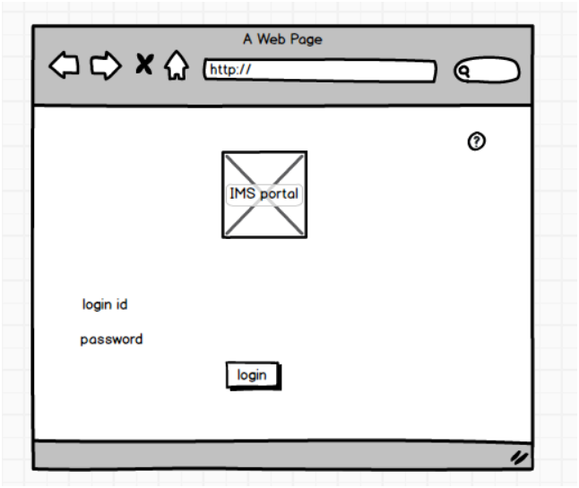
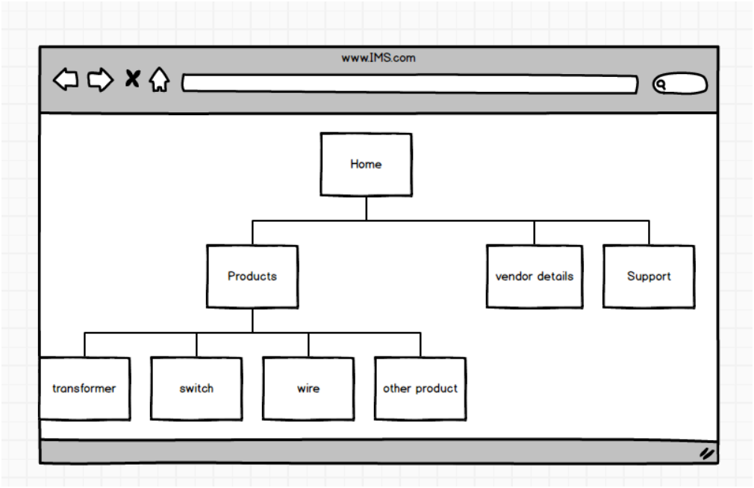
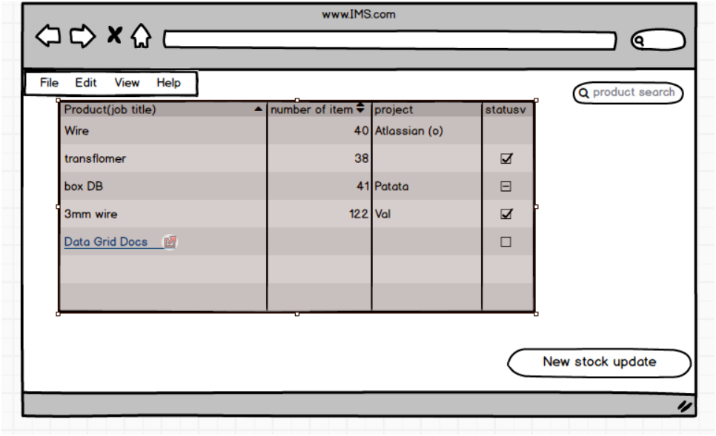

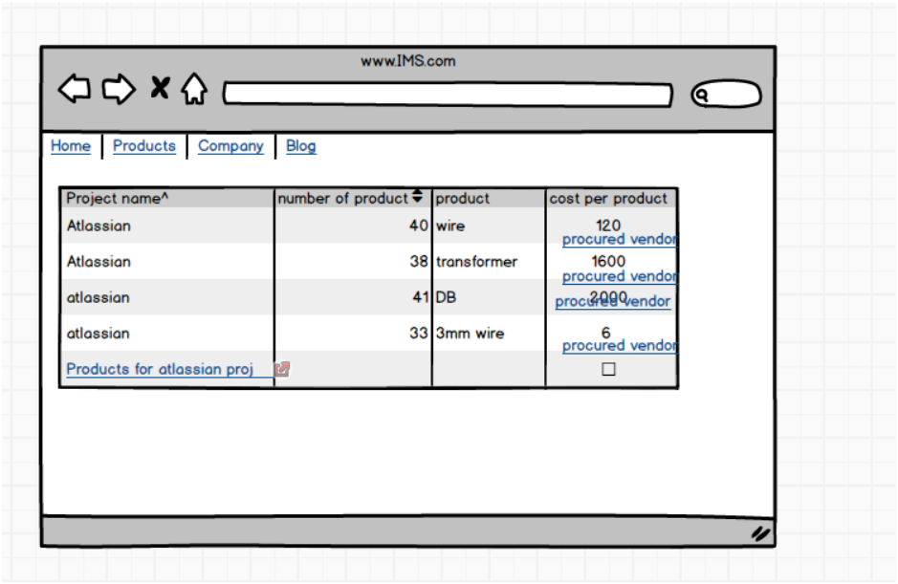

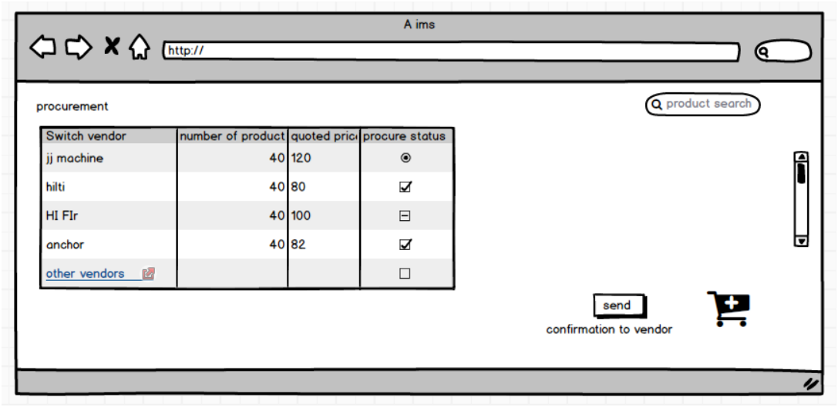
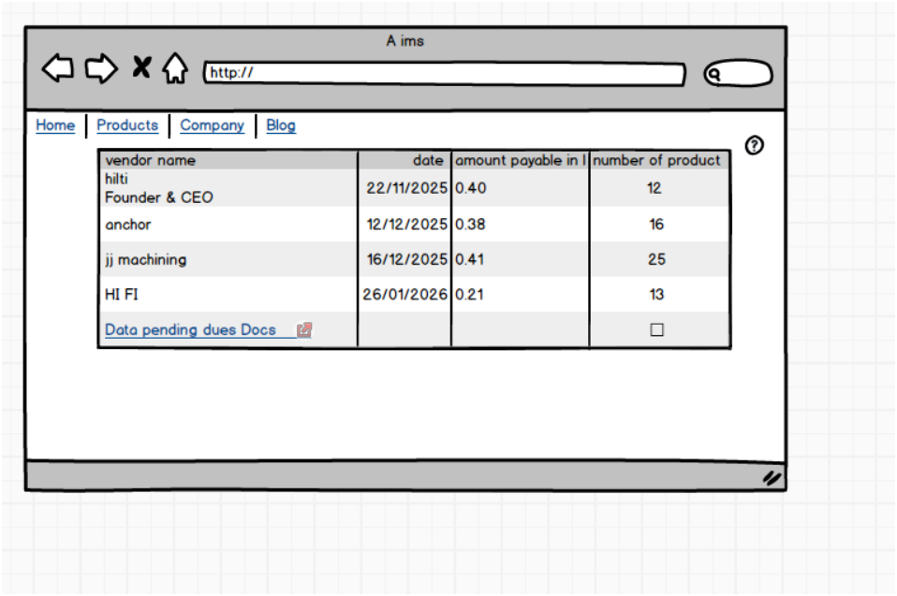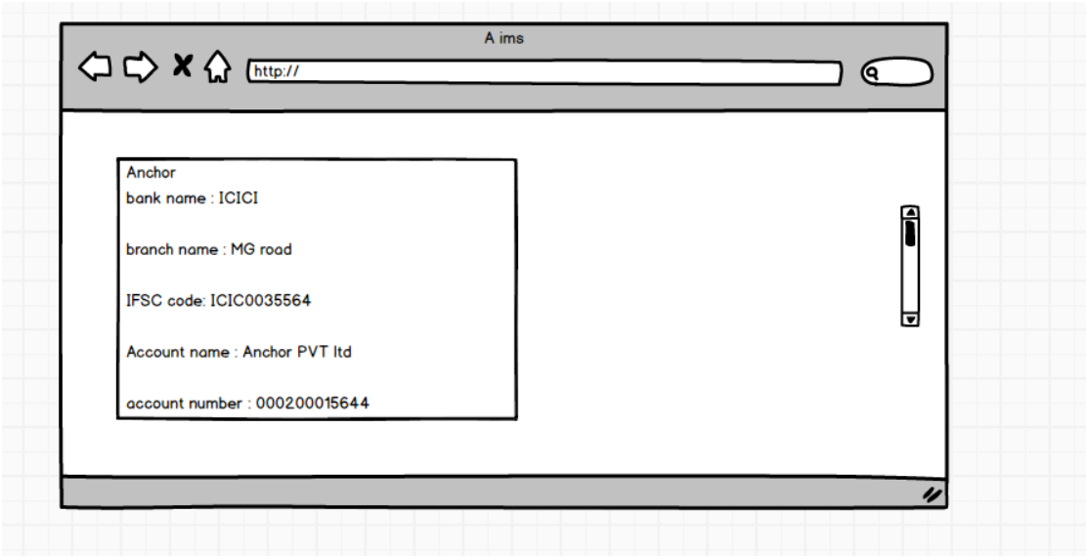
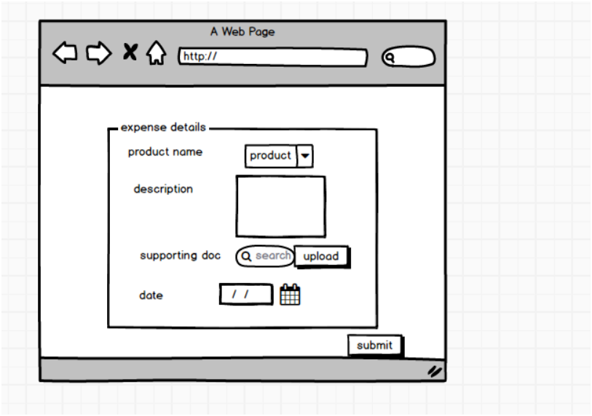
Document 8 – Tools Used: Visio and Axure (As Per IMS Project)

During the execution of the Inventory Management System (IMS) for Electrical Construction, both Microsoft Visio and Axure RP played an important role in the Requirement Analysis and Design phases of the Waterfall model.
Experience Using Microsoft Visio
Microsoft Visio was used to prepare the Use Case Diagram, Activity Diagram, and Process Flow Diagrams that represent the movement of materials from procurement to warehouse and from warehouse to various construction sites. Visio’s structured UML libraries helped in clearly illustrating the AS-IS manual workflow and the TO-BE automated workflow. These diagrams were shared with stakeholders such as warehouse staff, procurement managers, and project engineers to ensure that the new system design aligned with the operational practices of electrical construction inventory control. Visio made it easier for both technical and non-technical audiences to visualize processes, identify bottlenecks, and confirm workflow correctness before development started.
Experience Using Axure RP
Axure RP was used to create low-fidelity wireframes of the IMS screens including Login, Dashboard, Stock-In Entry, Stock-Out Issue, Alerts & Notifications, and Inventory Reports. These mockups simulated system navigation and helped stakeholders understand how the system would function after implementation. Demonstrating these screens early helped in gathering feedback and refining UI layout, form fields, validations, and user accessibility expectations. Axure wireframes supported the Waterfall approach by freezing the UI design before development, reducing rework and ensuring clarity for the developers. This tool was particularly helpful in bridging the communication between warehouse users (non-technical) and IT developers (technical).

✅ Document 9 – Business Analyst Experience (Based on Waterfall Phases in Your IMS Project)
1. Requirement Gathering
I conducted detailed discussions with warehouse personnel, procurement teams, site engineers, finance, and project managers to understand current challenges such as stock mismatches, manual entry delays, and lack of centralized tracking. Techniques used included interviews, observation, document review of stock registers, and workshops. Requirements were categorized and documented in the BRD, and were prioritized using the MoSCoW technique. All stakeholders validated and signed off the requirements before moving to the next phase, as aligned with the Waterfall methodology.
2. Requirement Analysis
The gathered requirements were analyzed and converted into functional and non-functional system specifications. I prepared Use Case diagrams, Activity diagrams, and TO-BE workflows using Visio to show how inventory will be tracked from purchase to utilization. A Functional Specification Document (FSD) was prepared for the development team. A Requirement Traceability Matrix (RTM) was created to ensure each requirement is tracked until testing and deployment.
3. Design
In this phase, I collaborated with solution architects and developers to design the system interface and functional workflows. Using Axure, I created screen-level wireframes for each IMS module such as Stock In, Stock Out, Vendor Management, Alerts, and Reporting Dashboard. These designs were reviewed with stakeholders and approved before development began. This step ensured clarity of navigation paths, data capture fields, and system controls.
4. Development
I supported developers by clarifying business rules, field-level validations, and workflow logics during coding. JAD sessions were conducted to address gaps or misunderstandings. Any change requests raised during this phase were evaluated for impact on scope, cost, and timeline and documented before approval. The development was aligned strictly as per the approved BRD and FSD.
5. Testing
I created Test Scenarios and Test Cases for validating all IMS functionalities including stock adjustments, reorder alerts, report generation, and barcode scanning. I facilitated User Acceptance Testing (UAT) with warehouse and procurement teams to ensure that the system supported real operational tasks. Defects identified were recorded, re-tested, and resolved before UAT sign-off. The RTM was updated to confirm each requirement was delivered and tested.
6. Deployment
I coordinated data migration from manual registers to the IMS, assisted in setting up user access rights, and prepared Training Manuals for warehouse and site staff. I conducted training sessions and issued step-by-step usage guides. After go-live, I supported system stabilization and tracked early feedback. A final project closure document was prepared, confirming system adoption and handover.

