Question 1 – write Agile Manifesto
The Agile Manifesto, introduced in 2001 by 17 software experts, outlines the core philosophy of Agile development. It consists of 4 values and 12 guiding principles that focus on flexibility, customer satisfaction, and delivering working software quickly.
Four Values of Agile Manifesto
1. Individuals and Interactions over processes and tools .
2. Working Software over comprehensive documentation.
3. Customer Collaboration over contract negotiation.
4. Responding to Change over following a plan.
Twelve Principles of Agile Manifesto
1. Customer satisfaction through early and continuous delivery.
2. Welcome changing requirements at any stage.
3. Deliver working software frequently in short cycles.
4. Close daily collaboration between business and developers.
5. Build projects around motivated individuals and trust them.
6. Prefer face-to-face communication for effectiveness.
7. Working software is the main measure of progress.
8. Maintain a sustainable pace of development.
9. Focus on technical excellence and good design.
10. Keep things simple—avoid unnecessary work.
11. Self-organizing teams create better solutions.
12. Regular reflection and adaptation to improve performance.

Question 2 – User Stories- Acceptance Criteria-BV-CP
User story No 1 BV 500 CP 3
As a customer
I want to register to scrum food app
so I can create my profile
Acceptance criteria
sign up page should be open at first time open to app
new user can register by adding user name, phone number ,address and password.
User story No 2 BV 200 CP 5
As a customer
I Want search menu option
so I can search expected menu
Acceptance criteria
1.After log in to application
2.search menu bar for searching product or restaurant
User story No 3 BV 200 CP 3
As a customer
I want order tracking option
so I can track my order delivery
Acceptance criteria
1. order tracking option should be displayed
2.current order delivery status should be updated
User story No 4 BV 500 CP 3
As a customer
I want multiple payment selection options available i.e. card/UPI/cod
so I can payment as per my preference
Acceptance criteria
1. after product selection multiple payment option should be displayed
2.customer can select any one option by clicking to radio button
User story No 5 BV 100 CP 5
As a customer
I want review/feedback and rating option
so I give preference by reviewing feedback and also I can rate to food
Acceptance criteria
1. after product delivery rating and feedback option should be pop up to customer
2.At product selection window rating customer rating and rewiev should be displayed
User story No 6 BV 100 CP 8
As a customer
I want add cart option for multiple products
so I order multiple product as same time.
Acceptance criteria
1. after product selected it should move to add to cart basket before payment
User story No 7 BV 50 CP 3
As a customer
I want filter selection option
so I select veg or non-veg menu
Acceptance criteria
1. at menu selection corner veg and non-veg button should displayed
User story No 8 BV 20 CP 3
As a customer
I want coupon or discount code selection option
so I get discount
Acceptance criteria
1. before payment discount and coupon code selection option should be displayed
User story No 9 BV 200 CP 13
As a customer
I want price view the price
so I order the product
Acceptance criteria
1.price should be displayed on list of menu items.
User story No 10 BV 20 CP 3
As a customer
I want order history details
so I can check order history and reorder the same product
Acceptance criteria
1.after log in to portal
2.order history option should be there with price and date when purchased
User story No 11 BV 20 CP 3
As a Restaurant owner
I want display my menu with picture price and quantity
so I can get order from customers
Acceptance criteria
1.product price and photo upload option for restaurant owner
2.order history option should be there with price and date when purchased
User story No 12 BV 10 CP 3
As a Restaurant owner
I want add special menu star to special menu of hotel
so I can show special menu of restaurant
Acceptance criteria
1.on corer of menu star should be display for restaurant special menu
User story No 13 BV 10 CP 3
As a Restaurant owner
I want add daily special menu
so I can show daily special menu of restaurant
Acceptance criteria
1.after selection of restaurant customer can see today’s special menu
User story No 14 BV 10 CP 3
As a Restaurant owner
I want view order
so I can view order details
Acceptance criteria
1.view order, display list of order
User story No 15 BV 50 CP 5
As a Restaurant owner
I want add details about dish i.e. ingredient
so I customer can view the dish ingredient and add special instruction for dish if any.
Acceptance criteria
1.after clicking on dish details
2.product ingredient should be display
User story No 16 BV 10 CP 3
As a Restaurant owner
I want add details about dish i.e. ingredient
so I customer can view the dish ingredient and add special instruction for dish if any.
Acceptance criteria
1.after clicking on dish details
2.product ingredient should be display
User story No 17 BV 500 CP 8
As a Delivery boy
I want create my profile to application
so I able to get order delivery details
Acceptance criteria
1.delivery boy register page with user name , password and mobile number
2. after successful registration delivery boy will get order notifications
User story No 18 BV 200 CP 8
As a Delivery boy
I want get customer address details with map tracking from current location
so I able deliver the order to customer location
Acceptance criteria
1.delivery location tracking details with detail address displayed
User story No 19 BV 200 CP 8
As a Delivery boy
I want get notification for order ready for pickup
so I collect order from restaurant
Acceptance criteria
1.order ready for pickup notification pop up.
2.restaurant users have order ready option available at order tracking details
User story No 20 BV 200 CP 13
As a Delivery boy
I want view order details invoice with payment paid or pending option
so I collect amount from customer before delivery the product if payment is pending
Acceptance criteria
1.invoice copy generate option available at order details
User story No 21 BV 100 CP 5
As a customer
I want view delivery boy contact number.
so I contact delivery boy for any specific instruction
Acceptance criteria
1. delivery boy contact details option display at order tracking details
User story No 22 BV 200 CP 8
As a customer
I want cancel order option
so I cancel order
Acceptance criteria
1. Go to order details
2.select cancel order
3.select reason
User story No 23 BV 100 CP 5
As a customer
I want add current location option
so I track my nearest restaurant food
Acceptance criteria
1. after log in to page
2.select location option pop up
User story No 24 BV 100 CP 5
As a Restaurant owner
I want open and close time restaurant
so I that customer can see availability of dish
Acceptance criteria
1. Go to time slot menu.
2.select Open and close time
User story No 25 BV 50 CP 5
As a Restaurant owner
I want open and close time restaurant
so I that customer can see availability of dish
Acceptance criteria
1. Go to time slot menu.
2.select Open and close time
User story No 26 BV 50 CP 5
As a customer
I want bestseller options
so I best sold dish
Acceptance criteria
1. select menu
2.select best seller options
User story No 27 BV 100 CP 8
As a customer
I want customisation option available
so I can customise my dish
Acceptance criteria
1. select menu
2.select customisation option
3.text pad open
4.add customisation note and submit
User story No 28 BV 100 CP 8
As a delivery boy
I want to select accept or reject order delivery option
so I can manage my work load
Acceptance criteria
1. receives delivery details with delivery request
2.accept or reject option available
3.if rejects its goes to next delivery partner.
User story No 29 BV 200 CP5
As a delivery boy
I want to see my earning
so I can track my income
Acceptance criteria
1. show daily weekly earning
2.show penalties and bonus
User story No 30 BV 200 CP5
As a customer
I want to multiple address
so I can choose quickly at time of checkout
Acceptance criteria
1. add, edit delete address
User story No 31 BV 200 CP5
As a customer
I want help option
so I can solve issues
Acceptance criteria
1. chat support
2.FAQs sections
User story No 32 BV 500 CP13
As a admin
I want full control over users, restaurant
so I can manage platform
Acceptance criteria
1. manage user and restaurant
2.refund approvals
User story No 33 BV100 CP13
As a customer
I want schedule my order for later
so I can get food delivery at specific time
Acceptance criteria
1. select delivery time slot
2.reminder notification send before order preparation
User story No 34 BV 50 CP3
As a customer
I want mark restaurants as favourites
so I can reorder product quickly
Acceptance criteria
1. add to favourite option
2.favorite list available on profile
User story No 35 BV 50 CP8
As a customer
I want an in app wallet
so I can store cash back and use it for future orders
Acceptance criteria
1. wallet balance visible
2.cashback added automatically
User story No 36 BV 50 CP3
As a Restaurant owner
I want see pick hours and order count
so I can manage staff better
Acceptance criteria
1. show dashboard with hourly orders
2.trend graph available
User story No 37 BV 50 CP3
As a Delivery boy
I want an auto assign mode
so I can receive order without manual acceptance
Acceptance criteria
1. new order assign instantly
User story No 38 BV 50 CP3
As a customer
I want search option using voice
so I can find items quickly without typing
Acceptance criteria
1. microphone button available
User story No 39 BV 50 CP3
As a delivery boy
I want to turn on BREAK MODE
so I don’t get order when I am on break
Acceptance criteria
1. break mode lasts for set duration
2.no order assigned
User story No 40 BV 50 CP3
As a customer
I want tip giving option for delivery boy
so I can give some amount of money as token of appreciation
Acceptance criteria
1. Tip to delivery boy option available after delivery of product.

Question 3– What is epic? Write 2 epics

An Epic is a large body of work in Agile that cannot be completed in a single sprint. It is big, high-level functionality that is broken down into smaller User Stories. Epics help teams manage and plan features that are too large to implement at once.
Epic 1: User Registration & Login System Description: As a new user, I want to create an account and log in so that I can securely access the application.
Business Value (BV): High – Enables user on boarding and access control.
Complexity Points (CP): 20 CP
Epic 2: Online Payment Integration Description: As a customer, I want to pay online using UPI, credit card, or net banking so that I can complete my purchase smoothly.
Business Value (BV): Very High – Direct revenue generation for the business.
Complexity Points (CP): 30 CP
Question 4 –What is the difference between BV and CP?
BV- Business value | CP-Complexity point
It represents the importance or benefit a user story brings to the business or customer. It helps prioritize work based on its impact on business goal. | It represents the effort or difficulty required to complete a user story, usually estimated by the development team using story points.
It shows how important or useful a task or story is for the business or customer | It shows how hard or time taking that task is for the team to complete

BV - Value to business
CP - Effort or complexity to deliver that value.

Question 5 –Explain about Sprint
A Sprint is a short, fixed period of time in the Agile Scrum framework during which a specific set of work has to be completed and made ready for review.
It is the heart of Scrum, where ideas are turned into working products.
Key Points about a Sprint:
- Duration: Usually lasts 1 to 4 weeks, most commonly 2 weeks.
- Goal: To achieve a Sprint Goal, which is a clear target or objective for that Sprint
- Planning: Each Sprint starts with a Sprint Planning Meeting where the team decides what work will be done
- Execution: During the Sprint, the team works on the selected tasks from the Product Backlog.
- Review & Retrospective: -
- At the end of the Sprint, a Sprint Review Meeting is held to show the completed work to stakeholders.
- Then a Sprint Retrospective Meeting happens to discuss what went well and what can be improved in the next Sprint.
A Sprint is a short cycle of work in Agile where the team plans, develops, tests, and delivers a small part of the product. It helps in making continuous progress and getting quick feedback.

Question 6 – Explain Product backlog and sprint back log

Product Backlog:
- The Product Backlog is a list of all features, requirements, enhancements, and fixes that need to be
- Developed for a product.
- It is maintained by the Product Owner and acts as the single source of
- work for the Scrum team. Each item in the backlog is called a Product Backlog Item (PBI) and is
- prioritized based on business value, importance, and urgency. It is a living document — items can be added, changed, or removed as the project evolves.
- Example: Adding new features like login, payment gateway, or profile update to an app.

Sprint Backlog:

- The Sprint Backlog is a subset of the Product Backlog selected by the team to work on during a specific Sprint (iteration).
- It contains all the tasks and user stories the team commits to completing
- within that sprint. The Sprint Backlog helps the team focus on short-term goals and track daily
- progress during the sprint. It is owned and updated by the Development Team throughout the sprint.

- Example: For a 2-week sprint, tasks like “design login page” and “test payment gateway” are selected from the product backlog.

- - Product Backlog: All possible work for the product (long-term).
- - Sprint Backlog: Work selected for the current sprint (short-term).

Question 7 – What is impediments log? write 2 impediments
An Impediments Log is a structured document used in Agile or Scrum projects to track any obstacles that slow down or stop the team from completing their work. These obstacles can be technical issues, resource shortages, delays from other teams, or anything that negatively affects progress.
The Scrum Master regularly reviews the impediments log to identify and remove these blockers so that the team can stay productive and meet their sprint goals. The log helps maintain transparency, improves team efficiency, and ensures that issues are resolved systematically.
Two Impediments:
- Technical Issues – Example: System downtime, tool not working, server crash, software crash, or missing tolls required for development or testing

- Dependency on Others – Example: Waiting for input, approval or information from another team or stakeholder, causing delay in the current work.

Question 8 – Explain Velocity of the Team
Velocity is the measure of how much work a team completes in a sprint. It is usually calculated by counting the total number of completed Complexity Points (CP) in that sprint.

Simple Definition:
Velocity = Total CP covered/finished by the team in one sprint.

Question 9 – Draw Sprint Burn Charts n Product Burn Down Charts

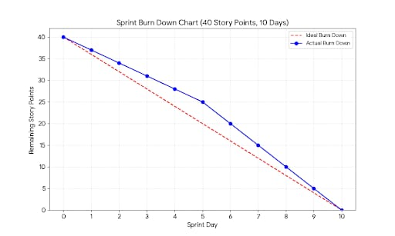

Sprint Burndown Chart A Sprint Burndown Chart shows how much work is left in the current sprint. It tracks daily progress inside one sprint.
Sprint Burndown: Shows daily progress within one sprint.
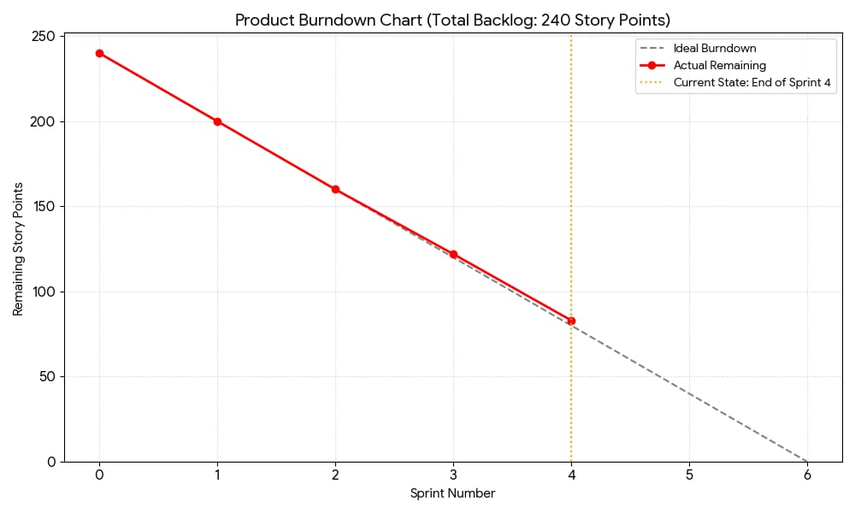
Product Burndown Chart A Product Burndown Chart shows how much total work is left in the entire project. It tracks progress across all sprints
It helps to see whether the whole project will finish on time.
Product Burndown: Shows project-level progress across multiple sprints.
Question 10 – Explain about Product Grooming
Product Grooming, also known as Backlog Grooming or Backlog Refinement, is a continuous process in Agile where the Product Owner and the Scrum Team review, update, and prioritize the Product Backlog items. The main purpose of Product Grooming is to ensure that the backlog is clear, well-defined, and ready for upcoming sprints.
During the grooming process, the team discusses each user story in detail, breaks large stories into smaller ones, adds acceptance criteria, estimates complexity (CP/Story Points), and removes out dated or irrelevant items. This helps the team understand what work is coming next and ensures the backlog items remain aligned with business goals.
Key Activities in Product Grooming:
1. Prioritizing backlog items based on business value and urgency.
2. Clarifying requirements and adding missing details or acceptance criteria.
.3. Breaking down large user stories (Epics) into smaller, manageable stories.
4. Estimating complexity or effort for each user story.
5. Removing or updating irrelevant, out dated, or duplicate items.
Benefits of Product Grooming:
- Ensures the backlog is organized and ready for Sprint Planning
.- Improves the team’s understanding of upcoming work.
- Reduces confusion and dependencies during the sprint.
- Helps deliver higher value to customers by prioritizing important items.
- Increases transparency and alignment between the Product Owner and the team.

Question 11 – Explain the roles of Scrum Master and Product Owner

Scrum Master

The Scrum Master is a facilitator and servant leader for the Scrum team. They ensure the team follows Scrum principles and works efficiently.
Key Responsibilities:
- Facilitates Scrum ceremonies such as Sprint Planning, Daily Stand-ups, Sprint Review, and Retrospective.
- Removes impediments that block the team’s progress.
- Coaches the team in Scrum practices and agile mind-set.
- Protects the team from external interruptions.
- Supports the Product Owner in backlog refinement.
Product Owner
The Product Owner is responsible for maximizing product value and managing the product backlog.
Key Responsibilities:
- Manages and prioritizes the product backlog.
- Defines and communicates the product vision.
- Prioritizes features based on business value.
- Acts as a bridge between stakeholders and the development team.
- Accepts or rejects completed work during Sprint Review.
Summary:
- The Scrum Master ensures smooth processes and removes blockers.
- The Product Owner focuses on product value, backlog management, and business goals alignment.
Question 12 – Explain all Meetings Conducted in Scrum Project.
- Sprint Planning Meeting
Held at the start of each Sprint. The team decides what work (user stories) will be done in the Sprint. The Product Owner explains high-priority items, and the team sets the Sprint Goal and creates the Sprint Backlog.

- Daily Scrum (Daily Stand-up)
A 15 minute daily meeting. Team members discuss: What they did yesterday, what they will do today, and if they have any blockers. It helps track progress and identifies issues early.

- Sprint Review
Conducted at the end of the Sprint. The team demonstrates completed work to stakeholders. Feedback is collected, and the Product Owner accepts or rejects the work done.

- Sprint Retrospective
Held after the Sprint Review . The team reflects on what went well, what didn’t, and what can be improved for the next Sprint. Focus is on team collaboration and process improvement.

- Backlog Refinement (Grooming)
Meeting Conducted during the Sprint. The Product Owner and team review and update the Product Backlog. User stories are clarified, estimated , prioritized, and made ready for the next Sprint Planning.

Question 13 – Explain Sprint Size and Scrum Size
Sprint Size
Sprint Size refers to how much work (in Story Points or Complexity Points) the team can complete in one sprint.
It is usually based on the team’s capacity, past velocity, and sprint duration.
Example:
If a team completes 30 Story Points in every 2-week sprint, then the Sprint Size is 30 SP.
Scrum Size
Scrum Size refers to the size (or complexity) of a User Story that the team assigns during estimation.
It is usually decided using story points (like 1, 2, 3, 5, 8, 13)
Example:
A small, simple story may be 3 SP, while a complex one may be 13 SP

Question 14 – Explain DOR and DOD
Definition of Ready (DOR)
DOR means a User Story is ready to be taken into the Sprint.
It tells whether the story has enough clarity, details, acceptance criteria, and no blockers so the team can start working on it.
Example points in DOR:
User story is clearly written
Acceptance criteria are defined
Dependencies are identified
Team understands the requirement
Meaning:
A story that meets DOR is ready for development.
Definition of Done (DOD)
DOD means a User Story is fully completed.
It tells whether all the required work—development, testing, review, and documentation—is finished.

Example points in DOD:
Code completed and reviewed
Unit and integration testing done
No defects pending
Accepted by Product Owner
Deployed to QA or production environment
Meaning: A story that meets DOD is ready for release.
Question 15 – Explain Prioritization Techniques and MVP.
- MoSCoW Technique -
Must Have: Essential features. –
Should Have: Important but not urgent. –
Could Have: Optional. –
Won’t Have: Not in this release.

- RICE Scoring
Used to score features based on:
Reach: How many users it impacts
Impact: Level of value
Confidence: Certainty of assumptions
Effort: Time required
Formula: (Reach × Impact × Confidence) / Effort.

MVP (Minimum Viable Product)

Definition:
MVP is the smallest version of a product that has the minimum essential features to solve the customer’s basic problem and deliver value.

Purpose of MVP:
To launch early with minimum effort
To test assumptions in the real market
To collect user feedback
To avoid building unwanted features

Benefits of MVP :Reduces development cost & time
Helps validate product-market fit
Makes future enhancements easier
Reduces risk of failure.

MVP is the smallest version of a product with essential features used to test the idea quickly, reduce risk, and gather real customer feedback.

Question 16 – Difference between Business Analyst and Product Owner.

A Business Analyst (BA) focuses on understanding business needs, gathering and analysing requirements, creating documentation (BRD, SRS, workflows), and ensuring the development team clearly understands the problem.

Interact with stakeholders, development team QA and sometimes customers

Scope-can work across multiple products or domain.

A Product Owner (PO) is responsible for owning the product vision, managing and prioritizing the Product Backlog, writing user stories, and making final decisions on what features will be developed to maximize product value.

Interact with stakeholders and scrum team to ensure right product.

Scope-focuses on single product at a time and ensure its success.

In simple terms:

BA = Requirement Analyst (understands and documents business needs)

PO = Value Owner (decides what to build and prioritizes features)

Question 17 – Prepare a sample Resume of 3yrs exp Product Owner
Name: ABC XYZ
Mobile: 98XXXXXXXX
Email: abc@gmail.com
Career Objective To work as a Product Owner in an agile environment where I can utilize my skills in backlog management, requirement gathering, and stakeholder collaboration to deliver high-value products.
Professional Summary
• 3 years of experience as a Product Owner in Agile/Scrum environment.
• Strong skills in user story writing, backlog prioritization, and sprint planning.
• Experienced in working with cross-functional teams and coordinating with stakeholders.
• Hands-on experience with Scrum ceremonies, product roadmaps, and MVP planning.
Key Skills
• Agile & Scrum
• Product Backlog Management
• User Story & Acceptance Criteria Writing
• Sprint Planning, Review & Retrospective • Prioritization Techniques
• Product Roadmap
• Communication & Stakeholder Management
Work Experience (3 Years) Product Owner – XYZ Technologies Pvt. Ltd. Jan 2022 – Present
Responsibilities:
• Collected business requirements and converted them into user stories.
• Maintained and prioritized the Product Backlog based on business value.
• Conducted Sprint Planning, Grooming, Reviews, and Retrospectives with the Scrum team.
• Coordinated with developers, testers, and UI/UX team for smooth sprint execution.
• Ensured delivery of MVP and continuous product improvements.
• Tracked team velocity and removed impediments with the help of the Scrum Master.

Education
• Bachelor’s Degree in Commerce.
• Certification: Agile / Scrum (Optional) Tools JIRA, , MS Excel,

