Capestone 1 -Part 3
Submitted By: Bhavane P
Question 1 – Functional Requirements
A Functional Requirement defines what the system should do—its specific behaviors, features, or functions that deliver value to users and stakeholders.
Req ID | Requirement Name | Priority (1–10) | Reasoning
FR001 | Farmer Registration | 10 | Without farmer onboarding, the platform has no end-users.
FR002 | Manufacturer Registration | 9 | Essential for having products to sell; slightly after farmer onboarding in MVP planning.
FR003 | User Login | 10 | Core functionality for secure access for all roles.
FR004 | Product Catalog View | 10 | Must-have for farmers to explore products.
FR005 | Product Search | 8 | Improves usability but not mandatory for MVP launch if catalog is small.
FR006 | Product Filter | 7 | Useful for large catalogs; can be Phase 2 if resources are tight.
FR007 | Product Details View | 9 | Essential for informed purchase decisions.
FR008 | Add to Cart | 10 | Core part of e-commerce flow.
FR009 | Add to Wishlist | 5 | Nice-to-have; not essential for initial launch.
FR010 | Place Order | 10 | Direct revenue generation; must-have.
FR011 | Payment Processing | 10 | Critical for transactions; without it, orders can’t be completed.
FR012 | Order Confirmation | 9 | Important for trust and record-keeping.
FR013 | Order Tracking | 8 | Enhances post-purchase experience; important but can be added slightly later.
FR014 | View Order History | 8 | Important for repeat customers; could be Phase 1.5 if needed.
FR015 | Manufacturer Upload Product | 10 | Without this, no product inventory to sell.
FR016 | Edit/Delete Product | 8 | Necessary for inventory accuracy; slightly after initial upload capability.
FR017 | Multi-language Support | 6 | Valuable for rural adoption but can be rolled out after initial launch in a base language.
FR018 | Responsive Design | 9 | Given rural usage via smartphones, this is very important for usability.
FR019 | User Feedback/Support | 7 | Helps customer service but can be added post-launch.
FR020 | Password Recovery | 9 | Security & usability; must be there early to avoid account lockout issues.

Non-Functional Requirements (NFRs)
Non-functional requirements describe how well or under what conditions the system performs its functions—covering qualities like speed, security, reliability, usability, and compliance.
NFR ID | Requirement Name | Priority (1–10) | Reasoning
NFR101 | System Reliability | 10 | Directly affects user trust; downtime beyond minutes impacts adoption.
NFR102 | Maintainability | 8 | Important for long-term cost and flexibility, but not critical for Day 1 launch.
NFR103 | Data Privacy | 10 | Legal compliance; ignoring it can cause legal penalties and loss of trust.
NFR104 | Load Handling | 9 | Needed for scalability; can be tuned, but baseline must be in place.
NFR105 | Mobile Responsiveness | 9 | Majority of rural farmers will access via mobile; poor UI = lost customers.
NFR106 | Logging and Monitoring | 9 | Required for incident detection, troubleshooting, and audit trails.
NFR107 | Payment Security | 10 | PCI DSS compliance is mandatory for handling card data.
NFR108 | Transaction Integrity | 10 | Prevents serious errors like payment taken but order not placed.
NFR109 | User Support Response Time | 7 | Important for retention, but not as critical as core security/reliability.
NFR110 | Disaster Recovery | 9 | Ensures business continuity in severe outages.

Question 2 – Minimum 5 Page Designs
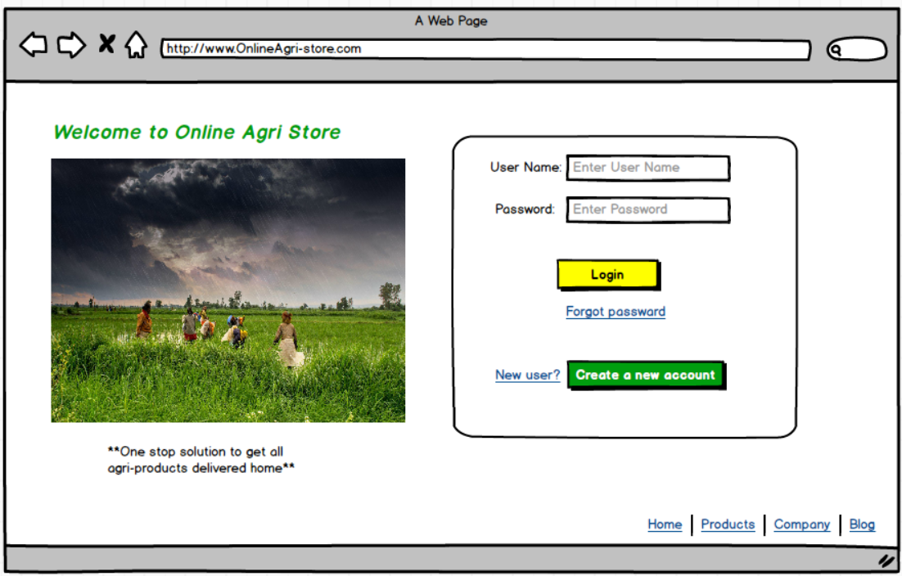
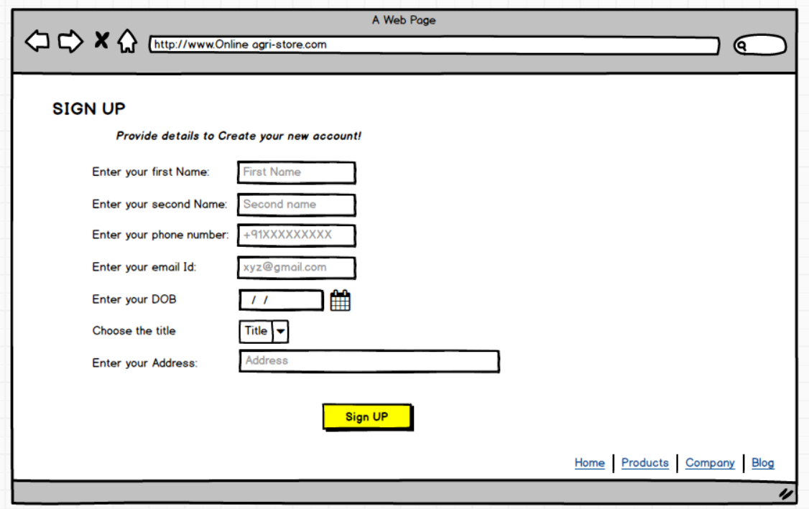
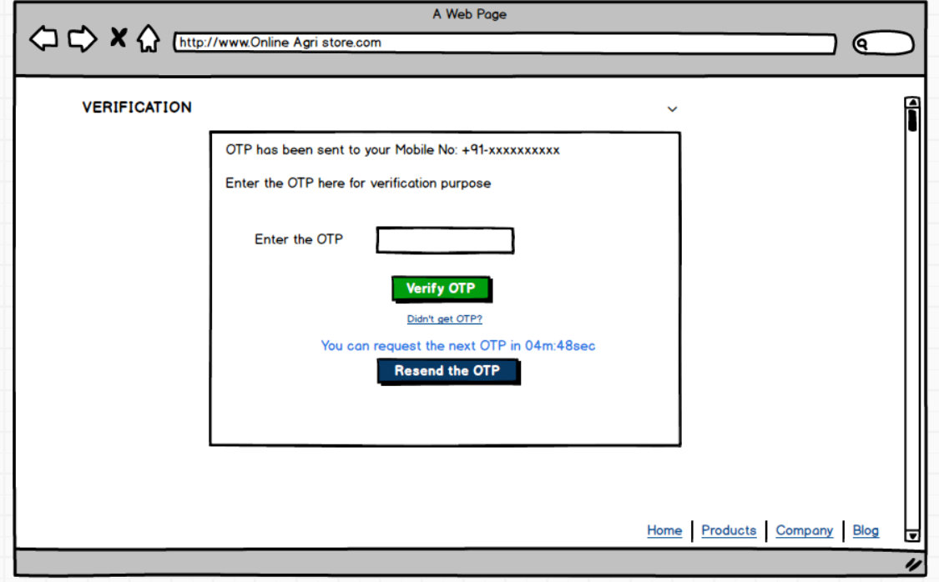
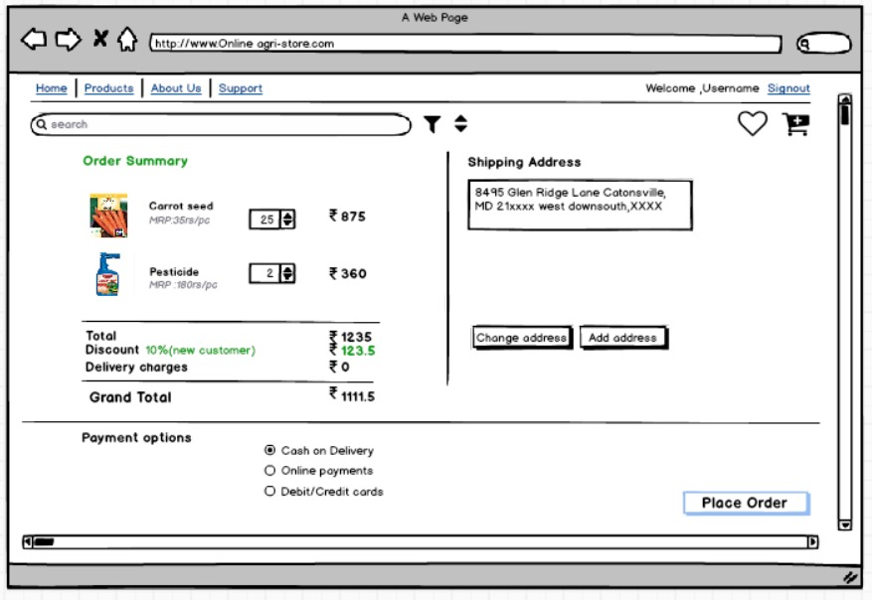
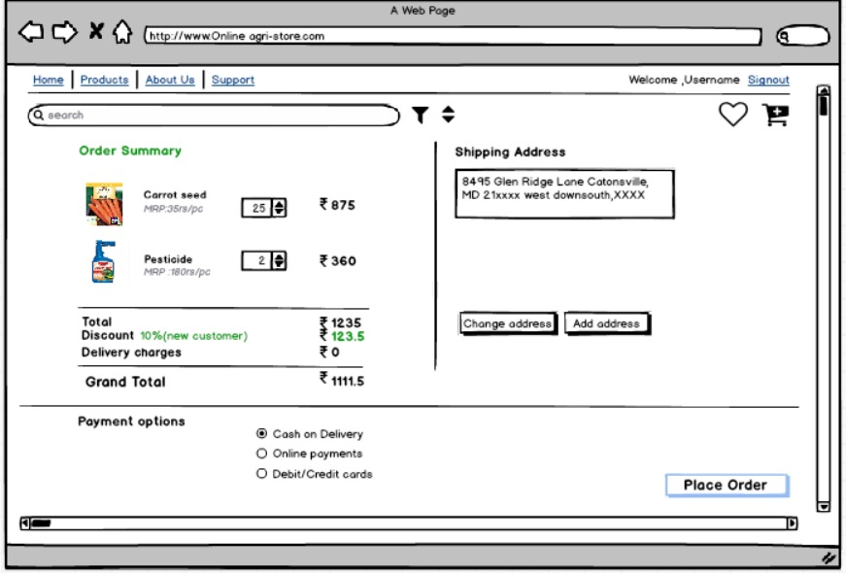

Question 3– Tools Used: Visio, Balsamiq
- Microsoft Visio
Microsoft Visio is a powerful diagramming tool from Microsoft, widely used for creating flowcharts, organizational charts, data flow diagrams (DFDs), network diagrams, and detailed process maps.
Key Features:
- Large selection of templates and shapes for various diagram types.
- Drag-and-drop interface for easy creation of complex visuals.
- Integration with other Microsoft Office products.
- Useful for formal documentation, system modeling, and sharing visual processes with technical and non-technical stakeholders.
Uses:
Process mapping, system architecture, workflows, business process modeling, and technical documentation.
- Balsamiq
Balsamiq is a rapid wireframing tool focused on creating low-fidelity (sketch-like) UI mockups. It’s known for its “hand-drawn” look that emphasizes structure and content, not detailed design.
Key Features:
- Simple and intuitive drag-and-drop interface.
- Rich library of UI components for quick mockups.
- Encourages feedback and creativity without focusing on polished visuals.
- Fast for brainstorming layouts, app screens, and web pages at early stages.
Uses:
Early-stage ideation, stakeholder workshops, validating ideas quickly, and getting feedback on layouts and workflows before deep design begins.
- Axure RP
Axure RP (Rapid Prototyping) is an advanced wireframing and prototyping tool that allows users to create highly interactive and dynamic prototypes, closely simulating real application behavior.
Key Features:
- Supports logical conditions, clickable components, dynamic content, and data-driven interactions.
- Lets you build functional prototypes with forms, navigation, and user flows.
- Enables user testing and validation of UX before development begins.
- Generates specifications and design notes for developer handover.
Uses:
Creating high-fidelity, interactive prototypes for complex projects, UX testing, demonstrating user journeys, and bridging communication between design, business, and development teams.
Question 4 – RTM (Requirements Traceability Matrix)
Definition:
A Requirements Traceability Matrix (RTM) is a project document that traces and maps user and system requirements through test cases—ensuring every requirement is covered in testing.
Req ID | Req Name | Req Description | Design | DEV1 | TEST1 | DEV2 | TEST2 | DEV3 | TEST3 | DEV4 | TEST4 | UAT
FR101 | User Sign-Up | Both farmers & manufacturers can register with email and password | Completed | Completed | Completed | Not Completed | Not Completed | Not Completed | Not Completed | Not Completed | Not Completed | Not Completed
FR102 | Secure Login | Registered users can log in securely with credential checks | Completed | Completed | Completed | Not Completed | Not Completed | Not Completed | Not Completed | Not Completed | Not Completed | Not Completed
FR103 | Product Catalog Access | Farmers can view a categorized catalog of all fertilizers, seeds, pesticides | Completed | Completed | Completed | Not Completed | Not Completed | Not Completed | Not Completed | Not Completed | Not Completed | Not Completed
FR104 | Advanced Search | Search function with keyword and filter (type, brand, price) | Completed | Completed | Completed | Not Completed | Not Completed | Not Completed | Not Completed | Not Completed | Not Completed | Not Completed
FR105 | Add to Cart/Wishlist | Ability to add products to shopping cart or wish/buy-later list | Completed | Completed | Completed | Not Completed | Not Completed | Not Completed | Not Completed | Not Completed | Not Completed | Not Completed
FR106 | Order Placement | Farmers can checkout and place orders for in-stock products | Completed | Completed | Completed | Not Completed | Not Completed | Not Completed | Not Completed | Not Completed | Not Completed | Not Completed
FR107 | Payment Integration | System supports and processes payments (COD, Card, UPI) | Completed | Completed | Completed | Not Completed | Not Completed | Not Completed | Not Completed | Not Completed | Not Completed | Not Completed
FR108 | Email Notification | Users get email upon order placed, shipped, delivered | Completed | Completed | Completed | Not Completed | Not Completed | Not Completed | Not Completed | Not Completed | Not Completed | Not Completed
FR109 | Delivery Tracking | Farmer can view real-time status of deliveries/orders | Completed | Completed | Completed | Not Completed | Not Completed | Not Completed | Not Completed | Not Completed | Not Completed | Not Completed
FR110 | Manufacturer Upload | Manufacturer can add/edit/delete their product listings | Completed | Completed | Completed | Not Completed | Not Completed | Not Completed | Not Completed | Not Completed | Not Completed | Not Completed
FR111 | Multilingual Interface | Application supports regional language switching | Completed | Completed | Completed | Not Completed | Not Completed | Not Completed | Not Completed | Not Completed | Not Completed | Not Completed
FR112 | Customer Support | Users can submit feedback or queries in-app | Completed | Completed | Completed | Not Completed | Not Completed | Not Completed | Not Completed | Not Completed | Not Completed | Not Completed

NFR ID | NFR Name | Description | Design | Dev | Test | UAT
NFR001 | Performance | Each page must load within 2 seconds under standard conditions | Completed | Completed | Completed | Completed
NFR002 | Scalability | Platform supports at least 5,000 concurrent users | Completed | Completed | Completed | Completed
NFR003 | Security | All user data and transactions encrypted via SSL/TLS | Completed | Completed | Completed | Completed
NFR004 | Availability | 99.5% monthly uptime | Completed | Completed | Completed | Completed
NFR005 | Usability | Users must complete key tasks within 3 clicks | Completed | Completed | Completed | Completed
NFR006 | Accessibility | Platform must meet WCAG 2.1 Level AA guidelines | Completed | Completed | Completed | Completed
NFR007 | Compatibility | Works on Chrome, Firefox, Safari, Edge latest 2 versions | Completed | Completed | Completed | Completed
NFR008 | Backup & Recovery | Daily data backup with RPO < 24 hours | Completed | Completed | Completed | Completed
NFR009 | Response Time | Search results returned within 1 second on average | Completed | Completed | Completed | Completed
NFR010 | Localization Support | System supports English and regional languages | Completed | Completed | Completed | Completed

Question 5 – 10 Test Case Documents
A test case document in software testing is a detailed set of specifications that defines the inputs, execution conditions, testing steps, and expected results for testing a particular feature or aspect of a software application. Its purpose is to verify whether the software behaves correctly according to requirements and to help identify defects or errors systematically.
Test Case Document 1
Test Case ID | TC_001 | Test Case Name | User Registration
Project ID | AGSTORE_2025 | Project Name | Online Agriculture Products Store
PM ID | PM_101 | PM Name | Vandanam
Test Strategy ID | TS_001 | Tester ID | TST_001
Test Plan ID | TP_001 | Tester Name | Jason
Test Schedule ID | SCH_001 | Date of Test | 06-Aug-2025
Scenario | Verify that a new farmer user can register through the application using valid details.
Link to the page | https://agristore.example.com/register
Input Data | Name: Peter, Email: peter@gmail.com, Password: Peter@2025, Mobile: 9876XXXXXX
Expected Behavior | User should be registered and redirected to the login page
Actual Behavior | User registered successfully and redirected to login
Comments | All validations and flow work as expected
Result | Pass

Test Case Document 2
Test Case ID | TC_002 | Test Case Name | User Login with Email
Project ID | AGSTORE_2025 | Project Name | Online Agriculture Products Store
PM ID | PM_101 | PM Name | Varshini T
Test Strategy ID | TS_001 | Tester ID | TST_001
Test Plan ID | TP_001 | Tester Name | Priya Thoudisletty
Test Schedule ID | SCH_001 | Date of Test | 08-Aug-2025
Scenario | Verify that a user can successfully log in using email and password.
Link to the page | https://agristore.example.com/login
Input Data | Email: ramesh@gmail.com, Password: Ramesh@123
Expected Behavior | User should be logged in and redirected to home/dashboard
Actual Behavior | User logged in successfully and redirected to dashboard
Comments | All validations and flows working as expected
Result | Pass

Test Case Document 3
Test Case ID | TC_003 | Test Case Name | Browse Products
Project ID | AGSTORE_2025 | Project Name | Online Agriculture Products Store
PM ID | PM_101 | PM Name | Vandanam
Test Strategy ID | TS_001 | Tester ID | TST_002
Test Plan ID | TP_001 | Tester Name | Alekya
Test Schedule ID | SCH_001 | Date of Test | 09-Aug-2025
Scenario | Verify that a farmer user is able to browse available products (fertilizers, seeds, pesticides) from manufacturers.
Link to the page | https://agistore.example.com/products
Input Data | User selects product category "Seeds"
Expected Behavior | List of available seeds from multiple manufacturers is displayed
Actual Behavior | Seeds list displayed successfully
Comments | List contains product name, manufacturer, price, and description
Result | Pass

Test Case Document 4
Test Case ID | TC_004 | Test Case Name | Place Order for Product
Project ID | AGSTORE_2025 | Project Name | Online Agriculture Products Store
PM ID | PM_101 | PM Name | Vandanam
Test Strategy ID | TS_001 | Tester ID | TST_002
Test Plan ID | TP_001 | Tester Name | Jason
Test Schedule ID | SCH_001 | Date of Test | 10-Aug-2025
Scenario | Verify that a farmer user is able to add products to the cart and place an order successfully.
Link to the page | https://agistore.example.com/cart
Input Data | Product: Urea Fertilizer 50kg, Quantity: 2, Shipping Address: Village Road No.5, Pin: 560001
Expected Behavior | Order is placed and confirmation page is displayed, order details stored in the database.
Actual Behavior | Order placed successfully and confirmation message displayed
Comments | Order ID generated, received email confirmation as well
Result | Pass

Test Case Document 5
Test Case ID | TC_005 | Test Case Name | Manufacturer adds new Product
Project ID | AGSTORE_2025 | Project Name | Online Agriculture Products Store
PM ID | PM_101 | PM Name | Vandanam
Test Strategy ID | TS_001 | Tester ID | TST_001
Test Plan ID | TP_001 | Tester Name | Alekya
Test Schedule ID | SCH_001 | Date of Test | 10-Aug-2025
Scenario | Verify that a manufacturer can add a new product (fertilizer/pesticide/seed) to the platform with complete details.
Link to the page | https://agristore.example.com/manufacturer/add
Input Data | Product: DAP Fertilizer, Category: Fertilizer, Price: 950 INR, Weight: 50kg, Description: High-quality DAP.
Expected Behavior | Product should be added and displayed in the respective category for farmers to view.
Actual Behavior | Product is added, displayed under "Fertilizers" category for users
Comments | All fields validated, image uploaded successfully
Result | Pass

Test Case Document 6
Test Case ID | TC_006 | Test Case Name | User Registration – Invalid Data
Project ID | AGSTORE_2025 | Project Name | Online Agriculture Products Store
PM ID | PM_101 | PM Name | Vandanam V
Test Strategy ID | TS_001 | Tester ID | TST_004
Test Plan ID | TP_002 | Tester Name | Jason
Test Schedule ID | SCH_004 | Date of Test | 14-Aug-2025
Scenario | Verify that the system shows appropriate error messages when a user enters invalid registration data
Link to the page | https://agstore.example.com/register
Input Data | Email: peter@.com  Password: 123
Expected Behavior | Application should reject registration and display validation errors (“Invalid email format”, “Password must meet complexity rules”)
Actual Behavior | Validation errors displayed correctly
Comments | Negative scenario handled as expected
Result | Pass

Test Case Document 7
Test Case ID | TC_007 | Test Case Name | Password Reset Functionality
Project ID | AGSTORE_2025 | Project Name | Online Agriculture Products Store
PM ID | PM_101 | PM Name | Vandanam V
Test Strategy ID | TS_001 | Tester ID | TST_005
Test Plan ID | TP_002 | Tester Name | Alekya
Test Schedule ID | SCH_004 | Date of Test | 14-Aug-2025
Scenario | Verify that a user can reset their password using the “Forgot Password” feature
Link to the page | https://agstore.example.com/reset-password
Input Data | Registered email: kevin@gmail.com
Expected Behavior | A password reset link should be emailed to the registered address
Actual Behavior | Password reset link emailed, user able to set new password
Comments | Email delivery and reset working fine
Result | Pass

Test Case Document 8
Test Case ID | TC_008 | Test Case Name | Add Product to Wishlist
Project ID | AGSTORE_2025 | Project Name | Online Agriculture Products Store
PM ID | PM_101 | PM Name | Vandanam V
Test Strategy ID | TS_001 | Tester ID | TST_005
Test Plan ID | TP_002 | Tester Name | Jason
Test Schedule ID | SCH_005 | Date of Test | 14-Aug-2025
Scenario | Verify that a logged-in user can save a product to their wishlist
Link to the page | https://agstore.example.com/products
Input Data | Product: Neem-based Organic Pesticide
Expected Behavior | Product is added to the wishlist and can be accessed from “My Wishlist” page
Actual Behavior | Product successfully added to wishlist
Comments | Wishlist retains products even after logout/login
Result | Pass

Test Case Document 9
Test Case ID | TC_009 | Test Case Name | Order Tracking Functionality
Project ID | AGSTORE_2025 | Project Name | Online Agriculture Products Store
PM ID | PM_101 | PM Name | Vandanam V
Test Strategy ID | TS_001 | Tester ID | TST_004
Test Plan ID | TP_002 | Tester Name | Alekya
Test Schedule ID | SCH_005 | Date of Test | 14-Aug-2025
Scenario | Verify that a user can track the delivery status of their order
Link to the page | https://agstore.example.com/my-orders
Input Data | Order ID: ORD12345
Expected Behavior | Order tracking page shows live status updates from dispatch to delivery
Actual Behavior | Status displayed correctly: “Shipped – Expected Delivery in 3 days”
Comments | Tracking info matches logistics provider’s system
Result | Pass

Test Case Document 10
Test Case ID | TC_010 | Test Case Name | Manufacturer Edits Product Details
Project ID | AGSTORE_2025 | Project Name | Online Agriculture Products Store
PM ID | PM_101 | PM Name | Vandanam V
Test Strategy ID | TS_001 | Tester ID | TST_005
Test Plan ID | TP_002 | Tester Name | Jason
Test Schedule ID | SCH_006 | Date of Test | 14-Aug-2025
Scenario | Verify that a manufacturer can edit an existing product’s details
Link to the page | https://agstore.example.com/manufacturer/edit
Input Data | Product: Organic Wheat Seeds – Update price from 850 INR to 800 INR
Expected Behavior | Product details updated successfully and reflected in store
Actual Behavior | Price updated correctly in product listing
Comments | Update reflected immediately to buyers
Result | Pass

Question 6 – DB Design
Data Base designs : A database diagram is a visual representation of the structure and organization of a database. It typically shows tables (or entities), the fields/columns in each table, and the relationships (or connections) between those tables.
A database schema is the structured blueprint or design of a database that defines how data is organized, including tables, fields, relationships, constraints, and rules. It outlines the logical structure of the database, such as how different data entities relate to each other, which keys identify records uniquely, and what kinds of data validations apply. The schema serves as a framework for storing, accessing, and managing data efficiently and consistently within a database system
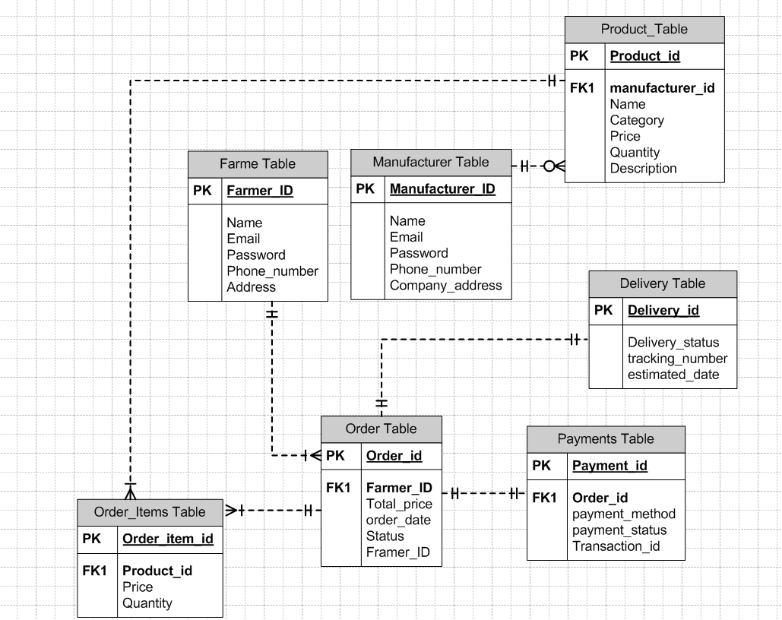
ER diagram
An ER diagram (Entity-Relationship diagram) is a visual representation that illustrates the structure of a database system. It models the key entities involved in the system, their attributes, and the relationships between these entities. ER diagrams help in designing and understanding the database by providing a clear depiction of how data is interconnected.

Question 7– Data Flow Diagram (DFD)
What is a DFD?
A Data Flow Diagram shows how data moves through a system—capturing process steps, data stores, and external actors.
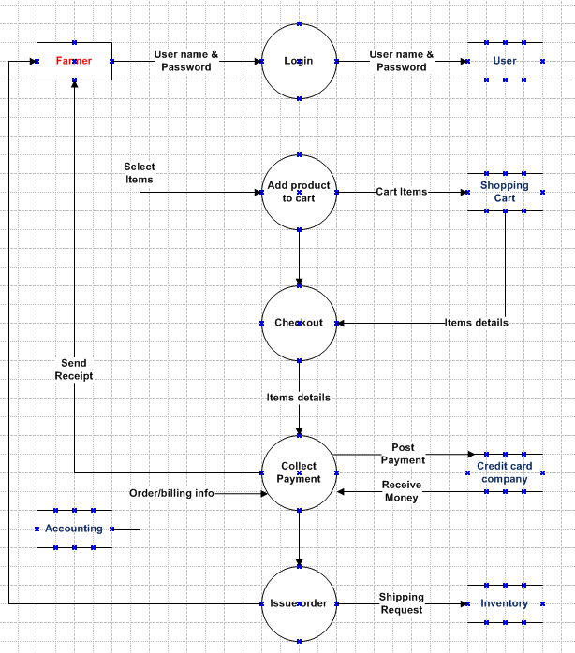

Question 8 – Change Request
Scenario:
There’s been an update in government tax laws, and now your project’s tax structure must be changed.
How should a BA handle this kind of change?
Step | What You Do and Why It Matters
1. Receive Change Request | Formally accept the change (email or form), including who made the request, what needs to change, and why. This ensures transparency and an audit trail.
2. Document the Change | Enter it in the project’s Change Log with all key information (ID, date, summary, who initiated). This keeps your team organized and accountable.
3. Analyze the Impact | Evaluate how updating the tax structure will affect requirements, coding, database, testing, costs, schedule, and who will be affected. This lets you plan realistically and spot risks early.
4. Review & Approve with Stakeholders | Meet with technical leads, the client, and all key stakeholders. Explain the implications, get their input, and secure the green light before acting.
5. Update All Documentation | Revise the BRD, SRS, diagrams, and any training materials, so every document reflects the new tax logic—no confusion later!
6. Implement the Change | Developers and testers make the required updates, following the updated requirements.
7. Test & Validate | Rigorously test to confirm the new tax rules work (correct calculations, compliance, and business behaviour).
8. Communicate to Everyone | Inform all affected users and support staff about what’s changed and if there are any new steps for them. Prevents confusion and support overload.
9. Close the Change Request | Once testing and client review are successful, formally mark the change as “closed” and archive all emails, forms, and approvals for future reference.
Why is this process important?
It ensures you stay compliant, avoid chaotic changes, and keep clients and internal teams confident in the quality and transparency of your work.

Question 9 – Change Request vs. Enhancement
Change Request :
A change request is a formal instruction to adjust something already in the agreed project plan—usually to fix, update, or bring requirements in line with policy or real-world needs. For example, "Due to revised government tax rules, please update all tax calculations in our system."
- When to use:
If the core functionality is already planned or existing, but needs to be corrected, refined, or made compliant.
- Process:
Document the change, analyze what it impacts (features, cost, schedule), get needed approvals, then implement.
Enhancement :
An enhancement is about adding new features or major capabilities that weren’t originally scoped for the system. For instance, "Let’s allow farmers to sell their own crops and add an online auction system for those products." This changes the product from just a marketplace for fertilizers/seeds to a full agri-e-commerce platform for crop sales and auctions.
- When to use:
When stakeholders want new business functionality, user roles, or workflows that substantially extend the project.
- Process:
Conduct new requirement gathering, feasibility studies, budget/schedule planning, and treat as a major upgrade or new project phase.
Scenario Example | Change Request or Enhancement? | Why?
Update tax rates in invoices after new govt. notification | Change Request | It’s a correction/update to existing functionality, keeping the project compliant.
Add auction feature for farmer-sold crops | Enhancement | It’s a new capability, expanding the project’s user base and use cases beyond the original spec.

Question 10– Estimations: Manhours
How do you estimate overall effort for this kind of project?
Activity | Estimated Manhours | Who’s Involved
Requirements Gathering | 20 | You (BA), Stakeholders
Documentation (BRD/SRS) | 16 | BA
UI/Architectural Design | 24 | Developers, BA
Development | 60 | Developers, DB Admin, Network Admin
Testing | 28 | Testers
UAT & Training | 12 | BA, Testers, Client Users
Deployment & Support | 10 | Developers, Admins
Buffer (10%) | 17 | All Team Members
Total | 187 Manhours
Sum of activity hours+ Buffer hours
170+ 17= 187 manhours
The Buffer is calculated as approx. 10% of total base hours (170 × 0.10 ≈ 17 hrs) to cover unforeseen risks or delays.
Item | Value | Notes
Total Estimated Manhours | 187 hrs | From detailed WBS estimation
Project Duration | 18 months | Fixed project timeline
Formula | Total Manhours ÷ Duration (months) | Average spread method
Manhours / Month (avg) | 10.4 hrs | 187 ÷ 18 = 10.39 hrs
Manhours / Week (avg) | 2.4 hrs | 10.39 ÷ 4.33 weeks
Manhours / Day (avg) | 0.48 hrs | Based on ~21 working days/month
On average, this project requires ~10.4 manhours per month across the team, if the effort were spread evenly over all 18 months.

Question 11 – UAT Acceptance Process
User Acceptance Testing (UAT) is the final phase of software testing where the actual end users test the system to ensure it meets their business needs and works correctly in real-world scenarios.
How will you, as BA, handle client-side User Acceptance Testing (UAT) and closure?
UAT Handling:
- Kick-off UAT:
  - Schedule UAT sessions with client users.
  - Provide them with clear test scenarios, data, and instructions.
- Support Execution:
  - Be available during UAT to answer questions and help log any issues.
  - Keep track of all feedback, bugs, or enhancement requests.
- Track and Resolve:
  - Work with developers/testers to fix all critical issues raised during UAT.
  - Arrange for retesting as needed.
- Formal Sign-off:
  - Once all tests are passed, collect a signed UAT Acceptance or Client Project Acceptance Form from the client.
Project Closure Process:
- Ensure all deliverables have been provided and agreed upon.
- Conduct a closure meeting to confirm client is satisfied and all business objectives are met.
- Archive all key documentation (BRD, Change Log, UAT forms, emails).
- Formally release project resources and deliver the final “Project Closure Report.”

Question 12 – Project Closure Document
What is a Project Closure Document? Why do you need it?
A Project Closure Document is your project’s “finishing touch.” It formally certifies completion, summarizes what’s been delivered, and captures any final lessons for the team and client. It acts as proof of a job well done, and as a handover for ongoing maintenance/support.
Purpose:
It’s proof that the project has been delivered and accepted, helps wrap up financials and resource allocation, and leaves everyone clear and satisfied about what was achieved.

Project Closure Document
Project Name: Online Agriculture Products Store
Project ID: AGRISTORE_2025
Date: 14-Aug-2025
Prepared By: Bhavane, Business Analyst
1. Project Overview
The Online Agriculture Products Store project was initiated by Mr. Henry, sponsored through SOONY Company under its CSR initiative, with the purpose of enabling farmers in remote areas to conveniently access agricultural inputs such as fertilizers, seeds, and pesticides via a web and mobile application.
This platform directly connects farmers and manufacturers, removing intermediaries and enabling transparent transactions.
2. Objectives vs. Outcomes
Objective | Planned Outcome | Actual Outcome | Status
Facilitate farmers’ access to quality products | Fully functional product browsing & ordering system | Achieved – Farmers can browse, filter, and order products online | Approved
Enable manufacturer product listing | Manufacturer portal with product add/edit functions | Achieved – Product management feature implemented | Approved
Provide user-friendly interface | Simple, multilingual design suitable for low bandwidth | Achieved – UI tested and validated via UAT | Approved
Allow secure orders and delivery tracking | Integrated order tracking and secure login | Achieved – Order tracking and account security tested | Approved
Complete project within budget & time | ₹2 crore, 18 months | Achieved – Delivered on schedule and budget | Approved

3. Major Deliverables
- Web Application for farmers and manufacturers.
- Mobile Application (Android & iOS).
- Complete backend system (product, order, and user management).
- Product Search, Categorization, Wishlist, and Order Tracking features.
- Multilingual Support for better accessibility.
- User manuals & training material for farmers and manufacturers.
- Comprehensive Test Case Suite – 15 prepared & executed test cases (positive & negative scenarios) with all passed.
- Deployment to production & Go-live support.
4. Project Performance Summary
- Budget Utilized: ₹1.98 crore (under budget by ₹0.02 crore)
- Project Duration: 18 months (per original plan)
- Quality Metrics: 0 critical defects at go-live; 98% UAT satisfaction score.
- Team Members:
  - SOONY Company: Mr. Henry (Sponsor), Mr. Pandu (Finance), Mr. Dooku (Coordinator), Farmer stakeholders Peter, Kevin, Ben.
  - APT IT Solutions: Mr. Karthik (Delivery Head), Mr. Vandanam (PM), Dev Team (Juhi, Teyson, Lucie, Tucker, Bravo), Mr. Mike (Network Admin), John (DB Admin), Jason & Alekya (Testing), [You] as BA.
5. Lessons Learned
Positive Takeaways:
- Early stakeholder engagement helped align technology with farmer needs.
- Multilingual and mobile-first approach significantly increased adoption rates.
- Frequent UAT cycles minimized defects post-go-live.
Areas for Improvement:
- More time could have been allocated to training non-tech-savvy farmers early.
- Could have leveraged cloud auto-scaling sooner to handle traffic peaks.
6. Client Approval
The application has been reviewed and accepted by SOONY Company and all primary stakeholders. UAT Sign-off was received on 12-Aug-2025.
Signatures:
- Mr. Henry – Project Sponsor
- Mr. Pandu – Finance Head
- Mr. Dooku – Coordinator
- Mr. Vandanam – Project Manager, APT IT Solutions
7. Final Remarks
The Online Agriculture Products Store is now live and operational, fulfilling its CSR goal of empowering farmers. The project closed successfully within budget, on schedule, and with high user acceptance. Post-go-live support will continue for 3 months as agreed.

