WATERFALL PROJECT

Documented by : B.Vaishnavi
Date : 05-May-20

Waterfall Deliverables - Part 2:

SINGLE REVIEW TOOL (SRT)

Enhancement Project – Business Analyst Documentation

DOCUMENT 6

Please prepare a
use case diagram,
activity diagram and
a use case specification document.

USE CASE DIAGRAM

ACTIVITY DIAGRAM

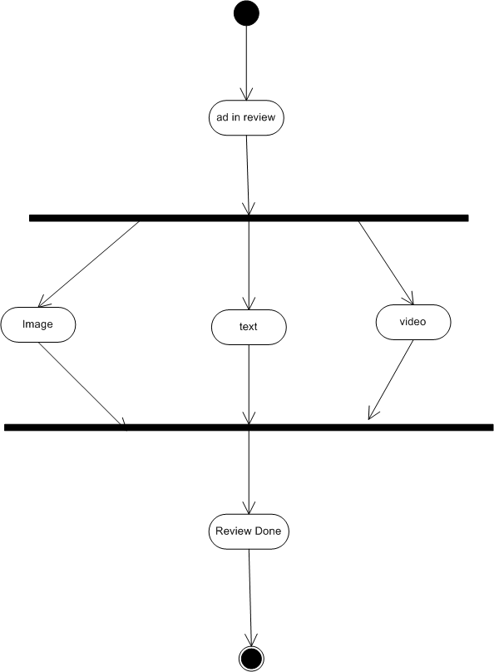

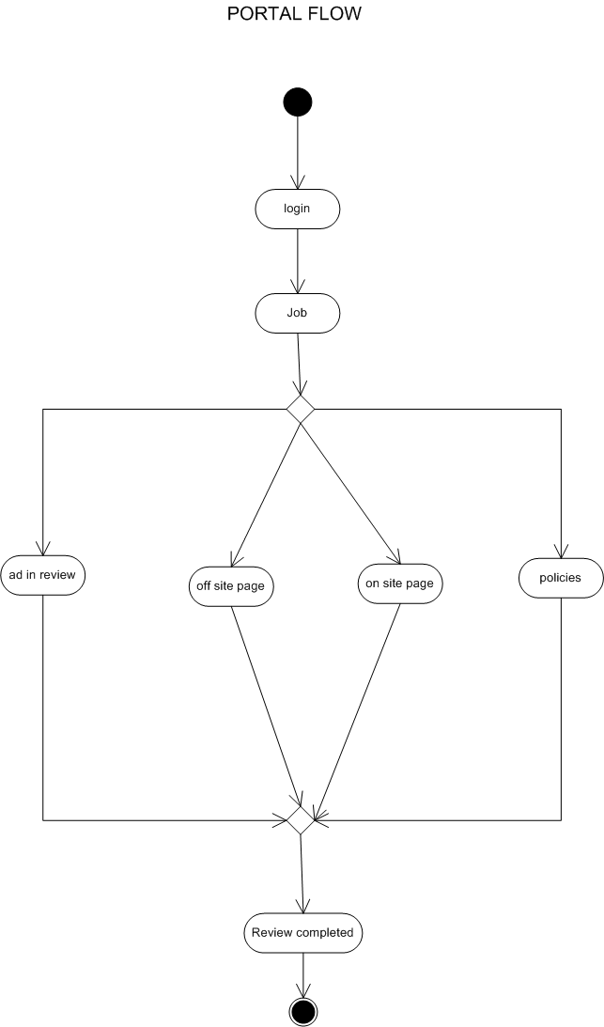
USE CASE SPECIFICATIONS :

UC001 – Highlight Key Policies
Use Case Name: Highlight Key Policies
Use Case Description: This use case enables the Single Review Tool (SRT) to display admin-tagged key policy rules at the top of the review interface. It helps moderators quickly scan important guidelines without scrolling through lengthy transcripts.
Actors:
- Primary Actor: Content Moderator
- Secondary Actor: SRT System (UI rendering and highlighting logic), Admin (tags policies for highlighting)
Basic Flow:
- Moderator logs into SRT.
- System automatically displays highlighted key policy rules tagged by admins.
- Moderator reviews the highlighted rules before checking the full transcript.
Alternate Flow:
- If no policies are tagged, the system shows a message “No highlights available.”
Exceptional Flows:
- If highlight rendering fails, system defaults to showing the full transcript.
Pre-Conditions:
- Policies are pre-tagged by admins.
- User has access to SRT with proper permissions.
Post-Conditions:
- Key rules are visible instantly, reducing review time.
Assumptions:
- Admins will keep tagged highlights accurate and updated.

Constraints:
- Feature available only in desktop version.
Dependencies:
- Policy database and tagging module.
Inputs and Outputs:
Input: Tagged policy data.
Output: Highlighted rules displayed in SRT UI.
Business Rules:
- Only admin-tagged policies can be highlighted.
Miscellaneous Information:
- Highlight colors should meet accessibility guidelines.

UC002 – Centralized URL Viewing
Use Case Name: Centralized URL Viewing
Use Case Description: This use case allows moderators to view all offsite URLs from a transcript in a single popup by clicking a button, eliminating manual searching and scrolling.
Actors:
Primary Actor: Content Moderator
Secondary Actor: SRT System (Popup module), Database (stores URL data)
Basic Flow:
  - Moderator clicks on the “View URLs” button in the transcript review interface.
  - System displays all offsite links in a popup window.
  - Moderator selects a URL to verify external content.

Alternate Flow:
If moderator does not need to verify URLs, this step is skipped.
Exceptional Flows:
- If popup is blocked by browser, system prompts user to enable popups.
Pre-Conditions:
- URLs must exist in the transcript data.
Post-Conditions:
- Moderator can verify URLs quickly without scrolling.
Assumptions:
- Users have stable internet and popup access.
Constraints:
- Works only with supported browsers (no mobile).
Dependencies:
- Content API and transcript data storage.
Inputs and Outputs:
- Input: Moderator action (button click).
- Output: URL list in popup window.
Business Rules:
- All URLs must display in a popup before navigation.
Miscellaneous Information:
- Popup must auto-close after navigation to reduce clutter.

UC003 – Collapsible Transcript
Use Case Name: Collapsible Transcript
Use Case Description: This use case allows moderators to minimize transcript sections for better screen space and reduced scrolling effort.
Actors:
Primary Actor: Content Moderator
Secondary Actor: SRT System (UI collapsible module)
Basic Flow:
- Moderator opens a transcript in SRT.
- Moderator clicks on the collapse icon to hide unnecessary sections.
- System remembers collapsed state during the session.
Alternate Flow:
- Moderator may choose to keep all sections open.
Exceptional Flows:
- If collapsible rendering fails, system shows full transcript.
Pre-Conditions:
- Transcript data must be loaded successfully.
Post-Conditions:
- Moderator completes review faster with reduced scrolling.
Assumptions:
- Browser supports collapsible UI features.
Constraints:
- Feature not available on unsupported browsers or mobile.
Dependencies:
- Transcript rendering module.

Inputs and Outputs:
- Input: Moderator action (collapse/expand click).
- Output: Collapsed/expanded transcript view.
Business Rules:
- Collapsed state should persist within the session.
Miscellaneous Information:
- Future scope: Auto-collapse long sections by default.

UC004 – Escalation Confirmation
Use Case Name: Escalation Confirmation
Use Case Description: This use case ensures that when moderators tag a case as “critical,” the system prompts for explicit confirmation to prevent accidental misclicks.
Actors:
Primary Actor: Content Moderator
Secondary Actor: SRT System (Confirmation popup logic)
Basic Flow:
- Moderator selects “Critical Escalation” tag.
- System displays confirmation dialog: “Are you sure you want to tag this as critical?”
- Moderator confirms or cancels.
Alternate Flow:
If the moderator selects a non-critical tag, no confirmation dialog appears.
Exceptional Flows:
- If confirmation popup fails, the system blocks tagging until it is restored.
Pre-Conditions:
- Moderator must have escalation privileges.

Post-Conditions:
- Critical cases are tagged accurately without mis-clicks.
Assumptions:
- Moderator will read and respond to confirmation prompt.
Constraints:
- Feature only available on desktop interface.
Dependencies:
- Tagging module, UI alert module.
Inputs and Outputs:
- Input: Moderator action (tag selection).
- Output: Confirmed escalation tag or cancelled action.
Business Rules:
- Every “critical” escalation must be explicitly confirmed.
Miscellaneous Information:
- Alert should be visually distinct (e.g., red colour, bold text).

DOCUMENT 7- SCREENS AND PAGES

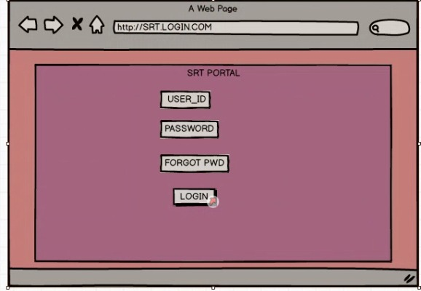

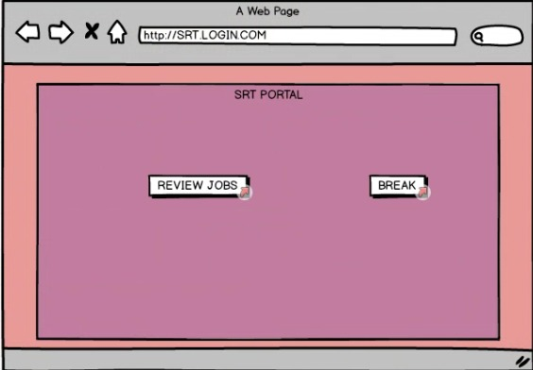

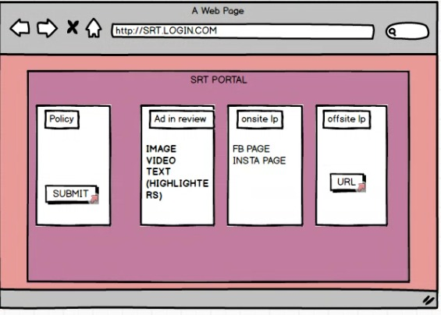

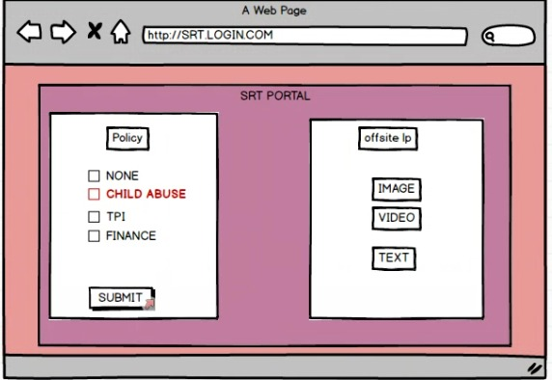

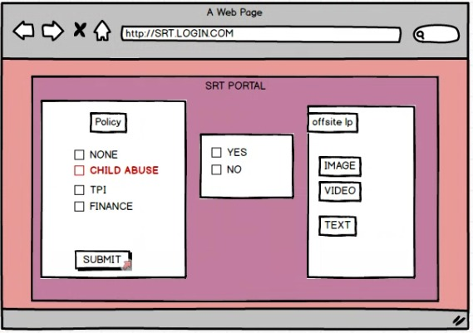

PROTO TYPES:

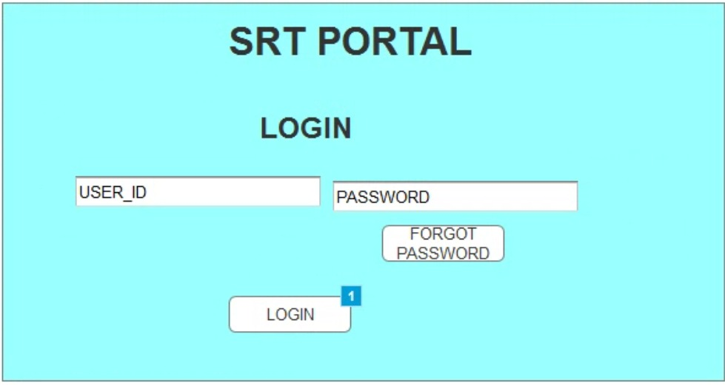

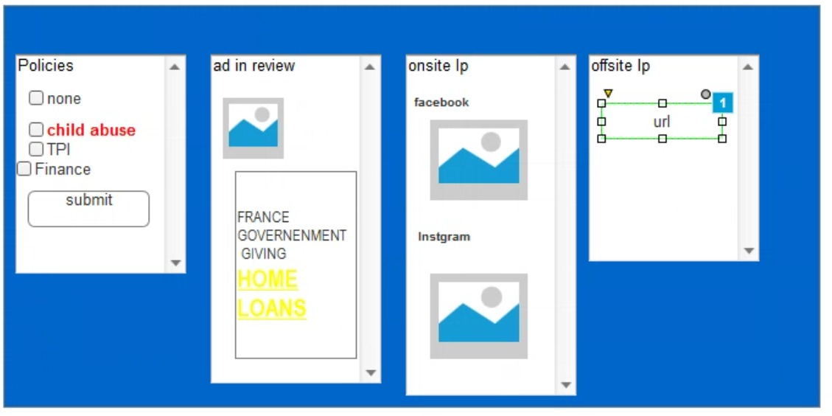

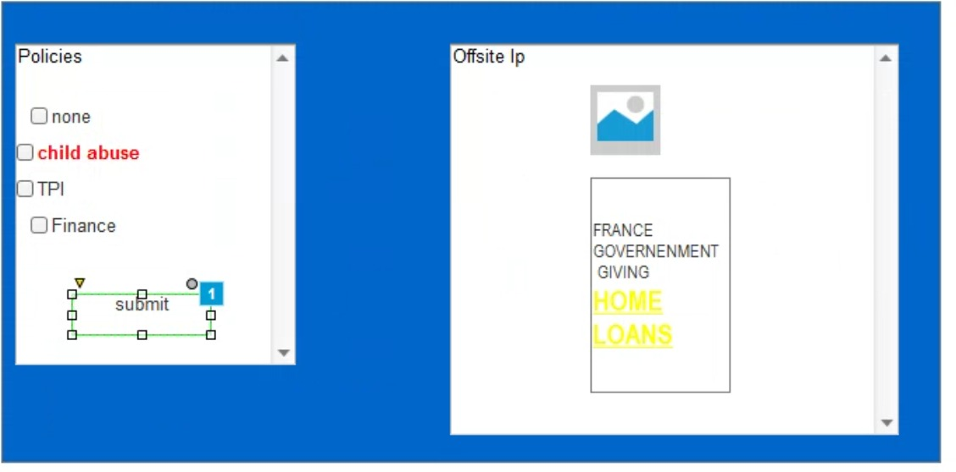

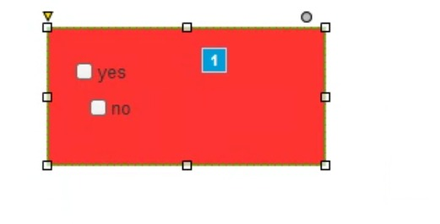
DOCUMENT 8- TOOLS-VISIO AND AXURE

Write a paragraph on your experience using Visio and Axure for the project.
As a Business Analyst on the SRT Workflow Optimization Enhancement project, which followed the Waterfall Model, I extensively used Microsoft Visio and Axure to ensure clear communication and structured documentation across all phases. During the requirements gathering and analysis stages, I utilized Visio to create detailed use case diagrams, activity diagrams, and workflow models that helped stakeholders clearly understand the proposed features such as policy highlights, centralized URL viewing, collapsible transcripts, and escalation confirmations. These visual models provided developers and testers with precise references during design and implementation. In parallel, I used Axure to build interactive wireframes and prototypes of the updated SRT interface, allowing stakeholders to validate the new UI elements early in the project lifecycle. This proactive approach helped identify potential usability issues and refine requirements before development began, minimizing rework. Leveraging Visio and Axure within a structured Waterfall framework enabled smooth, well-documented handoffs between phases, ensuring traceability, alignment, and successful delivery of project objectives.

DOCUMENT 9- BA EXPERIENCE

My experience as BA in following phases:

1. Requirement Gathering:
- To gather requirements for Policy Highlights, Centralized URL Viewing, Collapsible Transcript, and Escalation Confirmation, I conducted stakeholder interviews, process walkthroughs, and document reviews to understand current SRT workflow pain points.
- Since some stakeholders were unavailable at times, I proactively identified alternate points of contact within the Policy Operations team to avoid delays.
- I validated requirements using the FURPS framework (Functionality, Usability, Reliability, Performance, Supportability) to ensure completeness and quality.
- Prototyping with Axure was used to give stakeholders an early view of the new SRT UI features, helping refine requirements and remove ambiguity.
- I also began drafting the Requirement Traceability Matrix (RTM) at this stage to ensure every requirement would later be tracked during design, development, and testing.

2. Requirement Analysis:
- I prepared UML Use Case Diagrams and Activity Diagrams in Microsoft Visio to visually describe how each new feature would work within the SRT.
- Communicated these diagrams with the development and QA teams; whenever feedback or disagreements arose, I consolidated suggestions and updated the diagrams accordingly.
- Created Business Requirement Specification (BRS) and Functional Specification (SRS) documents with clear, detailed requirements.
- Updated the RTM to confirm that all requirements were mapped to functional and non-functional criteria for full coverage.

3. Design:
- Derived positive and negative test cases from use case diagrams to ensure robust design validation.
- Coordinated with the client to review UI/UX wireframes and solution design documents, confirming they aligned with stakeholder expectations.
- Prepared test data based on real-world moderation scenarios.
- Continuously updated the RTM to verify that every requirement was addressed by corresponding design elements.

4.Development:
- Organized Joint Application Development (JAD) sessions to clarify requirements with developers during coding.
- Resolved any misunderstandings or conflicts among team members by holding one-on-one discussions and ensuring everyone understood how their input affected project timelines and quality.
- Referred UML diagrams and workflow models during development to avoid misinterpretation of requirements.
- Conducted regular review meetings with both technical teams and clients to track progress, recording sessions and following up individually with members who missed meetings.

5. Testing:
- Prepared high-level test cases from use cases and reviewed coverage with the QA team.
- Verified test data requirements by requesting them directly from the client.
- Performed requirement validation testing to ensure features such as URL popups, collapsible transcripts, and escalation confirmation behaved as expected.
- Updated the RTM throughout testing to verify full coverage.
- Coordinated with the client to get formal sign-off on the validated features and prepared them for User Acceptance Testing (UAT).

6.Deployment:
- Forwarded the finalized RTM to the client as part of the Project Closure Document, ensuring full traceability of implemented requirements.
- Coordinated with technical writers to create and distribute End User Manuals explaining the new SRT features.
- Organized training sessions for content moderators, ensuring all users were briefed on UI changes.
- Monitored attendance, provided recordings, and followed up individually to ensure no one missed critical updates.
- Verified that post-deployment behaviour matched signed-off requirements and gathered early feedback for any final refinements.

use case specification

