Document 6- Please prepare a use case diagram, activity diagram and a use case specification document.
1. Use case Name
2. Use case Description
3. Actors Primary Actors Secondary actors
4. Basic Flow
5. ALTERNATE FLOW
6. Exceptional flows
7. Pre- Conditions
8. post-conditions
9. Assumptions
10. Constraints
11. Dependencies
12. Inputs and Outputs
13. Business Rules
14.Miscellaneous Information
ANSWER
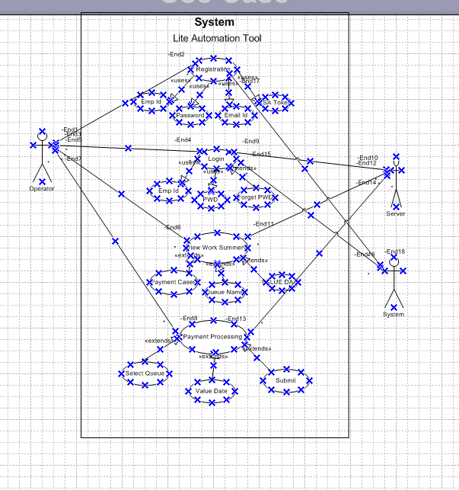

Use Case Specification – LITE AUTOMATION TOOL

Use Case Name
SEPA AUTOMATION TOOL

2. Use Case Description
This use case describes the operation by which operator can release the BULK payments through the automation Tool. The operator can select and filter the particular queue as Restriction verification, Funds Control and Insufficient Fund along with that can choose the value date, country.

3. Actors
Primary Actor: Operator
Secondary Actor: Automation Tool

4. Basic Flow
1. Candidate accesses FVQ (Folder VIEW QUEUE).
2. Candidate views work summery.
3. Candidate selects a desired queue.
4. Candidate fills out the country code and value date.
5. Operator runs the Tool.

5. Alternate Flow
If the operator has already registered, they may log in to pre-fill data from their profile.

6. Exceptional Flows
- If required fields are left empty, system prompts operator to complete them.
- If operator’s input is invalid, Tool doesn’t function.
- Tool fails to connect to server – prompts error message and retry option.

7. Pre-Conditions
- The Operator must have internet /VPN access.
- Work Summery (FVQ)must be active on the portal.

8. Post-Conditions
- The released payment is stored in the database.
- Notification is sent to the RM (Relationship Manager).

9. Assumptions
- Operator should have an official email address.
- RM will be responsible to response within TAT ,48 hours.

10. Constraints
- Payment must not exceed 20 counts.
- Tool timeout is 5 minutes.

11. Dependencies
- Tool configuration must support the system.
- Work Summery should be up and functional.

12. Inputs and Outputs
Inputs: Registration, Login, View work summery, Fiter for work queue
Outputs: Released payment stored in system

13. Business Rules
- Only one operator can run the Tool for one selected queue.
- Mandatory fields include Queue Name, Country, and Value Date.

14. Miscellaneous Information
- This use case supports localization in English.

Activity Diagram-
LITE AUTOMATION TOOL

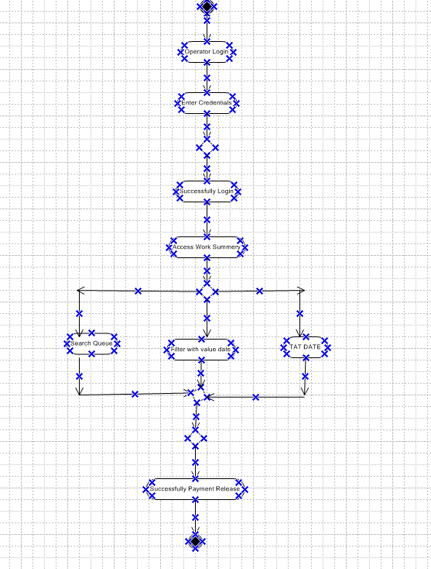

Document 7- Screens and pages (Mock-ups using Balsamiq)
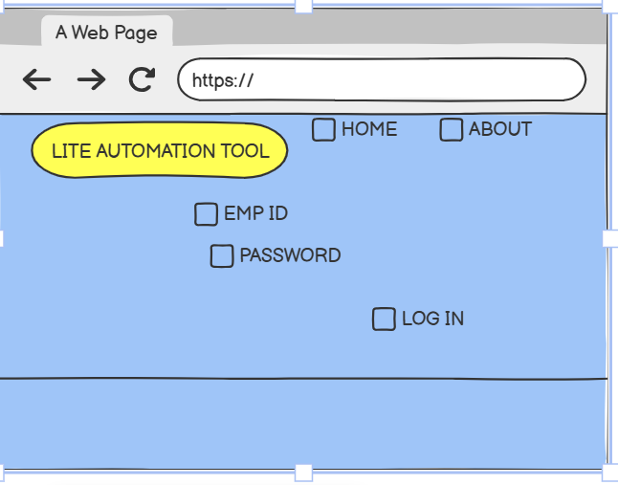

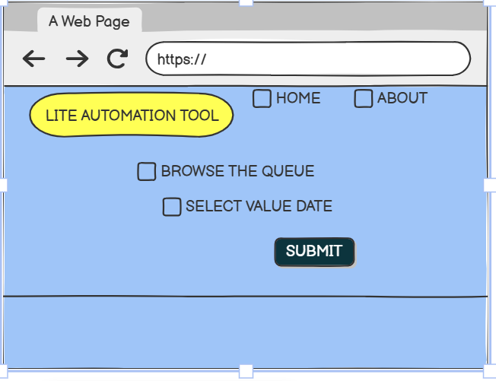

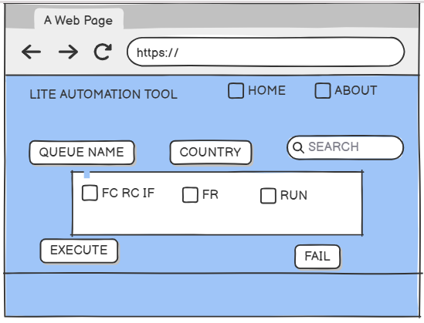
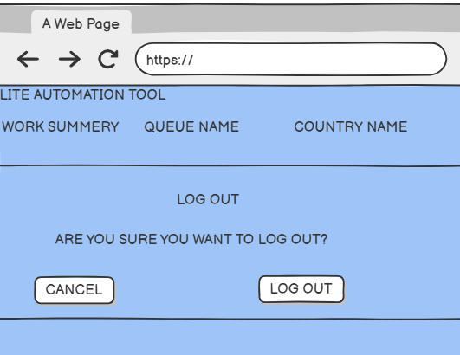

Document 8- Tools-Visio and Axure Write a paragraph on your experience using Visio and Axure for the project.
For this project, I used both Microsoft Visio and Balsamiq to create the screens and flows for the LA (Lite Automation Tool).
Utilized Microsoft Visio extensively to design precise and professional UML diagrams, including activity diagrams, use case diagrams, and process flows for the Bulk Payment release process within the LA tool. Visio’s flexibility in adding fork and join nodes, decision points, and relationship connectors allowed me to clearly represent process logic, actor interactions, and validation paths.
Additionally, I used Balsamiq for creating quick, low-fidelity wireframes to visualize the Tool’s operation before moving into detailed diagramming.
Balsamiq’s drag-and-drop simplicity helped in brainstorming user interface layouts and gaining stakeholder alignment early in the design phase, while Visio ensured the final deliverables were technically accurate and presentation-ready. This combination of tools streamlined the transition from conceptual mock-ups to fully detailed technical diagrams, improving both clarity and collaboration with the project team.
Document 9- BA experience My experience as BA in following phases:
1. Requirement Gathering:
- I used the MoSCoW technique to prioritize the requirements into Must Have, Should Have, Could Have, and Won’t Have.
- Conducted interviews with stakeholders and operators to understand the key needs and Pain points of the process .
- During stakeholder absence, I identified alternate points of contact from the client side to ensure smooth information flow and avoid delays.
- I used prototyping to gather more specific requirements—this helped clients visualize the screens and refine their inputs.
- Cleaned up duplicate and unclear requirements to maintain a clear and organized scope.
2. Requirement Analysis:
- Created detailed UML diagrams like use case diagrams and activity diagrams to represent system behaviour and flow.
- Used branch/merge and fork/join logic in the activity diagram to capture all possible flows in the candidate journey—from login to logout.
- Shared these diagrams with the team for review; when there were disagreements, I facilitated discussions, collected feedback, and revised the diagrams accordingly.
- Prepared BRS (Business Requirement Specification) and SRS (System Requirement Specification) to document and finalize the functional and non-functional requirements.
3. Design:
- Translated use cases into detailed test cases—covering both positive and negative scenarios.
- Communicated regularly with the Stakeholderto discuss design documents and solution flows to ensure expectations were aligned.
- Made sure no test case was missed, understanding how even one missed scenario could impact the entire development and testing later.
- Prepared relevant test data for QA teams to simulate various candidate profiles.
- Updated the Requirement Traceability Matrix (RTM) regularly to make sure all requirements were covered in development and testing.
4. Development:
- Organized JAD (Joint Application Development) sessions between developers, testers, and stakeholders to ensure alignment.
- Acted as a bridge between the technical team and client—clarifying functional queries raised by developers during the coding phase.
- Some team members had conflicting views or showed resistance during sessions; I handled such situations with one-on-one discussions, addressing concerns and explaining the larger project impact, creating a healthy and cooperative environment.
- Referred the previously created use case and activity diagrams to assist developers in understanding the logic for different user actions like Transaction Id search, Filter Country code, and logout from the tool.
- Set up regular sync-up meetings with developers and clients. For any team member who missed a session, I ensured to share recordings and have follow-up discussions to keep everyone in sync.
5. Testing:

- Closely worked with the QA team to validate each requirement during system, integration, and user acceptance testing (UAT).
- Reviewed all test cases to ensure complete coverage based on the Requirement Traceability Matrix (RTM).
- For any unclear test results or failed cases, I coordinated between the QA and development teams to identify root causes and provide clarity.
- Actively ensured that both functional and non-functional requirements (like number of payment release limits, operation time, and browser compatibility) were tested as per the original SRS.
6. Deployment:
- Participated in release planning meetings, helping define the scope of what features should go in each deployment phase.
- Ensured that release notes included all finalized functionalities, bug fixes, and known limitations, making them easy to understand for business users.
- Conducted post-deployment sanity checks to ensure all modules (like Operator Login, Work Search, App, Resume Upload, and Logout) were functioning as expected in the production environment.
- Captured early user feedback post-deployment and created a backlog of enhancements and minor fixes to be considered for future releases.
- Helped in drafting the training material and user manual to support end users in adopting the new system smoothly.

