Scrum Project – Janhavi
Question No 1 – Agile Manifesto
Four main Values
Individuals and interactions over processes and tools
Working software over comprehensive documentation
Customer collaboration over contract negotiation
Responding to change over following a plan

Twelve Principles of Agile Software
1.Satisfy the customer through early and continuous delivery of valuable software.
2.Welcome changing requirements, even late in development. Agile processes harness change for the customer's competitive advantage.
3.Deliver working software frequently, from a couple of weeks to a couple of months, with a preference to the shorter timescale.
4.Business people and developers must work together daily throughout the project.
5.Build projects around motivated individuals. Give them the environment and support they need, and trust them to get the job done.
6. The most efficient and effective method of conveying information to and within a development team is face-to-face conversation.
7. Working software is the primary measure of progress.
8. Agile processes promote sustainable development. The sponsors, developers, and users should be able to maintain a constant pace indefinitely.
9. Continuous attention to technical excellence and good design enhances agility.
10. Simplicity--the art of maximizing the amount of work not done--is essential.
11.The best architectures, requirements, and designs emerge from self-organizing teams.
12.At regular intervals, the team reflects on how to become more effective, then tunes and adjusts its behaviour accordingly.

Question No 2

USER STORIES

SPRINT-1  User Story No: 2 | Tasks: - | Priority: -
AS A CUSTOMER
I WANT TO REGISTER IN SCRUM FOODS
SO THAT I CAN PLACE ORDERS
BV: 600 | CP: 03
ACCEPTANCE CRITERIA
Registration screen with Name, Email, Mobile, Password. Successful notification sent.

SPRINT-1  User Story No: 3 | Tasks: - | Priority: -
AS A CUSTOMER
I WANT TO LOG IN WITH CREDENTIALS
SO THAT I CAN ACCESS ACCOUNT
BV: 500 | CP: 02
ACCEPTANCE CRITERIA
Login form, validation, error on wrong input, success on valid credentials.

SPRINT-1  User Story No: 4 | Tasks: - | Priority: -
AS A CUSTOMER
I WANT TO SEARCH FOR RESTAURANTS BY NAME OR CUISINE
SO THAT I CAN FIND FOOD EASILY
BV: 700 | CP: 04
ACCEPTANCE CRITERIA
Search bar, results displayed based on keywords.

SPRINT-1  User Story No: 5 | Tasks: - | Priority: -
AS A CUSTOMER
I WANT TO BROWSE THE MENU OF A RESTAURANT
SO THAT I CAN DECIDE WHAT TO ORDER
BV: 800 | CP: 05
ACCEPTANCE CRITERIA
Menu screen with item name, price, and image.

SPRINT-1  User Story No: 6 | Tasks: - | Priority: -
AS A CUSTOMER
I WANT TO ADD ITEMS TO A CART
SO THAT I CAN REVIEW BEFORE CHECKOUT
BV: 900 | CP: 05
ACCEPTANCE CRITERIA
Add to Cart button, items stored, update/remove options.

SPRINT-1  User Story No: 7 | Tasks: - | Priority: -
AS A CUSTOMER
I WANT TO APPLY COUPON CODES
SO THAT I CAN GET DISCOUNTS
BV: 500 | CP: 03
ACCEPTANCE CRITERIA
Coupon box, validation, discount applied.

SPRINT-1  User Story No: 8 | Tasks: - | Priority: -
AS A CUSTOMER
I WANT TO PAY ONLINE
SO THAT I CAN COMPLETE PURCHASE SECURELY
BV: 1000 | CP: 08
ACCEPTANCE CRITERIA
Payment gateway integration, confirmation message.

SPRINT-1  User Story No: 9 | Tasks: - | Priority: -
AS A CUSTOMER
I WANT TO PAY BY CASH ON DELIVERY
SO THAT I CAN ORDER WITHOUT ONLINE PAYMENT
BV: 600 | CP: 02
ACCEPTANCE CRITERIA
COD option on checkout page.

SPRINT-1  User Story No: 10 | Tasks: - | Priority: -
AS A CUSTOMER
I WANT TO TRACK ORDER LIVE
SO THAT I CAN KNOW WHEN IT WILL BE DELIVERED
BV: 1200 | CP: 08
ACCEPTANCE CRITERIA
Map integration, status updates (Preparing, On the way, Delivered).

SPRINT-1  User Story No: 11 | Tasks: - | Priority: -
AS A CUSTOMER
I WANT TO CANCEL ORDER BEFORE PREPARED
SO THAT I CAN AVOID CHARGES
BV: 800 | CP: 04
ACCEPTANCE CRITERIA
Cancel button visible until restaurant accepts order.

SPRINT-1  User Story No: 12 | Tasks: - | Priority: -
AS A CUSTOMER
I WANT TO RATE AND REVIEW RESTAURANTS
SO THAT I CAN SHARE FEEDBACK
BV: 700 | CP: 04
ACCEPTANCE CRITERIA
1–5 star rating, comment section.

SPRINT-1  User Story No: 13 | Tasks: - | Priority: -
AS A CUSTOMER
I WANT TO SEE ORDER HISTORY
SO THAT I CAN REORDER EASILY
BV: 600 | CP: 03
ACCEPTANCE CRITERIA
List of past orders with reorder option.

SPRINT-1  User Story No: 14 | Tasks: - | Priority: -
AS A DELIVERY BOY
I WANT TO LOG IN
SO THAT I CAN ACCESS DELIVERIES
BV: 500 | CP: 02
ACCEPTANCE CRITERIA
Secure login form.

SPRINT-1  User Story No: 15 | Tasks: - | Priority: -
AS A DELIVERY BOY
I WANT TO SEE AVAILABLE DELIVERY REQUESTS
SO THAT I CAN ACCEPT JOBS
BV: 800 | CP: 05
ACCEPTANCE CRITERIA
List of pending delivery requests.

SPRINT-1  User Story No: 16 | Tasks: - | Priority: -
AS A DELIVERY BOY
I WANT TO ACCEPT OR REJECT ORDER
SO THAT I CAN MANAGE DELIVERIES
BV: 900 | CP: 05
ACCEPTANCE CRITERIA
Accept/Reject button, system updates.

SPRINT-1  User Story No: 17 | Tasks: - | Priority: -
AS A DELIVERY BOY
I WANT TO SEE PICKUP LOCATION
SO THAT I CAN COLLECT FOOD FROM RESTAURANT
BV: 700 | CP: 03
ACCEPTANCE CRITERIA
Map or address displayed.

SPRINT-1  User Story No: 18 | Tasks: - | Priority: -
AS A DELIVERY BOY
I WANT TO SEE DELIVERY LOCATION
SO THAT I CAN DELIVER TO CUSTOMER
BV: 700 | CP: 03
ACCEPTANCE CRITERIA
Address with map directions.

SPRINT-1  User Story No: 19 | Tasks: - | Priority: -
AS A DELIVERY BOY
I WANT TO UPDATE DELIVERY STATUS
SO THAT I CAN NOTIFY CUSTOMER
BV: 1000 | CP: 06
ACCEPTANCE CRITERIA
Status update button, notification to customer.

SPRINT-1  User Story No: 20 | Tasks: - | Priority: -
AS A DELIVERY BOY
I WANT TO SEE COMPLETED DELIVERIES
SO THAT I CAN CHECK WORK RECORD
BV: 600 | CP: 03
ACCEPTANCE CRITERIA
History page with list of completed orders.

SPRINT-1  User Story No: 21 | Tasks: - | Priority: -
AS A DELIVERY BOY
I WANT TO RECEIVE EARNINGS REPORT
SO THAT I CAN KNOW INCOME
BV: 900 | CP: 05
ACCEPTANCE CRITERIA
Earnings summary, daily/weekly/monthly.

SPRINT-1  User Story No: 22 | Tasks: - | Priority: -
AS A RESTAURANT OWNER
I WANT TO REGISTER RESTAURANT
SO THAT I CAN RECEIVE ORDERS
BV: 1200 | CP: 06
ACCEPTANCE CRITERIA
Registration form with business license.

SPRINT-1  User Story No: 23 | Tasks: - | Priority: -
AS A RESTAURANT OWNER
I WANT TO LOG IN
SO THAT I CAN MANAGE ACCOUNT
BV: 500 | CP: 02
ACCEPTANCE CRITERIA
Login screen.

SPRINT-1  User Story No: 24 | Tasks: - | Priority: -
AS A RESTAURANT OWNER
I WANT TO ADD/EDIT/DELETE MENU ITEMS
SO THAT I CAN MANAGE OFFERINGS
BV: 1200 | CP: 07
ACCEPTANCE CRITERIA
CRUD operations on menu items.

SPRINT-1  User Story No: 25 | Tasks: - | Priority: -
AS A RESTAURANT OWNER
I WANT TO SEE INCOMING ORDERS
SO THAT I CAN PREPARE FOOD
BV: 1000 | CP: 06
ACCEPTANCE CRITERIA
Order dashboard with real-time updates.

SPRINT-1  User Story No: 26 | Tasks: - | Priority: -
AS A RESTAURANT OWNER
I WANT TO UPDATE ORDER STATUS
SO THAT I CAN ARRANGE DELIVERY
BV: 900 | CP: 05
ACCEPTANCE CRITERIA
Status buttons with live updates.

SPRINT-1  User Story No: 27 | Tasks: - | Priority: -
AS A RESTAURANT OWNER
I WANT TO VIEW SALES REPORT
SO THAT I CAN TRACK REVENUE
BV: 1200 | CP: 06
ACCEPTANCE CRITERIA
Report screen with filters.

SPRINT-1  User Story No: 28 | Tasks: - | Priority: -
AS A RESTAURANT OWNER
I WANT TO SET WORKING HOURS
SO THAT I CAN RESTRICT ORDERS TO OPEN TIMES
BV: 600 | CP: 03
ACCEPTANCE CRITERIA
Time slot settings.

SPRINT-1  User Story No: 29 | Tasks: - | Priority: -
AS A ADMIN
I WANT TO APPROVE RESTAURANT REGISTRATIONS
SO THAT I CAN VERIFY BUSINESSES
BV: 1200 | CP: 06
ACCEPTANCE CRITERIA
Approval dashboard.

SPRINT-1  User Story No: 30 | Tasks: - | Priority: -
AS A ADMIN
I WANT TO MANAGE CUSTOMERS
SO THAT I CAN HANDLE MISUSE
BV: 700 | CP: 03
ACCEPTANCE CRITERIA
Customer list with block/unblock option.

SPRINT-1  User Story No: 31 | Tasks: - | Priority: -
AS A ADMIN
I WANT TO MANAGE DELIVERY BOYS
SO THAT I CAN KEEP SYSTEM SECURE
BV: 700 | CP: 03
ACCEPTANCE CRITERIA
Delivery boy management screen.

SPRINT-1  User Story No: 32 | Tasks: - | Priority: -
AS A ADMIN
I WANT TO VIEW OVERALL SALES REPORTS
SO THAT I CAN MONITOR PERFORMANCE
BV: 1500 | CP: 08
ACCEPTANCE CRITERIA
Dashboard with charts.

SPRINT-1  User Story No: 33 | Tasks: - | Priority: -
AS A ADMIN
I WANT TO SET COMMISSION PERCENTAGES
SO THAT I CAN AUTOMATE REVENUE
BV: 1000 | CP: 05
ACCEPTANCE CRITERIA
Commission setup screen.

SPRINT-1  User Story No: 34 | Tasks: - | Priority: -
AS A ADMIN
I WANT TO MANAGE COUPON CODES
SO THAT I CAN OFFER PROMOTIONS
BV: 900 | CP: 04
ACCEPTANCE CRITERIA
Create/edit/delete coupon feature.

SPRINT-1  User Story No: 35 | Tasks: - | Priority: -
AS A CUSTOMER
I WANT TO SAVE MULTIPLE ADDRESSES
SO THAT I CAN ORDER FASTER
BV: 700 | CP: 04
ACCEPTANCE CRITERIA
Address book.

SPRINT-1  User Story No: 36 | Tasks: - | Priority: -
AS A CUSTOMER
I WANT TO SAVE CARD DETAILS SECURELY
SO THAT I CAN CHECKOUT FASTER
BV: 800 | CP: 05
ACCEPTANCE CRITERIA
Secure tokenized card storage.

SPRINT-1  User Story No: 37 | Tasks: - | Priority: -
AS A CUSTOMER
I WANT TO RECEIVE PUSH NOTIFICATIONS FOR ORDER STATUS
SO THAT I CAN STAY INFORMED
BV: 1000 | CP: 06
ACCEPTANCE CRITERIA
Notifications for Accepted, Preparing, Out for delivery, Delivered.

SPRINT-1  User Story No: 38 | Tasks: - | Priority: -
AS A CUSTOMER
I WANT TO RECEIVE PROMOTIONAL NOTIFICATIONS
SO THAT I CAN AVAIL DISCOUNTS
BV: 600 | CP: 03
ACCEPTANCE CRITERIA
Push/SMS/email campaigns.

SPRINT-1  User Story No: 39 | Tasks: - | Priority: -
AS A CUSTOMER
I WANT TO CHAT WITH DELIVERY BOY
SO THAT I CAN GIVE DIRECTIONS
BV: 1200 | CP: 07
ACCEPTANCE CRITERIA
In-app chat.

SPRINT-1  User Story No: 40 | Tasks: - | Priority: -
AS A CUSTOMER
I WANT TO CONTACT CUSTOMER SUPPORT
SO THAT I CAN RESOLVE ISSUES
BV: 1000 | CP: 06
ACCEPTANCE CRITERIA
Support chat or call button.

SPRINT-1  User Story No: 41 | Tasks: - | Priority: -
AS A DELIVERY BOY
I WANT TO RECEIVE NOTIFICATIONS OF NEW REQUESTS
SO THAT I CAN ACT QUICKLY
BV: 900 | CP: 05
ACCEPTANCE CRITERIA
Instant notification when new request assigned.

SPRINT-1  User Story No: 42 | Tasks: - | Priority: -
AS A RESTAURANT OWNER
I WANT TO RECEIVE NOTIFICATIONS OF NEW ORDERS
SO THAT I CAN PREPARE FOOD QUICKLY
BV: 1000 | CP: 06
ACCEPTANCE CRITERIA
Instant notification when order placed.

Question No 3 -
An Epic in Agile is a large body of work that delivers significant business value and is too complex or broad to be completed in a single sprint. It is typically broken down into smaller user stories for better estimation, planning, and execution.
- Food needs to be delivered to the customer.
- Hotels should get all required information to avoid mistakes

Question No 4 –

Business Value vs Complexity Points

Aspect | Business Value | Complexity Points (Story Points)
Definition | A measure of the impact or benefit a feature provides to the business or users | A measure of the effort, difficulty, and uncertainty in implementing a feature
Purpose | Helps prioritize work based on outcomes and value delivered | Helps estimate work based on time, resources, and technical effort
Who assigns it | Usually assigned by Product Owner or Stakeholders | Usually assigned by the Development Team
Unit of Measure | Often scored on a value scale (e.g., 1–100 or 1–10) | Measured in story points (e.g., 1, 3, 5, 8, 13...) or t-shirt sizes
Example Question | “How much will this help the business or end user?” | “How hard is it to build this?”
High Value Example | Feature that increases revenue or customer satisfaction | A feature with complex logic, new tech, or lots of dependencies

Question No 5 –
What is a Sprint in Agile? — In-Depth Explanation
A Sprint is the core unit of work in Agile methodologies, particularly in Scrum. It is a time-boxed iteration, typically 1–4 weeks long, in which a cross-functional team works to deliver a potentially shippable product increment.

1. Purpose of a Sprint
- Focus: Helps teams stay focused by working on a clearly defined scope.
- Predictability: Fixed duration allows predictable delivery of features.
- Frequent Feedback: Enables regular review and feedback from stakeholders.
- Incremental Delivery: Breaks down large projects into manageable parts.
- Continuous Improvement: Includes built-in reflection and refinement.

2. Structure of a Sprint
Each sprint follows a consistent structure:
Phase | Description
Sprint Planning | Team decides what work will be done and how it will be achieved.
Sprint Execution | Team works on coding, testing, designing, etc.
Daily Scrum (Stand-up) | Daily 15-minute sync to track progress and identify blockers.
Sprint Review | Product increment is demonstrated to stakeholders for feedback.
Sprint Retrospective | Team reflects on the sprint to improve future sprints.

3. Roles in a Sprint
Role | Responsibilities During a Sprint
Product Owner | Prioritizes the backlog, sets sprint goals, accepts/rejects work.
Scrum Master | Facilitates meetings, removes blockers, ensures Scrum practices.
Development Team | Builds the product increment, estimates work, collaborates daily.

4. Sprint Duration and Timeboxing
Duration | Common Practice
1 week | Very fast-paced, good for highly iterative teams.
2 weeks | Most common, balances speed and planning.
3–4 weeks | Useful for complex systems but risks slower feedback.
- The timebox is fixed — a sprint never extends or shortens once started.
- Helps in estimating velocity (how much work a team can deliver in a sprint).

5. Sprint Planning in Detail
Goal: Define what will be delivered and how it will be done.
- Product Owner presents top-priority user stories.
- Team estimates them using story points or t-shirt sizes.
- Stories are selected based on team’s capacity and velocity.
- Team breaks down stories into tasks (technical steps).
Sprint Planning Inputs:
- Product backlog
- Team velocity
- Team availability
- Definition of Done (DoD)

📦 6. Sprint Backlog
The Sprint Backlog is a subset of the Product Backlog — it contains:
- Selected user stories
- Their acceptance criteria
- Associated tasks
📌 It is the team's commitment for that sprint.

📊 7. Sprint Review (Demo)
- Held at the end of the sprint.
- Team demonstrates the working increment to stakeholders.
- Stakeholders provide feedback, which may influence the next sprint backlog.

🔁 8. Sprint Retrospective
- Internal meeting for the team.
- Discuss:
  - ✅ What went well
  - ❌ What didn’t go well
  - 🔧 What can be improved
- Encourages continuous improvement through action items.

🚦 9. Sprint Rules and Best Practices
Rule / Principle | Explanation
No scope changes | Sprint goal and scope are locked once sprint begins.
Cross-functional team | Team includes all skills needed to deliver work.
Work must meet DoD | Definition of Done must be met for a story to be accepted.
Deliver usable increment | Output should be testable, usable, and potentially shippable.
Team owns the commitment | Team chooses how much work they can complete.

📈 10. How Sprints Lead to Success
Sprints help Agile teams:
- React quickly to changes in market or requirements.
- Deliver value faster through regular feedback loops.
- Minimize risks by validating early and often.
- Foster a culture of accountability, transparency, and adaptation.

🧩 Real Project Example (Agriculture Product Store)
🔄 Sprint 1: “Farmer Registration and Product Upload”
- Duration: 2 weeks
- Sprint Goal: Farmers should be able to sign up and list products
- Stories:
  - User registration (5 SP)
  - Email verification (3 SP)
  - Product catalog creation (8 SP)
  - Product image upload (5 SP)
At the end of the sprint:
- Stakeholders test registration flow in the Sprint Review.
- Team identifies issues in the retrospective and improves the sign-up validation logic in the next sprint.

Question No – 6

1. Product Backlog
- Definition:
The Product Backlog is the master list of everything that needs to be built, enhanced, or fixed in the product.
It contains all features, requirements, improvements, bug fixes, and even research items.
- Owner: Product Owner
(They create, prioritize, and update the backlog based on business value and customer needs.)
- Nature:
  - High-level at the start.
  - Continuously refined (called Backlog Grooming or Refinement).
  - Prioritized by business value and urgency.
- Example (Online Agriculture Store):
  - User can register and log in
  - Farmer can add new products
  - Customer can search for organic vegetables
  - Payment gateway integration
  - Delivery tracking system
  - Discount coupon feature
Think of it like a long-term “to-do list” for the entire product.

2. Sprint Backlog
- Definition:
The Sprint Backlog is a subset of the Product Backlog, containing the items the team commits to complete in a specific Sprint (usually 2 weeks).
- Owner: Development Team
(They pick items from the product backlog during Sprint Planning.)
- Nature:
  - Fixed during the Sprint (cannot add new items once sprint starts, unless critical).
  - Contains selected PBIs (Product Backlog Items) broken down into tasks.
  - Provides a clear plan of action for the sprint.
- Example (For a 2-week sprint in Agriculture Store):
From Product Backlog, team selects:
  - User Registration (PBI)
    - Task 1: Create registration form UI
    - Task 2: Connect backend with database
    - Task 3: Validate user input
  - Farmer Add Product (PBI)
    - Task 1: Create product form UI
    - Task 2: Add image upload feature
    - Task 3: Save product details to database

Question No 7 –

Impediments Log
- Definition:
An Impediments Log is a document or tracker maintained by the Scrum Master (or team) that records all the obstacles, blockers, or issues preventing the team from making progress.
- Purpose:
  - Helps the Scrum Master monitor and resolve problems quickly.
  - Keeps a history of recurring issues.
  - Makes the team’s challenges visible to stakeholders.
- When Used:
During Daily Scrum, if a team member says “I am blocked by …”, the Scrum Master records it in the Impediments Log.

Example Impediments for a Food Delivery App
- Payment Gateway Issue
  - Description: The payment gateway API is not responding consistently, preventing successful order payments.
  - Impact: Customers can’t place orders → Sprint goal at risk.
  - Action Needed: Contact payment provider’s support team, set up retry logic, or find alternative gateway.
- Third-Party Maps API Limitation
  - Description: The maps service (used for delivery tracking) has a daily request limit, and the app exceeds it during peak hours.
  - Impact: Delivery tracking stops working → poor customer experience.
  - Action Needed: Purchase higher API quota or optimize API usage with caching.

Question No 8:
Velocity of the project means how many CP’s are covered in the project. In my project the total CP’s covered are 48.
There are 3 sprints in my project.
Velocity of first sprint is 15
Velocity of second sprint is 14.
Velocity of third sprint is 19.
Velocity of fourth sprint is 17.

Question No 9:

Registration and login – Sprint burndown chart
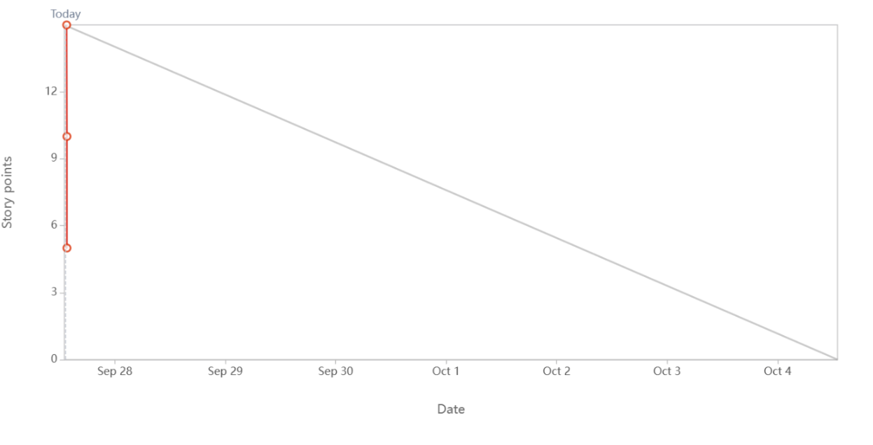

Search the products – Sprint Burndown chart
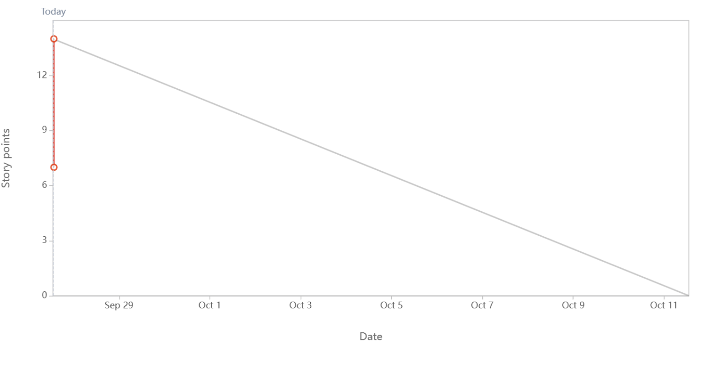
Place the order – Sprint Burndown chart

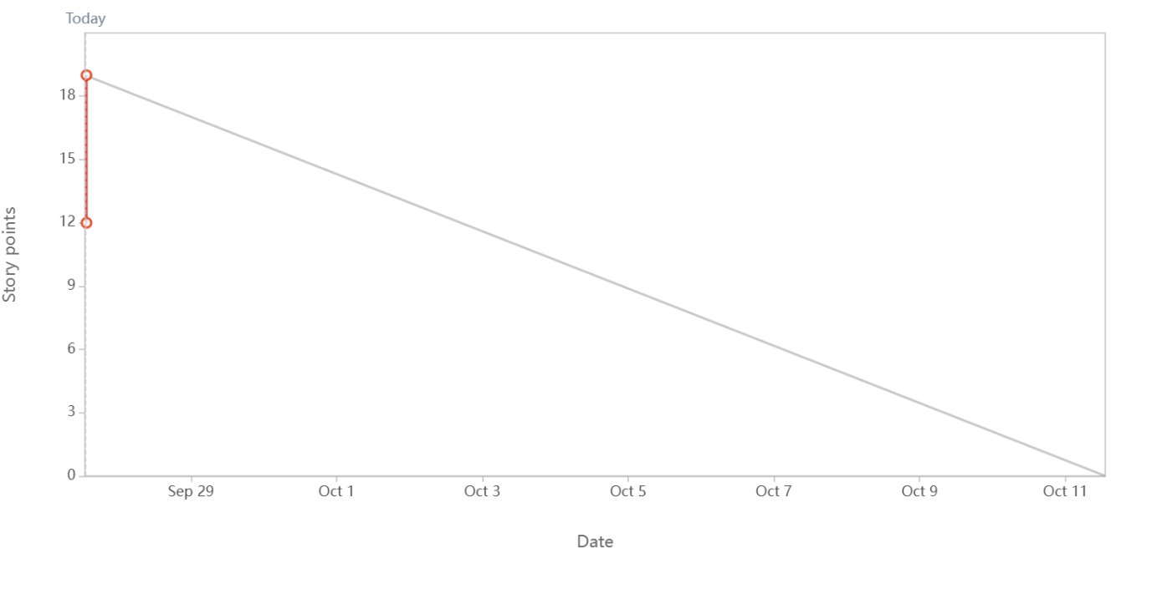

Payment and Confirmation – Sprint burndown chart
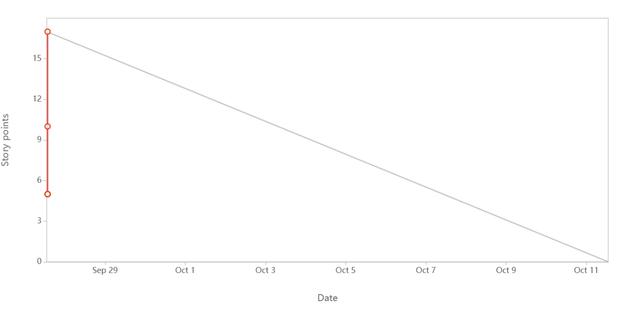

Question No 10 –

Product Grooming (Backlog Refinement)
Definition
Product Grooming is the continuous process of reviewing, refining, and updating the Product Backlog so that the items are clear, prioritized, and ready for upcoming sprints.
It ensures that backlog items are:
- Well-defined,
- Properly estimated,
- Prioritized by business value, and
- Free of major ambiguities.

When It Happens
- Conducted once or twice during a Sprint (not a formal Scrum event but a recommended practice).
- Usually takes 5–10% of the team’s Sprint time.

Who Participates
- Product Owner → ensures backlog is prioritized by business value.
- Development Team → estimates effort, identifies dependencies, and clarifies requirements.
- Scrum Master → facilitates and ensures effective discussion.

Activities in Product Grooming
- Review backlog items → Check whether stories are still relevant.
- Prioritize items → High-value features are placed at the top.
- Split large epics into smaller user stories.
- Estimate effort/Complexity Points (CP) for new or updated items.
- Clarify acceptance criteria so stories are "Ready" (meet DOR).

Example (Food Delivery App Grooming Session)
- Before Grooming:
  - “Add Rewards Program” → vague, no acceptance criteria, no estimate.
  - “Payment Gateway Integration” → not prioritized.
- After Grooming:
  - “Add Rewards Program” → split into stories: Track Points, Redeem Points.
  - “Payment Gateway Integration” → marked as Must Have for MVP and estimated at 8 CP.
  - Non-priority items moved down backlog.

Benefits of Product Grooming
- Keeps backlog organized and prioritized.
- Reduces confusion during Sprint Planning.
- Ensures the team always has a set of Ready stories to pull into a Sprint.
- Improves forecasting and planning accuracy.

Question No 11 –
1. Scrum Master
- Definition: The Scrum Master is a servant-leader for the Scrum Team. They ensure Scrum is understood and followed, facilitate meetings, and remove impediments.
Key Responsibilities
- Facilitator → Conducts Sprint Planning, Daily Scrum, Sprint Review, and Sprint Retrospective.
- Impediment Remover → Maintains Impediments Log and ensures blockers are resolved quickly.
- Coach & Mentor → Guides the team in Agile principles, ensures they follow Scrum values.
- Shield for the Team → Protects developers from external distractions and scope creep.
- Servant Leadership → Works for the benefit of the team, not as a boss.
Example (Food Delivery App):
- Scrum Master notices developers are blocked by Payment Gateway API issues → escalates to vendor and clears the roadblock.

2. Product Owner (PO)
- Definition: The Product Owner is responsible for maximizing product value by managing the Product Backlog. They represent the voice of the customer.
Key Responsibilities
- Backlog Management → Creates, refines, and prioritizes Product Backlog items.
- Prioritization → Decides which features bring the highest business value.
- Vision & Roadmap → Defines product vision and communicates it to the team.
- Acceptance of Work → Reviews Product Increment in Sprint Review and accepts/rejects work.
- Stakeholder Collaboration → Acts as bridge between clients, stakeholders, and Scrum Team.
Example (Food Delivery App):
- Product Owner prioritizes “Order Placement & Payment” above “Coupon Discounts” for MVP, because it provides immediate business value.

Question No 12 –

Meetings Conducted in a Scrum Project
1. Sprint Planning Meeting
- When: At the start of each Sprint.
- Who Attends: Product Owner, Scrum Master, Development Team.
- Purpose:
  - Decide what can be delivered in the upcoming sprint.
  - Team selects User Stories from Product Backlog and creates a Sprint Backlog.
  - Discusses Sprint Goal and capacity (Velocity).
- Output: Sprint Backlog + Sprint Goal.

2. Daily Scrum (Daily Stand-up)
- When: Every day of the Sprint (15 minutes max).
- Who Attends: Development Team (Scrum Master may facilitate, Product Owner may listen).
- Purpose:
  - Developers synchronize their work.
  - Each answers 3 questions:
    - What did I do yesterday?
    - What will I do today?
    - Do I face any impediments?
- Output: Updated Sprint plan for the next 24 hours, impediments are noted in Impediments Log.

3. Sprint Review Meeting
- When: End of each Sprint.
- Who Attends: Development Team, Scrum Master, Product Owner, Stakeholders (clients, 3rd party reviewers).
- Purpose:
  - Demonstrate the Product Increment (working features completed).
  - Gather feedback from stakeholders.
  - Discuss Velocity (how many CP completed), Burn Down Charts, and future improvements.
- Output: Adapted Product Backlog with stakeholder feedback.

4. Sprint Retrospective Meeting
- When: After the Sprint Review, before the next Sprint begins.
- Who Attends: Scrum Master + Development Team (Product Owner may attend if needed).
- Purpose:
  - Reflect on the Sprint process.
  - Discuss what went well, what didn’t, and what can be improved.
  - Capture lessons learned for the next Sprint.
- Output: Action items for process improvement.

Meeting | When | Who Attends | Purpose | Output
Sprint Planning | Start of Sprint | PO, SM, Dev Team | Decide Sprint Goal, select backlog items | Sprint Backlog
Daily Scrum | Every day | Dev Team (SM facilitates) | Synchronize work, raise impediments | Updated plan for 24 hrs
Sprint Review | End of Sprint | Dev Team, SM, PO, Stakeholders | Demo product increment, gather feedback | Adapted Product Backlog
Sprint Retrospective | After Review | Dev Team, SM | Reflect, improve process | Lessons learned + improvements

Question No 13 –

1. Sprint Size
- Definition: Sprint Size means the duration/length of the Sprint.
- A Sprint is a time-boxed iteration in which the Scrum Team delivers a working product increment.
- Typical Sprint sizes: 1 week, 2 weeks, or 4 weeks (most common = 2 weeks).
- The Sprint Size is decided by the Scrum Team and Product Owner based on project needs.
Example (Food Delivery App):
- Sprint Size = 2 weeks.
- In this 2-week Sprint, the team works on selected backlog items like User Registration, Add to Cart, and Payment Integration.

2. Scrum Size
- Definition: Scrum Size refers to the size of the Scrum Team (number of people in the team).
- According to the Scrum Guide, an ideal Scrum Team size is 10 or fewer people (usually 5–9).
- This includes:
  - Product Owner
  - Scrum Master
  - Developers (cross-functional team members)
Example (Food Delivery App):
- Scrum Size = 7 members
  - 1 Product Owner
  - 1 Scrum Master
  - 5 Developers (UI, Backend, Database, Testing, DevOps)
Question No 14 –

1. Definition of Ready (DOR)
- Meaning:
DOR defines the criteria a User Story (or Product Backlog Item) must meet before the Development Team accepts it into a Sprint.
- Purpose:
Ensures the backlog item is well-prepared, clear, and feasible for development.
- Who uses it: Product Owner + Development Team during Sprint Planning.
Example DOR Criteria (Food Delivery App):
- User Story is clearly written and understood.
- Acceptance criteria are defined.
- Dependencies are identified.
- Estimated Complexity Points (CP) are assigned.
- Test data and mockups (if needed) are ready.
If a User Story does not meet DOR → it should not be selected for the Sprint.
2. Definition of Done (DOD)
- Meaning:
DOD defines the criteria a Product Increment (feature) must meet to be considered completed and potentially shippable to the client.
- Purpose:
Ensures consistency, quality, and transparency across the team’s work.
- Who uses it: Development Team + Scrum Master ensures compliance.
Example DOD Criteria (Food Delivery App):
- Code is written, peer-reviewed, and checked into repository.
- Unit tests written and passed.
- Feature tested in QA environment.
- Meets acceptance criteria.
- No critical bugs open.
- Documented and demo-ready.
If a feature does not meet DOD → it stays In Progress, not counted as Done.

Question No 15 –
1. Prioritization Techniques in Agile/Scrum
Prioritization ensures the most valuable user stories are delivered first. Some common techniques are:
a. MoSCoW Technique
- Must Have → Essential features (cannot launch without).
- Should Have → Important but not critical.
- Could Have → Nice-to-have features.
- Won’t Have (for now) → Not in this release.
Example (Food Delivery App):
- Must Have → Place Order, Payment Integration
- Should Have → Order History
- Could Have → Coupon Discounts
- Won’t Have → AI Food Recommendation

b. Kano Model
- Categorizes features into:
  - Basic Needs (must exist, otherwise user is unhappy)
  - Performance Needs (more = better satisfaction)
  - Delighters (unexpected features that excite users)
Example:
- Basic → Order & Payment
- Performance → Real-time Delivery Tracking
- Delighter → Gamification (rewards for orders)

c. WSJF (Weighted Shortest Job First) – from SAFe
- Formula: (Business Value + Risk Reduction + Time Criticality) ÷ Job Size
- Higher score → Higher priority.
Example: Payment Gateway (high business value, urgent) > Add Ratings (less critical).

d. Business Value vs. Complexity
- Stories are plotted on a grid:
  - High Value, Low Complexity → Do first.
  - Low Value, High Complexity → Do later.
Example: Add to Cart (high value, simple) comes before AI Suggestions (low value, complex).

2. MVP (Minimum Viable Product)
- Definition:
MVP is the smallest usable version of a product that delivers core value to customers with minimum features.
- Purpose:
  - Quickly validate assumptions.
  - Collect feedback from real users.
  - Save cost and time by avoiding unnecessary features.
Example (Food Delivery App MVP):
- Features included in MVP:
  - User Registration/Login
  - Browse Menu
  - Add Food Item to Cart
  - Online Payment
  - Place Order & Get Delivery Status
- Features excluded (for later releases):
  - Coupons & Discounts
  - Ratings & Reviews
  - Loyalty Program
  - Chat with Delivery Agent
With MVP, customers can place an order and get food delivered — core value is achieved.

Question No 16 –

Aspect | Business Analyst (BA) | Product Owner (PO)
Role Type | Analyst / Bridge between Business & IT | Decision Maker / Owner of Product Backlog
Focus | Requirements – gathering, analyzing, documenting, and clarifying | Product Value – prioritizing backlog, maximizing ROI
Authority | Usually advisory – suggests solutions, but may not decide priorities | Accountable & empowered to make final decisions on backlog items
Responsibilities | - Elicit requirements from stakeholders- Document User Stories, Use Cases, Process Flows- Clarify doubts for Developers- Support testing (validation/verification) | - Owns and manages Product Backlog- Defines product vision & roadmap- Prioritizes user stories by Business Value- Accepts/Rejects deliverables in Sprint Review
Stakeholder Interaction | Works closely with business users & dev team to understand needs | Works directly with stakeholders, sponsors, and customers to align product goals
Scrum Involvement | Not an official Scrum role (but may assist PO) | Official Scrum role, part of Scrum Team
Decision Power | Provides inputs, analysis, and documentation | Makes final call on what to build and when
Example (Food Delivery App) | BA documents requirement: “As a customer, I should be able to tra

Question No 17 –

Sample Resume – Product Owner (3 Years Experience)
Name: [Your Full Name]
Mobile: +91-XXXXXXXXXX
Email: [yourname@email.com]
LinkedIn: linkedin.com/in/yourname
Location: [City, State]

Professional Summary
Product Owner with 3 years of experience in Agile-Scrum environments, skilled at managing product backlog, defining user stories, and prioritizing features to deliver maximum business value. Experienced in working with cross-functional teams, stakeholders, and clients to develop and deliver scalable digital products. Strong background in requirement gathering, sprint planning, and product roadmapping.

Key Skills
- Agile & Scrum Methodologies
- Product Backlog Management
- Sprint Planning & Review
- User Stories & Acceptance Criteria
- Stakeholder Management
- Business Value Prioritization (MoSCoW, WSJF)
- Jira / Confluence / Trello
- Roadmap & Release Planning
- Excellent Communication & Collaboration

Professional Experience
Product Owner
ABC Tech Solutions Pvt Ltd, Pune
Jan 2022 – Present
- Managed the Product Backlog of an e-commerce platform, ensuring stories were prioritized based on business value and customer needs.
- Defined MVP features (user registration, cart, payment gateway, delivery tracking) for the launch of a food delivery app.
- Collaborated with Business Analysts, Developers, QA, and UI/UX teams to clarify requirements and deliver increments within Sprint timelines.
- Participated in Sprint Planning, Daily Scrums, Sprint Reviews, and Retrospectives.
- Ensured user stories met Definition of Ready (DOR) before entering Sprint and validated Definition of Done (DOD) after delivery.
- Monitored team velocity (10–12 CP per sprint) and created reports using Jira to track progress.
- Engaged with stakeholders to refine roadmap, prioritize features, and implement customer feedback.
Key Achievements:
- Successfully launched MVP in 4 months, achieving 25% faster time-to-market.
- Improved backlog refinement practices, reducing scope creep by 15%.
- Increased stakeholder satisfaction score by 20% through effective communication.

Associate Product Owner
XYZ Digital Services, Bangalore
Aug 2020 – Dec 2021
- Assisted Product Owner in managing backlog for a mobile banking application.
- Documented and refined User Stories, Acceptance Criteria, and Epics.
- Coordinated with Scrum Team to resolve blockers recorded in Impediments Log.
- Conducted UAT (User Acceptance Testing) with stakeholders before production release.
- Supported in preparing Product Burndown Charts and analyzing velocity trends.
Key Achievements:
- Contributed to the delivery of 12 successful sprints on time.
- Streamlined requirement documentation, reducing clarification delays by 30%.

Education
- MBA – Business Analytics / IT Management (2020) – [University Name]
- B.Tech – Computer Science (2018) – [University Name]

Certifications
- Certified Scrum Product Owner (CSPO®) – Scrum Alliance
- Agile Business Analyst (Optional if you have BA background)
- Jira Fundamentals (Atlassian)

Projects (Highlight 1-2 Relevant Ones)
- Food Delivery App (Capstone Project): Defined MVP features, prioritized backlog, managed sprints, and delivered a working prototype.
- Mobile Banking App: Supported in backlog grooming, UAT, and release planning for core banking features like fund transfer and bill payments.

