Document 1: Definition of Done
As Per Agile Extension to the BABOK® Guide v2, Definition of Done is a technique where the team agrees on, and prominently displays, a list of criteria which must be met before a backlog item is considered done. That is the team has to create a well- defined, unambiguous, measurable, agreed-upon, and shared Definition of Done between all team members.
The best form of Definition of Done representation is a checklist of activities that has to demonstrate the agreed value and quality of a user story. So, this checklist should include:
- acceptance criteria (to satisfy customer requirements for a product)
- quality criteria (to satisfy quality requirements for a product)
Definition of Done may be defined for different levels of project work. For example, in Agile / Scrum framework these levels of work could be user story, sprint, and release.

Checklist for DOD:
- Produced code for presumed functionalities
- Assumptions of User Story met
- Project builds without errors
- Unit tests written and passing
- Project deployed on the test environment identical to production platform
- Tests on devices/browsers listed in the project assumptions passed
- Feature ok-ed by UX designer
- QA performed & issues resolved
- Feature is tested against acceptance criteria
- Feature ok-ed by Product Owner
- Refactoring completed
- Any configuration or build changes documented
- Documentation updated
- Peer Code Review performed

Document 2- Product Vision

Scrum Project Name : | LS Mobile Learning app
Venue: | Zoom meeting
Date: 26/07/2025 | Start time: 03:00PM | End time: 07:00PM | Duration: (3-4hrs)
Client: | LSedutechnology.Pvt.Ltd

Stakeholder list: | Project sponsor | Product owner | Business analyst
Scrum Master | Developer | QA  engineer | UI&UX  designer
DevOps engineer
Scrum Team
Scrum Master | Swetha
Product Owner | Deepak
Scrum Developer  1: | Balaji
Scrum Developer  2: | Logesh
Scrum Developer 3: | Arul
Scrum Developer  4: | Kishore
Scrum Developer 5: | Ashik
Scrum Developer  6: | Gowtham

VISION:
Empower learners everywhere by making high-quality, personalized education accessible, engaging, and flexible—helping them achieve their academic and career goals anytime, anywhere.

Target Group:

Market Segment:
Students and young professionals seeking flexible learning opportunities, especially those interested in upskilling for career advancement or academic help.

Target Users and Customers:
Primary users are students (ages 15–30) and working professionals who want to learn at their convenience.

Needs :

Problem Solved:
Difficulty accessing personalized, high-quality learning resources and progress tracking anytime, anywhere.

Provided Benefit:
Delivers interactive, mobile-first learning with tailored content, real-time progress tracking, practice quizzes, and community engagement—making learning more accessible and effective.

Product:

What Product Is It:
A mobile application for personalized learning, progress analytics, and peer/community support.

Desirability & Special Features:
Offers demo classes instant feedback, adaptive learning paths, and Live classes interacting with industry expert directly that differentiate it from many generic e- learning apps.

Feasibility:
Technically feasible using current app development tools and cloud infrastructure. Large market demand and scalable model make it viable for development.

Value:

Company Benefit:
Broadens the company’s reach into the edtech sector, creates recurring revenue through subscriptions or premium content, and builds brand reputation among young learners.

Business Goals:
Rapid user base growth in target segments High retention and course completion rates
Strong app store ratings and positive user feedback

Business Model:
Freemium: app free to download with essential features. Paid subscription unlocks premium Live lessons, advanced analytics, and exclusive community features.

Additional revenue streams could include corporate partnerships and educational institution licensing.

User Stories for LS Learning Mobile App

User Registration

User story No: 1 | Task:1 | Priority: High
As a new user, I want to register by providing my email, password, and required details, so that I can create a secure account and access the app.
BV: 50 | CP: 5
Acceptance Criteria:
User must enter a unique email and password. Account is created if email is unregistered.
On successful registration, the user receives a confirmation message or email.

- User Login

User story No: 2 | Task:1 | Priority: High
As a registered user, I want to log in using my user ID (email or username) and password, so that I can access my learning dashboard securely.
BV: 20 | CP: 3
Acceptance Criteria:
System validates user ID and password.
Incorrect credentials show a relevant error message. On success, user is redirected to their dashboard.

- View Course Catalog

User story No: 3 | Task:1 | Priority: Medium
As a logged-in user, I want to view available courses and their details, so that I can
explore and choose the right learning path.
BV: 50 | CP: 5
Acceptance Criteria:
User can see a list of active courses with descriptions, schedules, and fees. Courses display upcoming batch IDs and start dates.

- Select Course

User story No:4 | Task:1 | Priority:Medium
As a user, I want to select a course and upcoming batch from the catalogue, so that I can enroll according to my schedule.
BV: 50 | CP: 8
Acceptance Criteria:
User can view and select from multiple batch options (by batch ID and date). Selected course and batch are added to user's enrollment list before payment

.
- Make Payment

User story No: 5 | Task:1 | Priority:High
As a user, I want to securely pay for my selected course and batch, so that I can
confirm my enrollment and get access to course materials.
BV: 100 | CP: 40
Acceptance Criteria:
User is shown order summary, batch ID, and fee before payment.
Payment gateway processes credit/debit card, UPI, or other supported methods. On success, payment receipt and confirmation are shown.

- Confirmation and Batch/Zoom Link

User story No: 6 | Task:1 | Priority:High
As an enrolled user, I want to receive confirmation and my upcoming batch details (batch ID), so that I know when and how to join my course.
BV: 50 | CP: 20
Acceptance Criteria:
User receives a confirmation status page (and/or email/SMS) with batch ID. User sees their unique Zoom link, with user ID and password for the session. Zoom link appears in the course details section of the app and is sent before the first live session

.

Document 4: Agile PO Experience

The Product Owner has a vision of the product keeping the domain/industry experience and the market need.
Following are the responsibilities of PO in a project

Market Analysis
  - Analysis of market need/demand
  - Availability of similar products in the market

Enterprise Analysis
  - Due diligence on the market opportunity

Product Vision and Roadmap
  - Product vision keeping the need analysis in mind
  - Product roadmap with high-level features and timeline

Managing Product Features
  - Managing stakeholder expectations and prioritizing needs
  - Prioritization of the epics, stories, and features based on criticality and ROI involved

Managing Product Backlog
  - Prioritization of user stories
  - Reprioritization based on stakeholders' needs
  - Epics planning

Managing Overall Iteration Progress
  - Sprint progress review
  - Reprioritization of sprints and epics if needed
  - Sprint retrospectives with Business Analyst

From this project I have learned how to handle sprint meetings such as
  - Sprint planning meeting
  - Daily scrum meeting
  - Sprint review meeting
  - Sprint retrospective meeting
  - Backlog refinement meeting

Also, User stories creation and what things will be included in user stories such as
  - Story no
  - Tasks
  - Priority

  - Acceptance criteria
  - BV & CP value

In Scrum, a product owner serves as the liaison between multiple areas of an organization. This person communicates with business stakeholders and collaborates closely with Scrum teams to keep all areas of the business informed on a project's development.
The product owner develops a vision of a product's function and operation, which in turn allows this Scrum team member to define product features and break those features into product backlog items.

Document 5: Product and sprint backlog and product and sprint burndown charts
Product backlog:

User  story ID | User story | Tasks | Priority | BV | CP | Sprint
US-001 | User | User must | High | 50 | 5 | 1
 | Registration | enter a unique
 |  | email and
 |  | password.
 |  | Account is
 |  | created if
 |  | email is
 |  | unregistere
 |  | d.
 |  | On
 |  | successful
 |  | registration,
 |  | the user
 |  | receives a
 |  | confirmatio
 |  | n message
 |  | or email.
US-002 | User | System | High | 20 | 3 | 1
 | Login | validates
 |  | user ID and
 |  | password.
 |  | Incorrect
 |  | credentials
 |  | show a
 |  | relevant
 |  | error
 |  | message.

 |  | On success, user is redirected to their dashboard.
US-003 | View course | User can see a list of active courses with descriptions  , schedules, and fees.  Courses display upcoming batch IDs and start dates. | Medium | 50 | 5 | 1
US-004 | Select Course | User can view and select from multiple batch options (by batch ID and date). Selected course and batch are added to user's enrollment list before payment | Medium | 50 | 8 | 1
US-005 | Make payment | User is shown order summary, batch ID, and fee before payment. Payment gateway processes  credit/debit | High | 100 | 40 | 1

 |  | card, UPI, or other supported methods. On success, payment receipt and confirmatio n are shown.
US-006 | Confirmation and Batch/Zoom Lin | User receives a confirmatio n status page (and/or email/SMS) with batch ID.  User sees their unique Zoom link, with user ID and password for the session.  Zoom link appears in the course details section of the app and is sent before the first live session | High | 50 | 20 | 1

Sprint backlog:

User story | User story ID | Tasks | Owner | Status | Estimated effort
User Registration | US-001 | User must enter a  unique | Balaji | pending | 5

email and password. Account is created if email is unregistere d.
On successful registration, the user receives a confirmatio n message
or email.
User Login | US-002 | System validates user ID and password. Incorrect credentials show a relevant error message.  On success, user is redirected to their dashboard. | logesh | pending | 3
View course | US-003 | User can see a list of active courses with descriptions  , schedules, and fees.  Courses display upcoming batch IDs and start dates. | kishore | pending | 5
Select Course | US-004 | User can view and select from  multiple | arul | pending | 8

 |  | batch options (by batch ID and date). Selected course and batch are added to user's enrollment list before payment
Make payment | US-005 | User is shown order summary, batch ID, and fee before payment. Payment gateway processes credit/debit card, UPI, or other supported methods. On success, payment receipt and confirmatio n are shown. | Ashik | pending | 40
Confirmation and Batch/Zoom Lin | US-006 | User receives a confirmatio n status page (and/or email/SMS) with batch ID.  User sees their unique Zoom link,  with user ID and | Gowtham | pending | 20

password for the session. Zoom link appears in the course details section of the app and is sent before the first live session

Burnup diagram:
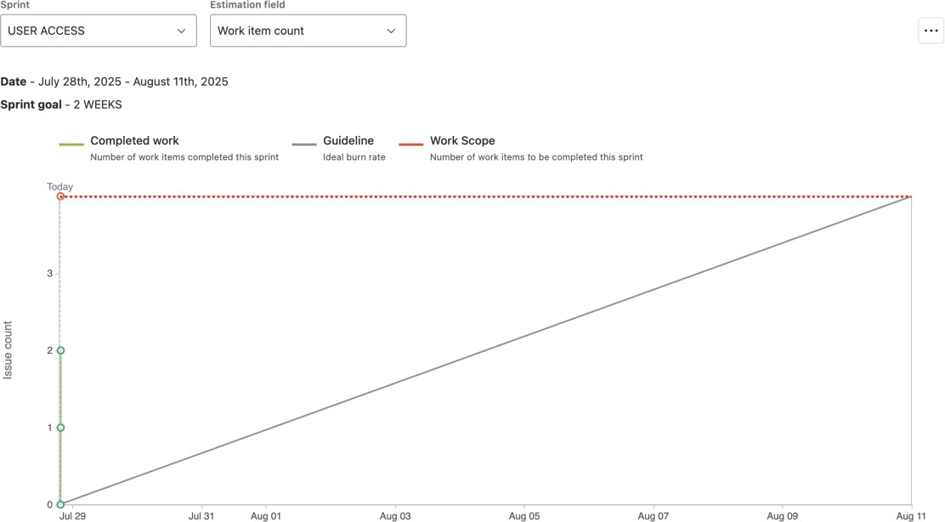

Sprint burndown

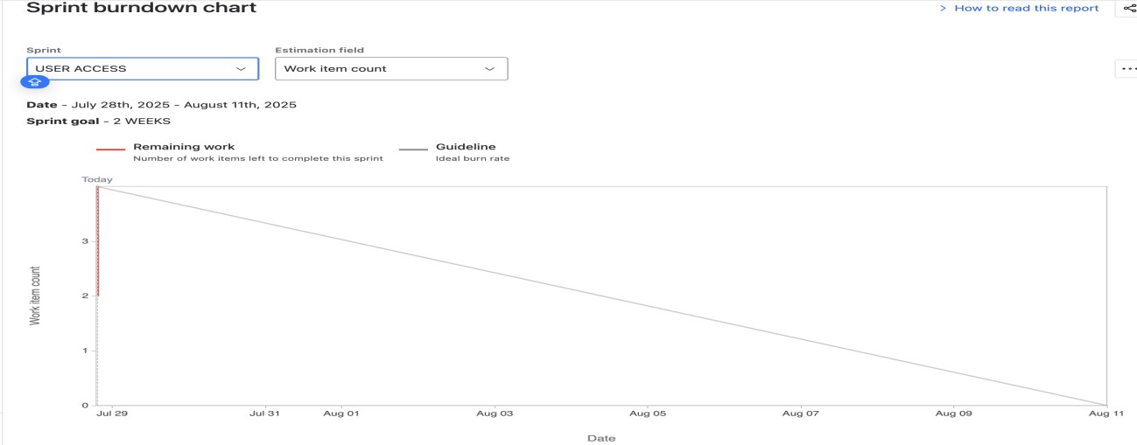

Document 6: Sprint meetings
Meeting Type 1: Sprint Planning meeting

Date | 29/07/2025
Time | 11:00 AM
Location | Zoom meeting
Prepared By | Swetha
Attendees | BA ,PO & Scrum team members

Agenda Topics

Topic | Presenter | Time allotted
Define & prioritizing  requirement | SM with the help PO | 2 hrs

Other Information

Observers | PO
Resources | JIRA tool, Zoom app
Special Notes | NIL

Meeting Type 2: Sprint review meeting

Date | 12/08/2025
Time | 10:00AM
Location | ZOOM meeting
Prepared | Swetha
By Attendees | BA ,PO & Scrum team members  Client

Sprint status | Things to demo | Quick updates | What’s next
Completed | PPT | nil | Prepare for  retrospective meeting

Meeting Type 3: Sprint retrospective meeting

Date | 13/8/2025
Time | 10:00AM
Location | ZOOM Meeting
Prepared | swetha
By Attendees | BA ,PO & Scrum team members

Agenda | What went well | What didn’t  go well | Questions | Reference
Identify | All features | Team co | nil | nil
progress | were added | ordination
 | and
 | presented
 | demo

Meeting Type 4: Daily Stand-up meeting

Question | Name/ Role | Week “1” (from 28/07/2025 to 02/08/2025)
Question | Name/ Role | Monda y | Tuesday | Wedn esday | Thurs day | Friday | Satur day | Sun day
What did you do yesterday  ? | Dev 1  Dev 2  Dev 3 | User registr ation | User login | - | - | - | - | -
What will you do today? | Dev 1  Dev 2  Dev 3 | User login | User View catalog | - | - | - | - | -
What (if any) is blocking your  progress? | Dev 1  Dev 2  Dev 3 | nil | nil | - | - | - | - | -

