Waterfall Project2 – Part -2/2

Project Title: Insurance Ledger Portal – Part 2/2 Evaluation
Submitted by: Suman Samaiya
Date: [04/10/2025]

Document 6- Please prepare a use case diagram, activity diagram and a use case specification document.
1. Use Case Diagram (Document 6 – Part A)
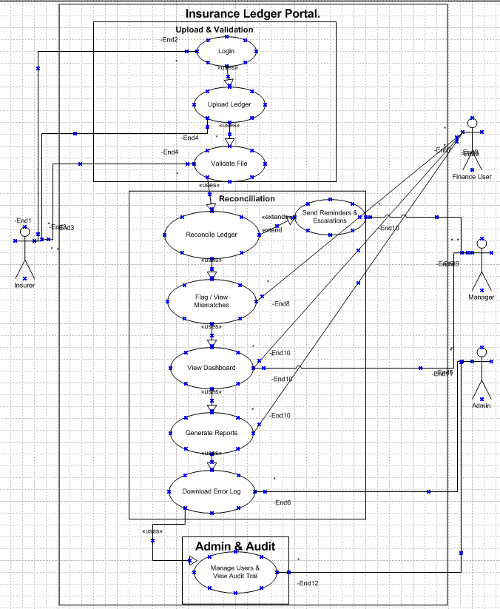
Use Case Diagram for Insurance Ledger Portal, showing actors, packages, and relationships (include/extend).

2. Activity Diagram
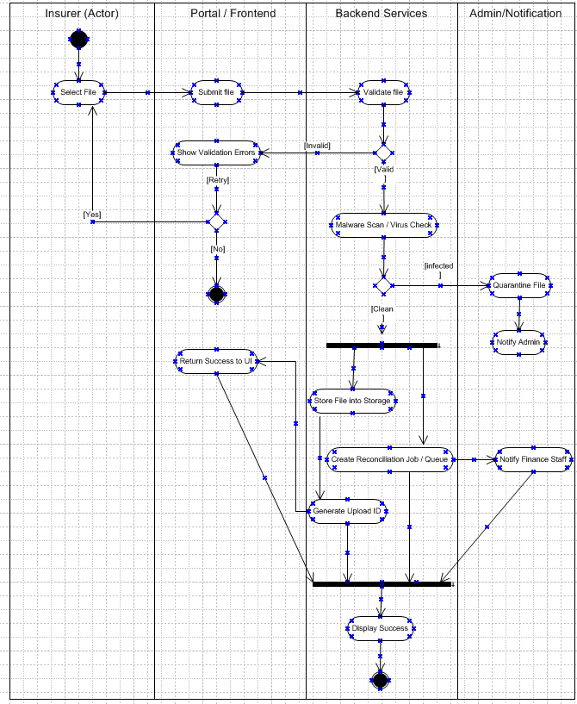
The activity diagram illustrates the end-to-end process of uploading a ledger file to the Insurance Ledger Portal. It shows how the insurer initiates the upload, the portal forwards the file to backend services for validation and malware scanning, and the flow branches based on outcomes such as errors, retries, or infected files. Clean files proceed through parallel processing where the system stores the file, generates an Upload ID, and simultaneously creates a reconciliation job and notifies finance staff. The parallel branches synchronize at a join point, after which the portal confirms success to the insurer. The diagram also captures exception handling such as validation errors, duplicate uploads, or malware detection, ensuring that all possible scenarios are clearly represented for traceability.
A use case specification document
Use case specifications helps in break down user actions into clear, step-by-step flows that guide the development and testing teams on what exactly the system should do.

Use Case Specification — Upload Ledger

- Description: Insurer uploads monthly ledger file (XLSX/PDF) for automatic reconciliation.
- Primary Actor: Insurer.
- Secondary Actors: Manager, Finance Staff (notification), Admin (if quarantined).
- Basic Flow: login → navigate → select file → submit → validate → store → queue reconciliation → notify → success)
- Alternate Flows: File invalid (missing required columns, wrong format)→ system returns validation errors → insurer corrects and re-uploads.
Network failure → retry option.
Duplicate file → reject with message.
- Exceptional Flows: Malware detected → file quarantined; admin notified.
Storage or parser service down → log incident; notify support.
- Pre-Conditions: Insurer is authenticated and authorized; file uses agreed template.
- Post-Conditions: File stored with status; if valid, reconciliation job created; Upload ID returned and audit log created.
- Assumptions: Insurer uses provided template; supported formats XLSX, CSV, PDF.
- Constraints: Max file size 10MB; files must be uploaded within the first week of the period; processing time < 2 minutes.
- Dependencies: Authentication service; File parser & validator; Storage service; Queue/Reconciliation service; Notification/email service.
- Inputs / Outputs:
  - Inputs: Ledger file, metadata (period, insurer id).
  - Outputs: Upload ID, validation report, success/failure message, audit log.
- Business Rules: Mandatory fields (Insurer ID, Payment Date, Invoice ID, Amount) required; no duplicate uploads; only allowed formats; uploads outside cutoff time are rejected.
- Miscellaneous: All actions logged for audit; quarantine policy for malicious files; retry policy on transient errors.

Document 7- Screens and pages Please follow the following steps to create the mock-ups
1. Kindly use balsamic or Axure.
2. Always start with a home page of an application.
3. Take a feature and follow it to the end
- Eg: Home page of SCRUM Foods
- Select Login- Create a login page
- Let’s assume, you want to search a restaurant
- Search page- Type the restaurant name and select the dish
- Add to cart page
- f. Payment page g. Logout page

7:- Mock-ups Via Axure

1. Home page

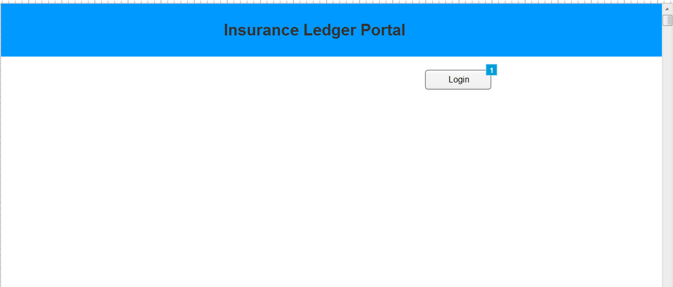

2. Select Login- Create a login page

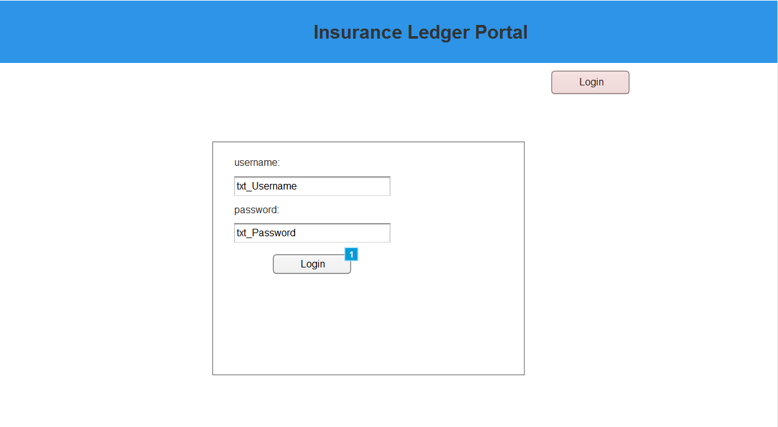

2. Let’s assume, you want to search a File/ Search page- Type the File name
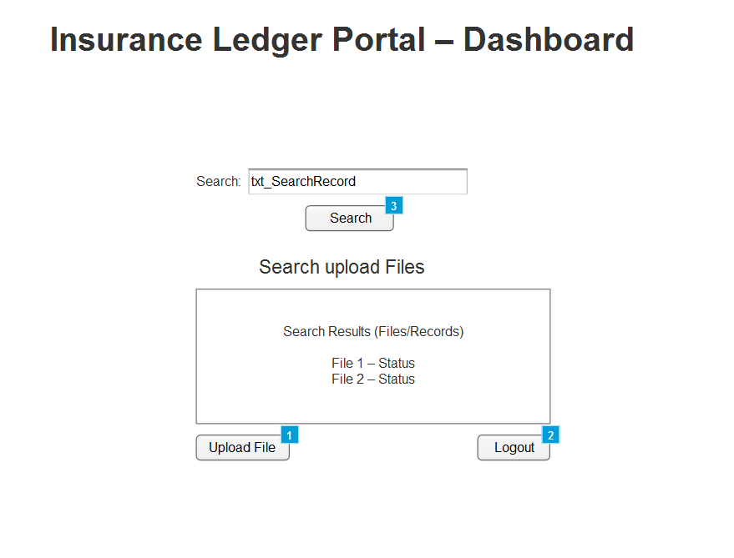

3. Select the File for e.g.- Aviva, Axa, Allianz etc

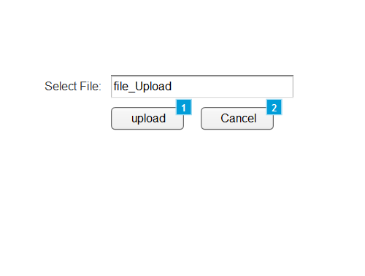
4. Upload Success message
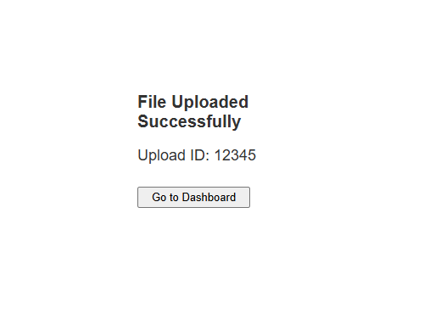

5. Logout page
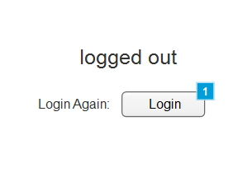

Document 8- Tools-Visio and Axure
Q8. Write a paragraph on your experience using Visio and Axure for the project.

Microsoft Visio: For this project, I used Microsoft Visio to design the use case & activity diagrams and Axure RP to create interactive mock-ups of the Insurance Ledger Portal. Visio was helpful in structuring complex flows into clear swim lanes, decisions, and fork/join connectors, making it easier to explain system logic and backend interactions. At times, aligning connectors and ensuring the correct use of UML shapes required careful attention, but the final diagrams provided a precise visual representation of the workflow.

Axure: on the other hand, was very effective for building page-level mock-ups with interactive elements. Using Sitemap, Widgets, Properties, Outline, and Interactions panels, I could simulate the portal’s navigation from login to dashboard, file upload, and logout. While it took some time to understand widget naming and linking pages correctly, Axure made it possible to demonstrate a near-real prototype. Overall, both tools complemented each other: Visio captured the process design and Axure showcased the user interface experience.

Document 9 – BA Experience

1. Requirement Gathering Phase
In the Requirement Gathering phase, my primary responsibility as a Business Analyst was to elicit, analyse, and document requirements in a structured manner to ensure clarity and alignment with business goals. To achieve this, I applied the MoSCoW Prioritization Technique (Must Have, Should Have, Could Have, Won’t Have) to categorize requirements based on business criticality. This technique ensured that the development team focused on high-priority features first, while still capturing lower-priority items for future releases.
A key challenge encountered during this phase was the limited availability of the client, which risked delaying requirement collection. To address this, I proactively identified and engaged alternative points of contact from the client’s team, ensuring continuity and avoiding project delays.
To validate the quality of requirements, I utilized the FURPS Framework (Functionality, Usability, Reliability, Performance, Supportability). This framework allowed me to confirm that requirements were not only functional but also addressed key non-functional aspects, thereby reducing potential gaps later in the lifecycle.
During analysis, I identified duplicate and conflicting requirements, which could lead to ambiguity. I applied requirement rationalization and de-duplication techniques to refine and consolidate these inputs, ensuring accuracy and consistency in the requirement set.
To further bridge understanding with stakeholders, I incorporated Prototyping and Wireframing techniques. By presenting early visual mock-ups, stakeholders were able to better visualize the system workflows, which led to more specific, actionable, and validated requirements. This iterative feedback loop also helped uncover hidden requirements that might have been missed in verbal discussions.
Through the structured application of these BA techniques, the requirement gathering phase resulted in a validated, prioritized, and high-quality set of requirements that provided a strong foundation for subsequent phases of the project.

2. Requirement Analysis Phase
During the Requirement Analysis phase, my role as a Business Analyst was to translate the gathered requirements into well-structured and visual representations that could be easily understood by both business and technical stakeholders. To achieve this, I utilized UML (Unified Modelling Language) diagrams such as Use Case Diagrams, Activity Diagrams, and Sequence Diagrams to visually describe the system requirements, interactions, and process flows. These diagrams helped bridge the communication gap between the client, developers, and testers.
Specifically, Activity Diagrams were used to illustrate the step-by-step flow of business processes, making it easier to identify dependencies, decision points, and alternate paths. This ensured that the entire team had a clear understanding of the end-to-end business flow.
Collaboration was a critical part of this phase. Once diagrams and models were prepared, I facilitated review sessions with the project team. In these discussions, some members suggested modifications or raised concerns about feasibility. As a BA, it was my responsibility to carefully consider their inputs, balance business needs with technical constraints, and make necessary refinements to the diagrams and requirement documents.
To formally capture and document requirements, I prepared Business Requirement Specification (BRS) and System Requirement Specification (SRS) documents. The BRS outlined the high-level business needs in a client-friendly format, while the SRS provided detailed functional and non-functional requirements tailored for the technical team. These deliverables served as the baseline reference for the design and development phases.
By applying structured requirement modelling techniques and maintaining open communication, the Requirement Analysis phase ensured that all stakeholders had a unified understanding of the system requirements, reducing ambiguities and risks in later stages of the project.

3. System Design
During the design phase of the Insurance Ledger Portal project, my focus as a Business Analyst was to ensure that the system design accurately reflected the business requirements and use cases defined earlier. I collaborated closely with the technical and QA teams to translate use case diagrams into detailed test cases, ensuring that each business scenario and alternate flow was properly captured and validated.
I regularly communicated with the client to review the design and solution documents, confirming that the proposed system architecture and user interface aligned with business expectations. It was important to capture every small change or clarification, as missing even a single detail could have a significant impact during development or testing.
To maintain high-quality standards, I prepared both positive and negative test cases — this helped validate not just the expected outcomes but also how the system handled exceptions and errors. I also developed test data that represented real-world input scenarios to verify functionality under various conditions.
An essential part of this phase was maintaining and updating the Requirements Traceability Matrix (RTM) to ensure that all business requirements were covered by test cases and that no functionality was left unvalidated. This helped maintain transparency between the business and technical teams and ensured complete alignment with the client’s objectives.
Through strong communication, attention to detail, and consistent documentation, the design phase laid a solid foundation for the development and testing stages that followed.

4. Development Phase
During the development phase of the Insurance Ledger Portal project, my primary responsibility as a Business Analyst was to ensure continuous alignment between business requirements and the technical implementation. I facilitated Joint Application Development (JAD) sessions to bridge the communication gap between business stakeholders and the technical team. These sessions helped the developers gain a clear understanding of the business logic and process flows derived from the earlier UML and activity diagrams.
I also supported the team during coding by clarifying queries related to functionality, field validations, and system behaviour. At times, there were differences in understanding or disagreements within the team regarding certain concepts. In such cases, I handled the situation diplomatically — conducting one-on-one discussions with concerned members to explain the rationale behind each requirement and how deviations could impact project outcomes. This approach helped foster a collaborative and healthy work environment.
I frequently referred to design artifacts such as use case diagrams, data flow diagrams, and process maps to ensure that every developed unit matched the intended business rules. Additionally, I conducted regular review meetings with the technical team and clients to track progress, address blockers, and validate interim outputs. Since team members or stakeholders were sometimes unavailable, I ensured continuity by recording sessions, sharing them with absentees, and scheduling follow-up discussions to keep everyone informed and aligned.
Through consistent coordination, structured communication, and strong stakeholder management, I ensured that the development phase progressed smoothly, with minimal misunderstandings and timely issue resolution.

5. Testing Phase
In the testing phase, my primary responsibility as a Business Analyst was to ensure that the system delivered matched the business requirements and functioned as expected. I began by preparing test cases derived from the use case diagrams, ensuring that every functional and alternate flow was properly validated. This helped verify that all user interactions were performing according to the business logic.
I conducted high-level testing to confirm the system’s overall functionality and alignment with the documented requirements before formal testing began. To make the testing environment realistic, I coordinated with the client to request test data, ensuring that data inputs closely mirrored real-world scenarios.
Throughout the phase, I continuously updated the Requirements Traceability Matrix (RTM) to ensure complete coverage of all requirements and to track which test cases had been executed successfully. Once all critical functionalities were verified and signed off internally, I facilitated the client sign-off process by demonstrating the system’s compliance with business needs.
Finally, I helped prepare the client for User Acceptance Testing (UAT) by walking them through the test cases, explaining the expected outcomes, and ensuring they had a clear understanding of how to validate the system. This structured approach minimized last-minute issues and ensured a smooth transition to deployment.

6. Deployment Phase
In the deployment phase, my primary responsibility as a Business Analyst was to ensure a smooth handover and successful transition of the system to end users. I began by forwarding the finalized Requirements Traceability Matrix (RTM) to the client, ensuring it was properly attached to the project closure document as proof that all requirements were developed, tested, and validated.
I closely coordinated with the technical and documentation teams to prepare and share end-user manuals, ensuring they were clear, user-friendly, and aligned with actual system behavior. Alongside this, I planned and organized comprehensive training sessions for end users, ensuring they were confident in using the new system.
My role also included monitoring attendance and participation during these sessions, making sure that all identified users were trained adequately. I maintained open communication with the client during this phase, addressing last-minute queries and gathering feedback to ensure a seamless transition.
This phase marked the formal closure of the project from a BA standpoint, confirming that the system was not only technically sound but also well adopted by its intended users.

