Agile Deliverables – Seat Booking App Project (Copeland, Pune)

Document 1: Definition of Done
Definition of Done (DoD) for the Seat Booking App ensures that every user story and sprint deliverable meets clear, measurable, and agreed-upon completion criteria. The checklist below defines the quality and value expectations.
• Produced working code for booked seat functionalities and related modules.
• Assumptions of user stories are met as per acceptance criteria.
• Application builds successfully without errors.
• Unit, Integration, and Regression tests executed and passed.
• Deployed on test and staging environments identical to production.
• Validated functionality on supported browsers and devices.
• QA testing completed, and issues resolved.
• Features verified by Product Owner and approved by stakeholders.
• Documentation and configuration details updated.
• Peer code review completed.
• DoD validated at user story, sprint, and release levels.
• Reduce seat conflicts to <5%.
• Ensure manager approval within 24 hours.
• Achieve 80% adoption in 3 months.
• 100% transparency in seat allocation.

Document 2: Product Vision

Scrum Project Name: Seat Booking – Copeland, Pune |  |  |  |  |  |  | Venue: Copeland India Pvt. Ltd., Pune
Date: |  |  |  |  |  |  | Start time: 10:00 AM
Client: Copeland India Pvt. Ltd.
Stakeholder list: HR Department, IT Department, Employees, Managers, Product Owner, Scrum Team
Scrum Team
 | Scrum Master | Product Owner | Scrum Developer 1 | Scrum Developer 2 | Scrum Developer 3 | Scrum Developer 4 |  | Scrum Developer 5
 | BA | HR Representatives | Dev 1- Backend (API & DB) | Dev 2- Frontend (UI/UX) | Dev 3- QA & Testing | Dev 4- Integration |  | Dev 5-Reporting & Analytics

Target group | Needs | Product | Value
Employees | Eliminate manual seat allocation errors. | Seat Booking Manually | Saves time, improves self-service, increases employee satisfaction.
HR & Managers | Improve visibility into seat availability. Reduce double bookings and conflicts. | HR dashboards. manager approval workflow | Provides better decision-making, ensures compliance, and tracks productivity.
Admins | Need to maintain system performance & file security. | File validation, restrictions, and secure uploads. | Ensures data security, reduces risks, improves system reliability.

Document 3: User Stories

User Story No: 1  Seat Booking by Employee | Task: | Priority: High
Value Statement:
As an employee, I want to book my office seat in advance so that I can ensure a seat is available when I come to work.

BV: | CP:
Acceptance Criteria:
- Employee can log in to the system.
- Available seats are displayed in real-time.
- Employee selects a date, seat, and shift timing.
- Booking request is sent for manager approval.
- Confirmation notification/email is sent once approved.

User Story No: 2  Seat Release Functionality | Task: | Priority: Medium
Value Statement:
As an employee, I want to release my booked seat when I cannot come to the office so that others can use it.

BV: | CP:
Acceptance Criteria:
- Employee can release a booked seat before the booking date.
- Released seat appears as available to others.
- Notification is sent to manager and HR.

User Story No: 3  View Seat Availability | Task: | Priority: High
Value Statement:
As an employee, I want to view the available seats on specific dates so that I can plan my office attendance accordingly.

BV: | CP:
Acceptance Criteria:
- Real-time availability shown in a floor layout or list view.
- Seats are categorized as “Booked”, “Available”, or “Released”.
- Filtering options by team, department, or date.

User Story No: 4  Manager Approval Workflow | Task: | Priority: High
Value Statement:
As a manager, I want to approve or reject seat booking requests so that I can manage seat allocation for my team fairly.

BV: | CP:
Acceptance Criteria:
- Manager receives notification of pending requests.
- Can approve or reject with comments.
- System updates seat status automatically.
- Email notification sent to the requester.

User Story No: 5  HR Dashboard and Reports | Task: | Priority: Medium
Value Statement:
As an HR user, I want to view booking statistics and occupancy reports so that I can analyze office utilization trends.

BV: | CP:
Acceptance Criteria:
- Dashboard displays daily, weekly, and monthly occupancy.
- Data export option to Excel/PDF.
- Insights include most booked areas and no-show rates.

User Story No: 6  Employee Profile Management | Task: | Priority: Low
Value Statement:
As an employee, I want to update my contact details and team information so that my seat bookings remain correctly mapped.

BV: | CP:
Acceptance Criteria:
- Employee can edit personal and team details.
- Updates reflect in booking and approval records.

User Story No: 7  Notifications and Reminders | Task: | Priority: Medium
Value Statement:
As an employee, I want to receive reminders and notifications for seat booking updates so that I stay informed about my bookings.

BV: | CP:
Acceptance Criteria:
- Notifications triggered on booking, approval, release, and reminders.
- Configurable via email and in-app alerts.

User Story No: 8  Admin Panel for Configuration | Task: | Priority: High
Value Statement:
As an admin, I want to configure seat layout, capacity, and user roles so that the system can adapt to office changes.

BV: | CP:
Acceptance Criteria:
- Admin can add, edit, or remove seats.
- Can assign roles (Employee, Manager, HR, Admin).
- Changes instantly reflect across modules.

User Story No: 9  Authentication and Access Control | Task: | Priority: High
Value Statement:
As an employee, I want to securely log in using my company credentials so that my data remains protected.

BV: | CP:
Acceptance Criteria:
- SSO or company login integration enabled.
- Role-based access implemented.
- Logout and session timeout features active.

User Story No: 10  Analytics and Power BI Integration | Task: | Priority: Medium
Value Statement:
As an HR manager, I want to view visual analytics on Power BI so that I can make data-driven workspace decisions.

BV: | CP:
Acceptance Criteria:
- Power BI dashboard connected to booking database.
- Visualization of seat utilization trends.
- Data auto-refresh enabled daily.

User Story No: 11  Mobile App Functionality | Task: | Priority: Medium
Value Statement:
As an employee, I want to access the Seat Booking system on mobile so that I can book or release seats on the go.

BV: | CP:
Acceptance Criteria:
- Mobile app compatible with Android and iOS.
- UI optimized for small screens.
- Syncs with web version instantly.

User Story No: 12  Search and Filter Options | Task: | Priority: Medium
Value Statement:
As an employee, I want to search for seats by floor, department, or proximity so that I can find convenient seating.

BV: | CP:
Acceptance Criteria:
- Search bar available for filters.
- Results show real-time availability.

User Story No: 13  Data Security and Privacy | Task: | Priority: High
Value Statement:
As a system admin, I want to ensure data encryption and access logging so that employee information remains secure.

BV: | CP:
Acceptance Criteria:
- All personal data encrypted in database.
- Access logs maintained for audit.
- Role-based data visibility ensured.

User Story No: 14  Integration with Attendance System | Task: | Priority: Medium
Value Statement:
As an HR manager, I want to integrate seat booking data with attendance so that presence records stay accurate.

BV: | CP:
Acceptance Criteria:
- Attendance auto-updated when seat booking is confirmed.
- Integration verified via API.

User Story No: 15  Feedback and Support | Task: | Priority: Low
Value Statement:
As an employee, I want to provide feedback or raise issues within the app so that the team can resolve them quickly.

BV: | CP:
Acceptance Criteria:
- In-app feedback form functional.
- Tickets assigned to IT or HR.
- Notifications on resolution sent to user.

Document 4: Agile Product Owner Experience
As a Product Owner for the Seat Booking App project, I was responsible for defining the vision, roadmap, and prioritizing features.

Responsibilities of the Product Owner

1. Market Analysis
- Analysis of market needs and demand.
- Identification of gaps and opportunities.
- Conducted market analysis to understand hybrid work challenges and similar tools.

2. Enterprise Analysis
- Conduct due diligence on the market opportunity.
- Align seat booking enhancements with organizational strategy.

3. Product Vision and Roadmap
- Define a clear vision of the Seat booking app product keeping the needs analysis in mind.
- Create a product roadmap with high-level features and timelines.
- Ensure alignment of product vision and roadmap with Copeland’s digit goals.

4. Managing Product Features
- Manage stakeholder expectations by gathering and analyzing requirements.
- Prioritize epics, user stories, and features based on criticality and ROI.
- Ensure balance between business value and technical feasibility.

5. Managing the Product Backlog
- Maintain and prioritize the product backlog.
- Reprioritize items based on stakeholder needs and business priorities. Collaborated with HR and IT to refine user stories and backlog items.
- Organize epics, stories, and features for incremental delivery. Reviewed sprint progress, facilitated sprint reviews, and retrospectives.

6. Managing Overall Iteration Progress
- Review sprint progress and ensure alignment with sprint goals.
- Reprioritize sprints or epics if business needs change.
- Collaborate with the Business Analyst during sprint retrospectives to identify improvements. Managed product backlog in Jira and ensured continuous feedback incorporation.

Agile Ceremonies and Meetings Handled
From this project, I as a Product Owner gained experience in effectively handling and participating in Agile meetings:
- Sprint Planning Meeting → Define sprint goals and backlog items.
- Daily Scrum Meeting → Monitor daily progress, resolve blockers.
- Sprint Review Meeting → Demonstrate increment to stakeholders and gather feedback.
- Sprint Retrospective Meeting → Identify improvements with the team.
- Backlog Refinement Meeting → Continuously groom and reprioritize backlog items.

User Story Experience
I as a Product Owner developed skills in user story creation, ensuring each story included:
- Story number
- Tasks
- Priority (High/Medium/Low)
- Acceptance criteria
- Business Value (BV) & Complexity Points (CP)
This structured approach enabled clear communication, accurate prioritization, and measurable delivery.

PO as a Liaison
In Scrum, the Product Owner acts as a liaison between:
- Business Stakeholders → to ensure business needs are met.
- Scrum Team → to clarify requirements, prioritize backlog, and provide feedback.
The PO ensures all stakeholders remain informed on project development and progress.

Conclusion
I as a Product Owner develops and communicates a vision of the product’s function and operation.
This vision allows the Scrum Team to:
- Define product features.
- Break them into manageable product backlog items.
- Deliver incremental value aligned with organizational strategy and market demand.
- Gained hands-on experience with sprint planning, backlog refinement, and retrospectives.
- Enhanced skills in stakeholder communication and Agile documentation.
- Improved ability to translate business needs into actionable user stories.

Document 5: Product and Sprint Backlog and Burndown Charts
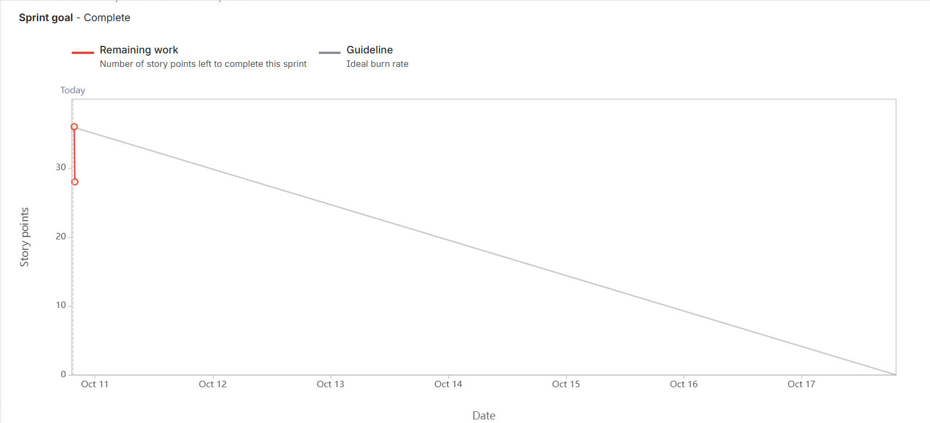

Document 6: Sprint Meetings
Meeting Type 1: Sprint Planning Meeting
Date
Time | 10:00 AM – 11:30 PM
Location | Conference Room / Teams
Prepared by | Ruchita Pawar- BA
Attendees | Product Owner, Scrum Master, Developers (4), QA

Topic | Presenter | Time allotted
Review prioritized backlog items | Product Owner | 20 mins
Define Sprint Goal | Scrum Master | 15 mins
Break down user stories into tasks | Developers | 40 mins
Estimate story points (Planning Poker) | All team | 15 mins
Meeting Type 2: Sprint Review Meeting
Date
Time | 03:00 AM – 04:00 PM
Location | Conference Room / Teams
Prepared by | Ruchita Pawar- BA
Attendees | Product Owner, Scrum Master, Developers (4), QA, Stakeholders

Sprint Review Summary
Sprint Status | Things to demo | Quick updates | What’s next
Completed 5/6 committed stories | Seat booking flow, manager approval. | Minor Bug fixes | Release Seat Release Feature.

Meeting Type 3: Sprint Retrospective Meeting
Date
Time | 03:00 AM – 04:00 PM
Location | Conference Room / Teams
Prepared by | Ruchita Pawar- BA
Attendees | Product Owner, Scrum Master, Developers (4), QA

Agenda | What went well | What didn’t go well | Questions | Reference
Sprint Overview | User stories were well-defined, making dev faster | Test cases were not ready on time for 2 user stories | Can QA be involved earlier in sprint planning? | JIRA Sprint-25
Development | CI/CD integration improved deployment speed | Story 10 had unclear acceptance criteria | Who should refine complex stories before sprint? | Story 104
Collaboration | Daily standups improved task tracking | Time zone differences affected some sync calls | Can we set a fixed time for all? | Standup Notes
Demos & Reviews | Stakeholders appreciated the sprint demo | Some feedback came after sprint closed | Can we record demos for late viewers? | Sprint Demo Video

Meeting Type 4: Daily Stand-up Meeting
Questions | Name/Role | Week “X” (from dd/mm/yyyy to dd/mm/yyyy)
Questions | Name/Role | Monday | Tuesday | Wednesday | Thursday | Friday
What did you do yesterday? | Developer 1 | Completed login UI | Fixed bug #304 | Reviewed | Refactored auth service | Worked
What did you do yesterday? | Developer 2 | API integration for payments | Testing payment module | Bug fixes | Code cleanup | Backend review
What did you do yesterday? | Developer 3 | Set up database schema | Connected frontend | Helped QA with test data | Created error logs | Documentation
What will you do today? | Developer 1 | Start logout functionality | Work on session timeout | Merge feature branch | Finalize login flow | Assist QA
What will you do today? | Developer 2 | Review API security | Start work flow | Peer code review | Improve error handling | Sprint planning
What will you do today? | Developer 3 | Optimize DB queries | Work on reporting | Attend | Implement feedback | Final code review
What (if any) is blocking your progress? | Developer 1 | None | Waiting for API from Dev 2 | None | None | No blockers
What (if any) is blocking your progress? | Developer 2 | Need test data from QA | None | Need Dev 3's inputs | None | None
What (if any) is blocking your progress? | Developer 3 | Waiting for feedback from PO | Blocked on permissions setup | None | None | None

