AGILE DOCUMENTS

Document 1: Definition of Done (DoD)
Project Name: Government Payroll & Finance Management System
Prepared By: Shailey Burad
Date: 24 June 2025

Definition of Done Checklist:
Criteria | Description
Produced code for presumed functionalities | Functional code is developed as per the user story description.
Assumptions of User Story met | All stated conditions and business assumptions are fulfilled.
Project builds without errors | Code compiles and builds successfully with no failures.
Unit tests written and passing | Unit-level tests cover key logic with acceptable coverage and no failures.
Project deployed on test environment identical to production | Deployment validated on a staging/QA environment with production-like configuration.
Tests on devices/browsers listed in the project assumptions passed | Validated for all stated device/browser combinations (e.g., Chrome, Edge, mobile).
Feature ok-ed by UX designer | Final UI/UX meets the approved design standards and is signed off.
QA performed & issues resolved | Functional, regression, and exploratory tests completed; defects resolved.
Feature tested against acceptance criteria | Each acceptance criterion is verified and marked as satisfied.
Feature ok-ed by Product Owner | Product Owner has formally accepted the feature post-demo or review.
Refactoring completed | Code is cleaned, optimized, and unnecessary complexity is removed.
Any configuration or build changes documented | Environment/config/script changes are properly recorded and communicated.
Documentation updated | Related user manuals, process notes, or design docs are up to date.
Peer Code Review performed | Code has been reviewed and approved by at least one developer peer.

Applicable on:
Level | Application of DoD
User Story | Each story must meet all checklist criteria before it's marked “Done.”
Sprint | All committed stories must fulfil the checklist; QA and demos must be completed.
Release | Full system testing, stakeholder sign-off, production readiness, and documentation must be complete.

Document 2: Product Vision
Scrum Project: Government Payroll & Finance Management System
Basic Information:
Field | Details
Name | Government Payroll & Finance Management System
Venue | Conference Room, APT IT Solutions
Date | 11-Jun-25
Start Time | 10:00 AM
End Time | 12:00 PM
Duration | 2 Hours
Client | Maharashtra State Government, Finance Department
Stakeholder List | HR Department Head
Stakeholder List | Finance Department Head
Stakeholder List | IT Director (Govt)
Stakeholder List | Treasury Officer
Stakeholder List | Compliance Officer
Stakeholder List | Auditor (Internal)

Scrum Team:
Role | Name
Scrum Master | Ms. Shailey Burad
Product Owner | Mr. XYZ (Govt Liaison Officer)
Scrum Developer 1 | ABC
Scrum Developer 2 | DEF
Scrum Developer 3 | GHI
Scrum Developer 4 | PQR
Vision:
To build a secure, compliant, and automated payroll and finance management system for the Maharashtra Government that ensures timely salary disbursements, transparent financial reporting, and audit-readiness – thereby empowering departments through digital governance.
Target Group:
Category | Description
Market Segment | Government Sector – State-Level Administrative Bodies
Target Users | HR Officers, Finance Officers, Treasury Officers, Departmental Heads
Target Customers | Maharashtra State Government, Department of Finance

Needs:
Aspect | Description
Problem Solved | Manual payroll processing leading to delays, errors, and audit non-compliance
Benefits Provided | Automation, reduced processing time, audit trail tracking, real-time reporting, and improved accuracy and compliance

Product Description:
Question | Answer
What is the product? | A web-based Payroll & Finance Management System tailored for government departments
What makes it special? | Compliance-driven design, centralized audit log, configurable workflow for diverse departments
Is it feasible to develop? | Yes, using Agile methodology, scalable architecture, and integration with existing ERP systems

Value:
Aspect | Description
How does it benefit the company? | Enhances governance, reduces payroll processing time by 60%, ensures transparency and accountability
Business Goals | Timely salary disbursements, regulatory compliance, financial visibility, and cost-saving on manual operations
Business Model | CSR-funded implementation with future SaaS model opportunities for other states; open-source adaptability considered for long-term scalability

Document 3: User stories:
User Story 1: Salary Slip Generation
- Tasks: Automate salary slip creation, design slip format, link payroll module
- Priority: High
- Value Statement: As an HR Officer, I want to auto-generate salary slips so that I can avoid manual errors.
- BV: 500
- CP: 5
- Acceptance Criteria: Slip includes employee details, allowances, deductions, and net pay; downloadable in PDF.

User Story 2: Employee Self-Service Portal
- Tasks: Build portal, login system, display profile, salary, leave info
- Priority: High
- Value Statement: As an Employee, I want to view my salary slip and profile online so that I can access them anytime.
- BV: 500
- CP: 8
- Acceptance Criteria: Employee logs in and sees latest payslip, profile, and leave records.

User Story 3: Income Tax Calculation
- Tasks: Create tax module, integrate slab logic, link to payroll
- Priority: High
- Value Statement: As a Finance Officer, I want tax to be calculated automatically so that deductions are accurate.
- BV: 2000
- CP: 8
- Acceptance Criteria: Tax auto-applies based on income slabs and exemptions; visible in payslip.

User Story 4: Audit Trail
- Tasks: Log all user actions, create audit viewer
- Priority: High
- Value Statement: As an Auditor, I want to track who made changes so that the process is auditable.
- BV: 500
- CP: 8
- Acceptance Criteria: System logs user ID, action, date/time; filterable and exportable.

User Story 5: Salary Revision Workflow
- Tasks: Create workflow, add approval levels, notify stakeholders
- Priority: Medium
- Value Statement: As an HR Officer, I want to revise salary with approvals so that it's traceable.
- BV: 200
- CP: 5
- Acceptance Criteria: Only approved revisions are applied; audit log maintained.

User Story 6: Automated Notifications
- Tasks: Setup email/SMS alerts, configure templates
- Priority: Medium
- Value Statement: As a User, I want to get notifications for salary updates so that I stay informed.
- BV: 100
- CP: 5
- Acceptance Criteria: System sends alerts for salary credit, tax deductions, and revisions.

User Story 7: Role-Based Access
- Tasks: Implement role matrix, restrict access
- Priority: High
- Value Statement: As a System Admin, I want to restrict access by role so that data remains secure.
- BV: 500
- CP: 8
- Acceptance Criteria: Roles defined (Admin, HR, Finance, Auditor); each can only access relevant modules.

User Story 8: Leave Deduction Integration
- Tasks: Connect leave records to payroll
- Priority: High
- Value Statement: As a Finance Officer, I want leave data to auto-deduct pay so that salary is accurate.
- BV: 200
- CP: 5
- Acceptance Criteria: Salary adjusts based on unpaid leaves; viewable in payslip.

User Story 9: Department-Wise Payroll Report
- Tasks: Build reporting module, add filters
- Priority: Medium
- Value Statement: As a Department Head, I want to view payroll reports so that I can monitor expenses.
- BV: 200
- CP: 5
- Acceptance Criteria: Report shows department payroll totals, headcount, and graphs.

User Story 10: Data Import Tool
- Tasks: Create Excel import tool for bulk employee upload
- Priority: Low
- Value Statement: As an HR Officer, I want to upload employee data in bulk so that onboarding is faster.
- BV: 100
- CP: 5
- Acceptance Criteria: Accepts .xls/.csv; validates mandatory fields; imports without errors.

User Story 11: Gratuity & PF Calculation
- Tasks: Implement rules, link to employee service data
- Priority: Medium
- Value Statement: As a Finance Officer, I want gratuity and PF auto-calculated so that compliance is ensured.
- BV: 500
- CP: 8
- Acceptance Criteria: Gratuity and PF calculated based on salary & service duration.

User Story 12: Generate Form 16
- Tasks: Pull yearly tax data, format into Form 16
- Priority: Medium
- Value Statement: As an Employee, I want my Form 16 generated so that I can file taxes easily.
- BV: 200
- CP: 5
- Acceptance Criteria: Auto-generated, includes all deductions, taxable income, and TDS.

User Story 13: Treasury Integration
- Tasks: Set up API for payment status fetch
- Priority: High
- Value Statement: As a Finance Officer, I want integration with treasury so that I can verify disbursement.
- BV: 1000
- CP: 8
- Acceptance Criteria: System fetches disbursement status; updates payroll record automatically.

User Story 14: Budget Forecasting Tool
- Tasks: Build forecasting module using salary trends
- Priority: Medium
- Value Statement: As a Department Head, I want to forecast salary expenses so that I can plan budgets.
- BV: 200
- CP: 8
- Acceptance Criteria: Tool projects salary expense trends based on filters (months, departments).

User Story 15: System Logs
- Tasks: Track system events like login, errors, deployments
- Priority: Low
- Value Statement: As a System Admin, I want to view logs so that I can troubleshoot issues.
- BV: 100
- CP: 3
- Acceptance Criteria: Logs categorized by user/system event; searchable and timestamped.

User Story 16: Pensioner Payroll Processing
- Tasks: Create pensioner module with rules
- Priority: Medium
- Value Statement: As a Pension Officer, I want to process pensions like salary so that retirees are paid on time.
- BV: 200
- CP: 8
- Acceptance Criteria: Applies pension rules; generates pension slips.

User Story 17: UAN & PAN Linking
- Tasks: Add PAN/UAN fields; validate on entry
- Priority: Medium
- Value Statement: As an HR Officer, I want PAN and UAN captured so that PF and tax data is linked.
- BV: 100
- CP: 5
- Acceptance Criteria: Valid PAN/UAN accepted only; linked to employee record and reports.

User Story 18: Payslip Email Automation
- Tasks: Auto-send payslips monthly to employee emails
- Priority: Medium
- Value Statement: As an Employee, I want my payslip emailed automatically so that I don’t need to request it.
- BV: 100
- CP: 5
- Acceptance Criteria: Payslip emailed on salary date; PDF attached securely.

User Story 19: Search Employee History
- Tasks: Add employee history tab, track salary changes
- Priority: Low
- Value Statement: As an HR Officer, I want to view historical salary changes so that I can handle audits.
- BV: 100
- CP: 8
- Acceptance Criteria: Shows changes in salary, grade, or department over time.

User Story 20: Real-Time Dashboard for Executives
- Tasks: Design executive dashboard, use data widgets
- Priority: Medium
- Value Statement: As a Government Official, I want real-time payroll metrics so that I can take informed decisions.
- BV: 200
- CP: 5
- Acceptance Criteria: Dashboard shows KPIs: total payroll cost, tax, active employees, exceptions.

User Story 21: Multi-Factor Authentication
- Tasks: Add OTP/email verification during login
- Priority: High
- Value Statement:
As a System Admin,
I want users to verify identity via OTP so that login is more secure.
- BV: 500
- CP: 8
- Acceptance Criteria: MFA via OTP/email after password login; mandatory for Admins.

User Story 22: Policy Document Upload
- Tasks: Create upload option, restrict file types, assign per department
- Priority: Medium
- Value Statement:
As an HR Officer,
I want to upload policy documents so that employees can access them.
- BV: 100
- CP: 5
- Acceptance Criteria: Accepts PDF/Doc formats; viewable by role and department.

User Story 23: Training Attendance Tracker
- Tasks: Log attendance, generate reports, notify non-attendees
- Priority: Medium
- Value Statement:
As a Training Coordinator,
I want to track training attendance so that records are maintained.
- BV: 100
- CP: 5
- Acceptance Criteria: Attendance logged per session; absentee list exportable.

User Story 24: Custom Payslip Branding
- Tasks: Add government logo, signature, and footer notes
- Priority: Medium
- Value Statement:
As a System Admin,
I want to customize payslip branding so that it matches government standards.
- BV: 100
- CP: 3
- Acceptance Criteria: Payslip includes logo, footer, and authorized signature line.

User Story 25: Biometric Integration
- Tasks: Connect biometric attendance with payroll
- Priority: High
- Value Statement:
As an HR Officer,
I want to sync biometric data with payroll so that leaves and absences are auto-calculated.
- BV: 500
- CP: 8
- Acceptance Criteria: Daily attendance auto-imported; leave deduction based on absences.

User Story 26: Over-Time Payment Calculation
- Tasks: Define OT rules, fetch hours, add to payslip
- Priority: Medium
- Value Statement:
As a Finance Officer,
I want OT payments to be calculated automatically so that manual effort is reduced.
- BV: 200
- CP: 3
- Acceptance Criteria: Payslip includes OT amount; based on defined hourly rate.

User Story 27: Payroll Freeze Function
- Tasks: Add freeze button, lock further changes, allow authorized override
- Priority: High
- Value Statement:
As a Payroll Manager,
I want to freeze payroll after processing so that no unauthorized changes occur.
- BV: 500
- CP: 5
- Acceptance Criteria: Payroll can be frozen by Admin; further edits restricted.

User Story 28: Employee Exit Clearance
- Tasks: Create clearance form, approval flow, disable access
- Priority: Medium
- Value Statement:
As an HR Officer,
I want exit formalities tracked so that offboarding is systematic.
- BV: 200
- CP: 5
- Acceptance Criteria: Exit checklist completed before deactivation; final settlement generated.

User Story 29: Mid-Year Bonus Processing
- Tasks: Create bonus module, calculate by grade/tenure
- Priority: Medium
- Value Statement:
As a Finance Officer,
I want to process bonuses automatically so that it's efficient.
- BV: 200
- CP: 8
- Acceptance Criteria: Bonus amount calculated and included in payslip with breakdown.

User Story 30: API Access for 3rd-Party Auditors
- Tasks: Build secure API endpoints with token-based access
- Priority: Medium
- Value Statement:
As an Auditor,
I want read-only access to payroll data so that I can validate compliance.
- BV: 500
- CP: 5
- Acceptance Criteria: Read-only APIs for audit logs, salaries, and user actions.

User Story 31: Bulk Payslip Re-Generation
- Tasks: Add re-generate button with filters
- Priority: Low
- Value Statement:
As a Payroll Manager,
I want to regenerate multiple payslips so that corrections can be applied efficiently.
- BV: 100
- CP: 8
- Acceptance Criteria: Payslips re-generated in batch by month/department.

User Story 32: Language Localization
- Tasks: Add Marathi/Hindi translations, language toggle
- Priority: Medium
- Value Statement:
As a Regional Officer,
I want the system in local languages so that it’s accessible to all users.
- BV: 200
- CP: 5
- Acceptance Criteria: UI toggles between English and regional language; key modules translated.

Document 4: Agile PO Experience
Role Overview:
As a Product Owner (PO), I was responsible for defining and delivering value-driven features in alignment with business goals, domain requirements, and market expectations. I collaborated closely with stakeholders, Scrum teams, and Business Analysts to ensure continuous delivery of high-quality increments.

Key Responsibilities:
- Market Analysis:
- Conducted need-gap analysis based on user personas and industry trends.
- Evaluated the availability of similar products in the market for benchmarking.

- Enterprise Analysis:
- Performed due diligence on business opportunity and risk assessment.
- Analysed strategic alignment between product goals and organizational objectives.

- Product Vision and Roadmap
- Developed and shared a clear product vision reflecting real-world challenges and stakeholder needs.
- Built and maintained a product roadmap with prioritized epics and milestone timelines.

- Managing Product Features
- Translated business goals into prioritized product features based on ROI and technical feasibility.
- Balanced stakeholder expectations with sprint-level delivery capacity.

- Managing Product Backlog
- Maintained and refined the product backlog regularly.
- Defined and prioritized user stories, epics, and themes as per evolving business needs.
- Conducted backlog grooming sessions with the Scrum team.

- Iteration and Sprint Oversight:
- Participated in all Agile ceremonies to ensure transparency and adaptation:
- Sprint Planning
- Daily Stand-Ups
- Sprint Reviews
- Sprint Retrospectives
- Backlog Refinement
- Reviewed and re-prioritized features and user stories to reflect sprint velocity and business priorities.

Agile Meeting Experience:
From this project, I gained deep exposure to Agile ceremonies and the role of a PO in managing them:
Meeting Type | Role as PO
Sprint Planning | Finalized sprint scope and team commitments
Daily Scrum | Ensured blockers were identified/resolved
Sprint Review | Demonstrated progress to stakeholders
Sprint Retrospective | Collaborated with BA to identify improvements
Backlog Refinement | Reviewed, detailed, and re-prioritized stories
User Story Management:
I actively contributed to defining comprehensive and testable user stories including:
- User Story Number
- Tasks and Subtasks
- Priority (High/Medium/Low)
- Acceptance Criteria
- Business Value (BV)
- Complexity Points (CP)

Document 5: Product and sprint backlog and product and sprint burndown charts:
Sprint 1:
Product Burndown Chart:
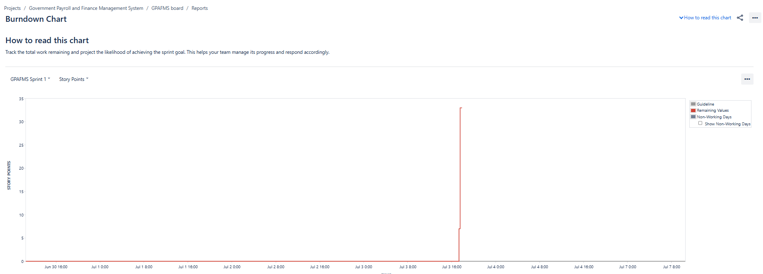

Sprint Burndown Chart:
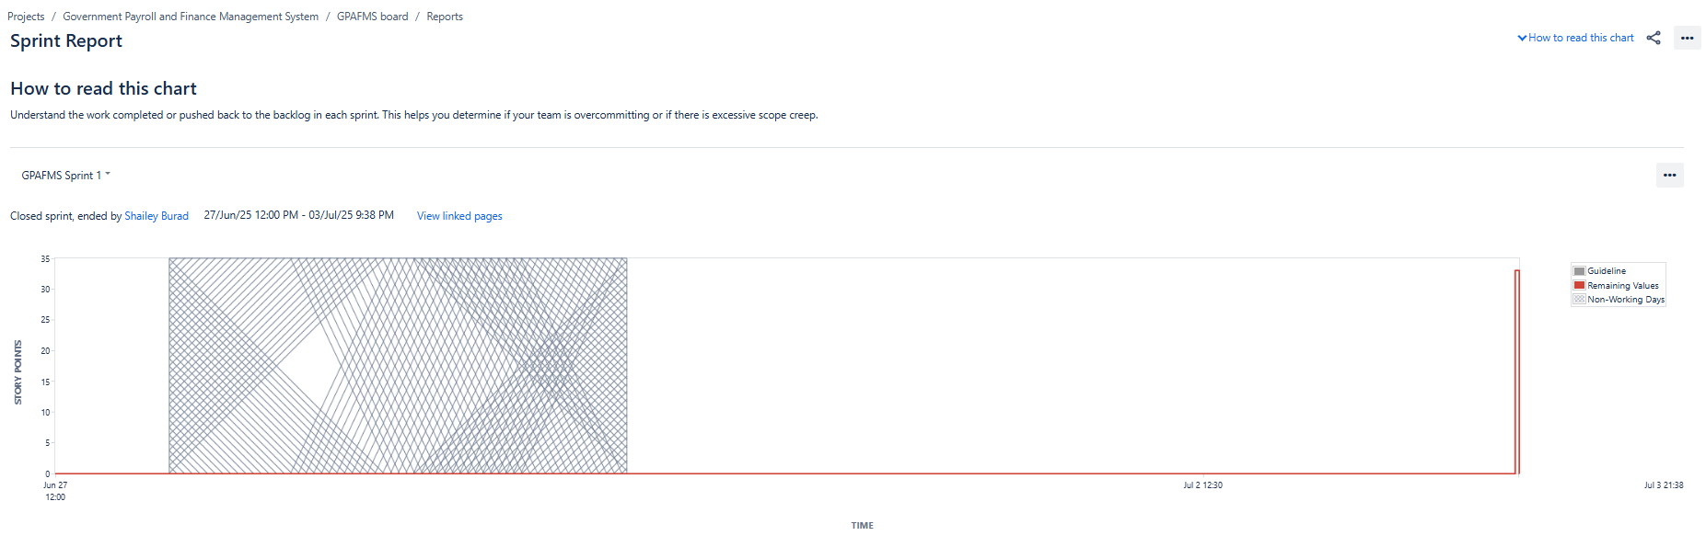

Sprint 2:
Product Burndown Chart:
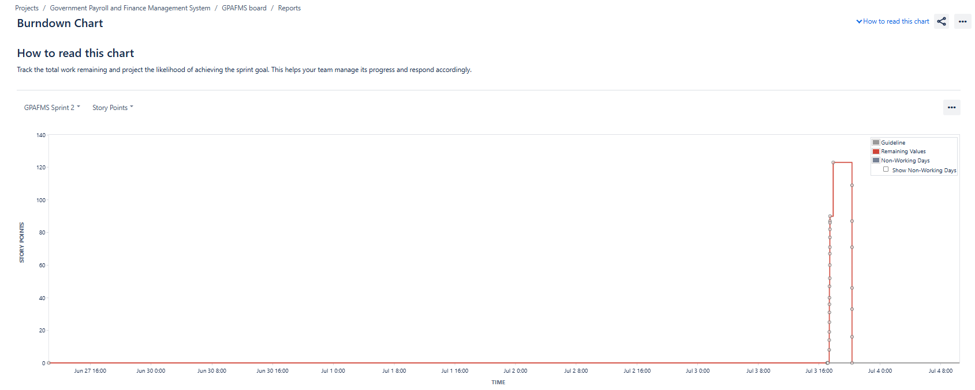
Sprint Burndown Chart:
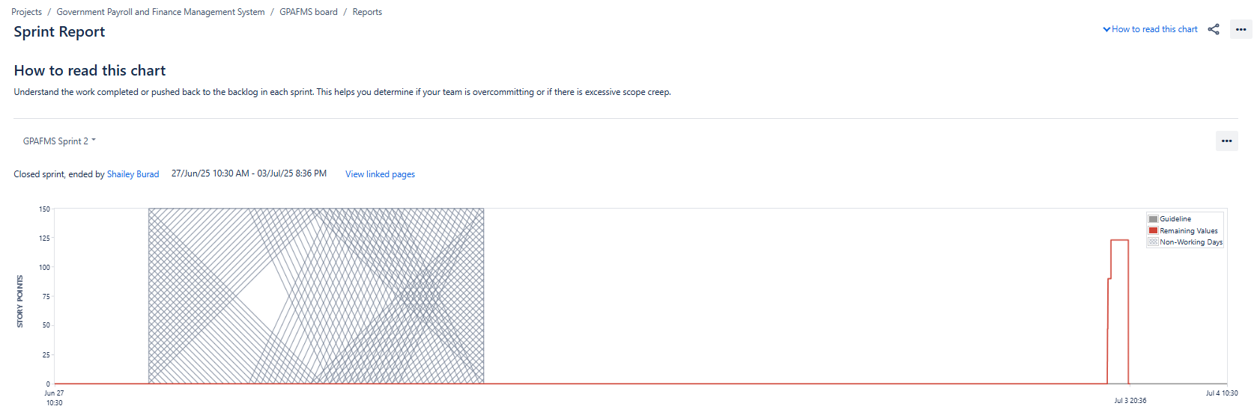

Sprint 3:
Product Burndown Chart:
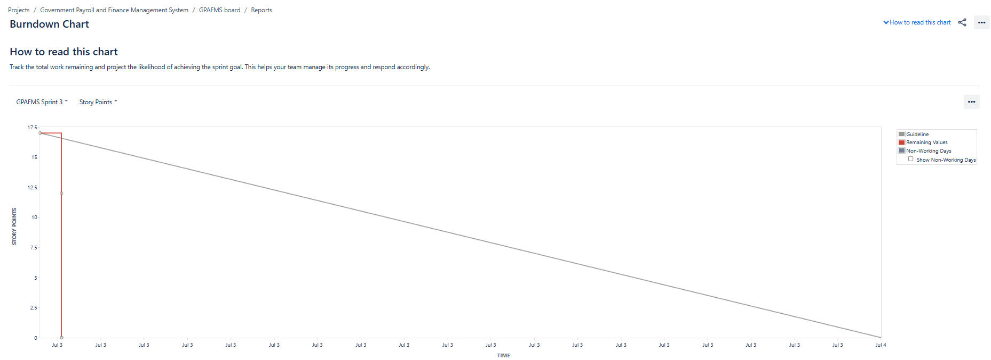

Sprint Burndown Chart:
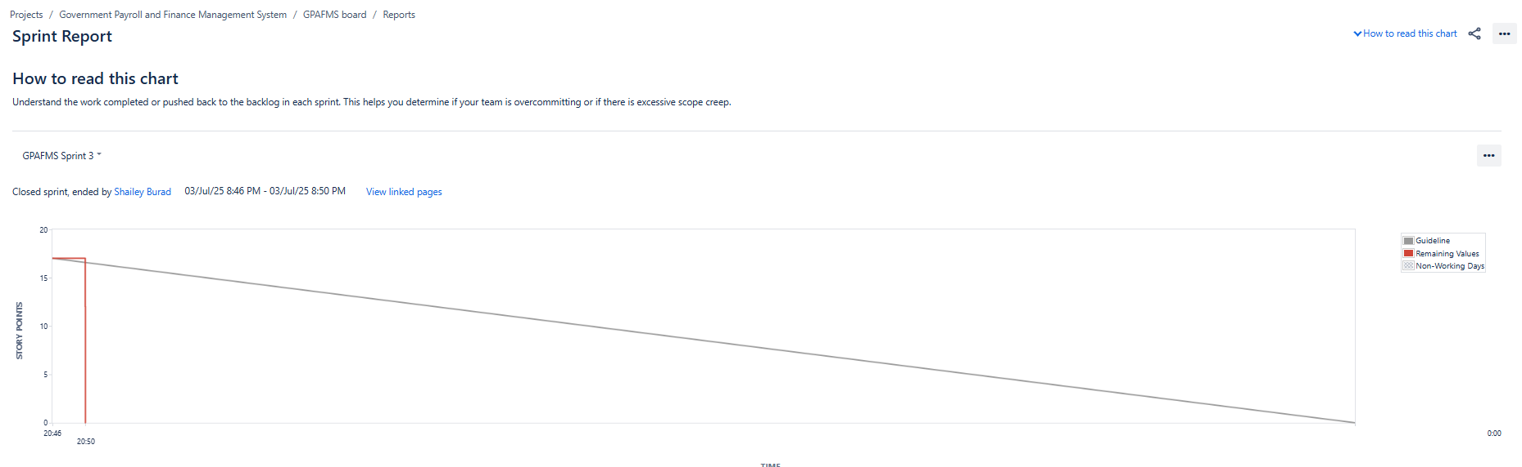

Sprint 4:
Product Burndown Chart:
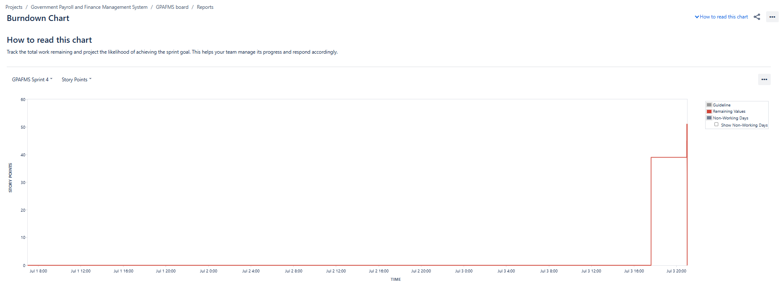

Sprint Burndown Chart:
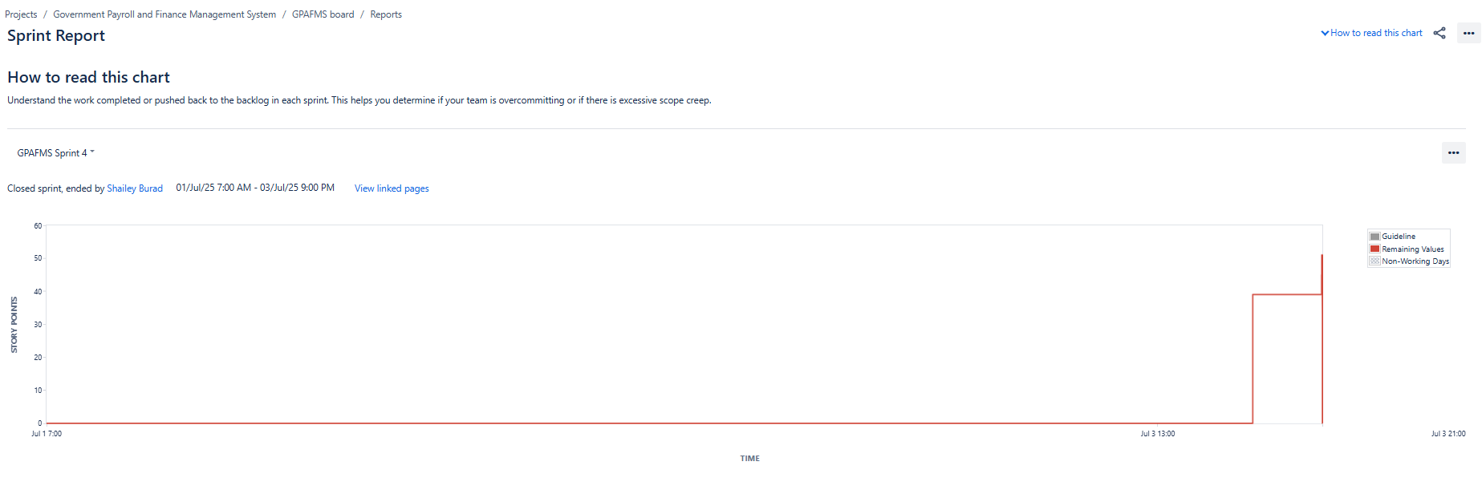

Document 6: Sprint meetings
Meeting Type 1: Sprint Planning Meeting:
Details | Information
Date | 23/06/2025
Time | 12:00 PM
Location | Online Meeting Link
Prepared By | Shailey Burad
Attendees | Scrum Master, Product Owner, Dev Team, QA

Agenda Topics:
Topic | Presenter | Time Allotted
Sprint Goals Discussion | Product Owner | 15 min
Backlog Item Review | Scrum Master/BA | 25 min
Estimation & Planning | Development Team | 30 min
Task Allocation | Scrum Master | 10 min

Observers: Project Manager
Resources: Product Backlog, Sprint Board
Special Notes: Include dependencies and risk factors

Meeting Type 2: Sprint Review Meeting:
Details | Information
Date | 24/06/2025
Time | 01:00 PM
Location | Office
Prepared By | Shailey Burad
Attendees | Product Owner, Scrum Master, Stakeholders, Dev Team

Review Agenda:
- Sprint Status:
Summary of completed user stories and sprint goals
- Things to Demo:
Features/functionalities completed and working

- Quick Updates:
Key observations, any changes or blockers

- What’s Next:
Backlog items for next sprint, feedback incorporated

Meeting Type 3: Sprint Retrospective Meeting:
Details | Information
Date | 24-06-2025
Time | 6:00 PM
Location | Office
Prepared By | Shailey Burad
Attendees | Scrum Team (Dev, QA, SM, PO)

Agenda:
Section | Input
What went well | [Team collaboration, delivery speed, etc.]
What didn’t go well | [Delays, unclear requirements, blockers]
Questions / Concerns | [Suggestions for improvement]
References | Sprint Board, Retrospective Notes

Meeting Type 4: Daily Stand-Up Meeting:
Question | Name / Role
What did you do yesterday? | Developer 1
What did you do yesterday? | Developer 2
What did you do yesterday? | Developer 3
What will you do today? | Developer 1
What will you do today? | Developer 2
What will you do today? | Developer 3
Any blockers or impediments? | Developer 1
Any blockers or impediments? | Developer 2
Any blockers or impediments? | Developer 3

