Document 1: Definition of Done

Definition of Done Checklist:
- All code written meets SHEIN's coding standards and guidelines
- User story acceptance criteria are fully met
- Responsive design works across all target devices (mobile, tablet, desktop)
- Cross-browser testing completed (Chrome, Safari, Firefox, Edge)
- Performance testing shows page load times under 2 seconds
- All automated unit tests pass (minimum 80% coverage)
- Integration tests with payment gateways and inventory systems pass
- Security scans show no vulnerabilities (OWASP Top 10 addressed)
- Accessibility compliance meets WCAG 2.1 AA standards
- Product images and descriptions are optimized for fast loading
- SEO metadata implemented according to requirements
- Documentation updated (technical and user-facing)
- Code reviewed and approved by at least one peer
- Feature approved by UX designer and Product Owner
- Deployed to staging environment matching production
- Smoke tests pass in staging environment
- Rollback plan documented

Document 2- Product Vision
Scrum Project Name: | SHEIN Platform Enhancement 2025
Venue: | Virtual (Global Team)
Date: 12/06/2025 | Start time: 9:00 AM | End time: 5:00 PM | Duration: 6 Sprints
Client: | SHEIN Global
Stakeholder list: | - SHEIN Executive Team | - Marketing Department | - Customer Service
 | - Logistics Team | - Payment Partners | - End Customers
Scrum Team
Scrum Master: | - Aarav Sharma | - Ishaan Patel | - Aditi Joshi
Product owner: | - Riya Kapoor | - Arjun Singh | - Ananya Iyer
Scrum Developer 1: | - Vihaan Reddy
Scrum Developer 2: | - Kavya Nair
Scrum Developer 3: | - Diya Choudhary
Scrum Developer 4: | - Kabir Desai
Scrum Developer 5: | - Anika Mehta

Vision Statement:
To create a seamless, personalized, and engaging online shopping experience that drives customer loyalty and increases conversion rates through innovative features and optimized performance.
Target Group  - Fashion-forward consumers aged 16–35  - Online shoppers across global markets | Needs  - Reduce page load time from 3.2s to <1.5s  - Simplify navigation and checkout  - Improve mobile responsiveness  - Ensure consistent design and accessibility | Product  - Enhanced product filtering & search  - One-click checkout  - Progressive Web App (PWA) performance  - UX/UI redesign  - Real-time stock updates | Value  - 25% projected increase in sales  - Improved customer retention  - Stronger brand loyalty  - Competitive edge in fast fashion e-commerce

Document 3: User stories

User story No: 1 | Tasks: 3 |  | Priority: HIGHEST
Value statement: As a customer, I want to experience page load times under 1.5 seconds so that I don't abandon my shopping session due to delays.
BV: 200 |  | CP: 8
Acceptance Criteria:
- Page load time is consistently less than 1.5 seconds on desktop.
- Page load time is consistently less than 2 seconds on mobile.
- Google Lighthouse score is ≥90 for core pages.

User story No: 2 | Tasks: 3 |  | Priority: HIGH
Value statement: As a customer, I want the website to be highly responsive during flash sales so that I can complete my purchase without encountering errors or bounces.
BV: 200 |  | CP: 1
Acceptance Criteria:
- Website maintains 99.9% uptime during peak sales periods.
- Bounce rates during high-demand periods are reduced by at least 5%.

User story No: 3 | Tasks: 4 |  | Priority: HIGHEST
Value statement: As a customer, I want a simplified checkout process (2 steps) so that I can complete my purchase quickly and easily.
BV: 200 |  | CP: 5
Acceptance Criteria:
- Checkout process is reduced from 5 steps to 2.
- Cart abandonment rate is reduced by 20%.

User story No: 4 | Tasks: 3 |  | Priority: HIGH
Value statement: As a returning customer, I want a 1-click reorder option so that I can quickly repurchase my favorite items.
BV: 100 |  | CP: 2
Acceptance Criteria:
- A 1-click reorder button is visible and functional for eligible past purchases.
- Reorders are processed successfully with a single click.

User story No: 5 | Tasks: 3 |  | Priority: HIGH
Value statement: As a customer, I want an AI-powered search function so that I can easily find specific items using natural language queries (e.g., "Show beach outfits under $30").
BV: 200 |  | CP: 2
Acceptance Criteria:
  - Search bar supports natural language queries.
  - Relevant search results are displayed based on complex queries.

User story No: 6 | Tasks: 2 |  | Priority: MEDIUM
Value statement: As a customer, I want to pay using Apple Pay or Google Pay so that I have more convenient payment options.
BV: 100 |  | CP: 5
Acceptance Criteria:
    - Apple Pay is integrated and available as a payment option.
    - Google Pay is integrated and available as a payment option.

User story No: 7 | Tasks: 3 |  | Priority: HIGHEST
Value statement: As a customer, I want AI-driven personalized bundles ("Frequently Bought Together") so that I can discover relevant products and increase my average order value.
BV: 500 |  | CP: 13
Acceptance Criteria:
    - Personalized product bundles are displayed on product pages.
    - Average order value increases by 30% due to these recommendations.

User story No: 8 | Tasks: 3 |  | Priority: HIGH
Value statement: As a customer, I want a "Style Genie" (AI-powered stylist) to suggest outfits so that I can get personalized fashion advice.
BV: 100 |  | CP: 1
Acceptance Criteria:
- "Style Genie" feature is launched in Beta within 3 months.
- The feature provides relevant and appealing style suggestions.

User story No: 9 | Tasks: 3 |  | Priority: HIGH
Value statement: As a customer, I want product rankings to dynamically adjust based on real-time trends (e.g., TikTok/Instagram virality) so that I see the most popular and relevant items.
BV: 200 |  | CP: 2
Acceptance Criteria:
- Product rankings are updated based on social media trends.
- Trending items appear prominently on relevant pages.

User story No: 10 | Tasks: 3 |  | Priority: HIGH
Value statement: As a customer, I want gamified elements (e.g., "Spin-to-Win" discounts) so that my session duration increases and I have a more "addictive" UX.
BV: 200 |  | CP: 1
Acceptance Criteria:
- "Spin-to-Win" discount feature is implemented and functional.
- Average session duration increases by 25%.

User story No: 11 | Tasks: 3 |  | Priority: MEDIUM
Value statement: As a Gen Z shopper, I want TikTok-style "Shop the Look" short videos integrated into product pages so that I can see products in action and be more engaged.
BV: 100 |  | CP: 2
Acceptance Criteria:
- Short shoppable videos are integrated into product pages.
- Engagement metrics on product pages show an increase.

User story No: 12 | Tasks: 2 |  | Priority: LOW
Value statement: As a customer, I want to view my past orders so that I can keep track of my purchases.
BV: 50 |  | CP: 3
Acceptance Criteria:
- A "My Orders" section is available in the user profile.
- All past orders are displayed accurately with relevant details.

User story No: 13 | Tasks: 2 |  | Priority: LOW
Value statement: As a customer, I want to receive order confirmation emails so that I have a record of my purchase.
BV: 50 |  | CP: 1
Acceptance Criteria:
- An automated order confirmation email is sent immediately after a successful purchase.
- The email contains order details and tracking information.

User story No: 14 | Tasks: 2 |  | Priority: HIGH
Value statement: As a new user, I want to easily register for an account so that I can access all website features.
BV: 50 |  | CP: 1
Acceptance Criteria:
    - Registration form is clear and intuitive.
- Successful registration leads to a confirmation message.

User story No: 15 | Tasks: 2 |  | Priority: HIGH
Value statement: As a returning user, I want to securely log in to my account so that I can access my personalized content.
BV: 200 |  | CP: 2
Acceptance Criteria:
    - Login page is secure with clear input fields.
- Users can successfully log in with correct credentials.

User story No: 16 | Tasks: 3 |  | Priority: MEDIUM
Value statement: As a user, I want to recover my password if I forget it so that I can regain access to my account.
BV: 100 |  | CP: 2
Acceptance Criteria:
    - "Forgot Password" link is available on the login page.
- Users can reset their password via email or mobile verification.

User story No: 17 | Tasks: 2 |  | Priority: HIGH
Value statement: As a user, I want to update my personal information (e.g., address, phone number) in my profile so that my details are always current.
BV: 200 |  | CP: 2
Acceptance Criteria:
    - Profile editing section is available.
- Users can successfully update and save their information.

User story No: 18 | Tasks: 3 |  | Priority: HIGH
Value statement: As a customer, I want to easily navigate through product categories so that I can find the types of items I'm looking for.
BV: 100 |  | CP: 1
Acceptance Criteria:
    - Navigation menu is intuitive and well-organized.
    - Users can filter products by category and sub-category.

User story No: 19 | Tasks: 2 |  | Priority: MEDIUM
Value statement: As a customer, I want to view high-quality product images and videos so that I can make informed purchasing decisions.
BV: 200 |  | CP: 2
Acceptance Criteria:
    - Product pages display multiple high-resolution images.
    - Product videos are embedded and play smoothly.

User story No: 20 | Tasks: 2 |  | Priority: MEDIUM
Value statement: As a customer, I want to see detailed product descriptions, including materials and sizing charts, so that I can be sure of my purchase.
BV: 200 |  | CP: 2
Acceptance Criteria:
    - Each product page includes comprehensive descriptions.
    - Sizing charts are easily accessible and accurate.

User story No: 21 | Tasks: 3 |  | Priority: MEDIUM
Value statement: As a customer, I want to read customer reviews and ratings so that I can gauge the quality and fit of a product.
BV: 100 |  | CP: 1
Acceptance Criteria:
    - Product pages display customer reviews and an average rating.
    - Customers can submit their own reviews.

User story No: 22 | Tasks: 2 |  | Priority: LOW
Value statement: As a customer, I want to add products to a wish list so that I can save items for later purchase.
BV: 200 |  | CP: 2
Acceptance Criteria:
    - A "Add to Wishlist" button is available on product pages.
    - Users can view and manage their wish list.

User story No: 23 | Tasks: 3 |  | Priority: LOW
Value statement: As a customer, I want to receive notifications for price drops on my wish-listed items so that I can buy them at a better price.
BV: 100 |  | CP: 2
Acceptance Criteria:
    - Users receive email or in-app notifications when wish-listed items have a price drop.
    - Notifications are timely and accurate.

User story No: 24 | Tasks: 3 |  | Priority: HIGH
Value statement: As a customer, I want real-time order tracking so that I know the status of my delivery.
BV: 50 |  | CP: 2
Acceptance Criteria:
    - Order tracking page displays real-time updates on delivery status.
    - Customers receive push notifications for significant status changes.

User story No: 25 | Tasks: 3 |  | Priority: MEDIUM
Value statement: As a customer, I want to easily initiate returns or exchanges so that I can manage my orders efficiently.
BV: 200 |  | CP: 2
Acceptance Criteria:
    - A clear "Return/Exchange" option is available in the order history.
    - The return/exchange process is guided and straightforward.

User story No: 26 | Tasks: 3 |  | Priority: LOW
Value statement: As a customer, I want to provide feedback on my purchases so that I can contribute to product improvement.
BV: 50 |  | CP: 2
Acceptance Criteria:
    - A feedback submission form is available after delivery.
    - Users can rate products and write comments.

User story No: 27 | Tasks: 3 |  | Priority: LOW
Value statement: As a guest user, I want to browse products and add them to a cart without logging in, so I can explore the site conveniently.
BV: 100 |  | CP: 2
Acceptance Criteria:
    - Website is fully browsable without an account.
    - Items can be added to a cart and persisted for a reasonable duration (e.g., 24 hours).

User story No: 28 | Tasks: 2 |  | Priority: LOW
Value statement: As a customer, I want to subscribe to email newsletters so that I can receive updates on new arrivals and promotions.
BV: 100 |  | CP: 1
Acceptance Criteria:
    - Newsletter subscription option is clearly visible.
    - Users receive a confirmation email upon subscription.

User story No: 29 | Tasks: 3 |  | Priority: HIGH
Value statement: As a delivery boy, I want to receive push notifications for new delivery assignments so that I can quickly accept or reject them.
BV: 200 |  | CP: 5
Acceptance Criteria:
    - Delivery app sends instant push notifications for new orders.
    - Delivery boys can accept/reject orders within the app.

User story No: 30 | Tasks: 2 |  | Priority: HIGH
Value statement: As a delivery boy, I want to view an optimized delivery route on a map so that I can complete deliveries efficiently.
BV: 100 |  | CP: 2
Acceptance Criteria:
    - In-app map displays the optimized route for multiple deliveries.
    - Turn-by-turn navigation is available.

User story No: 31 | Tasks: 2 |  | Priority: MEDIUM
Value statement: As a delivery boy, I want to view an optimized delivery route on a map so that I can complete deliveries efficiently.
BV: 200 |  | CP: 1
Acceptance Criteria:
    - Status update options are clearly visible and easy to select in the app.
    - Status changes are reflected in real-time for customers and suppliers.

User story No: 32 | Tasks: 2 |  | Priority: MEDIUM
Value statement: As a delivery boy, I want to contact the customer directly via call or chat so that I can resolve delivery issues (e.g., unable to locate address).
BV: 200 |  | CP: 2
Acceptance Criteria:
    - In-app call and chat functionality is available for contacting customers.
    - Communication logs are maintained.

User story No: 33 | Tasks: 3 |  | Priority: LOW
Value statement: As a delivery boy, I want to view my earnings and delivery history so that I can keep track of my income.
BV: 50 |  | CP: 2
Acceptance Criteria:
    - A dedicated section in the app displays earnings summary and detailed delivery history.
    - Earnings are updated accurately after each completed delivery.

User story No: 34 | Tasks: 2 |  | Priority: LOW
Value statement: As a delivery boy, I want to mark an order as "undeliverable" with a reason so that the system can initiate a return or re-delivery process.
BV: 50 |  | CP: 1
Acceptance Criteria:
    - Option to mark as undeliverable is available.
    - Mandatory reason selection is enforced for undeliverable status.

User story No: 35 | Tasks: 3 |  | Priority: HIGH
Value statement: As a supplier, I want to easily register and create my store profile so that I can start listing products on SHEIN.
BV: 500 |  | CP: 8
Acceptance Criteria:
    - Supplier registration form is clear and guides through the process.
    - Supplier profile can be created with necessary business details.

User story No: 36 | Tasks: 4 |  | Priority: HIGH
Value statement: As a supplier, I want to efficiently upload and manage my product listings (including images, descriptions, variants, and pricing) so that my products are accurately represented.
BV: 500 |  | CP: 2
Acceptance Criteria:
    - Product upload interface supports bulk upload and individual editing.
    - All product attributes (SKU, size, color, price) can be managed.

User story No: 37 | Tasks: 3 |  | Priority: MEDIUM
Value statement: As a supplier, I want to view and update my product inventory levels in real-time so that I avoid overselling or underselling items.
BV: 500 |  | CP: 1
Acceptance Criteria:
    - Inventory dashboard shows real-time stock levels.
    - Suppliers can easily adjust stock quantities.

User story No: 38 | Tasks: 3 |  | Priority: MEDIUM
Value statement: As a supplier, I want to view incoming orders and their details so that I can process and fulfill them promptly.
BV: 200 |  | CP: 1
Acceptance Criteria:
    - A dashboard displays all new and pending orders.
    - Order details (items, quantity, customer address) are clearly visible.

User story No: 39 | Tasks: 3 |  | Priority: MEDIUM
Value statement: As a supplier, I want to manage shipping details and generate shipping labels for my orders so that I can streamline the fulfillment process.
BV: 100 |  | CP: 2
Acceptance Criteria:
    - Suppliers can enter tracking numbers and carrier information.
    - Shipping labels can be generated directly from the platform.

User story No: 40 | Tasks: 3 |  | Priority: LOW
Value statement: As a supplier, I want to view my sales performance and earnings reports so that I can analyze my business growth on the platform.
BV: 100 |  | CP: 2
Acceptance Criteria:
    - Sales and earnings reports are accessible from the supplier dashboard.
    - Reports can be filtered by date and product.

Document 4: Agile PO Experience

➤ 1. Market Analysis
- Researched current fast fashion trends, mobile shopping habits, and the competitive landscape (e.g., Zara, H&M, Myntra).
- Identified critical pain points in the existing SHEIN platform: slow page loads, complex checkout, poor mobile UX.
- Benchmarked features like 1-click checkout and AI recommendations to enhance competitiveness.
➤ 2. Enterprise Analysis
- Analyzed SHEIN's declining retention rate and bounce rate issues.
- Justified the need for a platform redesign with projected ROI (25% increase in conversion through UX improvements).
- Proposed AI integration features (like Style Genie, Personalized Bundles) to increase user engagement.
➤ 3. Product Vision and Roadmap
- Defined a clear vision: “Deliver a seamless, personalized, high-performance fashion e-commerce experience.”
- Built a 6-sprint roadmap with feature milestones including checkout optimization, AI enhancements, supplier onboarding, and delivery automation.
- Roadmap was presented and approved by the executive team.
➤ 4. Managing Product Features
- Prioritized high-impact features like “AI Bundles,” “Simplified Checkout,” and “Gamified Discounts.”
- Used MoSCoW prioritization and impact vs. effort matrix to select backlog items.
- Continuously engaged stakeholders to balance their requests with delivery capacity.
➤ 5. Managing Product Backlog
- Created and maintained a backlog of 40+ user stories covering customers, delivery agents, and suppliers.
- Refined and reprioritized backlog in Backlog Grooming Meetings, ensuring stories were INVEST-compliant.
- Grouped features into epics (e.g., Checkout Optimization, Personalization, Supplier Module).
➤ 6. Managing Overall Iteration Progress
- Participated in Daily Scrums, reviewed progress via Sprint Boards.
- Led Sprint Planning, ensured user stories were ready with clear acceptance criteria.
- Evaluated product demos in Sprint Review Meetings, collected stakeholder feedback, and updated the roadmap.
- Conducted Sprint Retrospectives with the Scrum Master and BA to reflect and improve on delivery practices.

Sprint Meeting Experiences as PO

Meeting Type | My Role as PO
Sprint Planning | Presented high-priority backlog items and clarified goals for the sprint.
Daily Scrum | Observed progress and clarified product-related blockers if raised by developers.
Sprint Review | Validated deliverables against acceptance criteria, noted feedback from demos.
Sprint Retrospective | Collaborated with team to identify improvements in process and communication.
Backlog Refinement | Re-prioritized user stories based on updated business inputs and dependencies.

Learnings as a Product Owner
- Gained practical experience in transforming user needs into technical deliverables.
- Improved negotiation skills while balancing stakeholder desires and sprint capacities.
- Understood the importance of continuous feedback, quick decision-making, and adaptive planning.
- Developed a keen eye for defining user stories with clarity (Value Statement, BV/CP, Acceptance Criteria).
Document 5: Product and sprint backlog and product and sprint burndown charts
Product backlog:

User story ID | User story (Value Statement) | Tasks | Priority | BV (Rs.) | CP | Sprint
1 | Customer: Page load times under 1.5s | 3 | HIGHEST | 200 | 8 | Sprint 1
3 | Customer: Simplified 2-step checkout | 4 | HIGHEST | 200 | 5 | Sprint 1
7 | Customer: AI-driven personalized bundles | 3 | HIGHEST | 500 | 13 | Sprint 3
2 | Customer: Responsive during flash sales | 3 | HIGH | 200 | 1 | Sprint 1
5 | Customer: AI-powered search function | 3 | HIGH | 200 | 2 | Sprint 3
8 | Customer: "Style Genie" suggestions | 3 | HIGH | 100 | 1 | Sprint 3
29 | Delivery Boy: Push notifications for new assignments | 3 | HIGH | 200 | 5 | Sprint 3
30 | Delivery Boy: Optimized delivery route | 2 | HIGH | 100 | 2 | Sprint 4
35 | Supplier: Easy registration & store profile | 3 | HIGH | 500 | 8 | Sprint 4
36 | Supplier: Upload & manage product listings | 4 | HIGH | 500 | 2 | Sprint 5
4 | Customer: 1-click reorder option | 3 | HIGH | 100 | 2 | Sprint 2
9 | Customer: Dynamic product rankings by trends | 3 | HIGH | 200 | 2 | Sprint 3
10 | Customer: Gamified elements ("Spin-to-Win") | 3 | HIGH | 200 | 1 | Sprint 4
14 | Customer: Easily register for an account | 2 | HIGH | 50 | 1 | Sprint 1
15 | Customer: Securely log in to account | 2 | HIGH | 200 | 2 | Sprint 1
18 | Customer: Easily navigate product categories | 3 | HIGH | 100 | 1 | Sprint 5
24 | Customer: Real-time order tracking | 3 | HIGH | 50 | 2 | Sprint 6
6 | Customer: Pay using Apple Pay/Google Pay | 2 | MEDIUM | 100 | 5 | Sprint 6
11 | Gen Z Shopper: TikTok-style "Shop the Look" videos | 3 | MEDIUM | 100 | 2 | Sprint 7
13 | Customer: Receive order confirmation emails | 2 | MEDIUM | 50 | 1 | Sprint 7
16 | User: Recover password | 3 | MEDIUM | 100 | 2 | Sprint 8
19 | Customer: View high-quality product images/videos | 2 | MEDIUM | 200 | 2 | Sprint 6
20 | Customer: See detailed product descriptions/sizing | 2 | MEDIUM | 200 | 2 | Sprint 5
21 | Customer: Read customer reviews and ratings | 3 | MEDIUM | 100 | 1 | Sprint 7
25 | Customer: Easily initiate returns/exchanges | 3 | MEDIUM | 200 | 2 | Sprint 8
31 | Delivery Boy: Update delivery status | 2 | MEDIUM | 200 | 1 | Sprint 7
32 | Delivery Boy: Contact customer directly | 2 | MEDIUM | 200 | 2 | Sprint 8
37 | Supplier: View and update product inventory | 3 | MEDIUM | 500 | 1 | Sprint 6
38 | Supplier: View incoming orders and details | 3 | MEDIUM | 200 | 1 | Sprint 5
39 | Supplier: Manage shipping and generate labels | 3 | MEDIUM | 100 | 1 | Sprint 7
12 | Customer: View past orders | 2 | LOW | 50 | 3 | Sprint 8
17 | User: Update personal information in profile | 2 | LOW | 200 | 2 | Sprint 8
22 | Customer: Add products to a wish list | 2 | LOW | 200 | 2 | Sprint 8
23 | Customer: Receive price drop notifications on wishlist | 3 | LOW | 100 | 2 | Sprint 8
26 | Customer: Provide feedback on purchases | 2 | LOW | 50 | 2 | Sprint 8
33 | Delivery Boy: View earnings and delivery history | 3 | LOW | 50 | 1 | Sprint 8
40 | Supplier: View sales performance and earnings reports | 3 | LOW | 100 | 2 | Sprint 8
27 | Guest User: Browse and add to cart without login | 2 | LOW | 100 | 2 | Sprint 8
34 | Delivery Boy: Mark order as "undeliverable" | 2 | LOW | 50 | 1 | Sprint 8
28 | Customer: Subscribe to email newsletters | 2 | LOW | 100 | 1 | Sprint 8

Sprint Backlog (Sprint 1)
User story ID | User story (Value Statement) | Tasks | Owner | Status | Estimated effort (hours)
1 | Customer: Page load times under 1.5s | 3 | Dev Team A | In Progress | 60
3 | Customer: Simplified 2-step checkout | 4 | Dev Team B | To Do | 80
2 | Customer: Responsive during flash sales | 3 | Dev Team C | In Progress | 52
14 | Customer: Easily register for an account | 2 | Dev Team D | Done | 20
15 | Customer: Securely log in to account | 2 | Dev Team D | In Progress | 12

Sprint Backlog (Sprint 2)

User story ID | User story (Value Statement) | Tasks | Owner | Status | Estimated effort (hours)
7 | Customer: AI-driven personalized bundles | 3 | Dev Team A | To Do | 80
5 | Customer: AI-powered search function | 3 | Dev Team B | In Progress | 52
4 | Customer: 1-click reorder option | 3 | Dev Team C | To Do | 32

Sprint Backlog (Sprint 3)

User story ID | User story (Value Statement) | Tasks | Owner | Status | Estimated effort (hours)
8 | Customer: "Style Genie" suggestions | 3 | Dev Team A | In Progress | 52
29 | Delivery Boy: Push notifications for new assignments | 3 | Dev Team B | To Do | 32
9 | Customer: Dynamic product rankings by trends | 3 | Dev Team C | In Progress | 32

Sprint Backlog (Sprint 4)

User story ID | User story (Value Statement) | Tasks | Owner | Status | Estimated effort (hours)
30 | Delivery Boy: Optimized delivery route | 2 | Dev Team D | To Do | 52
35 | Supplier: Easy registration & store profile | 3 | Dev Team A | In Progress | 52
10 | Customer: Gamified elements (“Spin-to-Win”) | 3 | Dev Team B | To Do | 32

Sprint Backlog (Sprint 5)

User story ID | User story (Value Statement) | Tasks | Owner | Status | Estimated effort (hours)
36 | Supplier: Upload & manage product listings | 4 | Dev Team C | To Do | 80
18 | Customer: Easily navigate product categories | 3 | Dev Team D | In Progress | 32
20 | Customer: See detailed product descriptions/sizing | 2 | Dev Team A | To Do | 12
38 | Supplier: View incoming orders and details | 3 | Dev Team B | In Progress | 20

Sprint Backlog (Sprint 6)

User story ID | User story (Value Statement) | Tasks | Owner | Status | Estimated effort (hours)
24 | Customer: Real-time order tracking | 3 | Dev Team C | In Progress | 32
6 | Customer: Pay using Apple Pay/Google Pay | 2 | Dev Team D | To Do | 20
19 | Customer: View high-quality product images/videos | 2 | Dev Team A | In Progress | 20
37 | Supplier: View and update product inventory | 3 | Dev Team B | To Do | 32

Sprint Backlog (Sprint 7)

User story ID | User story (Value Statement) | Tasks | Owner | Status | Estimated effort (hours)
11 | Gen Z Shopper: TikTok-style "Shop the Look" videos | 3 | Dev Team C | To Do | 52
13 | Customer: Receive order confirmation emails | 2 | Dev Team D | In Progress | 8
21 | Customer: Read customer reviews and ratings | 3 | Dev Team A | To Do | 20
31 | Delivery Boy: Update delivery status | 2 | Dev Team B | In Progress | 20
39 | Supplier: Manage shipping and generate labels | 3 | Dev Team C | To Do | 32

Sprint Backlog (Sprint 8)

User story ID | User story (Value Statement) | Tasks | Owner | Status | Estimated effort (hours)
16 | User: Recover password | 3 | Dev Team D | In Progress | 20
25 | Customer: Easily initiate returns/exchanges | 3 | Dev Team A | To Do | 20
32 | Delivery Boy: Contact customer directly | 2 | Dev Team B | In Progress | 20
12 | Customer: View past orders | 2 | Dev Team C | To Do | 12
17 | User: Update personal information in profile | 2 | Dev Team D | In Progress | 12
22 | Customer: Add products to a wish list | 2 | Dev Team A | To Do | 12
23 | Customer: Receive price drop notifications on wishlist | 3 | Dev Team B | In Progress | 20
26 | Customer: Provide feedback on purchases | 2 | Dev Team C | To Do | 8
33 | Delivery Boy: View earnings and delivery history | 3 | Dev Team D | In Progress | 32
40 | Supplier: View sales performance and earnings reports | 3 | Dev Team A | To Do | 32
27 | Guest User: Browse and add to cart without login | 2 | Dev Team B | In Progress | 12
34 | Delivery Boy: Mark order as "undeliverable" | 2 | Dev Team C | To Do | 12
28 | Customer: Subscribe to email newsletters | 2 | Dev Team D | In Progress | 8

Burnup report
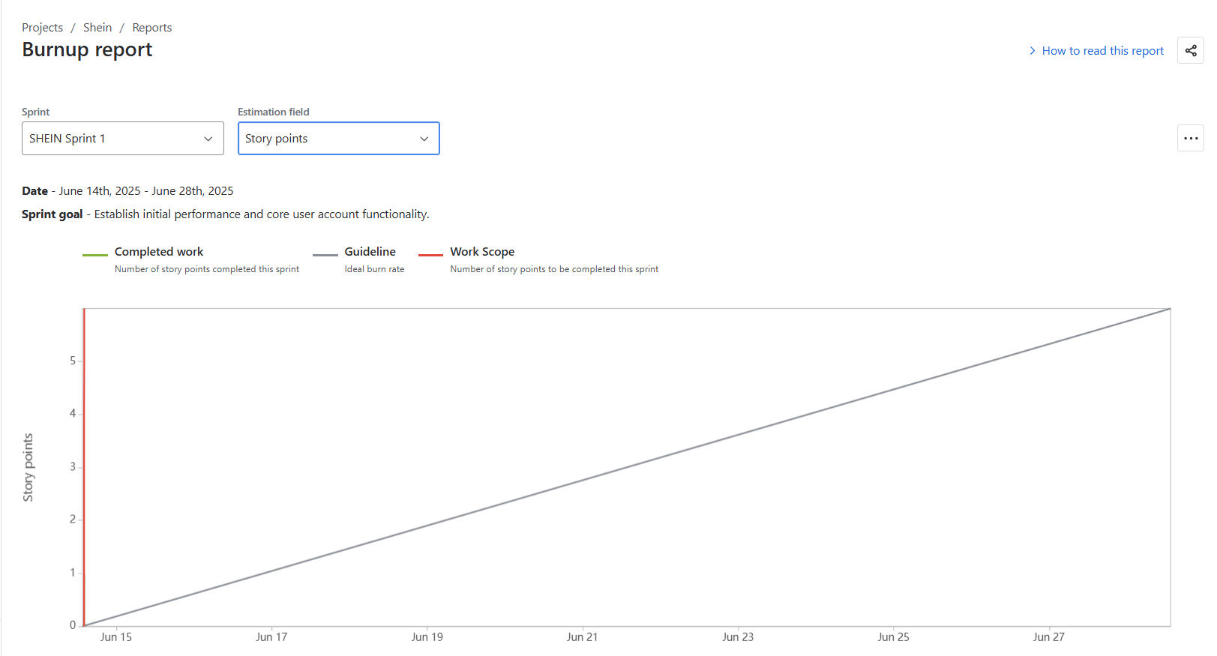

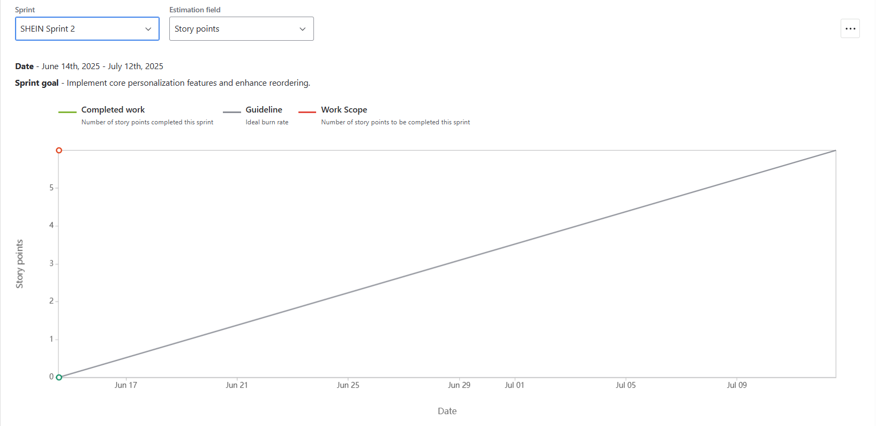

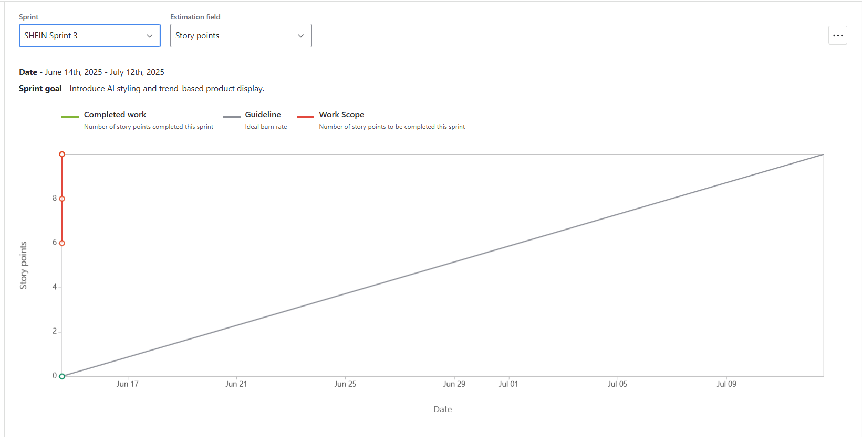

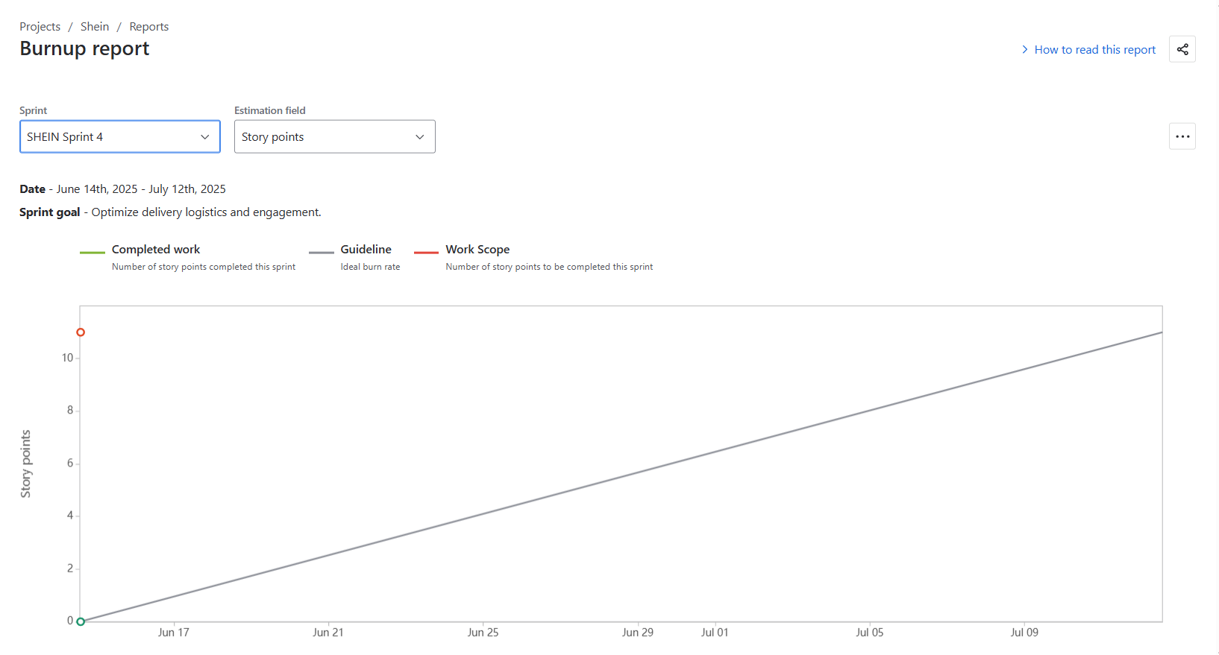

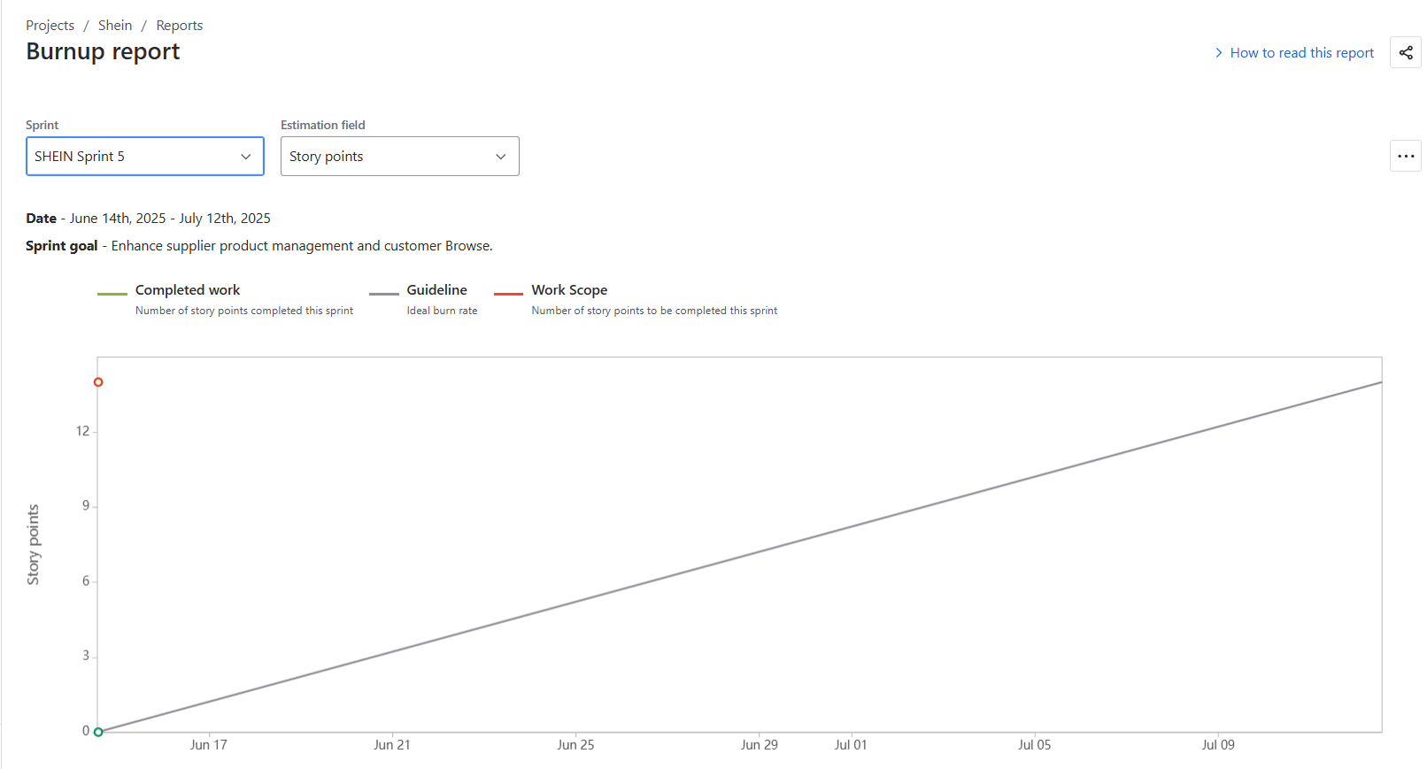

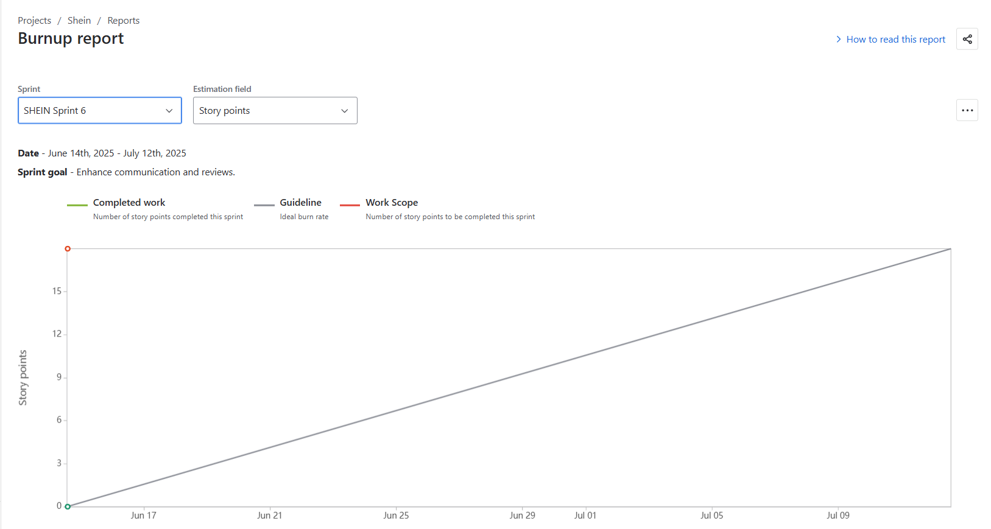

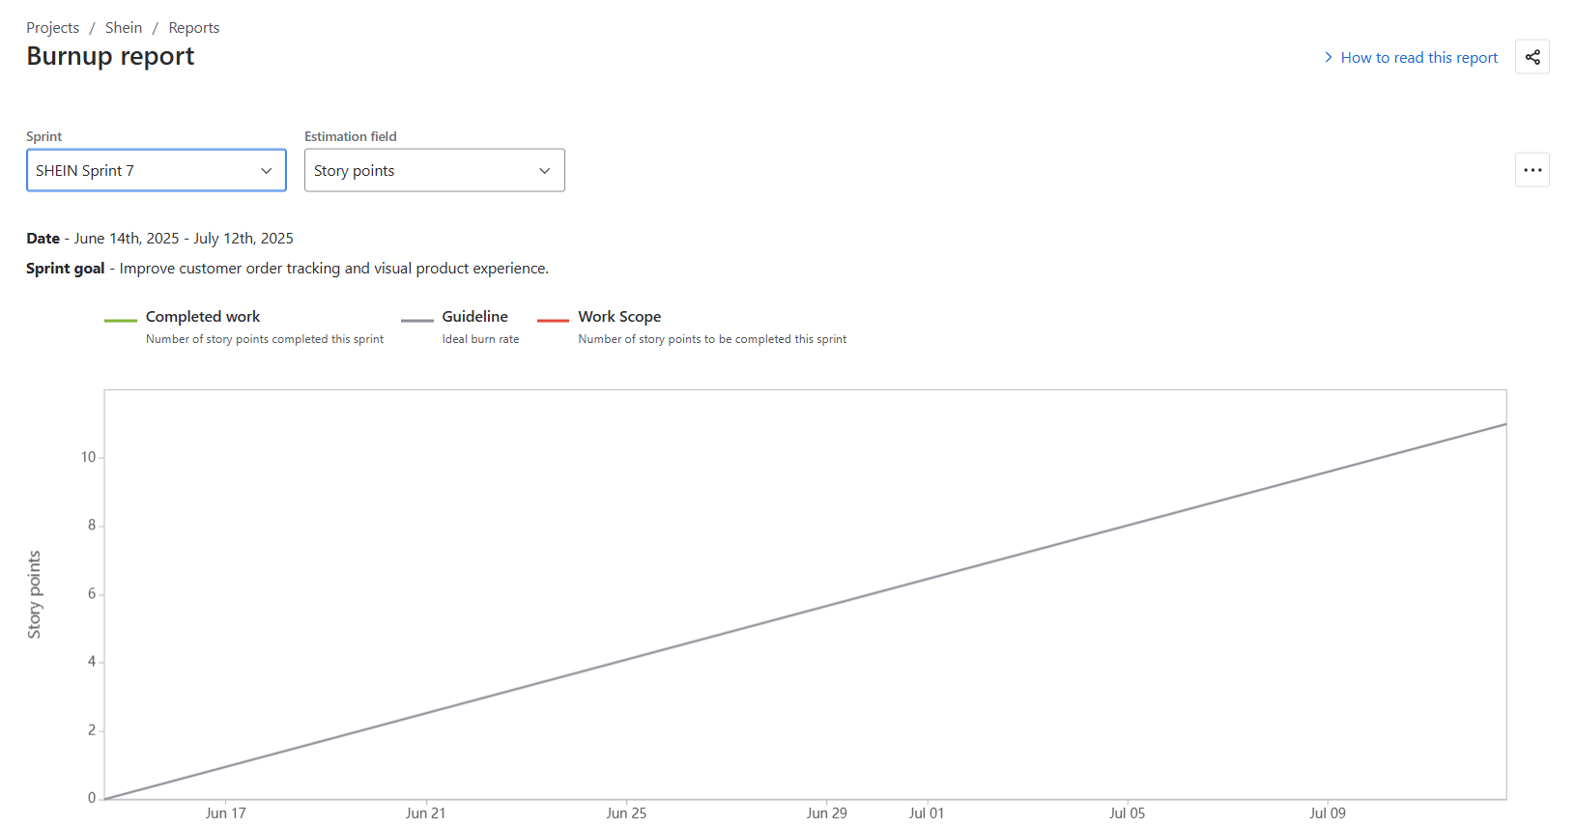

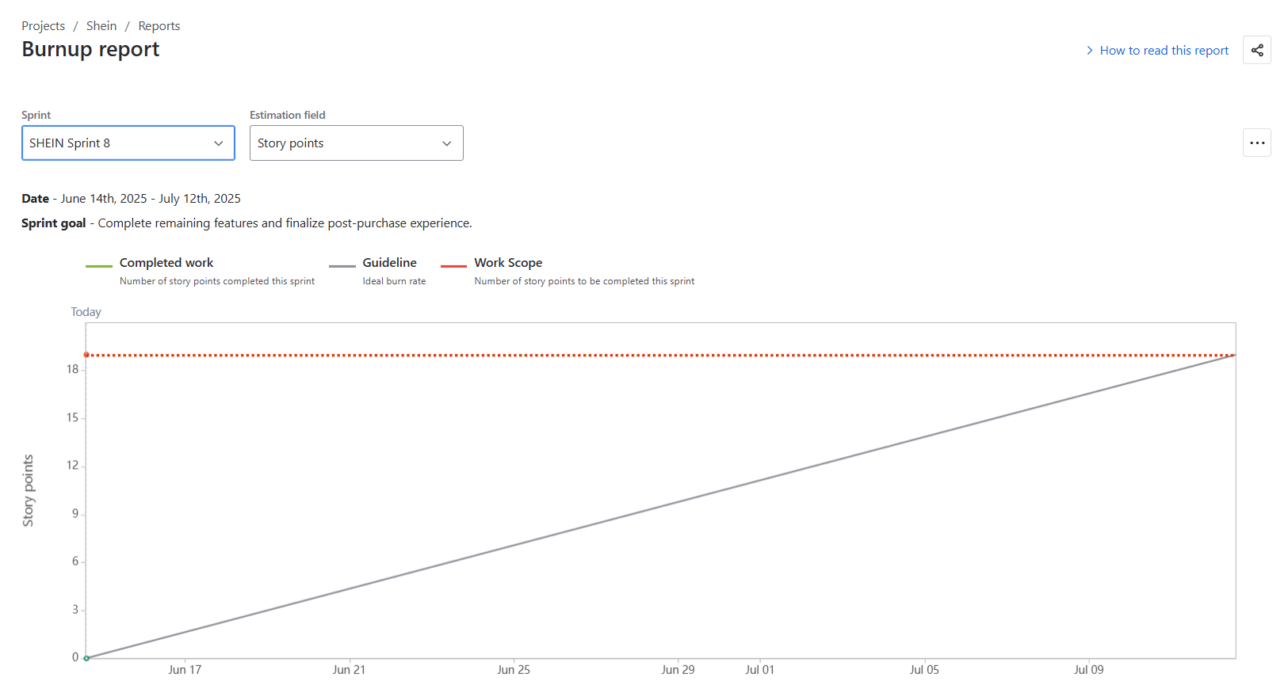

Sprint burndown chart

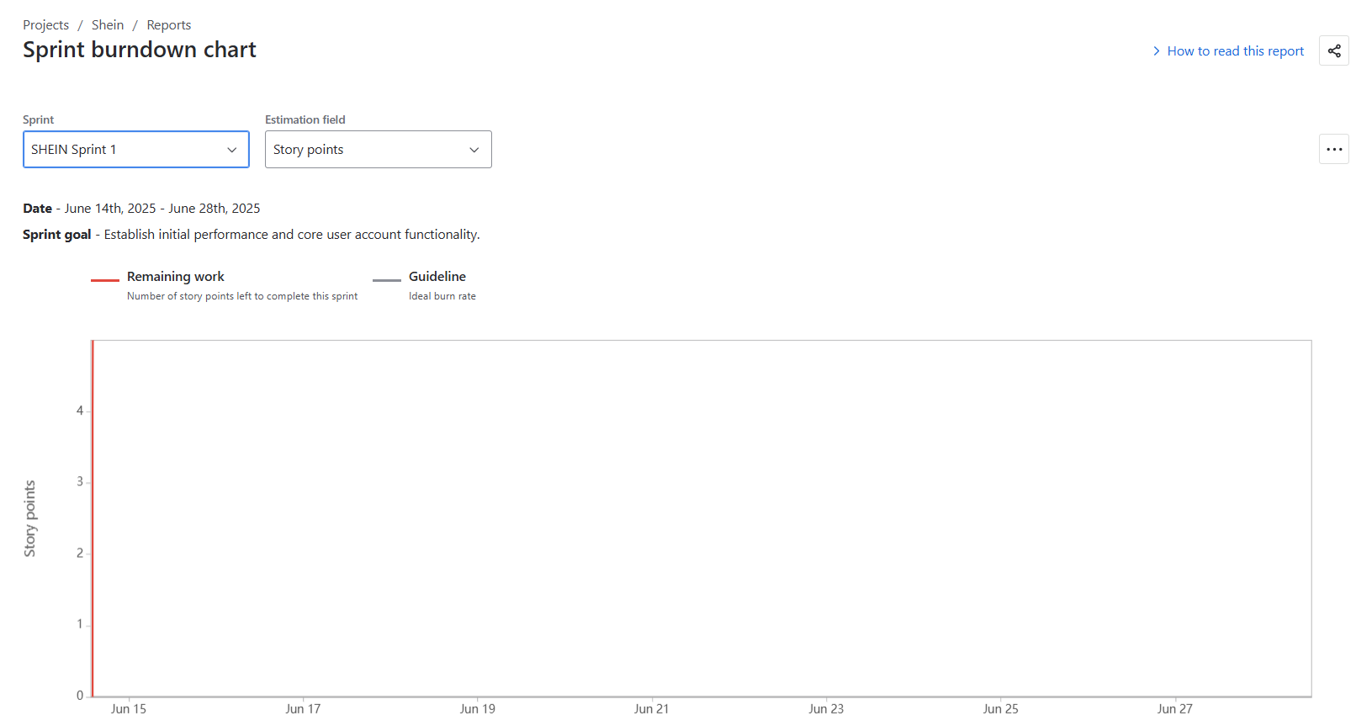

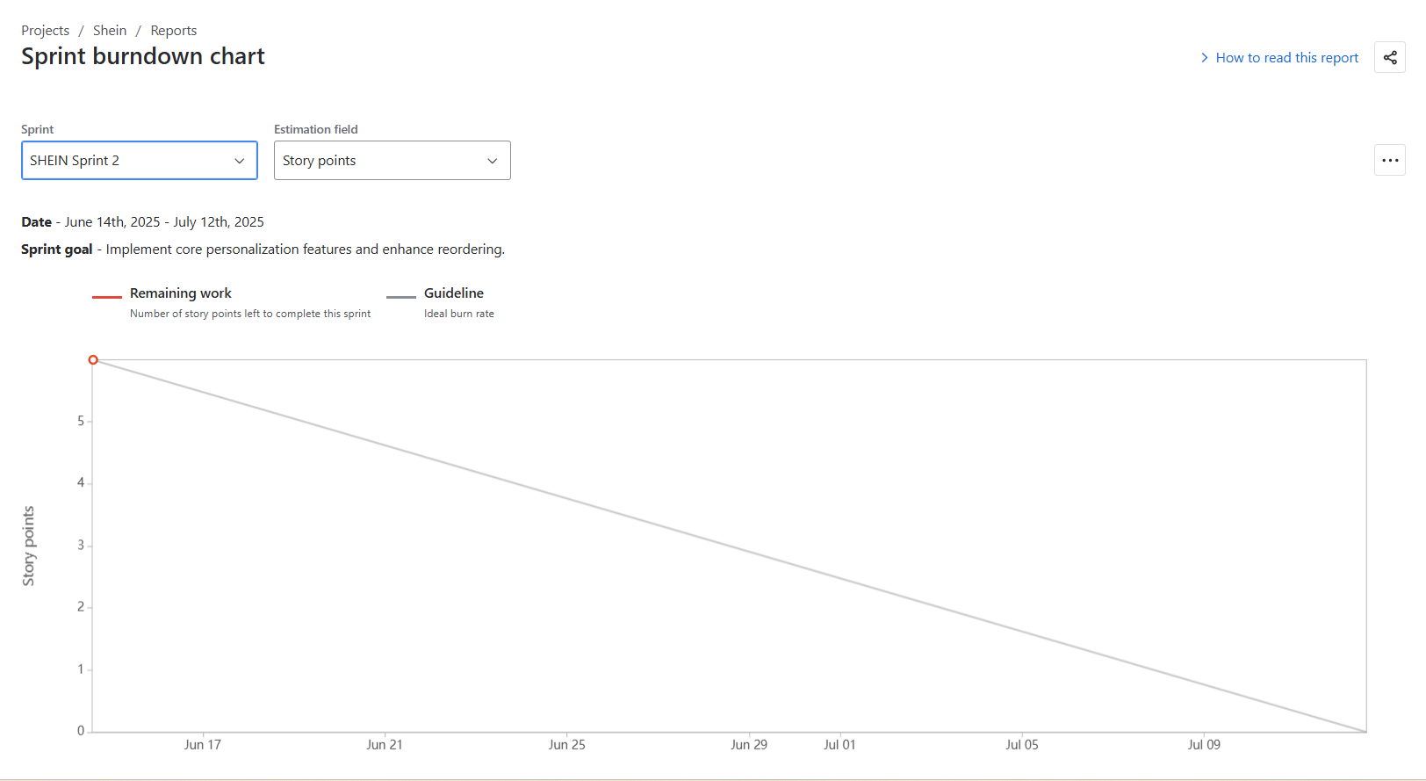

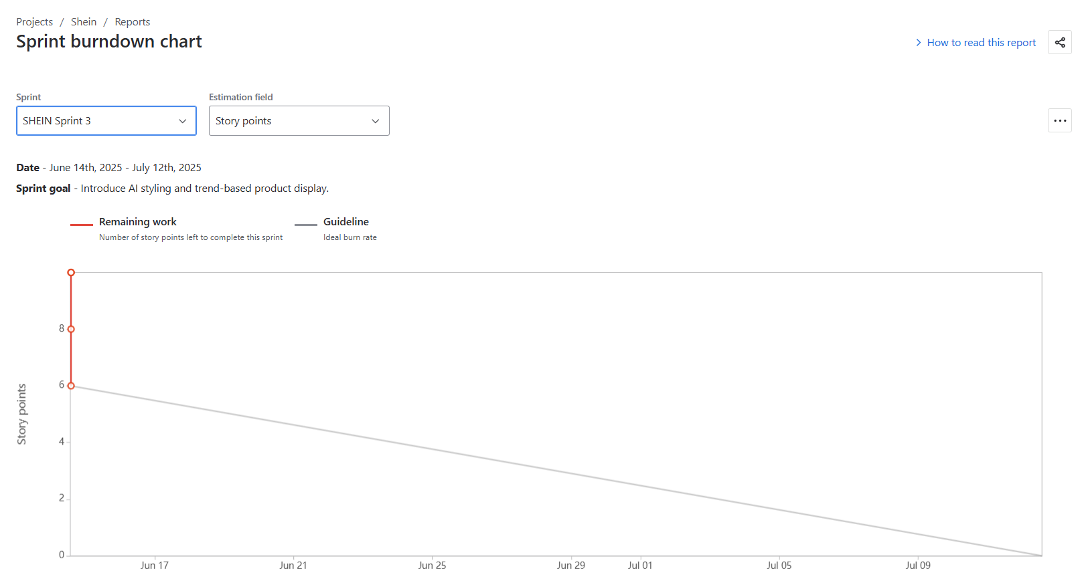

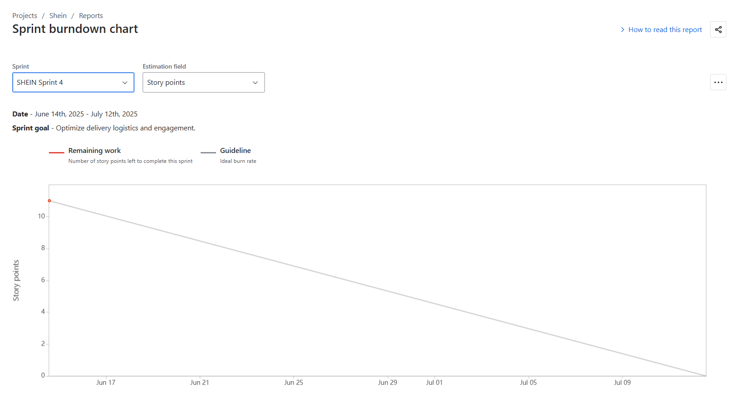

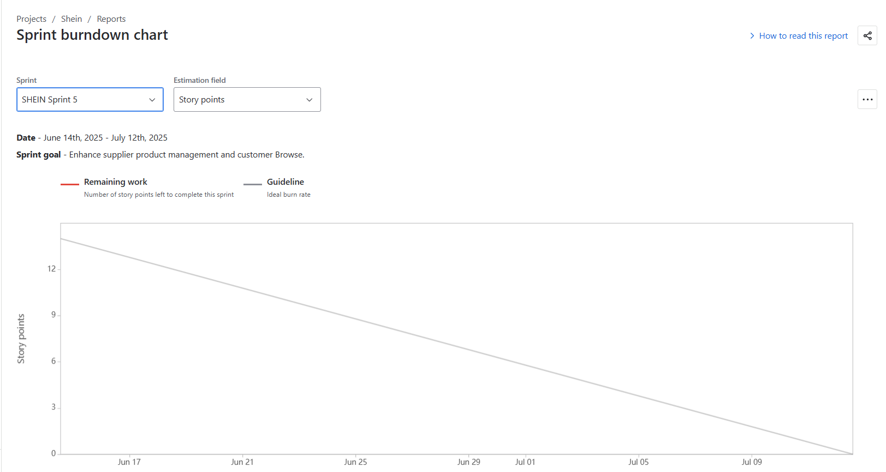

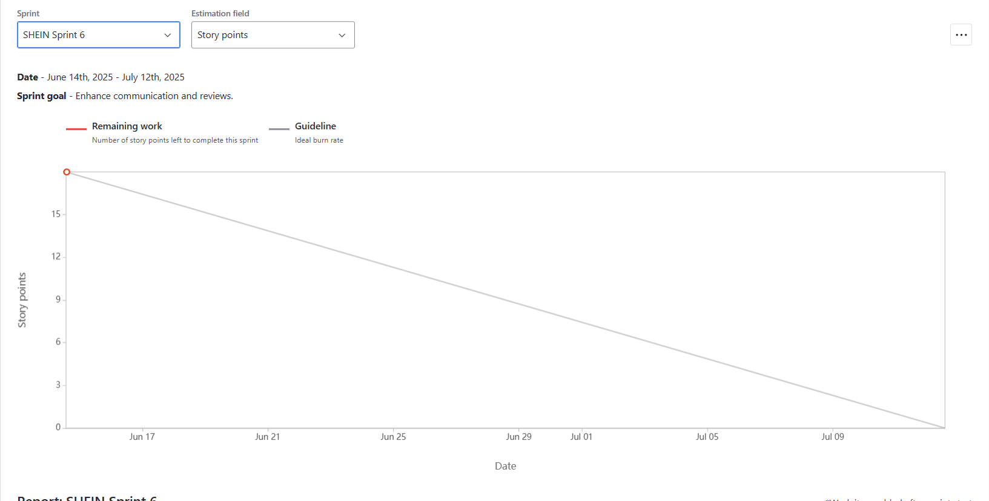

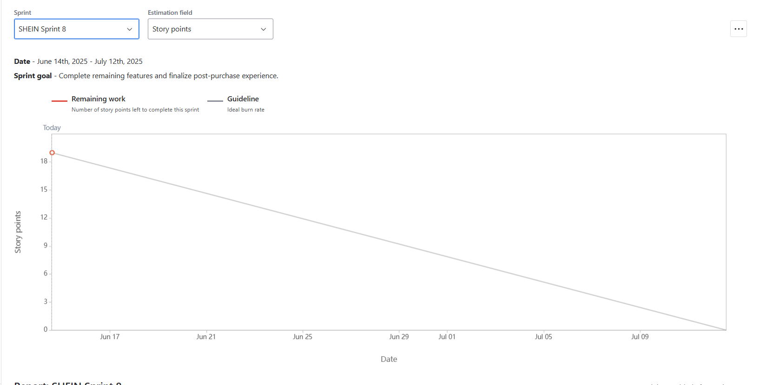
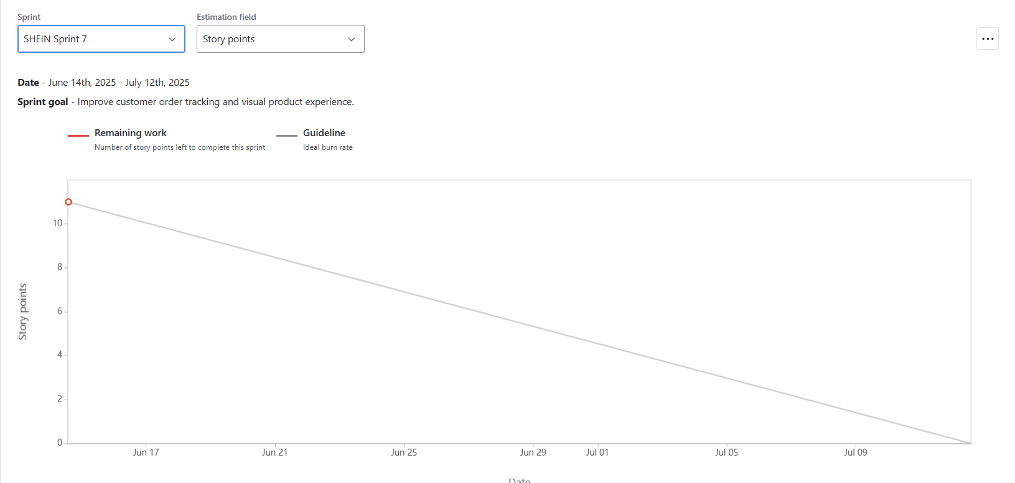
Document 6: Sprint meetings

Meeting Type 1: Sprint Planning meeting
Date | 24/06/2025
Time | 10:00 AM – 11:30 AM
Location | Zoom (Virtual)
Prepared By | Aarav Sharma (Scrum Master)
Attendees | Riya Kapoor (Product Owner)  Scrum Team: Vihaan, Kavya, Diya, Kabir, Anika  Stakeholder Observer: Arjun Singh (UX Team Lead)

Agenda Topics
Topic | Presenter | Time Allotted
Review Sprint Goals & Roadmap | Product Owner | 15 mins
Review High-Priority User Stories | Scrum Master | 20 mins
Task Estimation (CP) & Assignment | Development Team | 30 mins
Discuss Dependencies & Risks | All | 15 mins
Finalize Sprint Backlog | Scrum Master | 10 mins

Other Information

Observers | UX Team, QA Lead
Resources | Jira Board, Sprint Velocity Chart
Special Notes | Prioritized 5 user stories (US1, US2, US3, US14, US15) for Sprint 1, focused on performance and checkout flow.

Meeting Type 2: Sprint review meeting
Date | 07/07/2025
Time | 4:00 PM – 5:00 PM
Location | MS Teams
Prepared By | Riya Kapoor (Product Owner)
Attendees | Scrum Team, QA Lead, Product Owner, Stakeholders

Sprint status | Things to demo | Quick updates | What’s next
90% of Sprint goals completed | Simplified 2-step Checkout (US3) | Apple Pay integration story postponed to Sprint 2 | Begin Sprint 2: Personalization features + Reorder + Product Search
All high-priority features demo-ready except minor UI tweaks pending | Faster Page Load under 1.5s (US1) | Bounce rate metrics improved by ~10% post implementation
 | Secure Login & Registration (US14, US15)

Meeting Type 3: Sprint retrospective meeting
Date | 07/07/2025
Time | 5:30 PM – 6:00 PM
Location | MS Teams
Prepared By | Aarav Sharma (Scrum Master)
Attendees | Full Scrum Team, Product Owner

Agenda | What went well | What didn’t go well | Questions | Reference
- Review team performance  - Identify process improvements  - Reflect on communication gaps | - Timely delivery of core stories  - Strong coordination among Dev Team A & B  - Good sprint velocity improvement from previous estimate | - UI team got delayed feedback from stakeholder  - One blocker caused 1-day delay in Search functionality | - Can feedback cycles be scheduled mid-sprint to avoid bottlenecks?  - Is QA bandwidth enough for next sprint’s planned stories? | Agile Retrospective Method: Start / Stop / Continue

Meeting Type 4: Daily Stand-up meeting
Week “2” (from 01-07-2025 to 07-07-2025)
Question | Name/Role | Mon | Tue | Wed | Thu | Fri | Sat | Sun
What did you do yesterday? | Developer 1 (Vihaan) | ✔ | ✔ | ✔ | ✔ | ✔ | – | –
 | Developer 2 (Kavya) | ✔ | ✔ | ✔ | ✔ | ✔ | – | –
 | Developer 3 (Diya) | ✔ | ✔ | ✔ | ✔ | ✔ | – | –
What will you do today? | Developer 1 | ✔ | ✔ | ✔ | ✔ | ✔ | – | –
 | Developer 2 | ✔ | ✔ | ✔ | ✔ | ✔ | – | –
 | Developer 3 | ✔ | ✔ | ✔ | ✔ | ✔ | – | –
Developer 1 | Developer 1 | ❌ | ❌ | ❌ | ❌ | ❌ | – | –
 | Developer 2 | ❌ | ❌ | ❌ | ❌ | ❌ | – | –
 | Developer 3 | ❌ | ❌ | ❌ | ❌ | ❌ | – | –

