Document 1: Definition of Done

The Definition of Done (DoD) for the POS Terminal Management System ensures consistent, reliable, and quality deliverables by outlining when a backlog item is considered complete.

Checklist for DOD

- Code for the POS functionality is developed and integrated.
- Unit tests and integration tests are written and pass successfully.
- Build is free of errors and deployed to a test environment identical to production.
- Feature validated for PCI-DSS compliance and secure transaction processing.
- Functionality tested across all supported POS devices and operating systems.
- Acceptance criteria defined in the user story are met.
- QA testing completed; all critical and major defects resolved.
- UX/UI approved by the Product Owner/UX Designer.
- Peer code review completed with feedback addressed.
- Performance and reliability tests executed (transaction within ≤3 seconds).
- Logs, error handling, and monitoring integrated for terminal tracking.
- Configuration changes documented in release notes.
- User documentation, training guides, and help manuals updated.
- Approved by the Product Owner as ready for release.

Document 2- Product Vision

Scrum Project Name: POS Terminal Management System
Venue: C2 Meeting Hall
Date: 7-09-2025 | Start Time: 10 AM | End Time: 11 AM | Duration: 1 hr
Client: ABC
Stakeholder list:
Business Owner
Sales & Marketing
Customers
Scrum Team
Scrum Master | Andy Bernard
Product Owner | Krishna
Scrum Developer1 | Michael Scott
Scrum Developer2 | Jim Halpert
Scrum Developer3 | Pam Beesly
Scrum Developer4 | Dwight Schrute

VISION: To deliver a robust, secure, and scalable POS Terminal Management System that streamlines retail and financial transactions, enabling real-time monitoring, easy configuration, and compliance with financial regulations.
Target Group | Needs | Product | Value
The product targets enterprise retailers and service providers seeking a unified POS solution that delivers secure, compliant payments and centralized transaction management across all locations.  Technology-driven businesses that rely on accurate, high-volume sales data. | Businesses need to manage and monitor hundreds of distributed POS terminals without high operational costs.  Managers and support teams need real-time insights into transactions, sales performance, and terminal status, along with alerts and remote configuration to minimize downtime. | The POS Terminal Management System is a scalable, cloud-based platform with intuitive UX, enabling secure payments, remote configuration, real-time monitoring, and advanced analytics for businesses.  Can be developed iteratively with Agile, ensuring resource management and continuous alignment with business needs. | Increases efficiency, reduces errors, eliminates manual workflows.  Enables business growth and expansion through analytics.  Enhanced customer experience with seamless payments.
Document 3: User stories

User Story no: 1 | Tasks:2 |  | Priority: Highest
As a store manager,
I want to generate daily sales reports
so that I can track store performance.
BV:100 |  | CP:05
Acceptance Criteria : Sales reports available in PDF/Excel with 99% data accuracy

User Story no: 2 | Tasks:3 |  | Priority: Highest
As a store manager
I want to track inventory levels from the POS
so that I can avoid stockouts
BV:100 |  | CP:08
Acceptance Criteria : Inventory automatically updated with each sale and visible in reports.

User Story no: 3 | Tasks:2 |  | Priority: Medium
As a cashier
I want the system to support multiple currencies
so that international customers can pay easily.
BV:50 |  | CP:05
Acceptance Criteria : POS processes at least 3 currencies with correct conversion.

User Story no: 4 | Tasks:2 |  | Priority: Highest
As a system admin
I want biometric authentication for POS login
so that only authorized staff access it
BV:100 |  | CP:13
Acceptance Criteria : POS supports fingerprint/face login with <3 sec response time

User Story no: 5 | Tasks:3 |  | Priority: Highest
As a cashier
I want the POS to process card and wallet payments securely
so that customers can complete transactions without issues
BV:500 |  | CP:13
Acceptance Criteria : Payment transactions complete within 3 seconds and are encrypted end-to-end

User Story no: 6 | Tasks:3 |  | Priority: Highest
As a system admin
I want to configure POS terminals remotely
so that I can reduce on-site visits
BV:500 |  | CP:08
Acceptance Criteria : Terminal settings can be updated remotely and applied within 10 minutes

User Story no: 7 | Tasks:3 |  | Priority: Highest
As a support engineer
I want real-time alerts for terminal failures
so that I can take immediate corrective action
BV:100 |  | CP:08
Acceptance Criteria : Alert triggered within 30 seconds of failure, sent via email/SMS

User Story no: 8 | Tasks:2 |  | Priority: Medium
As a cashier,
I want barcode scanning functionality
so that I can speed up checkout
BV:100 |  | CP:03
Acceptance Criteria : POS supports barcode scans with <1 second recognition

User Story no: 9 | Tasks:2 |  | Priority: Highest
As a cashier
I want to accept split payments (card + cash)
so that customers have flexible payment options
BV:100 |  | CP:03
Acceptance Criteria : POS supports multiple payment methods in one transaction

User Story no: 10 | Tasks:2 |  | Priority: Highest
As a manager
I want role-based access control
so that sensitive operations are restricted
BV:20 |  | CP:03
Acceptance Criteria : Users can only access features assigned to their roles

User Story no: 11 | Tasks:2 |  | Priority: Highest
As a customer,
I want refunds processed quickly
so that I trust the store.
BV:100 |  | CP:05
Acceptance Criteria : Refunds processed within 24 hours and logged in reports

User Story no: 12 | Tasks:2 |  | Priority: Highest
As a store manager
I want shift-wise sales reports
so that I can track employee performance.
BV:50 |  | CP:03
Acceptance Criteria : Reports generated per shift with sales totals per cashier

User Story no: 13 | Tasks:2 |  | Priority: Highest
As a system admin
I want multi-language support
so that stores can serve diverse customers.
BV:50 |  | CP:08
Acceptance Criteria : POS supports at least 5 major languages.

User Story no: 14 | Tasks:2 |  | Priority: Highest
As a customer,
I want loyalty points updated instantly
so that I feel valued.
BV:100 |  | CP:05
Acceptance Criteria :Points updated in customer profile within 1 minute of purchase

User Story no: 15 | Tasks:2 |  | Priority: Medium
As a store manager
I want to configure discounts and promotions
so that sales increase
BV:50 |  | CP:05
Acceptance Criteria : Discounts applied correctly at checkout per defined rules

User Story no: 16 | Tasks:2 |  | Priority: Highest
As a support engineer
I want centralized logs
so that troubleshooting is faster
BV:100 |  | CP:08
Acceptance Criteria : All terminal logs available in one central repository

User Story no: 17 | Tasks:2 |  | Priority: Highest
As a manager
I want dashboard KPIs
so that I can monitor store performance at a glance
BV:100 |  | CP:08
Acceptance Criteria : Dashboard shows sales, returns, and active terminals

User Story no: 18 | Tasks:2 |  | Priority: Medium
As a cashier,
I want quick item search
so that checkout is faster
BV:20 |  | CP:03
Acceptance Criteria : Item search returns results in less than 2 seconds

User Story no: 19 | Tasks:2 |  | Priority: Highest
As a support engineer
I want automated software updates
so that all POS terminals are consistent
BV:100 |  | CP:05
Acceptance Criteria : Updates pushed remotely without manual intervention

User Story no: 20 | Tasks:2 |  | Priority: Highest
As an IT admin,
I want to restrict access by role
so only authorized staff can perform transactions
BV:100 |  | CP:05
Acceptance Criteria : Role permissions configurable and enforced for all users

Document 4: Agile PO Experience

As the Product Owner for this project,
Responsibilities as a Product Owner
Market Analysis: I started by understanding the market landscape thoroughly. I analyzed current trends, customer needs, and gaps in existing solutions. I also benchmarked similar products to ensure our offering would be competitive and valuable to our target audience. This helped me define the core problem our product needed to solve.
Enterprise Analysis: I conducted due diligence on the business opportunity, ensuring the project aligned with organizational goals and offered measurable value. This included assessing ROI potential, risks, dependencies, and alignment with regulatory or compliance requirements.

Product Vision & Roadmap: Based on my research and analysis, I crafted a clear product vision that articulated what we aimed to achieve and why it mattered. I translated this vision into a product roadmap, prioritizing features and functionality according to customer value, business impact, and development feasibility.
Backlog Management: I created and maintained the product backlog, writing user stories and defining acceptance criteria. I continuously refined and prioritized backlog items to ensure the development team was always working on the highest-value features
Stakeholder Collaboration: I worked closely with stakeholders, including business users, management, and the development team, to ensure everyone had a shared understanding of priorities, goals, and expectations. I facilitated discussions to resolve conflicts and clarify requirements.
Sprint Planning & Review: During sprint planning, I communicated the product priorities clearly, clarified any ambiguities, and ensured the team understood the “why” behind each story. I actively participated in sprint reviews, gathering feedback to validate that our increments met business needs and informed the next sprint planning session.
Continuous Improvement: Regularly assessed progress against KPIs and solicited feedback from stakeholders and end users. I adjusted the roadmap and backlog as needed, ensuring our product evolved with changing market needs and organizational priorities.

User Story Creation and Structure: In creating and refining user stories, I ensure each story clearly communicates requirements, business value, and completion criteria to the development team.
- Story Number: Assigned unique identifiers for tracking and referencing each story.
- Tasks: Broke down user stories into detailed tasks, enabling the team to address all aspects of functionality.
- Priority: Set priority levels based on business value and customer impact, ensuring high-impact stories are completed first.
- Acceptance Criteria: Defined clear, measurable criteria to confirm when a story is complete and meets user expectations, aligning with the Definition of Done (DoD).
- BV (Business Value) & CP (Cost of Delay): Evaluated each story’s business value and urgency, helping to optimize prioritization based on potential impact and delay costs.

Document 5: Product and sprint backlog and product and sprint burndown
Charts

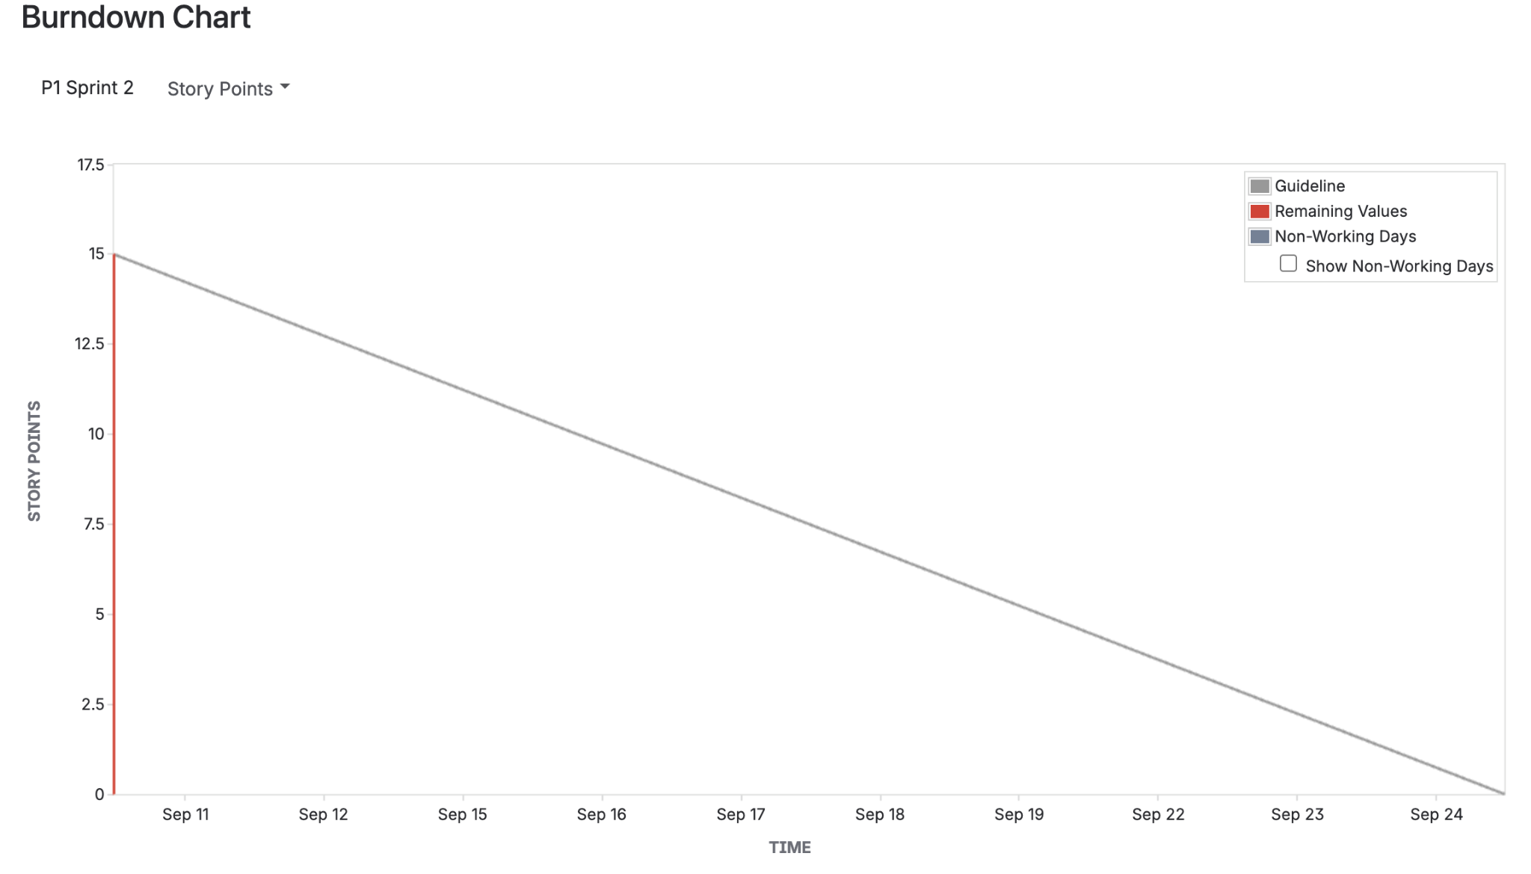

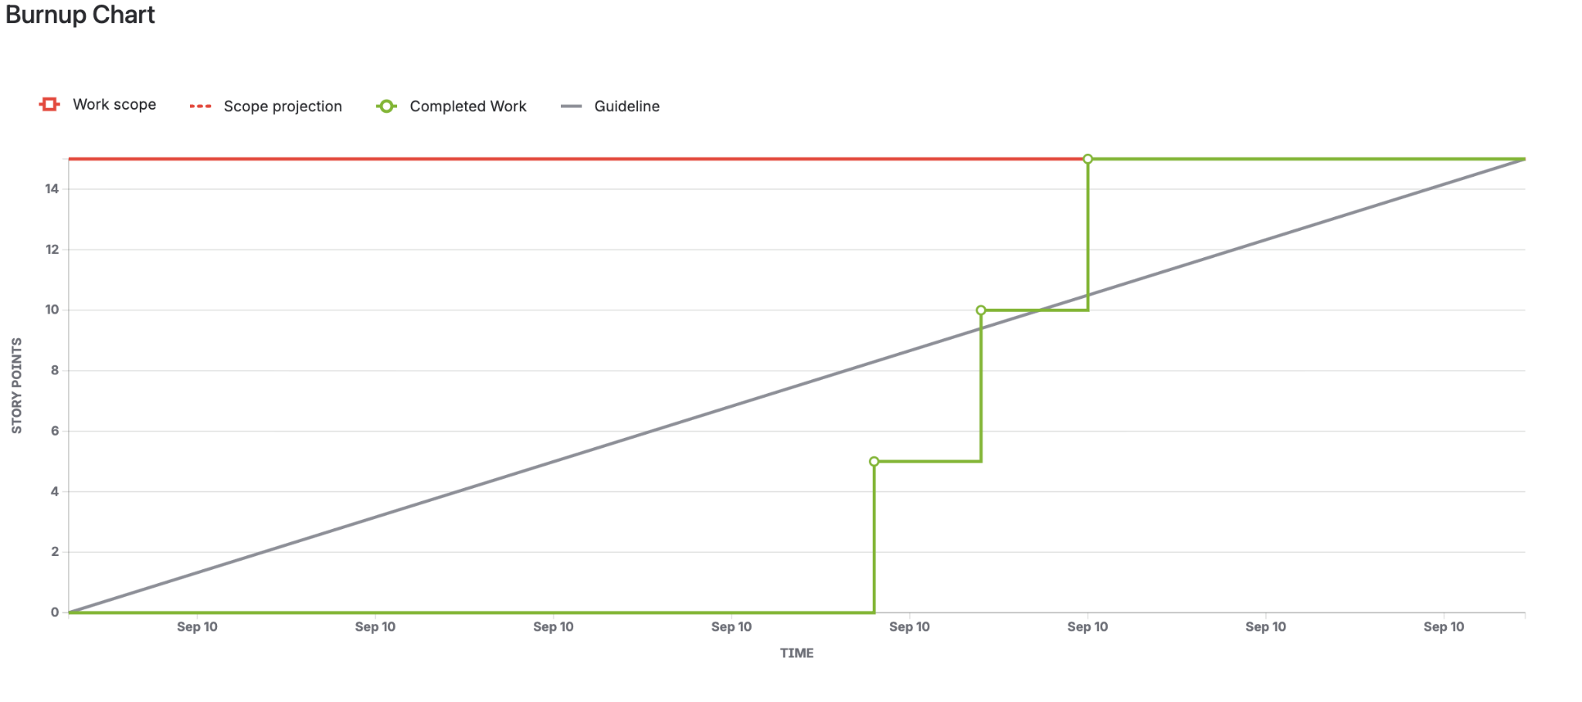

Document 6: Sprint Meetings for the Project
1: Sprint Planning Meeting
Date | 7-09-2025
Time | 10am
Location | C2 Meeting hall
Prepared by | Krishna
Attendees | Product Owner, Scrum Master, Development Team

Agenda Topics:
Topic | Presenter | Time Allotted
Review of prioritized backlog items for the sprint | Product Owner | 1hr
Breakdown of user stories into tasks | Product owner | 1hr
Define sprint goals and commitment based on team capacity | Product owner | 30min

Other Information:
Observers | Mr Shetty
Resources | Project roadmap, backlog list, sprint goals
Special Notes | Ensure team alignment on sprint goals and prioritization.

2: Sprint Review Meeting
Date | 7-09-2025
Time | 11am
Location | C2 Meeting hall
Prepared by | Krishna
Attendees | Product Owner, Scrum Master, Development Team

Sprint Status | Things to demo | Quick updates | What’s next
-Overview of sprint goal(s) and outcomes  -Summary of completed stories vs planned stories  -Review of top requirements and sprint metrics | -Live demonstration of features or product increments completed during the sprint  -Walkthroughs by team members responsible for the work  -Q&A and hands-on feedback from stakeholders | -Review of backlog items not completed and reasons why  -New insights, risks, or issues discovered during the sprint  -Adjustments or changes to backlog based on the demo and feedback | Outline next sprint plans based on feedback and upcoming goals

3. Sprint Retrospective Meeting
Date | 7-09-2025
Time | 12pm
Location | C2 Meeting hall
Prepared by | Krishna
Attendees | Product Owner, Scrum Master, Development Team

Agenda | What went well | what didn’t go well | Questions | Reference
Review and clarify backlog items | Successes of the sprint | Discuss issues | How can we improve next sprint? | Agile Extension to the BABOK® Guide
Ensure acceptance criteria are defined | Improvements of the sprint | Testing on all required devices and browsers was not completed | Any tools or techniques to boost productivity? | Scrum Guide, Product Backlog and Backlog Refinement.

4: Daily Stand-up meeting

Question | Name/role | Week “8” (from 3-09-2025 to 9-09-2025)
Question | Name/role | Monday | Tuesday | Wednesday | Thursday | Friday | Saturday | Sunday
What did you do yesterday? | Dev 1 | Completed API integration module | Began unit testing API endpoints | Fixed unit test failures | Refined API error handling | Began integration testing | Week off | Week off
What did you do yesterday? | Dev2 | Updated UI for inventory dashboard | Started real-time sync feature | Continued sync implementation | Integrated sync with backend | Debugged sync issues | Week off | Week off
What did you do yesterday? | Dev3 | Fixed bugs in access control | Prepared test cases for access | Tested access control module | Code review for access control | Supported integration tests | Week off | Week off
What will you do today? | Dev1 | Write unit tests for transactions | Execute unit test suite | Fix test issues | Validate API responses | Participate in sprint review | Week off | Week off
What will you do today? | Dev2 | UI enhancements | Sync feature coding continuation | Deploy sync to test environment | Performance testing of sync | Assist with sprint review setup | Week off | Week off
What will you do today? | Dev3 | Prepare access control demo | Draft test report | Review security requirements | Code improvements | Prepare demo scripts | Week off | Week off
What (if any) is blocking your progress? | Dev1 | Waiting for test environment setup | None | Test data issues | None | None | Week off | Week off
What (if any) is blocking your progress? | Dev 2 | None | Minor API delays | API sync bugs | Awaiting backend support | Sync bug fixes ongoing | Week off | Week off
What (if any) is blocking your progress? | Dev 3 | Need clarification on role permissions | None | None | Pending security specs | None | Week off | Week off

