Case Study 1 (Q1-Q6 ◊ 24 Marks) A customer can make a payment either by Card or by Wallet or by Cash or by Net banking.
Question 1: Draw a Use Case Diagram - 4 Marks
Answer: Use Case Diagram shows the interaction between actors (users/external systems) and the system functions.
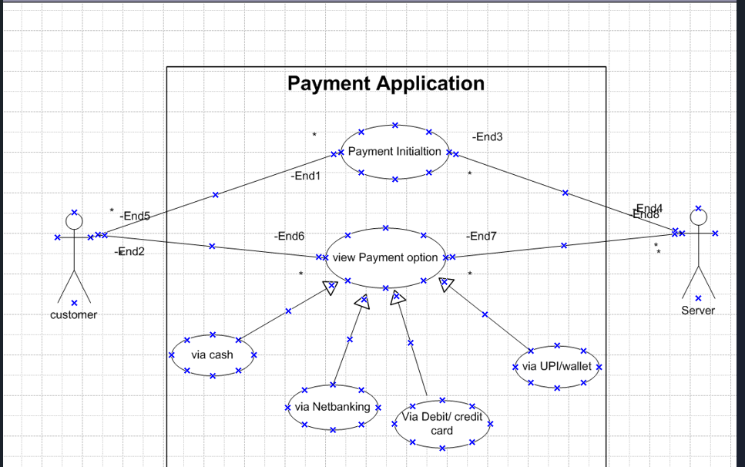
Question 2. Derive Boundary Classes, Controller classes, Entity Classes. - 4 Marks
Answer: 1. Boundary Classes (interface between actors & system)
Boundary classes are used to handle interactions between the system and the external actors (Customer).
- Customer Screen (for login/entering details)
- Payment Initiation Screen
- Payment Options Screen (Cash, Card, Wallet, Net Banking)
- Server Interface
Controller Classes (managing logic): Controller classes act as intermediaries between boundary and entity classes, coordinating logic.

Controller Classes (managing logic):
- Payment Controller (overall payment flow)
- Option Controller (selects payment method)
- Cash Controller
- Card Controller
- Wallet Controller
- Net Banking Controller
Entity Classes (data storage/business objects): Entity classes represent the core business objects and data.
- Customer
- Payment
- Transaction
- Card Details
- Wallet Details
- Bank Account
Question 3. Place these classes on a three tier Architecture. - 4 Marks
Answer: 1. Presentation Layer (Boundary Classes):
- Customer Screen
- Payment Initiation Screen
- Payment Options Screen
- Server Interface
2. Business Logic Layer (Controller Classes):
- Payment Controller
- Option Controller
- Cash Controller
- Card Controller
- Wallet Controller
- Net Banking Controller
3. Data Layer (Entity Classes):
- Customer
- Payment
- Transaction
- Card Details
- Wallet Details
- Bank Account
Question 4. Explain Domain Model for Customer making payment through Net Banking - 4 Marks
Answer: A Domain Model shows the key concepts (entities) and their relationships for the scenario.
When a customer makes a payment through Net Banking, the following concepts are involved:
- Customer
  - Initiates the payment process.
  - Provides login/authentication details for net banking.
Payment
  - Represents the actual transaction request.
  - Has attributes like paymentID, amount, status.
Bank Account
  - Linked to the customer.
  - Used for verifying funds and processing payment.
Net Banking Gateway
  - Authenticates credentials.
  - Routes the payment request to the respective bank.
- Transaction
  - Stores details of the payment (transactionID, timestamp, mode = net banking).
  - Updates status as success or failure.

Domain Model Explanation
- A Customer → initiates a Payment.
- The Payment → is processed via Net Banking Gateway.
- The Customer → is linked to a Bank Account used for payment.
- A Transaction → is generated and linked to the Payment.
Q5. Draw a sequence diagram for payment done by Customer Net Banking - 4 Marks
Answer: A sequence diagram is a type of interaction diagram used in software engineering and system design to illustrate how processes operate with one another and in what order.
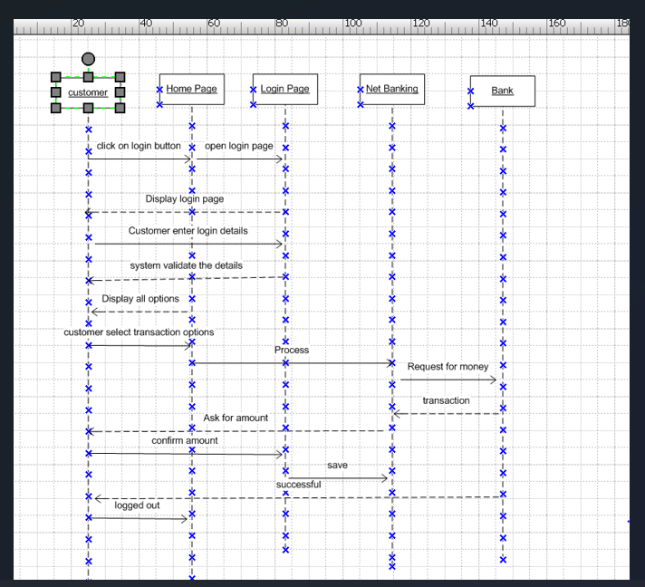
Q6. Explain Conceptual Model for this Case - 4 Marks
Answer: A Conceptual Model shows the high-level understanding of the system — focusing on business concepts, entities, and their relationships — without going into implementation or database details.
For the Customer Payment Case (via Net Banking):
Key Concepts / Entities:
- Customer – the actor who initiates the payment.
- Payment – the central entity representing any payment transaction.
- Payment Methods – Card, Wallet, Cash, Net Banking.
- Bank Account – linked to the customer and used for Net Banking.
- Net Banking Gateway – validates credentials and processes requests.
- Transaction – the record of the debit/credit action.
Relationships:
- Customer initiates → Payment.
- Payment is processed through → Payment Method (e.g., Net Banking).
- Customer owns → Bank Account.
- Net Banking Gateway authenticates → Bank Account.
- Payment generates → Transaction.
- Transaction updates → Bank Account balance.

In simple words:
The conceptual model describes that a Customer makes a Payment using different payment methods. If Net Banking is chosen, the system interacts with the Bank Account via the Net Banking Gateway, validates the details, processes the transaction, and updates the Transaction record.

Question 7. What is MVC architecture? Explain MVC rules to derive classes from use case diagram and guidelines to place classes in 3-tier architecture – 8 Marks
Answer: MVC stands for Model–View–Controller, an architectural design pattern used in software development for separating concerns.
MVC Architecture
To identify Classes from use case Diagram, We apply MVC rules on each use case to derive Classes.
- Model: The model class knows about all the data that need to be displayed. It is model who is aware about all the operations that can be applied to transform that class. It only represents the data of an application. The model represents enterprise data and the business rules that govern access to and updates of this data. This represents Database (Tables in DB). All Model Classes are represented as Entity Classes.
- Entity Class, Database classes, Persistent class (Back end designers).
- View: The view represents the presentation of the application. The view class refers to the model. It uses the query methods of the model to obtain the contents and renders it. The view is not dependent on the application logic. It remains same if there is any modification in the business logic. View Class is the data required by the query. View Class is represented as Boundary Class or Form Class.
- Boundary Class (or) FORM Class.
Actor speaks to system and vice-versa through boundary.
Authenticating information between boundary and Entity class.
- Controller: Whenever the user sends a request for something then it always go through the controller. The controller is responsible for intercepting the requests from view and passes it to the model for the appropriate action. After the action has been taken on the data, the controller is responsible for directing the appropriate view to the user. In GUIs, the views and the controllers often work very closely together.
- Controller Class or Transient Class (Given to Front end designers).
Controller class is working based on the user’s command. Understands the command / request given by user through boundary / Form Class.

MVC Architecture Rules
- Combination of One Actor and an use case results in one Boundary class.
- Combination of Two Actors and an use case results in two Boundary classes
- Combination of Three Actors and an use case results in Three Boundary classes and so on…
  - Note: only one primary actor is to be considered with a use case.
- Use case will result in a controller class.
- Each Actor will result in one entity class.
Guidelines for placing classes in 3-tier architecture:
- Presentation Layer (UI): Boundary classes (screens, forms, interfaces).
- Business Logic Layer: Controller classes (processing, validation, workflows).
- Data Layer: Entity classes (domain objects, database tables).

Q8. Explain BA contributions in project (Waterfall Model – all Stages) – 8 Marks
Answer: In Waterfall Model, a Business Analyst (BA) plays a crucial role in each stage:
- Requirement Gathering & Analysis:
  - Interact with stakeholders to capture business requirements.
  - Prepare BRD (Business Requirement Document), SRS (System Requirement Specification).
  - Conduct requirement validation sessions.
- System Design:
  - Help in creating functional specifications.
  - Support architects by providing process flows, data models, use cases.
  - Ensure design aligns with requirements.
- Implementation (Coding):
  - Clarify requirements to development team.
  - Support developers by giving requirement walk-throughs.
  - Handle change requests.
- Testing:
  - Prepare UAT test cases and scenarios.
  - Support QA team with requirement traceability matrix.
  - Participate in defect triage.
- Deployment:
  - Assist in UAT execution with business users.
  - Ensure solution readiness.
  - Provide sign-off.
- Maintenance:
  - Handle enhancement/change requests.
  - Conduct impact analysis.
  - Ensure requirements are updated in repository.
Q9. What is conflict management? Explain using Thomas – Kilmann technique – 6 Marks
Answer: Conflict Management is the process of identifying, addressing, and resolving conflicts effectively to ensure team collaboration and project success.
Thomas–Kilmann Conflict Management Technique identifies 5 conflict-handling modes:
- Competing (Win–Lose): Assertive and uncooperative. Focus on winning.
- Collaborating (Win–Win): Assertive and cooperative. Both parties work together.
- Compromising (Partial Win–Partial Win): Middle ground. Each side gives up something.
- Avoiding (Lose–Lose): Unassertive and uncooperative. Ignoring conflict.
- Accommodating (Lose–Win): Unassertive but cooperative. Prioritize others’ needs.
BA applies this by choosing the right style based on project situation (e.g., collaboration for requirement conflicts, compromising for timeline issues).
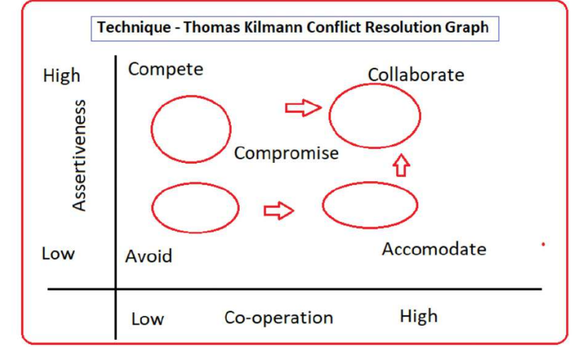
Q10. List down the reasons for project failure – 6 Marks
Answer: Projects often fail due to a combination of technical, managerial, and organizational issues. Some key reasons are:
- Poor or unclear requirements: If requirements are incomplete, ambiguous, or not properly documented, the solution built may not meet business needs.
- Lack of stakeholder involvement: When stakeholders are not actively engaged, important inputs are missed, leading to dissatisfaction at the end.
- Scope creep (uncontrolled changes): Adding new requirements without proper impact analysis or approval causes delays, cost overruns, and confusion.
- Poor project planning/estimations: Inaccurate time and effort estimates can lead to unrealistic schedules, missed deadlines, and budget issues.
- Ineffective communication: Misunderstandings between teams, stakeholders, or management lead to gaps in expectations and deliverables.
- Lack of skilled resources: Without the right technical or domain expertise, project quality and timelines suffer.
- Inadequate testing: Insufficient testing may result in defects reaching production, causing failures and loss of trust.
- Unrealistic timelines and budgets: Overly aggressive deadlines or underfunding can compromise quality and project success.
- Weak risk management: If risks are not identified, analyzed, and mitigated early, unexpected problems can derail the project.
- Poor leadership and governance: Lack of proper direction, decision-making, and monitoring can cause the project to lose focus and control.
Question 11. List the Challenges faced in projects for BA – 6 Marks
Answer: • Managing conflicting stakeholder expectations.
- Handling frequent requirement changes.
- Difficulty in prioritizing requirements.
- Bridging the gap between business and technical teams.
- Limited domain knowledge.
- Communication barriers (language, culture, time zones).
- Lack of stakeholder availability.
- Maintaining requirement traceability.
- Tight deadlines.
- Dealing with incomplete/unclear requirements.
Question 12. Write about Document Naming Standards – 4 Marks
Answer: Document naming standards ensure consistency, clarity, and version control.
Guidelines:
- Use clear descriptive names (e.g., "Payment_Requirement_Specification").
- Follow a consistent format: <ProjectName>_<DocType>_<Version>_<Date>.
- Include version numbers (V1.0, V1.1).
- Use date format (dd-mm-yyyy) for clarity.
- Avoid spaces, special characters. Use underscores or camelCase.
Example: AgriStore_BRD_V1.0_22-08-2025.docx

Question 13. What are the Do’s and Don’ts of a Business analyst – 6 Marks
Answer: Do’s (What a BA should do):
- Solve problems with IT solutions: Focus on providing practical IT solutions instead of probing too much into reasons for business failures.
- Be calm and neutral (like a lotus in the mud): Remain unaffected by unnecessary disputes and opinions; focus on clarity and correctness of requirements.
- Pass on tensions, not take them: Listen patiently to client concerns but don’t internalize the stress.
- Gather requirements in detail: Spend enough time to identify stakeholders, validate business goals, and document requirements thoroughly.
- Involve end users: Observe how they work, validate requirements with them, and ensure solutions are practical.
- Appreciate stakeholders: Build trust by recognizing even small contributions of stakeholders.
- Communicate clearly: Always consult SMEs for requirement clarifications and validate assumptions.
- Treat each client as unique: Understand that no two clients’ problems are the same.
- Extract solutions from client discussions: Ask the right questions and guide the client toward the solution.

Don’ts (What a BA should avoid):
- Never say “No” to client: Instead, suggest alternatives or explain feasibility.
- Never assume anything “by default”: Validate every detail instead of taking things for granted.
- Never imagine requirements in terms of GUI only: Focus on actual business needs, not just screen design.
- Never interrupt client while sharing problems: Listen carefully and completely before responding.
- Never bring personal stress into project: Don’t let client comments or deadlines affect your work approach.
- Never rush requirement gathering: Avoid hurrying due to deadlines, otherwise key needs may be missed.
- Never criticize stakeholders: Avoid negative remarks; maintain professionalism always.
- Never rely only on past experience: Each project is unique; don’t apply assumptions blindly.
- Don’t get carried away by add-ons: Stick to true and required functionalities, avoid unnecessary features.
Question 14. Write the difference between packages and sub-systems – 4 Marks
- Answer: Package: A grouping mechanism in UML for organizing related elements (classes, use cases). It’s mainly logical grouping.
- Subsystem: A part of the overall system that delivers a specific functionality. It can function independently.
Example:
- Package = "Payment Module Classes"
- Subsystem = "Payment Gateway System"
Question 15. What is camel-casing and explain where it will be used- 6 Marks
Answer: entire first word will be in lowercase and subsequent words first letter should be in Upper Case. There will be no gap in between words. Example: getEmpId(); turnLeftAndSlowDown();
Types:
- lowerCamelCase: first letter lowercase (e.g., customerName).
- UpperCamelCase (Pascal Case): first letter uppercase (e.g., CustomerName).
Usage:
- In programming (variables, methods, classes).
- Document/file naming.
- Database field names.
Question 16. Illustrate Development server and what are the accesses does business analyst have? -6
- Answer: Development Server: A dedicated environment used by developers to build and test applications before moving to QA/UAT/Production.
BA Access on Development Server:
- Read-only access to application (not code).
- Can execute application scenarios for validation.
- Can review logs and error messages.
- Cannot modify code or deploy builds.
- Can provide inputs for test data.

Question 17. What is Data Mapping 6 Marks
Answer: Data Mapping is the process of linking fields from one data source to another. It ensures accurate data transfer between systems.
Purpose:
- Data migration.
- System integration.
- Reporting & analytics.
Example:
Source: Customer_FName → Target: FirstName
Source: Customer_LName → Target: LastName

Question 18. What is API. Explain how you would use API integration in the case of your application Date format is dd-mm-yyyy and it is accepting some data from Other Application from US whose Date Format is mm-dd-yyyy 10 Mark
Answer: API (Application Programming Interface) is a set of rules and protocols that allows two applications to communicate and exchange data.
API Integration Example (Date Format Issue):
- Our application accepts dd-mm-yyyy format.
- US system sends data in mm-dd-yyyy format via API.
- During API integration, a data transformation logic will be applied in middleware/service layer:
  - Convert incoming date 08-22-2025 (mm-dd-yyyy) → 22-08-2025 (dd-mm-yyyy).
- BA ensures mapping is captured in Interface Control Document (ICD).
- Validation rules will be applied before storing into database.
Steps BA contributes:
- Identify integration points.
- Define data mapping rules.
- Document transformation rules.
- Work with dev team to implement API.
- Test API with different date inputs

