AGILE DOCUMENTS

Document 1: Definition of Done
As per Agile Extension to the BABOK® Guide V2, Definition of done is a technique where the team agrees on and promptly displays , a list of criteria which must be met before a backlog item considered Done.
That is the team has to create a well-defined, ambiguous, measurable, agreed-upon and shared definition of Done between all the team members.
The best form of Definition of Done representation is a checklist of activities that has to be demonstrate the agreed value and quality of a user story. So, this checklist should include:

- Acceptance criteria (to satisfy customer requirement for a product)
- Quality criteria( to satisfy quality requirements for product)
Definition of Done may be defined for different levels of project work. For example, In Agile/Scrum framework these level of work could be User story, sprint and release.
Checklist for DOD:
- Produce code for presumed functionalities
- Assumptions of User story met
- Projects build without errors
- Unit test written and passing
- Project Deployed on test environment identical to production platform
- Tests on devices/browser listed in the product assumption passed
- Feature ok-ed by UX designers
- QA performed and issue resolved
- Feature is tested against acceptance criteria
- Feature ok-ed by product Owner
- Refactoring completed
- Any configuration or build changes documented
- Documentation updated
- Peer code Reviewed performed

Document 2: Product Vision

Scrum Project Name | Developing Online Coaching Application
Venue | Jaipur
Date | Start time: 20/8/2025 | End time:7/2/2025 | Duration:36 weeks
Client | Focus Educations
Stakeholders list: | Product owner  Scrum Master  Developers  Testers
Scrum Team
Scrum Master: | monika
Product Owner: | Devina
Scrum Developer1: | niharika
Scrum Developer2: | Atul
Scrum Developer3: | Prerna
Scrum Developer4: | Suman
Scrum Developer5: | Promilla

Vision: To empower student through personalised, accessible and transformative coaching experience-anytime, anywhere with the help of expert guidance.

Target Groups  Which market segment does the product address? Education technology and professional development.  Who are the target users and customers?  The main users of the Application will be the students who want to learn from different areas with convenience and teachers who want to create a dynamic learning environment. | Needs  What problem does the product solve?  Limited accessibility  Lack of skilled teachers  Limited learning resources  Irregular payments  Which benefit does it provide?  Wider audience  Better profit margins  Flexibility and accessibility for both teacher and students  Cost and time saving  Scalability  Diverse learning resources | Product  What product is it?  Online coaching app which can run on mobile, desktop, tablet and connect students from different geographical areas to skilled teachers. which includes:  Online classes  Online assessment  Downloading different learning material  One to one student teacher interaction  Is it feasible to develop the product?  Product feasibility can be complex due to competition from market and require attention in every aspect. | Value  How is the product going to benefit the company?  Open up revenue stream  What are the business goals?  To be the leading and trusted online coaching app in the country.  What is the business model?  Create reputed brand image for other business opportunities

Document 3: User stories
User Story No: 1 | Task:4 | Priority: highest
Value statement:
As a student
I want to Login to the system
So that I can access my personalizes dashboard, courses , assignments and grades
BV: 500 | CP: 5
Acceptance criteria:
System to show login page
Text box must allow to enter credentials
Submit button to click

User Story No: 2 | Task: 3 | Priority: highest
Value statement:
As a Teacher
I want to Login to the system
So that I can access my personalizes dashboard, manage classes and view student progress
BV: 500 | CP: 5
Acceptance criteria:
System to show login page
Text box must allow to enter credentials
Submit button to click

User Story No: 3 | Task: 3 | Priority: highest
Value statement:
As an Admin
I want to Login to the system
So that I can access my personalizes dashboard
BV: 500 | CP: 5
Acceptance criteria:
System to show login page
Text box must allow to enter credentials
Submit button to click

User Story No:4 | Task: 2 | Priority: highest
Value statement:
As a student
I want to view list of available courses
So that I can choose the one that match my interest and academic goal
BV:500 | CP:3
Acceptance criteria:
Student must be able to access the course list from the main dashboard
The system must display the list of all currently available courses

User Story No: 5 | Task:3 | Priority: medium
Value statement:
As a student
I want to search and filter courses by subject
So that I can quickly find most suitable option
BV:200 | CP:5
Acceptance criteria:
Search and filter option are fully functional
UI elements adjust to screen size without breaking layout

User Story No: 6 | Task:2 | Priority: highest
Value statement:
As a student
I want to enrol in course
So that I can begin learning and access all related materials and assessments
BV:500 | CP:3
Acceptance criteria:
System verifies prerequisite before enrolment
Enrol button is visible
Enrolment is confirmed only after successful payment

User Story No:7 | Task: 1 | Priority: highest
Value statement:
As a student
I want to make a payment for my course
So that I can complete my enrolment and start learning
BV:500 | CP:2
Acceptance criteria:
Student can access the payment page from course registration
The course fees is clearly displayed before payment

User Story No: 8 | Task: 2 | Priority: highest
Value statement:
As a student
I want to download study material for my enrolled courses
So that I can study offline whenever needed
BV:200 | CP:5
Acceptance criteria:
Study materials are available only for enrolled courses
Download button is visible and functional
Files downloaded successfully in supported format

User Story No: 9 | Task: 2 | Priority: highest
Value statement:
As a student
I want to download materials in different format (PDF, PPT, DOC)
So that I can use them on my device
BV:500 | CP:5
Acceptance criteria:
Materials are available in multiple formats
Format options are clearly labelled
Selected format downloads correctly

User Story No: 10 | Task: 1 | Priority: medium
Value statement:
As a student
I want to access previously downloaded materials from my dashboard
So that I don’t have to search again
BV:200 | CP:5
Acceptance criteria:
Downloaded materials should be saved in students history
View downloads option should be available

User Story No: 11 | Task: 3 | Priority: highest
Value statement:
As a student I want to take scheduled test for my courses
So that I can evaluate my understanding and progress
BV:500 | CP:3
Acceptance criteria:
Tests are visible only for enrolled courses
Test start and end time clearly displayed

User Story No: 12 | Task: 3 | Priority: medium
Value statement:
As a student
I want to receive scores and feedback after submitting a test
So that I know how I performed
BV:200 | CP:3
Acceptance criteria:
Sore is displayed immediately after submission
Feedback include explanation

User Story No: 13 | Task: 2 | Priority: medium
Value statement:
As a student
I want to see my test history and score
So that I can track my academic progress over time
BV:500 | CP:5
Acceptance criteria:
Student can access Progress section from their profile
The section is clearly labelled and load within 3 seconds

User Story No: 14 | Task: 3 | Priority: highest
Value statement:
As a student
I want to update my personal information (name, e-mail, phone no )
So that my profile stays accurate
BV:200 | CP:3
Acceptance criteria:
Editable fields are available in profile section
Changes are save and reflected immediately
Validation prevents invalid entries

User Story No: 15 | Task: 3 | Priority: highest
Value statement:
As a student
I want to change my password
So that I can protect my account
BV:500 | CP:5
Acceptance criteria:
Password change require current password
New password must meet security criteria

User Story No: 16 | Task: 2 | Priority: highest
Value statement:
As a student
I want to upload my profile picture
So that my account feels personalised
BV:200 | CP:5
Acceptance criteria:
Upload button is available in profile setting
Only supported formats are accepted

User Story No: 17 | Task: 1 | Priority: medium
Value statement:
As a student
I want to delete my account if I choose to leave
So that my data is no longer stored
BV:500 | CP:2
Acceptance criteria:
Delete account option is available in students profile setting
The option is clearly labelled and easy to locate

User Story No: 18 | Task: 2 | Priority: highest
Value statement:
As a student
I want to attend my scheduled online class
So that I can learn from my teacher and stay on track with my coursework
BV:200 | CP:3
Acceptance criteria:
Student can view upcoming class in their dashboard
Join class button active before 5-10 minutes before scheduled start time
Clicking join class opens the virtual classroom in a new tab
‘
User Story No: 19 | Task: 1 | Priority: highest
Value statement:
As a teacher
I want to join and host my scheduled online class
So that I can deliver live lessons to my students

BV:200 | CP:5
Acceptance criteria:
Teacher sees upcoming class in their dashboard
Start class button is available 10 minutes before scheduled time
Clicking join button opens virtual classroom with video, audio and screen sharing
Student can join once teacher start the session

User Story No: 20 | Task: 2 | Priority: medium
Value statement:
As a teacher
I want to create and assign test
So that I can assess the student understanding

BV:500 | CP:3
Acceptance criteria:
Teacher can create test with multiple question type
Test setting include duration, start/end time, and grading criteria
Student can receive a notification when a test is assigned

User Story No: 21 | Task: 3 | Priority: highest
Value statement:
As a teacher
I want to upload study material to my course
so that student can access resources for learning

BV:200 | CP:5
Acceptance criteria:
Teacher can upload files in various format (PDF,DOC, VEDIO)
Materials are linked to specific lesson
Teachers can edit and delete material anytime

User Story No: 22 | Task:1 | Priority: medium
Value statement:
As a teacher
I want to grade student submission and provide feedback
So that I can they can improve their performance

BV:500 | CP:2
Acceptance criteria:
Teacher can view student submission for each test
Scores should be auto calculated
Feedback can be typed or uploaded as a file

User Story No: 23 | Task: 2 | Priority: highest
Value statement:
As a teacher
I want to update my profile
So that students and admin see accurate and professional information

BV:500 | CP:3
Acceptance criteria:
Teacher can edit personal detail (name, email, bio, qualifications)
Profile picture can be uploaded or changed
Password can be updated securely with validation

User Story No: 24 | Task:3 | Priority: highest
Value statement:
As an Admin
I want to manage student and teachers accounts
So that I can ensure proper access and maintain platform integrity

BV:200 | CP:3
Acceptance criteria:
Admin can view searchable list of all users with filters(role, status, registration date)
Admin can create, edit, deactivate, or delete user accounts
Admin receive confirmation after each action

User Story No: 25 | Task:3 | Priority: medium
Value statement:
As an Admin
I want to create, edit and approve course
So that platform offers high-quality learning content
BV:500 | CP:3
Acceptance criteria:
Admin can create new courses
Admin can reject or approve courses submitted by instructor
Admin can edit and archive existing course
Admin can set course visibility (public,private,draft)

User Story No: 26 | Task: 2 | Priority: highest
Value statement:
As an Admin
I want to monitor platform usage and performance
So that I can make informed decision and improvements

BV:200 | CP:5
Acceptance criteria:
Admin dashboard displays metrics( active users, course completion, tests scores, login frequency)
Reports are downloadable in standard formats

User Story No: 27 | Task:2 | Priority: medium
Value statement:
As an Admin
I want to oversee course payments and refunds
So that financial operations run smoothly

BV:200 | CP: 5
Acceptance criteria:
Admin can view transaction history for all users
Admin can issue refunds or adjust payment statuses
Payment data is securely stored and complies with financial regulations

Document 4: Agile PO Experience
The Product Owner has a vision of Product keeping the Domain/ industry experience and the market need.
Following are the responsibilities of PO in a project:
- Market Analysis; Analysis of the market need or demand, Availibility of similar product.
- Enterprise Analysis: due diligence on the market opportunity.
- Product vision and Roadmap: Product vision keeping the need analysis in mind, product roadmap with high level features and timeline.
- Managing Product Features: Managing stakeholder’s expectation and prioritising needs, prioritization of Epic, stories, and features based on criticality and ROI involved.
- Managing product Backlog: Periodization of user stories, Reprioritization based on stakeholders need Epic Planning.
- Managing Overall Iteration Progress: sprint progress review, reprioritization of sprints and Epics if needed, sprint retrospective with Business analysts.
From this project I have learned how to handle sprint meetings such as:
- Sprint planning meeting: This happens at the beginning of each Sprint and Team decides what they will deliver in the sprint.

- Daily scrum meeting: This happens every day for 15 minutes where team will just answer 3 Questions
- What did you do today?
- What will you do tomorrow?
- Is there any Impediments that is slowing down or stopping you?

- Sprint review meeting: This happens at the end of the Sprint, where team will demo the completed stories to product owner and get it clear

- Sprint retrospective meeting: Meeting: This also happens at the end of the Sprint where team will answer 3 questions:
- What went well in the Sprint?
- What did not go well?
- What are the required areas of improvement in next Sprint?
- Backlog refinement meeting
Also, User stories creation and what things will be included in user stories such as
- Story no
- Tasks
- Priority: List of prioritized user stories
- Acceptance criteria
- BV & CP value: Business Value BV is not a cost of Development of the Features. Business Value is how important is this feature or USER Story using technology. This is estimated by scrum currency NOTES. We Provide Rs 1000, Rs 500, Rs 200, Rs 100, Rs 50, Rs 20 & Rs 10 Denominations. These Estimations are done by the Clients (Stakeholders). If different values are created by the Stakeholders, then discussions will happen, then they agree to one BV Value to their user story.
Complexity Point is also referred as a Story Point. CP is effort required to Scrum development to develop this user story using technology. Efforts include time taken to solve the complexity and write the CODE. CP is estimated by Scrum Developers by using POKER Cards. We provide pokers with values 1, 2, 3, 5, 8, 13, 20, 40, 100 and BIG.

In Scrum, a product owner serves as the liaison between multiple areas of an organization. This person communicates with business stakeholders and collaborates closely with Scrum teams to keep all areas of the business informed on a project's development.
The product owner develops a vision of a product's function and operation, which in turn allows this Scrum team member to define product features and break those features into product backlog items.

Document 5: Product and Sprint Backlog and product and Sprint Burn down chart

Product Backlog:
A product backlog is a dynamic, prioritized list of work items that a team maintains to build and improve a product. It’s a key concept in Agile and Scrum methodologies, acting as the single source of truth for everything that might be needed in the product.
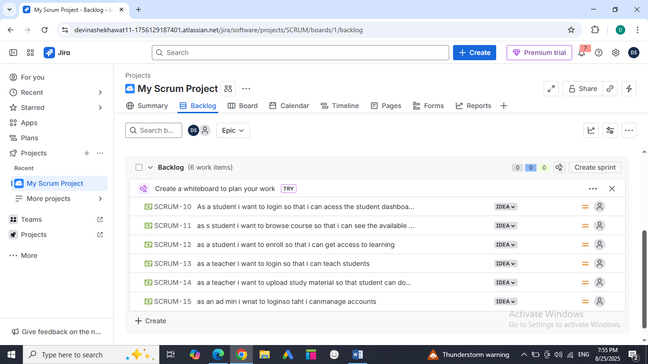

Sprint Backlog:
A sprint backlog is a subset of the product backlog that the development team commits to completing during a specific sprint—usually a 1–4 week period in Agile or Scrum frameworks.
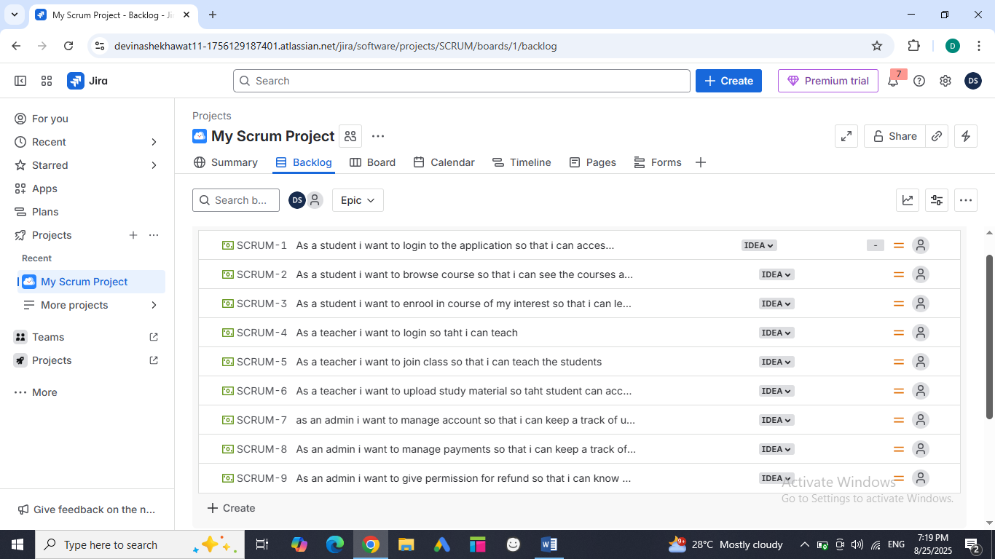

Product Burn down chart:
A product burn down chart is a visual tool used in agile project management to track the progress of work over time. It shows how much work remains in the product backlog and helps teams see whether they’re on track to complete the project by the target date.
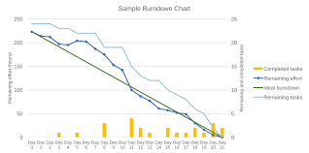

Sprint burn down chart:
It is a visual representation of remaining work in a sprint, tracked over time. The chart typically displays total work remaining on vertical axis and days on the horizontal axis.
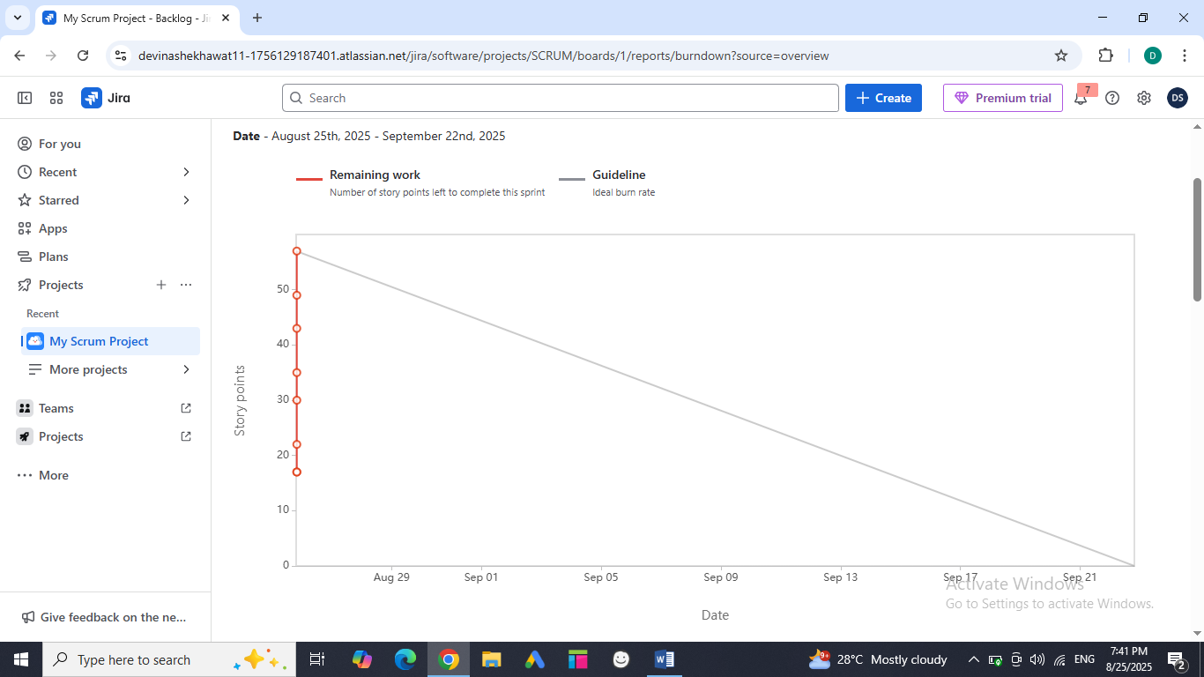
Document 6: Sprint Meetings
Meeting Type 1: Sprint Planning Meeting
Date | 15/7/2025
Time | 10:30 AM
Location | Office
Prepared by | Scrum master
attendees | Scrum team

Agenda Topics:
Topic | Presenter | Time allotted
Define the Sprints | Scrum Team | 1 day

Other information
Observer | Scrum master, project manager
Resources | Scrum team
Other Notes | Divide Product log into various Sprints

Meeting Type 2: Sprint Review Meeting
Date | 20/8/2025
Time | 10:00 AM
Location | Meeting Room
Prepared By | Scrum master
Attendees | Scrum team

Sprint status | Things to demo | Quick updates | What’s next
Completed Sprint 1 | Pic of software demo to product owner | Development team updates the Sprint Backlog status | Plan for next sprint

Meeting Type 3: Sprint Retrospective meeting
Date | 21/8/2025
Time | 10:00 AM
Location | Meeting Hall
Prepared By | Scrum master
Attendees | Scrum team

Agenda | What went well | What did not go well | Questions | Reference
Sprints 1 milestones | Team explain what went well | Whether they have faced any difficulty while in sprint development | Questions for improvement | NA

Meeting Type 4: Daily Stand Up meetings

Questions | Name/Role | Week “X” (from dd-mm-yyyy to dd-mm-yyyy)
Questions | Name/Role | Monday | Tuesday | Wednesday | Thursday | Friday | Saturday | Sunday
What did you do yesterday |  | Design the technical user story | Coding  Testing  Review | Coding  Review  testing | Coding designing testing | Unit testing  Coding  Error detection | Code Review,  UAT error | Error test,  UAT code
  Niharika
  Atul
  Prerna
What will you do today |  | Coding  Review  Plan for tomorrow | Designing  Review Testing | Verification  Design,  Testing | Error test, Coding , Review | Coding,  Designing | Review,  UAT ,  Error detection | Verification  Client meet, UAT
  Suman
  monika
  akash
What(if any) is blocking your progress |  | User stories are not clearly defined | Design,  Review,  Testing | Coding  Review  testing | Coding  Designing  Testing | Unit Testing,  Coding,  Error Detecting | Review, UAT  Error detection | Verification signoff
  Neha
  Priya
  akash

