Q1: Business requirements

Req ID | Req Name |  |  | Req Description |  | Priority
FR0001 | Farmer Registration |  |  | Farmers should be able to register with the application. |  | 8
FR0002 | Farmer Search for Products |  |  | Farmers should be able to search for available products in fertilizers, seeds, pesticides. |  | 8
FR0003 | Manufacturer Registration |  |  | Manufacturers should be able to create an account in the application. |  | 8
FR0004 | Manufacturer Product Upload |  |  | Manufacturers should be able to upload products (fertilizers, seeds, pesticides). |  | 9
FR0005 | Login/Authentication |  |  | All users should be able to log in with valid credentials. |  | 10
FR0006 | View Product Details |  |  | Farmers should be able to view detailed information about products. |  | 8
FR0007 | Add to Cart |  |  | Farmers should be able to add products to a shopping cart. |  | 9
FR0008 | Wishlist Functionality |  |  | Farmers should be able to add products to a buy-later list. |  | 7
FR0009 | Place Order |  |  | Farmers should be able to place orders after selecting products. |  | 10
FR0010 | Payment Gateway Integration |  |  | Farmers should be able to pay via UPI, Card, or COD. |  | 10
NFR0101 |  | Page Loading Time | Each page should load within 2 seconds. |  | 9

NFR0102 | WCAG 2.1 Compliance | The system must meet Web Content Accessibility Guidelines WCAG 2.1. | 8

NFR0103 | Secure Data Handling | All user data should be encrypted in transit and at rest. | 10

NFR0104 | High Availability | The application should maintain 99.9% uptime. | 9

NFR0105 | Email Delivery Speed | Confirmation emails must be delivered within 1 minute. | 8

NFR0106 | Mobile Responsiveness | The app must function fully on mobile browsers and devices. | 9

NFR0107 | Concurrent Users | The system must support 500 concurrent users without performance degradation. | 8

NFR0108 | Session Timeout | User sessions should expire after 15 minutes of inactivity. | 7

NFR0109 | Multi-language Support | The system must support at least 2 languages (e.g., English and Hindi). | 7

NFR0110 | Audit Logging | All admin activities should be logged for audit purposes. | 9

Q2.Minimum 5 page designs - 15 Marks Make wireframe and prototypes

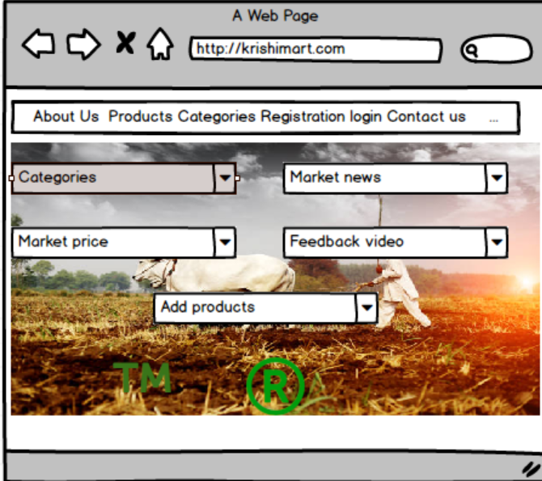
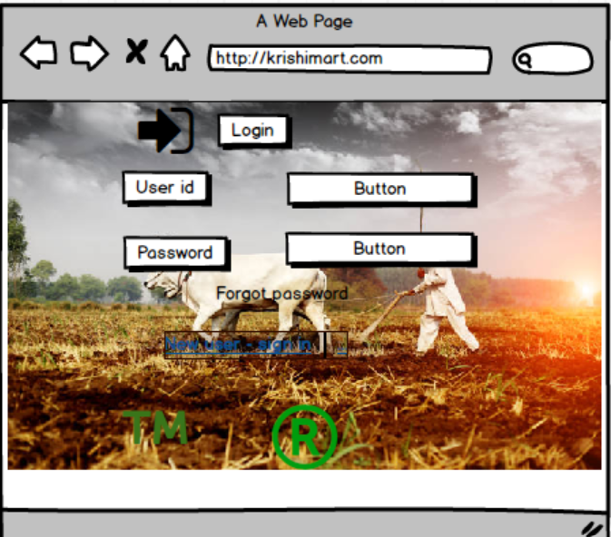

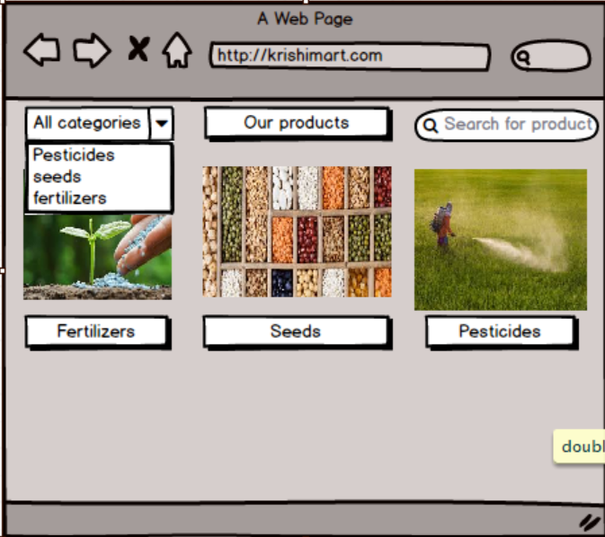

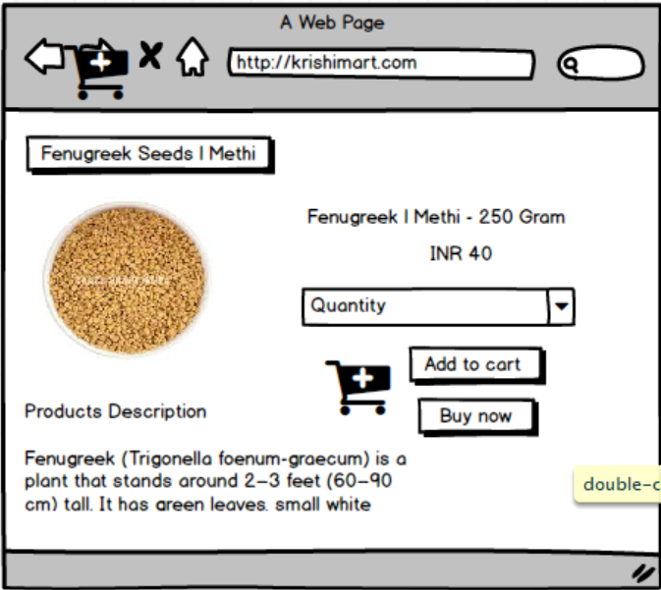

Question 3 – Tools (Visio, Balsamiq) –
Make a note of the Tools, which you are using for above concepts.
To design the wireframes and develop prototypes for the Online Agricultural Product Store, the following tools are commonly recommended and/or used:

1. Microsoft Visio
- Purpose: Used for creating Use Case Diagrams, Activity Diagrams, and System Architecture Diagrams.
- Why Used:
  - Supports UML diagram standards.
  - Easy drag-and-drop interface for modelling business processes.
  - Suitable for documentation and presentation to stakeholders.

2. Balsamiq Mock-ups
- Purpose: Used for designing low-fidelity wireframes for application screens.
- Why Used:
  - Mimics hand-drawn wireframes for clarity and focus on structure over design.
  - Helps clients and development teams understand the layout and flow.
  - Quick to iterate and modify as per feedback.

Question 4 – RTM
Mr. Henry and peter have approached you regarding the current status of the project. How will you tackle this situation?
1. Acknowledge and Welcome Their Query
Start by appreciating their interest and assuring them of transparency:
"Thank you, Mr. Henry and Peter, for reaching out. I appreciate your involvement in checking on the project’s progress."

2. Present the Current Status Using the RTM
Share the Requirements Traceability Matrix (RTM) or project tracking sheet that shows:
- All captured functional and non-functional requirements
- Requirement IDs and descriptions
- Status (Not Started / In Progress / Completed / Tested)
- Test case mapping (to show coverage)
- Any pending or at-risk items clearly marked
"We are using an RTM to track all requirements throughout the development life cycle. Each requirement is mapped to its related design, development, and test cases to ensure full coverage."

3. Give a Summary of Progress
Brief them with a quick summary:
"As of today, out of 50 total requirements:
- 42 have been fully implemented and tested,
- 5 are under development, and
- 3 are pending due to changes from the last review meeting.
All updates are documented and traceable."

4. Show How Changes Are Handled
Explain your change management approach:
"Any changes to requirements are logged through a formal change request process. We update the RTM accordingly and ensure re-testing is planned if necessary."

5. Invite for Review or Walkthrough
Offer to walk them through the RTM or progress dashboard:
"If you'd like, I can walk you through the RTM and status dashboard so you can see the exact tracking of each requirement."

6. Ask for Feedback or Concerns
Keep it open and collaborative:
"Please let me know if you have any specific concerns or need a deeper look at any area. I'm here to make sure the requirements are fully aligned and nothing is missed."

Req ID | Req Name | Req Description | Design (D1) | Test Case (T1) | Test Case (T2) | Test Case (T3) | Test Case (T4) | UAT
FR0001 | Farmer Registration | Farmers should be able to register with the application | ✔️ | ✔️ |  |  |  | ✔️
FR0002 | Farmer Search for Products | Farmers should be able to search for available products in fertilizers, seeds, etc. | ✔️ | ✔️ | ✔️ |  |  | ✔️
NFR0101 | Page Loading Time | Each page should load within 2 seconds | ✔️ |  | ✔️ | ✔️ |  | ✔️
NFR0102 | WCAG 2.1 Compliance | The system must meet Web Content Accessibility Guidelines (WCAG 2.1) | ✔️ |  |  | ✔️ | ✔️ | ✔️
Question 5 – 10 Test Case Documents

Test Case ID | Test Scenario | Test Steps | Expected Result | Actual Result | Status
Test Case 1
TC_ID | TC001
Scenario | Farmer Registration
Steps | 1. Go to Registration Page  2. Enter valid email, password, confirm password  3. Click Register
Expected | User account should be created and confirmation message displayed
Actual | Pending
Status | Not Executed
Test Case 2
| TC_ID | TC002 |
| Scenario | Login with valid credentials |
| Steps | 1. Go to Login Page <br> 2. Enter registered email and password <br> 3. Click Login |
| Expected | User should be successfully logged in |
| Actual | Pending |
| Status | Not Executed |

Test Case 3
| TC_ID | TC003 |
| Scenario | Login with invalid credentials |
| Steps | 1. Enter incorrect email/password <br> 2. Click Login |
| Expected | System should show error: “Invalid credentials” |
| Actual | Pending |
| Status | Not Executed |

Test Case 4
| TC_ID | TC004 |
| Scenario | Search for product using search bar |
| Steps | 1. Enter “Fertilizer” in search bar <br> 2. Click search |
| Expected | Related fertilizer products should be displayed |
| Actual | Pending |
| Status | Not Executed |

Test Case 5
| TC_ID | TC005 |
| Scenario | Add product to cart |
| Steps | 1. Browse a product <br> 2. Click “Add to Cart” |
| Expected | Product should be added to shopping cart |
| Actual | Pending |
| Status | Not Executed |

Test Case 6
| TC_ID | TC006 |
| Scenario | Proceed to Checkout |
| Steps | 1. Go to cart <br> 2. Click “Checkout” |
| Expected | Checkout page should load with delivery and payment options |
| Actual | Pending |
| Status | Not Executed |

Test Case 7
| TC_ID | TC007 |
| Scenario | Place Order with UPI |
| Steps | 1. Select UPI option <br> 2. Enter valid UPI ID <br> 3. Click Place Order |
| Expected | Order should be placed, and confirmation displayed |
| Actual | Pending |
| Status | Not Executed |

Test Case 8
| TC_ID | TC008 |
| Scenario | Page loading performance |
| Steps | 1. Open any product page |
| Expected | Page should load in less than 2 seconds |
| Actual | Pending |
| Status | Not Executed |

Test Case 9
| TC_ID | TC009 |
| Scenario | Accessibility Compliance Check |
| Steps | 1. Use screen reader and keyboard navigation <br> 2. Check color contrast |
| Expected | Should pass WCAG 2.1 standards |
| Actual | Pending |
| Status | Not Executed |

Test Case 10
| TC_ID | TC010 |
| Scenario | Email confirmation after placing order |
| Steps | 1. Place order <br> 2. Check email |
| Expected | Email should be sent with order details |
| Actual | Pending |
| Status | Not Executed |

Question 6 – DB Design –After the requirements are thoroughly explained to the entire project team by business analyst, the Database architects have decided to do the database design and also to represent the in-flow and out-flow of data.
Database Schema (Tabular Design)
🔷 User
Column Name | Data Type | Constraints
user_id | INT | PRIMARY KEY
name | VARCHAR(100) | NOT NULL
email | VARCHAR(100) | UNIQUE, NOT NULL
password | VARCHAR(100) | NOT NULL
user_type | VARCHAR(50) | CHECK ('Farmer', 'Manufacturer')

🔷 Product
Column Name | Data Type | Constraints
product_id | INT | PRIMARY KEY
name | VARCHAR(100) | NOT NULL
category | VARCHAR(50) | CHECK ('Fertilizer', 'Seed', 'Pesticide')
price | DECIMAL(10,2) | NOT NULL
manufacturer_id | INT | FOREIGN KEY → User(user_id)
stock_quantity | INT | NOT NULL

🔷 Cart
Column Name | Data Type | Constraints
cart_id | INT | PRIMARY KEY
user_id | INT | FOREIGN KEY → User(user_id)
created_at | DATETIME | DEFAULT CURRENT_TIMESTAMP

🔷 CartItem
Column Name | Data Type | Constraints
cart_item_id | INT | PRIMARY KEY
cart_id | INT | FOREIGN KEY → Cart(cart_id)
product_id | INT | FOREIGN KEY → Product(product_id)
quantity | INT | NOT NULL

🔷 Order
Column Name | Data Type | Constraints
order_id | INT | PRIMARY KEY
user_id | INT | FOREIGN KEY → User(user_id)
total_amount | DECIMAL(10,2) | NOT NULL
order_date | DATETIME | DEFAULT CURRENT_TIMESTAMP
status | VARCHAR(50) | DEFAULT 'Pending'

🔷 OrderItem
Column Name | Data Type | Constraints
order_item_id | INT | PRIMARY KEY
order_id | INT | FOREIGN KEY → Order(order_id)
product_id | INT | FOREIGN KEY → Product(product_id)
quantity | INT | NOT NULL
price | DECIMAL(10,2) | NOT NULL

🔷 Payment
Column Name | Data Type | Constraints
payment_id | INT | PRIMARY KEY
order_id | INT | FOREIGN KEY → Order(order_id)
payment_type | VARCHAR(50) | CHECK ('UPI', 'Card', 'COD')
payment_status | VARCHAR(50) | DEFAULT 'Pending'

🔷 Delivery
Column Name | Data Type | Constraints
delivery_id | INT | PRIMARY KEY
order_id | INT | FOREIGN KEY → Order(order_id)
delivery_status | VARCHAR(50) | DEFAULT 'Preparing'
tracking_number | VARCHAR(100) | NULLABLE
estimated_delivery | DATE | NULLABLE
ERD
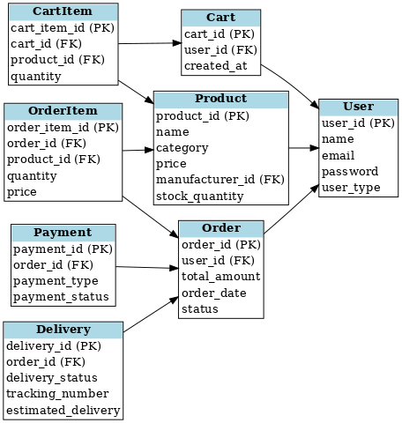

Question 7 – Data Flow Diagram - 3 Marks What is a data flow diagram? Draw a data flow diagram to represent the in-flow and out-flow of data when a Farmer is placing an order for the product

A Data Flow Diagram (DFD) is a graphical representation that shows how data moves through a system. It illustrates the inputs, processes, data stores, and outputs involved in a system without going into technical details (like code or hardware).

Key Components of a DFD:
- External Entities:
  - Represent outside systems or users that interact with the system (e.g., Farmers, Payment Gateway).
  - Symbol: Rectangle
- Processes:
  - Represent the operations or functions where data is processed.
  - Symbol: Circle or Rounded Rectangle
- Data Stores:
  - Represent where data is stored within the system.
  - Symbol: Open-ended Rectangle
- Data Flows:
  - Represent the movement of data between entities, processes, and data stores.
  - Symbol: Arrow

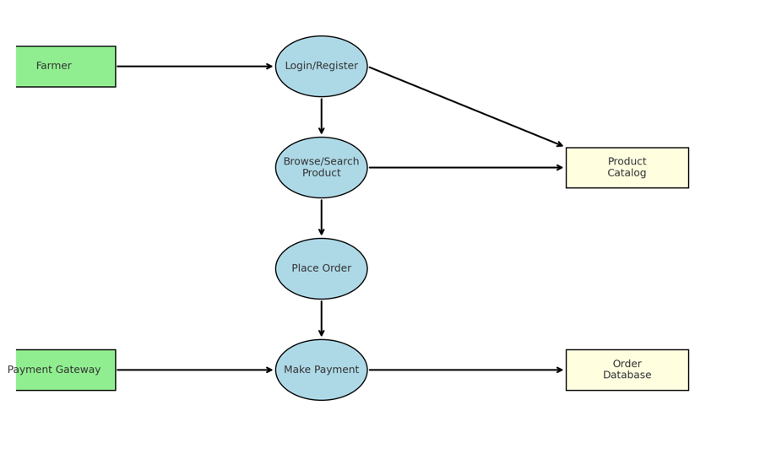

Question 8 – Change Request - 10 Marks Due to change in the Government Taxation structure . we should change the Tax structure How do you handle change requests in a project?

1. Receive the Change Request
- Source: Client (e.g., Mr. Henry), Government Notification, Compliance Team.
- In this case: Tax structure needs to be changed due to government mandate.

2. Document the Change Request
Create a Change Request Form that includes:
- Change Request ID: CR-001
- Title: Update Tax Structure as per Government Policy
- Raised By: Mr. Henry (SOONY)
- Description: Modify existing tax logic to align with new government regulations (e.g., GST updates).
- Date Raised: [Insert Date]
- Priority: High (since it’s compliance-related)

3. Perform Impact Analysis
- Functional Impact:
  - Payment module
  - Invoice generation
  - Product pricing logic
- Non-Functional Impact:
  - Performance (additional calculations?)
  - Legal compliance
- Affected Artifacts:
  - BRD, SRS, test cases, database schema (if tax rates are stored)

4. Stakeholder Review and Approval
- Discuss with:
  - Mr. Henry (Client)
  - Mr. Vandanam (PM)
  - Mr. John (DB Admin)
  - Ms. Juhi (Senior Developer)
- Get sign-off from the Change Control Board (CCB) or project sponsor

5. Update Project Artifacts
- Update BRD and SRS with the new tax calculation logic
- Revise Use Cases and Diagrams
- Test Cases for new scenarios (e.g., different tax slabs)

6. Assign and Implement
- Developer(s) implement new logic
- Database team (John) updates tax-related tables if applicable
- QA (Jason and Alekya) test new functionality and regression test

7. Validate and Close
- Confirm with stakeholders (e.g., Mr. Henry) that the change meets requirements
- Move changes to UAT and finally production
- Update Change Log and close the change request

Sample Change Request Form (Summary)
Field | Value
Change ID | CR-001
Title | Update Government Tax Structure
Description | Modify application to apply new government tax regulations
Priority | High
Requestor | Mr. Henry
Impacted Areas | Payment Module, Invoice, Product Price Calculation
Status | Approved
Approval Authority | Change Control Committee (Mr. Henry, Mr. Pandu, Mr. Dooku)
Question 9 – Change Request Vs an Enhancement - 5 Marks
Scenario Recap
Ben and Kevin (Stakeholders) have requested:
- New Feature: Farmers should be able to sell their crop yields through the application.
- Additional Feature: An auction system for selling these yields.

As a Business Analyst, your response:
"Thank you, Ben and Kevin. The requested functionality—allowing farmers to list and sell their crop yields along with an auction mechanism—introduces entirely new features that were not originally scoped in the current project plan. Hence, this request qualifies as an Enhancement."

Change Request vs Enhancement – Key Difference
Criteria | Change Request | Enhancement
Definition | A modification to an existing feature or requirement. | A request to introduce a new feature not originally planned.
Examples | Updating tax structure, modifying search logic | Adding a farmer marketplace, auction system
Impact | Usually moderate, within current system | Can require new modules, UI, DB design, workflows
Type | Usually reactive (e.g., policy/law changes) | Usually proactive or value-adding

🎯 Conclusion
✅ This is an Enhancement, not a change request.
As a Business Analyst, you would:
- Initiate a new feature proposal
- Conduct feasibility analysis
- Update the BRD/SRS accordingly
- Communicate estimated effort and timelines with project management

Question 10 – Estimations - 6 Marks Come up with estimations – How many Manhours required

Objective
Estimate the Manhours required to complete the development of the online agriculture product store system for SOONY Company.

Assumptions for Estimation
- Project Size: Medium
- Team:
  - 1 Business Analyst (BA)
  - 2 Developers
  - 1 UI/UX Designer
  - 1 Tester (QA)
  - 1 Project Manager
- Development Methodology: Agile (3 Sprints of 2 weeks each)
- Working Hours/Day: 8 hours
- Working Days/Week: 5 days
- Total Duration: ~6 weeks (3 sprints)

Module-wise Estimation Breakdown
Module | Role | Estimated Hours | Notes
Requirement Gathering & Analysis | BA | 40 hrs | 1 week full-time
Wireframes & Prototypes | UI/UX Designer | 32 hrs | Basic screens
Use Case + Activity Diagrams | BA | 24 hrs | Visio/Balsamiq
DB Design + ER/DFD | Developer + BA | 32 hrs | Includes normalization
Farmer Registration/Login/Search | Developer | 40 hrs | Basic CRUD
Product Upload (Manufacturer) | Developer | 32 hrs | File handling + DB
Product Details + Filters | Developer | 24 hrs | Includes UI work
Shopping Cart + Order Placement | Developer | 40 hrs | Logic-heavy
Payment Integration + Taxation | Developer | 40 hrs | Includes tax logic
Auction Module (New Enhancement) | Developer | 56 hrs | Advanced logic
Testing + Bug Fixes (All Modules) | QA | 48 hrs | Manual + Regression
UAT Support & Feedback Fixes | Dev + BA + QA | 40 hrs | Final adjustments
Project Management & Reviews | PM | 24 hrs | Coordination

Total Manhours (Rough Estimate)
Role | Total Hours
Business Analyst | 104 hrs
Developer(s) | 264 hrs
UI/UX Designer | 32 hrs
QA | 48 hrs
Project Manager | 24 hrs
Grand Total: ~472 Manhour

Question 11 – UAT – 6 Marks Project has finally completed all the stages i.e., design, development, testing etc. Now, it is the roleof a business analyst to contact the client for testing of the final product and have to successfully complete it. How are you going to handle this situation? And once it is done, what will be the process to close the project? Explain UAT Acceptance process

User Acceptance Testing is the final phase of the software testing process where the client or end users validate whether the developed product meets their business needs and requirements.

Step-by-Step UAT Acceptance Process
1. Plan UAT
- Schedule UAT with the client (e.g., Mr. Henry, Peter, Kevin, Ben).
- Create a UAT Plan including:
  - Scope
  - Timeline
  - Environment setup
  - Roles and responsibilities

2. Prepare UAT Scenarios and Test Cases
- Derive UAT scenarios from finalized business requirements.
- Share with the client for review and confirmation.
- Example UAT Scenarios:
  - Can a farmer register and search for products?
  - Can a manufacturer upload product details?
  - Can farmers place an order and make payment?

3. Conduct UAT Sessions
- Arrange demo or walkthrough sessions for stakeholders.
- Provide access to UAT environment.
- Support the client team during testing.
- Record issues or change requests (if any).

4. Collect Feedback and Fix Bugs
- Document all feedback and issues.
- Coordinate with developers and testers to resolve critical bugs.
- Provide updated build for re-testing, if needed.

5. Obtain UAT Sign-off
- Once all scenarios are tested and accepted, prepare a UAT Sign-Off Document.
- Get formal approval from the client (Mr. Henry or the Committee).
- This acts as confirmation that the system meets expectations.

✅ Process to Close the Project
- Release Final Deliverables
  - Deployment of the system to Production
  - Delivery of documentation (BRD, SRS, Training Manual, etc.)
- Conduct a Project Closure Meeting
  - With client (SOONY) and internal team (APT IT SOLUTIONS)
  - Present achievements, scope delivered, unresolved issues if any
- Handover & Training
  - Provide final system training to client stakeholders (e.g., Peter, Kevin, Ben)
  - Transfer all admin access, credentials, backups
- Project Closure Report
  - Includes summary, deliverables, timeline, resource utilization, learnings
  - Signed off by Project Manager and Client
- Celebrate Completion & Archive
  - Archive all documents
  - Send closure emails to stakeholders

Question 12 – Project Closure Document - 6 Marks Explain Project closure document
The Project Closure Document is an official record that formally marks the end of a project. It confirms that all deliverables were completed, stakeholder expectations were met, and project objectives were achieved. It includes a summary of the entire project, lessons learned, and client sign-off.

🧾 Purpose of the Document
- To formally close the project and release resources.
- To capture learnings for future projects.
- To verify that all work is completed and accepted by the client.
- To document any final deliverables or pending issues (if any).

📑 Contents of a Project Closure Document
Section | Description
1. Project Summary | High-level overview of the project objectives, scope, and outcome.
2. Deliverables Completed | List of all deliverables (documents, modules, features, training) provided to the client.
3. Final Milestones Achieved | Summary of key milestones like design completion, UAT sign-off, deployment.
4. Budget & Timeline Overview | Actual vs Estimated time and cost.
5. Issues & Resolutions | Summary of major issues encountered and how they were resolved.
6. Client Feedback | Final comments or feedback received from stakeholders (e.g., Mr. Henry, Peter, Kevin, Ben).
7. Lessons Learned | Insights for future improvements (technical, process, communication, etc.).
8. Handover Details | Login credentials, admin rights, final documentation given to the client.
9. Sign-Off | Formal sign-off from the client (Mr. Henry or Committee).

🧾 Benefits of a Closure Document
- Provides clarity on project completion
- Helps in audits or reviews
- Supports knowledge transfer
- Promotes accountability from both the delivery team and the client

✅ Sample Statement from Project Closure Section
“We confirm that all planned deliverables have been completed and accepted by SOONY Company. No outstanding issues remain, and the system is live and functioning as expected. We consider this project successfully closed.”

✍️ Signatures Section
Name | Role | Signature | Date
Mr. Henry | Client | _______ | ____
Mr. Vandanam | Project Manager | _______ | ____
Business Analyst (You) | BA | _______ | ____

