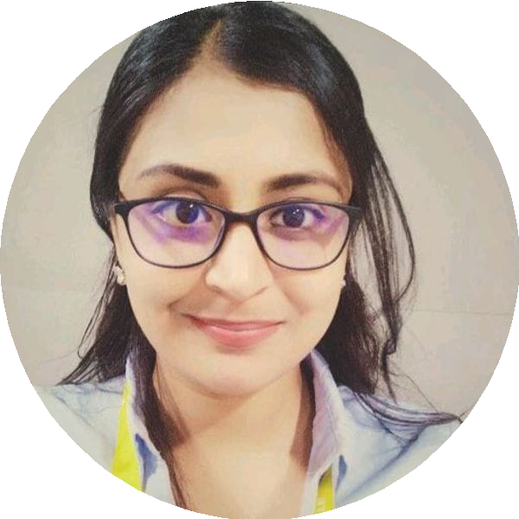
DEBADRITA DAS
Business Analyst

PH: ¦91 − 8240198368
E: debadritadas0@gmail.com
LinkedIn : https://www.linfiedin.com/in/debadrita-das-655795109

EXPERIENCE

Project Consultant

eClerx
10/2024 - PRESENT
- Created and refined User Stories with clear Acceptance Criteria, ensuring alignment with business needs and development objectives
- Oversaw the Product Backlog in JIRA, prioritized items, and supported Sprint Planning using Story Points estimation
- Facilitated Sprint Reviews and Retrospective Meetings to track progress, capture feedback, and drive continuous improvement
- Handled Change Requests efficiently while conducting Feasibility Studies to assess impact and ensure smooth delivery within project timelines
- Ensured 80% of project development within first half of the Project Life Cycle

Associate Analyst

WNS Global
06/2023 - 06/2024

- ML threshold optimization has been emphasized to cut false positives the alerts by ≈ 95%
- The App identifies up to 4: more true positives, significantly reducing missed suspicious activities
- Performed SWOT and Gap Analysis to identify business needs
- Gathered requirements using elicitation techniques, documentation G interviews
- Created Prototypes and authored BRD, FRD, SRS
- Designed UML diagrams for system workflows

Risk Operations Analyst

ePIfi Technologies
08/2022 - 02/2023
- Requirement gathering, process analysis, documentation, compliance alignment, and stakeholder coordination to enhance regulatory efficiency and accuracy.-
SUMMARY

I am a motivated Business Analyst with 7 years of experience, transitioning from a background in banking to deepen my expertise in Business Analysis. I excel in requirement gathering, Proficient in SDLC, hands on experience in Waterfall & SCRUM Model, stakeholder management, and project delivery.

CORE COMPETENCES

* Business Analysis Planning and Monitoring.
* Elicitation and Collaboration.
* Requirement Life Cycle Management.
* Requirement Analysis and Design Definition
* Strategy Analysis
* Solution Evaluation
* Stakeholder Management
* Project Management

TECHNICAL SKILLS

* Documentation Tools: MS Suite.
* Prototyping & Wire frames Tools: Axure and Balsamiq
* Modelling Tools: MS Visio, draw.io
* Database: SQL.
* Project Management Tool: JIRA.
* Reporting Tools: Power BI & Tableau

CERTIFICATION

* CERTIFIED BUSINESS ANALYST, IIBA [EEP]

DOMAIN KNOWLEDGE

* CRM Next
* Finacle

STRENGTHS

* Soft Skills
Excellent organizational, written and verbal
communication skills, Problem solving, Team
Player, Active Listen

Senior Executive

JANA SMALL FINANCE BANK
09/2020 - 08/2021
- Directed client interactions, addressing banking needs, cross-selling products, ensuring customer satisfaction, and maintaining long-term relationships

Deputy Manager

HDFC BANK LIMITED
03/2020 - 09/2020
- Supervised authorizing high-value transactions, ensuring compliance, monitoring teller activities, maintaining accuracy, and safeguarding customer accounts

Assistant Manager

AXIS BANK LIMITED
03/2020 - 09/2020
- Handled customer queries, processed banking transactions, cross-sold financial products, and ensured service excellence with compliance adherence

KEY ACHIEVEMENTS

* Student Representative for Cultural Fest
Coordinated between program organizers and
300= participants to ensure smooth cultural fest.

* Quiz Competition Achievements
Participated and won Trophies multiple times for
Inter School Quiz Competition

* Cultural Fest Coordinator
Coordinated between program organizers and
300= participants to ensure smooth cultural fest.

LANGUAGES

English
Proficient

Hindi
Proficient*

Bengal

EDUCATION

M.Tech

West Bengal University Of Technology
08/2014 - 05/2016

