A Customer can make a payment either by Card or by Wallet or by Cash or by Net Banking.
Q.1 – Draw a Use Case Diagram.
Answer :- Use case diagrams is a high level diagrams . The main focus of this diagram will be on how external interfaces, special Databases and internet connectivity will be interacting with the proposed IT system.

Q.2 Derive Boundary Classes, Controller Classes ,Entity Classes.
Answer :-
- Boundary Class : - Boundary Class used to handle interactions between the system and external actors
Ex: Payment Option Boundary
Card Payment Boundary
Wallet Payment Boundary
Cash Payment Boundary
Net Banking Payment Boundary

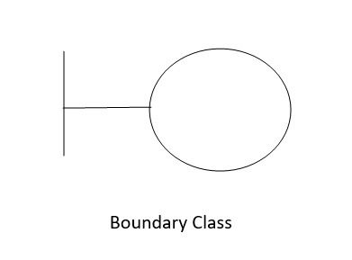

- Controller Class:- Controller class act as an intermediaries between boundary and entity classes.
Ex : Payment Initiated Controller
Card Payment Controller
Wallet Payment Controller
Cash Payment Controller
Net Banking Payment Controller

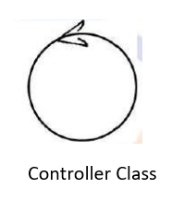

- Entity Class:- Entity class represents core data and business logic of the application.
Ex : Customer
Payment
Bank Server
Card
Wallet

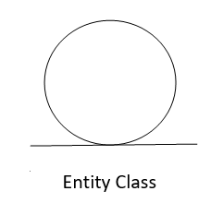

Q.3 Place these Clases on a three tier Architechture.

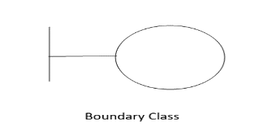

Customer make Payment BC Payment Controller Customer EC
Application Layer

Business Logic Layer
(Payment by Cash / Wallet / Card / Net Banking)

Bank Server Verify Bank Server EC
Details BC
Data Layer

Q.4 Explain Domain Model for Customer making payment through Net Banking.
Answer:-
A Domain Model is a conceptual representation that defines the structure, relationships and behaviors of entities within a specific problem domain.

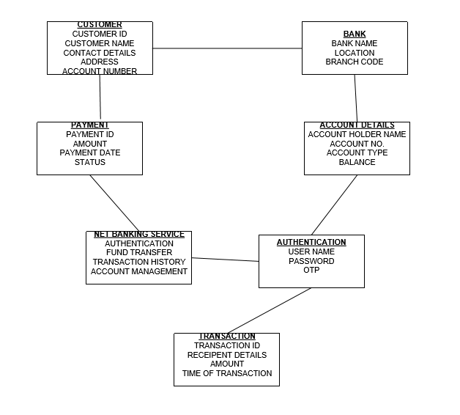

Q.5 Draw a sequence diagram for payment done by Customer Net Banking .
Answer :-
The Sequence diagram is used primarily to show the interactions between classes in the sequential order in which those interaction occur.

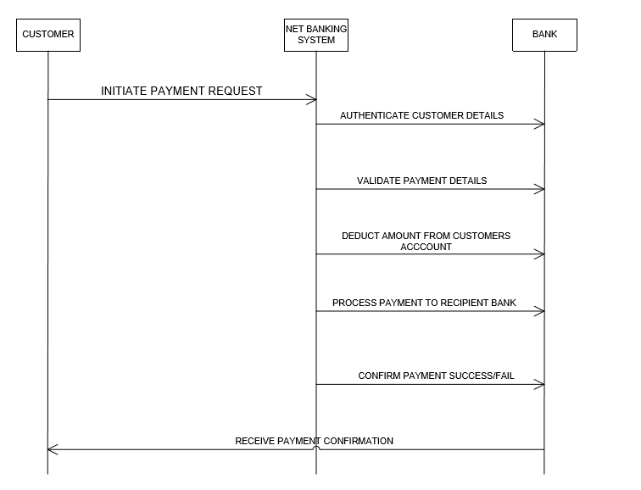

Q.6 Explain Conceptual Model for this Case.
Answer :-
A Conceptual Model is similar to the Domain Model. A Conceptual Model for the payment process done by a customer using Net Banking provides a high level understanding of the key concepts and their relationships involved in the payment transaction.
It helps in visualizing the overall structure and flow of the payment process.
A Conceptual Model explain the flow of data, sequence of task and relationship between the entities in very clear manner.
Following steps are involved in this particular case:-
- A customer initiates payment request with the help of Net Banking system.
- For initiating the transaction first he has to create User Name and Set Password.
- For setting User Name & Password he has to enter basic information like Customer ID, Name, Contact Details, Email ID etc.
- After registration he has to login by using User Name & Password.
- The Login details were authenticated by Bank server, If found correct he can proceed further.
- After successful login, he can initiate payment by entering Beneficiary’s Account No , Amount and Bank Details.
- After proceeding further the request transferred to Bank server via Net Banking system and OTP generates on customer registered Mobile no.
- Bank server authenticates the OTP.
- After entering OTP the transaction gets completed, funds get transferred and Transaction ID generates which is a confirmation of successful transaction.
- All the details are saved in Bank server, a customer can view the details of previous transactions any time.
- Net Banking system acts as a facilitator between customer and Bank server.
- Bank server authenticates all the information of customer and give confirmation of successful completion of transaction via Net Banking system.

Q.7 What is MVC architecture? Explain MVC rules to derive classes from Use case diagram and guidelines to place classes in 3-tier architecture?
Answer :-
MVC represent Model, View and Controller. MVC is an architecture which use to derive classes from Use case.
- Model :-
- The model class knows about all the data that need to be displayed.
- It is model who is aware about all the operations that can be applied to transform that class.
- It only represents the data of an application.
- The model represents enterprise data and the business rules that govern access to and updates of this data.
- All Model classes are represented as Entity classes.

- View :-

- The view represents the presentation of the application.
- The view class refers to the model.
- It uses the query methods of the model to obtain the contents and renders it.
- The view is not dependent on the application logic.
- It remains same if there is any modification in the business logic.
- View class is the data required by the query.
- View class is represented as Boundary Class or Form Class.

- Controller :-

- Whenever the user sends a request for something then it always go through the controller.
- The Controller is responsible for intercepting the requests from view and passes it to the model for the appropriate action.
- After the action has been taken on the data the controller is responsible for directing the appropriate view to the user.
- In GUI’s the views and controllers often work very closely together.
- Controller class working is based on the users command.
- It understands the commands / requests given by user through boundary.

MVC Architecture rules:-
- Combination of One Actor and a use case results in one Boundary Class.
- Combination of Two Actors and a use case results in two Boundary Class.
- Combination of Three Actors and a use case results in three boundary Class and so on …
Note : only one primary actor is to be considered with a use case.
- Use case will result in a controller class.
- Each Actor will result in one entity class.

MVC Classes in 3 Tier – Guidelines:-

- Place all Entity Classes in DB layer.
- Place Primary Actor associated Boundary Class in Application Layer.
- Place Controller class in Application Layer.
- If governing body influence or reusability is there with any of remaining Boundary classes, place them in Business Logic else place them in Application Layer.

Q.8 Explain BA contributions in project(Waterfall Model – all Stages)
Answer:-
- A business analyst is work along with the development team and customer.
- The BA is taking information form customer as per their requirement and handed over to technical team for development.
- BA will elicit, analyze, communicate and validate requirement as per the customer need.
- BA understands the business problem and provide appropriate solution to achieve their business goal.
- The prime responsibility of BA are as client interaction, ownership of requirements and Process Re-engineering.
The BA contribution in stages of Waterfall Model Project as follows :-
- Pre Project:-
- Enterprises analysis – SWOT analysis, toGAP analysis Market Research, Feasibility study, Root cause Analysis, Decision Analysis, Strategy Analysis, Enterprise Architectural Frameworks and Risks Analysis.
- In this stage BA also try to identify the scope of the project, prepares Business Case Document and SOW(Statement of Work).

- Planning, Estimations & Assessment :-
- Understands Assumptions and Constraints along with Business Rules and Business Goals.
- Plan Packages for Big Projects.
- Understands the project Plan from Project Manager.
- Conduct stakeholders Analysis.
- Plan approach strategy for the project i.e Req. gathering techniques ,Communication, Req. Management, Documents to follow to use, Change Request handling methodology etc.

- Requirement Gathering:-
- Identification of stakeholders and Documentation.
- Preparation of BRD (Business Requirement Document) by interacting with Client using various Elicitation Techniques.
- Prototyping can be used by BA to make client to give more specific requirements.
- Sorting the gathered requirements (avoiding duplicate req., grouping into similar functionality or into modules).
- Prioritize requirements by using techniques like MoSCoW.
- Validating requirements by using techniques like FURPS.

- Requirement analysis :-
- Draw UML Diagram (Use Case & Activity Diagram )
- Prepares Functional Requirements from Business Requirements.
- Come up with Supplementary Support Document (SSD) and Software Requirement Specification (SRS).
- Take signoff on SRS from Client because it is the first legal document between business and technical team.
- Prepares Requirement Traceability Matrix (RTM) from SRS before Design Phase starts, because it is BA’s responsibility.
- BA traces how requirements are dealt in each phase of development life cycle from design till UAT.

- Design :-
- Preparation of Test case Document from Use case Diagram.
- Communicates with client on design and solution documents (update status of project to the client and make them understand how the solution would look like to prepare them to drive UAT).
- Initiating the preparation of End user manuals.
- Updation of RTM.
- From Use Case Diagram solution architect recommends architecture of the IT Solution.
- DB architect uses Entity Classes and come up with ER Diagram and DB Schema.
- GUI Designer will look into Boundary Classes and designs all possible screens for the IT solutions.

- Coding :-
- Organization of JAD sessions.
- Clarifies queries of technical team during coding.
- Developers refer diagrams and controller classes of BA and code their unit.
- Update end user manual.
- Update RTM.
- Conducts regular status meetings with technical team and the client and tuning client for preparation in UAT.
- Testing
- Prepares test cases from use cases.
- Perform high level testing.
- Prepares client for UAT.
- Test data is required by BA from Client.
- Updates End User Manuals.
- Updates RTM.
- Take sign off from client on client project acceptance form.
- Deployment and Implementation :-
- Forwards RTM to client or Project Manager which should be attached to the Project Closure document.
- Coordinates to complete and share End User Manual.
- Plan and Organizes Training sessions for End users.
- Prepares lessons learned from this project (to take precautions for coming project).

Q.9 What is conflict management? Explain using Thomas – Kilmann technique.
Answer :-
Conflict Management :-
- Conflict management is the practice of being able to identify and handle conflicts sensibly and efficiently.
- To managing the conflicts, require high level of energy for resolution.
- Managing the conflicts is all about maintaining the relation with all stakeholders, team members and clients.
- Before engaging in conflict, first think about expected outcome.
- There are 5 steps to conflict management –
- Identify the conflict as we need to know what exactly the problem is.
- Discuss the details with all stakeholders.
- Agree with the root problems.
- Check for every possible solution for conflict negotiation.
- Provide solution to avoid future complication/conflict.

Thomas – Kilmann Technique
This model is based on two dimension of conflict management :
Assertiveness and Co -operativeness.
Assertiveness – The ability to speak up and stand by your opinions. It can be used either positively or negatively depending on its application. While assertive behaviour may seem aggressive it is actually a way of expressing yourself effectively.
Co-operativeness -It means understanding another person's point of view and feelings. When you empathize with someone else, you're able to put yourself into that other person's situation. As a result, you'll find ways to resolve the conflict more easily.

Based on these two dimensions, there are 5 conflict resolution strategies as per below diagram –
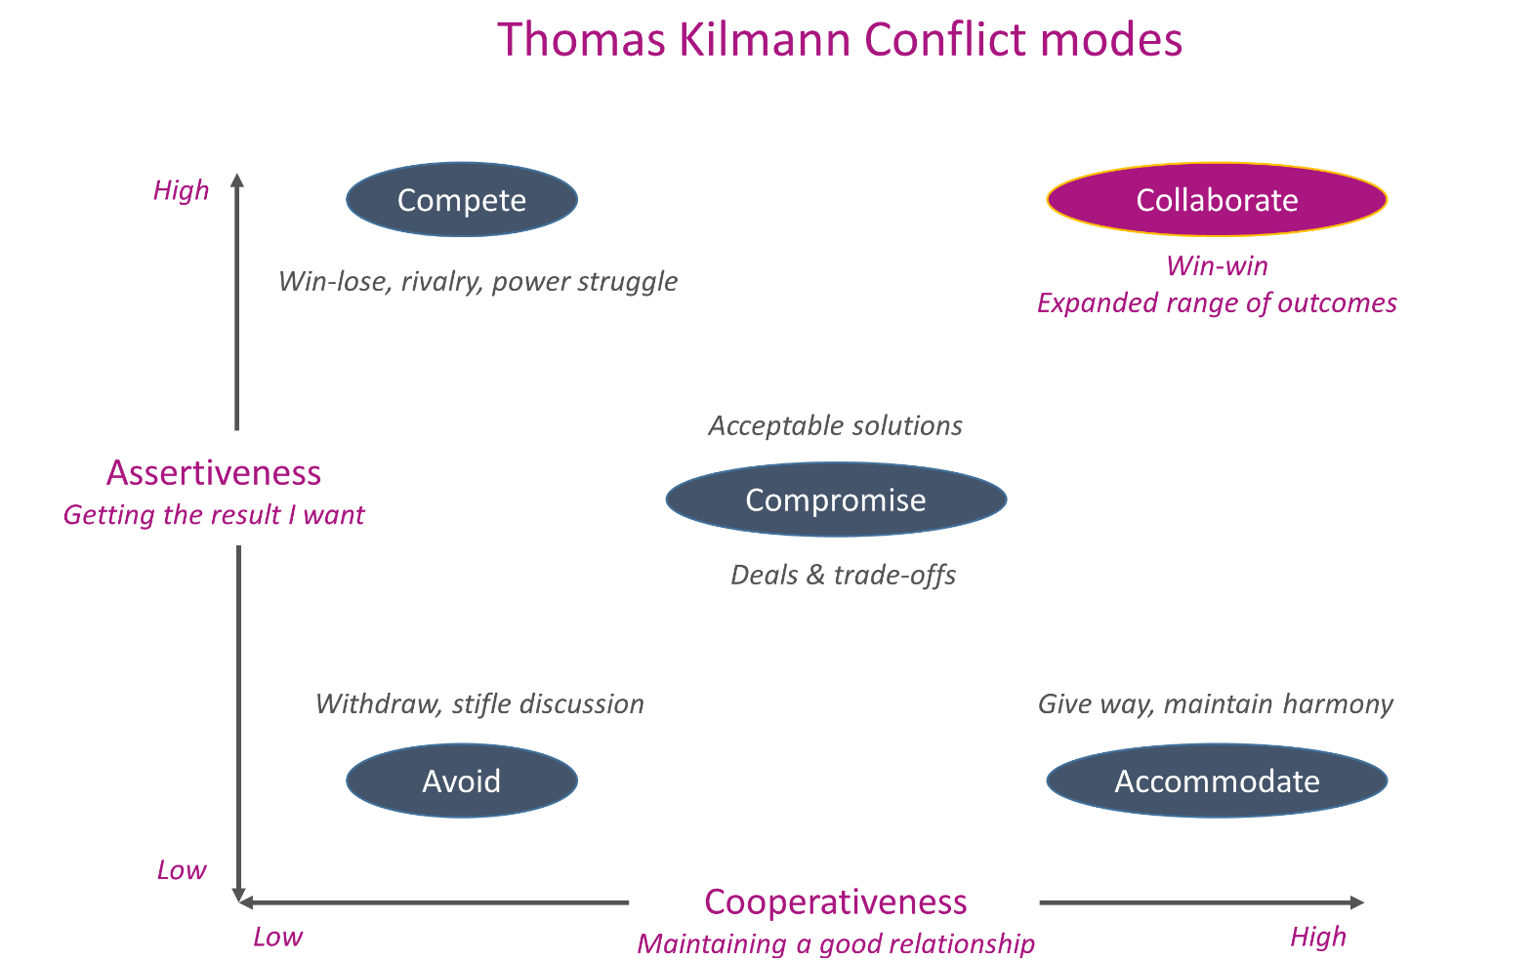

- Competing :-
- At the top left end of the chart, we have high assertiveness and low cooperativeness. We use competing as a conflict resolution strategy whenever we resort to being aggressive. In addition, we also get uncooperative with the opponent.
- The first strategy for dealing with conflict is competing.
- This strategy works well when you are in a commanding position and have limited time and resources to resolve the conflict.
- Competing is not always bad. If you think about it, competing helps us to achieve our goals.
- It has few drawbacks. 1. competing usually leads to negative emotions such as anger, frustration, aggression and hostility. 2. it doesn't help you to build good relationships because you don't listen to what others say. Finally, it might result in losing opportunities because the other person doesn't want to work with you anymore.

- Avoiding:-

- At the bottom left end of the diagram, we see low assertiveness and low empathy. That means you neither assert your position nor do you consider or emphasize the other persons point of view.
- The second strategy for dealing with conflict is avoiding it.
- People use this conflict management strategy when they know that they don't have any authority over the other person. Instead, they avoid confrontation by ignoring or avoiding the conflict entirely. They also choose to ignore the issue altogether.
- Avoiding is often seen as passive and weak. However, if you really need to avoid a conflict, you should definitely do so.

- Accomodating :-
- In the bottom right part of the diagram, we find low assertiveness and high empathy.
- Accommodating is a third strategy for dealing with conflict.
- The idea behind this approach is to make concessions. For example, if one person makes a request, you agree to do what the first person requested instead of arguing about the matter.
- It's an effective way to manage conflict when you lack power. But be careful — by making concessions, you may start to lose control over your own agenda.

- Collaboration :-

- Up above on the top right, we see high assertiveness and high empathy.
- When you collaborate, you take a moderate approach to solving problems. You attempt to balance power between yourself and another person. You also try to find common ground and work together towards achieving a shared goal.
- It's an ideal choice if both parties are committed to reaching a mutual agreement. The goal here is to reach an agreement with each other.
- But remember: collaboration isn't always easy. It requires sharing personal opinions and feelings. It also needs two people who trust each other and value working together.

- Compromising :-

- In the middle of the model is the fifth strategy, which is compromising. This is the middle of assertiveness and empathy scales.
- If you compromise, you take the middle road between opposing views. This means agreeing to specific terms and giving up on certain other items. And since you're trying to resolve a disagreement, it's important that you show flexibility.
- This strategy usually gives the feeling of a win-win scenario, where both parties feel that they gained something out of the conflict.

Q.10 List down the reasons for project failure .
Answers :-
Please find below reasons for project failure :-
- Improper Requirements Gathering
- Requirement gathering is very important part of a project planning. Proper requirement gathering leads to clear understanding of objectives of the project, hence It helps the team to understand their roles and responsibility throughout the project.
- Improper requirement gathering leads to unclear goals and incomplete understanding of what needs to be delivered which can lead to project failure.

- Continuous change in Requirements
- The continuous change in Requirements by the stakeholders may cause of the project failure. If the changes happen continuously then its need to change the developments task too. Due to this scope creep happened.
- scope creep- If any project cannot be completed within budget and time constraints.
- This is very common when projects are not appropriately documented.

- Lack of User Involvement
- Lack of User Involvement is one of the most important reasons for project failure
- It is the responsibility of project managers to identify all stakeholders and communicate with them on time, without any delays.
- Engaged stakeholders offer support and insights to drive your projects towards success, but disengaged stakeholders may become barriers to success.

- Unrealistic Expectations
- When you want to do something fast, with a limited budget, and a reduced team, it can really make your project fail.
- You should be realistic when it comes to your teams’ capabilities, deadlines, and the resources available – only then can you obtain the results you want.

- Lack of Executive Support
- The support from each stakeholder, project manager, development team is essential for the successful project.
- Planning shouldn’t be limited to agendas, meetings, and responsibilities. It should also include human, intellectual, financial, or structural resources.

- .Improper Planning
- The lack of planning can make a project fail. Having a successful project depends on properly defining in detail the scope, the time frame, and each member’s role.
- If there is not a proper planning then the goal/agenda of the project will not meet. Proper planning is very important in every phase of the project.

Q.11 List the Challenges faced in project for BA.
Answer :-
Below are the challenges faced by a Business Analysts: -

Lack of Domain Knowledge

Domain knowledge plays a vital role in having a clear and complete understanding of the requirements.

It is challenging for business analysts to be assigned to a wide variety of projects as learning new domains needs time and energy.

Unclear Project Objective
- One of the crucial role played by BA very skilfully is to understand what is the exact objective / goal of the project, what client wants to make and what he wants to achieve by the project.
- Ba has to arrange meetings with stakeholders and he needs to interact more with the stakeholders to understand the objective of the project, because stakeholders are not trained to explain what they want, but it is BA’s responsibility as he is trained to extract the requirements from stakeholders
- Unclear understanding of objective lead to waste of time, money, resources and ultimately the failure of project.

Lack of required and up-to-date process/system documentation

To thoroughly understand the business process, existing IT landscape, systems functionalities, integrations, and many other aspects affecting the Project in question, Business Analysts need to get hold of existing documentation.

However, most of the times the documentation is either not available or is not updated. This is a common scenario faced by Business Analysts in a maintenance project.

Changing Business Needs/Requirements

Business analysts often come across situations wherein business stakeholders have asked for changes in requirements even after requirements have been finalized and signed off.

It is one of the most common challenges because it can occur not just once but several times, even for the same requirement. Such changes are likely to affect business analyst’s efforts and the overall project, cost, and timelines.

Inadequate Stakeholder Involvement

Stakeholders’ involvement is one of the critical success factors for every Project. As a Business Analyst, you may any of the following situations:

Unavailability of Key Stakeholders: If this happens, they will not sync with the latest requirements discussions. Either they will not be able to share their inputs or come up with changes later on.

Non-Cooperation of Stakeholders: Sometimes, you may encounter Stakeholder(s) who is not co-operating. It may lead to issues related to sign-offs, approvals, and even delays.

Unrealistic Timelines

As a Business Analyst, you may find yourself in a difficult situation as far as timelines are concerned and that may happen because of the following reasons:

Unrealistic commitment by Sales Team
- Unrealistic expectations by Stakeholders- It’s important to handle these expectations with a balanced approach and without spoiling the relationships forever.

Managing Conflicts and Negotiations

Conflict management is one of most unavoidable and time consuming task in project.
- As a BA, you must establish a good communication system with team members, clients and stakeholders so that the chances of conflicts arising gets reduced and if found anything odd you must pro-actively try to resolve it so that it may not affect the project.

Q.12 Write about document naming standards.
Answer :-
A file naming convention is a systematic method for naming files that will make them easier to retrieve later. A consistent and descriptive convention will allow you to:
- Know the content of a file without opening it
- Find and identify files even if they are no longer in their original folder
- Easily browse long lists of files to inventory or check if any are missing
- Manage files more easily, even when they’re all stored in one central folder or directory

Designing your file naming convention
A filename can be made up of a series of descriptive elements, such as Project Id, Document Type, Version, Document Number and extention.
For example, a file naming convention may include the following components, in the following order: [Project Id]_[Document Type]_[Version]_[Document No.]_[Extention]
Examples of filenames based on this example convention might be:
- ABC123_BRD_V1_D1_DOCX
- XYZ789BRDV2D3.PDF

Q.13 What are Do’s and Don’ts of a Business Analyst.
Answer :-
Following are the Do’s and Don’ts of BA :-
1. Never say No to client.
When client is explaining his problem or giving requirements, listen carefully and try to understand what he/ she is trying to explain, and never say “No” to client upfront, because the client is explaining his problem and he expects some solution from us.
So rather than say “No” we can provide alternate solution after discussing with our internal teams.

2. Never imagine anything in terms of GUI
Never imagine the requirements by seeing graphical representation, ask right questions to client and get clarity on the requirements.
Login page may appear same for most of the websites but functionality is different.
For example: If you want to login to any website we need to enter correct user id and password to login the page. Here user id and password is common, but password length and validations differ from website to website, based on the client requirement.
Example: Password should be 10 characters and it should have at least 1 capital letter and 1 special character.

3. Question Everything
Never feel bad to ask questions, ask the right questions and get clarity from the client. You can ask the questions till you get clarity. Sometimes client may not tell the complete requirement unless you ask the questions.
Example : Client will say I need login page. But here you need to ask multiple questions to client to get clarity. Let us see some sample questions here.
What are the validations required,
Specific Terms and conditions required or not.
And when this button should be disabled or enabled.
Which type of error message should be shown on the screen if user enters wrong password or user id.
Password length should be how much and all.

4. Consult an SME for clarifications in Requirements
If requirement is not clear and you need more clarity on the requirement, then we can discuss with SME (Subject Matter Expert). And ensure to document the requirements what you discussed with SME and get approval from solution owner. And explain to him what you understand by discussing with the SME.

5. Every problem of client is unique.
Every problem of Client is unique, so talk to the client with an open mind and with no assumptions from your previous experiences.
Never come to any conclusion before listening or understanding all the aspects of requirement from client, if you have a small doubt about any demand or change it’s always preferable to clear it with the client, subject matter expert, or with your team members.

6. Do not interrupt the client, when he/she is giving you the problem.
Listen very carefully and completely to the client as well as to the end user and then ask questions, don’t interrupt them in between. Maximum try to extract the leads and solutions to it from the client itself. Never try to give solutions to client straight away with your previous experience and assumptions.

7. Should not be hurry.
Should not gather the requirements in hurry, conduct a meeting in a convenience and take your own time to understand the requirement or gather the requirements. Because if you are in a hurry to capture the requirement then there are chances to misunderstand the requirement, it may lead to project failure. As a Business Analyst we should have open mind when we are gathering requirements.

8. BA should focus on “what” and “when” to develop rather than focus on “how” to develop.
As a Business Analyst our responsibility is to understand what to deliver and when to deliver the project, how to develop is the responsibility of development team or development manager. We need not to concentrate on this part and need not to worry. Always have a prior discussion with our project manager and sponsor before conducting a meeting.

9. Should not miss any requirement
We should make sure that we have gathered all the requirements from the stakeholder for our project, missing out any information can result to unwanted redo the work as well as delay projects and increase cost.

10. Should know what the Scope of the Project is
Sometimes non-functional requirements of client are not feasible because of budget or time constraint, so it’s always better to liaison with our Project Manager to find out what is out of scope so that all will be in the same page and avoid misunderstanding.

Q.14 Write the difference between packages and Sub-systems.
Answer :-
PACKAGES | SUBSYSTEMS
Packages simply groups elements. | A subsystem groups elements that together provide services such that other elements may access only those services and none of the elements themselves.
Packages is more smaller and more focused in scope. | Subsystem are more larger and encompass multiple packages or modules.
Packages allow us to partition our system into logical groups and relate these logical groups. | Subsystems allow us to consider what services these logical groups provide to one another.
Packages manage dependencies at a class/component level. | Sub – system manage dependencies at higher level, defining boundaries and interfaces between different parts of the system.
You use packages to organize your requirements at analysis time. | You use subsystems to organise your solution at design time.
Packages depend on classes and Components level. | Subsystem depend on the interfaces between different parts of the system.
A packages is a collection of headers and source files that provide related functionality. | A subsystem is a collection of one or more packages.
Q.15 What is camel – casing and explain where it will be used.
Answer :-

- Camel Case is a naming convention used in computer programming and is characterized by removing spaces between words and capitalizing the first letter of each word except for the first word.
- In Camel Casing entire first word will be in lowercase and subsequent words first letter should be in Upper Case. There will be no gap in between words.
- The name Camel Casing is derived from the appearance of the resulting string, which resembles the humps of a Camel.
- Camel Case is used in programming language to name different files and functions without violating the naming laws of the underlying language. Camel Casing exclusively used by the developers when they are creating diagrams so that they can understand later.
- By using Camel Casing, developers can create meaningful and readable names that are easier to understand and follow coding standards.
- It promotes consistency within the codebase and improves collaboration among team members.
- Example : myNameIsMahesh

Q.16 Illustrate Development server and what are the accesses does Business Analyst has ?
Answer :-
- Whenever a project is happening means the project is not ready, all the data is saved into a temporary server and not in a database. There are many servers like production servers, testing servers, Deployment Server, UAT Server etc. Deployment server is one of them.
- A Development Server refers to a dedicated environment or server that is used during the software development process. It is a server where developers save their work. It provides a platform for developers and testers to build, test and debug applications before they are deployed to a production environment.
- Development server is a kind of temporary environment server where a developer can save their data, rework on it and when he finds that the work is ready, he can transfer it to the Deployment Server or Production Server where Client will also have an access to it.
- The development server typically replicates the target production environment to ensure compatibility and accurate testing.
- The BA will have only Read Only Access, Collaborative Access and Limited Configuration Access to Development server because it is exclusively for the developers so that they can save their work, rework on it and make it complete.

Q.17 What is Data Mapping ?
Answer :-

- Data Mapping is the process of establishing a relationship or connection between data elements in two or more different data sources or data formats.
- Data Mapping is the process of connecting a data field from one source to another, one table to another table.
- It involves defining how data from one source corresponds to or transforms into data in another source.
- Data Mapping is commonly used in data integration, data migration, and data transformation processes.
- The purpose of Data Mapping is to ensure that data can be accurately and effectively transferred, converted or transformed between different systems, databases or formats.
- It involves identifying the source data elements, determining their meaning and structure, and mapping to the corresponding target data elements.
- If Data Mapping is not done correctly, it will be very difficult for us to organize and understand the data in correct manner and make solutions from it.
- Example : In IRCTC portal when we type journey Mumbai to Pune, it shows all the trains that has stop at Mumbai and Pune within same journey.

Q.18 What is API. Explain how you would use API integration in the case of your application Date format is dd-mm-yyyy and it is accepting some data from other Application from US whose date format is mm-dd-yyyy.
Answer :-

- An API (Application Programming Interface) is a set of rules and protocols that allows different software applications to communicate and interact with each other.
- It is nothing but a communication channel between one application and another application.
- In short the two applications uses API as a tool to communicate with each other.

Following is the process of API Integration :
- Establish API Communication :-
- First we need to establish API Communication between our application and another application to exchange data.

- Data Formatting :-
- When sending date data from our application to the other application, convert the date from dd-mm-yyyy format to the mm-dd-yyyy format.

- This can be achieved by extracting the day, month and year components from date and rearranging them according to the target format.

- Data Parasing :-
- When receiving date data from other application, parase the mm-dd-yyyy formatted date into our applications dd-mm-yyyy format.

- Again we need to extract the day, month and year components from date and
rearranging them according to our target format.

- Data Validation :-
- Perform Data Validation and ensure that the converted data remains valid after the format conversion.
- Check for edge cases, such as invalid dates or date ranges that might be affected by the format conversion, and handle them appropriately.

