NURTURING PROCESS – CAPSTONE PROJECT – 3

A customer can make a payment either by Card or by Wallet or by Cash or by Net banking.
Q1. Draw a Use Case Diagram
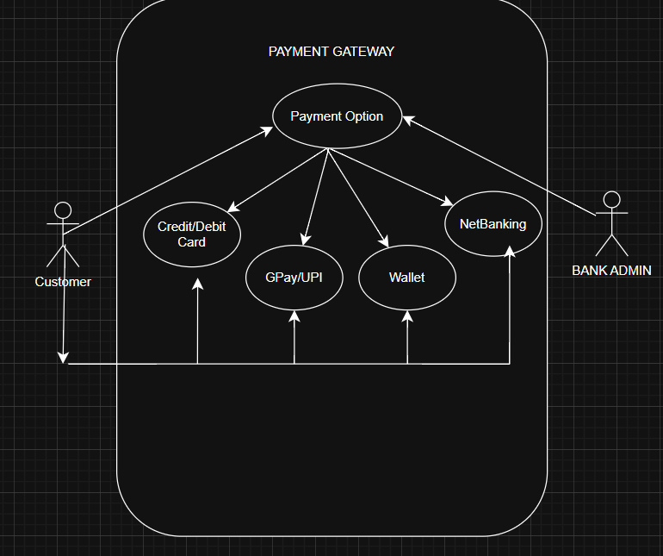

Q2. Derive Boundary Classes, Controller classes, Entity Class
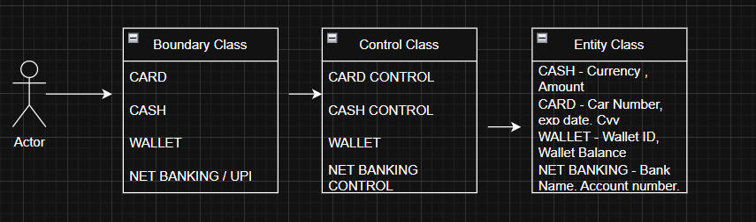

Q3. Place these classes on a three tier Architecture

Client Handles the presentation layer – Application server handles application layer & server system handles database layer
Presentation layer – This is the layer we see when we use a software . By using this we can access the webpages. The core functionality of this layer is to communicate with the application . I mean payment access gateway

Application layer – Is also known as business logic layer. As per the payment gateway option., we selects the payment option. Application layer will interact will the database layer. This acts as a mediator between presentation layer & database layer. It will gather the requirement or the data which we selects
Example – Credit-card? Gpay? Wallet? Net-banking?) & communicate to the presentation layer. It use to perform the operations of the application

Database layer – Data is stored in data layer. Application layer communicate with data layer to retrieve the input & performs required action
Which means API (Application program interface) – using JAVA / PYTHON etc
Example – After selecting the payment option will initiate the process to complete the transaction
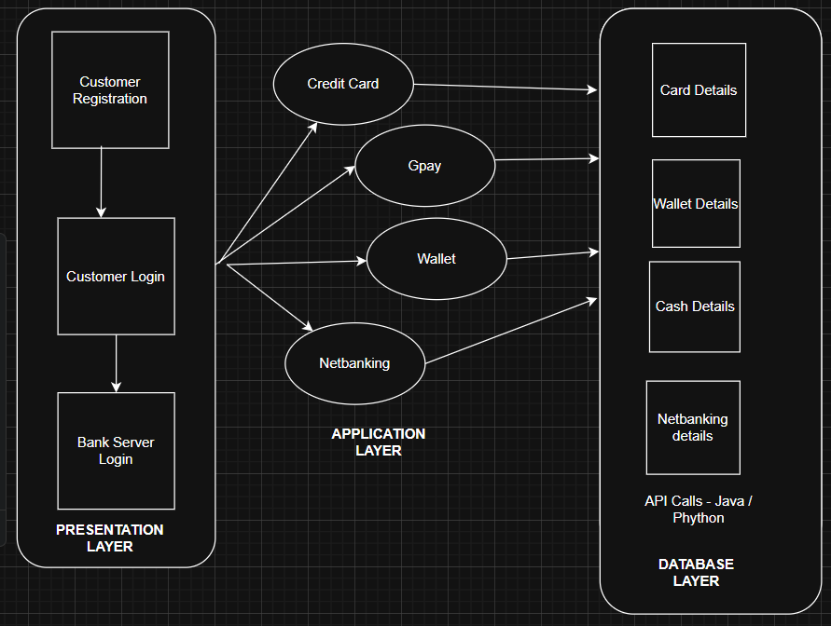

Q4. Explain Domain Model for Customer making payment through Net Banking

Domain Model for Net Banking Payment (Entities + Relationships)
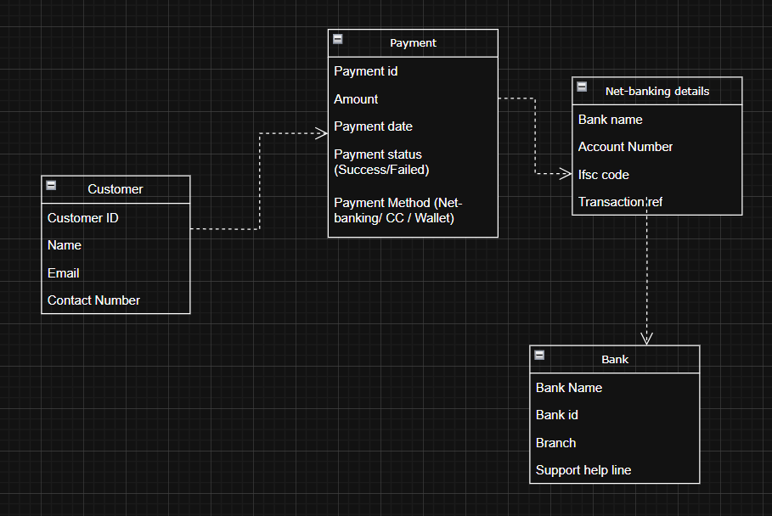

Relationships

- A Customer initiates a Payment.
- A Payment is associated with NetBankingDetails
- NetBankingDetails belongs to a Bank

Q5. Draw a sequence diagram for payment done by Customer Net Banking –

Interaction between classes in the sequential order. It is a step- step process .

It is used to show the flow of message (Event or action)

- Initially customer opens the bank website & then he or she will be entering their credentials to login.

- Once it takes you to the home-screen

- Select for payment (Netbanking)

- Add the details of the person to whom the transfer must be done. (Which includes his Name - account number- branch code- ifsc)

- Enter the amount - Initiate the payment – get otp – transaction done
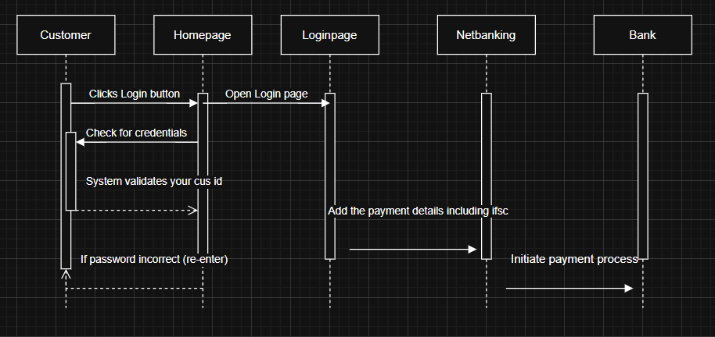

Q6. Explain Conceptual Model for this Case

Conceptual Data means data connected by lines . It represents the entity & the line represents the relationship between the entity

Bank – Represent the service provider who offer services

Security & Privacy – Bank should provide at-most security & privacy for their net-banking users. This should built a trust among customers . It should enable various features under the privacy restriction. The bank should provide strong infrastructure.

Login Credentials – Customers must use their customer id or user id along with password to login to their net-banking page. Adding to that it must have additional features like multi-level authentication like otp to the registered number or virtual authentication

Payment option – Picking the Net-banking as preferred payment option & adding the 3rd party transfer person details along with his IFSC / Account number / Branch code etc

Policies – This includes various policies RBI regulations , netbanking services, ensuring flawless services, & monitoring the compliance
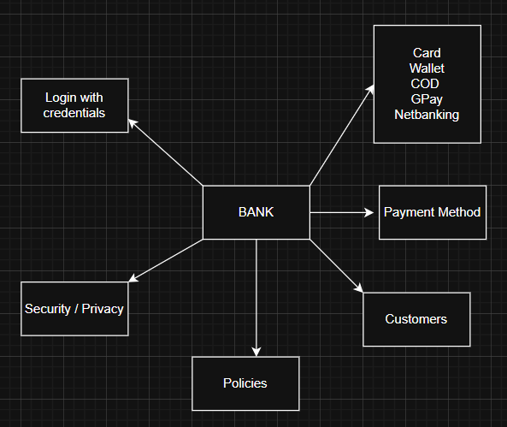

Q7. What is MVC architecture? Explain MVC rules to derive classes from use case diagram and guidelines to place classes in 3-tier architecture

MVC (Model–View–Controller) is a design pattern used to separate responsibilities in a system:

Payment ------> Card Details ------ > Wallet Details ----- > Netbanking Details ------ > Gpay

Model represents the data & the Business Logic . It is also responsible for multiple task like

Managing the application data
Performing data validation
Implementing business rules

It is not depend on how data is presented or how the user interacts with the application
It represents the data that is being transferred between view and controller
All the models are represented as entity class

View is responsible for presenting data to the user
It can be a web-page desktop application window

Controller - It acts as a Intermediary between Model & view . It receive input from the user. Process the input . Whenever user request anything that request first goto the controller. It takes input from the client

Model – Customer , Payment, Netbanking , card , cash

View class – Login View Payment option view , Netbanking view , credential view, Payment confirmation view , Logout View

Controller Class - – Login Controller, Payment option Controller , Netbanking Controller , credential Controller, Payment Controller , Logout Controller
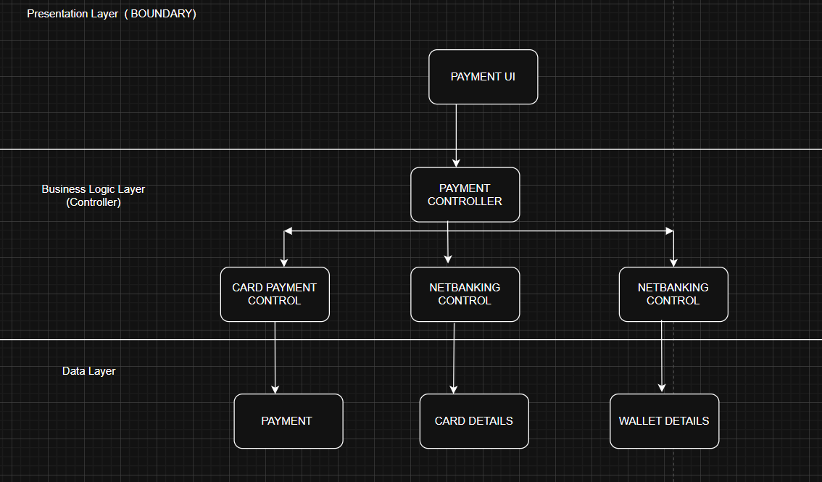

Q8. Explain BA contributions in project (Waterfall Model – all Stages)

- Requirement Gathering & Analysis
- System Design
- Implementation
- Deployment
- Maintenance

In Requirement gathering Stakeholders will be identified & requirement will be gathered from stakeholders
Business analyst will participate & will take all the download .
BRD will be prepared

In system design – Clarify the business rules regarding the payment option (Net banking – Bank reuires account number, branch code, ifsc code) & authentication
Validate that the System Design Document (SDD) aligns with BRD.

Implementation
BA Role - Support developers by clarifying requirements.
Ensure functional flows are aligned with requirements. Also Participate in review meetings.
Answer business logic questions (e.g., What happens if Net Banking fails?).

Deployment
BA Role: Ensure business stakeholders are informed about payment process
Confirm the system supports all payment methods smoothly.
Cross verify with checklist before the go-live

In Maintenance BA Role – Make sure the services are uninterrupted , also ensure Change Request process are also included Updated RTM must be available.

Q9. What is conflict management? Explain using Thomas – Kilmann technique

Conflict can occur due to several reasons. Goals/ Values / Resource .
The process of identifying and addressing the conflict.. Aimed at resolving disputes , or difference of opinion among individuals

By identifying the conflict efficiently , It will really helpful to reduce the negative impact.

Competing / Collaborating / Compromising / Avoiding / Accommodating

- Only Card + Net Banking delivered; Cash & Wallet postponed.
- Phase 1 (Card, Net Banking), Phase 2 (Wallet), Phase 3 (Cash).
- Ignore Cash option discussion until later.
- Accept Business demand to add Wallet spite of challenges and concerns

Resolving disagreements in a way that minimizes disruption and maximizes project success

Q10. List down the reasons for project failure

- Poor Requirement Gathering & Analysis
- Lack of Stakeholder Engagement
- Confusing also frequent Changing Requirements
- Ignoring Prioritization
- Not a effective Documentation or a Improper documentation
- Poor Validation
- Regulatory & Compliance Oversights
- Misalignment between business & technology
- Lack of team co-ordination among team

Q11. List the Challenges faced in projects for BA

Requirement Gathering Challenges

- Difficulty in eliciting clear requirements from stakeholders
- Customers demand “all payment modes” but do not specify about refunds, failed payments,, retry.

Stakeholder Alignment Issues

- Conflicting priorities
- IT Devlopment team says only Card can be delivered in first sprint

Scope Creep & Changing Requirements

- Stakeholder may demand UPI Integration along with the existing payment modes
- Netbanking login attempt should be restricted to 2 times
- There should be 3 layer authentication.whiile login to home page. Initially it was agreed only using the credentials alone. But now client demands , otp & digital face sensor confirmation

Communication Gaps

- Misunderstandings between Business (non-technical language).
- Developers (technical jargon).

Example – If a requirement is explained by the stakeholder differently. But the development team understood incorrectly & start building the feature. (Ex – Refund of wallet)

Technical Complexity & Integration

      - Bank APIs, Wallet providers, integration
      - High dependency on third-party vendors during API Integration
      - BA must constantly update requirements when integration points change.

Change Management

- New payment methods (Ex – UPI, Buy now pay later
- OTP verification must be sent to both mobile & registered email-id
- Forget password / Recovery password

Unrealistic Expectation

- Goals that that cannot be achieved or that are out of scope.

Q12. Write about Document Naming Standards

Good Document Naming Standards (with Payment Case Example)

- A consistent set of rules for naming project documents.
- Ensures clarity and easy retrieval of documents.
- Avoids confusion when multiple versions exist.
- Makes collaboration smoother among Business, Development, QA, and Compliance teams.

Example - Business Requirement Document (BRD) (PAYSYS_BRD_v1.0.docx)
Functional Specification Document (FSD – Wallet Module) PAYSYS_Wallet_FSD_v1.1.docx
Test Scenarios – Card Payment: PAYSYS_Card_TestScenarios_v2.0.docx

Q13. What are the Do’s and Don’ts of a Business analyst

First lets see DO’S

Elicit Clear Requirements
Conduct workshops with Business, Banks, Wallet providers, and Finance teams.
Example: Ensure requirements cover success, failure, timeout, refund flows for Net Banking.

Document Requirements Properly
Maintain BRD, FSD, and Use Case Diagrams with Document Naming Standards.

Prioritize Features Using Techniques
Apply MoSCoW / KANO / MVP.

Bridge the Gap Between Business & Technical Teams
Translate business needs into technical stories.
Example: Convert “Wallet refund” requirement into Clear detail manner without any jargon words

Manage Conflicts Professionally
Example: If Business wants Wallet first but Tech insists on Card → Use “Compromise” to deliver Card in Sprint 1, Wallet in Sprint 2.

Now lets see DONT’S

Don’t assume requirements are obvious
Don’t make any assumption without getting clear concerete update from the stakeholder in regard to the requirement. That should be analysed whether it is within scope.

Don’t Use Vague Language
Incorrect: “System should allow quick payment.”
Right: “System should process Card payment within 5 seconds with 95% success rate.”

Don’t Allow Scope Creep Without Change Control
Example: Suddenly adding UPI without analyzing impact → project delays
Never say “NO” to the client & also don’t accept all the requirement without analysing the challenges and risk.

Q14. Write the difference between packages and sub-systems
Packages is a group of classes or a usecase used to organize model elements
It can be nested within other packages
It is used to represent system architecture
A package is a logical grouping of related classes, interfaces, or use cases in UML. a higher-level unit of the system that provides specific functionality
Example- Payment Methods , WalletPayment , Netbanking, Cash
Packages - Card_Payment_Package ----- > CardUI, CardController, CardEntity
Subsystems - Payment Processing Subsystem → Includes all above packages.

Order Management Subsystem → Handles orders before triggering payment.
Inventory Subsystem → Updates stock after successful payment.
Bank Integration Subsystem → Works with Net Banking & Card payments.

Q15. What is camel-casing and explain where it will be used-
Camel-casing is a naming convention in programming where words are combined without spaces, and each new word starts with a capital letter.

lowerCamelCase – process Payment, validate Card Payment
UpperCamelCase – Payment Controller, Net-Banking Entity

Classes Subsystem & Entities
- Customer
- CardPayment
- WalletPayment
- NetBankingPayment

Q16. Illustrate Development server and what are the accesses does business analyst has

A development server is a dedicated environment where software is built, integrated, and tested before moving into QA/ UAT

Development Server in the Payment Project

Payment modules (Card, Wallet, Cash, Net Banking).

Test databases with dummy customer/payment records.

Collaboration Access: Access to tools like JIRA, Confluence, or DevOps are track development progress.
Can raise defects / clarifications during sprint reviews.

BA can log in as a test user → choose "Net Banking" → simulate payment with a dummy bank account.

BA can verify logs/screens → confirm that the transaction status moves from Initiated → Success.

Q17. What is Data Mapping

Data Mapping is the process of matching fields from one data source to another so that information can flow correctly across systems.
In projects, especially with payments, data mapping ensures that customer data, payment details, and transaction status are transferred accurately between:
- Frontend (UI) → Backend (Business Logic) → Database → External Systems (e.g., Banks, Wallet APIs)
Data Mapping in Your Payment Project
Customer UI (Front-end)
Payment Controller (Business Logic layer)
Database (Entity layer)
External System (Bank API, Wallet Service, etc.

For Instance - Customer makes a Net Banking Payment
The steps are
Customer-Id
Payment Amount
Bank Name
Account Number
Ifsc Code

Data Mapping is Important – Consistency / Accuracy / Integration / Error Prevention
Business Analyst - Define field mappings between UI, backend, DB, and external systems
Create Data Mapping Documents (DMD) to guide developers & testers.
Validate that during testing (Dev/UAT), data flows correctly end-to-end.
Data Mapping in your Payment Case Study ensures that when a customer pays via Card/Wallet/Cash/Net Banking, all required fields are correctly transformed and transferred between systems, database

Q18. What is API. Explain how you would use API integration in the case of your application Date format is dd-mm-yyyy and it is accepting some data from Other Application from US whose Date Format is mm-dd-yyyy
API (Application Programming Interface) is a set of rules & endpoints that allow two applications to talk to each other.
APIs help in integration, i.e., connecting your Payment System with external systems like:
Bank Net Banking API
Wallet providers (Paytm, Google Pay, etc.)
When a customer pays via Net Banking, your system must call the Bank’s API to:
Send customer ID, amount, bank account details.
Get response: transaction status (Success / Failure).
When a customer pays via Wallet, your system must call Wallet APIs to deduct money.

Convert the date format from DD/MM/YYYY
Other Application (US) sends API data in → mm-dd-yyyy

