Case study
Project Idea: This project aims to create an easy-to-use online platform that helps farmers buy essential agricultural products like seeds, fertilizers, and pesticides from Manufacturer using internet access.
Current Needs: Farmers should not struggle to access seeds, fertilizers, and pesticides due to limited local availability.
Overview of the project: This project is about developing an online store that allows farmers to easily buy agricultural products such as seeds, fertilizers, and pesticides through the internet from Manufacturer. It is designed especially for Farmers. The platform will be user-friendly, keeping in mind that new user can be involved. By using this application, farmers can save time, avoid travel, and get quality products delivered to their location. The goal is to support farmers by making farming supplies more accessible, reliable, and affordable through technology.
Current Problem: Farmers often face difficulty in getting quality seeds, fertilizers, and pesticides.
- Business Process Model
Goal: It aims to make agricultural products more accessible, reduce the need for travel, save time and money, help farmers and earn profit.
Input: Trained Employees, Customer’s Data, Manufacturer’s details, Marketing Campaign
Resources: Warehouse, Office space, Internet, PC
Output: Product delivery, Customer’s feedback
Activities: Customer’s Registration> Product search> Selection of product> Order placement, Payment processing> Order confirmation> Inventory update> Order tracking> Feedback collection.
Value: Discounts, Coupons.

- SWOT Analysis
Strength Weakness
Less competitors Dependency on external Venders
High in demand Inventory Shortage
Save Time, Cost, Efforts Only literate Farmers can use this

Opportunities Threats
Expansion on International Market Fraud
Growing demand Internet Connectivity issue

Feasibility Study:
Amount assigned to the project 2cr.
Cost estimated 1.75 cr.
Technology based: Based on the database server, Payment gateway
Web server: Apache HTTP server
Database Server: MySQL
Programming language: JAVA
Content management system: WordPress
Hardware:
Software:
Resources:
Project Sponsor | Mr. Henry
Financial Head | Mr. Pandu
Project Co-Ordinator | Mr. Dooku
Delivery head | Mr. Karthik
Project Manager | Mr. Vandanam
Developer | Mr. Teyson, Ms Lucie, Mr. Tucker, Mr Brave, Ms Juhi
Network Admin | Mr. Mike
DB Admin | Mr. John
Tester | Mr. Jason, Ms Alekya
BA | Ms. Harsha
Budget: 2cr
Timeframe: 18 months

Gap Analysis:
Current State:
1. Farmers in remote areas struggle to get seeds, fertilizers, and pesticides due to lack of local availability. They must travel long distances or rely on middlemen.
2. Manufacturers rely on local distributors or wholesalers to reach farmers; limited direct interaction.
3. Farmers order products via phone calls, physical visits, or intermediaries—prone to delays and errors.
4. Delivery timelines are uncertain; farmers have no way to track shipments.
5. Farmers rely on word-of-mouth or local sellers for product info; often incomplete or inaccurate.
Desired State:
1. Farmers can browse and purchase agricultural products online from anywhere with internet access
2. Manufacturers can upload product details directly into the application, visible to farmers instantly.
3. Farmers place orders through a simple, user-friendly online interface (web/mobile app).
4. Farmers can track order status online and get notifications for dispatch and delivery.
5. Product catalog with detailed descriptions, usage instructions, prices, and manufacturer details.

Risk Analysis:
Internal Risk:
1. Depends upon external vendors for product supply
2. Technical issue and system downtime can be affect the customer experience

External Risk:
1. Competition from other online shopping platform
2. Changes in govt. policies can affect online shopping insudtries
BA Risk:
1. Incomplete requirements
2. Change in requirements
Project related Risk:
1. Scope Risk
2. Stakeholder Risk.

RACII Matrix
 | Project Plan | BRD | Design | Test Case
Project Manager | R | A | I | I
BA | I | R | A | A
Developer | I | I | C | I
Tester | I | I | I | R
DB Admin | I | I | R | I
Network Admin | I | I | I | I

Business Case document
Summary
The proposed project aims to develop an Online Agriculture Products Store to enable farmers, especially in remote areas, to purchase essential agricultural products like fertilizers, seeds, and pesticides directly from manufacturers. The application will be accessible via the internet, ensuring ease of access and reducing dependency on physical availability in rural markets.
The project will be executed by APT IT SOLUTIONS under the CSR initiative of Mr. Henry’s company, SOONY, with a budget allocation of ₹2 Crores and a planned duration of 18 months.

Current problem
Farmers in remote villages, such as Peter, Kevin, and Ben, face significant challenges in procuring fertilizers, seeds, and pesticides.
These issues negatively affect crop yield, quality, and overall agricultural productivity, leading to reduced income for farmers.
Problem to be solved.
1. Enable farmers to access agricultural products anytime, anywhere.
2. Reduce procurement delays and associated costs for rural farmers.
3. Improve communication between farmers and manufacturers.

Stakeholders
Project Sponsor | Mr. Henry | Provide Funding
Financial Head | Mr. Pandu | Budget Approval and monitoring
Project Co-Ordinator | Mr. Dooku | Liaison between Sponser and Vender
Delivery head | Mr. Karthik | Oversees delivery from APT.
Project Manager | Mr. Vandanam | Day-to-Day Project execution
Developer | Mr. Teyson, Ms Lucie, Mr. Tucker, Mr Brave, Ms Juhi | Coding and devoloping
Network Admin | Mr. Mike | Infrastucture Setup
DB Admin | Mr. John | Database Management
Tester | Mr. Jason, Ms Alekya | Quality assurance
BA | Ms. Harsha | RG and Documentation

Timeframe
Requirement Gathering | 1 Month
Requirement Analysis | 1 Month
Design | 2 Months
Development | 8 Months
Teasing | 3 Months
Deployment | 1 month
Maintenance | 2 months

Organizational Changes
1. Appoint dedicated technical staff for platform maintenance, security, and upgrades.
2. Establish a support/helpdesk team to handle farmer and manufacturer queries.
3. Training for employees on the new platform, data handling, and customer support.

Four SDLC Methodology and Model
Sequential- Waterfall:
In waterfall model, each phase must be completed in its entirety before the next phase can begin, At the end of each phase a review take place to determine if the project is on the right path and whether or not to continue or discard the project.
Stages of Waterfall Model:
Requirement Gathering – BA, PM
Requirement Analysis – BA, PM, Sol Architech, NW Architech, DB Admin
Design – Sol Architeck, NW Architech, Db Architech, GUI Designer
Development- Developers
Testing – Tester
Deployment & Implementation
Maintance
Iterative-RUP:
RUP is based on a set of buiding bloks, or content elements, describing what is to be produced, the necessary skills required and specific development goals are to be achieved.
It has 6 engineering discipline:
Business Modelling
Requirements
Analys and Design
Implementation
Test
Deployement
And has 3 supporting discipline:
Configuration and change management
Project Management
Environment.
and 4 life cycle phase:
Inception
Elaboration
Construction
Transition

Evolutionary-Spiral:
The Spiral gives more emphases placed on risk analysis.
The spiral model has 4 plases
Planning
Risk Analysis
Engineering
Evaluation
A software project repeatedly passes through these iteration
The baseline spiral, starting in the planning phase, requirements and gatheres, and risk is assessed.
Agile-Scrum:
Agile is not planned driven, its value driven
Requirement may come any stage of SDLC and we have to fulfill it.
Can be implement where fast delivery required
It has 4 main value
- Individuals and interactions over processes and tools
- Working software over comprehensive documentation
- Customer collaboration over contract negotiation
- Responding to change over following a plan.

V Model:
The V-Model (Verification and Validation Model) is a software development life cycle model where development and testing activities are planned in parallel.
Verification Phases
- Requirement Analysys.
- System Design
- High level Design
- Low level Design
- Coding and Implementation
Validation Phases
- Unit Testing
- Integration testing
- System Testing
- User Acceptance testing

Waterfall Madel vs V model:
Facors | Waterfall | V model
Defination | A linear sequential software development model where each phase starts only after the previous one is completed. | A verification and validation model where development phases are mapped to corresponding testing phases.
Process Flow |  | Parallel: Each development phase has a corresponding testing phase planned simultaneously.
  Sequential: Requirements → Design → Development → Testing → Deployment.
Testing Approach | Testing happens after the development phase is completed. | Testing activities start in parallel with each development phase.
Cost | Generally lower cost due to less early testing involvement and fewer parallel activities. | Generally higher cost due to early and continuous involvement of testers and more documentation
Risk Handelling | Higher risk of finding major defects late in the cycle. | Lower risk since testing happens throughout the process

Justify your Choice:
Waterfall can be better than Agile or Iterative methods when a project has clear, fixed requirements and needs a predictable budget and timeline. It works step-by-step, making it easy to manage and track progress. Each phase is completed before moving to the next, with full documentation at every stage. This makes it ideal for projects that need strict compliance, detailed records, and minimal client involvement after starting. It’s cost-efficient and reliable when nothing is expected to change during the project.

Gantt Chart:
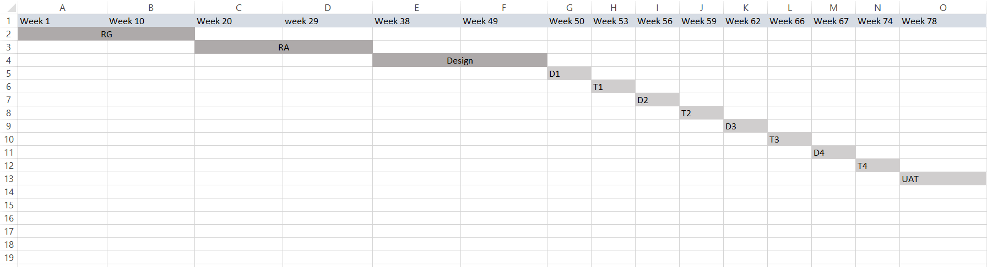

Fixed Bid vs Billing:
Fixed Bid | Billing
The client pays a fixed amount agreed before the project starts, regardless of the time/resources used. | The client pays based on actual effort, time, and resources spent during the project.
Fixed deadlines are often strict; vendor has to meet them. | Flexible timelines; billing depends on actual work duration.
Projects with clear requirements and low changes. | Projects with uncertain requirements or evolving scope.
Mostly on the vendor. If the project takes longer or costs more, vendor bears the loss. | Mostly on the client. Client pays for all work done, even if it takes longer than expected.
Fixed and agreed upfront. | Flexible, depends on hours worked or resources consumed.

Timesheet:
Design
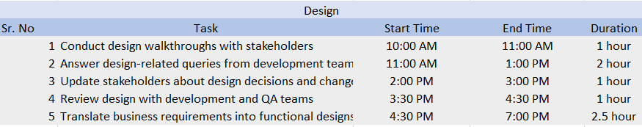
Development
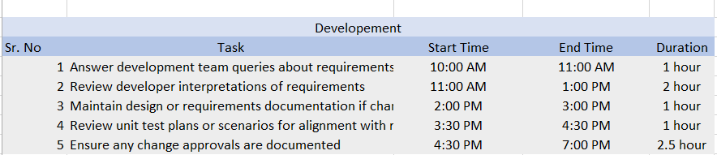

Testing
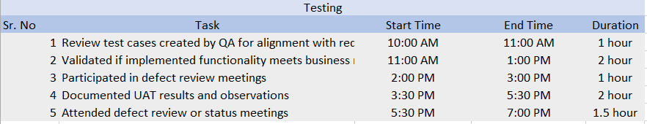

UAT
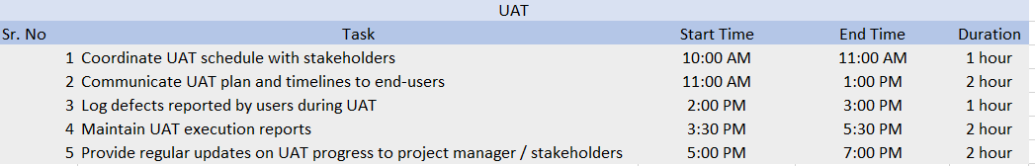

Deployment n Implementation
