Trade Finance 3

Document 1: Definition of Done
As Per Agile Extension to the BABOK® Guide v2, Definition of Done is a technique where the team agrees on, and prominently displays, a list of criteria which must be met before a backlog item is considered done.
That is the team has to create a well-defined, unambiguous, measurable, agreed-upon, and shared Definition of Done between all team members.
The best form of Definition of Done representation is a checklist of activities that has to demonstrate the agreed value and quality of a user story. So, this checklist should include:
- Acceptance criteria (to satisfy customer requirements for a product).
- Quality criteria (to satisfy quality requirements for a product)
Definition of Done may be defined for different levels of project work. For example, in Agile / Scrum framework these levels of work could be user story, sprint, and release.
Checklist for DOD:
- Produced code for presumed functionalities:
- Code adheres to coding standards.
- Code follows best practices.
- Code is modular and maintainable.

- 2. Assumptions of User Story met:
- a) User Story is well-defined and understood.
- b) Assumptions documented and validated.

- 3. Project builds without errors:
- a) Build process is automated.
- b) Build artifacts are versioned and tagged.

4. Unit tests written and passing:
a) Code coverage meets project standards.
b) Test cases cover edge cases and common scenarios.

5. Project deployed on the test environment identical to the production platform:
a) Configuration consistency between environments.
b) Data in the test environment is representative of production data.

6. Tests on devices/browsers listed in the project assumptions passed:
a) Cross-browser testing performed.
b) Compatibility with different devices and screen sizes ensured.

7. Feature ok-ed by UX designer:
a) Design consistency across the application.
b) Usability testing conducted.

8. QA performed & issues resolved:
a) Comprehensive testing, including functional, performance, and security testing.
b) All identified issues are documented and addressed.

9. Feature is tested against acceptance criteria:
a) Acceptance criteria are clear and met.
b) Any deviations documented and justified.

- Feature ok-ed by Product Owner:
- a) Product Owner has reviewed and approved the implemented feature.
- b) Any feedback or changes addressed.

- 11. Refactoring completed:
- a) Code refactoring adheres to coding standards.
- b) Refactoring improves code quality and maintainability.

- 12. Any configuration or build changes documented:
- a) Changes to configuration files documented.
- b) Build process changes documented and communicated.

13. Documentation updated:
a) README files are updated.
b) User documentation is revised.

14. Peer Code Review performed:
a) Code reviews are documented.
b) Feedback addressed and acknowledged.

Document 2- Product Vision

Scrum Project Name: | Trade Finance 3
Venue: | Pune
Date: | Start Time: 01.02.2025 | End Time: 02.02.2028 | Duration: 3 years
Client: | Deutschland bank Ltd.
Stakeholder list: | Project stakeholder: | Business stakeholders: | 3rd Party stakeholders:
 | Scrum master | Business owner | Auditors
 | Product owner | Business Sponsor | Legal team
 | All developers, testers | Operation team | Outsource
 | Operations, networks, trainers | Subject Matter Expert | Vendor
 |  |  | Regulators
Scrum Team
Scrum Master | Vijay
Product owner | Vishnu E
Scrum developer 1 | Sneha
Scrum developer 2 | Bharath Kumar
Scrum developer 3 | Arun Kumar
Scrum developer 4 | Ganesh M
Scrum developer 5 | Venkatesh K
Tester 1 | Arundhathi A
Tester 2 | Payal K

Vision: To create a trade finance application reducing work and user-friendly application
Target Group | Needs | Product | Value
We are targeting the banking sector via this project. | Customers of bank for fast and better banking experience and users of bank for reduce their work per transactions | Trade finance | By processing transactions faster with better compliance check, clients of bank will bring in more business and more business means more revenue
We are targeting bank employees for better processing and customers of bank for fast and better banking experience | For customer faster transaction process.  For employees i.e., the user of application reduce work and provide bank with strict compliance checks | It’s an ever-green product in banking sector.  The product is very flexible. | To increase customer base by 50%.  To create a user friendly & easy to use application.

Document 3: User stories

User Story No: 1 | Tasks: 3 | Priority: Highest
AS A USER OF APPLICATION
I WANT TO LOGIN TO APPLICATION
BY PROVIDING EMP ID
BV: 500 | CP: 13
ACCEPTANCE CRITERIA
Provide user id which is employee id.
System data base needs to be updated with all the employees using this application
Authenticating using Microsoft authenticator

User Story No: 2 | Tasks: 2 | Priority: Medium
AS A USER
SELECT CORRECT PRODUCT AS PER CLIENT REQUEST
INPUT THE TRANSCATION
BV: 100 | CP: 05
ACCEPTANCE CRITERIA
Client request to be provided to user
User to have proper knowledge of product he/she is working in.

User Story No: 3 | Tasks: 2 | Priority: Medium
AS A USER
NEED TO SEND SWIFT TO CORRESPONDENT BANK
SELECT CORRECT MESSAGE TYPE
BV: 100 | CP: 03
ACCEPTANCE CRITERIA
System needs to have options of all the message type
all the fields of selected message need to be made mandatory fields

User Story No: 4 | Tasks: 2 | Priority: Low
AS A USER
NEED TO REPRINT THE ADVICE LETTER
NEED TO SELECT CORRECT PRINTER NUMBER
BV: 50 | CP: 02
ACCEPTANCE CRITERIA
Provide reprinted manger option in the application.
Select correct transaction ID to reprinting deal.

User Story No: 5 | Tasks: 2 | Priority: Medium
AS A DATA BASE SERVER
PLEASE KEEP ALL THE ACCOUNT DETAILS UPDATED
BV: 500 | CP: 08
ACCEPTANCE CRITERIA
To data base we need to provided client details.
Such as account, charges details, address and RM details

User Story No: 6 | Tasks: 1 | Priority: Low
AS A USER
I WANT TO VIEW THE PRICING OF COMMISSION
SO THAT I PROVIDE CUSTOMER WITH BEST PRICING
BV: 20 | CP: 01
ACCEPTANCE CRITERIA
Display pricing of different currency and time period with clarification of product

User Story No: 7 | Tasks: 3 | Priority: Low
AS A USER
LOAN TO BE PROCESSED AS PER CUSTOMER REQUEST
BV: 10 | CP: 02
ACCEPTANCE CRITERIA
1. Display type of loan to be selected as per client request.
2. Display loan rates and period of loans.
3. Loans to disbursed as per client request.

User Story No: 8 | Tasks: 4 | Priority: Medium
AS A CUSTOMER
CUSTOMER NEEDS TO HAVE LIMITS WITH BANK
SO THAT CLIENT CAN AVAIL LOANS
BV: 500 | CP: 08
ACCEPTANCE CRITERIA
1. Client needs to have proper KYC for using banking facility.
2. Client needs to avail account in bank for operating trade finance.
3. Update the data in application data base.
4. Process the loan as per client request with above details in place.

User Story No: 9 | Tasks: 2 | Priority: High
AS A USER
I WANT TO CREATE A NEW BANK ACCOUNT USING THE MOBILE.
APP SO I CAN CARRY OUT FINANCIAL TRANSACTIONS
BV: 500 | CP: 21
ACCEPTANCE CRITERIA
User can download app from all app stores
User can open the app

User Story No: 10 | Tasks: 2 | Priority: High
AS A USER
I WANT TO SEND MONEY INTO MY ACCOUNT FROM ANOTHER BANK AND SEE THE MONEY IN MY MOBILE APP
SO THAT I CAN CARRY OUT TRANSACTIONS USING MY NEW ACCOUNT
BV: 500 | CP: 13
ACCEPTANCE CRITERIA
User can retrieve details with which credit can be made to their account
User can see a change in account balance once a credit is made to their account

Document 4: Agile PO Experience

The Product Owner has a vision of the product keeping the domain/industry experience and the market need.

Following are the responsibilities of PO in a project.

- Market Analysis - Market analysis is a detailed assessment of your business's target market and the competitive landscape within a specific industry. This analysis lets you project the success you can expect when you introduce your brand and its products to consumers within the market.

- Enterprise Analysis - Enterprise Analysis is the identification of business opportunities, development and maintenance of a business architecture, and the determination of optimum project investment. The most significant result that can come from effective enterprise analysis would be a business meeting its strategic goals.

- Product Vision and Roadmap - "Product Vision specifies the What and Why of the product, while Product Strategy elaborates how to realize the vision with a specific approach, and provides a roadmap showing a timeline for executing the strategy.

- Managing Product Features-

  - Market research & user research.
  - Idea management.
  - Technical specifications.
  - Road mapping.
  - Prioritization.
  - Product development.
  - MVP release and customer feedback collection and iterations.

- Managing Product Backlog-
  - Review the backlog before the iteration planning meeting to ensure that the prioritization of tasks is correct and that the previous feedback has been implemented.
  - When the backlog gets larger, you must categorize the backlog items into short-term/ near-term and long-term.
  - Delete items that aren't required and keep the ones that aren't ready to be off the backlog.
  - Do not add tasks unless planned.
  - Make prioritization of the backlog tasks a priority!

- Managing Overall Iteration Progress- An iteration manager manages the work done by one team within an iteration, although there might be some coordination with other teams. An iteration manager helps to optimize the efficiency of the team. People on software development teams tend to like to focus on their tasks.
  - Set iteration goals. The future iteration's goal or a new feature may come from a user request, from the customer, or a priority order/list....
  - Estimate user stories....
  - Establish capacity....
  - Planning steps - internal priority....
  - From stories to tasks.

- From this project I have learned how to handle sprint meetings such as:
  - Sprint planning meeting - Which requirements to be undertaken and can be delivered withing the scrum time framework.
  - Daily scrum meeting - This usually lasts for less than 10 min where each team member informs what they did and what they are working on.
  - Sprint review meeting - Finished work is shown to the stakeholders, customers and or the users who provide the feedback. Based on the response to the finished work, the product owner will add, remove or adjust prioritizes of product backlog items. (Scrum master, Product owner, development team).
  - Sprint retrospective meeting - Entire team gathers in a room and discusses the burn down chart and what went right and what went wrong.
  - Backlog refinement meeting - During this meeting, the product owner and the Scrum team look at the remaining product backlog items. The product owner may re- prioritize product backlog items. Scrum team members then plan a new sprint based on which item is at the top of the list.

- Also, User stories creation and what things will be included in user stories such as:
  - User Story- As a [type of user], I want [an action or feature]. So that [benefit or value].
    - For example: as per above user story 1
  - Task- List of specific tasks required to complete the user story. These are the individual steps or actions that need to be taken to implement the feature.
    - For example: Implement "Microsoft authenticator" button on login page, create a secure password mechanism, once authenticated login to page.
  - Priority- Indicates the importance or urgency of the user story in the context of the overall project. Priorities are usually categorized as high, medium, or low. For example:
    - High priority: Critical for the next release.
    - Medium priority: Important but can wait for the next iteration.
    - Low priority: Nice to have, can be considered later.
  - Acceptance Criteria- A set of conditions or criteria that must be met for the user story to be considered complete. These criteria help ensure that the implemented feature meets the user's expectations.
    - For example: User will select account details, If incorrect account error message pop ups, user needs to provide correct select.
  - Business Value- Describes the value that the user story brings to the business or end-user. It helps prioritize features based on their impact. For example:
    - High business value: Increases user engagement and satisfaction.
    - Medium business value: Adds a useful feature but not critical.
    - Low business value: Nice-to-have, minimal impact on users.
  - Complexity Points- An estimation of the complexity or difficulty of implementing the user story. Complexity points are often used in Agile methodologies for capacity planning and sprint commitments. For example:
    - 1-3 points: Low complexity, straightforward implementation.
    - 5-8 points: Medium complexity, may require some effort.
    - 13+ points: High complexity, may involve significant challenges.

- In Scrum, a product owner serves as the liaison between multiple areas of an organization. This person communicates with business stakeholders and collaborates closely with Scrum teams to keep all areas of the business informed on a project's development.

- The product owner develops a vision of a product's function and operation, which in turn allows this Scrum team member to define product features and break those features into product backlog items.

Document 5: Product and sprint backlog and product and sprint burndown charts.
Product backlog:
A product backlog is a list of the new features, changes to existing features, bug fixes, infrastructure changes, or other activities that a team may deliver in order to achieve a specific outcome.
It should be cheap and fast to add a product backlog item to the product backlog, and it should be equally as easy to remove a product backlog item that does not result in direct progress to achieving the desired outcome or enable progress toward the outcome.
Product backlog items take a variety of formats, with user stories being the most common. The team using the product backlog determines the format they chose to use and looks to the backlog items as reminders of the aspects of a solution they may work on.
User story ID | User story | Tasks | Priority | BV | CP | Sprint
US001 | AS A USER OF APPLICATION  I WANT TO LOGIN TO APPLICATION  BY PROVIDING EMP ID | Provide user id which is employee id.  System data base needs to be updated with all the employees using this application  Authenticating using Microsoft authenticator | High | 500 | 13 | 1
US002 | AS A USER  SELECT CORRECT PRODUCT AS PER CLIENT REQUEST  INPUT THE TRANSCATION | Client request to be provided to user  User to have proper knowledge of product he/she is working in. | Medium | 100 | 5 | 2
US003 | AS A USER  NEED TO SEND SWIFT TO CORRESPONDENT BANK  SELECT CORRECT MESSAGE TYPE | System needs to have options of all the message type  all the fields of selected message need to be made mandatory fields | Medium | 100 | 3 | 2
US004 | AS A USER  NEED TO REPRINT THE ADVICE LETTER  NEED TO SELECT CORRECT PRINTER NUMBER | Provide reprinted manger option in the application.  Select correct transaction ID to reprinting deal. | Low | 50 | 2 | 3
US005 | AS A DATA BASE SERVER  PLEASE KEEP ALL THE ACCOUNT DETAILS UPDATED | To data base we need to provided client details.  Such as account, charges details, address and RM details | Medium | 500 | 8 | 2
US006 | AS A USER  I WANT TO VIEW THE PRICING OF COMMISSION  SO THAT I PROVIDE CUSTOMER WITH BEST PRICING | Display pricing of different currency and time period with clarification of product | Low | 20 | 1 | 3
US007 | AS A USER  LOAN TO BE PROCESSED AS PER CUSTOMER REQUEST | Display type of loan to be selected as per client request.  Display loan rates and period of loans.  Loans to disbursed as per client request. | Low | 10 | 2 | 3
US008 | AS A CUSTOMER  CUSTOMER NEEDS TO HAVE LIMITS WITH BANK  SO THAT CLIENT CAN AVAIL LOANS | Client needs to have proper KYC for using banking facility.  Client needs to avail account in bank for operating trade finance.  Update the data in application data base.  Process the loan as per client request with above details in place. | Medium | 500 | 8 | 2
US009 | AS A USER  I WANT TO CREATE A NEW BANK ACCOUNT USING THE MOBILE.  APP SO I CAN CARRY OUT FINANCIAL TRANSACTIONS | User can download app from all app stores  User can open the app | High | 500 | 21 | 1
US010 | AS A USER  I WANT TO SEND MONEY INTO MY ACCOUNT FROM ANOTHER BANK AND SEE THE MONEY IN MY MOBILE APP  SO THAT I CAN CARRY OUT TRANSACTIONS USING MY NEW ACCOUNT | User can retrieve details with which credit can be made to their account  User can see a change in account balance once a credit is made to their account | High | 500 | 13 | 1

Sprint backlog:
The Sprint Backlog is composed of the Sprint Goal (why), the set of Product Backlog items selected for the Sprint (what), as well as an actionable plan for delivering the Increment (how).
The Sprint Backlog is a plan by and for the Developers. It is a highly visible, real-time picture of the work that the Developers plan to accomplish during the Sprint in order to achieve the Sprint Goal. Consequently, the Sprint Backlog is updated throughout the Sprint as more is learned. It should have enough detail that they can inspect their progress in the Daily Scrum.
User story ID | User story | Tasks | Owner | Status | Estimated effort
US001 | AS A USER OF APPLICATION  I WANT TO LOGIN TO APPLICATION  BY PROVIDING EMP ID | Provide user id which is employee id.  System data base needs to be updated with all the employees using this application  Authenticating using Microsoft authenticator | Sneha | Pending | 6
US002 | AS A USER  SELECT CORRECT PRODUCT AS PER CLIENT REQUEST  INPUT THE TRANSCATION | Client request to be provided to user  User to have proper knowledge of product he/she is working in. | Arundhathi A | Done | 4
US003 | AS A USER  NEED TO SEND SWIFT TO CORRESPONDENT BANK  SELECT CORRECT MESSAGE TYPE | System needs to have options of all the message type  all the fields of selected message need to be made mandatory fields | Payal K | Done | 5
US004 | AS A USER  NEED TO REPRINT THE ADVICE LETTER  NEED TO SELECT CORRECT PRINTER NUMBER | Provide reprinted manger option in the application.  Select correct transaction ID to reprinting deal. | Payal K | Done | 5
US005 | AS A DATA BASE SERVER  PLEASE KEEP ALL THE ACCOUNT DETAILS UPDATED | To data base we need to provided client details.  Such as account, charges details, address and RM details | Arundhathi A | Done | 7
US006 | AS A USER  I WANT TO VIEW THE PRICING OF COMMISSION  SO THAT I PROVIDE CUSTOMER WITH BEST PRICING | Display pricing of different currency and time period with clarification of product | Bharath | Pending | 8
US007 | AS A USER  LOAN TO BE PROCESSED AS PER CUSTOMER REQUEST | Display type of loan to be selected as per client request.  Display loan rates and period of loans.  Loans to disbursed as per client request. | Arun Kumar | Pending | 6
US008 | AS A CUSTOMER  CUSTOMER NEEDS TO HAVE LIMITS WITH BANK  SO THAT CLIENT CAN AVAIL LOANS | Client needs to have proper KYC for using banking facility.  Client needs to avail account in bank for operating trade finance.  Update the data in application data base.  Process the loan as per client request with above details in place. | Venkatesh | Pending | 9
US009 | AS A USER  I WANT TO CREATE A NEW BANK ACCOUNT USING THE MOBILE.  APP SO I CAN CARRY OUT FINANCIAL TRANSACTIONS | User can download app from all app stores  User can open the app | Arundhathi A | Done | 8
US010 | AS A USER  I WANT TO SEND MONEY INTO MY ACCOUNT FROM ANOTHER BANK AND SEE THE MONEY IN MY MOBILE APP  SO THAT I CAN CARRY OUT TRANSACTIONS USING MY NEW ACCOUNT | User can retrieve details with which credit can be made to their account  User can see a change in account balance once a credit is made to their account | Ganesh | Pending | 6

MoSCoW: This technique categorizes items into Must have, should have, could have, and won’t have categories. It helps clarify essential features from those that are optional or lower priority.
There are multiple other techniques for prioritization of product back logs such as Weighted Shortest Job First (WSJF), Kano Model, Value vs. Effort Matrix, Relative Prioritization and Minimum Viable Product (MVP).
Product burndown Chart-
A product burndown chart shows how much work remains for the entire project, whereas a sprint burndown chart shows how much work remains in a specific iteration. A product burndown chart collects a larger amount of data.
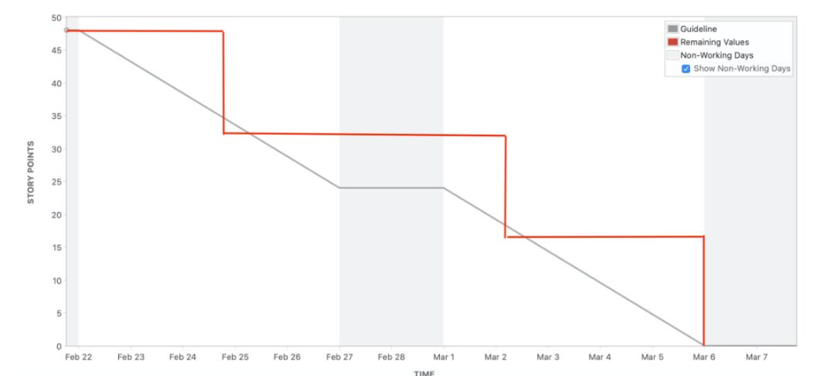

Sprint burndown Chart-
It can be used to track the total work remaining in the sprint, and to project the likelihood of achieving the sprint goal. By tracking the remaining work throughout the sprint, a team can manage its progress, and respond to trends accordingly.
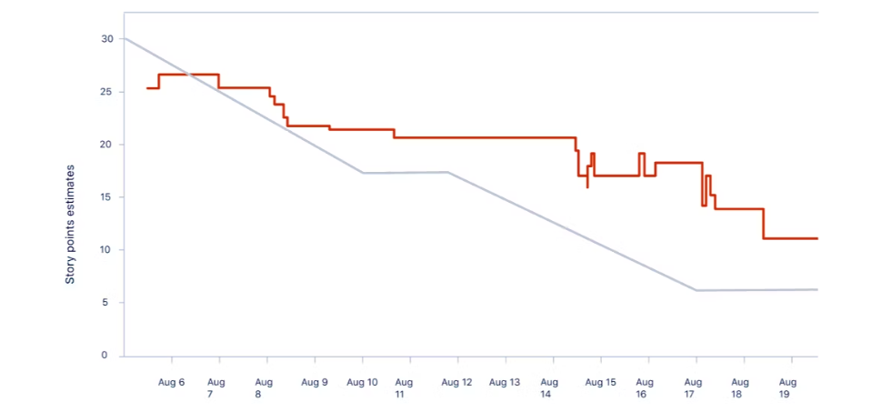

Document 6: Sprint meetings
Sprint Planning meeting-
Date | 10.02.2025
Time | 10:00 AM
Location | Pune
Prepared By | Vijay
Attendees | Scrum Master Vijay  Product owner Vishnu E  Scrum developer 1 Sneha  Scrum developer 2 Bharath Kumar  Scrum developer 3 Arun Kumar

Agenda Topics-
Topic | Presenter | Time allotted
Scopes | Vijay | 11.00 am to 11.15 am
Strategy & planning | Vishnu, Vijay | 11.20 am to 11.35 am
Resource Management | Vijay | 11.40 am to 12.00 pm
Billing & in voices | Vishnu | 12.05 am to 12.20 pm
GD | Vishnu | 12.30 pm to 01.15 pm

Other Information-
Observers | Tester team, SME
Resources | Manpower: business stakeholder from XYZ, Product owner, scrum master,  Developer, project team, etc.  Time: 3 years  Budget: Billing basis  Other: Database, Internet, Past transaction History, Reports
Special Notes | Clients would be onboarded virtually from the Legacy tool

Sprint review meeting-
Date | 14.02.2025
Time | 10:00 AM
Location | Pune
Prepared By | Vijay
Attendees | Scrum Master Vijay  Product owner Vishnu E  Scrum developer 1 Sneha  Scrum developer 2 Bharath Kumar  Scrum developer 3 Arun Kumar  Tester 1 Arundhathi A

Sprint status | Things to demo | Quick updates | What's next
Sprint 1: Done | Login page with login  ID and authenticating  With Microsoft  authenticator | All features enable | Deploy in live  environment

Sprint retrospective meeting-
Date | 14.02.2025
Time | 5:00 PM
Location | Pune
Prepared By | Vijay
Attendees | Scrum Master Vijay  Product owner Vishnu E  Scrum developer 1 Sneha  Scrum developer 2 Bharath Kumar  Scrum developer 3 Arun Kumar  Tester 1 Arundhathi A

Agenda | What went well | What didn't go  Well | Questions | Reference
Sprints analysis | All the sprint  backlog covered  in time.  Sign-off taken  for first  iteration | Had issue while  approval  module code | UAT, and unit  testing has to  complete | SME, PO

Daily Stand-up meeting-
Question | Name/Role | Week “1” (from 10-02-2025 to 14-02-2025)
Question | Name/Role | Monday | Tuesday | Wednesday | Thursday | Friday
What did you do yesterday? | Developer 1  Developer 2  Developer 3 | Have  worked  in login  page | Completed login  page | Login page  completed | Completed  searching  page | Search  option  completed
What will you do today? | Developer 1  Developer 2  Developer 3 | Have to  complete by  today | Recoding  login has  some  errors | Code on  searching  correct product | Recoding  error  codes | Checking for previous TRN id  option
What (if any) is blocking your progress? | Developer 1  Developer 2  Developer 3 | Few bugs | Nope | Few bugs | Nope | Few bugs

