Document 1- Business case document
- Why is this project initiated?
This project is initiated to digitally transform student management within the institution. The current system is manual and inefficient, leading to errors, delays, and high administrative workload. The aim is to centralize academic, financial, and administrative student data in one secure and efficient digital platform to improve operations, decision-making, and student satisfaction.

- What are the current problems?
The current system is facing multiple issues:
- Manual maintenance of records is time-consuming and error-prone.
- Data is scattered across departments, lacking centralization.
- No real-time access to student performance and academic data.
- Communication between students and admin is inefficient.
- No unified platform for managing fees, attendance, and academics.
- High administrative burden due to disconnected systems and paper-based processes.

- With this project how many problems could be solved?

This project can resolve the majority of existing problems, including:
- Centralizing all student-related data and processes.
- Automating registration, attendance, and grade management.
- Enabling real-time access to academic records.
- Reducing manual work by 70% or more.
- Improving communication and grievance redressal.
- Enhancing student experience with personalized dashboards.

- What are the resources required?

Human Resources:
- Project Manager
- Business Analyst
- Software Developers
- Testers
- Subject Matter Experts (from academic/admin teams)
- Administrative Staff & Faculty
- Training Specialists
- Technical Support & Security Advisor
Technology and tools:
- Development framework and languages: JavaScript, Python
- Database management systems: MySQL
- Testing Tools

Other Requirements:
- Hardware and Software infrastructure
- Budget of ₹15,00,000
- Project Timeline: 9 months (including development, testing, deployment, and support)

- How much organizational change is required to adopt this technology?
A moderate organizational change is required:
- Transition from manual to automated systems.
- Staff training on using the new platform.
- Redesign of some internal processes to align with the digital system.
- Cultural shift toward technology-driven operations. This change is essential but manageable with proper training and support.

- Time frame to recover ROI?
Based on the: Reduction in manual labor and paperwork, Improved efficiency and productivity, Long-term cost savings, The ROI can be expected to be recovered within 1–2 years after full implementation.

- How to identify Stakeholders?
Identifying stakeholder involves understanding who will be affected by the project or who has an interest in its outcome. Conducting interviews and surveys within the organization. Mapping who is affected by the system and who interacts with student data. Key stakeholders include:
- Administrative and Academic Staff
- IT Department
- Students and Parents
- Project Sponsor
- Project Manager
- External software vendors (for integrations)
These stakeholders should be involved early in requirement gathering and testing phases

Document 2: BA Strategy
Write BA Approach strategy (As a business analyst, what are the steps that you would need to follow to complete a project-What Elicitation Techniques to apply, how to do Stakeholder Analysis RACI/ILS, What Documents to Write, What process to follow to Sign off on the Documents, How to take Approvals from the Client, What Communication Channels to establish n implement, How to Handle Change Requests, How to update the progress of the project to the Stakeholders, How to take signoff on the UAT-Client Project Acceptance Form)

Answer 2:
- Elicitation Techniques
As a BA I will be using Stakeholder Interviews Technique as It is used to gather information directly from stakeholders by asking them questions.
An interview is a one-on-one conversation between the BA and a stakeholder (like a teacher, admin, or IT person) to understand their needs, problems, and expectations about the system or project.

- Stakeholder analysis RACI
Stakeholder analysis can be done by using the RACI matrix involves identifying stakeholders and defining their roles and responsibilities within a project. – Identify Stakeholders, Define Roles and Responsibilities, Create the RACI Matrix, Assign RACI Roles.
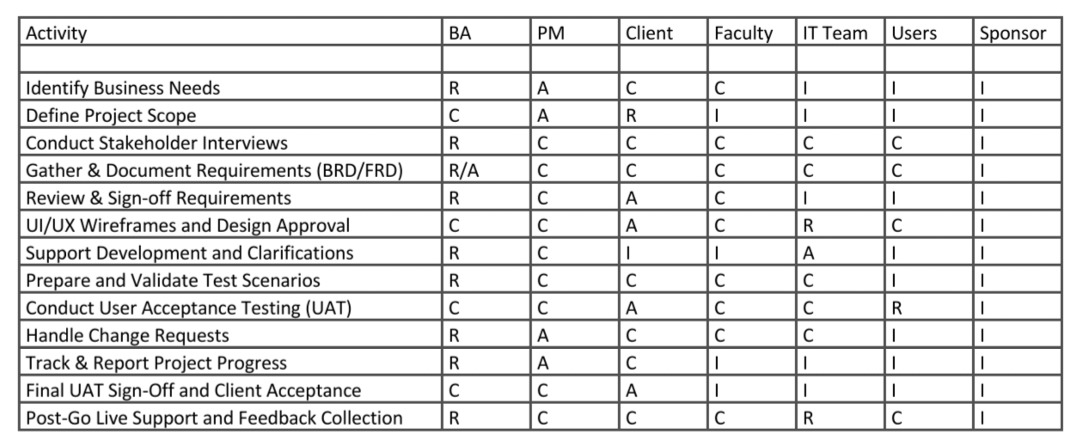
- What Documents to Write?

- Scope
- Solution Architecture diagram
- Technology specification
- FRD-Functional and Non-functional documents
- BRD
- Project Time line (gantt chart)
- Risks and mitigation plan
- Change management
- Standard Terms and conditions
- Sign off documents
- Use Case Documents
- User Stories
- User Acceptance Testing (UAT) Plan

- What process to follow to Sign off on the Documents?
- Share draft documents with stakeholders for review and feedback
- Incorporate feedback and revisions as necessary.
- Obtain formal sign-off from stakeholders indicating their acceptance of the documents.
- Maintain version control to track changes and updates.

- How to take Approvals from the Client?
Whenever we seek approval from a manager or client , we will have to draft a request for an approval letter.

By following These steps we can get approvals efficiently:
- Prepare the Document/Deliverable
- Present finalized documents to the client for approval.
- Provide explanations and clarifications as needed to ensure understanding.
- Obtain formal approval from the client through signed agreements or email confirmation.

- What Communication Channels to establish n implement?

- Video conferencing
- Face to Face communication-physical meeting
- Phone calls
- Emails
- Text messages
- Online messaging platform(skype, teams)
- Establish regular meetings with stakeholders to discuss project progress, issues, and updates.
- Utilize email, project management software, and collaboration tools for asynchronous communication.
- Maintain an open-door policy for stakeholders to raise concerns or provide feedback

- How to Handle Change Requests:

- Change Request Form: Use a Change Request Form (CRF) to document the request.
- Impact Analysis: Assess how the change affects
- Approval Process: Share the impact analysis with key stakeholders.
- Documentation: Update project documents (SRS, design, schedule, etc.).

- How to update the progress of the project to the Stakeholders:

- Provide regular updates on project milestones, deliverables, and risks.
- Use status reports, dashboards, and presentations to communicate progress effectively.
- Highlight achievements, challenges, and upcoming tasks to keep stakeholders informed.

- How to take signoff on the UAT- Client Project Acceptance Form

- Coordinate User Acceptance Testing (UAT) with the client to validate that the software meets requirements.
- Provide clear instructions and test cases for the client to execute during UAT.
- Obtain sign-off on the UAT-Client Project Acceptance Form once the client confirms satisfaction with the software functionality.

Document 3- Functional Specifications
Answer 3:

Project Name: | Campuslink: Student Management Application
Customer Name: | ABC Institute
Project Version: | SMA-1.0
Project Sponsor: | ABC Educational Board
Project Manager: | Anushk Porwal
Project Initiation Date: | 01st July 2025

Functional Requirement specifications: define the specific behaviour, functions or operation of a system. They describe what the system should do, outlining the necessary tasks, actions or activities it must perform to achieve its objective.
 | Req. ID | Req. Name | Description
 | FR001 | Login to portal | User should be able to log in using role-based credentials (Admin/Faculty/Student).
 | FR002 | Student registration | Admin should be able to register a new student with all required academic and personal details.
 | FR003 | Attendance management | Faculty should be able to mark and view attendance records for each student.
 | FR004 | Fee payment tracking | Admin should be able to track and update fee payment status for each student.
 | FR005 | Grade management | Faculty should be able to upload and update student exam scores and generate results.
 | FR006 | Timetable display | Students should be able to view their class timetable as per their course and semester.
 | FR007 | Communication alerts | System should send notifications to students and faculty for deadlines, events, and alerts.
 | FR008 | Document upload | Students should be able to upload documents like ID proofs, certificates, etc.
 | FR009 | Reports & dashboards | Admin should be able to generate academic, attendance, and fee reports in tabular or graphical format.
 | FR010 | Grievance submission | Students should be able to raise grievances and track their resolution status.

Non-Functional requirements will describe the qualities and attributes of a system, focusing on how the system performs rather than specific behaviour or functions.

Req. ID | Req. Name | Description
NFR001 | Usability | The system should have an intuitive and easy-to-navigate interface for all users.
NFR002 | Performance | Pages and reports should load within 3 seconds.
NFR003 | Scalability | The application should handle concurrent access by at least 1000 users.
NFR004 | Security | All student data should be encrypted and role-based access must be enforced.
NFR005 | Availability | The system should have 99.9% uptime during academic working hours.
NFR006 | Compatibility | The application should run across desktops, tablets, and mobile devices.
NFR007 | Data backup & recovery | The system must perform daily backups and support quick recovery in case of failure.
NFR008 | Responsiveness | System must respond to user actions within 2 seconds.
NFR009 | Maintainability | The application should be easily upgradable and maintainable for future versions.
NFR010 | Transparency and Accuracy | The system must ensure accurate and consistent data across modules

Document 4- Requirement Traceability Matrix
Answer 4:
Req. ID | Req. Name | Description | Design | D1 | T1 | D2 | T2 | UAT
FR001 | Login to portal | User should be able to log in using role-based credentials (Admin/Faculty/Student). | Yes | Yes | Pending | Yes | No | Yes
FR002 | Student registration | Admin should be able to register a new student with all required academic and personal details. | Yes | Yes | Yes | No | Yes | In Progress
FR003 | Attendance management | Faculty should be able to mark and view attendance records for each student. | Yes | No | Yes | Yes | Yes | No
FR004 | Fee payment tracking | Admin should be able to track and update fee payment status for each student. | In  Progress | Yes | No | No | No | Yes
FR005 | Grade management | Faculty should be able to upload and update student exam scores and generate results. | Yes | Yes | In Progress | No | Yes | Yes
FR006 | Timetable display | Students should be able to view their class timetable as per their course and semester. | Yes | Yes | Yes | Pending | No | No
FR007 | Communication alerts | System should send notifications to students and faculty for deadlines, events, and alerts. | Yes | Yes | Yes | Yes | Yes | In  Progress
FR008 | Document upload | Students should be able to upload documents like ID proofs, certificates, etc. | No | Yes | Yes | No | Yes | No
FR009 | Reports & dashboards | Admin should be able to generate academic, attendance, and fee reports in tabular or graphical format. | In  Progress | Yes | Yes | No | Yes | No
FR010 | Grievance submission | Students should be able to raise grievances and track their resolution status. | No | Yes | Pending | Yes | Pending | In Progress

Req. ID | Req. Name | Description | Design | D1 | T1 | D2 | T2 | UAT
NFR001 | Usability | The system should have an intuitive and easy-to-navigate interface for all users. | Yes | Yes | Pending | Yes | No | Yes
NFR002 | Performance | Pages and reports should load within 3 seconds. | Yes | Yes | Yes | No | Yes | In Progress
NFR003 | Scalability | The application should handle concurrent access by at least 1000 users. | Yes | No | Yes | Yes | Yes | No
NFR004 | Security | All student data should be encrypted and role-based access must be enforced. | In  Progress | Yes | No | No | No | Yes
NFR005 | Availability | The system should have 99.9% uptime during academic working hours. | Yes | Yes | In Progress | No | Yes | Yes
NFR006 | Compatibility | The application should run across desktops, tablets, and mobile devices. | Yes | Yes | Yes | Pending | No | No
NFR007 | Data backup & recovery | The system must perform daily backups and support quick recovery in case of failure. | Yes | Yes | Yes | Yes | Yes | In  Progress
NFR008 | Responsiveness | System must respond to user actions within 2 seconds. | No | Yes | Yes | No | Yes | No
NFR009 | Maintainability | The application should be easily upgradable and maintainable for future versions. | In  Progress | Yes | Yes | No | Yes | No
NFR010 | Transparency and Accuracy | The system must ensure accurate and consistent data across modules | No | Yes | Pending | Yes | Pending | In Progress

Document 5: BRD Template
Answer 5:
Project Title: Campuslink- Student Management Application
Prepared By: Anushk Porwal, Business Analyst
Date: [8th July 2025]
Version: 1.0

Contents

1.Document Revisions………………...................................................................................................... 11 2. Approvals....................................................................................................................................... 11
3. RACI Chart for This Document......................................................................................................... 11
4. Introduction............................................................................................................................. 12 4.1. Business Goals............................................................................................................................. 12
4.2. Business Objectives...................................................................................................................... 12
4.3. Business Rules............................................................................................................................. 13
4.4. Background................................................................................................................................. 14
4.5. Project Objective......................................................................................................................... 15
4.6. Project Scope............................................................................................................................... 16
4.6.1. In Scope Functionality.............................................................................................................. 16
4.6.2. Out Scope Functionality............................................................................................................ 16
5. Assumptions................................................................................................................................... 17
6. Constraints..................................................................................................................................... 18
7. Risks................................................................................................,…........................................... 19
- Technological Risks.................................................................................................................... 19
- Skills Risks.................................................................................................................................. 19
- Political Risks............................................................................................................................. 20
- Business Risks........................................................................................................................ 20
8. Business Process Overview.................................................................................................... 21
8.1. Legacy System (AS-IS)..................................................................................................... 21
8.2. Proposed Recommendations (TO-BE)............................................................................ 21
9. Business Requirements ......................................................................................................... 21
10. Appendices......................................................................................................................... 21
10.1. List of Acronyms .........................................................................................................21
10.2. Glossary of Terms....................................................................................................... 21
10.3. Related Documents .................................................................................................... 21
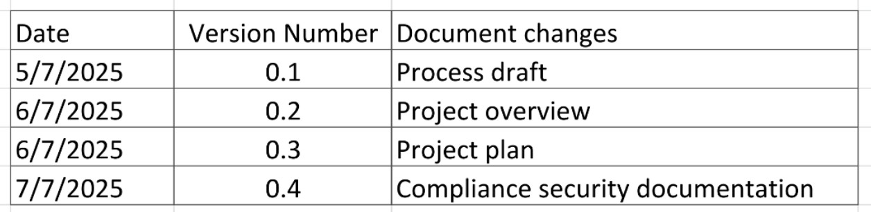
- Document Revisions:

- Approvals :
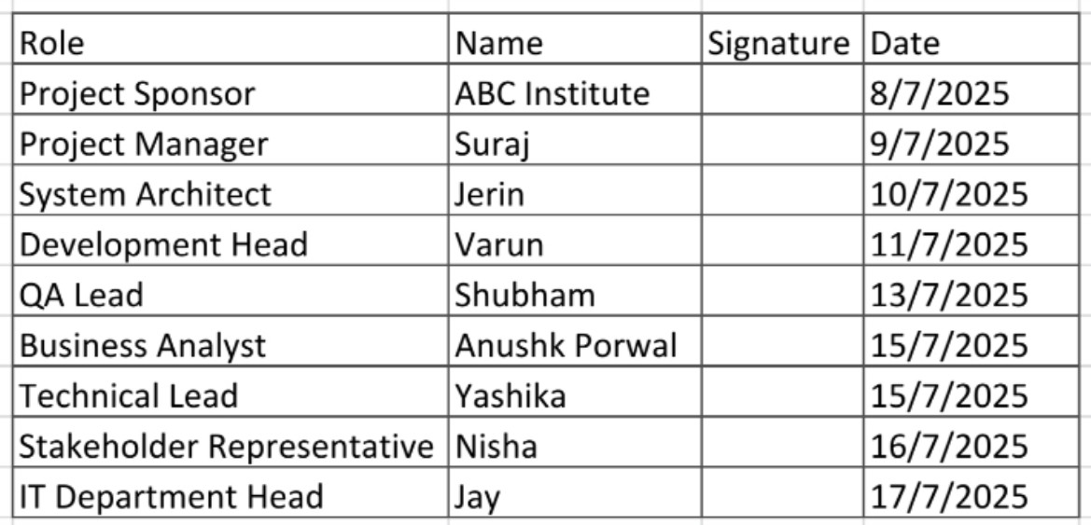

- RACI Chart:

A RACI chart helps clarify roles and responsibilities for tasks within a project. It stands for Responsible, Accountable, Consulted, and Informed

- Business Goals:

- Digital Transformation: Shift from manual, paper-based processes to a fully digital student management ecosystem.
- Operational Efficiency: Reduce administrative burden by automating key student lifecycle activities like registration, attendance, and grading.
- Data Centralization: Create a single source of truth for all academic, financial, and administrative student data.
- Student-Centric Services: Improve student satisfaction through better access to academic records, personalized dashboards, and faster grievance handling.
- Compliance and Reporting: Ensure timely compliance with educational board/government regulations and enhance internal reporting and analytics.

- Business Objectives:

- Achieve 100% digital record-keeping for student data within the first academic year.
- Automate at least 70% of manual processes like fee tracking, attendance, and results publishing.
- Enable role-based access for Admin, Faculty, Students, and Parents with real-time data access.
- Reduce student query response time by 50% through streamlined communication and alert systems.
- Integrate with existing systems such as ERP, exam software, and payment gateways within 6 months.
- Ensure data accuracy and reduce errors in student records by at least 80% by replacing manual entries.

- Business Rules:

- BR001 – Role-Based Access Control: Only authorized users (Admin, Faculty, Student, Parent) may access the system, and each role must have access only to permitted modules and data.
- BR002 – Unique Student Identification: Each student must be assigned a unique Student ID at the time of admission, which will be used to track all academic and administrative activities.
- BR003 – Mandatory Fields for Registration: Fields such as student name, date of birth, mobile number, address, guardian details, and photo must be mandatory during student registration
- BR004 – Attendance Cut-off Criteria: Students must maintain a minimum of 75% attendance to be eligible for final exams, as per university policy.
- BR005 – Automated Fee Reminder: The system must auto-generate reminders for fee due dates via email/SMS 7 days before the due date and on the due date.
- BR006 – Grade Calculation Formula: Final grades must be calculated based on predefined weightage: 40% internal assessment + 60% external examination.
- BR007 – Restricted Modification of Records: Student academic records and fee transactions can only be edited by the admin, and only with proper authorization and logging.
- BR008 – Exam Eligibility Check: A student is eligible to appear for an exam only if all dues are cleared and the required documents are verified.
- BR009 – Data Backup Frequency: System data must be backed up daily and stored in a secure cloud location to prevent data loss.
- BR010 – Grievance Resolution Timeline: All student grievances must be acknowledged within 24 hours and resolved within 7 working days.

- Background

In many educational institutions, student data is still managed manually or through disconnected systems, leading to inefficiencies, data inaccuracy, and administrative burden. Academic records, fee details, attendance, and communication are often scattered across departments, making it difficult to track and manage student progress effectively. This project was initiated to overcome these challenges by developing a centralized, digital Student Management Application that integrates all academic, administrative, and financial information onto a single platform. The aim is to enhance data accuracy, streamline operations, reduce manual workload, and improve the overall student and faculty experience through automation and real-time access to information.

- Project Objectives

- Centralized Student Information: To create a unified platform that consolidates academic, administrative, and financial data of all students.

- Streamline Academic Processes: To automate student lifecycle processes like registration, attendance, grading, and promotion for improved efficiency.

- Reduce Administrative Burden: To minimize manual tasks by at least 70%, allowing staff to focus on more value-driven activities.

- Enable Real-Time Access: To provide real-time access to student records, fee status, results, and attendance to all stakeholders (admin, faculty, students, parents).

- Enhance Data Accuracy and Security: To improve data integrity by reducing manual errors and ensuring role-based, secure access to sensitive student information.

- Integration with External Systems: To integrate seamlessly with existing systems such as ERP, examination software, and payment gateways.

- Project Scope:
The scope defines the boundaries of the project in terms of what functionalities and features are included (In-Scope) and what are explicitly excluded (Out-of-Scope) from the current implementation phase.

In-Scope Functionalities

- Student Registration & Profile Management: Capture and manage student personal, academic, and document details.
- Attendance Management: Faculty can mark attendance, and students/parents can view it in real time.
- Fee Management: Track fee payment status, generate fee receipts, send due reminders.
- Academic Record Management: Upload and manage internal/external exam scores and calculate grades.
- Role-Based Access: Access control for different user roles – Admin, Faculty, Student, Parent.
- Grievance Redressal System: Students can raise issues/queries, and admins can resolve and track them.

Out-of-Scope Functionalities

- Learning Management System (LMS): No course content delivery, online assignments, or quizzes included.
- Payment Gateway Integration: Fee data will be updated manually or via existing systems, no new online payment gateway.
- Placement or Career Services Module: Job portal, resume uploads, or placement tracking is not in current scope.
- Library Management: Book issuance, return tracking, and library catalog features are excluded.

- Project Assumptions:

- Stakeholder Availability: All key stakeholders (Admin, Faculty, IT Team, and Management) will be available for timely inputs, approvals, and validations during the project lifecycle.
- Stable Internet & Infrastructure: The institution has or will provide a reliable internet connection and necessary hardware infrastructure (servers, computers) to support the web-based application.
- User Readiness: Faculty, admin staff, and students are open to transitioning from manual processes to a digital system and will actively participate in training sessions.
- Data Availability: Required historical student data (academic records, fees, attendance, etc.) will be available in structured formats for initial migration into the system.
- Third-Party Systems Are Accessible: Any existing ERP, exam software, or other legacy systems required for integration will be accessible and compatible for integration.
- Legal & Compliance Support: All necessary approvals from regulatory or educational boards will be obtained by the institution as per schedule.
- Budget & Resources Are Fixed: The project will be executed within the approved budget (₹15,00,000) and within the allocated timeline of 9 months.
- No Major Policy Changes: Institutional policies and academic processes will remain largely stable during the course of development.

- Project Constraints:

- Time Constraint: The entire project (from planning to post-deployment support) must be completed within 9 months, as per institutional timelines.
- Budget Constraint: The total budget for the project is ₹15,00,000, which includes development, testing, training, support, and infrastructure setup.
- Resource Availability: Limited availability of internal stakeholders (faculty, administrative staff, IT team) for interviews, validations, and UAT may restrict project progress.
- Data Migration Complexity: Historical student data exists in various formats (manual registers, Excel files, PDFs), and only a partial dataset may be available for accurate migration.

- Risks:

1. Technological Risk
- New technologies used might not be compatible with existing systems.
- Server or software performance issues could impact user experience.
- Integration with ERP or exam systems may fail or be delayed.

2. Skill Risk
- Developers or testers may lack experience in building educational systems.
- Faculty or admin staff may struggle to adapt to the new digital tools.
- Training may be insufficient for end-users (especially non-technical staff).

3. Political/Regulatory Risk
- Changes in educational board rules or government policies could affect system requirements.
- Delay in getting approvals from higher authorities may pause progress.
- Non-compliance with regulations could lead to rework or rejection.

4. Business Risk
- The project may exceed the ₹15,00,000 budget if scope or timelines change.
- If the system doesn't meet stakeholder expectations, adoption may be low.
- Delay in project delivery could affect academic schedules and exams.

5. Data Migration Issue
- Historical student data may be incomplete, outdated, or in inconsistent formats.
- Manual records might be hard to convert into digital format.
- There’s a risk of data loss or duplication during migration.

6. Requirement Risk
- Stakeholders may provide unclear or changing requirements after development starts.
- Misunderstanding user needs can lead to features that are not useful.
- Late discovery of missing requirements can cause delays and rework.

- Business Process Overview

Legacy System (AS-IS)

- Manual student registration using physical forms and Excel sheets.
- Attendance recorded manually in registers by faculty.
- Fee collection tracking maintained through separate accounting software or paper records.
- Exam results entered manually and distributed physically or via email.
- Communication done through notice boards, phone calls, or emails (non-centralized).
- Grievances handled manually with no tracking system.
- Data spread across departments, with no central access.
- Reporting is time-consuming, done manually using multiple sources.
- Data backup is inconsistent or done manually.
- High risk of errors, duplication, and delays in student-related operations.

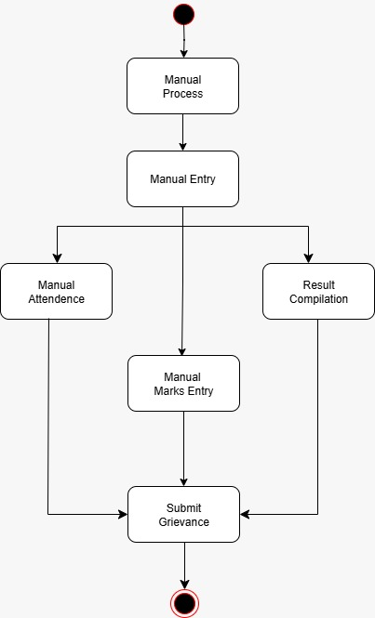

Proposed System (TO-BE)

- Online student registration with automated form submission and verification.
- Digital attendance system – faculty can mark attendance online with real-time visibility for students and admin.
- Integrated fee management with payment tracking, receipts, and due alerts in one place.
- Online exam result publishing with grade calculation and student access portals.
- Centralized communication system with SMS/email notifications and announcements.
- Structured grievance module to submit, track, and resolve student issues efficiently.
- Single, centralized database for academic, financial, and administrative data.
- Automated reporting and dashboards for real-time insights and analytics.
- Daily automatic data backup for security and reliability.
- Reduced human error and increased speed through system automation and standardization.

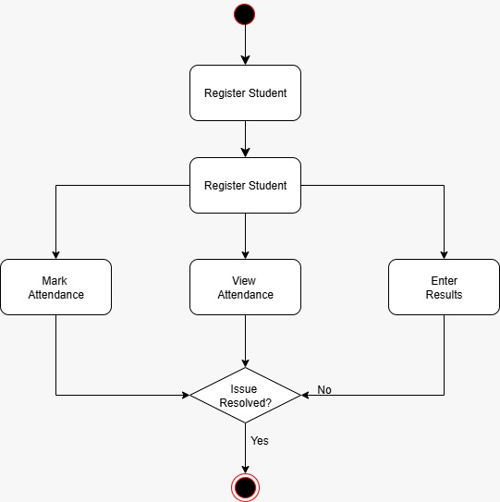
- Business Requirement:

Functional requirements
  - Student Registration: System must allow admin to register new students and update their profiles.
  - Attendance Management: Faculty should be able to mark and view attendance online. Students and admin can track attendance records.
  - Fee Management: System should allow fee status tracking, payment logging, and auto-alerts for due payments.
  - Examination and Grade Management: Faculty must be able to upload marks, and the system should calculate final grades automatically.
  - Grievance Redressal Module: Students should be able to raise complaints, and admins should manage resolution status.
  - Timetable & Academic Scheduling: Students should be able to view subject-wise class schedules online.
  - Login and Role-Based Access: System must provide secure login for admin, faculty, students, and parents with specific access rights.
  - Document Management: Users must be able to upload and view documents such as ID proofs, grade sheets, certificates.
  - Communication Module: System should send SMS/Email notifications for events, fees, results, and updates.
  - Report Generation and Dashboard: Admin should be able to generate academic, financial, and attendance reports in various formats.

Non-Functional Requirements:
  - Performance: The system should respond to user actions within 2–3 seconds.
  - Scalability: It should support at least 1000+ concurrent users without performance drop.
  - Usability: Interface must be user-friendly and easy to navigate for non-technical users.
  - Availability: The system must be available 99.9% of the time during working hours.
  - Security: All sensitive data must be encrypted, and access should be based on user roles.
  - Maintainability: The system must be easy to update and maintain with minimal downtime.
  - Compatibility: The application must run across common browsers (Chrome, Edge, Firefox) and devices (desktop/tablet).
  - Backup & Recovery: Automatic daily backups must be in place, with the ability to recover data within 2 hours.
  - Compliance: The system should comply with data protection policies and education board regulations.

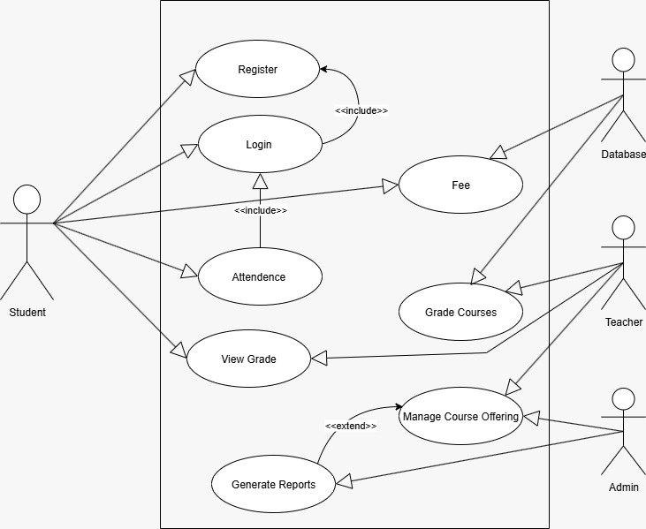
- Appendices:

- List of acronyms
- R (Responsible): The person or team responsible for completing the task.
- A (Accountable): The person ultimately accountable for the task's success and has decision-making authority.
- C (Consulted): Individuals or groups to be consulted for input and feedback.
- I (Informed): Individuals or groups who need to be kept informed of progress and decisions.
- UAT: User Acceptance Testing
- BRD: Business Requirement Document
- UI: User Interface

- Glossary of Terms
NA

- Related Documents
All related documents attached herein
- Project overlook
- Signoff Documents
- Stakeholder Analysis
- Mailer
- Functional Specifications

