BRD

Project Name: Centralized Inventory & Delivery Optimization System
Client: Ice-Cream & Milk Products by MilkyWay
Prepared By: Mugdha Borhade – Business Analyst
Version: 1.0
Date: 11-Aug-2025

- Document Revisions

Version | Date | Author | Description of Change
1 | 11-Aug-25 | Mugdha Borhade | Initial draft for client review

- RASCI Chart for This Document

Activity | BA | PM | Dev Team | QA Team | Client SME | IT Ops
Requirement Gathering | R | S | I | I | C | I
BRD Preparation | R | A | I | I | C | I
Solution Design | C | S | R | I | C | I
Development | I | S | R | I | I | C
Testing & UAT | S | S | S | R | C | I
Deployment | I | S | C | I | I | R

4.1. Business Goals
- Ensure accurate real-time inventory tracking across all plants & warehouses.
- Reduce product wastage due to expiry.
- Achieve faster delivery times with optimized routing.
- Enable data-driven decision-making via analytics dashboards.

4.2. Business Objectives
- Centralize inventory data from multiple sites.
- Automate delivery route planning using location & traffic data.
- Improve customer satisfaction by reducing delivery delays.
- Provide warehouse managers with predictive replenishment alerts.

4.3. Business Rules
- Perishable products must be dispatched based on First Expiry First Out (FEFO).
- Orders cannot be assigned to warehouses with stock levels below safety thresholds.
- Delivery vehicles must comply with cold chain requirements.

4.4. Background
Currently, stock is tracked manually using spreadsheets at each warehouse.
Delivery assignments are done manually without considering real-time location data, leading to delays and inefficient logistics.

4.5. Project Objective
Develop a web-based and mobile-enabled platform to integrate inventory management with automated delivery scheduling.

4.6. Project Scope

4.6.1. In Scope Functionality
- Real-time inventory tracking
- Order management system
- Route optimization engine
- Role-based dashboards
- Reports & analytics

4.6.2. Out Scope Functionality
- Payment processing
- Manufacturing process automation

5. Assumptions
- All warehouses have stable internet connections.
- GPS-enabled vehicles or delivery partner API is available.
- Accurate initial master data will be provided by the client.

6. Constraints
- Perishable nature of products limits storage time.
- Seasonal demand fluctuations may impact delivery scheduling.
- Integration dependent on third-party mapping APIs.

7. Risks

Technological Risks
- API downtime from map service provider.

Skills Risks
- Limited in-house technical expertise for advanced route optimization.

Political Risks
- Regional regulations on cold storage transport.

Business Risks
- Loss of sales if inventory system fails.

Requirements Risks
- Scope creep due to evolving delivery requirements.

Other Risks
- User adoption resistance.

8. Business Process Overview

8.1. Legacy System (AS-IS)
- Inventory tracked manually in spreadsheets.
- Delivery planning done by phone calls and manual route mapping.
- No centralized visibility across warehouses.

8.2. Proposed Recommendations (TO-BE)
- Automated stock updates in centralized system.
- AI-driven delivery route optimization.
- Integrated dashboard for warehouse, sales, and logistics teams.

9. Business Requirements

Req ID | Requirement
REQ-001 | Real-time stock level tracking across all warehouses
REQ-002 | Batch tracking with expiry date alerts
REQ-003 | Customer order placement & tracking
REQ-004 | Route optimization considering location & traffic
REQ-005 | Reports for stock, wastage, and delivery performance

10. Appendices

10.1. List of Acronyms
- BRD – Business Requirements Document
- UAT – User Acceptance Testing
- FEFO – First Expiry First Out

10.2. Glossary of Terms
- Route Optimization – Algorithmic calculation of the shortest delivery path.
- Batch Tracking – Monitoring products based on manufacturing batch.

10.3. Related Documents
- AS-IS & TO-BE Process Flows
- Requirement Traceability Matrix (RTM)

11. Process flow diagram :

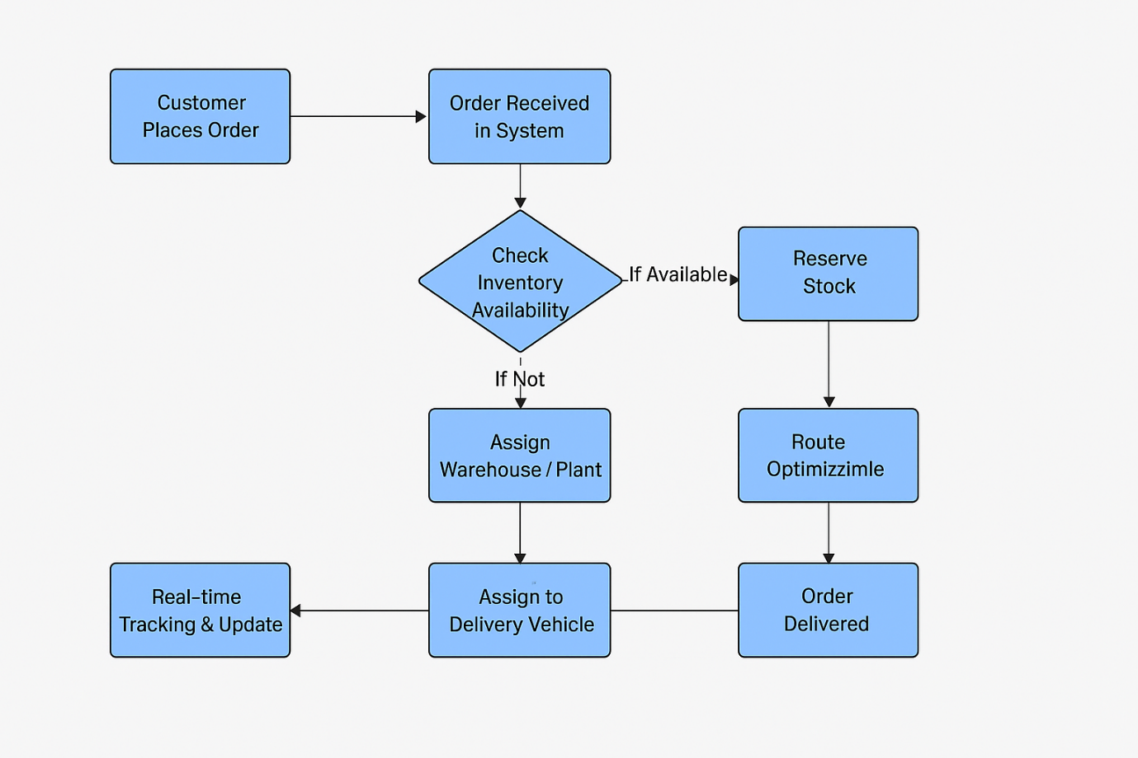

Assignment 2

1. Introduction Letter to Client
Subject: Introduction as Business Analyst – Project Initiation for Online Store Platform
Dear Mr. M.S.Deshmukh,
I hope this message finds you well.
My name is Mugdha Borhade, and I will be serving as the Business Analyst for FreshCart Retail Pvt. Ltd.’s new Online Store Platform project. My primary role will be to work closely with you and your team to understand the business needs, capture requirements, and translate them into clear and actionable specifications for our development and QA teams.
Over the coming days, I will initiate the business understanding phase, during which we will:
- Conduct stakeholder interviews.
- Analyse existing processes and systems (if applicable).
- Define and document business requirements in a structured format.
- Align on project goals, scope, and success criteria.
My aim is to ensure that the final solution aligns perfectly with your business objectives, addresses current challenges, and delivers measurable value.
I look forward to collaborating with you and your team to make this project a success. Please feel free to reach out to me at any time for discussions or clarifications.
Best Regards,
Mugdha Borhade
Business Analyst
borhade.mugdha@tcs.com | 9607857882

2. Brief BRD & SRS – Online Store for FreshCart Retail Pvt. Ltd.

BRD – Online Store
Business Objectives:
- Enable customers to browse, search, and purchase grocery products online.
- Provide real-time inventory visibility from all FreshCart outlets.
- Support secure and multiple online payment options.
- Enhance customer experience with same-day delivery and order tracking.
Scope (In Scope):
- Product catalogue & categories.
- Shopping cart.
- Checkout & payment processing.
- Order tracking.
- User account management.
Scope (Out of Scope):
- Physical store POS enhancements.
- In-person payment handling.
High-Level Requirements:
- System should allow customers to register/login.
- Customers can browse products by category, brand, or search keywords.
- System supports multiple payment methods (cards, UPI, net banking).
- Customers can view order history and track orders in real-time.

SRS – Online Store
Functional Requirements:
- User Registration & Login
  - Register with email, phone number, or social accounts.
- Product Search & Filter
  - Search by name, category, brand, or price range.
- Shopping Cart
  - Add, remove, and update product quantities.
- Checkout
  - Apply discount codes, select delivery slot, choose payment method.
- Order Tracking
  - View shipment status and delivery ETA.
Non-Functional Requirements:
- Performance: Pages should load in <3 seconds.
- Security: PCI-DSS compliance for payment data encryption.
- Availability: Minimum 99.9% uptime.

3. ERD – Support Ticket / Ticketing Life Cycle
Entities & Attributes:
- User
  - User_ID (PK)
  - Name
  - Email
  - Phone
- Ticket
  - Ticket_ID (PK)
  - User_ID (FK)
  - Category_ID (FK)
  - Priority_ID (FK)
  - Status_ID (FK)
  - Subject
  - Description
  - Created_Date
  - Closed_Date
- Category
  - Category_ID (PK)
  - Category_Name (Order Issue, Payment Issue, Product Query, Technical Issue)
- Priority
  - Priority_ID (PK)
  - Priority_Level (Low, Medium, High, Urgent)
- Status
  - Status_ID (PK)
  - Status_Name (Open, In Progress, Resolved, Closed)
- Agent
  - Agent_ID (PK)
  - Name
  - Email
- Ticket_History
  - History_ID (PK)
  - Ticket_ID (FK)
  - Updated_By (User_ID / Agent_ID)
  - Old_Status
  - New_Status
  - Update_Date
Relationships:
- A User can create many Tickets.
- A Ticket belongs to one Category, has one Priority, and has one Status at a time.
- A Ticket is assigned to one Agent.
- A Ticket can have many Ticket_History records.

4.User story of shopping from ecommerce.

I)Browsing & Searching Products
As a : Customer,
I want to : Browse and search for products by category, brand, and filters,
So that : I can easily find the products I need without wasting time.
Acceptance Criteria:
- Search works by product name and keywords.
- Filters include category, price range, and brand.
- Products display with image, name, price, and stock status

II) Shopping Cart Management
As a : Customer,
I want : To add, update, or remove items from my cart,
So that : I can adjust my purchase before checking out.
Acceptance Criteria:
- Adding a product shows updated cart count.
- Quantity can be adjusted in the cart.
- Removing an item updates the total price instantly.

III) Checkout Process
As a : Customer,
I want : To select a delivery address and payment method during checkout,
So that : I can complete my purchase conveniently.
Acceptance Criteria:
- Delivery address can be selected or added.
- Payment options include UPI, cards, and net banking.
- Order confirmation is displayed after successful payment.

IV) Order Tracking
As a : Customer,
I want : To track my order status from placement to delivery,
So that : I know when to expect my groceries.
Acceptance Criteria:
- Order status updates: Placed → Packed → Out for Delivery → Delivered.
- Tracking page shows estimated delivery time

V) Customer Registration & Profile
As a : New user,
I want : To create an account with FreshCart,
So that : I can save my details for faster future orders.
Acceptance Criteria:
- Registration via email or phone number.
- Profile stores name, contact details, and default address.

VI) Product Review & Ratings
As a : Customer,
I want : To rate and review products after purchase,
So that : Other customers can benefit from my feedback.
Acceptance Criteria:
- Rating is 1–5 stars.
- Reviews require order history for that product.
- Admin can moderate reviews.

