Aamir S
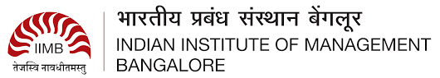
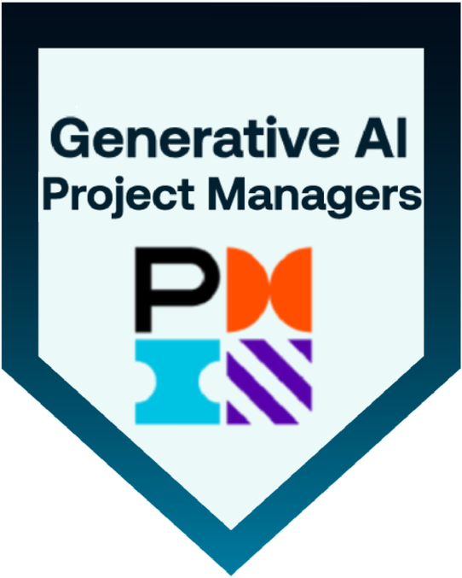
Sr Business Analyst | Product Owner
saifleader001@gmail.com
M: +91-9966577563
Linkedin
PROFESSIONAL SUMMARY

- Senior Business Analyst with 7+ years of experience in business analysis, requirement elicitation, documentation, process modeling, and functional testing. Experienced across all phases of the Software Development Life Cycle (SDLC), supporting cross-functional teams in translating business needs into technical solutions.
- Proficient in preparing BRD, SRS, and RTM documentation, with hands-on experience in UML modeling for use cases and activity diagrams. Skilled in requirements planning, facilitating stakeholder sessions, user story creation, and backlog prioritization in Agile environments.
- Well-versed in JIRA for project tracking, and Axure/Balsamiq for prototyping. Background includes stakeholder engagement in supply chain and brand management domains.
Achievements
- Best Employee Award for the years 2020 & 2021 at Arla Foods for consistently reducing the manual tasks by up to 40%.
- Got a Silver Award from Google Inc. along with a Certificate of Excellence for the best productivity as a lead of a Navigation Project.
Core Competencies:
- Agile Product Development, Backlog Management & Prioritization, Business Process Reengineering, KPI Tracking, Stakeholder Analysis, Change Management, User Training, Risk Analysis, Business Case Development, Data Modeling, UAT Planning, Agile Ceremonies, Requirements Elicitation, Workflow Optimization
Skills & Tools:
Programming Languages | Python, SQL.
Software Methodologies | Agile, Scrum, SDLC, Waterfall.
Databases | Oracle, MS SQL Server, PostgreSQL, MySQL
Operating Systems | Windows, Linux, Unix, macOS
Data Visualization Tools | Power BI, Tableau, Airtable
UI/UX Design & Prototyping Tools | Balsamiq, MS Visio, Axure RP, Figma, Adobe XD, Zephyr
Packages | MS SharePoint, MS Office, Airtable
Project Management & Collaboration Tools | Jira, Confluence

Certifications:
- Certified Generative Overview for Project Managers by PMI.
- IT Business Analyst Training from IIBA (COEPD)

PROFESSIONAL EXPERIENCE
Client: Renown Health, Reno, Nevada
Employer: ProhireIT Inc, Hyderabad, India
Role: Sr Business Analyst | Product Owner July 2024- Present
Responsibilities
- Defined and prioritized product backlog based on customer needs, business objectives, and stakeholder input to ensure value-driven delivery.
- Collaborated with cross-functional teams (engineering, design, data) to drive agile product development from discovery through release
- Ensured compliance with HIPAA standards while enhancing claims adjudication accuracy and reducing turnaround time by automating touchpoints in the claim lifecycle from charge capture to payment posting.
- Designed UML modeling, creation of Use Cases and Activity diagrams, Data Flow Diagrams (DFDs), Entity Relationship Diagrams (ERDs), and web page mock-ups using modeling tools.
- Created and prioritized product backlogs and user stories with clear acceptance criteria, enabling agile delivery across cross-functional teams.
- Conducted market/user research and competitor analysis & collaborated with design, tech, and data teams to drive product development.
- Quality Center & JIRA tool for project tracking management.

Client: Axia Women’s Health, Voorhees, New Jersey
Employer: Amvotech Solutions Inc, Hyderabad, India
Role: Sr Business Analyst June 2022- July 2024
Responsibilities:
- Collaborated with product managers and UI/UX teams to design mobile-first interfaces aligned with warehouse operations, incorporating barcode scanner compatibility and Salesforce Mobile App considerations.
- Created low- and high-fidelity prototypes of Healthcare HL7 using Figma and Balsamiq to validate user journeys and functional specifications.
- Created a Traceability Matrix to maintain the Traceability of the requirements.
- Supported integration efforts between ServiceNow HRSD and third-party HR systems.
- Conducted requirements elicitation using interviews, focus groups, surveys, and observation techniques to gather high-quality functional and non-functional requirements.
- Conducted detailed assessments of current-state ITSM processes and designed optimized workflows leveraging ServiceNow’s Flow Designer and Workflow Editor.
- Worked with the QA team for designing Test Plan and Test Cases for the User Acceptance testing (UAT) using
- Conducted ServiceNow-centric business analysis initiatives to identify and document functional requirements for ITSM modules, including Incident, Change, Problem, and Knowledge Management.

Arla Foods, Riyadh, KSA. Oct 2019 - May 2022
Role: Business Analyst
Project: Inter-nation Financial Management
Responsibilities
- Translated product vision into clear user stories and acceptance criteria, ensuring alignment with strategic goals and technical feasibility.
- Designed UML diagrams using MS Visio & increased efficiency and productivity by 30% by automating Brand management.
- Led sprint planning, product demos, and stakeholder communication to ensure timely delivery and measurable impact on key product metrics.
- Facilitated agile ceremonies, ensured timely sprints/demos, and championed best practices in Scrum and modern product management.
- Collaborated with supply chain operations SPOC to create backlog requirement & worked on end-to-end supply chain operation
- Authored user stories, wireframes, and process flows.
- Designed Tableau and ServiceNow dashboards to monitor stock levels, order cycles, and fulfillment KPIs.
- Led JAD sessions and implemented requirement traceability matrices (RTM), using MoSCoW prioritization to ensure delivery of high-impact features.
- Partnered with development teams to define user interactions and data bindings for Salesforce LWC

Dr. Mamdooh Ashy Hospitals, Jeddah, Kingdom of Saudi Arabia. August 2018 - Sept 2019
Role: Business Analyst
Responsibilities:
- Facilitated end-to-end business analysis by preparing BRDs, FSDs, and RTMs, SRS; gathered cross-functional requirements through interviews, workshops, and observations across HR, IT, and operations teams.
- Ensured regulatory compliance by aligning EMR system enhancements with Saudi Ministry of Health (MOH) standards; conducted gap analyses and coordinated with key stakeholders to meet functional requirements.
- Provided post-deployment support, including root cause analysis, issue resolution, and hypercare for HRSD and non-HR ServiceNow modules through JAD sessions and ongoing stakeholder coordination.
- Conducted impact analysis, stakeholder mapping, and process re-engineering using BPMN and UML; collaborated with product owners and SMEs to define user stories, acceptance criteria, and prioritize features in Agile environments.
- Utilized tools such as JIRA, Confluence, and Power BI to manage backlogs, document use cases.

Wathba International Company Ltd, Jeddah, Kingdom of Saudi Arabia. June 2014 - July 2018
Role: Asst. Manager
Responsibilities:
- Led cross-functional teams to plan, execute, and monitor IT service delivery and trade operations, ensuring timely execution of import/export processes, compliance with international trade regulations, and alignment with service-level agreements (SLAs).
- Managed vendor coordination, customs clearance documentation, shipping schedules, and ERP-based inventory systems, supported data integrations for Wathba merger with Ashy Group of Companies.
- Integrated WooCommerce with backend systems for real-time order and inventory sync.
- Connected ZKTeco fingerprint system to MS SQL Server for automated reporting.

Client: Google Inc., Hyderabad, India, Employer: GlobalLogic May 2011-May 2014
Role: Sr. Analyst/Team Lead, Content Engineering
Responsibilities:
- Tested front-end Maps interfaces and internal tools for Google Maps Local Data Operations to ensure GIS data accuracy.
- Supported quality control and documentation for GIS content and linear road segments, ensuring consistency across platforms.
- Led data quality initiatives by monitoring KPIs, resolving navigation and routing issues, and collaborating with product teams to enhance map accuracy.
- Created ad-hoc reports and dashboards using Excel, VB Script, and Macros to support data-driven decisions at the managerial level.
- Coordinated with vendors to validate third-party geospatial data and contributed to Maps program execution and innovation.
Education
- Post Graduate Level Program- Strategic Management from IIM Bangalore. -(2024-2025)
- Masters of Computer Applications -(MCA) from JNTU Kakinada. - (2008-2011)

