Waterfall Project2 – Part -2/2

Project Title: Insurance Ledger Portal – Part 2/2 Evaluation
Submitted by: Suman Samaiya
Date: [04/10/2025]

Document 6- Please prepare a use case diagram, activity diagram and a use case specification document.
1. Use Case Diagram (Document 6 – Part A)
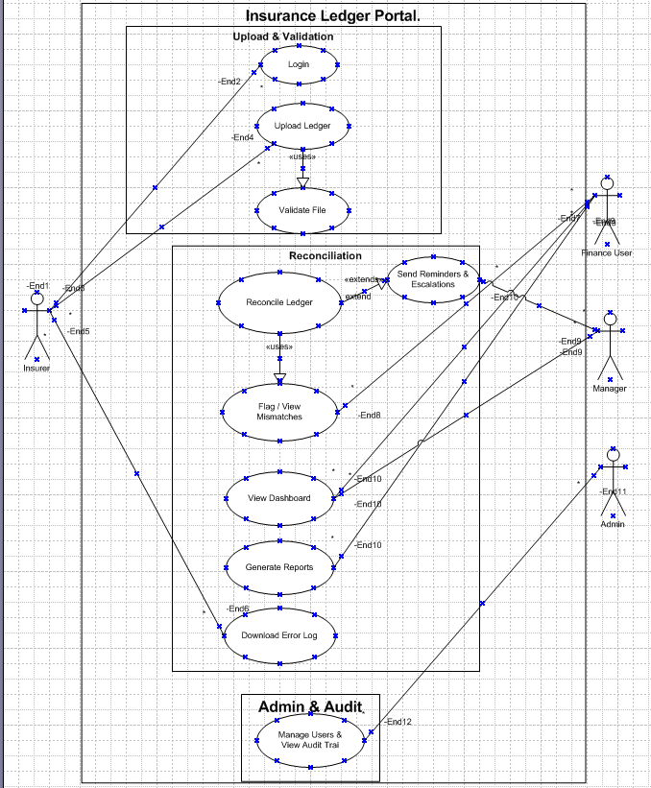
“Figure 1: Use Case Diagram for Insurance Ledger Portal, showing actors, packages, and relationships (include/extend).”
2. Activity Diagram (Document 6 – Part B)
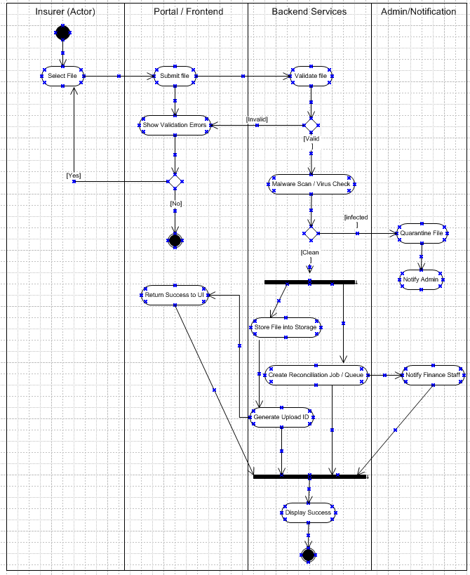
The activity diagram illustrates the end-to-end process of uploading a ledger file to the Insurance Ledger Portal. It shows how the insurer initiates the upload, the portal forwards the file to backend services for validation and malware scanning, and the flow branches based on outcomes such as errors, retries, or infected files. Clean files proceed through parallel processing where the system stores the file, generates an Upload ID, and simultaneously creates a reconciliation job and notifies finance staff. The parallel branches synchronize at a join point, after which the portal confirms success to the insurer. The diagram also captures exception handling such as validation errors, duplicate uploads, or malware detection, ensuring that all possible scenarios are clearly represented for traceability.
Use case Description

1. Use Case Name
Upload Ledger
2. Use Case Description
Insurer (external user) uploads a periodic ledger file (XLSX/CSV/PDF) to the Insurance Ledger Portal. The system validates the file, scans for malware, stores it, creates a reconciliation job, and returns an Upload ID / success confirmation to the user. If problems occur (validation errors, malware, duplicates), the system shows errors or performs quarantine and notifies appropriate staff.
3. Actors
- Primary Actor: Insurer (external).
- Secondary Actors: Portal / Frontend (UI), Backend Services (Validator, Storage, Queue/Reconciliation), Admin / Notification (Finance staff, System Admin).
4. Basic Flow (happy path)
- Insurer selects ledger file and clicks Upload (Select File → Submit File).
- Portal sends the file to backend for validation.
- Backend validates format and mandatory fields.
- If valid, backend performs malware scan.
- If clean, backend stores file and generates Upload ID.
- Backend creates a reconciliation job in the queue and notifies Finance staff.
- Portal displays success message with Upload ID to the Insurer.
- Activity ends; audit log entry created.
5. Alternate Flow(s)
A1 — Validation errors: file fails validation (missing required columns, wrong format).
- System returns validation errors to portal.
- Insurer corrects the file and retries upload (loop to step 1) OR cancels (end).
A2 — Duplicate file detected: system identifies duplicate upload (same period & invoice set).
- System rejects duplicate, displays message and duplicate details. Insurer may cancel or contact support.
A3 — Network or transient failure during upload: portal shows retry option. On retry, flow resumes from submit.
6. Exceptional Flows
E1 — Malware / Infected file detected: backend quarantines the file, writes a security/audit entry, sends a notification to Admin, and ends the upload flow (user sees a generic failure message for security).
E2 — Storage or reconciliation service unavailable: backend logs the incident, shows an error to the user with an incident reference, and notifies support (may queue file for later processing depending on SLA).
7. Pre-Conditions
- Insurer is authenticated and authorized to upload for the selected insurer ID.
- Insurer has the correct upload template and required metadata (period, insurer id).
- Portal is reachable.
8. Post-Conditions
- If successful: file is stored, Upload ID is generated, reconciliation job queued, finance notified, and audit log recorded.
- If failed: validation errors are returned or file is quarantined and admin notified; audit log recorded.
9. Assumptions
- Insurer will use the provided file template.
- Supported formats: XLSX, CSV, PDF (as per BRD).
- BPO ledger is accessible to reconciliation service.
- Notification service (email/queue) available.
10. Constraints
- Max file size: 10 MB (example — adjust per BRD).
- Upload window: within defined period (e.g., 1st week of month).
- Processing time objective: validated and queued within 2 minutes (NFR).
- Only authorized insurers may upload for their own insurer ID.
11. Dependencies
- Authentication & Authorization service.
- File parser & validator module.
- Malware/AV scanning service.
- Object storage (or DB) for files.
- Reconciliation queue / job processor.
- Notification/email service.
- Audit logging service.
12. Inputs and Outputs
- Inputs: ledger file (XLSX/CSV/PDF), metadata (insurer id, period, uploader id), optional notes.
- Outputs: Upload ID (on success), validation report (on failure), audit log entries, notifications to finance/admin.
13. Business Rules
- Mandatory fields in file: Insurer ID, Invoice ID, Payment Date, Amount.
- Reject files that are duplicates for same period & invoice set.
- Reject files outside upload window.
- Accept only configured file formats and sizes.
- Quarantine and notify Admin for any malware detection.
- All upload actions must be recorded in the audit trail.
14. Miscellaneous Information
- Error messages should be user-friendly, listing validation errors with row/column references where possible.
- Security: do not display internal error details to end users; show incident reference for support.
- Audit: each upload attempt (success/failure) must include uploader, timestamp, IP, file checksum, and Upload ID if created.
- Traceability: map this use case to FR0002 (Upload Statement) and FR0008 (Validate Upload) in the RTM.
- Test cases to include: happy path, validation error scenarios, malware detection, duplicate upload, network failure retry, performance under large file load.

Document 7- Screens and pages Please follow the following steps to create the mock-ups
1. Kindly use balsamic or Axure.
2. Always start with a home page of an application.
3. Take a feature and follow it to the end
- Eg: Home page of SCRUM Foods
- Select Login- Create a login page
- Let’s assume, you want to search a restaurant
- Search page- Type the restaurant name and select the dish
- Add to cart page
- f. Payment page g. Logout page

1. Home page

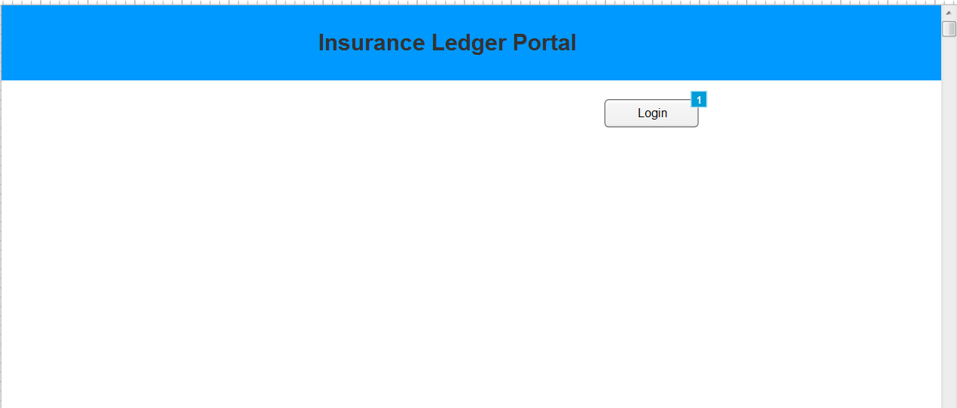

2. Select Login- Create a login page

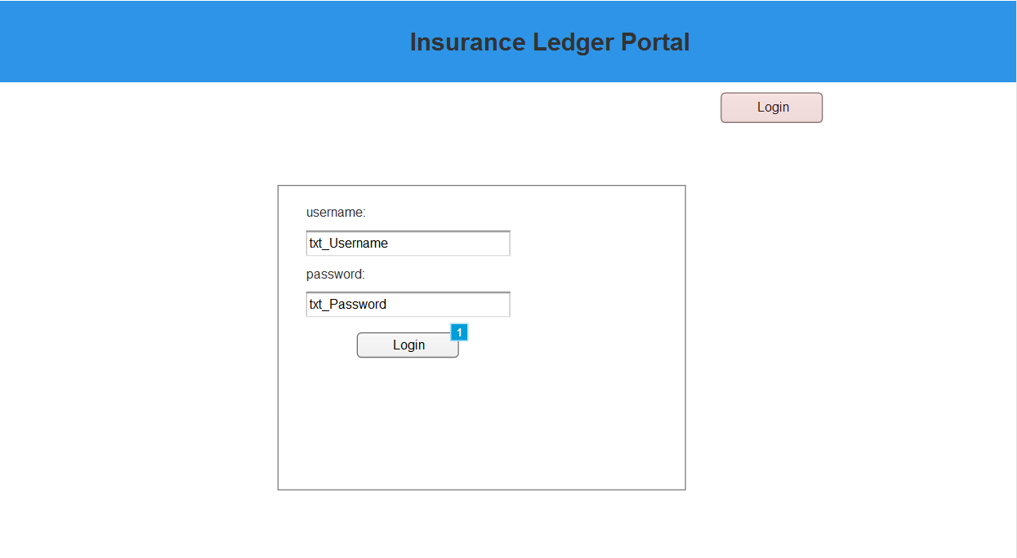

2. Let’s assume, you want to search a File/ Search page- Type the File name
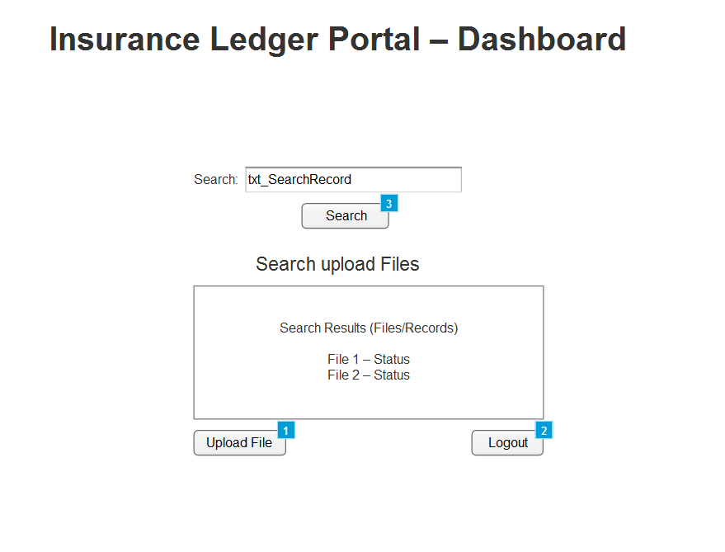

3. Select the File for e.g.- Aviva, Axa, Allianz etc

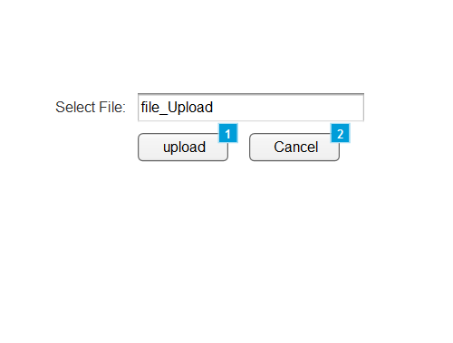
4. Upload Success message
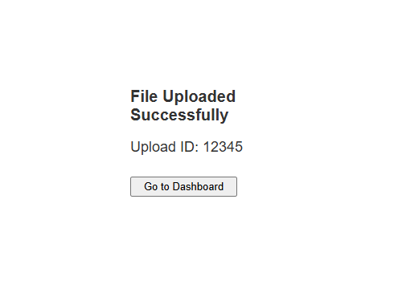

5. Logout page
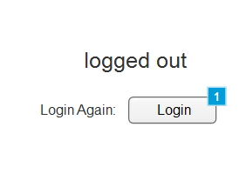

Document 8- Tools-Visio and Axure
Q8. Write a paragraph on your experience using Visio and Axure for the project.

For this project, I used Microsoft Visio to design the use case & activity diagrams and Axure RP to create interactive mock-ups of the Insurance Ledger Portal. Visio was helpful in structuring complex flows into clear swim lanes, decisions, and fork/join connectors, making it easier to explain system logic and backend interactions. At times, aligning connectors and ensuring the correct use of UML shapes required careful attention, but the final diagrams provided a precise visual representation of the workflow.

Axure, on the other hand, was very effective for building page-level mock-ups with interactive elements. Using Sitemap, Widgets, Properties, Outline, and Interactions panels, I could simulate the portal’s navigation from login to dashboard, file upload, and logout. While it took some time to understand widget naming and linking pages correctly, Axure made it possible to demonstrate a near-real prototype. Overall, both tools complemented each other: Visio captured the process design and Axure showcased the user interface experience.

Document 9 – BA Experience

1. Requirement Gathering Phase
In the Requirement Gathering phase, my primary responsibility as a Business Analyst was to elicit, analyse, and document requirements in a structured manner to ensure clarity and alignment with business goals. To achieve this, I applied the MoSCoW Prioritization Technique (Must Have, Should Have, Could Have, Won’t Have) to categorize requirements based on business criticality. This technique ensured that the development team focused on high-priority features first, while still capturing lower-priority items for future releases.
A key challenge encountered during this phase was the limited availability of the client, which risked delaying requirement collection. To address this, I proactively identified and engaged alternative points of contact from the client’s team, ensuring continuity and avoiding project delays.
To validate the quality of requirements, I utilized the FURPS Framework (Functionality, Usability, Reliability, Performance, Supportability). This framework allowed me to confirm that requirements were not only functional but also addressed key non-functional aspects, thereby reducing potential gaps later in the lifecycle.
During analysis, I identified duplicate and conflicting requirements, which could lead to ambiguity. I applied requirement rationalization and de-duplication techniques to refine and consolidate these inputs, ensuring accuracy and consistency in the requirement set.
To further bridge understanding with stakeholders, I incorporated Prototyping and Wireframing techniques. By presenting early visual mock-ups, stakeholders were able to better visualize the system workflows, which led to more specific, actionable, and validated requirements. This iterative feedback loop also helped uncover hidden requirements that might have been missed in verbal discussions.
Through the structured application of these BA techniques, the requirement gathering phase resulted in a validated, prioritized, and high-quality set of requirements that provided a strong foundation for subsequent phases of the project.

2. Requirement Analysis Phase
During the Requirement Analysis phase, my role as a Business Analyst was to translate the gathered requirements into well-structured and visual representations that could be easily understood by both business and technical stakeholders. To achieve this, I utilized UML (Unified Modelling Language) diagrams such as Use Case Diagrams, Activity Diagrams, and Sequence Diagrams to visually describe the system requirements, interactions, and process flows. These diagrams helped bridge the communication gap between the client, developers, and testers.
Specifically, Activity Diagrams were used to illustrate the step-by-step flow of business processes, making it easier to identify dependencies, decision points, and alternate paths. This ensured that the entire team had a clear understanding of the end-to-end business flow.
Collaboration was a critical part of this phase. Once diagrams and models were prepared, I facilitated review sessions with the project team. In these discussions, some members suggested modifications or raised concerns about feasibility. As a BA, it was my responsibility to carefully consider their inputs, balance business needs with technical constraints, and make necessary refinements to the diagrams and requirement documents.
To formally capture and document requirements, I prepared Business Requirement Specification (BRS) and System Requirement Specification (SRS) documents. The BRS outlined the high-level business needs in a client-friendly format, while the SRS provided detailed functional and non-functional requirements tailored for the technical team. These deliverables served as the baseline reference for the design and development phases.
By applying structured requirement modelling techniques and maintaining open communication, the Requirement Analysis phase ensured that all stakeholders had a unified understanding of the system requirements, reducing ambiguities and risks in later stages of the project.

3. System Design
During the Design phase, I focused on transforming requirements into structured testable scenarios. Using the use case diagrams, I derived detailed test cases to ensure functional coverage. I communicated design specifications and solution documents with the client to validate alignment and reduce the chances of rework. Test design included both positive and negative test cases, as testing for invalid inputs or error handling is equally important. I ensured no test case was overlooked, as missing even one could have a significant downstream impact on project quality. Additionally, I prepared test data to simulate real-world conditions. Finally, I maintained and updated the Requirement Traceability Matrix (RTM) to verify that every requirement was covered by corresponding test cases, ensuring full validation of the system.

4.

