Business Requirements Document (BRD)
Project Name: Ice Cream & Milk Products Inventory and Delivery Management System
Prepared by: Kalyani Bhavsar– Business Analyst
Date: 01/07/2025

1. Introduction
The company operates multiple manufacturing plants and warehouses across the country, producing ice creams and milk products. Currently, inventory tracking and delivery scheduling are partially manual, resulting in stock mismatches, delays, and wastage of perishable goods.
The goal is to develop a centralized software solution that manages inventory in real time and ensures quickest delivery to customers, retailers, and distributors.

2. Objectives
- Automate inventory management across manufacturing plants and warehouses.
- Minimize wastage of perishable products by accurate stock monitoring.
- Provide quickest delivery routes and real-time order tracking.
- Integrate order processing, payment, and customer feedback into one platform.

3. Scope

In-Scope:
Inventory tracking at all warehouses and manufacturing plants.
Real-time stock updates when production or dispatch occurs.
Customer order management with payment gateway integration.
Route optimization for quickest delivery.
Role-based dashboards for Admin, Warehouse Manager, Delivery Staff, and Customers.
Notifications for delivery status and inventory alerts.

Out-of-Scope:
External vendor billing system integration (future phase).
Integration with 3rd party ERP (future phase).

4. Stakeholders
- Internal:
  - Operations Head
  - Manufacturing Plant Manager
  - Warehouse Manager
  - Delivery Staff
  - IT Team
- External:
  - Distributors
  - Retailers
  - End Customers

5. Business Requirements
- Inventory Management
  - The system shall update inventory in real-time when production is completed.
  - Warehouse managers shall receive automatic stock alerts when levels fall below threshold.
  - System shall check nearest warehouse availability for fulfilling orders.
- Order Management
  - Customers can browse products (ice creams, milk products) and add them to cart.
  - System shall allow multiple payment methods (COD, Credit/Debit Card, UPI).
  - Orders must be automatically routed to the nearest warehouse with stock.
- Delivery Management
  - System shall generate a picklist for the warehouse staff after payment confirmation.
  - Delivery staff shall receive optimized routes for faster delivery.
  - Customers shall get live tracking and email/SMS notifications.
- Customer Engagement
  - System shall collect customer feedback after successful delivery.
  - Notifications for promotions and inventory updates shall be sent to customers.

6. Functional Requirements (High-Level)
- FR1: User Registration & Login (Customer, Admin, Manager).
- FR2: Browse & Search Products.
- FR3: Add to Cart & Checkout.
- FR4: Payment Processing & Confirmation.
- FR5: Real-Time Inventory Sync.
- FR6: Order Allocation to Nearest Warehouse.
- FR7: Delivery Route Optimization & Tracking.
- FR8: Customer Feedback Collection.

7. Non-Functional Requirements
- Performance: Inventory updates should reflect within 2 seconds.
- Availability: System uptime must be at least 99.5%.
- Security: All payment transactions must be encrypted (PCI DSS compliant).
- Scalability: System must handle at least 1000 concurrent orders.

8. Assumptions
- All warehouses have stable internet connectivity.
- Product SKUs are standardized across all warehouses and plants.
- Delivery staff have smartphones for live tracking.

9. Constraints
- System must integrate with existing manufacturing database.
- Limited initial budget; phase-wise rollout required.

10. Risk
- Incorrect stock data due to delayed updates.
- Delivery delays due to external traffic/weather conditions.
- Payment gateway downtime affecting order confirmation.

11. Resource Plan

Team Structure:
- 1 Business Analyst
- 1 Project Manager
- 2 Backend Developers
- 2 Frontend Developers
- 1 Database Administrator
- 1 QA Engineer
- 1 UI/UX Designer

Timeline (High-Level):
- Requirement Gathering: 3 weeks
- Design & Architecture: 2 weeks
- Development: 8 weeks
- Testing: 3 weeks
- Deployment: 1 week

Technology Stack:
- Backend: Java / Node.js
- Frontend: React / Angular
- Database: Oracle / PostgreSQL
- Mobile App: Flutter / React Native
- Hosting: AWS / Azure

12. Approval
Business Owner: Rakesh Sharma – Head of Operations
Project Sponsor: Ms. Priya Mehta – Chief Technology Officer (CTO)
Date:01/07/2025

2. Process flow diagram:

Assignment 2:
1. Write an introduction letter to a client introducing yourself as a business analyst in charge of working with the client and his team to start the business understanding process.
2. Prepare a brief BRD and SRS for a project- Horoscope or Ticketing system or online store. 3. Make an ERD of creating a support ticket/Ticketing life cycle.
4. User story of shopping from ecommerce.

- Introduction letter to a client introducing as a business analyst in charge of working with the client and his team to start the business understanding process
To: client@gmail.com
CC: projectmanager@gmail.com
Subject: Introduction - Business Analyst for Business Understanding Process
Dear [Client's Name],
I hope this email finds you in good health and high spirits. My name is Kalyani Bhavsar, and I am delighted to introduce myself as the Business Analyst assigned to work closely with you and your esteemed team. I am eager to embark on this journey together and facilitate the process of understanding your business requirements and objectives.
As a Business Analyst, my primary role is to bridge the gap between business goals and technical solutions. I specialize in analysing and interpreting complex business processes, identifying areas for improvement, and designing effective strategies to drive growth and success. With a strong background in business analysis and a passion for problem-solving, I am committed to facilitating a smooth and productive collaboration.
Throughout my career, I have had the privilege to work with diverse clients across various industries, enabling me to gain valuable insights into different business models and challenges. This exposure has equipped me with a broad knowledge base and a comprehensive understanding of best practices in the field of business analysis.
My approach to business analysis is centred around active listening and effective communication. I believe in building strong relationships with clients and stakeholders, as it forms the foundation for a successful partnership. By thoroughly understanding your unique business requirements, I aim to provide tailored solutions that align with your goals and objectives.
During our engagement, I will work closely with you and your team to conduct comprehensive business analysis. This will include activities such as process mapping, requirements gathering, and requirements analysis. I will strive to ask the right questions, challenge assumptions, and explore innovative approaches to help you achieve your desired outcomes.
I am genuinely enthusiastic about the opportunity to collaborate with you and contribute to the growth and success of your business. I am confident that my skills, experience, and dedication will add value to our partnership and pave the way for fruitful results.
I kindly request a meeting to discuss further details and define a roadmap for our collaboration. Please let me know your availability so that we can schedule a convenient time to connect.
Thank you for your time and consideration. I am eager to embark on this journey with you and your team.
Best regards,
Kalyani Bhavsar
(Business Analyst)

2. BRD AND SRS
Business Requirements Document (BRD):
Project Name: Online Ticketing System
Prepared By: Kalyani Bhavsar – Business Analyst
Date: 01/07/2025

1. Executive Summary
The company requires the development of a centralized Online Ticketing System to facilitate seamless event ticket booking for customers and efficient event management for organizers. This platform will handle high-volume transactions, provide real-time seat allocation, integrate multiple payment gateways, and generate instant e-tickets.

2. Business Objectives
- Enable customers to search, book, and pay for tickets conveniently.
- Automate real-time seat availability to eliminate double booking.
- Provide a robust backend for event organizers to manage events and analyze sales.
- Ensure a scalable, secure, and user-friendly platform accessible via web and mobile devices.

3. Project Scope

In-Scope:
- Web and mobile applications for customers.
- Real-time seat selection and inventory management.
- Integration with secure payment gateways.
- QR/barcode-based e-ticket generation.
- Admin panel for event organizers and company staff.

Out-of-Scope:
- Third-party travel or hotel booking integration.
- Automated refund system (manual in phase one).
- Integration with external loyalty programs (future phase).

4. Stakeholders
- Internal:
  - Project Sponsor – Priya Mehta (CTO)
  - Business Owner – Rakesh Sharma (Head of Operations)
  - Development Team
  - QA & Testing Team
  - Customer Support Team
- External:
  - Event Organizers
  - Customers
  - Payment Gateway Providers

5. Business Requirements
- Event Management:
  - Organizers can create, edit, and delete events.
  - Set pricing tiers and seat layouts.
- Ticket Booking:
  - Customers can view events, select seats, and book tickets.
  - Seats must be locked during checkout for 10 minutes.
- Payments:
  - Support multiple payment modes (Credit/Debit Cards, UPI, Wallets).
  - Generate tickets only after successful payment confirmation.
- E-Ticket Delivery:
  - Generate QR/barcode-based e-tickets instantly.
  - Send tickets via email and SMS automatically.
- Analytics:
  - Admin panel to generate reports on sales, occupancy, and revenue.

6. Business Rules
- Tickets are non-transferable between accounts.
- Refunds can only be initiated 24+ hours before the event.
- Payment failure releases locked seats back into inventory immediately.

7. Assumptions & Dependencies
- Internet connectivity is available for all customers and organizers.
- Payment gateways provide instant callback on transaction status.
- Seat maps are provided by event organizers before event listing.

8. Risks
- Payment failures impacting user trust.
- Peak-hour traffic may cause server load issues.
- Incorrect seat layouts from organizers causing booking errors.

9. Resource & Timeline Plan
- Project Team:
  - 1 Project Manager
  - 1 Business Analyst
  - 2 Backend Developers
  - 2 Frontend Developers
  - 1 Mobile App Developer
  - 1 Database Administrator
  - 1 QA Engineer
- Timeline:
  - Requirement Gathering: 2 weeks
  - Design & Architecture: 2 weeks
  - Development: 8 weeks
  - Testing & UAT: 3 weeks
  - Deployment: 1 week

10. Approval
- Business Owner: Rakesh Sharma – Head of Operations
- Project Sponsor: Priya Mehta – CTO
- Date: 01/07/2000

Software Requirements Specification (SRS)
Project Name: Online Ticketing System
Prepared By: Kalyani Bhavsar – Business Analyst
Date: 01/07/2025

1. Purpose
This document defines the detailed functional and non-functional requirements for the Online Ticketing System. It will ensure accurate seat allocation, secure payments, and instant ticket delivery while providing an admin panel for event organizers to manage bookings and generate reports.

2. System Overview
- Platform: Web and Mobile
- Users: Customers, Event Organizers, Admins
- Key Features:
  - Event browsing & search
  - Seat selection with real-time locking
  - Payment gateway integration
  - QR/barcode e-ticket generation
  - Admin dashboards with reports

3. Functional Requirements

FR1 – User Account Management
- Register/login using email or phone.
- Social login via Google/Facebook.
- View past bookings and e-tickets.

FR2 – Event Browsing
- Search and filter events by location, category, and date.
- Display detailed event info: pricing, venue, seat layout.

FR3 – Ticket Booking
- Select seat type and quantity.
- Lock seats during checkout (10-minute window).

FR4 – Payment Processing
- Support multiple payment methods.
- Trigger ticket generation after successful payment.

FR5 – E-Ticket Generation
- Generate QR/barcode-based e-tickets.
- Send tickets via email and SMS instantly.

FR6 – Admin/Event Management
- Organizers can create/manage events.
- Admin dashboard for sales and revenue analytics.

FR7 – Cancellations
- Allow cancellations 24 hours before the event.
- Manual refund initiation in phase one.

4. Non-Functional Requirements
- Performance: Handle 10,000 concurrent users with <2s response time.
- Availability: 99.9% uptime.
- Security: PCI DSS compliance; all data encrypted via SSL/TLS.
- Scalability: Support 100+ events simultaneously.
- Usability: Mobile-first, user-friendly UI.

5. System Architecture
- Frontend: React/Angular (Web), Flutter/React Native (Mobile).
- Backend: Java/Spring Boot or Node.js.
- Database: PostgreSQL/Oracle.
- Hosting: AWS/Azure cloud.
- Payment Integration: Razorpay/Stripe/PayPal.

6. Database Entities
- User: User_ID, Name, Email, Phone, Password, Role.
- Event: Event_ID, Title, Location, Date, Price, Seat_Map.
- Ticket: Ticket_ID, Event_ID, User_ID, Seat_No, Status.
- Payment: Payment_ID, Ticket_ID, Amount, Status, Timestamp.

7. Interfaces
- Customer UI: Event search, booking, payment, and ticket download.
- Organizer/Admin UI: Event creation, reports, user management.
- Payment Gateway API: Secure transaction handling.

8. Acceptance Criteria
Users can book tickets end-to-end without manual intervention.
Payment failures release locked seats automatically.
E-tickets are delivered instantly upon successful payment.
Admin dashboard reflects real-time sales data.

3. ERD

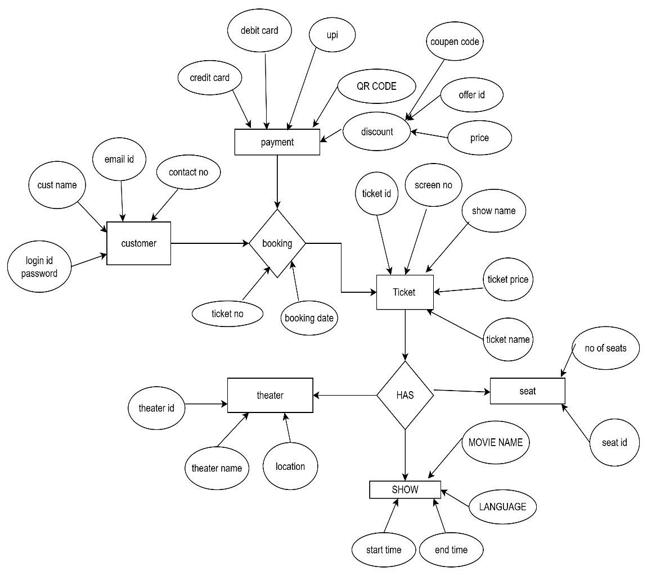
4. User stories
USER STORY 1 | TASK -Browse Products |  | PRIORITY- HIGHEST
As a customer,
I want to browse products by category,
So that I can easily find the items I’m interested in.
BV-100 |  | CP-2
ACCEPTANCE CRITERIA

- Products are grouped into categories like clothe jewellery, cosmetics
- User can filter by brand, price, rating, etc.
- User can search by product name or keyword.

USER STORY 2 | TASK -Add to Cart |  | PRIORITY- medium
As a customer,
I want to add products to my shopping cart,
So that I can purchase multiple items at once
BV-200 |  | CP-2
ACCEPTANCE CRITERIA
- Product gets added to cart with selected quantity.
- Cart updates total price in real time.
- User can remove or change quantity from cart.
.

USER STORY 3 | TASK -Place Order |  | PRIORITY- medium
As a customer,
I want to checkout using my saved address and payment method,
So that I can complete my purchase easily.
BV-500 |  | CP-2
ACCEPTANCE CRITERIA
- User sees a summary of items and total price.
- User can select address or enter a new one.
- Multiple payment options available (COD, UPI, Card).
- User receives order confirmation after successful payment.

.

USER STORY 4 | TASK -Track My Order |  | PRIORITY- medium
As a customer,
I want to track the delivery status of my order,
So that I know when to expect it..
BV-500 |  | CP-5
ACCEPTANCE CRITERIA
- Order status updates: Ordered → Packed → Shipped → Out for Delivery → Delivered.
- Delivery estimated date and tracking ID is visible.
- SMS/email notification sent at each stage.
.

.

USER STORY 5 | TASK - Review Product |  | PRIORITY- medium
As a customer,
I want to review and rate the product I purchased,
So that I can help others make informed choices.
BV-500 |  | CP-5
ACCEPTANCE CRITERIA
- User can add star rating (1–5).
- Optional comment box for feedback.
- Only customers who purchased can review.
.

.

USER STORY 6 | TASK -login |  | PRIORITY- HIGHEST
As a user, I want to register with my email and password
so that
I can create an account
BV-200 |  | CP-2
Acceptance Criteria:
- The user must provide a valid email and password.
- Password must meet minimum security criteria.
- User receives a verification email.

USER STORY 7 | TASK -login |  | PRIORITY- HIGHEST
As a user, I want to log in using my credentials
so that
I can access my account.
BV-50 |  | CP-2
Acceptance Criteria:
- User can log in with valid credentials.
- Invalid login attempts display an appropriate error message.
- User is redirected to the dashboard after login

USER STORY 8 | TASK –generate password |  | PRIORITY- HIGHEST
As a user, I want to reset my password if I forget it
so that
I can regain access..
BV-100 |  | CP-2
Acceptance Criteria:
- User receives a reset link via registered email.
- The link allows user to set a new password securely.
- User is notified upon successful reset.

USER STORY 9 | TASK –profile |  | PRIORITY- HIGHEST
As a user,
I want to update my profile details
So that
my information stays current.
BV-100 |  | CP-2
Acceptance Criteria:
- User can edit and save name, phone, and address.
- Changes reflect immediately after saving.
- Validation is performed on input fields.
.

USER STORY 10 | TASK –product search |  | PRIORITY- HIGHEST
As a user, I want to search for products by name
so that
I can find what I’m looking for.
BV-100 |  | CP-5
Acceptance Criteria:
- A search bar is available on the homepage.
- Search results display matching products.
- No results message shown for unmatched keywords.
.

USER STORY 11 | TASK –product search |  | PRIORITY- HIGHEST
As a user,
I want to filter products by price range
so that
I can stay within my budget.
BV-100 |  | CP-3
Acceptance Criteria:
- Price filter is available on category pages.
- Applying filter updates product list.
- User can clear filters anytime
.

USER STORY 12 | TASK –product search |  | PRIORITY- HIGHEST
As a user,
I want to filter products by brand
so that
I can choose my preferred brand.
BV-100 |  | CP-2
Acceptance Criteria:
- Brand filter is shown in side panel.
- Only products of selected brand appear.
- Multiple brand filters can be applied.
.

USER STORY 13 | TASK –sort product |  | PRIORITY- medium
As a user,
I want to sort products by price or popularity
So that
I can make better decisions.
BV-100 |  | CP-2
Acceptance Criteria:
- Sorting options: Low to High, High to Low, and Popularity.
- Product list rearranges as per selected option.
.

USER STORY 14 | TASK –product details |  | PRIORITY- high
As a user,
I want to view detailed information on a product page
so that
I understand what I’m buying..
BV-100 |  | CP-2
Acceptance Criteria:
- Product name, images, description, price, and availability shown.
- Product specs and reviews available on the same page.

USER STORY 15 | TASK –product details |  | PRIORITY- high
As a user,
want to remove items from my cart so that
I can update my purchase.
BV-100 |  | CP-5
Acceptance Criteria:
- User can click “Remove” button to delete an item.
- Cart total updates accordingly.

USER STORY 16 | TASK –summary view |  | PRIORITY- high
As a user,
I want to view a summary of items in my cart
so that
I can review my selections.
BV-500 |  | CP-2
Acceptance Criteria:
- Cart summary shows item name, image, quantity, and price.
- Total cost is displayed at the bottom.

USER STORY 17 | TASK –summary view |  | PRIORITY- high
As a user,
I want to enter my shipping address during checkout
so that
my items are delivered correctly.
BV-50 |  | CP-2
Acceptance Criteria:
- Form for entering address is available.
- Address is validated before proceeding.
- User can save address for future use.

USER STORY 18 | TASK –payment |  | PRIORITY- high
As a user,
I want to choose a payment method
so that
I can complete the purchase.
BV-20 |  | CP-2
Acceptance Criteria:
- Options include credit/debit card, UPI, net banking, and COD.
- Selected method processes payment successfully.

USER STORY 19 | TASK –discount |  | PRIORITY- high
As a user,
I want to apply a promo code
so that
I can get a discount.
BV-200 |  | CP-5
Acceptance Criteria:
- Input for promo code is available.
- Valid code applies discount immediately.
- Invalid code shows error.

USER STORY 20 | TASK –confrimation |  | PRIORITY- high
As a user,
I want to receive an order confirmation email
so that
I know my purchase was successful.
BV-200 |  | CP-5
Acceptance Criteria:
- Email is sent with order ID and item list.
- Email is sent immediately after payment.

USER STORY 21 | TASK –confrimation |  | PRIORITY- high
As a user,
I want to track the shipping status of my order
so that
I know when it will arrive..
BV-100 |  | CP-5
Acceptance Criteria:
- Order tracking link available in order history.
- Status updates include: Processing, Shipped, Out for Delivery, Delivered.
.

USER STORY 22 | TASK –confrimation |  | PRIORITY- high
As a user,
I want to return a product after delivery
so that
I can get a refund or replacement.
BV-100 |  | CP-5
Acceptance Criteria:
- Return button available within return window.
- System captures reason for return and preferred action (refund/replacement).

USER STORY 23 | TASK –history |  | PRIORITY- high
As a user,
I want to view my past order history
so that
I can reorder easily.
BV-100 |  | CP-5
Acceptance Criteria:
- “My Orders” page shows all previous orders.
- Reorder option available.

USER STORY 24 | TASK –change the details |  | PRIORITY- medium
As a user,
I want to choose delivery options (standard/express)
so that
I can decide how fast I want the product.
BV-100 |  | CP-5
Acceptance Criteria:
- Delivery mode selection available at checkout.
- Charges and delivery timelines shown.

USER STORY 25 | TASK –rating |  | PRIORITY- medium
As a user,
I want to rate a product
so that
I can share my feedback.
BV-100 |  | CP-5
Acceptance Criteria:
- Star rating available.
- User must have purchased the item to rate.

USER STORY 26 | TASK –review |  | PRIORITY- medium
As a user,
I want to read reviews from other
so that
I can make informed decisions.
BV-100 |  | CP-2
Acceptance Criteria:
- Reviews sorted by date or helpfulness.
- Star rating and comments are shown

USER STORY 27 | TASK –details |  | PRIORITY- medium
As a user,
I want to upload photos in my review
so that
I can show the actual product.
BV-200 |  | CP-2
Acceptance Criteria:
- Image upload supported in review form.
- Images are previewed before submission.

USER STORY 28 | TASK –sales |  | PRIORITY- medium
As a user,
I want to get notified about flash sales
so that
I can shop at discounted prices..
BV-500 |  | CP-2
Acceptance Criteria:
- Push/email alerts sent for flash deals.
- Deals show start/end time.

USER STORY 29 | TASK –review |  | PRIORITY- medium
. As a user,
I want to receive order status updates via SMS or email
so that
I stay informed.
BV-200 |  | CP-2
Acceptance Criteria:
- Status notifications sent at each stage: Order Placed, Shipped, Delivered.

USER STORY 30 | TASK –review |  | PRIORITY- medium
As a user,
I want to be alerted when a product is back in stock
so that
I can purchase it..
BV-200 |  | CP-2
Acceptance Criteria:
- Notify me button on out-of-stock products.
- Email/SMS sent when available.

USER STORY 31 | TASK –review |  | PRIORITY- medium
As a user,
I want to be alerted when a product is back in stock
so that
I can purchase it..
BV-100 |  | CP-2
Acceptance Criteria:
- Notify me button on out-of-stock products.
- Email/SMS sent when available.

USER STORY 32 | TASK –payment |  | PRIORITY- medium
As a user,
I want to enable two-factor authentication
so that
my account is more secure.
BV-10 |  | CP-2
Acceptance Criteria:
- Option available in settings.
- OTP sent via email/SMS during login

USER STORY 33 | TASK –delet |  | PRIORITY- medium
As a user,
I want to delete my account permanently
so that
I choose to leave the platform.
BV-100 |  | CP-2
Acceptance Criteria:
- Delete account button in profile settings.
- Confirmation prompt shown before deletion.

USER STORY 34 | TASK –delete |  | PRIORITY- medium
As a user, I want my personal and payment data to be protected
so that
I shop safely.
BV-500 |  | CP-2
Acceptance Criteria:
- Platform uses SSL and encryption.
- Payment info stored securely with tokenization.

USER STORY 35 | TASK –delete |  | PRIORITY- medium
. As a user,
I want to share my wishlist with friends and family
so that
they can gift me.
BV-500 |  | CP-2
Acceptance Criteria:
- Wishlist can be shared via link or email.

USER STORY 36 | TASK –confirmation |  | PRIORITY- high
As a user,
I want to receive an order confirmation email
so that
I know my purchase was successful.
BV-500 |  | CP-2
Acceptance Criteria:
- Email is sent with order ID and item list.
- Email is sent immediately after payment.

USER STORY 37 | TASK –mop |  | PRIORITY- high
As a user,
I want to choose a payment method
so that
I can complete the purchase.
BV-200 |  | CP-2
Acceptance Criteria:
- Options include credit/debit card, UPI, net banking, and COD.
- Selected method processes payment successfully.

USER STORY 38 | TASK –purchase quantity |  | PRIORITY- medium
As a user,
I want to update the quantity of items in my cart to match my needs.
So that
I can purchase easily
BV-500 |  | CP-2
Acceptance Criteria:
- Quantity input is editable.
- Total updates dynamically with changes.

USER STORY 39 | TASK –mop |  | PRIORITY- high
As a user,
I want to view total pricing including discounts
So that
Pay taxes before checkout.
BV-200 |  | CP-2
Acceptance Criteria:
- Subtotal, taxes, and any discounts are displayed.
- Final total is accurate.
- .

USER STORY 40 | TASK –alert |  | PRIORITY- high
As a user,
I want to control my notification preferences
so that
I only receive relevant alerts.
BV-200 |  | CP-2
Acceptance Criteria:
- Toggle options for email, SMS, push notifications.
- Preferences are saved successfully.

