CAPSTONE PROJECT -1 PART -3

1. Identify minimum 20 functional requirements?
Functional Requirements: Functional requirements define the specific behaviours
Functions, or operations of a system. They describe
What the system should do, outlining the necessary
Tasks, actions, or activities it must perform to
Achieve its objectives.

REQ ID | REQ NAME | REQ DESCRIPTION | PRIORITY
FR001 | User registration | Users should be able to register with the application using email or mobile number. | 9
FR002 | User login | Users should be able to log in using registered credentials. | 9
FR003 | Password recovery | Users should be able to reset their password if forgotten. | 7
FR004 | Search products | Users should be able to search for available products by name, category, or keyword. | 9
FR005 | Filter products | Users should be able to filter products by price, rating, and brand. | 8
FR006 | View product details | Users should be able to view detailed product information including price, description, and reviews. | 9
FR007 | Add to cart | Users should be able to add products to the shopping cart. | 10
FR008 | Update cart | Users should be able to update product quantity or remove items from the cart. | 9
FR009 | Add to Wishlist | Users should be able to add desired products to the Wishlist for future purchase. | 6
FR010 | Checkout process | Users should be able to proceed to checkout with selected items. | 10
FR011 | Payment options | Users should be able to make payments using multiple methods (credit, card, upi, PayPal, etc.,) | 10
FR012 | Order confirmation | Users should receive confirmation after placing an order successfully. | 9
FR013 | Order tracking | Users should be able to track their order status in real-time. | 8
FR014 | Product reviews | Users should be able to write and submit reviews for purchased products. | 7
FR015 | Admin login | Admin should be able to log in securely to the admin panel. | 9
FR016 | Manage products | Admin should be able to add, update, or delete product listings. | 9
FR017 | Manage orders | Admin should be able to view and update order statuses (pending, shipped, delivered). | 9
FR018 | Manage users | Admin should be able to view and manage user accounts. | 8
FR019 | Notifications | The system should send notifications for order updates, offers, and promotions. | 7
FR020 | Generate reports | Admin should be able to generate sales and inventory reports. | 6

2. Make wireframe and prototypes. (minimum 5-page designs)?

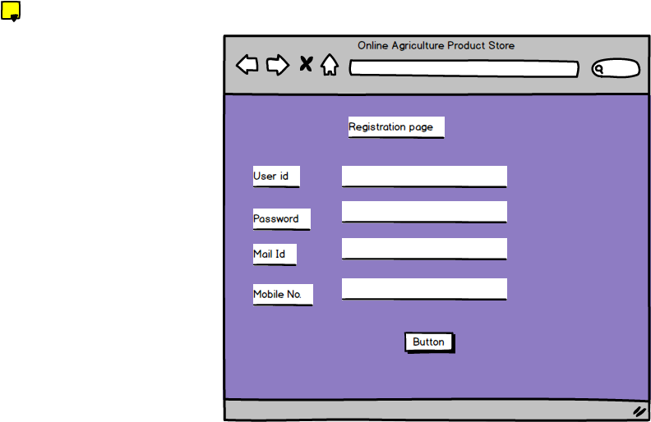

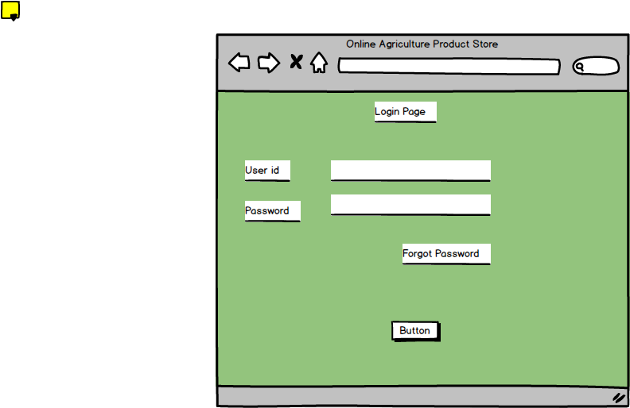

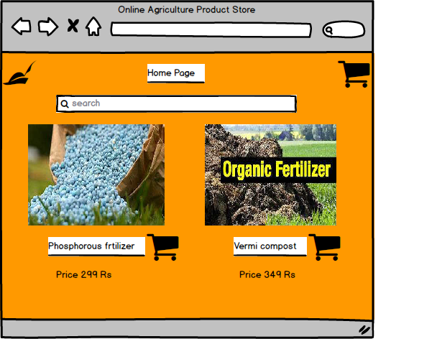
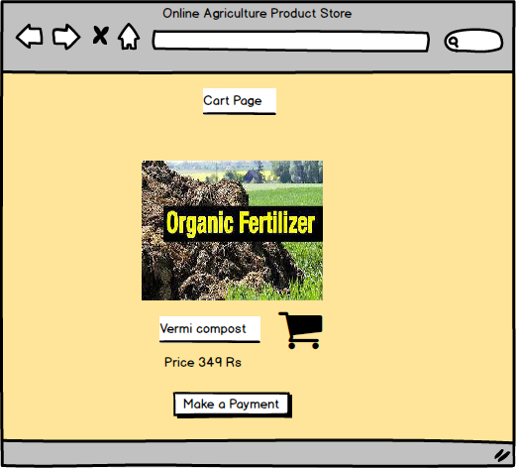

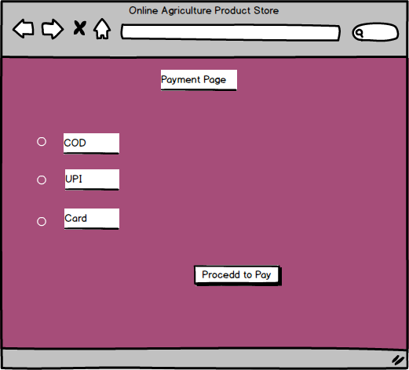

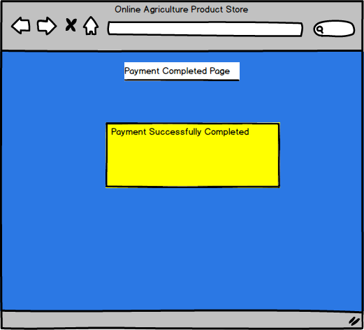

Prototypes:

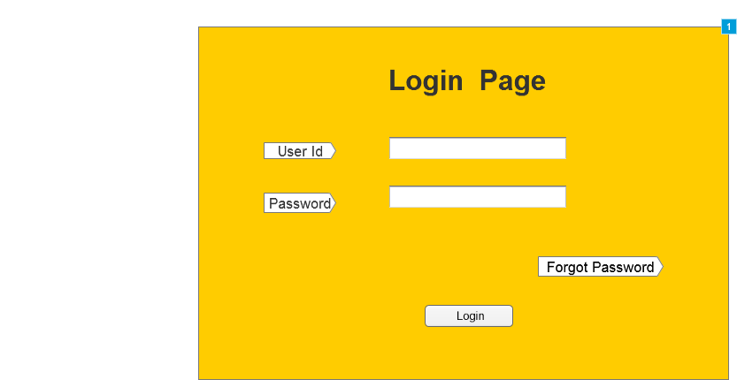

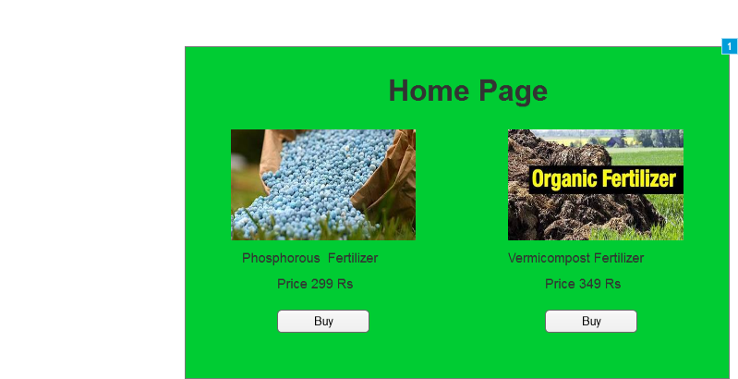

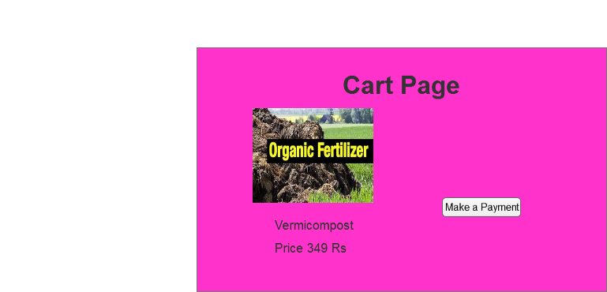
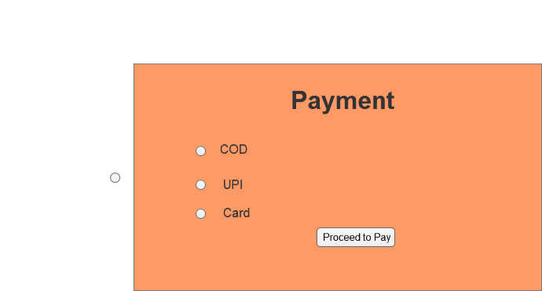

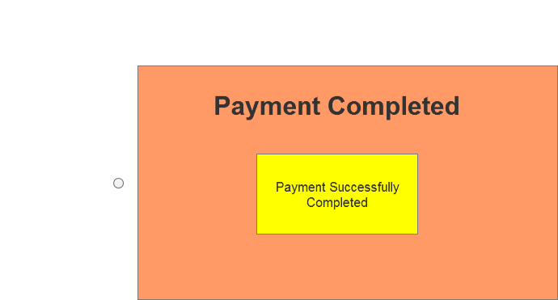

3. Make a note of the Tools, which you are using for above concepts.

BALASMIQ:
It is a wireframing tool used to create quick, low-fidelity mock-ups of user interface. It
Helps designers focus on the layout, structure, and flow of an application before adding
Colores or images. The interface looks hand-drawn, which keeps attention on
Functionality rather than decoration.
PURPOSE IN THE PROJECT:
In this case study, Balsamiq was used to design the initial wireframes of the agricultural
e-commerce application. It helped in arranging key components such as the homepage,
product list, product detail, cart, and checkout screens. These wireframes were the
blueprint for how users would navigate through the app.
FEATURES USED:
DRAG AND DROP UI ELEMENTS: buttons, text, boxes, images, and containers.
LINKING BETWEEN SCREENS: to demonstrate simple navigation flow.
ANNOTATIONS AND LABELS: used to describe actions or functions.
EXPORT TO IMAGE/PDF: for including mock-ups in the report and presentation.
ADVANTAGES:
Very easy to use - ideal for beginners.
Allows quick changes based on feedback.
Keeps focus on usability and layout rather than colours or graphics.
Perfect for early-stage brainstorming and sharing ideas with teammates.
OUTCOME:
Using Balsamic saved time & made it easy to visualize and communicate ideas clearly
Before building high-fidelity prototypes.
2. AXURE RP:
Axure RP is a professional prototyping tool that allows designers to create interactive &
High-fidelity prototypes. It supports not only layout design but also dynamic behaviours
Like page links, animations, and conditional interactions.
PURPOSE IN THE PROJECT:
After completing the wireframes in Balsamic, Axure was used to develop clickable,
Interactive prototypes that looked and behaved like a real application. This helped
Demonstrate how users would move from one screen to another and how buttons or
Forms would respond to input.
FEATURES USED:
PAGE INTERACTIONS: linking buttons to diff pages (e.g., “add to cart” - cart page).
DYNAMIC PANELS AND STATES: to simulate content changes within the same page.
STYLING TOOLS: for adding colours, shapes, and images to make the prototype visually
Realistic.
PREVIEW & PUBLISH: allowed testing in a browser to experience real navigation flow.
ADVANTAGES:
Enables realistic simulation without writing code.
Helps identify usability issues early through interactive testing.
Provides a professional look and feel, useful for client or teacher demonstration.
Supports export to HTML or image / pdf for easy sharing and documentation.
OUTCOME:
Axure transformed static designs into an interactive prototype that closely resembled a
Functioning app. It made it easier to evaluate user flow and interaction before actual
Development.
0
4. A Business Analyst’s key responsibilities are to keep track of the requirements &
Make sure that no requirement is missed.
The Requirement Traceability Matrix (RTM) is a doc used to track the requirements
Throughout the project lifecycle, ensuring that all requirements defined for a system
Are tested and fulfilled completely.

Req Id | Req Name | Req Description | Design | code | Component testing | Unit testing | Integration testing | System testing | UAT
FR001 | User registration | User can register by entering name, email, & password | complete | complete | complete | complete | complete | complete | complete
FR002 | Search products | User can search agriculture products such as fertilizers & seeds | complete | complete | complete | complete | complete | complete | Complete
FR003 | View product details | User can view product name, price, & description before buying | complete | complete | complete | complete | complete | complete | complete
FR004 | Add to cart | User can add selected products to their cart for checkout. | complete | complete | complete | complete | complete | complete | complete
FR005 | Payment processing | System should process online payment securely via payment gateway. | complete | complete | complete | complete | complete | complete | complete
FR006 | Order confirmation | User receives order confirmation mssg & email after payment. | complete | complete | complete | complete | complete | complete | complete
FR007 | View order history | User can view a list of previous orders & their statuses. | complete | complete | complete | complete | complete | complete | complete
FR008 | Admin management | Admin can add, edit, or delete products from the store inventory. | complete | complete | complete | complete | complete | complete | complete
Project id | PM ID | PM strategy ID | Test plan ID | Test schedule ID | Test case ID | Scenario | Link to that page | Input data | Expected behaviour | Actual behaviour | Result pass/fail
AGR001 | PM01 | STR01 | TP01 | TS01 | TC01 | User registration | Registration page | Name: anu  Email: xxxxx password: xx | User acct should be created | Acct created | Pass
AGR002 | PM01 | STR01 | TP01 | TS02 | TC02 | User login | Login page | Username: anu  Password: xx | User should be logged in | Login successfully | Pass
AGR003 | PM01 | STR01 | TP01 | TS03 | TC03 | Search for product | Home page | Product name: fertilizer | Product list should display | Product list displayed | Pass
AGR004 | PM01 | STR01 | TP01 | TS04 | TC04 | View product details | Product page | Product id: P001 | Product details should be visible | Product details displayed | Pass
AGR005 | PM01 | STR01 | TP01 | TS05 | TC05 | Add product to cart | Product page | Product: organic fertilizer | Product should be added to cart | Product added successfully | Pass
AGR006 | PM01 | STR01 | TP01 | TS06 | TC06 | Update quantity | Cart page | Quantity: 2 | Cart total should update automatically | Total updated correctly | Pass
AGR007 | PM01 | STR01 | TP01 | TS07 | TC07 | Payment process | Payment page | Card no.:123456789  Cvv: 123 | Payment should be processed | Payment processed successfully | Pass
AGR008 | PM01 | STR01 | TP01 | TS08 | TC08 | Order confirmation | Confirmation page |  | Confirmation mmsg should appear | Confirm displayed | Pass
AGR009 | PM01 | STR01 | TP01 | TS09 | TC09 | View order history | My orders page |  | Past orders should be displayed | Orders displayed correctly | Pass
AGR010 | PM01 | STR01 | TP01 | TS10 | TC10 | Admin add product | Admin dashboard |  | Product should be added to system | Product added successfully | Pass

5. Prepare 10 Test Case Documents.
A Test Case Document is a detailed outline used by testers to ensure that a software
Application or system is working as expected.

6. After the requirements are thoroughly explained to the entire project team by BA,
The database architects have decided to do the database design and also to represent the
In-flow and out-flow of data.

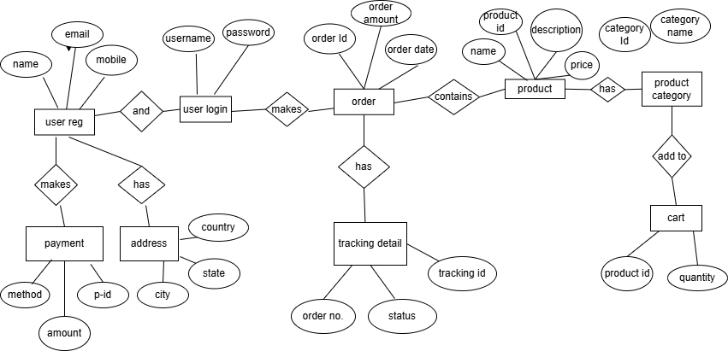

7. What is a data flow diagram? Draw a data flow diagram to represent the in-flow
And out-flow of data when a farmer is placing an order for the product.

A DFD is a diagram that shows how data moves through a system.
It represents the flow of information between processes, data stores, & external entities.
MAIN COMPONENTS:
1. PROCESS (CIRCLE/ROUNDED BOX):
Shows actions or functions (e.g., “place order”, “process payment”).
2. DATA FLOW (ARROW):
Indicates how data moves between parts of the system.
3. DATA STORAGE (OPEN-ENDED RECTANGLE):
Shows where data is kept (e.g., “customer database”).
4. EXTERNAL ENTITY (SQUARE):
Represents people or systems outside the process (e.g., “customer”, “payment gateway”).

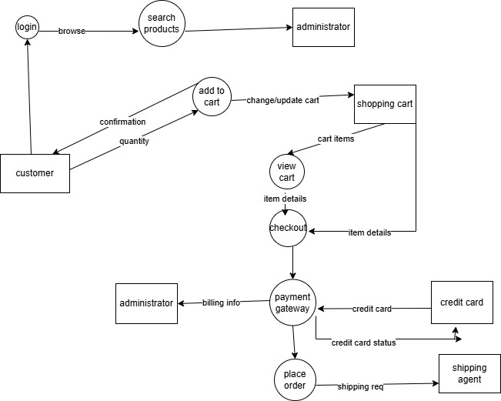

8. Due to change in the Government Taxation Structure, we should change the Tax
Structure. How do you handle change requests in a project?
A change request is a formal proposal to alter a system, product, or project.
1. UNDERSTAND THE SCOPE OF THE CHANGE REQUEST:
Capture who raised it, why (gov tax change), and the precise elements that must change
(tax calculation logic, tax rates, tax-related reports, invoices, validations).
Documents requirements, affected modules, data fields, and any regulatory reference.
2. DO THE IMPACT ANALYSIS- PROJECT SCOPE, SCHEDULE, BUDGET, RESOURCES & RISKS
Identify what parts of the solution (code, configuration, integration, reports) will change.
Estimate effort, extra testing, rework, potential delays, & any additional budget/resource
Needs.
Record risks (compliance risk if delayed, revenue calculation errors, downstream system
Failures.
3. PRIORITIZE CHANGE REQUESTS BASED ON ITS URGENCY, IMPORTANCE & IMPACT ON
PROJECT:
Because this is a government-mandated taxation change, classify it high priority
(urgent, compliance-driven).
If multiple changes compete, use business value + regulatory deadline to rank this above
Non-mandatory changes.
4. SEEK APPROVAL FROM THE PROJECT SPONSOR FOR THE CHANGE REQUEST:
Prepare an impact summary (scope, cost, timeline, risks, recommended approach)
And present to the sponsor/change control board.
Obtain formal sign-off before any development begins to ensure governance and
Budget alignment.
5. COMMUNICATE THE CHANGE REQUEST & ITS POTENTIAL IMPACTS TO ALL RELEVANT
STAKEHOLDERS, INCLUDING THE PROJECT TEAM:
Notify developers, QA, business users, operations, finance, & any integration partners
About the decision, timelines, & expected impacts.
Update project documentation (requirements, traceability matrices, release notes) &
Schedule any training or rollout communication needed for users.
CONCLUSION:
Government taxation changes are regulatory & affect legal compliance & financial reporting.
Handling the request through a formal change control process- understanding scope, assessing impact, prioritizing, obtaining approval, & communicating - ensures the organization implements the change correctly, on time, & with documented governance to avoid compliance breaches or financial errors.

9. Change Request vs an Enhancement. Is this a change request or enhancement?
In this case, adding new tax computation and reporting features to the application would
Be considered an Enhancement, as it involves adding new functionality beyond the
Original agreed scope.
As a BA, u should first document the client’s new requirement in detail & analyse how it
Differs from existing tax functionalities.
Next, work with the development & design teams to determine the feasibility, effort, &
Impact of adding these enhancements - for example, changes in database structures,
New UI components, & testing efforts.
You should also evaluate the business value, risks, costs, & benefits associated with
Implementing these new features, ensuring that they align with overall business
Objectives.
After your analysis, prepare an enhancement proposal or change impact document
Outlining:
Functional description of the new feature.
Estimated effort, cost, & schedule impact.
Risks & Dependencies.
Expected business benefits.
Finally present your recommendations to the client and project sponsor for review &
Approval before proceeding. Once approved, the enhancement can be added to the
Product roadmap or the next release plan.
CONCLUSION:
This request goes beyond the original system design - it does not correct a defect or adjust
To a regulatory requirement but adds new features that enhance system capability. Hence
It should be categorized as an Enhancement, handled through the formal change control
& approval process before implementation.

10. Come up with Estimations - How many Manhours required.

1. PROJECT DETAILS & ASSUMPTIONS
PARAMETER | VALUE / ASSUMPTION
Project Duration | 18 months
Team Size | 15 members (BA, PM, Developers, Testers, Designers)
Working days per week | 5 days
Public holidays | 10 days per year
Working Hours per day | 8 hours

2. CALCULATE EFFECTIVE WORKING DAYS
1 year = 52 weeks *5 days = 260 working days
For 18 months = 260 * 1.5 = 390 days
Minus public holidays - 375 effective working days.
3. CALCULATE TOTAL MAN-HOURS
Each person: 375 days * 8 hrs = 3000 hrs/ person
Total for 15 members = 3000*15 = 45000 man-hours
Since this is a large project not all hours are 100% productive - roughly 3-4% of the total
Timeline represents the core analytical & implementation window for the BA’s case
Study calculation exercise. So, the effective effort is = 1500 man-hours.
4. PROJECT CLASSIFICATION

PROJECT TYPE | EFFORT (MAN-HOURS)
Small project | Up to 500 hrs
Medium project | Up to 1000 hrs
Large project | Up to 1500 hrs

Therefore, this project is categorized as a Large Project. With an estimated - 1500 man-hours of effort.

11. Explain UAT Acceptance process?
1. PLANNING:
Prepare the UAT plan - define what to test, who will test, and the testing timeline.
Example: new tax rules, checkout, invoice, generation, auctions.)
2. DESIGNING TEST CASES:
Create user-based test cases from business requirements.
Example: test correct tax rates, order completion, auction winner flow.)
3. SELECTING UAT TESTERS:
Choose business users or clients to perform testing, since they know real business
Needs.
4. BUG FIXING:
Report issues found - developers fix them.
Testers recheck until everything works properly.
5. SIGN-OFF:
After successful testing, business users approve that the system meets requirements
& is ready to go live.
UAT is important because it ensures the system works correctly for real users and
Meets business & regulatory requirements (like correct tax calculations & auction
Flows). It gives final confirmation that the project is ready for production and helps
Avoid issues after go-live.

12. Explain Project Closure Document?
A Project Closure Document (also called Project Closure Report) is a formal document
That summarizes all the key outcomes, achievements, lessons learned, & final project
Details after completing a project.
It acts as a comprehensive record of what was delivered, how successfully it was
Completed, & what can be improved in future projects.
POINTS TO BE INCLUDED IN THE PROJECT CLOSURE DOCUMENT:
1. PROJECT OVERVIEW:
Summary of the project objectives, duration (18 months) & scope.
Eg: implementation of new taxation structure & enhancement of e-commerce app.
2. ACHIEVEMENTS:
Successful implementation of updated tax module.
Completed UAT testing & client sign-off.
Auction & holiday giveaway features added & tested.
3. LESSONS LEARNED:
Early stakeholder involvement reduces rework.
Proper documentation of change requests improves approval timelines.
4. QUALITY ASSURANCE:
All modules tested & approved through UAT.
100% of critical bugs resolved before go-live.
5. RESOURCE UTILIZATION:
15 team members (BA, developers, testers, PM, UI designers).
Resources effectively used across analysis, design, testing, & deployment.
6. RISK MANAGEMENT:
Major risk: delay due to gov tax policy updates - mitigated by quick requirement
Analysis & planning.
Backup & rollback plan implemented for deployment.
7. CHALLENGES:
Complex integration with taxation APIs & accounting systems.
Tight deadlines & coordination with multiple teams.
8. CUSTOMER SATISFACTION:
UAT signed off by client.
Client satisfaction level: 90%(high).
9. VALUE TO THE COMPANY:
Enhanced compliance with gov regulations.
Improved business credibility & secured future projects.
Financial value added: 2 cr.
10. ATTACHMENTS / REFERENCES:
Finance breakdown.docx
Business scope document.docx.
The project closure doc is essential bcz it provides a complete summary of project performance, confirms that all objectives were achieved, captures lessons learned, & acts as a reference for future projects. It officially marks the end of the project and ensures that the client and organizations are aligned on the outcomes and benefits achieved.

