Document 6- Please prepare a use case diagram, activity diagram and a use case specification document.
Use Case Diagram:
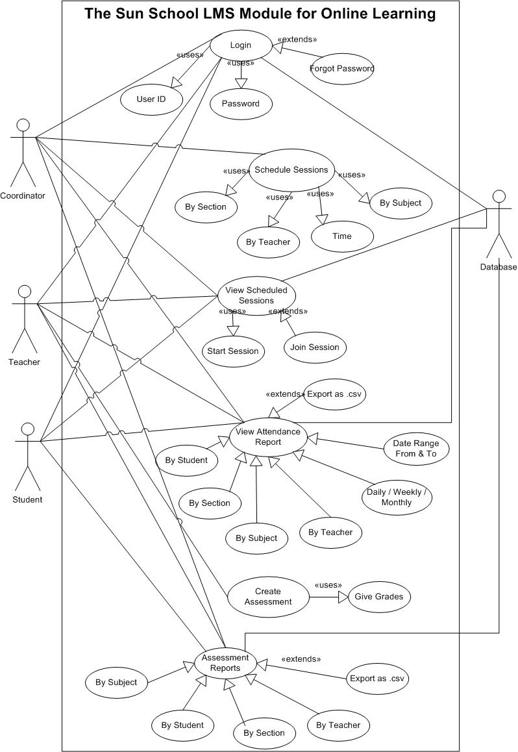
Activity Diagram:
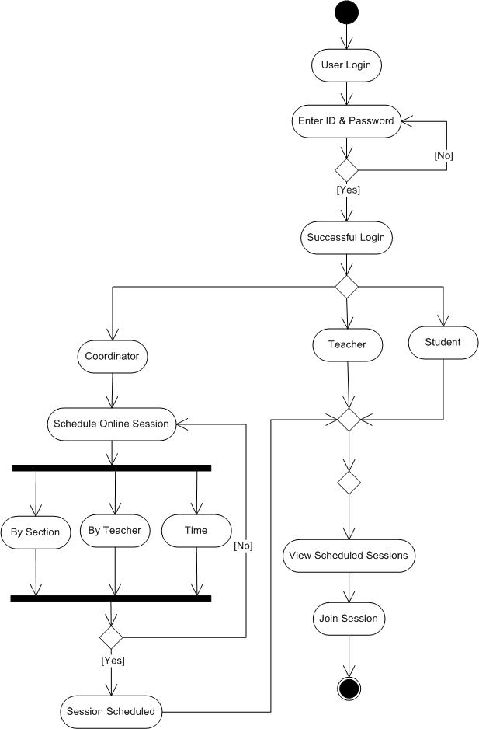

Attendance Report:
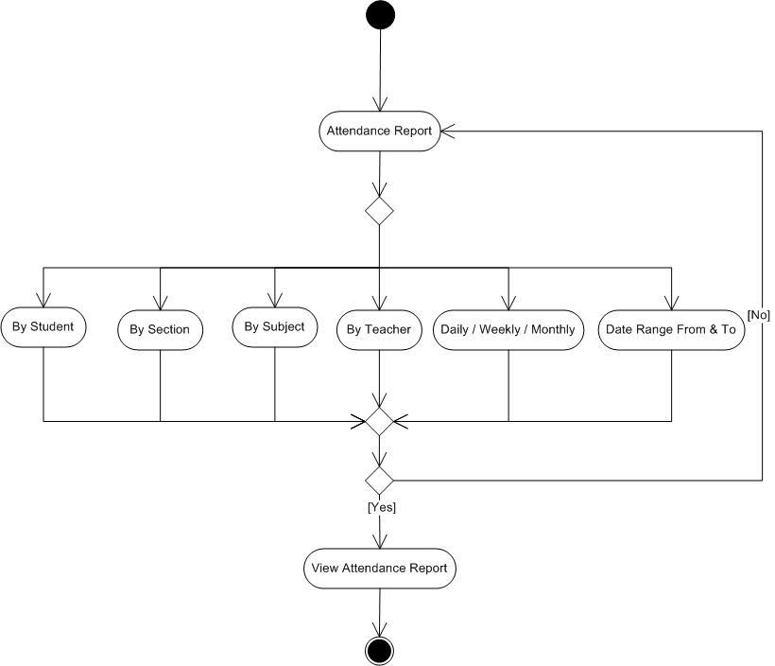

Use Case Specification Document:
Use Case ID | UC 001
Use Case Name | Login
Created By | Mr. Samuel | Last Updated By
Date Created | October 2nd, 2025 | Last Revision Date
Actor | Teacher, Student, and Coordinator
Description | User logs into the system with credentials to access LMS features.
Pre - Condition | User must be The Sun School’s employee and student
Post - Condition | User logged in
Basic Flow | 1. User enters login credentials.  2. System validates details.  3. User dashboard opens.
Alternate Flow | 1: If user enters invalid credentials, system prompts for re-entry  2: If user forgets password, select “Forgot Password”, and receives reset link to email.
Exceptions | Invalid credentials, account locked.
Frequency of Use | High
Assumptions | Device and Internet available.
Constraints | Login process must be <5 sec.
Dependencies | Authentication server.
Inputs & Outputs | Input: Credentials  Output: Dashboard access/error message
Business Rules | Passwords must follow security policies (min. 8 chars, special chars, etc.).
Miscellaneous Information | Single Sign-On (SSO) may be supported in future.

Use Case ID | UC 002
Use Case Name | Schedule Classes
Created By | Mr. Samuel | Last Updated By
Date Created | October 2nd, 2025 | Last Revision Date
Actor | Coordinator
Description | Coordinator schedules online classes for teachers/students.
Pre - Condition | Class & sections must exist.
Post - Condition | Class available in student/teacher dashboard.
Basic Flow | 1. Coordinator selects class & section.  2. Enters schedule.  3. System notifies teachers & students.
Alternate Flow | Class rescheduled.
Exceptions | Conflicting schedule.
Frequency of Use | Medium
Assumptions | Correct teachers mapping.
Constraints | Time conflicts prevented.
Dependencies | Calendar system.
Inputs & Outputs | Input: Class details  Output: Scheduled class
Business Rules | Coordinator only schedules assigned courses.
Miscellaneous Information | Reminders may be sent.

Use Case ID | UC 003
Use Case Name | Start Online Class
Created By | Mr. Samuel | Last Updated By
Date Created | October 2nd, 2025 | Last Revision Date
Actor | Primary: Teacher  Secondary: Students
Description | Teacher starts live online class session.
Pre - Condition | Class scheduled.
Post - Condition | Class session running.
Basic Flow | 1. Teacher clicks "Start Class".  2. System notifies students.  3. Live session begins.
Alternate Flow | Reschedule or Cancel option available.
Exceptions | Technical failure in starting.
Frequency of Use | High
Assumptions | Video conferencing functional.
Constraints | Max concurrent users limited.
Dependencies | Conferencing integration.
Inputs & Outputs | Input: Start command  Output: Live session
Business Rules | Only assigned teacher can start.
Miscellaneous Information | Recording may be enabled.

Use Case ID | UC 004
Use Case Name | Join Online Class
Created By | Mr. Samuel | Last Updated By
Date Created | October 2nd, 2025 | Last Revision Date
Actor | Primary: Student  Secondary: Teacher, Coordinator
Description | Student joins scheduled online classes.
Pre - Condition | Class must be scheduled, and Teacher starts the class
Post - Condition | Student attends class.
Basic Flow | 1. Student checks class schedule.  2. Clicks "Join".  3. System connects to class.
Alternate Flow | Student joins late but still connect.
Exceptions | Network error, expired link.
Frequency of Use | High
Assumptions | Device supports conferencing, and internet available
Constraints | 100 participants max.
Dependencies | Integrated video conferencing tool.
Inputs & Outputs | Input: Join action  Output: Live session
Business Rules | Only active students can join.
Miscellaneous Information | Auto attendance marking.

Use Case ID | UC 005
Use Case Name | View Attendance Reports
Created By | Mr. Samuel | Last Updated By
Date Created | October 2nd, 2025 | Last Revision Date
Actor | Coordinator, Teacher and Student
Description | User (Teacher, Student, and Coordinator) generates system-wide reports on classes, attendance, and performance.
Pre - Condition | Data available in system.
Post - Condition | Report generated/exported.
Basic Flow | 1. User requests for report.  2. System compiles full data.  3. Report generated as requested.
Alternate Flow | Filters applied.
Exceptions | No data found.
Frequency of Use | Medium
Assumptions | Coordinator has highest permissions.
Constraints | Large data may slow system.
Dependencies | Report engine.
Inputs & Outputs | Input: Report request  Output: Report
Business Rules | Coordinator can access all data.  Teachers see only assigned classes.  Only own student records visible.
Miscellaneous Information | Export to PDF/Excel.

Use Case ID | UC 006
Use Case Name | Create Assessment
Created By | Mr. Samuel | Last Updated By
Date Created | October 2nd, 2025 | Last Revision Date
Actor | Teacher
Description | Teacher creates and publishes assessments.
Pre - Condition | Teacher has section assigned.
Post - Condition | Assessment available to students.
Basic Flow | 1. Teacher selects subject.  2. Prepares questions.  3. Publishes assessment.
Alternate Flow | Save as draft.
Exceptions | Database error while saving.
Frequency of Use | Medium
Assumptions | Teacher trained to use tool.
Constraints | Valid subject mappings.
Dependencies | Question bank.
Inputs & Outputs | Input: Questions  Output: Published assessment
Business Rules | Assessment linked to subject.
Miscellaneous Information | Auto-grading rules applied.

Use Case ID | UC 007
Use Case Name | Grade Student
Created By | Mr. Samuel | Last Updated By
Date Created | October 2nd, 2025 | Last Revision Date
Actor | Teacher
Description | Teacher reviews and grades student submissions.
Pre - Condition | Student must submit work.
Post - Condition | Grades stored in system.
Basic Flow | 1. Teacher opens student submission.  2. Assigns marks/feedback.  3. Saves grades.
Alternate Flow | Auto-grade applied to objective type.
Exceptions | System error during saves.
Frequency of Use | Medium
Assumptions | Teacher authorized.
Constraints | Grade entry within deadlines.
Dependencies | Assessment module.
Inputs & Outputs | Input: Teacher grades  Output: Stored grades
Business Rules | Only assigned teacher grades.
Miscellaneous Information | Feedback optional.

Use Case ID | UC 008
Use Case Name | Write Assessment
Created By | Mr. Samuel | Last Updated By
Date Created | October 2nd, 2025 | Last Revision Date
Actor | Primary: Student  Secondary: Teacher
Description | Student attempts subject assessments.
Pre - Condition | Teacher must publish assessment.
Post - Condition | Answers saved.
Basic Flow | 1. Student selects assessment.  2. Attempts questions.  3. Submits answers.
Alternate Flow | Pause and resume (if enabled).
Exceptions | Timeout, system crash.
Frequency of Use | Medium
Assumptions | Stable internet.
Constraints | Auto-submit at time limit.
Dependencies | Assessment database.
Inputs & Outputs | Input: Answers  Output: Submission confirmation
Business Rules | One attempt unless allowed.
Miscellaneous Information | Auto-grading for MCQs.

Document 7- Screens and pages
Login Page:
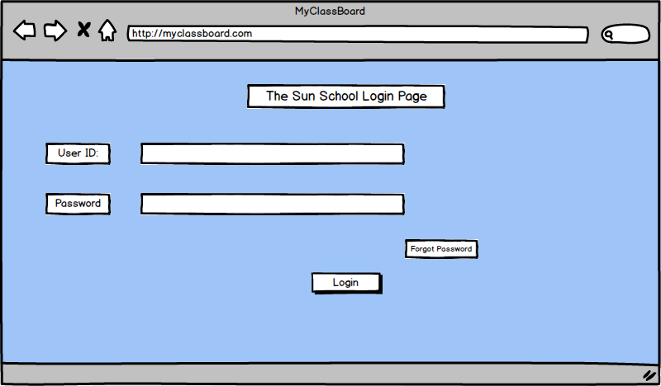
Home Page:
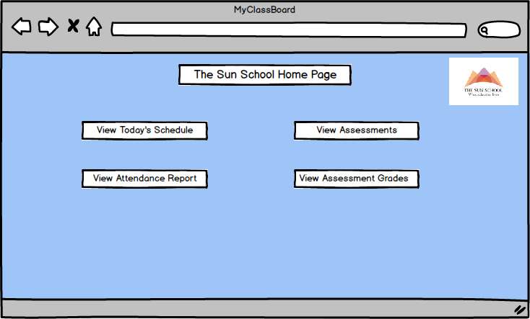

Create Schedule:
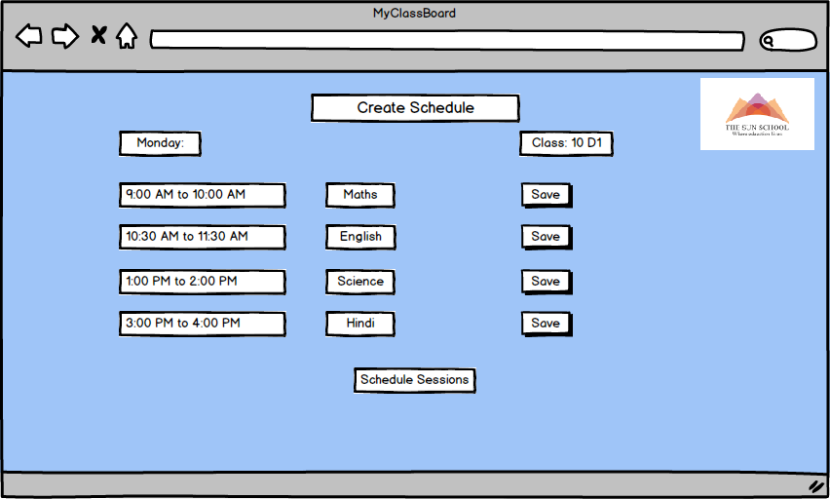
Student’s Schedule:
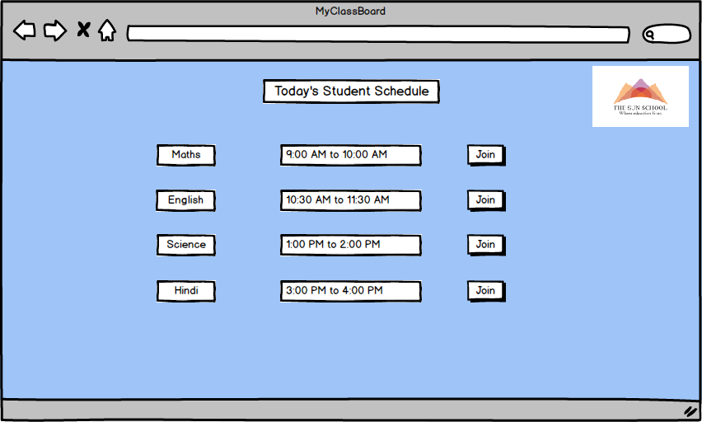

Teacher’s Schedule:
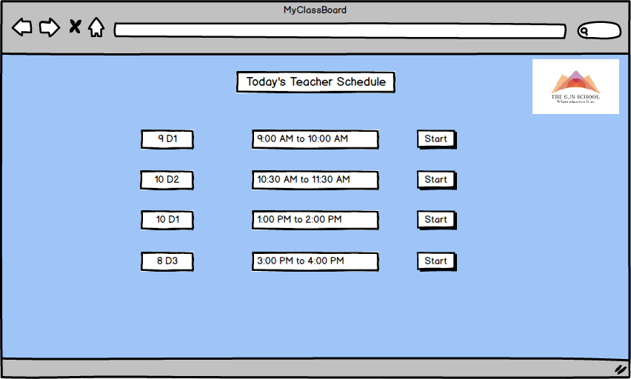
Attendance Reports:
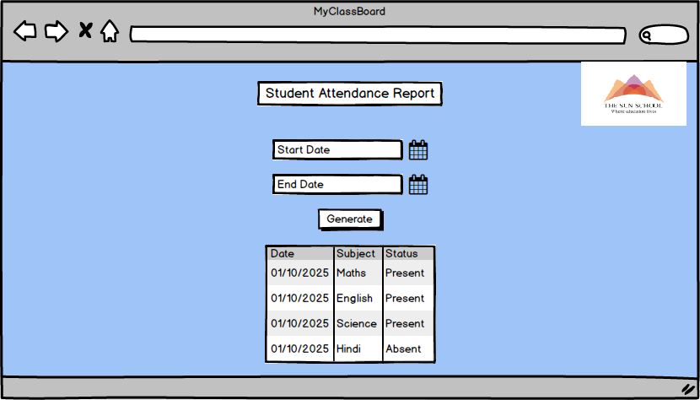
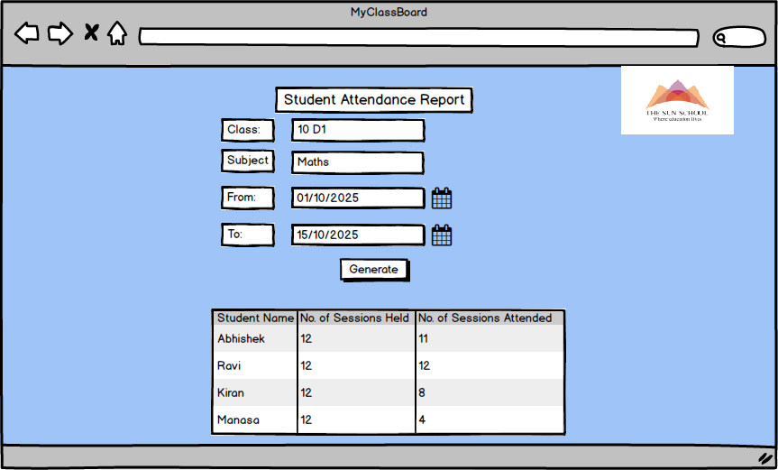

Document 8- Tools-Visio, Balsamic and Axure
- MS Visio: MS Visio (Microsoft Visio) is a diagramming and vector graphics application developed by Microsoft. It is commonly used for creating professional diagrams, flowcharts, organizational charts, network diagrams, process maps, floor plans, engineering designs, and more.
- Balsamiq: Balsamiq is a wireframing tool designed to help users quickly create mock-ups and low-fidelity sketches of user interfaces for websites, web applications, and mobile apps. Its main feature is its simple, drag-and-drop style that looks and feels like drawing on a whiteboard, making it easy to focus on layout and structure rather than detailed design.
- Axure: Axure (Axure RP) is a professional prototyping and wireframing tool used for designing interactive, high-fidelity prototypes of web and mobile applications. Unlike simple sketching tools, Axure allows users to build clickable, realistic demos that closely mimic real software behaviour, including complex interactions, dynamic content, and conditional logic.

Document 9- BA experience:
1. Requirement gathering:
- Conducted stakeholder analysis and identified primary actors (Students, Teachers, Coordinators, Admin).
- Conducted requirements workshop, brainstorming sessions, and interviews with stakeholders. Applied 5W1H (Who, What, When, Where, Why, How) to elicit detailed business needs.
- Used MoSCoW prioritization (Must have, Should have, Could have, Won’t have) for requirement categorization.
- Ensured requirements were documented clearly in BRD and reviewed with client.
2. Requirement Analysis:
- Created Use Case Diagrams, Activity Diagrams, and Process Flowcharts to visually describe the requirements.
- Created Mockups and Wireframes to refine unclear requirements and gain stakeholder clarity.
- Conducted walkthrough sessions with team members, considered their feedback, and modified diagrams accordingly.
- Prepared and reviewed Business Requirement Specification (BRS) and System Requirement Specification (SRS) documents.
- Established Requirement Traceability Matrix (RTM) to ensure complete coverage.
3. Design:
- Collaborated with client on solution design documents and validated alignment with requirements.
- Derived test cases from approved use cases to ensure test coverage.
- Created test data and shared with QA team for test execution.
- Prepared both positive and negative test cases to capture all possible scenarios.
- Updated RTM to ensure all requirements were addressed in the design phase.
4. Development:
- Clarified requirement-related queries raised by the technical team during coding.
- Organized and facilitated JAD (Joint Application Development) sessions with developers and stakeholders.
- Referred UML diagrams and process flows as reference material for developers during coding.
- Conducted regular meetings with technical team and client to update the status.
- Updated RTM to ensure all requirements were addressed in the development phase.
5. Testing:
- Prepared detailed test cases directly from use cases and functional requirements.
- Performed high-level functional testing to validate flows like class scheduling, attendance, and assessments.
- Requested required test data from client and ensured its accuracy.
- Coordinated with stakeholders and obtained formal sign-off on test execution.
- Assisted in preparing client for User Acceptance Testing (UAT) and ensured readiness.
- Continuously updated the RTM to track requirement coverage during testing.
6. Deployment:
- Forwarded finalized RTM as part of the project closure documentation for client reference.
- Supported Go-Live Planning and coordinated with cross-functional teams.
- Organized and facilitated training sessions for end users to ensure smooth adoption.
- Collected feedback from stakeholders' post-deployment
- Coordinated preparation of end-user manuals and ensured their delivery.

