Capstone Project1 – Part -2/3
Online Agriculture Products Store

Question 1 – Audits
4 Quarterly Audits are planned Q1 , Q2, Q3, Q4 for this Project What is your knowledge on how these Audits will happen for a BA ?
Answer:
Quarterly audits are formal reviews conducted every 3 months (Q1–Q4) to ensure:
- The project is progressing as planned.
- Budget and timeline are in control.
- Compliance with internal and external standards.
- Proper documentation and traceability exist.
These audits can be internal (by SOONY or APT IT management) or external (by auditors or CSR compliance teams).
Stage | Quater1 Audit Report (Requirement Gathering & Planning ) |  | Stage | Quarter 2 Audit Report (Requirement Analysis and Design )
Completed | 12 Weeks(Week1 to Week12) |  | Completed | 12 Weeks(Week13 to Week 24)
Checklist | Present the Business Requirements Document (BRD) and FRD how it was gathered.  Need to submit which elicitation techniques used and how the requirements are gathered.  Demonstrate early requirement sign-offs from business users and committee.  Ensure baseline requirements are well documented and version controlled. Email Communication - To , CC, BCC |  | Checklist | Prepare UML Diagrams and use case to represent Visually. Convert Business Requirements into Functional Documents and Share updated FRD/SRS (Functional/Software  Taking Sign off from the client regarding what functionality will be used.  Present the Requirement Traceability Matrix (RTM) linking requirements to design documents.  Utilization of tools for preparing mock-ups  Show evidence of stakeholder meetings and minutes of meetings (MoMs). Email Communication - To , CC, BCC
Stage | Quarter 3 Audit Report (Development & Testing ) |  | Stage | Quarter 4Audit Report (UAT, Go-Live Readiness & CSR Documentation)
Completed | 12Weeks(Week 25 to Week 36) |  | Completed | 12 Weeks(Week 37 to Week 48)
Checklist | Prepare JAD Session report, Developers (Juhi, Lucie, Bravo, etc.) are building as per requirements. End user Manual Preparation Document  Prepare Test Case Summary and validate that testers (Jason, Alekya) have mapped test cases to user stories/use cases.  Participate in meetings to explain requirements-related clarifications and prepare and maintaining BA and Developer MOM Email Communication - To , CC, BCC |  | Checklist | Coordinate and support UAT with stakeholders like Peter, Kevin, Ben.  Maintain a UAT defect log and capture feedback.  Submit final signed-off requirements, RTM, and UAT reports.  Help prepare CSR outcome documentation to show social impact.  Archive all BA documentation for future audits or reference.

Note – Supporting documents that’s needs to be provided to the Auditors for verifications
Documents | Purpose
BRD (Business Requirement Document) | Captures all high-level business needs
FRD/SRS | Detailed functional/system requirements
MoMs (Minutes of Meetings) | Evidence of stakeholder collaboration
RTM (Requirement Traceability Matrix) | Trace requirement to design, code, and test
UAT Plan and Reports | User testing and feedback validation

Question 2 – BA Approach Strategy
Answer: - As a Business Analyst, the goal is to drive requirement clarity, ensure stakeholder alignment, and support solution delivery. Below is the step-by-step BA approach strategy:

1. Project Initiation & Stakeholder Engagement
- Understand project scope
- Perform stakeholder identification and classification
- Prepare a RACI Matrix to define roles
- Schedule kick-off meetings with all key stakeholders (Mr. Henry, Peter, Kevin, Ben, Mr. Pandu, Mr. Dooku)

2. Elicitation Planning & Techniques
Use a mix of elicitation methods based on the stakeholder type:
Technique | Stakeholder | Purpose
Interviews | Mr. Henry, Mr. Karthik | Understand high-level business needs
Workshops | Project Team | Detailed requirement breakdown
Document Analysis | Existing systems/docs | Understand current processes (AS-IS)
Brainstorming | Peter, Kevin, Ben | Gather real-world problems and solutions
Prototyping | Internal/UX team | Visual validation of requirements

3.Documentation & Sign-off Process
Documents to Prepare:
- BRD – Business Requirements Document
- SRS – Software Requirements Specification
- Use Case Specs
- RTM – Requirements Traceability Matrix
- Change Request Forms
- UAT Scenarios
Sign-off Process:
- Submit drafts for stakeholder review
- Capture feedback, revise as needed
- Share final documents with version control
- Get email or e-sign approval from client and sponsors (Mr. Henry, Committee)

4. Communication Channels
Channel | Purpose | Tool/Method
Email | Formal updates & sign-offs | Outlook/Gmail
Weekly Meetings | Project progress & issues | Zoom/MS Teams
Status Reports | Task updates | Excel / Jira reports
Document Sharing | BRD/SRS exchange | Google Drive / SharePoint

5. Change Request Management
- Maintain a Change Request Log
- Use an impact analysis template (cost, timeline, scope)
- Get formal approval from client (Mr. Henry/Committee)
- Update RTM and affected documents post-approval

6. Status Updates & Progress Tracking
- Share weekly or bi-weekly status reports with PM and stakeholders
- Conduct milestone reviews (Post-RG, Post-Design, Pre-UAT)
- Ensure stakeholder concerns are logged and addressed

7. UAT Planning & Client Acceptance
- Prepare UAT Plan and Test Scenarios
- Coordinate UAT with Peter, Kevin, Ben
- Support testers with requirement clarifications
- Capture feedback and manage fixes
- Get Client Project Acceptance Form signed off by Mr. Henry/Committee

Question 3 – 3-Tier Architecture
Explain and illustrate 3-tier architecture?
Answer: 3-tier architecture is a software design pattern that divides an application into 3 distinct layers
- Application Layer
- Business Logic Layer
- Data Layer
Application Layer: User Interface through which users interact with the system, example- A farmer logs into the app and browses fertilizer listings using Web browser/ mobile App.
Business Logic Layer: This layer contains the core business logic and the processing rule. It handles communication between the UI and the database. Example-the app checks product availability and validates the delivery pin code.
Data Layer: Store and manages all application data. Example- The app saves an order placed by a farmer into the orders table.

Question 4 – BA Approach Strategy for Framing Questions
Business Analyst should keep What points in his/her mind before he frames a Question to ask to the Stakeholder
( 5W 1H – SMART – RACI – 3 Tier Architecture – Use Cases, Use case Specs, Activity Diagrams,Models, Page designs)
Answer: BA needs to ensure that questions are well-thought-out, aligned with business and technical goals, and elicit clear, actionable, and complete requirements from stakeholders. For this its necessary to action on the following-
5W 1H Approach
Element | Intent | Sample Questions
Who | Identify roles, actors | Who will use this feature? Who approves the purchase?
What | Understand functions/data | What should happen after the farmer places an order? What is the Purpose?
When | Capture time/sequence | When does the stock get updated? When the product will be ordered?
Where | Define locations or access points | Where should delivery be available? Where will users access the system?
Why | Uncover reasoning/motivation | Why do farmers prefer offline purchases currently? Why we are developing this application
How | Learn process or method | How does the current fertilizer procurement work? How will the overall function flows?

SMART Approach
SMART | Focus
Specific | Ask clearly about a particular need (e.g., What specific crops do you need seeds for? What kind of fertilizers and pesticides are mostly required?)
Measurable | Ask for quantifiable answers (e.g., How many units do you order monthly? )
Achievable | Keep questions grounded in what's technically possible
Relevant | Align questions with business objectives (e.g., usability for farmers)
Time-bound | Include timing or deadlines when needed considering the seasonal based nature of the crops

3 Tier Architecture: Under this concept the question needs to be framed considering the different layers of software
Example:
- How should the data be displayed to the farmers in “Application Layer”
- What should be the flow for Large or bulk orders, How the overall functional process should look like “ Business Logic Layer”
- What reports admin be able to download, Which data is required for future reference “database layer”
RACI
RACI helps to define the overall role and responsibilities within the team outlining who will be responsible, Accountable, Consulted and Informed for the each task assigned

UML/Use cases/Use case Specs, Activity Diagrams, Models, Page designs
Structure questions around user goals and flows.
- Use Cases:
What happens when a farmer places an order?
What if a product is out of stock?
- Use Case Specifications:
Are there any alternate flows if payment fails?
Should the user get an SMS and Email?
- Activity Diagrams:
Use diagram walkthroughs - Does this sequence match your real-life process?”
- Page Designs / Wireframes:
Show mockups - Is this how you’d like to see your dashboard?
Are the labels and buttons easy to understand?”

Question 5 – Elicitation Techniques
As a Business Analyst, What Elicitation Techniques you are aware of? ( BDRFOWJIPQU)
Answer: Requirement Elicitation is the process of digging out the information from the stakeholders and serves as the foundation in documenting the requirements
Code | Technique | Description & Example
B | Brainstorming | Collaborative group session to generate ideas or solutions quickly.  ✔ Used with Peter, Kevin, Ben to identify all farmer-related challenges.
D | Document Analysis | Reviewing existing documentation, reports, or systems to understand current processes.  ✔ Useful to study SOONY’s prior operational process (if any).
R | Reverse Engineering | Understanding a system by analyzing its current outputs and processes, often used when documentation is missing.  ✔ Can be used if the client has an old website/system.
F | Focus Groups | Discussions with a selected group of stakeholders with common interests.  ✔ Used for gathering opinions from a group of farmers together.
O | Observation | Directly watching users interact with a system or perform tasks.  ✔ Observing how farmers currently purchase agricultural inputs offline.
W | Workshops | Structured sessions bringing together stakeholders and technical teams to define and refine requirements.  ✔ Used with Committee + APT IT team.
J | Joint Application Development (JAD) | Intensive sessions that involve users and developers working together for faster requirement collection.  ✔ Accelerates development planning.
I | Interviews | One-on-one or group conversations to gather detailed requirements.  ✔ Used with Mr. Henry, Mr. Pandu, and Mr. Dooku.
P | Prototyping | Creating wireframes or mockups of screens to visually represent requirements.  ✔ Helps in getting feedback from non-technical users.
Q | Questionnaires / Surveys | Used when a large group needs to be consulted efficiently.  ✔ Applicable if farmer base expands.
U | User Task Analysis | Studying how users complete tasks step-by-step.  ✔ Helps refine product catalog and checkout flow based on farmer behavior.

Question 6: Which Elicitation Techniques can be used in this Project and Justify your selection of Elicitation Techniques?
Answer: According to me following techniques can be used in this project
Prototyping
Reason for Selection –
- The target users (e.g., Peter, Kevin, Ben) may not understand detailed documentation.
- Visual representations (screens, buttons, flows) will help non-technical users express what they want or correct what’s shown.
- Early feedback can be captured on usability, layout, and flows.
Benefits
- -Farmers can see how they'll search for seeds or fertilizers and place an order.
- -Helps build a user-friendly application by validating design choices.
- -Encourages engagement and avoids misinterpretation of user needs.
We can use Balsamiq
Use case Specifications
Reason for Selection –
- -Clearly outlines actor interactions (e.g., "Farmer buys a pesticide", "Manufacturer lists a product").
- -Helps developers, testers, and UI designers to understand exact behaviour flow.
- - Use cases are simple, structured, and easy to validate with SMEs or client committee.
Benefits
- -Useful in explaining the steps involved in placing an order or updating product inventory.
- -Supports functional clarity and alignment with system design.
- We can use MS Word, Lucidchart, UML Tools
Document Analysis
Documents which can be analysed are Brochures, product catalogs, order forms, CSR policy, Govt policies, Internal memos etc.
Reason for Selection –
- -The committee (Mr. Henry, Mr. Pandu, Mr. Dooku) or APT IT Solutions may already have internal templates, CSR policies, product catalog formats, or market research reports.
- -Manufacturer companies may provide sample data of fertilizers, seeds, pesticides, etc
Benefits
- -Saves time by with analysing the existing information.
- -Helps understand industry standards, product attributes, pricing formats.
- -Clarifies regulatory or documentation expectations (e.g., delivery timelines, return policy).
Brainstorming
Reason for Selection –
- -Useful in early stages to generate ideas around: which features to include, delivery methods for rural areas, payment mechanism, mobile vs web which will be better.
- - Involves technical team + client committee + stakeholders to explore creative and feasible solutions
Benefits
- - Promotes team ownership and engagement.
- - Drives collaborative innovation( support multilingual screens, if internet is slow)
- - Encourages open dialogue and
- creativity from all parties.

Question 7 – 10 Business Requirements
Answer: Below mentioned are the 10 business requirements –
BR001 – Farmers should be able to search for available products in fertilizers, seeds, pesticides
BR002 – Manufacturers should be able to upload and display their products in the application
BR003- New users (farmers or manufacturers) should be able to register using an email ID and password
BR004- The system should have a secure login functionality for both farmers and manufacturers
BR005- The application should provide a secure and easy-to-use payment gateway, including COD, Credit/Debit cards, and UPI.
BR006- Farmers should be able to browse the product catalogue without restriction.
BR007- Farmers should be able to add products to a Buy Later/Wishlist.
BR008- Once the Order is placed, the system should send an email confirmation to the farmers
BR009- Once the order is placed, we should provide the delivery tracking feature as well
BR010- System should be user friendly and mobile supportive so to be useful in remote areas.

Question 8 –Assumptions
List your assumptions
Answers: Few of the assumptions considered while working on this project
1) Internet Connectivity: It is assumed that farmers and manufacturers in remote areas have access to basic internet connectivity to use the web/mobile application.
2) Device Accessibility: It is assumed that farmers and manufacturers will have and use smartphones or desktops to access the application.
3) Valid Email ID- t is assumed that all users will have valid email addresses, which will be used for registration and communication (e.g., confirmations, password resets, login)
4) Basic Digital Literacy: It is assumed that users (farmers, manufacturer) have basic knowledge of using mobile/web apps (e.g., login, browse, add to cart, add and updated product details).
5) Logistics Partner Will Handle Deliveries: It is assumed that an external logistics partner (or an integrated system) will handle the delivery of products and provide tracking information.
6) Payment Gateway Integration: It is assumed that the project will integrate with a reliable payment gateway to support COD, UPI, and card payments from all available banks.
7) Maintain Security Standards: It is assumed that the development team will implement industry-standard authentication and data protection mechanisms.
8) Feedback from Stakeholders: It is assumed that key stakeholders (e.g., Peter, Kevin, Ben, Committee) will be available and responsive during requirement reviews, UAT, and approvals.
9) Product Catalogue Categories are Defined: It is assumed that the product categories (fertilizers, seeds, pesticides) are predefined and agreed upon by the stakeholders.
10) Manufacturers Will Maintain Product Information: It is assumed that manufacturers will upload, update and maintain their product listings.
11) Performance and Scalability: It is assumed that the system will initially support a limited number of concurrent users (e.g., 500-1000), assuming the rural adoption will grow gradually.

Question 9: Give Priority 1 to 10 numbers (1 being low priority – 10 being high priority) to these Requirements after discussions with the stakeholders
Answer:
Req ID | Req Name | Req Description | Priority
BR003 | Registration of New User | New users (farmers or manufacturers) should be able to register using an email ID and password. | 10
BR004 | Secure login Functionality | The system should have a secure login functionality for both farmers and manufacturers. | 10
BR001 | Search Functionality for available Products | Farmers should be able to search for available products in fertilizers, seeds, pesticides. | 9
BR002 | Display of available products | Manufacturers should be able to upload and display their products in the application. | 9
BR006 | Browse functionality | Farmers should be able to browse the product catalogue without restriction. | 8
BR005 | Payment Security | The application should provide a secure and easy-to-use payment gateway (COD, Card, UPI) | 8
BR010 | User friendly interface | System should be user friendly and mobile supportive to be useful in remote areas. | 7
BR009 | Delivery tracking system | Once the order is placed, a delivery tracking feature should be provided. | 6
BR008 | Email Confirmation | Once the Order is placed, the system should send an email confirmation to the farmers. | 6
BR007 | Enabling Buylater/ Wishlist functionality | Farmers should be able to add products to a Buy Later/Wishlist | 5

Question 10: Use Case Diagram (ReDo)

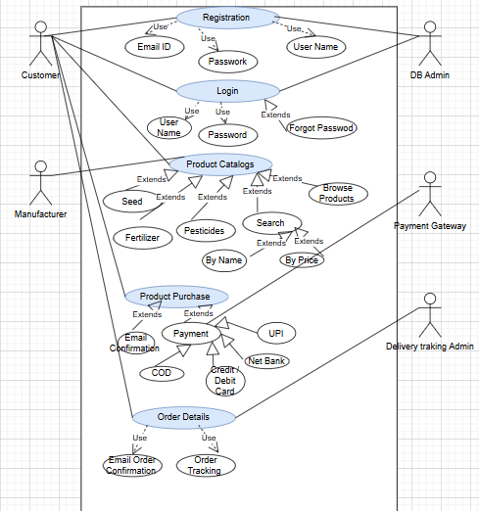

Question 11 – (minimum 5) Use Case Specs
Use Case 1: Farmer Login
- Actors: Farmer
- Preconditions: Farmer is registered with valid credentials.
- Main Flow:
  - Farmer opens the app/website.
  - Enters registered email and password.
  - System validates credentials.
  - Redirects farmer to dashboard.
- Alternate Flow:
  - If invalid credentials → Error message displayed → Retry option provided.
- Postconditions: Farmer is logged into the system.

Use Case 2: Search Products
- Actors: Farmer
- Preconditions: Farmer must be logged in.
- Main Flow:
  - Farmer enters keyword in search bar.
  - System displays matching products (seeds, fertilizers, pesticides).
  - Farmer applies filters (category, price, brand).
- Alternate Flow:
  - If no results → Display "No products found" message.
- Postconditions: Product list is shown to the farmer.

Use Case 3: Upload Product (Manufacturer)
- Actors: Manufacturer
- Preconditions: Manufacturer is logged in and approved by Admin.
- Main Flow:
  - Manufacturer clicks on "Upload Product".
  - Fills form (name, type, price, quantity, photo).
  - Clicks Submit → Product goes to Admin for approval.
- Alternate Flow:
  - If required fields are missing → Prompt validation error.
- Postconditions: Product is submitted for approval.

Use Case 4: Place Order
- Actors: Farmer
- Preconditions: Farmer has selected products in cart.
- Main Flow:
  - Farmer opens cart and reviews items.
  - Chooses payment method (UPI/Card/COD).
  - Confirms delivery address.
  - Clicks “Place Order”.
  - System processes order and sends confirmation.
- Alternate Flow:
  - Payment fails → Display failure message → Allow retry.
- Postconditions: Order is placed and confirmation is sent.

Use Case 5: Track Delivery
- Actors: Farmer
- Preconditions: Farmer has at least one order placed.
- Main Flow:
  - Farmer opens “My Orders”.
  - Selects an order → Clicks “Track”.
  - System fetches real-time status (Dispatched, In Transit, Delivered).
- Alternate Flow:
  - If tracking unavailable → Display “Status not available” message.
- Postconditions: Farmer views current delivery status.

Question 12: Activity diagrams
Answer:

Activity Diagram For user Registration & Login
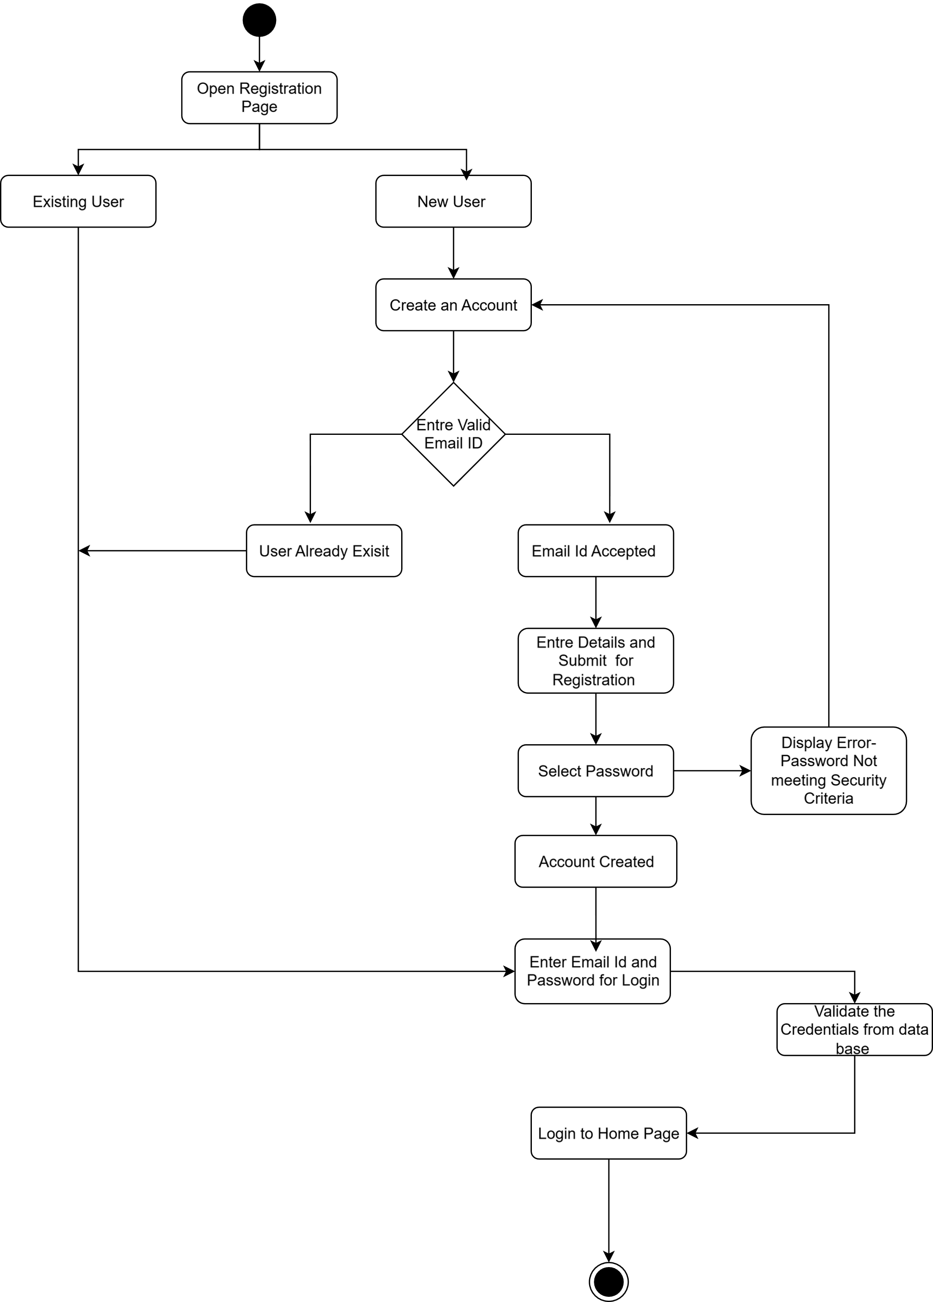

Activity Diagram for Product Search and Adding to Cart
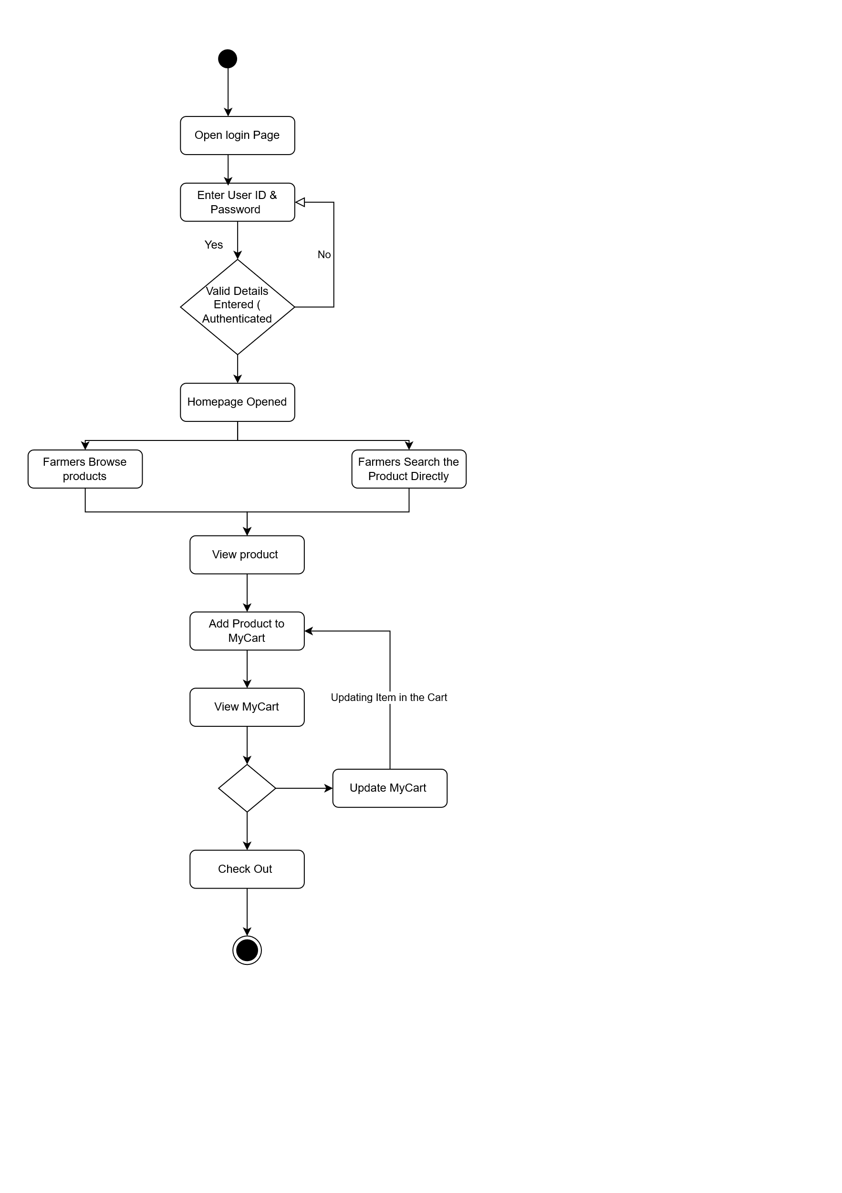

Activity Diagram For Making Payment 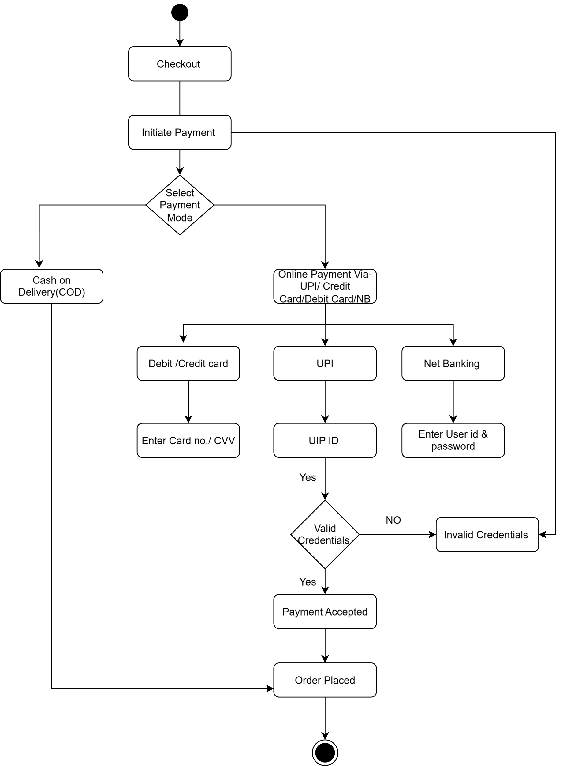

Activity Diagram For Order Processing
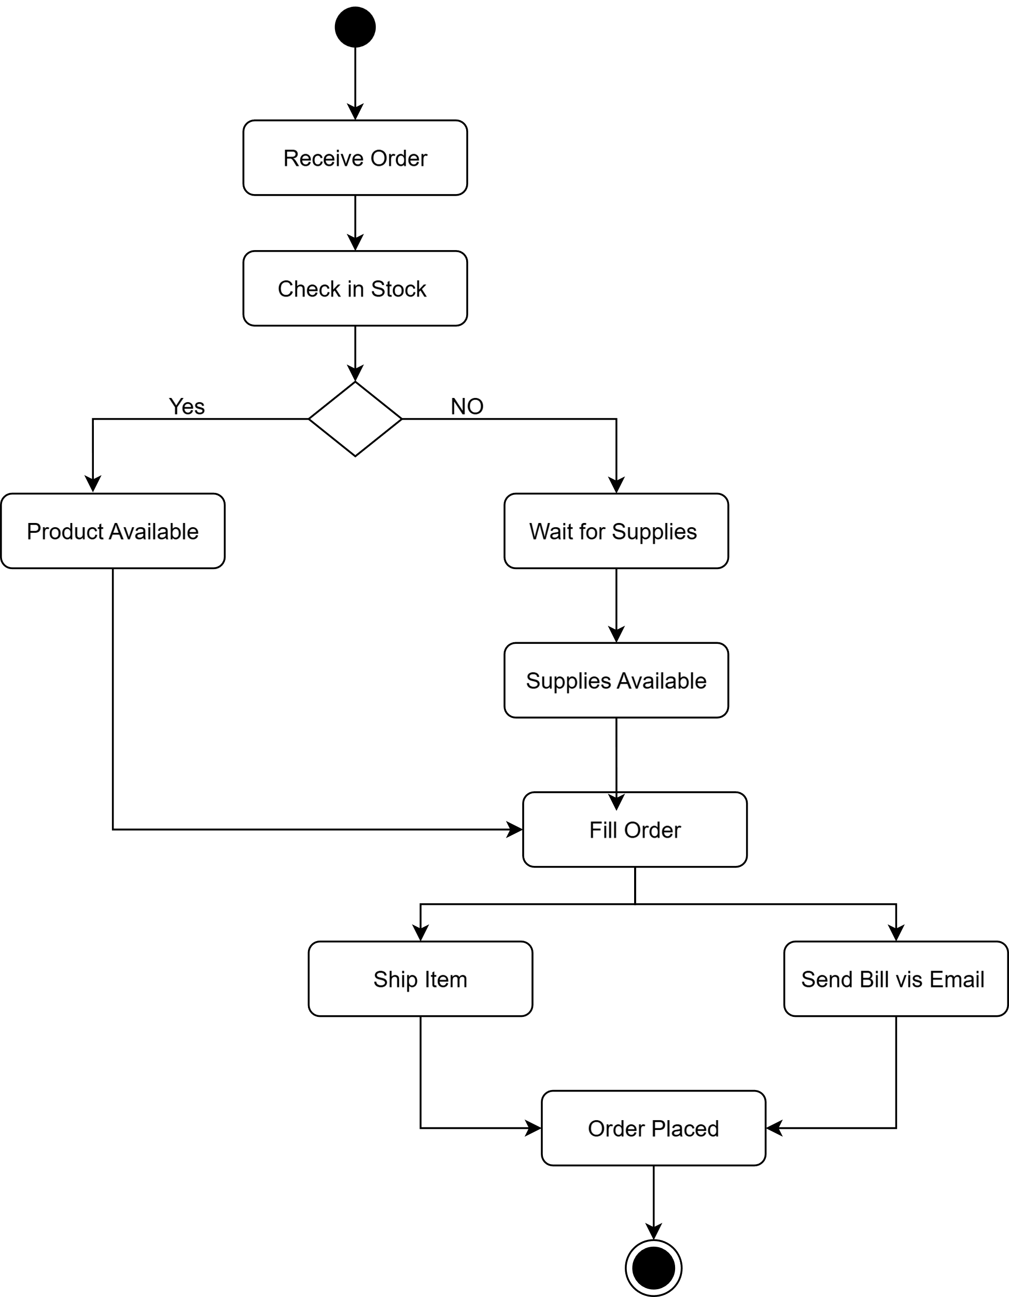

Activity Diagram For Delivery
