Online Agriculture Products Store
Q1. Identify Business Process Model for Online Agriculture Store – (Goal, Inputs, Resources, Outputs, Activities, Value created to the end Customer)
Ans:
- Goal: To bridge the gap between the buyer i.e. the farmers and the companies providing fertilizers, seeds and pesticides for farming via mobile application.
- Input: Customer data, marketing campaign, companies providing farming necessities, resources/company for developing mobile application.
- Resources: Software company, office space, warehouse
- Outputs: Efficiency of the application(user-friendly), sales revenue, benefit for farmers as well as farming companies.
- Activities: Excellent customer services, partnered with leading farming brands.
- Value: Customer satisfaction, hassle-free purchase and selling of farming goods.
Q2. Mr Karthik is doing SWOT analysis before he accepts this project. What Aspects he Should consider as Strengths, as Weaknesses, as Opportunity and as Threats.
Ans:
STRENGTH | WEAKNESS
- Strong brand recognition  - Reputation in agriculture industry  - Opportunities for farmers | - Supply chain disruption (excluding middlemen)  - Communication gap between buyer and seller  - Geographical presence
OPPORTUNITIES | THREATS
- Expansion in agriculture industry  - New opportunities for farmers  - Scaling in farming manufacturing products | - Exploitation of less knowledgeable  - Impacting small scale unlisted agriculture industries  - Disrupting farm credit system

Q3. Mr Karthik is trying to do feasibility study on doing this project in Technology (Java), Please help him with points (HW SW Trained Resources Budget Time frame) to consider in feasibility Study.
Ans:
Definition:
A feasibility study is a structured assessment carried out to determine whether a proposed solution, product, or project is practical, achievable, and worth pursuing considering factors like technical capability, cost, timeline, legal constraints, and business value.
The feasibility study can be performed with the following pointers:
- Technology -Based on the database servers, listing all companies’ details, payment gateways, security and API.
- Hardware-Backup systems and network infrastructure
- Software-payment gateway system, buying cart system and content management system
- Resources-Project management system, Business analyst, Java developers and testers, network and DB admin
- Budget- 2 crores INR
- Time frame- 18 months under CSR initiative.
Q4. Mr Karthik must submit Gap Analysis to Mr Henry to convince to initiate this project. What points (compare AS-IS existing process with TO-BE future Process) to showcase in the GAP Analysis.
Ans:
Definition:
Gap Analysis is meant by the gap between the current state scenario and the desired state scenario.
Current state (AS-IS)
- The farmers are unable to get right agricultural goods (fertilizers, seeds, pesticides) from a good trusted source at right time and right price.
- Lack of understanding the power of mobile application technology also resulting a gap between the manufacturer of agricultural goods selling and buying.
Desired state (TO-BE)
- A web/mobile application where farmers can buy all the farming tools and requirements from a trusted agricultural company without having worry of middlemen.
- Agricultural manufacturer can acquire more customers(farmers) through this user-friendly mobile application and having transparent transaction of buying and selling goods.
Q5. List down different risk factors that may be involved (BA Risks And process/Project Risks)
Ans:
Definition:
Risk analysis is the process of identifying, assessing, and prioritizing potential risks that could affect the success of a project, product, or business initiative, and then figuring out ways to mitigate, monitor, or manage those risks.
The following pointers will define the risk factors:
Internal Risks:
Lack of required expertise, especially in the field of agriculture, web design and mobile app design, or advanced payment systems, could face delays or quality issues in application.
External Risks:
Competition with vendors who sell agriculture products completely offline.
BA Risks:
Incomplete requirements, lack of domain knowledge and change in requirement.
Project based risks:
Scope risks, technology risks
Q6. Perform stakeholder analysis (RACI Matrix) to find out the key stakeholders who can take Decisions and Who are the influencers
Ans:
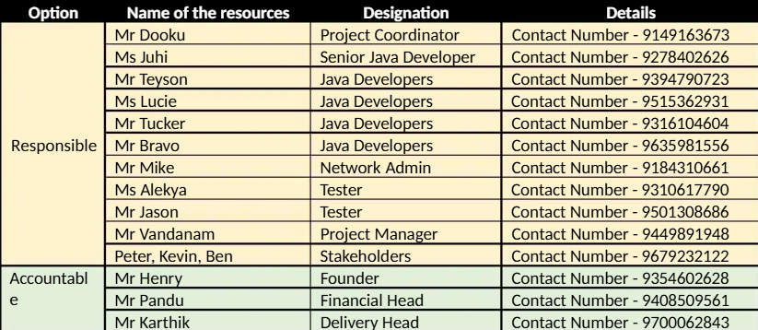
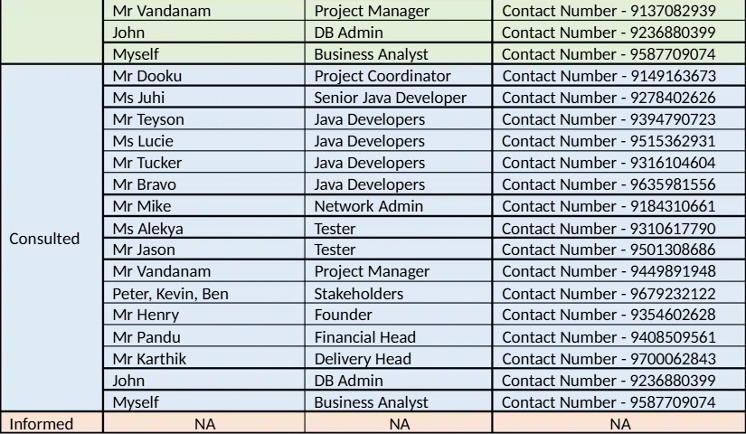

Q7. Help Mr Karthik to prepare a business case document
Ans:
Business Case Document
Project Title: Online Agriculture Products Store
Prepared By: Alisha Mohanty

1. Introduction
This business case is about building an Online Agriculture Products Store for farmers living in remote villages. The idea came from Mr. Henry, a businessman who wanted to help his childhood friends — farmers who are struggling to get fertilizers, seeds, and pesticides on time.
Through this online platform (both website and mobile app), farmers will be able to directly connect with agriculture product companies and buy what they need easily.

2. Problem Statement
Farmers in remote villages face the following problems:
- Difficulty in buying fertilizers.
- Difficulty in buying seeds.
- Lack of pesticides availability.

3. Proposed Solution
The solution is to create an Online Agriculture Products Store where:
- Companies can add product details (fertilizers, seeds, pesticides).
- Farmers can browse, compare, and purchase products.
- Orders will be delivered to the farmers’ location.
- The application will be user-friendly and available in local languages for better adoption.

4. Objectives
- To help farmers get fertilizers, seeds, and pesticides on time.
- To provide farmers with a direct platform to buy products without middlemen.
- To connect companies directly with rural farmers.
- To support farmers through SOONY Company’s CSR initiative.

5. Scope
In Scope
- Web and mobile app development.
- User registration for farmers and companies.
- Product listing and catalogue display.
- Purchase and delivery management.
- Multi-language support.
Out of Scope
- Offline store support.
- Government subsidy or loan features
6. Stakeholders
Name | Role | Responsibility
Mr. Henry | Project Sponsor | Initiated the project under CSR
Mr. Pandu | Financial Head | Approves budget and financial planning
Mr. Dooku | Project Coordinator | Manages day-to-day project activities
SOONY Committee | Decision makers(stakeholders) | Guides and reviews project progress
APT IT Solutions | Vendor | Designs and develops the application
Peter, Kevin, Ben | Farmers / Users | Share farmer requirements and feedback
Agriculture Companies | Suppliers | List their products on the platform

7. Estimated Cost and Duration
- Budget: ₹2 Crores
- Timeline: 18 Months

8. Risks and Mitigation
 |  | Mitigation
  Risk
  Impact
Farmers may not use app due to low digital knowledge | High | Keep app simple, train farmers, add local languages
Delay in delivery of products | Medium | Tie up with local transport partners
Budget may exceed limit | High | Regular progress checks and scope monitoring
Cybersecurity risks | High | Use secure login and data encryption

9. Benefits
- Farmers can easily access farming essentials.
- Lower dependency on middlemen.
- Companies can expand their reach to rural markets.
- Improves farming productivity and farmer income.
- Enhances SOONY Company’s CSR reputation.

10. Conclusion
This project is feasible and beneficial for farmers and agriculture companies. With a budget of 2 Crores INR and duration of 18 months, the project will help address a real problem and improve farming communities.

Q8. Four SDLC Methodologies.
Ans:
SDLC Methodologies – The process which an IT company follows to develop the software application.
Sequential
Sequential models in the Software Development Life Cycle (SDLC), such as the Waterfall Model, follow a linear and structured approach to software development. Each phase is completed in a strict sequence, and the next phase begins only after the previous one is finalized. This model is widely used for projects with well-defined requirements and minimal expected changes.
Iterative
The Iterative Model in the Software Development Life Cycle (SDLC) is a methodology that emphasizes incremental progress and continuous feedback. Instead of attempting to define all requirements upfront, this model begins with a basic implementation of a subset of requirements. Over successive iterations, the software evolves by incorporating feedback, refining designs, and adding new functionality until the complete system is developed.
Evolutionary
The evolutionary model is a combination of the Iterative and Incremental models of the software development life cycle. Delivering your system in a big bang release, delivering it in incremental process over time is the action done in this model. Some initial requirements and architecture envisioning need to be done. It is better for software products that have their feature sets redefined during development because of user feedback and other factors. This article focuses on discussing the Evolutionary Model in detail.
Agile
The Agile Model is a modern software development methodology that emphasizes iterative development, flexibility, and collaboration. Unlike traditional SDLC models like the Waterfall model, Agile divides the development process into smaller, manageable iterations called sprints, allowing for continuous feedback and adaptation to changing requirements.
5year project
Methodologies | Year 1 | Year 2 | Year 3 | Year 4 | Year 5 | Year 6
 | 2015 | 2016 | 2017 | 2018 | 2019 | 2020
Sequential |  |  |  |  |  | ||||||||
Iterative |  | || | || | || | || | ||
Evolutionary |  |  | |||| | || | || | ||
Agile | |||| | ||| | ||| | ||| | ||| | |||

Q9. Waterfall RUP Spiral and Scrum Models.
When the APT IT SOLUTIONS company got the project to make this online agriculture product store, there is a difference of opinion between a couple of SMEs and the project team regarding which methodology would be more suitable for this project. SMEs are stressing on using the V model and the project team is leaning more onto the side of waterfall model. As a business analyst, which methodology do you think would be better for this project?
Ans:
SDLC model
1)Waterfall Model
➢Waterfall model is a traditional model. Waterfall model follows a structured approach with each phase having specific deliverables.
➢At the end of each phase a review takes place to determine if the project is running fine.
➢ Waterfall model works well for smaller projects where requirements are very well understood.

2) V Model
➢ V-model means Verification and Validation model.
➢ Each phase must be completed before the next phase begins. Testing of the product is planned in parallel with a corresponding phase of development in V-model.
➢ Proactive defect tracking – that is defects are found at early stage.
➢ Works well for small projects where requirements are easily understood
3) RUP – Rational Unified Process
➢RUP stands for Rational Unified Process, where phase/ module wise (long term project) application is developed. Hence, we can track the defects at early stages. This avoids the downward flow of the defects.
➢Change request is welcomed in every phase of development.
➢This model is called heavy weight process model.
➢This model has multiple stages which requires more resources and more budget.

4) Spiral Model
➢The spiral model is a risk-driven process model generator for software projects. ➢The spiral model has four phases: Planning, Risk Analysis, Engineering and Evaluation.
➢A software project repeatedly passes through these phases in iterations (called Spirals in this model).
➢The baseline spiral, starting in the planning phase, requirements are gathered and risk is assessed. Each subsequent spirals builds on the baseline spiral.
5)Scrum
➢Scrum is an Agile framework used for developing, delivering, and sustaining complex products.
➢ It’s lightweight, simple to understand but hard to master.
___________________________________________________________________
As a business analyst, the suitable methodology for the application is waterfall model because for the following reasons
->The problem is clearly stated: farmers need access to fertilizers, seeds, and pesticides via an online app.
->The system requirements (farmer can browse, manufacturers can upload, orders placed, delivery facilitated) are not vague, and stakeholders (farmers + manufacturers + committee) already know what they want.
->Since requirements won’t change frequently, a linear Waterfall approach fits well.
->The project has fixed budget (₹2 Crores) and fixed timeline (18 months) under a CSR initiative.
->Waterfall allows strict phase-by-phase progress (requirement gathering → design → development → testing → deployment), making it easier to plan, control cost, and meet deadlines.

Q)10. 20Write down the differences between waterfall model and V model.
Ans:

Aspect | Waterfall Model | V-Model
Definition | Linear sequential model where phases flow step by step. | Extension of Waterfall, shaped like “V”, emphasizes verification & validation.
Approach | Sequential and one-directional. | Parallel – each development phase has a corresponding testing phase.
Focus | Development first, testing later. | Development and testing go hand-in-hand.
Testing | Starts only after development is complete. | Planned early and executed in parallel with development.
Flexibility | Very rigid, not good for handling changes. | Slightly better, early error detection, but still rigid overall.
Error Detection | Errors found late, during testing phase. | Errors can be caught early in corresponding test phases.
Cost of Fixing Defects | High, since bugs are detected late. | Lower, since bugs are detected early.
Best Suited For | Projects with stable, well-defined requirements (e.g., CSR, government projects). | Quality-critical projects (e.g., medical, banking, aerospace).
Diagram Shape | Straight downward flow (like a waterfall). | V-shape, showing link between dev and test stages.
User Involvement | Minimal until the final stage. | More involvement during validation/testing stages.

Q11) As a BA, state your reason for choosing one model for this project
Ans:
As a BA, waterfall model is suitable for this project because for the following reasons
->Waterfall allows strict phase-by-phase progress (requirement gathering → design → development → testing → deployment), making it easier to plan, control cost, and meet deadlines.
->The problem is clearly stated: farmers need access to fertilizers, seeds, and pesticides via an online app.
->The project has fixed budget (₹2 Crores) and fixed timeline (18 months) under a CSR initiative.

Q)12 Prepare a Gantt chart
The Committee of Mr. Henry, Mr Pandu, and Mr Dooku discussed with Mr Karthik and finalised on the V Model approach (RG, RA, Design, D1, T1, D2, T2, D3, T3, D4, T4 and UAT) Mr Vandanam is mapped as a PM to this project. He studies this Project and Prepares a Gantt chart with V Model (RG, RA, Design, D1, T1, D2, T2, D3, T3, D4, T4 and UAT) as development process and the Resources are PM, BA, Java Developers, testers, DB Admin, NW Admin.
Ans
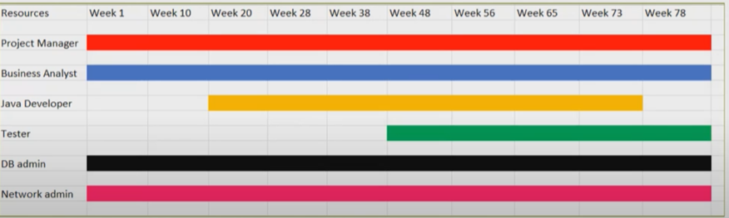
Q)13 Explain the difference between Fixed Bid and Billing projects
Ans
Fixed bid project
A fixed bid project is one in which the service provider agrees to deliver a specific scope of work for a fixed price. The scope of work, deliverables and timelines are agreed upon upfront, and the service provider assumes the risk for any cost overruns or delay.
Billing project
A billing project is one in which the service provider bills the client for the actual time and materials expended on the project. The client pays for the service provider’s time and expenses, and the scope of work can be adjusted as needed throughout the project.
As a BA, this project is a fixed bid project as it clearly mentions the budget as 2 crore rupees with timeline as 18 months.
Q)14 Preparer Timesheets of a BA in various stages of SDLC
➢ Design Timesheet of a BA
➢ Development Timesheet of a BA
➢ Testing Timesheet of a BA
➢ UAT Timesheet of a BA
➢ Deployment n Implementation Timesheet of a BA

Ans
Weekly TIMESHEET
Fields | Detail
Name of BA
Email
Phone Number
Project
Project timeframe
Reporting Manager

Stage Name-Design
Date | Stage/Process name | Start Time | End time | Total hours | Task Description | Remarks
DD/MM/YY | Design
DD/MM/YY | Design
DD/MM/YY | Design
DD/MM/YY | Design

Stage Name-Development
Date | Stage/Process name | Start Time | End time | Total hours | Task Description | Remarks
DD/MM/YY | Development
DD/MM/YY | Development
DD/MM/YY | Development
DD/MM/YY | Development

Stage Name-Testing
Date | Stage/Process name | Start Time | End time | Total hours | Task Description | Remarks
DD/MM/YY | Testing
DD/MM/YY | Testing
DD/MM/YY | Testing
DD/MM/YY | Testing

Stage Name-UAT
Date | Stage/Process name | Start Time | End time | Total hours | Task Description | Remarks
DD/MM/YY | UAT
DD/MM/YY | UAT
DD/MM/YY | UAT
DD/MM/YY | UAT

Stage Name-Deployment and Implementation
Date | Stage/Process name | Start Time | End time | Total hours | Task Description | Remarks
DD/MM/YY | Deployment and Implementation
DD/MM/YY | Deployment and Implementation
DD/MM/YY | Deployment and Implementation
DD/MM/YY | Deployment and Implementation

Summary

