Document 6- Please prepare a use case diagram, activity diagram and a use case specification document.
Use Case Diagram-

Activity Diagram-

- Use case specs for all use cases

Use Case ID | UC001
Use Case Name | Book appointment with Developer
Created by | Shital Kadam | Last updated by | January 11th 2025
Date Created | December 13th 2024 | Last revision Date | January 11th 2025
Actor | Customer, Developer
Description | These use case describe how user can register for Curia app or website
Pre-Condition | User should have valid email address or mobile
Post condition | User account is successfully created
Normal flow of events | 1. Patient/Doctors visits the website and clicks on "Register  2. The system displays a registration form  3. User enters details (e.g., name, contact, address, and password, and other clinical details) for Doctors (Education, Licence, Expertise) and submits the form  4. The system validates the information  5. The system creates a User account and sends a confirmation email/SMS
Alternative flow | 1. If validation fails, the system highlights errors and requests corrections
Expectations | User can successfully Register himself or herself into app.
Frequency of Use | High
Assumptions | The Patient/Doctors has access to the internet and a valid email address or mobile phone number  The registration form is simple and user-friendly, with mandatory fields clearly marked  The system is accessible via both desktop and mobile device

Use Case ID | UC002
Use Case Name | Book appointment with Developer
Created by | Shital Kadam | Last updated by | January 11th 2025
Date Created | December 13th 2024 | Last revision Date | January 11th 2025
Actor | Customer, Developer
Description | These use case describe how user can log in app and allow user to login into app.
Pre-Condition | User should have registered account
Post condition | Successfully login into app
Normal flow of events | 1. System describe a login or Registered option  2. User can login into app by using user id and password  3. System validate user Id and password  4. System verified user id and password  5. The system displays the user’s homepage  6. The use case end
Alternative flow | 1. Missing user id and password  2. Maximum 3 attempt exceeded  3. Invalid user id password
Expectations | User can login successfully into app. While login into app user should enter valid email id and password
Frequency of Use | High
Assumptions | It is assumed that the customer is registered  It I assumed that the customer has basic knowledge about use of or handling of mobile and computers

Use Case ID | UC003
Use Case Name | Book appointment with Developer
Created by | Shital Kadam | Last updated by | January 11th 2025
Date Created | December 13th 2024 | Last revision Date | January 11th 2025
Actor | Customer, Developer
Description | These use case describe if user forgot password then how to Rest Password
Pre-Condition | User should have registered account
Post condition | Password is successfully updated
Normal flow of events | 1. User navigates to the "Forgot Password" page  2. The system prompts for the registered email or phone number  3. User submits the information (OTP)  4. The system sends a password reset link or code  5. User resets the password using the link or code
Alternative flow | 1. Invalid Email/Phone Number: The user enters an email address or phone number that is not associated with any account. User can re-enter the correct email/phone number or contact support  2. Expired or Invalid Reset Link: User clicks on the reset link in the email, but it has expired or is invalid. The user can request another password reset
Expectations | User can login successfully into app after resetting password Successfully
Frequency of Use | Medium
Assumptions | It is assumed that the customer is registered  The email or phone number used during the password recovery process must match the one provided during registration

Use Case ID | UC004
Use Case Name | Book appointment with Designer
Created by | Shital Kadam | Last updated by | January 11th 2025
Date Created | December 13th 2024 | Last revision Date | January 11th 2025
Actor | Customer, Designer
Description | These use case describe how user can Browse the Doctors in app
Pre-Condition | User must be logged in
Post condition | User is informed about the available Doctors
Normal flow of events | 1. User selects a Doctors category (e.g., Availability, Expertise, Treatment condition, Location).  2. The system displays available Doctors.  3. User filters and sorts Doctors based on criteria (e.g., Location, expertise).  4. User views Doctors details.
Alternative flow | 1. No Doctors Available in Selected Category  2. View Limited Doctors Details (Guest User)  3. The Patient uses the search bar to find a specific Doctors for treatment.
Expectations | User can Browse and view Doctors easily on app
Frequency of Use | High
Assumptions | Patient/Doctors are familiar with basic browsing and filtering operations.  The system has a robust database to handle Doctors listings and queries efficiently

Use Case ID | UC005
Use Case Name | Book appointment with Developer
Created by | Shital Kadam | Last updated by | January 11th 2025
Date Created | December 13th 2024 | Last revision Date | January 11th 2025
Actor | Customer, Developer
Description | These use case describe Doctors can Track Patient Health
Pre-Condition | User must have taking treatment.
Post condition | Doctors is informed about the Patient health status
Normal flow of events | 1. Doctors navigates to the treatment history section  2. User selects a patient treatment view detail  3. Patient uploaded test report file and status of health progress  4. The system displays the Patient health status and tracking information
Alternative flow | 1. Doctors navigates to the treatment history section  2. User selects a patient treatment view detail  3. Patient uploaded test report file and status of health progress  4. The system displays the Patient health status and tracking information
Expectations | If no reports are available, system displays a message.
Frequency of Use | High
Assumptions | The user must undergo treatment and continue to make progress in their health.  The user should upload correct reports during treatment.

Constraints:-
- Regulatory Compliance: Must strictly comply with healthcare regulations like HIPAA (USA), GDPR (EU), and local data protection laws.
- Time Constraint: Project must be completed within the defined timeline and milestones.
- Budget Limitations: Development and operational activities must remain within the approved project budget.
- Third-Party Dependency: Reliance on external data sources (e.g., clinical trial databases, doctor directories) which may affect timelines and data accuracy.
- Technical Constraints: Application must be compatible across Android, iOS, and web platforms with performance optimization.
- Language Support: Only limited languages will be supported at launch, with plans to expand post-launch.
- Limited Initial Geographic Reach: The platform will initially be available in selected countries/regions.

Dependencies:-
- Dependency on third-party data providers for clinical trials, cancer treatments, and hospital information.
- Dependency on the mobile app stores (Google Play, Apple App Store) for distribution.
- Requires timely updates from research analysts and backend teams for accurate information.
- Dependency on external platforms for teleconsultation or doctor search if integrated.
- Functional integration with notification services for updates and alerts.

Inputs:-
- User Profile Information: Age, Gender, Cancer Type, Location.
- User-selected preferences for types of cancer information.
- Research data from external data providers.
- Feedback and ratings provided by users.
- Backend system updates related to new clinical trials, treatments, and support groups.
Business Rules:-
- Only authenticated users can save preferences or join support groups.
- The application must provide information relevant to the selected cancer type.
- Users cannot access age-restricted information (if applicable) without verification.
- All provided information should be up-to-date, verified, and sourced from reliable medical databases.
- Critical changes in treatment recommendations must trigger user notifications.
- The application must log user consent for receiving notifications and personalized data.
Inputs:-
- User Profile Information: Age, Gender, Cancer Type, Location.
- User-selected preferences for types of cancer information.
- Research data from external data providers.
- Feedback and ratings provided by users.
- Backend system updates related to new clinical trials, treatments, and support groups
Outputs:-
- Personalized cancer treatment information.
- List of ongoing clinical trials relevant to the user.
- Nearby hospitals, doctors, and support groups.
- Notifications for updates on research, new trials, or medical articles.
- Visual reports or summaries tailored to the user’s cancer type.

Miscellaneous Information:-
- Support for multiple languages depending on the user’s region.
- The application should offer a feedback mechanism for continuous improvement.
- User activity may be anonymously tracked for research and application performance improvement.
- Offline mode should allow users to view previously downloaded information.
- The app should provide links to external resources like cancer helplines or emergency services.

Document 7- Screens and page

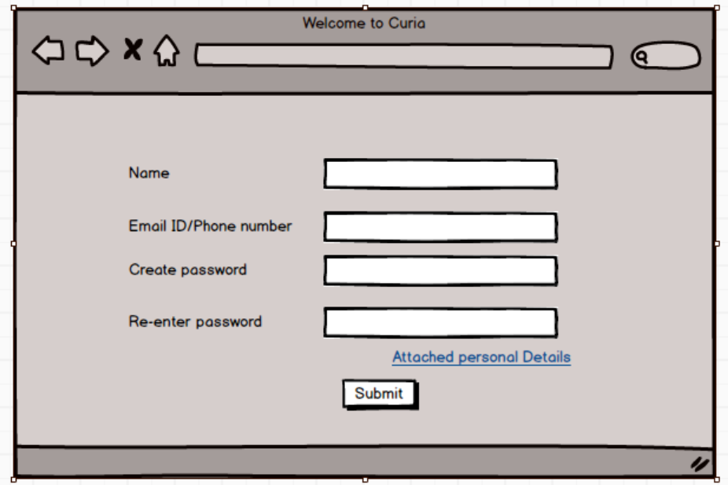

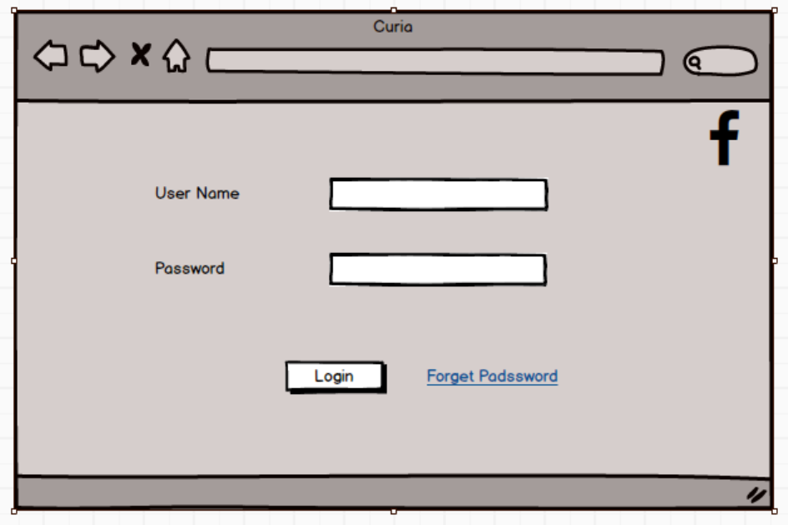

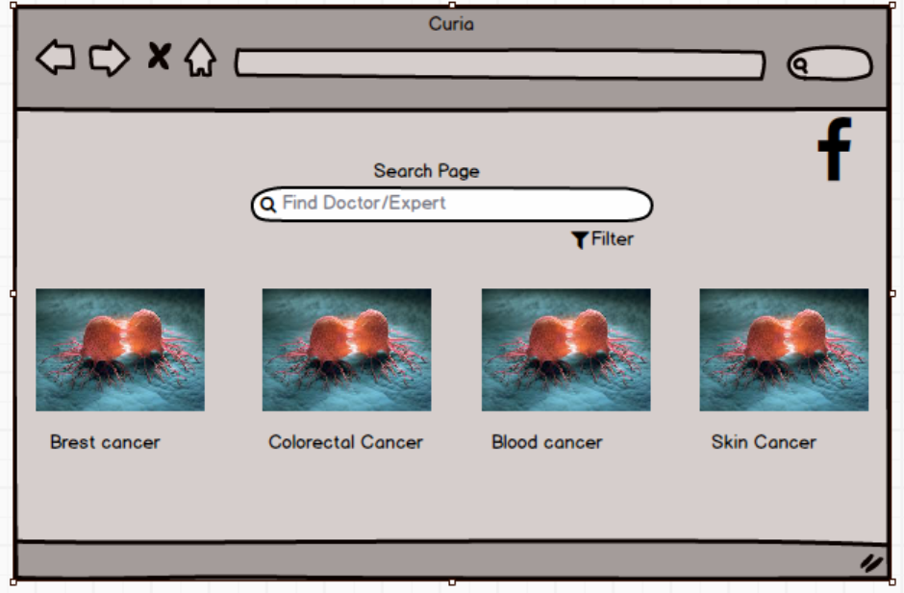

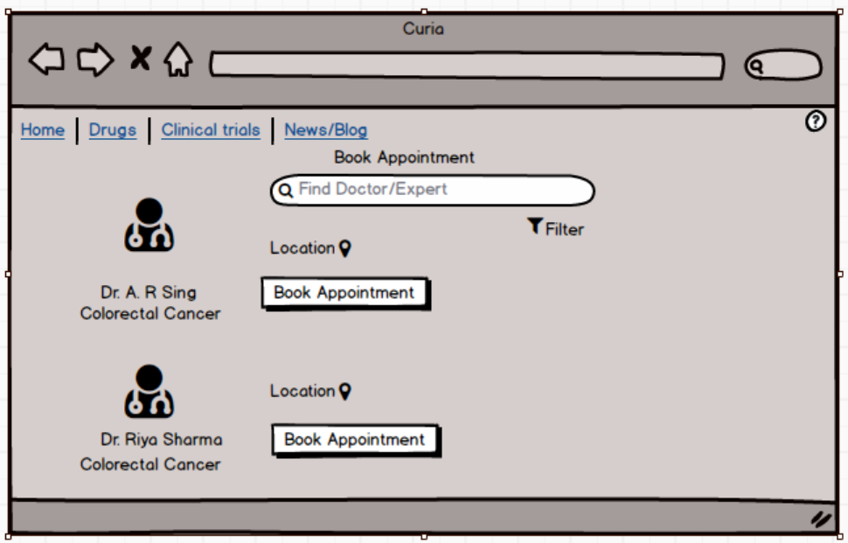

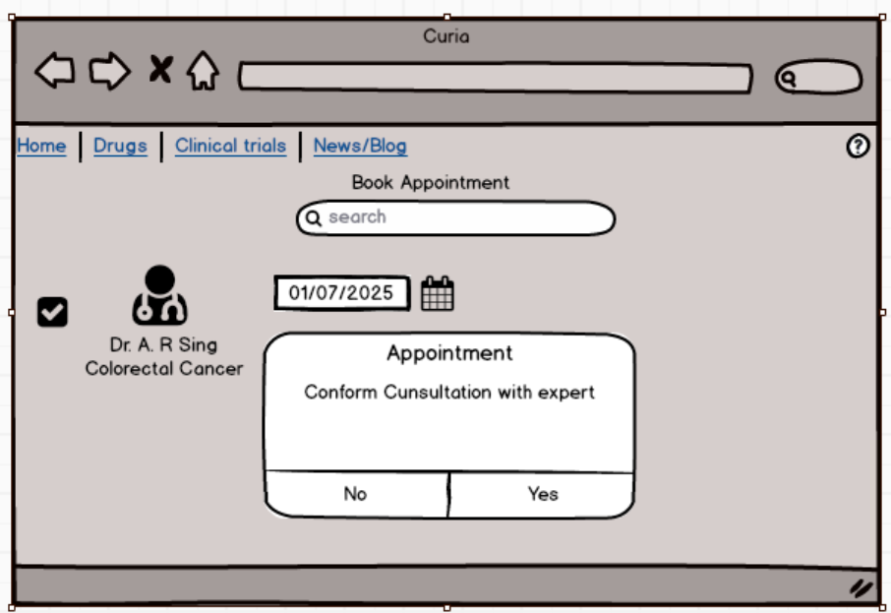

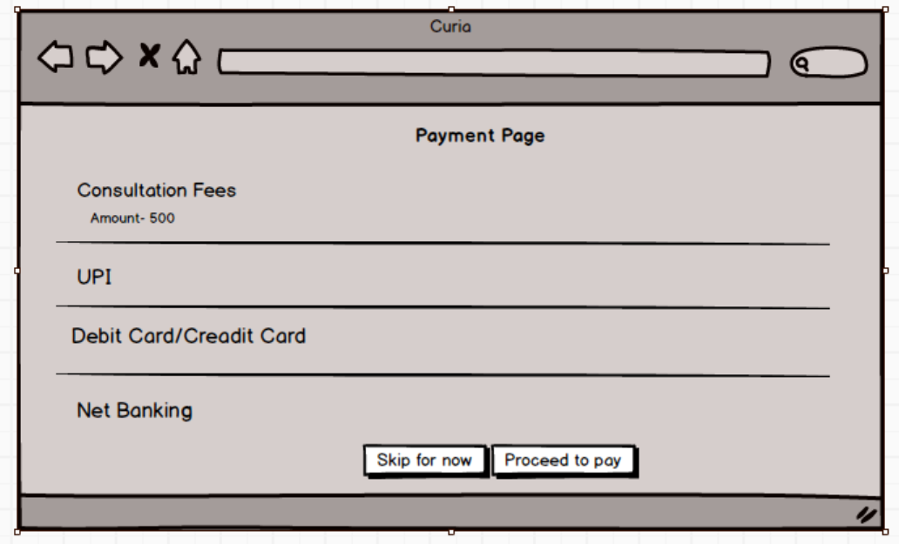

Document 8- Tools-Visio and Axure

1) Microsoft Visio- it is diagramming and vector graphics application used to create diagrams, Flowchart, and other visual representation of complex information. Microsoft Visio is a diagramming tool used for creating UML diagrams like Use Case, Activity, and Sequence diagrams. Its integration with Microsoft Office enhances documentation. Visio simplifies complex processes through drag-and-drop features and making it essential for business and technical analysis.

2) Axure- it is more advance prototype tool used to create high-fidelity, interactive wireframes and prototypes for web and mobile application. It supports dynamic panels, conditional logic, and data-driven elements to create realistic user experiences. Axure aids in user flow validation, stakeholder communication, and usability testing, ensuring a well-defined and structured design before development

Document 9- BA experience
My experience as BA in following phases:
1. Requirement gathering:
As a Business Analyst, I played a key role in the Requirement Gathering phase by employing the MOSCOW prioritization technique to effectively classify and prioritize client needs. During this phase, the client was occasionally unavailable, requiring me to proactively identify alternative points of contact on the client’s side to ensure continuous information flow and prevent delays.
I meticulously validated the gathered requirements using the FURPS framework to ensure they met essential quality criteria.
I also addressed challenges such as identifying and eliminating duplicate or repetitive requirements to maintain clarity and avoid confusion.
Additionally, I utilized prototyping techniques to help stakeholders visualize the system early, which led to more specific and refined requirements.

2. Requirement Analysis:
In the Requirement Analysis phase, I was responsible for translating the gathered requirements into visual models using UML diagrams to clearly represent system functionalities and interactions.
I also created activity diagrams to outline the detailed process flows, which helped the team understand the sequence of operations.
As part of my role, I regularly communicated these diagrams to the project team, encouraging feedback and discussions. When team members provided suggestions or identified discrepancies, I carefully reviewed their input and made necessary modifications to ensure accuracy and alignment.
Additionally, I was involved in preparing key documentation such as the Business Requirement Specification (BRS) and System Requirement Specification (SRS), which served as essential references throughout the project.

3. Design:-
During the Design phase, I was actively involved in deriving test cases from use case diagrams to ensure thorough test coverage.
I maintained continuous communication with the client to review and validate the design and solution documents, ensuring they aligned with business expectations.
I was diligent in writing both positive and negative test cases, recognizing that missing even a single scenario could have significant consequences in later stages of development.
I also prepared test data to support effective testing and validation activities.
Throughout the phase, I regularly updated the Requirement Traceability Matrix (RTM) to ensure that all requirements were properly mapped to corresponding test cases and no requirement was left unaddressed.

4. Development:
In the Development phase, I facilitated Joint Application Development (JAD) sessions to promote collaboration between the technical team and stakeholders.
I actively supported the development team by promptly clarifying queries during the coding process to ensure accurate implementation.
When facing situations where certain team members disagreed with concepts or showed reluctance to cooperate during JAD sessions, I handled the situation diplomatically through one-on-one discussions, explaining the potential project impacts and fostering a healthy, collaborative team environment.
I also guided the team by referring to the prepared diagrams for unit-level coding. Regular coordination with both the technical team and the client was a key part of my role, even when it was challenging to ensure full participation.
In cases where members missed meetings, I ensured they stayed informed by sharing session recordings and conducting follow-up discussions individually.

5. Testing:
In the Testing phase, I was responsible for preparing detailed test cases derived from use cases to ensure comprehensive validation of the system.
I conducted high-level testing to verify the core functionalities and identify any major issues early. As part of the process, I coordinated with the client to request and obtain necessary test data for accurate and realistic testing scenarios.
I continuously updated the Requirement Traceability Matrix (RTM) to track the coverage and fulfillment of all business requirements.
Additionally, I facilitated the client signoff on completed testing activities and worked closely with the client to prepare them for User Acceptance Testing (UAT) by providing necessary guidance and support.

6. Deployment:
During the Deployment phase, I ensured a smooth project handover by forwarding the updated Requirement Traceability Matrix (RTM) to the client, which was also included in the project closure documentation.
I actively coordinated with the team to complete and share end-user manuals to support user onboarding and system adoption.
Additionally, I was responsible for planning and organizing training sessions for the end users to ensure they were well-prepared to use the system effectively.
I closely monitored participation to ensure all intended candidates attended the training sessions, providing follow-ups where necessary to guarantee full user readiness.

