Question 1: Audits
Ans:
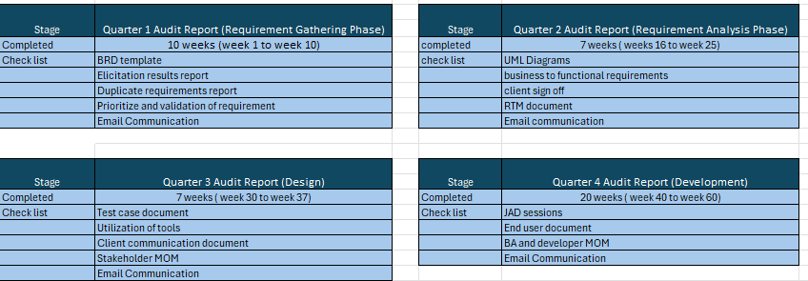
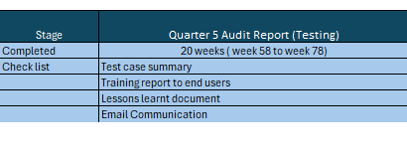
Question 2: BA Approach strategy
Ans:
- Business Requirements Initiation (gathering stage):
After receiving SOW (Statement of work) Requirements are gathered by first conducting stakeholder Analysis.
- Stakeholder Analysis:
First step is to identify Stakeholders and categorize them based on the influence and interest in the project, then we can apply RACI analysis to define their roles and responsibilities.
RACI means:
R – Responsible → The people who carry out the task
A – Accountable → The main owner who makes sure the work is done right.
C – Consulted → The people whose opinions are sought before decisions are made.
I – Informed → The people are updated or informed about what’s happening.
Identifying the stakeholders through the ILS. i.e., Identify the stakeholders, List the stakeholders, Summarize the stakeholder.
Business stakeholders - Mr. Henry, Mr. Pandu, Mr. Dooku, Peter, Kevin, and Ben.
Project stakeholders - Project Manager- Mr. Vandanam,
Senior Java Developer- Ms. Juhi,
Java Developers- Mr. Teyson, Ms. Lucie, Mr. Tucker, Mr. Bravo,
Network Admin- Mr. Mike,
DB Admin- Mr. John,
Testers- Mr. Jason & Ms. Alekya, BA-Self.
3rd party stakeholder – Peter, Kevin & Ben.
- Documents to Write
A BA would Document many things in a Project like BRD (business requirement document), RTM (requirements traceability matrix), FRD (functional requirement document), SRS (Software requirements specification), Feed backs from stakeholders, Documentation from elicitation techniques like JAD sessions or Brainstorming, User manuals, UAT Meetings, Status Report, MOM (minutes of meeting) with Client or Stakeholder.
- Process to follow sign off on the documents:
Prepare the document with accurate requirements and details, ensuring nothing is missing. Schedule a review session with relevant stakeholders, presenting the document. Gather feedback and make approved changes while explaining their impact. Conduct a final presentation or review session to ensure stakeholders are satisfied with the document. Clearly request formal sign-off from stakeholders, indicating their approval and acceptance of the document.
- Take Approvals from the client:
Taking approvals from a client involves clear communication & documentation. BA communicates with clients on the design & solution documents and make them understand how software is going to work. He explains about benefits and concerns in detailed manner to the client and gets approval from the client to complete the project.
- BA communication channels to establish & implement:
BA conducts regular status meetings with the technical team & the client.
BA uses Emails for formal communication, document sharing and updates.
He organizes JAD sessions (Joint Application Development) to get high quality information in a short period of time.
He clarifies queries of technical team during coding by conducting meetings.
- Change Request Handling:
Change in requirement happens when users/stakeholders change their minds, preferences, trends, etc., over time. Whenever a change request comes from a client, BA should be able to manage change requests. Change management will impact the project scope. BA will analyze the change in requirements and needs in between projects or at any stage. BA will do feasibility study and Impact Analysis study to handle change request. He will analyze the Time frame, budget & resources when a change request comes.
- Update the progress of the project to the stakeholders:
BA will update the progress of the project to the stakeholders through emails or by conducting regular status meetings on updates. BA always updates end user manuals & RTM on a regular basis so that stakeholders can refer to those documents to view the project status. BA prepares and manages all the documents of the project to assist the project team and work on it.
- Taking signoff on the UAT – Client Project Acceptance Form:
Firstly, we need to prepare UAT- Client Project Acceptance Form with all the details regarding the project, Scope, UAT report and relevant signoffs. Schedule a meeting with Client and stake holders and discuss contents of Acceptance form and UAT results. Show how project has met the Requirements and constraints. Then once all the details are clarified Signatures are taken either virtual or on Physical copies, then those are shared with relevant parties.

Question 3: 3 - tier architecture
Ans:
In 3-tier architecture there are three layers, Application layer, Business Logic tier where data is processed and the Database tier where the data associated with the application is stored and managed.
1. Application Tier: This tier is the user interface or the front end. It interacts directly with users and collects input. Examples include web servers, screens and pages, mobile apps or desktop applications.
2. Business Logic Tier: This tier processes user requests, performs application-specific functionality, and manages the flow of data between the Application and data tiers. It acts as a mediator between them. Examples include Printer, Payment Gateways, Mail Servers, RBI rules for banks, IRDA rules for insurance, etc.
3. Data Tier: Data tier is a database. It stores and retrieves information. It is responsible for managing the data and ensuring data integrity. Database, file systems, or other storage mechanisms are part of this tier.

Screens, Pages, Validations on Pages,
company Specific Logic, Functionality
---------------------------------------------Application Layer------------------------------------------------
All re-usable components, frequently changing components, Governing Body Rules & Regulations, Compliances. Example: Printer, Payment gateways, Mail servers, RBI rules for banks, IRDA rules for insurance
--------------------------------------------Business Logic Layer--------------------------------------------------
Database components connecting to databases.
-------------------------------------------------Data Layer----------------------------------------------------------

Question 4: BA approach strategy for framing questions
Ans:
Business Analyst should keep the above points in his/her mind before he frames a Question to ask to the Stakeholder –
5W 1H: The 5W1H framework is a useful tool for gathering information from the stakeholders on the project about who, what, when, where, why and how.
- What is the project about?
- Why is project initiated?
- Who will be benefited?
- When should it get completed?
- Where to get connected for requirement?
- How can we complete the project?

SMART: The SMART technique can help in creating questions. The requirement should be Smart requirement. A well-formed requirement should comply with SMART i.e.,
- Specific: Be clear, simple & well-defined avoid ambiguous.
- Measurable: The requirements can be measured, Measure progress towards the goal.
- Attainable: Ensure the requirement is achievable or attainable.
- Realistic: Ensure the requirement must be relevant to the business needs of the organization & be realistic as well and will get positive Return on Investment.
- Time bound: Ensure requirements are designed & implemented in a timely manner.

RACI:
Used to assign roles and responsibilities to team members and stake holders in Project
- Responsible
- Accountable
- Consulted
- Informed
3 tier architecture
- In this approach BA needs to identify the logical and physical content?
- What is the information need to require in the online store?
- Project availability for the farmer?
- Reasonable price and easy updates are there?
- Their preferred languages are?
USE CASES: Use case is prepared to know how external system is interacting with the system. It helps in knowing the functionality of the system. i.e.,
- Who is the primary Actor?
- Who is the Secondary Actor?
- What will be the essential use case?
- What will be the supporting use case?
- Which use cases are Includes?
USE CASE SPECS: Every use case will have its own use case specification.
- What are the use case descriptions?
- What will be the basic flow or positive flow?
- What is an alternative flow?
- What is an exceptional flow?
- What are the pre-conditions?
- What are the post-conditions?
Activity Diagrams: An activity diagram is drawn to model how the system should function in order to achieve business logic, business functionality & business objectives. It flows from one activity to another activity. It’s a system perspective activity but not an actor perspective.
- Identify what activity it is going to perform?
- Identify what conditions are applied?
- What will be the events?
- What will be the business functionalities?
- How is the decision taken to complete the activity?

Modelling& page design
It’s a very important part of the question for requirement getting where BA needs to ask a stakeholder about.
- In what way do you want functioning to look like?
- The web page looks like?
- What will be the Functional activity?
- How should be the home page design or pattern?
- How product items should be displayed?
- What will be the Colour, font, Size, etc.

Question 5: elicitation techniques
Brainstorming
Brainstorming can be done individually or in groups to generate innovative ideas and solutions. Inputs may come from users or stakeholders past experiences or what they have seen elsewhere. It is especially useful for identifying all possible solutions to a problem and simplifying opportunities for improvement.
Document Analysis
You may have documentation about your current system which could provide some of the input for the new system requirements. Such documentation (if it exists) could include interface details, user manuals, and software vendor manuals. Evaluating the documentation of a present system can assist when making AS-IS process documents and also when driving the gap analysis.
Reverse Engineering
In situations where the software for an existing system has little or outdated documentation and it is necessary to understand what the system actually does, reverse engineering is an elicitation technique that can extract implemented requirements. There are 2 Types
- Black Box Reverse Engineering
- White Box Reverse Engineering
Focus groups.
Focus group is a means to elicit ideas and attitudes about a specific product, service or opportunity in an_ interactive group environment. A focus group typically has 6-12 attendees. It may be necessary to invite twice as many individuals in order to allow for no-shows.
Observation
Shadowing users or even doing part of their job, can provide information of existing processes, also we can see ideas for improving processes or removing unnecessary activities from the new system. There are 2 types.
- Passive / invisible.
- Active / visible.
Workshop
Workshops can comprise 6-10 or more users / stakeholders, working together to identify requirements. A Requirements Workshop is a structured way to capture requirements. A workshop may be used to scope, discover, define, prioritize and reach closure on requirements for the target system.
JAD (Joint Application Development)
This is an extended, facilitated workshop. It involves collaboration between stakeholders and systems analysts to identify needs or requirements in a concentrated and focused effort by this we can simultaneously gather and consolidate large amounts of information. This technique provides multiple points of view regarding a topic.
Interview
Interviews of users and stakeholders are important in creating wonderful software. Without knowing the expectations and goal of the stakeholders and users, you are highly unlikely to satisfy them. Listening is a quality that assists an excellent analyst to gain better value through an interview. This require less planning and scheduling effort than large workshops and provide an opportunity to explore or clarify topics in more detail.
Prototyping
Mockups help the business representatives or clients visualize the functionality of the system. This can be a big advantage to help analysts and stakeholders identify problems in early stages. Screen mockups alone cannot capture the flow through the system. Often analysts will accompany screen mockups with a written description of what happens when certain buttons are clicked or when certain values are entered within a field or dropdown.
Questionnaire
Best Technique for gathering requirements from stake holders who have minor inputs or are in save time typing.
Use Case Specs
Use cases are an effective & widely used technique for eliciting software requirements. A use case specs is a textual description of the functionality provided by the system. It captures actor-system interaction, i.e., it specifies how a user interacts with a system & how the system responds to the user actions.

Question 6: this project elicitation techniques
As a BA I would like to use Brainstorming, Prototype, JAD Session
Brainstorming because this type of project is completely new to the organization and project team, so understanding the requirement sitting together what possible needs of the farmers and to make it a user- friendly we need the client too. Through this we can generate lots of ideas on a specific issue and then determine which idea is the best solution.
Jad Session because this technique produces large amounts of high- quality information in a short period of time. It has higher customer satisfaction and a smaller number of errors as the user is directly involved in the development process.

Question 7: business requirements:

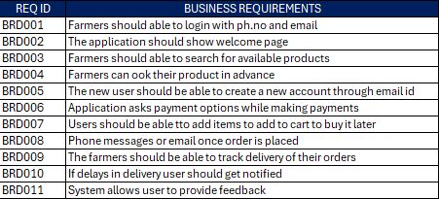

Question 8: assumptions
The assumptions of the project are,
1. Application built for the project will deliver the product to farmers in quick time.
2.The manufacturers would be able to look at mostly ordered items and can be able to do inventory management.
3. Farmers have knowledge on all varieties of agricultural products.
4. Farmers have online accounts for secured payment processing.
6. Farmers can be able to buy agricultural products online from anywhere easily.
7. The website would require very less maintenance.
8. Customer’s reviews and feedback can help in creating Brand images.
9. There will be smooth delivery of products
10. Increase in sales as soon as Product is launched
11. Farmers have a good network and internet connections.

Question 9: this project requirements priority

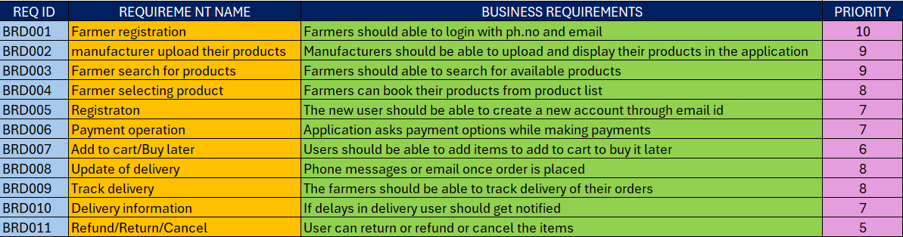

Question 10: Use case diagram
Ans: Use Case Diagram (UCD) is a high-level diagram and mother of all diagrams. It depicts the relationship between external users and the system. Use Case diagram is drawn from an End-User point of view. It has 4 major elements: (1) The Actors, (2) The System, (3) The Use cases and (4) The Relationships. Use Case Diagram for Online Agriculture Products Store is as follows:
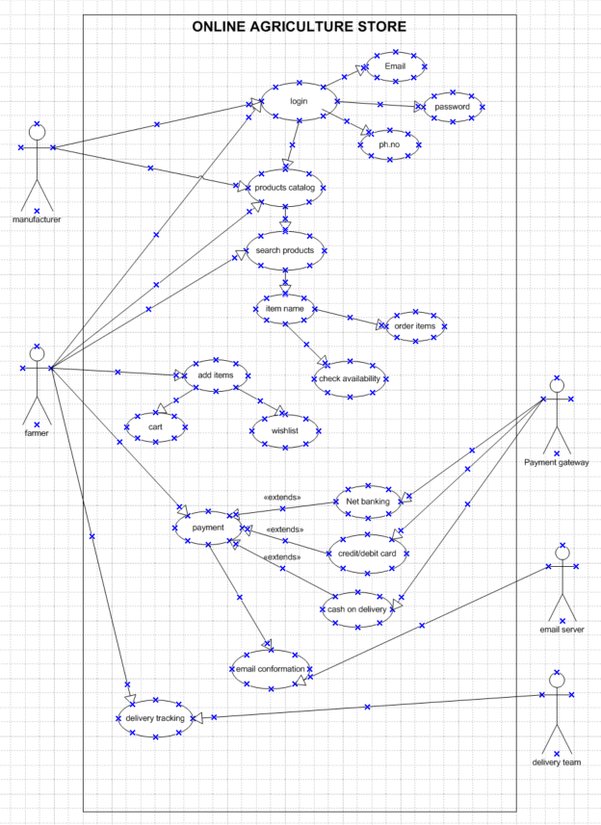

Question 11: (minimum 5) use case specs
Ans:
Every Use Case will have its own Use Case Description Document or Use Case Specification. The following is the Use Case Specification for all the Use Cases.
Title: Online Agriculture Product Store
- Use case: New User
Use Case Description: Registration & Email verification.
Actors: Farmers & System
Preconditions: Active internet connection, should have a Gmail account, ph.no
Postconditions: Able to register and log in to website.
Basic flows:
- Mobile no. verification
- Gmail verification done through sending otp
Alternate flows:
- OTP is not going to the number
- Verification mail is not going to the mail
- OTP & verification mail not going to the mail
- OTP is shown as invalid after timed out.
Exceptional flows:
- Gmail account not there
- Number out of service
Assumptions: Users have Gmail account & basic mobile knowledge
Constraints: both mobile no. & Gmail account need to be verified to complete the registration process.
Dependencies: User should have Gmail & mobile no. to be linked
Inputs: OTP & Gmail
Outputs: Registration done and able to login to the website
Business rules:
- Username should have valid Email ID
- Password should have special character.
- Password should have Uppercase letter
- Password should be 8 letters long
Miscellaneous Information: Interactive Design & browser compatible
- Use Case Name: Login
Use Case Description: Username & Password
Actors: Farmers & System
Preconditions: Active internet connection, Browser compatible & Devices
Postconditions: Home page should be displayed.
Basic flows: Username and Password are correct.
Alternate flows: Password is wrong
- Username is wrong
- Password is wrong
- Username & password is wrong
Exceptional flows:
- forgot password
- forgot username
Assumptions: Users have basic computer knowledge & can understand English.
Constraints: Usernames cannot be names or special character.
Dependencies: User should complete registration process
Inputs: Username & password
Outputs: Login successful or error code
Business rules:
- Username should have valid Email ID
- Passwords should have special characters
Miscellaneous Information: Interactive Design & browser compatible
- Use case: Search for products.
Use Case Description: search product name & price & Check product availability.
Actors: Farmers & System
Preconditions: Active internet connection, browse through wide range of products
Postconditions: Able to find the product with image & price descriptions.
Basic flows: Items searched are correctly displayed on the screen.
Alternate flows:
- Unable to search for the product
- Items are not found in the list
- Out of stock
Exceptional flows:
- Takes more time to search the product
- Product image or price is not displaying
- Showing items which are not searched, instead of searched items in the product catalogue
Assumptions:
- Users have basic knowledge on how to browse for the products
- Users have idea about products available in the online market
Constraints: Items name should be typed correctly when searching
Dependencies: Products which are searched should be available with the company with full description
Inputs: Items found with full description
Outputs: Products will be added to cart for purchasing
Business rules: Products should be available with the company & full in stock.
Miscellaneous Information: Interactive Design & browser compatible

- Use case: Order Items
Use Case Description: Add to Cart & Purchase
Actors: Farmers & System
Preconditions: Active internet connection, browse through different products
Postconditions: Able to add items to cart to buy it later & directed to payment page after items ordered.
Basic flows: Items selected are correctly captured by the system.
Alternate flows: Wrong items captured while adding to cart.
Exceptional flows: While adding to cart different pages pop out, unable to open payment page.
Assumptions: Users should know how to add items to the cart & how to order it later.
Constraints: At least 2 products to be added to the cart.
Dependencies: The product should be available with the company, which user wants to buy.
Inputs: Selecting a product
Outputs: The order gets through the payment site
Business rules:
- Visa cards or Master cards to make a payment
- Maestro cards to make a payment
- UPI to make a payment
- Cash on delivery to make a payment
Miscellaneous Information: Good looking payment page

- Use case: Payment
Use Case Description: COD, Card & other Payment options.
Actors: Farmers & System
Preconditions: The items purchasing need to be in the cart & User should have bank account for online payment
Postconditions: Farmer to be able to make payment through UPI, Card, or COD
Basic flows: Able to make payment.
Alternate flows: Not able to make payment.
Exceptional flows:
- UPI is not registered
- Card got blocked
- Customer is not available to make COD
Assumptions:
- Users have Bank account
- Users have basic knowledge about using cards
- Users know how to make payments through UPI
Constraints: User cannot make payment from Gpay or Phone pe
Dependencies: Orders need to be in cart
Inputs: Payment options & Card details
Outputs: Payment Gateway or Error page
Business rules: Card should be either Visa or Maestro
Miscellaneous Information: Interactive Design & browser compatible

Question 12: (minimum 5) activity diagrams:
- Login
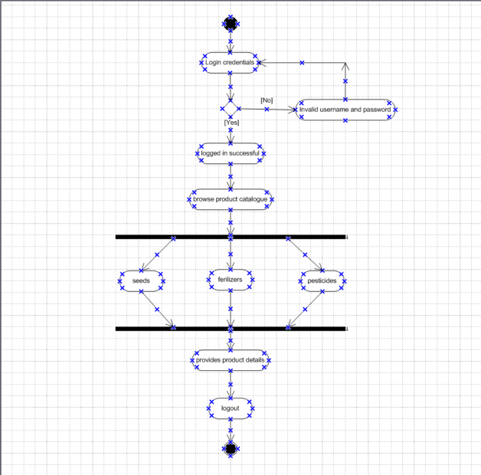

- Activity diagram for payment:

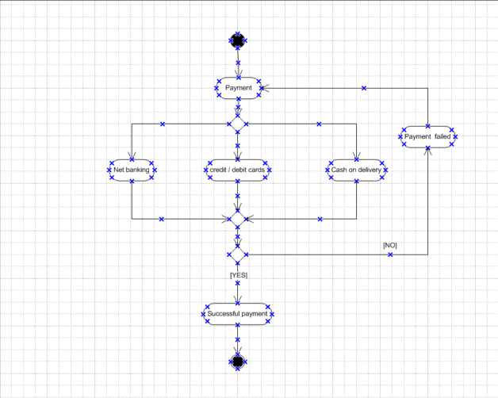

- Activity diagram for placing an order:

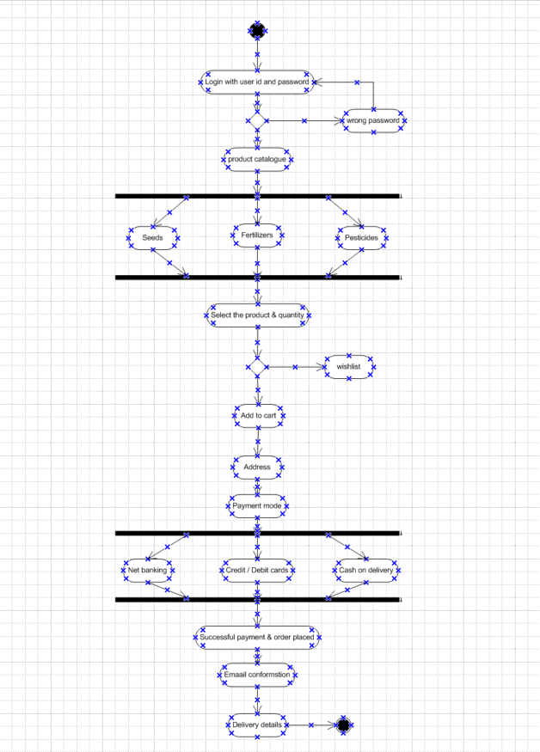

- Activity diagram for delivery tracking:

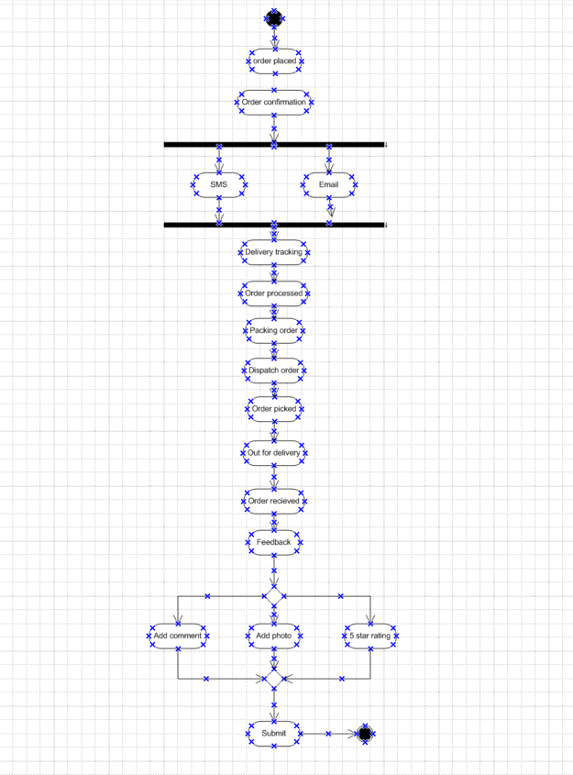

- Activity diagram for return cancel replace of product:

