CAPSTONE PROJECT – 1 ONLINE AGRICULTURE PRODUCTS STORE
PREP 1 ( PART-3 )
Documented by : B.Vaishnavi
Date : 05-May-2025

Mr. Henry, after being successful as a businessman and has become one of the wealthiest persons in the city. Now, Mr. Henry wants to help others to fulfil their dreams. One day, Mr. Henry went to meet his childhood friends Peter, Kevin and Ben. They live in a remote village and do farming. Mr. Henry asked his friends if they are facing any difficulties in their day-to-day work. Peter told Mr. Henry that he is facing difficulties in procuring fertilizers which are very important for farm. Kevin said that he is also facing the same problem in-case of buying seeds for farming certain crops. Ben raised his concern on lack of pesticides which could help in greatly reducing pests in crops. After listening to all his friends’ problems, Mr. Henry thought that this is a crucial problem faced not only by his friends but also by so many other farmers. So, Mr. Henry decided to make an online agriculture product store to facilitate remote area farmers to buy agriculture products. Through this Online Web / mobile Application, Farmers and Companies (Fertilizers, seeds and pesticides manufacturing Companies) can communicate directly with each other. The main purpose to build this online store is to facilitate farmers to buy seeds, pesticides, and fertilizers from anywhere through internet connectivity. Since new users are involved, Application should be user friendly. This new application should be able to accept the product (fertilizers, seeds, pesticides) details from the manufacturers and should be able to display them to the Farmers. Farmers will browse through these products and select the products what they need and request to buy them and deliver them to farmers location .
Mr. Henry has given this project through his Company SOONY. In SOONY Company, Mr Pandu is Financial Head and Mr Dooku is Project Coordinator. Mr. Henry , Mr Pandu , and Mr Dooku formed one Committee and gave this project to APT IT SOLUTIONS company for Budget 2 Crores INR and 18 months Duration under CSR initiative. Peter, Kevin and Ben are helping the Committee and can be considered as Stakeholders share requirements for the Project.
Mr Karthik is the Delivery Head in APT IT SOLUTIONS company and he reached out to Mr Henry through his connects and Bagged this project. APT IT SOLUTIONS company have Talent pool Available for this Project. Mr Vandanam is project Manager, Ms. Juhi is Senior Java Developer, Mr Teyson, Ms Lucie, Mr Tucker, Mr Bravo are Java Developers. Network Admin is Mr Mike and DB Admin is John. Mr Jason and Ms Alekya are the Tester. And you joined this team as a BA.

Your Team
Project Manager - Mr Vandanam Senior
Java Developer - Ms. Juhi
Java Developers - Mr Teyson, Ms Lucie, Mr Tucker, Mr Bravo
Network Admin - Mr Mike
DB Admin - Mr John.
Testers - Mr Jason and Ms Alekya
BA - You

Fertilizers, seeds, pesticides details from the manufacturers and should be able to display them to the Farmers. To gather the business requirements from the client, you went to SOONY and met Mr. Henry. When Mr.Henry was asked about the project and what are they expecting from the project, Mr. Henry stated that he is expecting to have a login for all its users (fertilizers, seeds, pesticides manufacturers and Farmers) , a product catalog of fertilizers, seeds, pesticides, a search option to search for products, payment process, and delivery tracking.
After doing the stakeholder analysis, you have found out that Peter, Kevin, Ben are the key stakeholders and you have scheduled an appointment to meet them. After meeting with them and trying to gather the stakeholder requirements, Kevin said that, a Farmer should be able to browse through the products catalog once they visit the website and need to have a search option so that they can search for any product they need. Peter said that, if a farmer wants to buy any product or add them to buy-later list, they need to login first using their email id and password. If it is a new user, then they can create a new account by submitting their email ID and creating a secure password. Ben added saying that, Farmers needs to have an easy-to-use payment gateway which should include cash-on-delivery (COD), Credit/Debit card and UPI options so that the user’s experience should be better. Kevin mentioned that, a user gets an email confirmation regarding
their order status. A delivery tracker to track the whereabouts of their order.
Identify Business Requirements (which includes Stakeholder Requirements)
BR001 – Farmers should be able to search for available products in fertilizers, seeds, pesticides.
BR002 – Manufacturers should be able to upload and display their products in the application
Make suitable Assumptions and identify at least 10 Business Requirements.
List your assumptions
Give Priority 1 to 10 numbers ( 1 being low priority – 10 being high priority) to these Requirements
after discussions with the stakeholders.

Once the requirements are finalized, as a business analyst, one of the major roles is to act as a liaison between the client and the project team. To gather the requirements correctly from the client side and then to deliver those requirements to the project team in a way they understand. To make the project team understand the requirements, you need to convert those requirements into UML diagrams and screen mock-ups.
You will draw use case diagram Prepare use case specs for all use cases
And you will all Activity diagrams required.
Question 1 – Functional Requirements - 15 Marks
Identify minimum 20 functional requirements.
Functional requirement: When an order is fulfilled, the local printer shall print a packing slip.
Non-Functional Requirement: Packing slips shall be printed on both sides of 4”x 6” white paper, the standard size for packing slips used by local printers.
Req ID | Req Name | Req Description | Priority
FR0001 | Farmer  Registration | Farmers should be able to register with the  application | 8
FR0002 | Farmer  Search for  Products | Farmers should be able to search for available  products in fertilizers, seeds, pesticides | 8
NFR0101 | Page  Loading  Time | Each Page should load within 2 seconds time | 9
NFR0102 | WCAG 2.1. | The system must meet Web Content Accessibility  Guidelines WCAG 2.1. | 8

Answer 1 :
Functional requirements
Define the specific operations, behaviours, and functionalities a system must perform to meet business needs. These requirements focus on what the system should do.

Req ID | Req Name | Req Description
FR0001 | Farmer Registration | Farmers should be able to register with the application
FR0002 | Farmer Search for Products | Farmers should be able to search for available products in fertilizers, seeds, pesticides
FR0003 | Shopping Cart | Allow farmers to add product to cart and review
FR0004 | Payment Processing | Provide secure payment processing options to customers.
FR0005 | Order Management | Allow farmers to view their order history and track the status.
FR0006 | Search | Implement a search bar to allow customers to find products.
FR0007 | Product reviews and ratings | Allow customers to leave reviews and ratings for products they have purchased to help other customers make informed decisions.
FR0008 | Wishlist | Allow customers to save products they are interested.

FR0009 | Shipping & Delivery | Provide customers with shipping options and estimated delivery
FR0010 | Return & Refund Policy | Outline the return and refund policy for customers to ensure a positive customer experience and minimize customer complaints
FR0011 | Availability of product | If the product is out of stock or sold out, it will be mentioned below the product. The inventory updates will, be  integrated at the backend.
FR0012 | Search Products | After selecting a particular product category, customers will further be able to filter products based on different attributes available of product like  price, newly added, Category
FR0013 | Availability of product | If the product is out of stock or sold out, it will be mentioned below the product. The inventory updates will, be integrated at the backend.
FR0014 | New Deals and Festive offers | Banners of all deals and offers will be showcased on homepage, so that user can view all products under that deal or offer in one click.
FR0015 | Company logo and name | Users will be able to view the company logo and name
FR0016 | Search | When three words for search are typed in the search bar, the auto suggestions give suggestions to users as they enter their search query into the search box
FR0017 | Buy now | On clicking on ‘buy now’, the customer will be redirected to the checkout page:  - Payment Gateway
FR0018 | Product Comparison | Farmers can view multiple products and compare them to their liking
FR0019 | Product Delivery | Farmers should get real time notifications on their order progress.
FR0020 | Product return | Farmers should be able to initiate return of products if it is of bad quality or broke while shipping

Non-functional Requirements:
Non-functional requirements specify the system's quality attributes, performance criteria, and operational constraints. These focus on how the system should function to ensure usability, security, and efficiency.
Req ID | Req Name | Req Description | Priority
NFR-01 | User-Friendly UI | The system shall be easy to use for non-technical users. | 9
NFR-02 | System Availability | The system shall have 99.9% uptime. | 8
NFR-03 | Performance | The system shall have a response time of less than 3 seconds. | 9
NFR-04 | Data Security | The system shall ensure secure transactions and encrypt sensitive data. | 10

Question 2–Minimum 5 page designs - 15 Marks
Make wireframe and prototypes.
Answer 2 :
Wireframe: A wireframe is a basic, visual representation of a website or app, acting as a blueprint that outlines the structure, layout, and functionality of a page or screen, without focusing on visual design elements like colours or images.

Registration Page
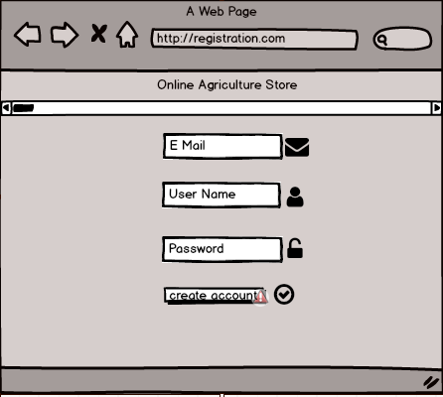

Login
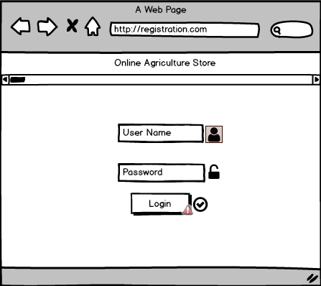
Product CatLog
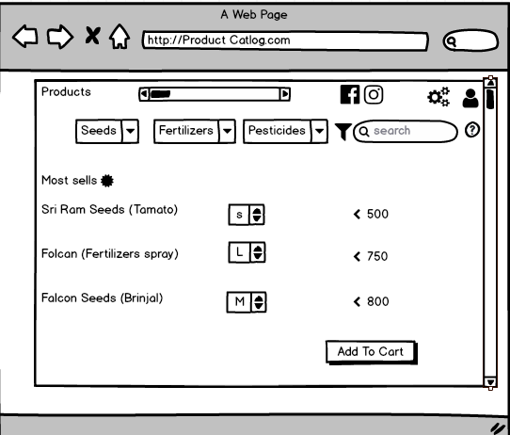

Add-To-Cart
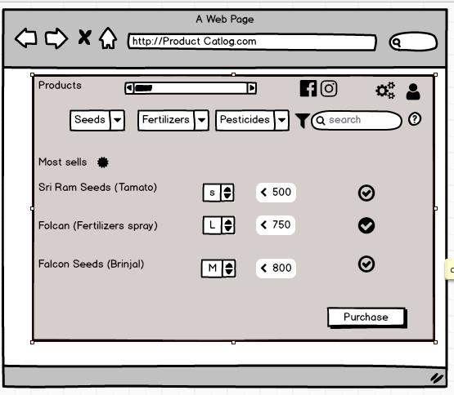

Payment
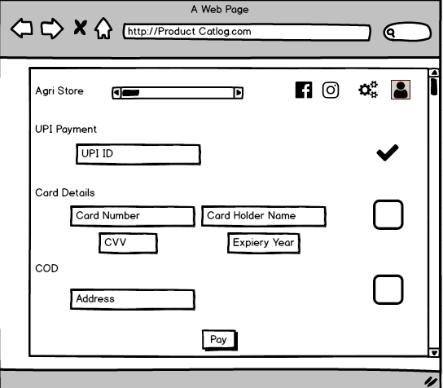

Payment Status
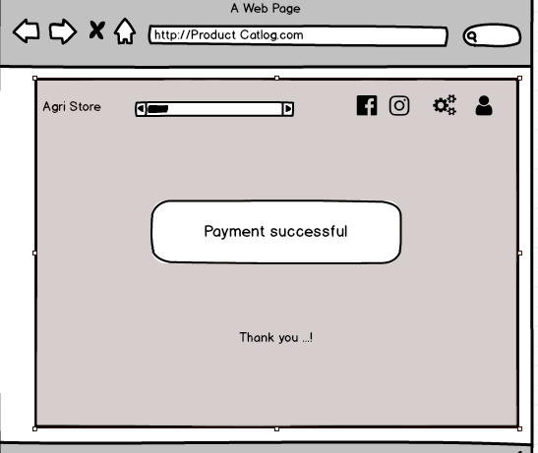
Question 3 – Tools (Visio, Balsamiq) - 15 Marks
Make a note of the Tools, which you are using for above concepts.
Answer 3 :
Balsamiq – A Rapid Wireframing Tool
- Balsamiq is a low-fidelity wireframing tool used to create UI mock-ups quickly. It helps Business Analysts, UX designers, and product teams visualize application layouts before development, focusing on structure rather than aesthetics.
- Also is a user interface design tool for creating wireframes .You can use it to generate digital sketches of your idea or concept for an application or website, to facilitate discussion and understanding before any code is written.
Microsoft Visio – A Powerful Diagramming Tool
- MS Visio is used to create diagrams such as flowcharts, organizational charts, floor plans, and more. It allows users to add and connect shapes, text, and pictures to show relationships in their data. Users can also give diagrams a professional look with styles, effects, themes, and backgrounds. Additionally, Visio can create dynamic diagrams and link to data from Excel, Access, or SharePoint. It is available for Windows operating systems.
- Microsoft Visio is a diagramming tool used for creating flowcharts, organizational charts, network diagrams, wireframes, and more. It helps in visualizing complex systems, processes, and structures, making it an essential tool for Business Analysts, IT professionals, and engineers.
- Visio is software for drawing a variety of diagrams. These include flowcharts, org charts, building plans, floor plans, data flow diagrams, process flow diagrams, business process modeling, swimlane diagrams, 3D maps, and many more.
Axure:
- Axure is a UX design tool used for creating wireframes and interactive prototypes. Axure is especially useful for designers of desktop and mobile applications, and it is highly regarded among enterprise companies for the high level of functionality and visual detail that can be built into its prototypes.

Question 4 – RTM - 6 Marks
A business analyst’s key responsibilities are to keep track of the requirements and make sure that no requirement is missed. Mr. Henry and peter have approached you regarding the current status of the project. How will you tackle this situation?
Prepare RTM
Req ID | Req Name | Req Description | Design | D1 | T1 | …… | T4 | UAT
FR0001 | Farmer  Registration | Farmers should be able  to register with the  application
FR0002 | Farmer  Search for  Products | Farmers should be able  to search for available  products in fertilizers,  seeds, pesticides
NFR0101 | Page  Loading  Time | Each Page should load  within 2 seconds time
NFR0102 | WCAG 2.1. | The system must meet  Web Content  Accessibility Guidelines  WCAG 2.1
Answer 4 :
A Requirements Traceability Matrix (RTM) is a document that tracks and maps requirements throughout the project lifecycle to ensure they are met through design, development, and testing . Types of Traceability in RTM :
- Forward Traceability – Links requirements to test cases to ensure everything is tested.
- Backward Traceability – Ensures all test cases and features are justified by a requirement.
- Bidirectional Traceability – Combines both to track dependencies in both directions.

Req ID | Req Name | Req Descripti  on | Priori ty | Desig n | D1 | T1 | T2 | T3 | T4 | UAT
FR000 1 | Farmer Registra tion | Farmers should be able to register with the applicati  on | High | Comple ted | Comple ted | Comple ted | Comple ted | Comple ted | Comple ted | Comple ted
FR000 2 | Farmer Search for Products | Farmers should be able to search | High | Comple ted | Comple ted | Comple ted | Comple ted | Comple ted | Comple ted | Comple ted

for available products in fertilizer s, seeds, pesticide
s
NFR01 01 | Page Loading Time | Each Page should load within 2 seconds  time | High | Comple ted | Comple ted | Comple ted | Comple ted | Comple ted | Comple ted | Comple ted
NFR01 02 | WCAG 2.1. | The system must meet Web Content Accessibi lity Guidelin es WCAG  2.1. | High | Comple ted | Comple ted | Comple ted | Comple ted | Comple ted | Comple ted | Comple ted
NFR01 03 | Bill Printing | Bill should be printed on page on both sides when order id  dispatch ed | High | Comple ted | Comple ted | Comple ted | Comple ted | Comple ted | Comple ted | Comple ted

Question 5 – 10 Test Case Documents - 10 Marks
Prepare 10 Test Case Documents

Answer 5 : A Test Case Document is a detailed document that outlines specific conditions, inputs, and expected results for testing a software application. It helps ensure that the system functions correctly and meets requirements.

Test Case ID | TC001 | Test Case Name
Project ID | OAA | Project Name | Online Agriculture Product Store
PM ID |  | PM Name | Mr Vandanam

Test Strategy ID |  | Tester ID | T001
Test Plan ID |  | Tester Name | Mr Jason
Test Schedule ID |  | Date of Test | 01-Oct-23
Scenario | To authenticate a successful user login on Gmail.com
Link to that page
Input Data | Name, Contact number, Email ID
Expected Behaviour | Once username and password are entered, the web page redirects to the user’s inbox, displaying and highlighting new  emails at the top.
Actual Behaviour | As expected,
Comments | NA
Result(Pass/Fail) | Pass

Test Case ID | TC00 2 | Test Case Name
Project ID | OAA | Project Name | Online Agriculture Product Store
PM ID |  | PM Name | Mr Vandanam
Test Strategy ID |  | Tester ID | T001
Test Plan ID |  | Tester Name | Mr Jason
Test Schedule ID |  | Date of Test | 02-Oct-23
Scenario | Seller Product Creation
Link to that page
Input Data | Productid, Product pictures, product prices
Expected Behaviour | Authenticated sellers can access authorized product creation panels under authorized categories
Actual Behaviour | As expected,
Comments | NA
Result(Pass/Fail) | Pass

Test Case ID | TC003 | Test Case Name | Test Product Reviews and Ratings
Project ID | P001 | Project Name | Online Agriculture Products Store
PM ID | PM001 | PM Name | Mr Vandanam
Test Strategy ID | TS001 | Tester ID | T001
Test Plan ID | TP001 | Tester Name | XYZ
Test Schedule ID | TS001 | Date of Test | 03-Oct-23
Scenario | Verify that the farmer can leave a review and rating for a purchased product.
Link to that Page | /product/organic-fertilizer
Input Data | Rating: 5 stars  Review: "Great product!"
Expected Behaviour | The system should allow the review to be posted.
Actual Behaviour | The review was successfully posted.
Comments | None
Result (Pass/Fail) | Pass

Test Case ID | TC0004 | Test Case Name | Test Security Standards
Project ID | P001 | Project Name | Online Agriculture Products Store
PM ID | PM001 | PM Name | Mr Vandanam
Test Strategy ID | TS001 | Tester ID | T001
Test Plan ID | TP001 | Tester Name | XYZ
Test Schedule ID | TS001 | Date of Test | 04-Oct-23
Scenario | Verify that the system implements encryption for sensitive data.
Link to that Page | /login
Input Data | Password: Test1234
Expected Behaviour | Password should be encrypted during transmission.
Actual Behaviour | Password was encrypted using HTTPS.
Comments | None
Result (Pass/Fail) | Pass

Test Case ID | TC0005 | Test Case Name | Test Order Tracking
Project ID | P001 | Project Name | Online Agriculture Products Store
PM ID | PM001 | PM Name | Mr Vandanam
Test Strategy ID | TS001 | Tester ID | T001
Test Plan ID | TP001 | Tester Name | XYZ
Test Schedule ID | TS001 | Date of Test | 05-Oct-23
Scenario | Verify that the farmer can track their order from dispatch to delivery.
Link to that Page | /Order-tracking
Input Data | Order ID: 12345
Expected Behaviour | The system should display the status and location of the order.
Actual Behaviour | The order status and location were displayed correctly.
Comments | None
Result (Pass/Fail) | Pass

Test Case ID | TC0006 | Test Case Name | Test Page Loading Time
Project ID | P001 | Project Name | Online Agriculture Products Store
PM ID | PM001 | PM Name | Mr Vandanam
Test Strategy ID | TS001 | Tester ID | T001
Test Plan ID | TP001 | Tester Name | XYZ
Test Schedule ID | TS001 | Date of Test | 06-Oct-23
Scenario | Verify that the page loads within 2 seconds.
Link to that Page | /home
Input Data | NA
Expected Behaviour | The page should load within 2 seconds.
Actual Behaviour | The page loaded in 1.5 seconds.
Comments | None
Result (Pass/Fail) | Pass

Test Case ID | TC0007 | Test Case Name | Test Order Confirmation
Project ID | P001 | Project Name | Online Agriculture Products Store
PM ID | PM001 | PM Name | Mr Vandanam
Test Strategy ID | TS001 | Tester ID | T001
Test Plan ID | TP001 | Tester Name | XYZ
Test Schedule ID | TS001 | Date of Test | 07-Oct-23
Scenario | Verify that the system sends an order confirmation email after a purchase.
Link to that Page | /order-summary
Input Data | Order Details: Product: Organic Fertilizer, Quantity: 2
Expected Behaviour | The system should send an email with order details and payment status.
Actual Behaviour | The email was sent with the correct order details.
Comments | None
Result (Pass/Fail) | Pass

Test Case ID | TC0008 | Test Case Name | Test Farmer Search for Products
Project ID | P001 | Project Name | Online Agriculture Products Store
PM ID | PM001 | PM Name | ABC
Test Strategy ID | TS001 | Tester ID | T001
Test Plan ID | TP001 | Tester Name | XYZ
Test Schedule ID | TS001 | Date of Test | 08-Oct-23
Scenario | Verify that a farmer can search for products like fertilizers, seeds, and pesticides.
Link to that Page | /search
Input Data | Search Term: "fertilizers”
Input Data | Search Term: "seeds”
Expected Behaviour | The system should display a list of available fertilizers.
Actual Behaviour | The list of fertilizers was displayed correctly.
Comments | None
Result (Pass/Fail) | Pass

Test Case ID | TC0009 | Test Case Name | Test Farmer Search for Products
Project ID | P001 | Project Name | Online Agriculture Products Store
PM ID | PM001 | PM Name
Test Strategy ID | TS001 | Tester ID | T001
Test Plan ID | TP001 | Tester Name | XYZ
Test Schedule ID | TS001 | Date of Test | 09-Oct-23
Scenario | Verify that a farmer can search for products like fertilizers, seeds, and pesticides.
Link to that Page | /search
Input Data | Search Term: "fertilizers”
Input Data | Search Term: "seeds”
Expected Behaviour | The system should display a list of available fertilizers.
Actual Behaviour | The list of fertilizers was displayed correctly.
Comments | None
Result (Pass/Fail) | Pass

Test Case ID | TC010 | Test Case  Name
Project ID | OAA | Project Name | Online Agriculture Product  Store
PM ID |  | PM Name | Mr Vandanam
Test Strategy ID |  | Tester ID
Test Plan ID |  | Tester Name | Mr Jason
Test Schedule ID |  | Date of Test | 10-Oct-23
Scenario | App installation/uninstallation
Link to that page
Input Data | device details, auto fill up, contact number
Expected Behaviour | The application is installed and works correctly/ The application is uninstalled. The app’s icon isn’t displayed on  the device’s OS.
Actual Behaviour | As expected,
Comments | NA
Result (Pass/Fail) | Pass

Question 6 – DB Design – 8 Marks
After the requirements are thoroughly explained to the entire project team by business analyst, the Database architects have decided to do the database design and also to represent the in-flow and out-flow of data.
Answer 6 : : Database Schema (DB Schema)
A database schema is a database structure that defines how data is organized. It includes:
Tables (where data is stored) , Columns (attributes of the data) ,Data types (such as text, number, date) ,Relationships (connections between tables) , Constraints (rules like unique values, primary keys, and foreign keys) .It acts as a blueprint for storing and managing data in a database.

ER Diagram (Entity-Relationship Diagram)
An ER diagram is a visual representation of the database structure.
It shows: Entities (things like Students, Teachers) Attributes (StudentID, Name, etc.) Relationships (how entities are connected, like "A student enrols in a class") . It helps in designing a database before implementation.

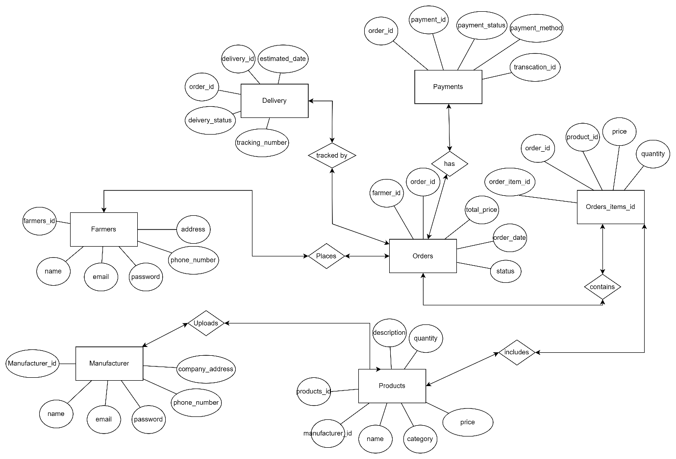
Question 7 – Data Flow Diagram - 3 Marks
What is a data flow diagram? Draw a data flow diagram to represent the in-flow and out-flow of data when a Farmer is placing an order for the product.
Answer 7 :
A data flow diagram (DFD) maps out the flow of information for any process or system. It uses defined symbols like rectangles, circles, and arrows plus short test labels to show data inputs, outputs, storage points and the routes between each destination.
- External entity - Rectangle
- Data flow - arrow
- Process or bubble – circle (process)
- Data store –Parallel lines (Backend)

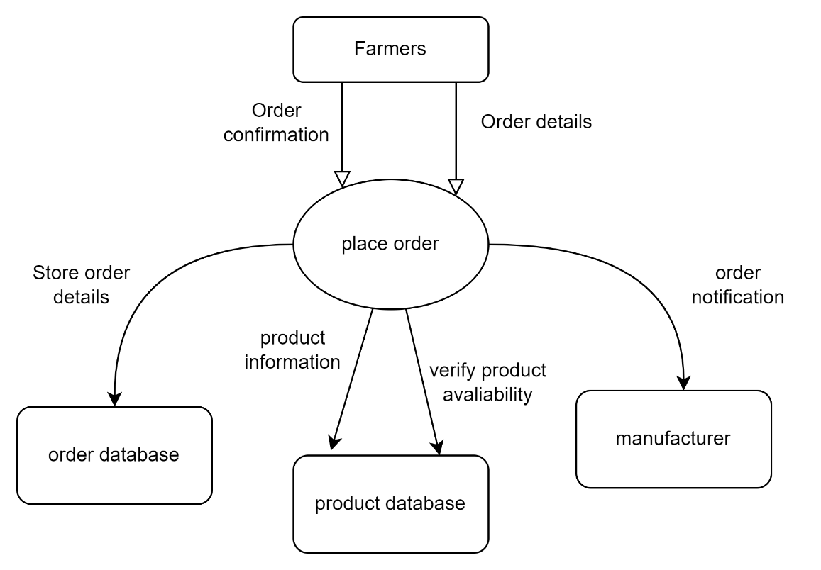

Question 8 – Change Request - 10 Marks
Due to change in the Government Taxation structure . we should change the Tax structure
How do you handle change requests in a project?

Answer 8 :
Handling a Change Request (CR) in a project follows a structured approach to ensure that changes are assessed, approved, and implemented without disrupting the project timeline or budget. Here’s how you should handle a change request like the Tax Structure Change in your Online Agriculture Products Store project.
Initiate Change Request:
- Clearly document the change request, specifying the nature of the change and the reasons behind it.
- Assign a unique identifier to the change request for easy tracking.
Assessment:
- Assess the impact of the change on the project scope, schedule, budget, and other relevant aspects.
- Evaluate the feasibility and risks associated with implementing the change.
Documentation:
- Update project documentation, including the project plan, requirements documentation, and any affected deliverables.
- Ensure that all stakeholders are aware of the proposed change and its implications.
Review and Approval:
- Present the change request to the project's change control board or relevant stakeholders.
- Seek approval for the change after presenting a comprehensive analysis of the impact.
- Obtain sign-off from authorized personnel to proceed with the change.

Implementation:
- If the change is approved, implement the necessary modifications to the project plan, codebase, or other affected areas.
- Update the project team and relevant stakeholders on the changes being made.
Testing and Validation:
- Conduct testing to ensure that the changes do not adversely affect the project's functionality or quality.
- Validate that the change aligns with the project's objectives.
Communication:
- Keep all stakeholders informed about the progress of the change implementation.
- Communicate any schedule adjustments or impacts resulting from the change.
Documentation Update:
- Update project documentation to reflect the implemented changes.
- Ensure that all project artifacts are consistent with the approved change.
Post-Implementation Review:
- Conduct a post-implementation review to evaluate the effectiveness of the change.
- Gather feedback from stakeholders to assess user satisfaction and system performance.
Closure:
- Once the change has been successfully implemented and validated, formally close the change request.
- Archive documentation related to the change for future reference

Question 9 – Change Request Vs an Enhancement - 5 Marks
As the project is in process, Ben and Kevin have contacted you. The reason is to inform you that they want the Farmers to sell their crop yields through this application i.e. Farmers should be able to add their crop yields or products and display to general public and should be able to sell them. They also want to introduce Auction system for their Crop yields. As a BA, what will be your response?
Is this a change request or an enhancement???
Answer 9 :
Change Request (CR):
A Change Request is a modification that alters the original project scope, objectives, or functionality.
Enhancement:
An Enhancement is a minor improvement to an existing feature that does not change the core.This request qualifies as a Change Request rather than an Enhancement because it introduces new business functionality that was not part of the original project scope.
Justification:
- Scope Deviation: Initially, the application was designed for Farmers to purchase agricultural products like fertilizers, seeds, and pesticides. The new requirement transforms the platform into a marketplace where Farmers can sell their crop yields and introduce an Auction system, which is a fundamental shift from the original business objective.
- Significant System Modifications: Requires new database structures to store and manage farmer-listed products.Implementation of seller dashboards and public listing features. Auction system development, which involves bidding logic, time constraints, and real-time updates. Changes in payment processing, integrating buyer-side transactions.
3 .Effort & Complexity: The requested features involve major changes in business logic, user roles, and workflows, requiring substantial development, testing, and deployment efforts. Since this alters the core functionality and system requirements, it is classified as a Change Request rather than a minor Enhancement.

To handle this request, I shall follow the following steps:
- Firstly, I will acknowledge Ben and Kevin's suggestion and express enthusiasm for the new feature.
- Schedule a meeting to gather detailed requirements, including user flow and business rules for crop sales and auctions.
- Assess the impact on the current system, including database, user interface, and integrations.
- Collaborate with the technical team to evaluate feasibility and resource requirements.
- Update the project documentation and timeline to reflect these changes.
- Prepare a Change Request document for stakeholder review and approval, as this request introduces new business functionality beyond the initial scope.
- Once approved, communicate the updated plan to all stakeholders and initiate development.
- Monitor progress and ensure thorough testing of the new feature before deployment.

Question 10 – Estimations - 6 Marks
Come up with estimations – How many Manhours required
Answer 10 :
Project Overview:
- Project Name: Online Agriculture Products Store
- Budget: 2 Crores INR
- Duration: 18 months (540 calendar days)
- Company: APT IT SOLUTIONS
- Team Members: 10 (Project Manager, Senior Java Developer, Java Developers, Network Admin, DB Admin, Testers, Business Analyst)
- Total Working Days: 396 (Excluding weekends and holidays)
- Daily Effort Per Resource: 8 hours
- Total Manhours (Including Buffer): 3168 Hours

Project Phase | Estimated Days | Man-Hours (Days × 8 hrs)
Requirement Gathering & Analysis | 14 | 112
UI/UX Design for Registration & Product Display | 12 | 96
Database Architecture & Setup | 10 | 80
Development – Farmer Registration | 24 | 192
Development – Product Catalogue & Search | 28 | 224
Development – Order Processing & Management | 40 | 320
Development – Auction System | 50 | 400
Integration – Payment Gateway | 36 | 288
Testing & Quality Assurance (QA) | 44 | 352
User Acceptance Testing (UAT) | 28 | 224
Deployment & Post-Go-Live Support | 24 | 192
Project Management & Coordination | 30 | 240
Total Estimated Work | 370 Days | 2968 Man-Hours
Buffer Allocation | 40 Days | 320 Man-Hours
Grand Total | 410 Days | 3168 Man-Hours

- The project is categorized as a medium-scale project based on effort estimation.
- A buffer of 40 days (320 hours) is included to accommodate unforeseen challenges.
- The team is well-trained, so no additional training effort is considered.
- The auction system and order management require the most development effort due to their complexity.
- Proper testing and UAT phases ensure a smooth rollout.
Question 11 – UAT – 6 Marks
Project has finally completed all the stages i.e., design, development, testing etc. Now, it is the role of a business analyst to contact the client for testing of the final product and have to successfully complete it. How are you going to handle this situation? And once it is done, what will be the process to close the project? Explain UAT Acceptance process.
Answer 11 :
UAT (User Acceptance Testing)is the final stage of the software development lifecycle where the end-users of the system test the product to ensure that it meets their requirements and is ready for deployment. The UAT Acceptance process involves the following steps:
Planning: The business analyst works with the client to plan the UAT phase, including defining the scope, identifying the test scenarios and cases, and setting the acceptance criteria.
Test Execution: The end-users perform the testing on the software product in a real-world environment and provide feedback on its usability, functionality, and performance.
Issue Resolution: If any issues are identified during the UAT phase, they are recorded and addressed by the development team.
Sign-off: Once the UAT is completed successfully, the end-users sign-off on the product, indicating that it meets their requirements and is ready for deployment. To close the project, the following steps can be taken:
Project Review: The business analyst conducts a project review to ensure that all the requirements have been met, and the project objectives have been achieved.
Documentation: All project documentation, including requirements documents, design documents, test cases, and project plans, are reviewed and updated.
Closure Meeting: A closure meeting is held with the stakeholders to discuss the success of the project, any lessons learned, and future recommendations.
Project Closure Report: The business analyst prepares a project closure report that includes the project review, documentation updates, closure meeting outcomes, and any final recommendations.
Archiving: The project documentation and artifacts are archived for future reference, and the project team is disbanded.

Question 12 – Project Closure Document - 6 Marks
Explain Project closure document

Answer 12 :

A Project Closure Document is a formal document that officially marks the completion of a project. It ensures that all objectives are met, deliverables are completed, and stakeholders sign off on the closure. It also captures lessons learned and recommendations for future projects.
1. Introduction :
The Project Closure Document is a formal report that marks the successful completion of a project. It ensures that all project objectives have been met, deliverables have been accepted by stakeholders, and necessary closure activities have been completed.
2. Purpose of the Project Closure Document
- Confirm that all project objectives, scope, and deliverables have been achieved.
- Ensure a structured transition from the project team to the client or operations team.
- Document financials, contracts, and lessons learned for future reference.
- Ensure stakeholder satisfaction and obtain formal approval for project closure.
3. Key Components Document of a Project Closure
A. Project Summary
- Project Name: [Project Name]
- Client: [Client Name]
- Project Sponsor: [Sponsor Name]
- Project Duration: [Start Date] – [End Date]
- Budget Allocated vs. Utilized: ₹[X] Cr / ₹[Y] Cr
- Project Objective: Brief statement of the project’s purpose and intended outcome.
B. Deliverables & Outcomes
- List of core features developed (e.g., user registration, product catalogue, payment gateway).
- Additional features added (e.g., delivery tracking, notifications).
- Documentation provided (e.g., user manual, technical guides).
C. Performance Evaluation
- Comparison of planned vs. actual performance in terms of:
- Timeline adherence
- Budget utilization
- Quality of deliverables
- UAT (User Acceptance Testing) success rate

Metric | Planned | Actual | Variance
Timeline (Months) | 18 | 17 | -1
Budget (INR Crores) | 2.0 | 1.92 | -0.08
Quality Defects | 0 | 3 (fixed) | 0
UAT Pass Rate | 95% | 98% | +3%
D. Lessons Learned
- What Worked Well: Clear requirement gathering and stakeholder engagement. Well-structured development and testing processes. Effective risk management.
- Challenges Faced: Last-minute feature requests (e.g., auction system). Connectivity issues in remote areas affecting accessibility.
- Recommendations for Future Projects: Conduct stakeholder workshops earlier to capture evolving needs. Plan for scalability in the initial design.
E. Client Sign-Off & Approval
- Formal section where stakeholders approve and sign off the project.
- Ensures the project meets all acceptance criteria.
F. Financial Summary
- Planned vs. actual budget analysis.
- Breakdown of cost components.
- Any pending payments or refunds to be settled.
G. Post-Project Support & Maintenance Plan
- Details on ongoing support and maintenance.
- Transition plan for operational teams. Contact details for issue escalation.
4. Project Closure Process
- Final Review & Documentation: Verify all deliverables meet acceptance criteria. Ensure project documentation is complete and accurate.
- Client Approval & Sign-Off: Conduct UAT and resolve any final issues. Obtain formal approval from stakeholders.
- Knowledge Transfer & Handover:
  - Transition project knowledge and documentation to the client or operations team.
  - Provide training sessions if required.
- Financial & Contract Closure:
  - Reconcile project budget and payments.
  - Close contracts with vendors and suppliers.
- Archive Project Records:
  - Store documents and reports for future reference.
  - Maintain records for audits and compliance.
- Formal Project Closure Announcement:
  - Communicate project completion to all stakeholders.
- Conduct a closure meeting to discuss key takeaways.
5. Importance of the Project Closure Document
- Ensures accountability by documenting project completion.
- Facilitates a smooth transition to the client or operations team.
- Captures valuable insights for improving future projects.
- Provides formal validation of project success.
6. Conclusion
The Project Closure Document is a critical step in the project lifecycle that ensures transparency, accountability, and structured project handover. It confirms that all objectives have been met, stakeholder expectations have been fulfilled, and lessons learned are documented for future projects.
Project Overview: A brief summary of the project, including its objectives, scope, and constraints. Project Deliverables: A list of the final deliverables produced by the project.
Lessons Learned: A summary of the lessons learned during the project, including what worked well and what could be improved in future projects.
Project Success: An assessment of the project's overall success, including whether it met its objectives, stayed within budget, and was completed on time.
Project Sign-Off: A formal sign-off from the client or stakeholders indicating that they accept the final deliverables and that the project is complete.

