Document 6- Please prepare a use case diagram, activity diagram and a use case specification document.

USE case diagram

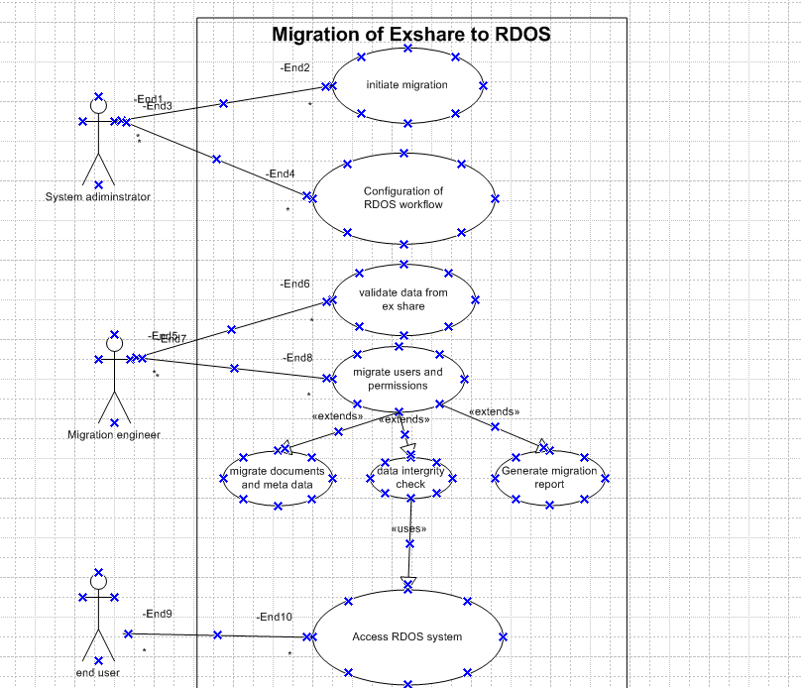

Activity diagram

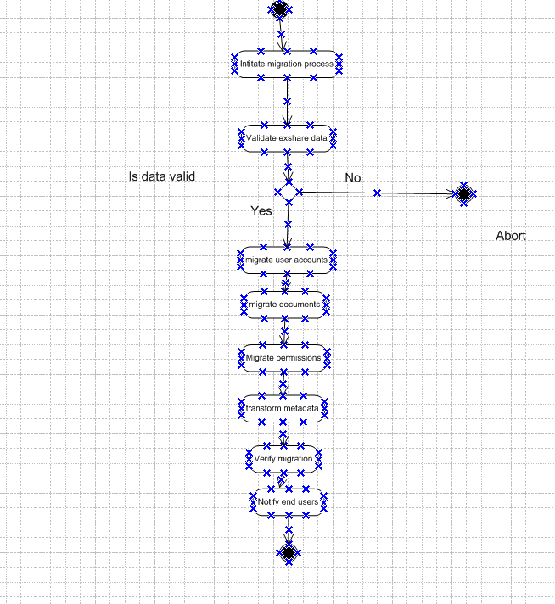

Use case specification document.
1. Use Case Name
Migration from Exshare to RDOS

2. Use Case Description
This use case describes the migration of data from the legacy system (Exshare) to the new system (RDOS). It includes extracting user data, validating it, transforming it to match the RDOS schema, and importing it into the RDOS system while preserving roles and credentials.

3. Actors
- Primary Actor: Migration Tool
- Secondary Actor: Admin

4. Basic Flow
- Admin initiates the migration process.
- Migration tool connects to Exshare database.
- Tool retrieves user data (user ID, name, email, roles, status).
- Data is validated for completeness and correctness.
- Valid data is transformed to RDOS-compatible schema.
- Tool creates users in RDOS with appropriate roles.
- Migration status is logged for each record.
- A summary report is generated.

5. Alternate Flow
5a. Skipped Inactive Users
- Step 4a: If a user account is marked as inactive in Exshare, it is skipped.
- Step 4b: The skipped record is logged with a note “Inactive – Not Migrated.”

6. Exceptional Flows
6a. Database Connection Failure
- If connection to Exshare or RDOS fails, log the error and halt the process.
6b. Data Validation Error
- If mandatory fields are missing or invalid, mark the user as "Error in Migration" and continue with others.
6c. Role Mapping Failure
- If a user role in Exshare has no equivalent in RDOS, assign default role “Viewer” and flag for admin review.

7. Preconditions
- Admin is authenticated and authorized to perform migration.
- Exshare and RDOS systems are accessible.
- Role mapping configuration file is prepared.

8. Post-conditions
- All valid user accounts are available in RDOS.
- Migration log and report are stored.
- Errors are logged for later resolution.

9. Assumptions
- User schemas in Exshare and RDOS are logically mappable.
- The system is under maintenance mode to prevent live updates.
- All role IDs used in Exshare have corresponding mappings in RDOS.

10. Constraints
- Migration must be completed within the maintenance window.
- No partial account data should be migrated.
- Passwords may need rehashing due to encryption differences.

11. Dependencies
- Role Mapping Table between Exshare and RDOS.
- Validated Exshare user database.
- Admin login and authorization.
- Network connectivity between systems.

12. Inputs and Outputs
- Inputs:
  - User records from Exshare
  - Role mapping configuration
- Outputs:
  - User records in RDOS
  - Migration log
  - Summary report

13. Business Rules
- Every user must have a unique email ID.
- Each user must belong to at least one role.
- Roles must comply with RDOS access policy.
- Users marked as “inactive” in Exshare should not be migrated.

14. Miscellaneous Information
- Migration should ideally be tested in a staging environment before production.
- A notification may be sent to migrated users after verification.

Document 7- Screens and pages

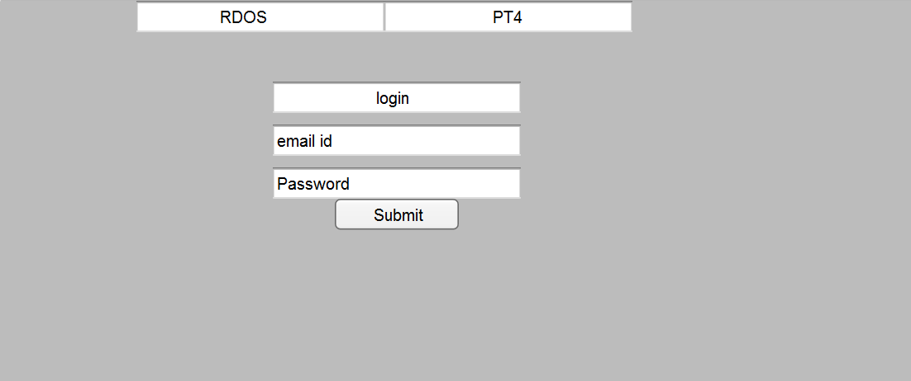

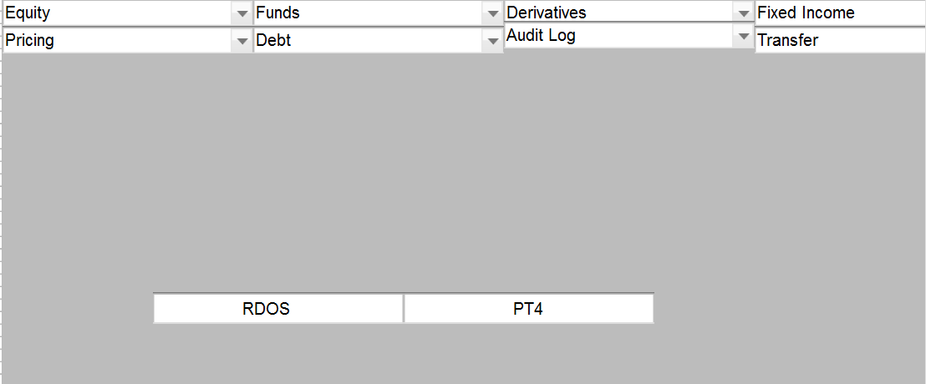

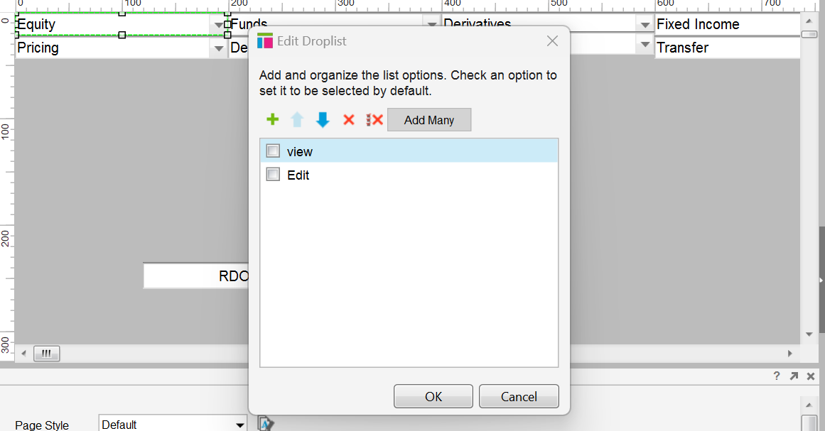

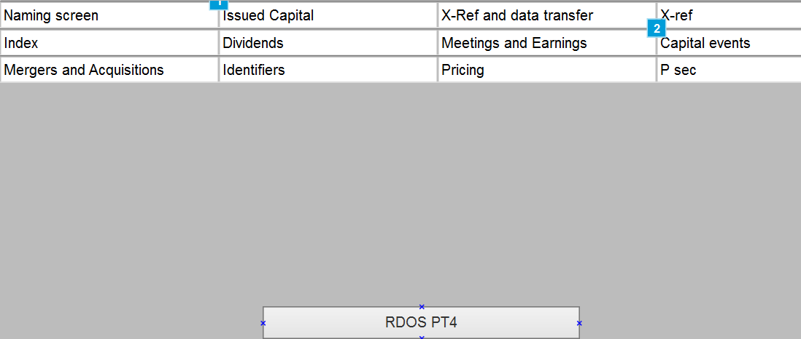

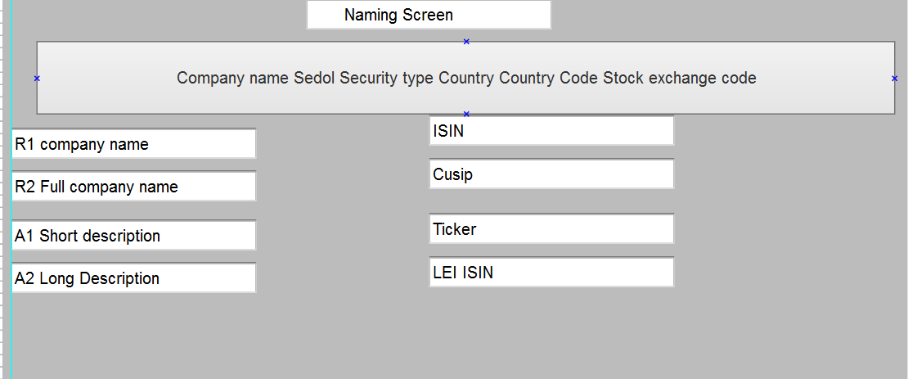

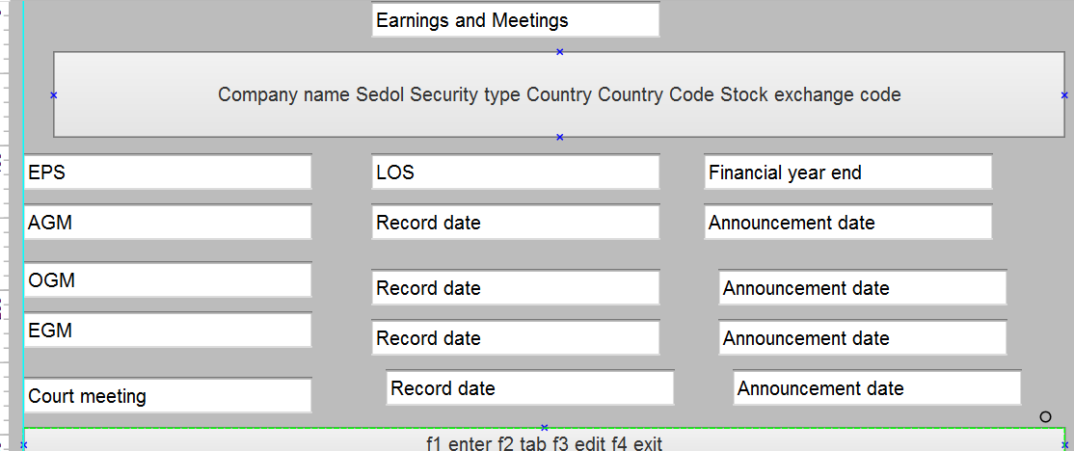

Document 8: Tools – Visio and Axure:

Experience Using Visio and Axure for the Project
During the migration of Exshare to RDOS, Visio and Axure played crucial roles in visual modeling and UI/UX design. Visio was extensively used to create clear, structured use case diagrams, activity diagrams, and data flow representations, allowing stakeholders to easily understand the system architecture and migration workflows. The drag-and-drop functionality and stencil libraries in Visio helped streamline the diagramming process. On the other hand, Axure was instrumental in designing interactive mockups and wireframes of the RDOS interface. Starting with the home page, we used Axure to simulate user interactions and layout flows, enabling early feedback from users and facilitating iterative design improvements. Together, these tools enhanced both the technical planning and user interface design aspects of the project, ensuring a smooth and well-documented migration process.

Document 9: Business Analyst (BA) Experience
As a Business Analyst during the Exshare to RDOS migration project, I played a critical role in ensuring clear, validated, and stakeholder-approved requirements throughout the project lifecycle.
1. Requirement Gathering Phase
To structure and prioritize the requirements effectively, we adopted the MOSCOW technique (Must have, Should have, Could have, Won’t have). This allowed us to clearly communicate priorities and manage stakeholder expectations early in the project.
During this phase, the client was unavailable for a certain period, which posed a risk to timely progress. To mitigate this, I proactively identified and engaged alternate Points of Contact (PoCs) from the client’s organization, ensuring that requirement clarification and follow-ups continued without delay.
Once the initial set of requirements was collected, I applied the FURPS model (Functionality, Usability, Reliability, Performance, Supportability) to validate the completeness and quality of each requirement. This helped ensure that both functional and non-functional aspects were addressed thoroughly.
Additionally, I noticed that several requirements were duplicated or restated in slightly different ways. These redundancies were identified early, and I collaborated with the development and QA teams to remove or consolidate them, ensuring a cleaner and more efficient specification document.
To further clarify and refine ambiguous requirements, I utilized prototyping techniques. Low-fidelity mockups and interface sketches were shared with stakeholders, helping them better visualize the expected system behavior and provide more precise feedback.
Overall, this phase required adaptability, strong communication skills, and a structured analytical approach to gather, refine, and finalize requirements efficiently despite challenges.

2. Requirement Analysis Phase
In the Requirement Analysis phase of the Exshare to RDOS migration project, my key responsibility was to translate gathered business requirements into clear, structured, and actionable documentation for both technical and non-technical stakeholders.
To ensure proper understanding across teams, I created UML diagrams, such as use case diagrams, class diagrams, and sequence diagrams, to visually represent the system behavior and data interactions. In addition, I developed activity diagrams to map out end-to-end process flows, particularly for critical migration steps like user data validation, permission transfer, and rollback operations.
Once these visual models were prepared, I actively communicated the diagrams with development, QA, and infrastructure teams. During these discussions, some team members provided alternative interpretations or raised technical concerns. As a BA, I facilitated collaborative reviews, incorporating valid suggestions and updating the diagrams to ensure alignment with both business needs and technical feasibility.
Following the diagram review, I prepared two key deliverables:
- Business Requirement Specification (BRS) – capturing high-level business needs and expectations.
- Software Requirement Specification (SRS) – translating those needs into detailed, system-level requirements that could guide the design and development teams.
This phase required a balance of analytical thinking, collaboration, and adaptability to refine and formalize requirements in a way that minimized ambiguity and aligned all stakeholders.
3. Design Phase
In the Design phase of the Exshare to RDOS migration project, I worked closely with both the development and QA teams to ensure that the business requirements were accurately translated into a testable and functional solution.
Starting with the finalized use case diagrams, I derived test cases that mapped to each functional flow. These included both positive and negative test cases to cover not only the expected user behavior but also edge cases and failure scenarios. I emphasized the importance of not missing a single test case, as overlooking even one could potentially lead to significant gaps during development or system validation later.
I maintained regular communication with the client to review design documents and solution proposals, ensuring that the proposed workflows, screens, and data mappings aligned with their expectations. This also helped in early identification of misinterpretations or misalignments before development began.
To support the testing effort, I prepared comprehensive test data that reflected real-world scenarios, including valid, boundary, and invalid data sets. This test data was shared with QA for use in manual and automated testing.
Additionally, I was responsible for updating the Requirement Traceability Matrix (RTM) to ensure that each business requirement had a corresponding design element and associated test case. This step was critical for tracking completeness and ensuring that no requirement was left unaddressed during implementation.
Overall, the design phase required detailed planning, precision in documentation, and constant collaboration across stakeholders to ensure a seamless transition from requirement analysis to development.

4. Development Phase
During the Development phase of the Exshare to RDOS migration project, my role as a Business Analyst was to act as a key bridge between the technical team and business stakeholders, ensuring the smooth implementation of approved requirements.
I organized JAD (Joint Application Development) sessions to bring developers, testers, and business users together for collaborative discussions on feature implementation and technical feasibility. These sessions were essential for aligning everyone on the solution’s functional and technical aspects.
While facilitating these sessions, I occasionally encountered resistance or lack of cooperation from certain team members. In such cases, I handled the situation professionally by initiating one-on-one discussions with those individuals. I explained the impact of their involvement on the overall project timeline and quality, fostering a healthy and collaborative work environment. This approach helped in resolving misunderstandings and improving team cohesion.
Throughout the development process, I provided constant clarification on business logic, data structures, and process flows by referring back to the validated UML diagrams and activity diagrams. These visuals served as guidance for developers during unit development and helped reduce the chances of misinterpretation.
Managing communication was also challenging, especially when some team members or clients were unavailable during scheduled meetings. To ensure continuity, I recorded the sessions and followed up individually with those who missed them. I provided summaries, clarified doubts, and ensured everyone remained aligned with project goals.
My proactive involvement during the development phase significantly contributed to minimizing rework, reducing misunderstandings, and ensuring development progress remained aligned with business expectations.

5. Testing Phase
In the Testing phase of the Exshare to RDOS migration project, I took an active role in supporting both the QA team and the client to ensure that the system met the specified requirements.
I began by preparing detailed test cases directly from the use cases and process flows, ensuring full coverage of both functional and non-functional requirements. These test cases served as a baseline for both internal testing and later client-facing UAT.
In addition to helping QA, I personally performed high-level testing to validate critical business functionalities and check for any gaps or deviations. This allowed early detection of major issues before formal testing cycles began.
Since realistic testing scenarios were crucial, I worked with the client to request and prepare necessary test data, especially for validating user roles, permissions, and migrated content. This ensured that the tests reflected real-world conditions as closely as possible.
Throughout the process, I maintained the Requirement Traceability Matrix (RTM), updating it to reflect the status of each requirement and its corresponding test coverage. This ensured that every business requirement was tested and validated without exceptions.
Once testing was complete and all critical issues were addressed, I coordinated with the client to obtain formal sign-off. I also helped in preparing the client for User Acceptance Testing (UAT) by sharing test scenarios, expected results, and walkthrough sessions to guide their evaluation.
This phase required precision, patience, and thorough communication to ensure quality, traceability, and client confidence in the delivered solution.

6. Deployment Phase
In the Deployment phase of the Exshare to RDOS migration project, I focused on ensuring a smooth transition from development to production while supporting user readiness and project closure activities.
One of my key responsibilities was to forward the updated Requirement Traceability Matrix (RTM) to the client, ensuring it was included as part of the Project Closure Document. This helped demonstrate that all agreed-upon requirements were implemented and tested successfully.
I also played a vital role in coordinating the creation and delivery of End User Manuals, which were essential for helping users understand how to navigate and utilize the RDOS system effectively. I ensured that the documentation was clear, concise, and tailored to various user roles.
To support system adoption, I planned and organized training sessions for different user groups. This included preparing training materials, scheduling sessions at convenient times, and addressing potential questions or concerns that users might have during their early interaction with the system.
Furthermore, I made sure that all relevant users attended the training sessions, following up individually with anyone who was absent and arranging alternative sessions if needed. This helped ensure that no user was left behind during the go-live process.
Overall, my involvement in the deployment phase focused on knowledge transfer, user enablement, and project closure coordination, ensuring a confident and well-supported handover to business users.

