Document 6 – Use Case Diagram : 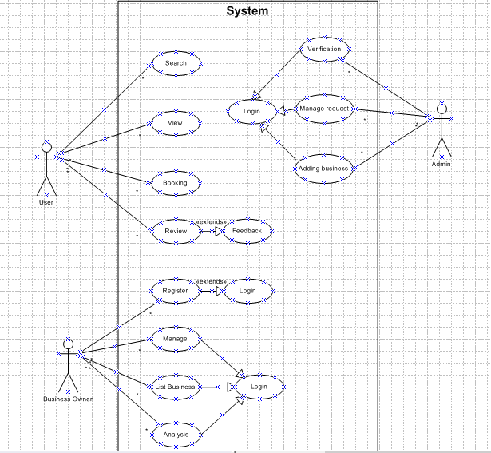
Activity Diagram : 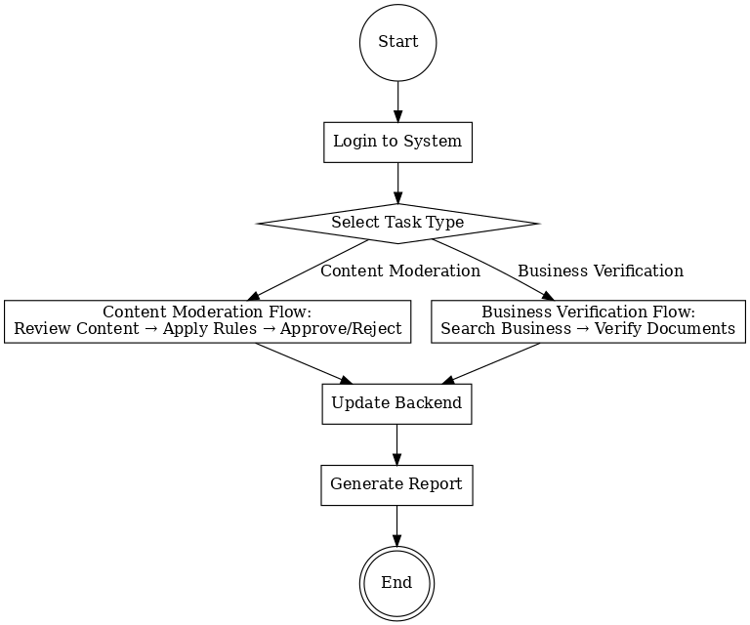
Use Case Specification:
- Use Case Name
Moderate Content
2. Description
Review and remove harmful content before it reaches users, ensuring compliance with platform and legal standards.
3. Actors
Primary: Content Reviewer
Secondary: Backend System, Client
4. Basic Flow
Reviewer logs into moderation tool.
Selects “Moderate Content” task.
Reviews flagged content.
Applies rules from SOP.
Approves or rejects content.
Updates backend with decision.
5. Alternate Flow
If content needs escalation, reviewer sends it to senior reviewer or client for decision.
6. Exceptional Flows
If backend system is down, store decisions locally and update once system is restored.
7. Pre-Conditions
Reviewer has valid login credentials.
Updated rulebook/SOPs are available.
8. Post-Conditions
Backend updated.
Flagged content removed or approved.
Audit trail maintained.
9. Assumptions
Reviewer is trained.
Internet connection stable.
Guidelines are up to date.
10. Constraints
Content must be reviewed within SLA (e.g., 2 hours from flagging).
11. Dependencies
Client-provided SOPs.
Working backend tools.
Access to moderation system.
12. Inputs / Outputs
Input: User-generated content flagged for review.
Output: Approval/rejection decision in backend system.
13. Business Rules
Follow moderation guidelines.
Document every decision.
Maintain compliance logs.
14. Miscellaneous Information
Weekly moderation reports generated for client audits.

Document 7- Screens and pages :
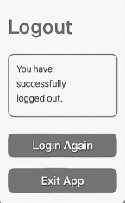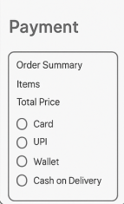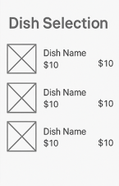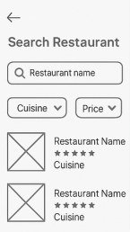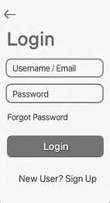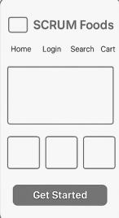

Document 8 – Tools Experience :
Visio: In this project, Microsoft Visio was used to design the use case diagrams and activity diagrams for the Secure Content Moderation and Business Verification system.
Visio helped visually map the interaction between the Content Reviewer, Client, Backend System, and Verification Database, making it easier to communicate workflows for moderation, verification, and backend updates to both the client and the technical team.
It was especially useful in aligning all stakeholders during the Requirement Analysis and Design phases, ensuring no process step was overlooked.

Axure: was used to create interactive mock-ups of the system’s key pages such as the Home Page, Login, Dashboard, Content Moderation, Business Verification, Report Generation, and Logout. These clickable prototypes simulated the actual user journey, allowing the client to experience the process flow before development began.
This early visualization helped in validating requirements, improving clarity, and reducing the risk of rework in later phases.
Both tools together ensured that the design and process flows were well-documented, easy to understand, and ready for smooth handover to the development team.

Document 9- BA experience:
Requirement Gathering
For the Secure Content Moderation and Business Verification project, I initiated requirement gathering by engaging with the client to understand their specific needs for real-time content moderation, harmful content removal, and business verification in compliance with regulatory standards.
Applied the MoSCoW technique to prioritize requirements, addressing “Must Have” needs first, such as timely backend updates and accurate verification.
Managed client unavailability by identifying alternate points of contact to obtain critical information proactively.
Validated requirements using the FURPS technique, eliminating duplicates and redundant items.
Created early-stage prototypes to provide stakeholders with a clear visualization of workflows for content review, verification, and backend updates.
- Requirement Analysis
Prepared UML and activity diagrams to represent workflows, including step-by-step processes for moderating flagged content and verifying businesses.
Facilitated collaborative feedback from the technical and QA teams, integrating beneficial suggestions into requirements.
Delivered comprehensive Business Requirement Specification (BRS) and System Requirement Specification (SRS) documents to ensure the development team had a precise understanding of system functionality.
- Design
Developed use case diagrams to support test planning and design.
Collaborated with QA to prepare positive and negative test cases for all functionalities.
Maintained communication with the client to finalize design and solution documents, ensuring alignment with platform compliance and moderation standards.
Prepared test data for functional areas and updated the Requirements Traceability Matrix (RTM) to ensure all requirements were mapped to design and testing activities.
- Development
Facilitated Joint Application Development (JAD) sessions to clarify functional and compliance-related queries.
Conducted one-on-one discussions to resolve disagreements and encourage team cooperation.
Shared diagrams and process flows as reference materials during coding.
Organized regular review meetings with both the client and development team, recording sessions for absent members and conducting follow-ups to avoid missing critical details.
- Testing
Derived test cases from use cases to ensure comprehensive coverage of system functionality.
Performed high-level workflow testing, including backend updates and compliance validation.
Requested additional test data from the client to verify edge cases where required.
Updated the RTM during testing to track requirement coverage.
Obtained client sign-off and prepared them for User Acceptance Testing (UAT) by sharing test scope and expected results.
- Deployment
Shared the final RTM with the client for inclusion in the project closure document.
Coordinated with the client to create end-user manuals detailing moderation and verification procedures.
Organized and conducted training sessions for the client’s moderation team, ensuring complete understanding of operational procedures.
Supported a smooth transition from development to live operations, enabling the client to maintain safe and compliant platform practices.

