DDoll

Project Name

ADP IMPLEMENTATION AT DDOLL

Business Requirements Document (BRD)

Prepared by: Srividya Murugan

Prepared for:
Date Submitted: [21.07.2025]

Project Sponsor: MS.Priya Client Acceptor: CSSI Project Manager: Mr.Arun R

Document Number: 6450-20/Project Number /BRD
Version: 0.1

Last Updated: Creation Date:

Table of Contents
TABLE OF CONTENTS 2
- INTRODUCTION 4
  - Document Purpose 4
  - Intended Audience 4
  - Project Background 4
  - Purpose of the Business Requirements 4
  - Business Goals/Objectives to be achieved 5
  - Benefits/Rationale 7
  - Stakeholders 8
  - Dependencies on existing systems 8
  - References 8
  - Assumptions 8
- REQUIREMENTS SCOPE 8
  - In Scope 8
  - Out of Scope 9
- FUNCTIONAL REQUIREMENTS 9
  - Actor Profiles Specification 10
  - Essential Use Case Diagram 10
  - Essential Use Case Specifications 11
  - Function Hierarchy Diagram 21
  - Function Definition Report 21
  - Business Rules 23
- DATA REQUIREMENTS 24
  - Data Architecture 25
    - Domain Class Diagram 25

    - Entity Relationship Diagram 26
  - Data Volumes 27
  - Data Conversion 28
  - Data Retention and Archiving 28
  - FOI/Privacy Implications 29
  - Data Definition Reports 30
    - Domain Class Definition Report 31
    - Entity Definition Report 32
- NON-FUNCTIONAL REQUIREMENTS 32
  - Security Requirements 33
    - Authentication 34
    - Authorization and Access Controls 35
  - Availability Requirements 36
  - Usability Requirements 37
  - System Help Requirements 37
  - Performance Requirements 38
  - Scalability Requirements 38
    - User Scalability 39
    - Application Scalability 40
- INTERFACE REQUIREMENTS 40
  - User Interface Requirements 26
  - System Interface Requirements 41
- BUSINESS GLOSSARY 42
APMS UPDATE 27
REVISION LOG 27
APPENDICES 44
APPROVAL 28

- Introduction

  - Document Purpose

This document covers the business requirements for business processes requirements for the implementation of ADP Software at DDoll, as agreed between DDoll and CSSI. The proposed system will focus on inventory management and enabling swift customer delivery. This document will have iterative changes until defining an agreed scope, herein. After signing this document, all subsequent modifications to business requirements will require a Process Change Request.

  - Intended Audience
- This document is intended for project stakeholders including business sponsors, analysts, developers, QA teams, and end users such as warehouse staff and delivery planners. It ensures all parties understand the business requirements, system scope, and functional expectations for the successful implementation of the ADP software for inventory and delivery optimization.

  - Project Background
The current inventory and delivery operations rely heavily on manual processes and disconnected systems, leading to inefficiencies, errors, and delays. To address these challenges, the organization has proposed the implementation of ADP software—a centralized solution to automate inventory tracking, streamline order allocation, and optimize delivery routing. This project supports the broader goal of improving operational efficiency, reducing costs, and enabling data-driven decision-making across logistics functions.

  - Purpose of the Business Requirements

The purpose of this document is to define and communicate the business needs, functional expectations, and system requirements for implementing the ADP software. It serves as a foundational reference for aligning stakeholders, guiding system design and development, and ensuring the final solution addresses the operational challenges in inventory management and delivery optimization.

  - Business Goals/Objectives to be achieved

Streamlined Inventory Management: Ensure real-time monitoring of inventory levels across warehouses and plants to reduce spoilage and optimize stock levels.
Ensures Enhanced Delivery: Implement a system to bring about the fastest delivery routes and automate order processing based on location and availability.
Improved Customer Satisfaction: Ensure the validity of the product and reduce the order fulfillment time.
Business Process Overview AS-IS:
Inventory is managed manually or using isolated systems.
Order allocation is manually determined, leading to inefficiencies. Delivery routes are planned based on experience, not optimized.

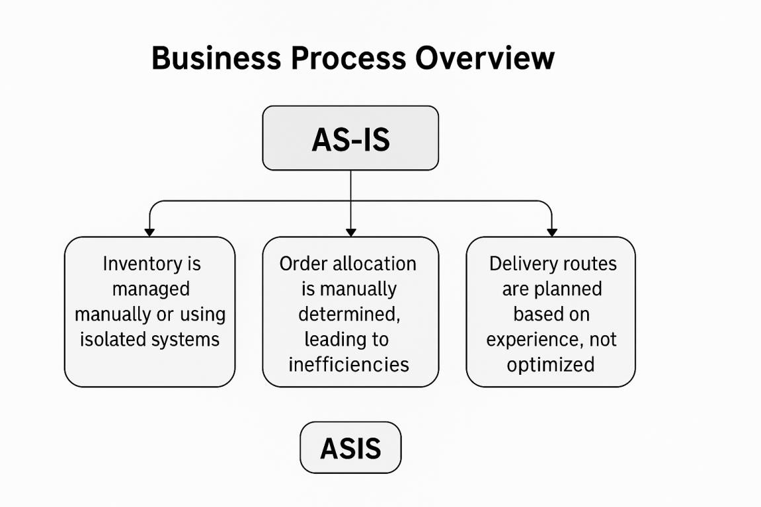

TO-BE:

A centralized system enables automated inventory management. Orders are allocated and dispatched through as intelligent algorithm. Delivery routes are optimized dynamically for speed and cost.
Business Requirements Inventory Management Module:
Real-time inventory tracking locations.
Expiry-date monitoring and alerts for perishable items. Order-Management Module:
Automated order allocation based on location and inventory. Bulk order prioritization.
Delivery Optimization Module:
Integration with GPS and real-time data for route planning. Dynamic Rerouting in case of delays.
Reporting Module:
Insights into inventory levels, order trends, and delivery performance.

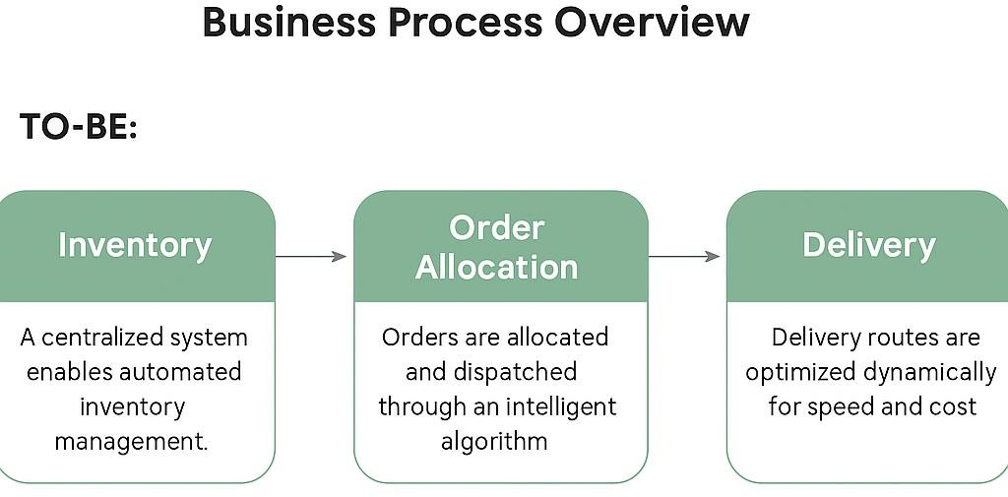

  - Benefits/Rationale

The ADP system will streamline inventory and delivery operations by reducing manual errors, accelerating order processing, and optimizing delivery routes. It enables cost savings through reduced wastage and labor, while real-time dashboards support better decision-making. Its scalable design ensures future integration with other business systems, supporting long-term growth.

  - Stakeholders
The key stakeholders in the ADP project include the project sponsor, business analyst, project manager, development and QA teams, inventory controllers, warehouse staff, delivery managers, and ERP integration specialists. Each plays a crucial role in ensuring successful implementation through requirement gathering, development, testing, and adoption of the system.

2.c. Dependencies on existing systems
The ADP implementation depends on seamless integration with existing ERP systems for order data, inventory balances, and customer information. It also relies on external APIs such as GPS and traffic data for real-time route optimization. Accurate functioning of these systems is critical for the success of the automation and delivery modules.

2.7. References

- Internal process flow documents related to inventory and delivery operations
- Company ERP system user manuals and integration guides
- ADP Software Product Overview & Feature Documentation
- Stakeholder meeting notes and requirement gathering session records

2.8. Assumptions
- All warehouses and plants have internet connectivity for real-time updates.
- Delivery vehicles are GPS-enabled to support route optimization.
- Data from external sources (e.g., traffic, weather) is available via APIs.

- Requirements Scope
  - In Scope

Inventory tracking at manufacturing plants and warehouses. Order management and allocation.
Delivery route optimization. Analytics and reporting dashboards.

  - Out of Scope

Manufacturing process management. Customer relationship management (CRM).

- Functional Requirements

MODULE | FUNCTIONALITY
Inventory Management | - Track real-time stock across warehouses  - Validate expiry before dispatch  - Alert for low stock and expiring items  - Import/sync data from ERP
Order Allocation | - Auto-allocate orders based on inventory and location  - Allow manual override by authorized users  - Maintain audit trails for changes
Dispatch & Delivery | - Schedule dispatches using optimized routing  - Integrate GPS & traffic data  - Real-time delivery status updates  - Enable dynamic re-routing
User & Role Management | - Define user roles and permissions  - Secure login and session tracking  - Admin configuration control
Reporting & Dashboard | - Display real-time operational dashboards  - Generate and schedule reports  - Export data to Excel/PDF
  - Actor Profiles Specification

ACTOR NAME | ACTOR TYPE | ACCESS TYPE NEEDED | COMMENTS
Inventory Controller | Primary Actor | Create, Read, Update, Export | Manages inventory tracking, expiry validation, and stock adjustments.
Warehouse Staff | Supporting Actor | Read, Update | Inputs physical stock data and performs

 |  |  | regular inventory updates.
Delivery Manager | Primary Actor | Read, Update, Export, Others | Uses route optimization tools and monitors delivery operations.
System Administrator | Stakeholder | Create, Read, Update, Delete, Others | Maintains user roles, configurations, and ensures system security.

4.1.1 User Stories

User ID | User Story | CV | BP | Priority
US01 | As an Inventory Controller, I want to track inventory in real time so that I can avoid stock-outs. | High | Yes | High
US02 | As a Warehouse Staff, I want to update stock entries so that the system reflects the physical inventory accurately. | Medium | Yes | Medium
US03 | As an Inventory Controller, I want to receive alerts on expiring items so that I can minimize losses. | High | Yes | High
US04 | As an Order Manager, I want to auto-allocate orders based on availability so that I can process orders efficiently. | High | Yes | High
US05 | As an Order Manager, I want to override order allocations so that I can handle exceptions manually. | Medium | Yes | Medium
US06 | As a Delivery Manager, I want optimized delivery routes so that I can reduce fuel cost and time. | High | Yes | High
US07 | As a Delivery Manager, I want GPS integration so that real-time delivery tracking is possible. | Medium | Yes | Medium
US08 | As a Delivery Staff, I want to update delivery status on the go so that the manager gets real-time updates. | Medium | Yes | Medium
US09 | As a Delivery Manager, I want to reroute dynamically in case of traffic so that deliveries are not delayed. | High | Yes | High
US10 | As an Admin, I want to define user roles so that access control is maintained. | Medium | Yes | High
US11 | As a System Admin, I want to secure login access so that unauthorized access is prevented. | High | Yes | High
US12 | As a System Admin, I want to track user sessions so that I can audit the system. | Medium | Yes | Medium
US13 | As a Business Analyst, I want dashboards showing inventory and delivery metrics so that we can make informed decisions. | Medium | Yes | Medium
US14 | As a Reporting User, I want to generate scheduled reports so that performance can be tracked over time. | Low | Yes | Medium
US15 | As a Manager, I want to export reports to Excel/PDF so that I can share them with leadership. | Low | Yes | Low
US16 | As a Delivery Staff, I want to confirm delivery completion in the system so that tickets are closed promptly. | Medium | Yes | Medium
US17 | As a Warehouse Staff, I want to validate expiry before dispatch so that perished stock is avoided. | High | Yes | High
US18 | As an Admin, I want to import inventory data from ERP so that the system is always synced. | Medium | Yes | Medium
US19 | As a Support Agent, I want to receive notifications for new tickets so that I can respond quickly. | High | Yes | High
US20 | As a Delivery Manager, I want to view past delivery performance so that we can improve SLAs. | Medium | Yes | Medium
US21 | As a System Admin, I want to monitor API failures so that external integrations work smoothly. | Medium | Yes | High
US22 | As a Delivery Manager, I want to schedule dispatches so that workload is managed efficiently. | High | Yes | High
US23 | As a Business Analyst, I want audit logs of order allocations so that traceability is maintained. | Medium | Yes | Medium
US24 | As a Warehouse Staff, I want alerts for low stock so that replenishment is timely. | Medium | Yes | Medium
US25 | As a Manager, I want bulk order prioritization so that large clients are served first. | High | Yes | High

4.2 Essential Use Case Diagram

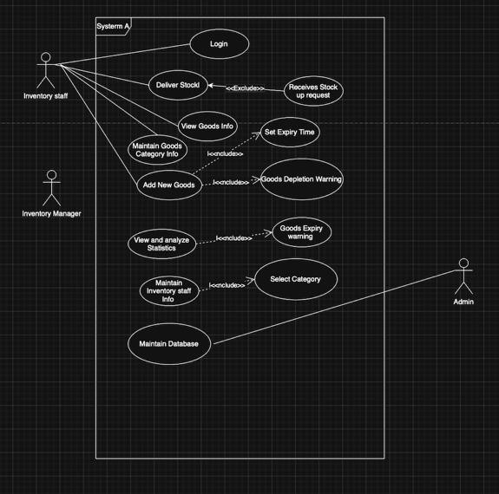
4.2 Essential Use Case Specifications

USE CASE NAME | RAISE A NEW TICKET
Description | A user creates a ticket to report an issue, provide details, and request assistance.
Actors | Primary: End-User, Secondary: System
Business Rules | BR-01, BR-02
Basic Flow | - User logs into the ticketing system.  - Navigates to 'Raise a Ticket'.  - Selects issue type, fills description.  - Attaches files (if needed), sets priority.  - Submits ticket. System confirms with ID.
Alternate Flows | 5a. User saves ticket as draft.  6a. Required fields missing → system highlights. 6b. File too large → error shown.
Non-Functional Requirements | System uptime, file upload ≤ 5MB.
Pre-Conditions | User account active.
Post-Conditions | Ticket logged and ID generated, user notified.

USE CASE NAME | VIEW TICKET DETAILS
Description | A user views the details of a submitted ticket.
Actors | Primary: End-User, Secondary: System
Business Rules | BR-03
Basic Flow | - User logs in.  - Goes to 'My Tickets'.  - Selects ticket. System shows full details.
Alternate Flows | 5a. If ticket is closed, show resolution.  6a. Ticket not accessible → error shown.
Non-Functional Requirements | Accessible on mobile and desktop.
Pre-Conditions | User logged in with access rights.
Post-Conditions | Ticket info displayed to user.

USE CASE NAME | EDIT DRAFT TICKET
Description | User edits a previously saved draft ticket.
Actors | Primary: End-User, Secondary: System
Business Rules | BR-04, BR-05

Basic Flow | - User logs in and goes to 'My Drafts'.  - Selects a draft ticket.  - Updates fields and submits or saves.
Alternate Flows | 4a. Saves changes without submission.  6a. Draft not found → error shown.
Non-Functional Requirements | Drafts expire after 30 days.
Pre-Conditions | Draft exists in the system.
Post-Conditions | Draft updated or ticket submitted.

USE CASE NAME | DELETE DRAFT TICKET
Description | User deletes an unwanted draft ticket.
Actors | Primary: End-User, Secondary: System
Business Rules | BR-06
Basic Flow | - User chooses 'Delete' on a draft.  - System confirms deletion.  - Draft removed.
Alternate Flows | 5a. User cancels deletion.  6a. Draft not found → error shown.
Non-Functional Requirements | User confirmation required.
Pre-Conditions | Draft exists in system.
Post-Conditions | Draft permanently deleted.

USE CASE NAME | SUBMIT FEEDBACK FOR A RESOLVED TICKET
Description | User provides feedback on a resolved ticket.
Actors | Primary: End-User, Secondary: System
Business Rules | BR-07
Basic Flow | - User goes to 'Resolved Tickets'.  - Selects ticket and provides rating/comments.  - System saves feedback.

Alternate Flows | 5a. User skips feedback.  6a. Submission fails → retry later.
Non-Functional Requirements | Feedback within 30 days.
Pre-Conditions | Ticket marked 'Resolved'.
Post-Conditions | Feedback stored in system.

USE CASE NAME | REOPEN A CLOSED TICKET
Description | Users reopen a ticket if the issue persists.
Actors | Primary: End-User, Secondary: Support Team, System
Business Rules | BR-08
Basic Flow | - User navigates to 'Closed Tickets'.  - Selects ticket and clicks 'Reopen'.  - System changes status and notifies support.
Alternate Flows | 5a. User adds info while reopening.  6a. Reopening not allowed → message shown.
Non-Functional Requirements | Allowed within 15 days of closure.
Pre-Conditions | Ticket must be 'Closed'.
Post-Conditions | Ticket status updated to 'Reopened'.

USE CASE NAME | SUBMIT FEEDBACK FOR A RESOLVED TICKET
Description | User provides feedback on the resolution of a ticket.
Actors | Primary: End-User  Secondary: System
Business Rules | BR-005, BR-010
Basic Flow | - User navigates to 'Resolved Tickets'.  - User selects a ticket.  - System displays resolution details.  - User submits feedback.  - System saves the feedback.

Alternate Flows | 4a. User skips feedback.  5a. Feedback fails due to system error.
Non-Functional Requirements | Feedback must be recorded within 5 seconds.
Pre-Conditions | Ticket must have 'Resolved' status.
Post-Conditions | Feedback is recorded and linked to the ticket.

USE CASE NAME | REOPEN A CLOSED TICKET
Description | Users can reopen a ticket if the issue persists after resolution.
Actors | Primary: End-User  Secondary: Support Team, System
Business Rules | BR-006, BR-011
Basic Flow | - User navigates to 'Closed Tickets'.  - User selects a ticket and clicks 'Reopen'.  - System changes the ticket status to 'Reopened'.  - Notification is sent to the support team.
Alternate Flows | 3a. Reopening is restricted.  4a. User adds additional information.
Non-Functional Requirements | Reopen action should not exceed 3 seconds.
Pre-Conditions | Ticket must be in 'Closed' status.
Post-Conditions | Ticket status is updated to 'Reopened'.

USE CASE NAME | ATTACH FILES TO A TICKET
Description | Users can upload files for ticket context.
Actors | Primary: End-User  Secondary: System
Business Rules | BR-007
Basic Flow | - User accesses ticket submission.  - Clicks 'Attach File'.  - Selects and uploads file.  - System confirms attachment.

Alternate Flows | 3a. File exceeds size limit.
Non-Functional Requirements | Max file size 5MB. Allowed types: PDF, PNG.
Pre-Conditions | User has access to draft or active ticket.
Post-Conditions | File is attached to the ticket.

USE CASE NAME | SUBMIT FEEDBACK FOR A RESOLVED TICKET
Description | User provides feedback on the resolution of a ticket.
Actors | Primary: End-User  Secondary: System
Business Rules | BR-005, BR-010
Basic Flow | - User navigates to 'Resolved Tickets'.  - User selects a ticket.  - System displays resolution details.  - User submits feedback.  - System saves the feedback.
Alternate Flows | 4a. User skips feedback.  5a. Feedback fails due to system error.
Non-Functional Requirements | Feedback must be recorded within 5 seconds.
Pre-Conditions | Ticket must have 'Resolved' status.
Post-Conditions | Feedback is recorded and linked to the ticket.

USE CASE NAME | REOPEN A CLOSED TICKET
Description | Users can reopen a ticket if the issue persists after resolution.
Actors | Primary: End-User  Secondary: Support Team, System
Business Rules | BR-006, BR-011
Basic Flow | - User navigates to 'Closed Tickets'.  - User selects a ticket and clicks 'Reopen'.

- System changes the ticket status to 'Reopened'.
- Notification is sent to the support team.
Alternate Flows | 3a. Reopening is restricted.  4a. User adds additional information.
Non-Functional Requirements | Reopen action should not exceed 3 seconds.
Pre-Conditions | Ticket must be in 'Closed' status.
Post-Conditions | Ticket status is updated to 'Reopened'.

USE CASE NAME | ATTACH FILES TO A TICKET
Description | Users can upload files for ticket context.
Actors | Primary: End-User  Secondary: System
Business Rules | BR-007
Basic Flow | - User accesses ticket submission.  - Clicks 'Attach File'.  - Selects and uploads file.  - System confirms attachment.
Alternate Flows | 3a. File exceeds size limit.
Non-Functional Requirements | Max file size 5MB. Allowed types: PDF, PNG.
Pre-Conditions | User has access to draft or active ticket.
Post-Conditions | File is attached to the ticket.

USE CASE NAME | SEARCH TICKETS BY CRITERIA
Description | Users search for tickets in the system using various criteria such as status, priority, date, and agent.
Actors | Primary: End-User, Support Staff, Support Manager
Business Rules | BR21
Basic Flow | 1. User navigates to the 'Search Tickets' page.

- User enters search criteria (e.g., ticket status, priority, assigned agent).
- System displays a list of tickets that match the criteria.
Alternate Flows | 5a. User applies multiple filters to narrow down the search results.
Non-Functional Requirements | System must support fast search queries with updated data.
Pre-Conditions | User must be logged in with appropriate search permissions.

USE CASE NAME | REOPEN A CLOSED TICKET
Description | A support agent or manager reopens a closed ticket if the issue is not fully resolved or if new information arises.
Actors | Primary: Support Agent, Support Manager
Business Rules | BR22
Basic Flow | - Support agent or manager navigates to the closed ticket.  - Support agent or manager selects 'Reopen Ticket'.  - System prompts for a reason to reopen the ticket.  - Support agent or manager provides the reason and confirms the action.  - System updates the ticket status to 'Open' and logs the reason for reopening.
Alternate Flows | 5a. Support agent adds comments or updates to the ticket before reopening.
Non-Functional Requirements | Ticket tracking system must be real-time and audit compliant.
Pre-Conditions | Ticket must be in the 'Closed' status.

USE CASE NAME | SEND TICKET NOTIFICATIONS

Description | The system sends notifications (e.g., email, SMS) to users and support staff about ticket updates, status changes, or assigned actions.
Actors | Secondary: End-User, Support Staff, Support Manager
Business Rules | BR23
Basic Flow | - The system detects a ticket status change, comment update, or other relevant event.  - The system identifies the appropriate recipients.  - The system sends notifications to the recipients.
Alternate Flows | 5a. User customizes notification preferences to receive specific updates.
Non-Functional Requirements | Notification system must deliver messages within 5 minutes.
Pre-Conditions | The notification system must be configured and operational.

USE CASE NAME | MERGE DUPLICATE TICKETS
Description | Support agents or managers merge tickets that are identified as duplicates to prevent redundant work.
Actors | Primary: Support Agent, Support Manager
Business Rules | BR24
Basic Flow | - Support agent or manager identifies two tickets as duplicates.  - Support agent or manager selects both tickets and clicks 'Merge'.  - System prompts the user to confirm the merge.  - Support agent or manager confirms the merge.  - System merges the tickets and closes the duplicate ticket.

Alternate Flows | 5a. Support agent adds comments to explain the reason for the merge.
Non-Functional Requirements | Ticket merging must retain most relevant data and maintain audit logs.
Pre-Conditions | Tickets to be merged must be open or unresolved.

USE CASE NAME | ASSIGN PRIORITY TO A TICKET
Description | A support agent or manager assigns a priority level (e.g., Low, Medium, High, Critical) to a ticket based on its urgency and impact.
Actors | Primary: Support Agent, Support Manager
Business Rules | BR25
Basic Flow | - Support agent or manager navigates to a ticket.  - Support agent or manager selects 'Assign Priority'.  - System presents priority options.  - Support agent or manager selects the appropriate priority.  - System updates the ticket with the selected priority and logs the change.
Alternate Flows | 5a. Support agent or manager uses an auto- suggest feature to assign priority based on predefined criteria.
Non-Functional Requirements | Priority assignment must be real-time and validated.
Pre-Conditions | The ticket exists and is in an unresolved status.

  - Function Hierarchy Diagram

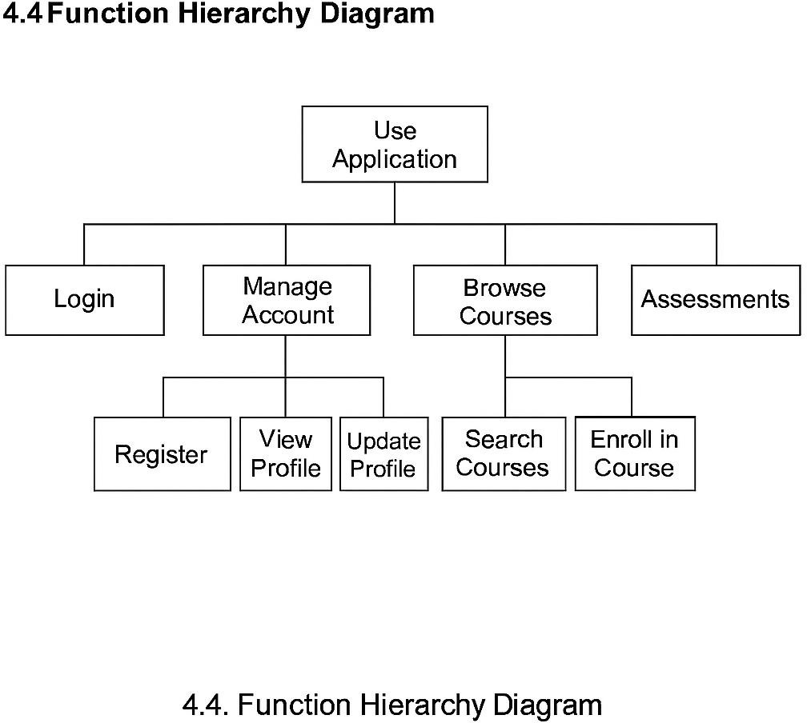

  - Function Definition Report

FUNCTION ID | FUNCTION NAME | DESCRIPTION
F1 | Inventory Management | Manage inventory levels across all warehouses; includes updating, tracking, and reporting.

F1.1 | Stock Level Tracking | Continuously monitors stock quantities across storage locations.
F1.2 | Inventory Update | Allows updates after stock receipts, dispatches, or adjustments.
F1.3 | Inventory Reports | Generates analytics and dashboards based on inventory status and trends.
F2 | Order Allocation | Assigns customer orders to appropriate warehouses or fulfillment centers.
F2.1 | Order Analysis | Analyzes incoming orders by location, quantity, and delivery urgency.
F2.2 | Warehouse Assignment | Allocates orders to optimal warehouses based on availability and proximity.
F2.3 | Dispatch Trigger | Initiates dispatch process after successful allocation.
F3 | Delivery Optimization | Ensures cost-effective and timely delivery using routing algorithms.
F3.1 | Route Planning | Suggests shortest and fastest delivery paths dynamically.
F3.2 | GPS Integration | Incorporates real-time location data from GPS systems.
F3.3 | Delivery Status Update | Enables delivery tracking and customer updates.
F4 | System Management | Administrative and configuration tasks for the ADP system.
F4.1 | User Authentication | Controls access to the system using login credentials and roles.

F4.2 | Admin Controls | Allows admin-level users to configure and monitor system settings.
F4.3 | Notification Management | Sends alerts for low inventory, dispatches, delays, etc.

  - Business Rules

- Inventory must be updated in real-time upon receipt, dispatch, or adjustment.
- Orders should only be fulfilled if the inventory is available and meets the required shelf- life criteria.
- Delivery routes must prioritize freshness while minimizing transportation costs.
- Customer priority orders (e.g., bulk orders) must be flagged for immediate action.
- Warehouse reordering thresholds should trigger automated purchase orders Inventory must be updated in real-time upon receipt, dispatch, or adjustment.
Orders should only be fulfilled if the inventory is available and meets the required shelf-life criteria.
Delivery routes must prioritize freshness while minimizing transportation costs.
Customer priority orders (e.g., bulk orders) must be flagged for immediate action.5. Warehouse reordering thresholds should trigger automated purchase orders.

- Data Requirements

FIELD NAME | DESCRIPTIO N | DATA TYPE | LENGT H | MANDATORY/OPTION AL | SOURC E | DEFAUL T VALUE
Ticket_ID | Unique identifier for each ticket | Intege r | 10 | Mandatory | System | Auto- generate d
User_ID | Identifier of the user creating the ticket | String | 50 | Mandatory | User | None
Issue_Typ e | Category of the issue | String | 30 | Mandatory | User | None
Priority | Urgency level | String | 10 | Mandatory | User | Medium
Descriptio n | Details of the issue | Text | 500 | Mandatory | User | None
Attachme nt | Optional file uploaded by user | File | 5MB | Optional | User | None
Status | Current ticket status | String | 15 | Mandatory | System | Open

VALIDATI ON RULES | FORMAT | DEPENDENCI ES | REMARK S | SYSTEM USAGE | CRUD OPERATIO NS | BUSINE SS RULES
Must be unique | Numeric | None | Used for tracking | Reporting | Create, Read | BR1
Must be valid user | Alphanume ric | Ticket_ID | Cross check user ID | Security | Create, Read | BR2
Predefined list | Dropdown | None | Determin es priority | Routing | Create, Read | BR3

Must be valid | Dropdown | Issue_Type | Used for SLA | Prioritizati on | Create, Update | BR4
None | Free text | None | Descripti ve purpose | Support Analysis | Create, Update | BR5
PDF, PNG  only | File Upload | None | Optional input | Attachme nt | Create, Delete | BR6
Controlled vocabulary | Dropdown | Ticket progress | Reflects progress | Workflow | Read, Update | BR7

  - Data Architecture

The ADP system uses a centralized relational database to manage ticketing, user information, delivery records, and support interactions. Key entities include User, Ticket, Attachment, Feedback, SLA Configuration, and Audit Logs.

- User: Stores details of customers and support agents.
- Ticket: Central entity capturing all issue-related data, linked to users, attachments, and feedback.
- Attachment: Stores files related to each ticket.
- Feedback: Captures user satisfaction after resolution.
- SLA Configuration: Defines timelines and rules for issue handling.
- Audit Log: Tracks system actions for accountability.

Data flows from user actions (e.g., ticket creation) through workflows managed by SLAs and support teams, ensuring traceability, notification, and reporting. All data is stored securely and supports real-time access for performance monitoring.

    - Domain Class Diagram

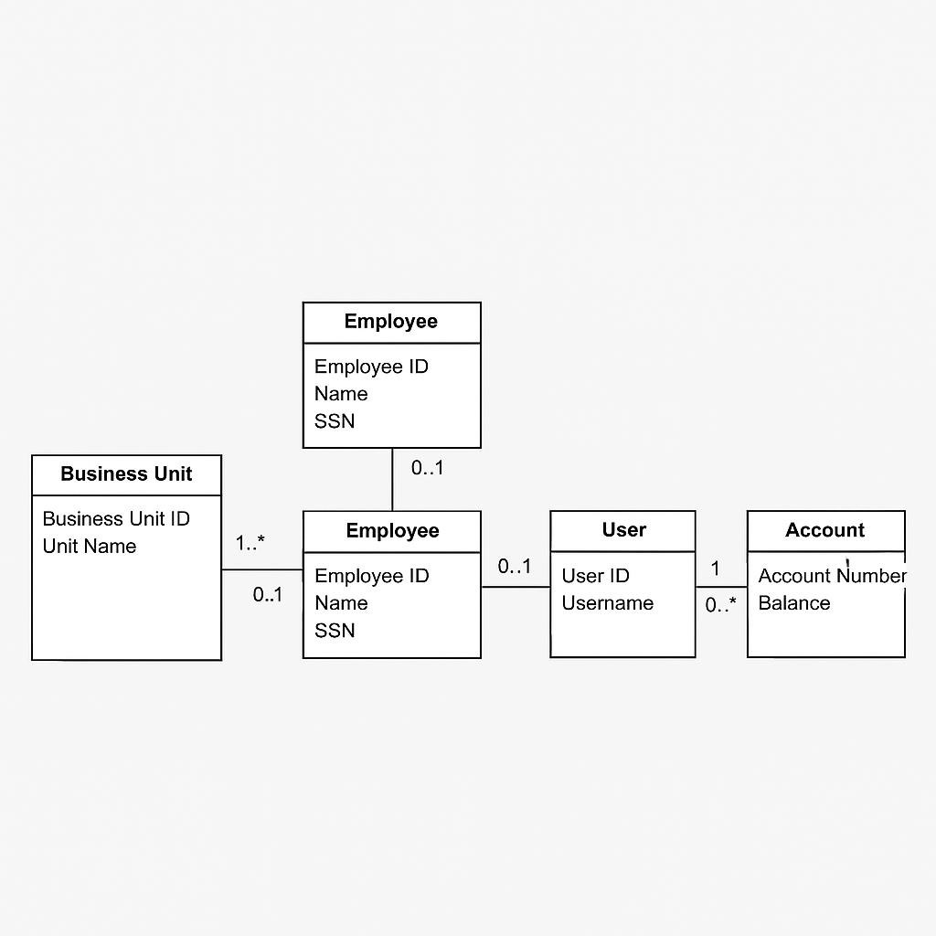

    - Entity Relationship Diagram

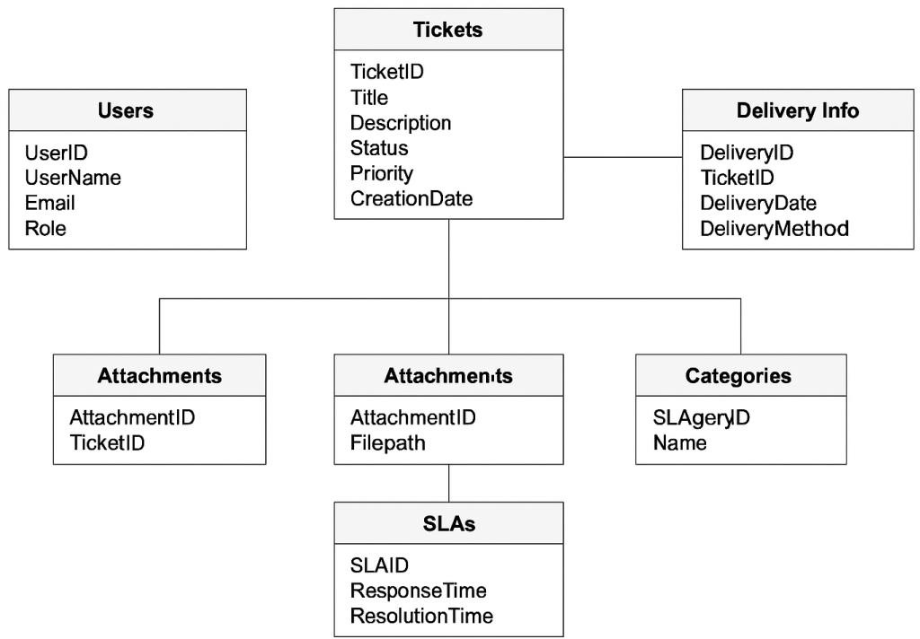

  - Data Volumes

The ADP system is expected to manage high volumes of operational data across warehouses and delivery units. Anticipated data volumes include:

DATA ENTITY
ESTIMATED VOLUME (PER DAY)
RETENTION PERIOD
STORAGE IMPACT

Inventory Records

Order Transactions
10,000+ updates 5 years Moderate

5,000–7,000 entries 7 years High

Delivery Logs 3,000+ logs 3 years Medium

DATA ENTITY
ESTIMATED VOLUME (PER DAY)
RETENTION PERIOD
STORAGE IMPACT

User Access Logs 15,000 login records 1 year High (archived
quarterly)

API Calls (GPS/ERP)
20,000+ calls Rolling 30 days Low

This analysis helps in estimating infrastructure capacity and planning for database scaling and archival strategies.

  - Data Conversion

The transition to the ADP system requires seamless migration of legacy data to ensure continuity in operations. The key aspects of the data conversion strategy include:

DATA SOURCE
TARGET SYSTEM
CONVERSION APPROACH
VALIDATION METHOD

Excel-based Inventory
ADP Inventory DB Scripted ETL with data
cleansing
Reconciliation reports, manual spot-checks

Legacy Order Logs
Order Management
CSV import with mapping templates
Sample order verification

Manual Delivery Notes
Delivery Module Scanned digitization +
structured input
Random audits

Vendor Master Data
ERP Integration API-based batch migration Cross-validation with ERP

  - Data Retention and Archiving

To ensure regulatory compliance and efficient system performance, the ADP system will implement structured data retention and archiving policies as follows:

DATA TYPE RETENTION PERIOD
ARCHIVING POLICY ACCESS
METHOD

Inventory Records 7 years Archived to secure cold storage after 2 years
Read-only access via ADP

Delivery & Order Logs 5 years Archived after 1 year Exportable upon
request

User Activity Logs 1 year Automatically purged post retention period
Internal access only

Vendor/Partner Master Data
Active as long as valid
Archived after contract closure Accessible via
audit trail

The system will use automated archival processes to move inactive data into encrypted storage, with logs maintained for audit purposes. Archiving will ensure minimal performance impact while maintaining traceability.

  - FOI/Privacy Implications

The ADP system will manage sensitive inventory and delivery data, requiring compliance with FOI and data privacy standards. Role-based access, encryption, and audit logs will ensure data security and controlled access. Only necessary data will be collected, retained per policy, and made FOI-compliant for transparency without breaching confidentiality.

CONCEPTUAL CLASS / ENTITY NAME | DATA SENSITIVITY LEVEL  (NON-SENSITIVE, PROTECTED A, PROTECTED B, PROTECTED C)
User Profile | Protected A
Employee Records | Protected B

Inventory Details | Non-sensitive
Delivery Logs | Protected A
Payment Details | Protected C
Supplier Information | Protected B
Product Listings | Non-sensitive

4.c. Data Definition Reports

ENTITY | ATTRIBUTE | TYPE | DESCRIPTION | FORMAT | CONSTRAINTS
Customer | Customer_ID | Integer | Unique customer ID | 10 digits | Primary Key
Customer | Name | Varchar | Customer name | 50 chars | Not Null
Order | Order_ID | Integer | Unique order ID | 8 digits | Primary Key
Order | Customer_ID | Integer | Refers to customer | 10 digits | Foreign Key
Order | Order_Date | Date | Date of order | YYYY-MM- DD | Not Null
Product | Product_ID | Integer | Unique product ID | 8 digits | Primary Key
Product | Name | Varchar | Product name | 50 chars | Not Null
Product | Price | Decimal | Unit price | 9999.99 | > 0
Inventory | Product_ID | Integer | Links to product | 8 digits | Foreign Key

Inventory | Quantity | Integer | Available units | Integer | >= 0
Delivery | Delivery_ID | Integer | Unique delivery ID | 8 digits | Primary Key
Delivery | Order_ID | Integer | Linked order | 8 digits | Foreign Key
Delivery | Delivery_Date | Date | Scheduled delivery | YYYY-MM- DD | > Order_Date
Warehouse | Warehouse_ID | Integer | Unique warehouse ID | 6 digits | Primary Key
Warehouse | Location | Varchar | Warehouse location | 100 chars | Not Null

    - Domain Class Definition Report

Class Name: InventoryItem
Class Description:

Represents products available in the warehouse, including quantity, SKU, and product metadata used in tracking, reporting, and delivery fulfillment.

Initial Data Volume (approx.): 5,000 records Annual Data Growth Rate (approx. %): 12% Attributes (fields) of the class:
- Name: ItemID
Description: Unique identifier for each inventory item.
- Name: ItemName
Description: Name/description of the product.
- Name: Category
Description: Classification of item for reporting and analytics.
- Name: QuantityAvailable
Description: Current stock level of the item in the warehouse.
- Name: ReorderLevel
Description: Minimum stock threshold before reordering is triggered.
- Name: UnitPrice
Description: Price per unit for invoicing and valuation.

4.6.1 Entity Definition Report

ENTITY NAME | ENTITY DESCRIPTION | ATTRIBUTES (FIELDS) | ATTRIBUTE TYPE | ATTRIBUTE DESCRIPTION
User | Represents a system user | User ID | Integer | Unique identifier
 |  | Name | String | Full name
 |  | Email | String | User email
 |  | Role | String | User's system role
Order | Represents a purchase order | Order ID | Integer | Unique order ID
 |  | User ID | Integer | ID of ordering user
 |  | Product ID | Integer | Product ID
 |  | Order Date | Date | Date of order placement

- Non-Functional requirements

REQUIREMENT TYPE
DESCRIPTION

Performance
The system should support concurrent processing of orders and inventory updates for up to 10,000 transactions per minute without delay.

Scalability The platform must scale horizontally to accommodate new branches and increased customer traffic as the business grows.

Availability The system should maintain an uptime of 99.9% with high availability during business hours across all locations.

REQUIREMENT TYPE

DESCRIPTION

Security Data encryption must be enforced for both in-transit and at-rest data.
Only authorized users should access sensitive modules.

Maintainability The architecture should support modular components to allow easy updates and bug fixes without downtime.

Usability The interface must be intuitive, with minimal training required for warehouse staff and delivery partners.

Compliance The solution must comply with applicable data protection and financial transaction regulations (e.g., GDPR, Indian IT Act).

Backup & Recovery Daily automated backups should be configured, and the system should support full restoration within 4 hours.

Localization The UI should support multiple regional languages for operations in diverse geographic regions.

  - Security Requirements

SECURITY REQUIREMENT
DESCRIPTION

Authentication System must support secure login with username and password.
Admins require multi-factor authentication (MFA).

Authorization
Role-based access control (RBAC) must ensure users can only access data relevant to their role (e.g., Inventory Manager, Delivery Manager).

Data Confidentiality Sensitive user and inventory data must be encrypted in transit (HTTPS) and at rest (AES-256).

Audit Logging All critical user actions (login, edit, delete, access) must be logged and stored for at least 6 months for audit purposes.

Session Management User sessions expire after 10 minutes of inactivity. Re-authentication is required post-timeout.

SECURITY REQUIREMENT

DESCRIPTION

Password Policy Strong password policy with minimum 8 characters, alphanumeric mix, and expiry every 90 days must be enforced.

Data Backup & Recovery Secure daily backups must be maintained. Data recovery process should be tested quarterly.

Only authorized personnel should access sensitive financial or
Data Access Restrictions delivery-related data. External users must not access internal modules.

Third-Party Integrations All third-party APIs must comply with organizational security policies and require API keys with encrypted transmission.

Compliance System must comply with applicable data protection laws such as GDPR/IT Act as relevant to the region of deployment.

    - Authentication

ASPECT DETAILS
Login Mechanism Username and password authentication for all user roles.

Multi-Factor Authentication (MFA)
Enabled for Admin and Delivery Head roles to enhance security.

Password Policy
Passwords must be a minimum of 8 characters, include uppercase, lowercase, number, and symbol. Passwords must be changed every 90 days.

Session Timeout Automatic logout after 10 minutes of user inactivity.

Account Lockout Account will be temporarily locked after 5 unsuccessful login attempts within 10 minutes.

Encryption Login credentials are encrypted using SHA-256 during transmission.

Forgot Password Users can reset passwords via registered email with token validation (valid for 15 minutes).

.

Authorization and Access Controls

ASPECT DETAILS
Role-Based Access Access to modules and features is determined based on user roles such as
Control Admin, Inventory Manager, Delivery Head, and Store Manager.

Granular Permissions
Each user role has specific privileges such as view, edit, delete, and approve, mapped to their respective modules.

Module-Level Restrictions
For example, only Admins can manage users, while Delivery Heads can approve stock movements and deliveries.

Audit Logging All access and modifications are logged, including user ID, timestamp, and activity. Logs are stored securely and retained for 12 months.

Access Revocation Inactive or exited employees’ accounts are disabled immediately by the
Admin team to prevent unauthorized access.

Approval Workflow
Sensitive actions like stock deletion or inter-location transfers require dual- level approvals (Initiator + Approver).

Temporary access to restricted modules can be granted with time-based expiration and justification approval.

  - Availability Requirements

ASPECT DETAILS
System Uptime The ADP platform must maintain an uptime of at least 99.9% during business hours (9 AM – 9 PM IST).

Maintenance Windows
Scheduled maintenance must be conducted during non-peak hours with prior communication to stakeholders.

High Availability (HA)
Redundancy should be built across servers and database clusters to avoid single points of failure.

Disaster Recovery (DR)
A disaster recovery plan must ensure restoration of services within 4 hours of major disruptions.

Monitoring & Alerts
Real-time system monitoring tools should be used, and alerts sent to the IT team for outages or errors.

Business Continuity
In case of application downtime, offline inventory and delivery logs should be updated and synced later.

  - Usability Requirements

USER
ASPECT DETAILS
THE SYSTEM SHOULD HAVE A SIMPLE, INTUITIVE, AND

INTERFACE (UI) RESPONSIVE INTERFACE ACCESSIBLE ON DESKTOP AND MOBILE.

EASE OF NAVIGATION
LANGUAGE SUPPORT
KEY FEATURES SUCH AS ORDER PLACEMENT, INVENTORY STATUS, AND DELIVERY TRACKING MUST BE REACHABLE IN ≤ 3 CLICKS.
ENGLISH (MANDATORY); ABILITY TO SCALE TO OTHER INDIAN LANGUAGES BASED ON USER BASE EXPANSION.

USER TRAINING
MINIMAL TRAINING (MAX 2 HOURS) SHOULD BE SUFFICIENT FOR BASIC OPERATIONS FOR WAREHOUSE AND DELIVERY STAFF.

ACCESSIBILITY INTERFACE SHOULD BE COMPLIANT WITH WCAG 2.1 STANDARDS TO ENSURE USABILITY FOR ALL USERS.

ERROR HANDLING
HELP AND SUPPORT
CLEAR MESSAGES SHOULD GUIDE USERS TO CORRECT MISTAKES WITHOUT TECHNICAL JARGON.
EMBEDDED HELP GUIDES AND TOOLTIPS SHOULD BE AVAILABLE THROUGHOUT KEY MODULES.

  - System Help Requirements

USE CASE / BUSINESS FUNCTION NAME | HELP REQUIREMENTS  - FIELD LEVEL (ONLINE)  - SCREEN LEVEL (ONLINE)  - HELP PRINTING OPTIONS  - OPERATIONS MANUAL (OFFLINE)  - ANY OTHER (PLEASE DESCRIBE)
Login Functionality | - Field level (online)  - Screen level (online)  - Help Printing Options  - Operations Manual (Offline)
Generate Invoice | - Field level (online)  - Screen level (online)

- Help Printing Options
- Operations Manual (Offline)
View Report | - Field level (online)  - Screen level (online)  - Help Printing Options  - Operations Manual (Offline)
User Profile Management | - Field level (online)  - Screen level (online)  - Help Printing Options  - Operations Manual (Offline)
Data Export | - Field level (online)  - Screen level (online)  - Help Printing Options  - Operations Manual (Offline)

  - Performance Requirements

This section describes system performance expectation levels (response times).

USE CASE NAME / BUSINESS FUNCTION NAME / TRANSACTION DESCRIPTION | PERFORMANCE REQUIREMENTS (RESPONSE TIME) (IN SECONDS OR MINUTES)
Login | Within 3 seconds
Search Inventory | Under 5 seconds
Generate Report | Up to 2 minutes
Submit Order | Within 10 seconds
Update User Profile | Under 7 seconds
Fetch Order History | Within 15 seconds

5.c. Scalability Requirements

REQUIREMENT CATEGORY

DESCRIPTION

User Load Scalability System should support up to 5,000 concurrent users during
peak periods.

Data Volume Scalability Should handle up to 100,000 transactions per day with 20%
annual growth.

Geographic Scalability System should operate efficiently across multiple regions (multi-
location).

Modular Expansion Capability System modules should support plug-and-play upgrades with
minimal downtime.

Infrastructure Scalability Should support scaling through cloud-based infrastructure
(vertical/horizontal).

Response Time Under Load Maintain sub-2-second response time with up to 80% load
threshold.

    - User Scalability

USE CASE / FUNCTION
EXPECTED CONCURRENT USERS
PEAK USAGE PERIOD
PERFORMANCE EXPECTATION

Ticket Booking 2,000 users Weekends & Holidays

Inventory Tracking 500 users Weekdays, 9 AM
– 6 PM
Response time < 2 seconds

Response time < 3 seconds

Delivery Status Updates

Reporting Dashboard Access
800 users Daily, 7 PM – 10 PM

300 users Month-end & Quarterly
Response time < 2 seconds

Response time < 5 seconds

Admin & Configuration Tasks
100 users Office Hours Response time < 3 seconds

    - Application Scalability

ASPECT SCALABILITY REQUIREMENT DESCRIPTION
Transaction Volume The application should support a 3x increase in daily transactions during peak periods.

Data Volume Database should scale to handle a 5-year growth of transactional and historical data without lag.

API Load APIs must support up to 5,000 concurrent requests with auto-scaling infrastructure.

New Module Integration
Application architecture must allow plug-and-play integration for new delivery/warehouse modules.

UI Performance Frontend should maintain consistent performance with increased complexity or component additions.

Background Processing Batch jobs (e.g., inventory sync, delivery updates) should scale to run
Tasks hourly with minimal latency.

- Interface Requirements

USER INTERFACE (UI)
EXTERNAL SYSTEMS

INTERNAL SYSTEMS
INTERFACE TYPE DESCRIPTION
THE SYSTEM SHALL PROVIDE A RESPONSIVE AND INTUITIVE WEB INTERFACE FOR USERS, INCLUDING DASHBOARDS, FILTERS, AND FORMS.
THE SYSTEM SHALL INTEGRATE WITH THIRD-PARTY APIS SUCH AS PAYMENT GATEWAYS, DELIVERY TRACKING SERVICES, AND INVENTORY SOFTWARE.
MUST SUPPORT DATA EXCHANGE WITH INTERNAL ERP SYSTEMS AND DATABASES THROUGH SECURE API ENDPOINTS.

DEVICE INTERFACE
COMPATIBLE ACROSS DESKTOPS, TABLETS, AND MOBILE DEVICES FOR FIELD AND OFFICE USE.

  - User Interface Requirements

UI ELEMENT REQUIREMENT DESCRIPTION
Layout Clean, intuitive layout with clear navigation menus.

Accessibility Should comply with accessibility standards (e.g., font size, contrast, keyboard navigation).

Responsiveness Interface must adapt across desktop, tablet, and mobile devices.

Input Validation Real-time validation on forms (e.g., email format, required fields).

Feedback Mechanisms Users should receive confirmations, alerts, and error messages where necessary.

Language & Labels Use of clear, simple English; tooltips for complex fields.

Customization (Optional)
Allow basic theme preference (light/dark mode).

  - System Interface Requirements

SYSTEM / MODULE
Inventory Management

Authentication System
INTERFACE TYPE DESCRIPTION

API (RESTful) Sync inventory data with central database.

OAuth / LDAP Secure user authentication and session management.

SYSTEM / MODULE

INTERFACE TYPE DESCRIPTION

Reporting Engine Database Connection
(ODBC)
Retrieve data for generating analytics and reports.

Notification Service SMTP / SMS Gateway Sends alerts and notifications to users.

External Vendor System
Web Services / XML Exchange order and status data with third- party systems.

- Business Glossary

TERM DEFINITION
User An individual who interacts with the system to perform specific operations.

Admin A privileged user who manages system settings, users, and core data. Inventory The stock of goods maintained by the business to fulfill customer orders. Order A transaction created when a user purchases or requests goods/services.
Invoice A financial document issued to a customer detailing purchased items and charges.

Vendor External supplier providing goods/services to the business. Dashboard Visual summary of key metrics and system data for user insights. Authentication The process of verifying a user's identity.
Authorization Permission granted to a user to access specific resources or features.

Database Structured data storage used to store system i
Revision Log

DATE VERSION CHANGE REFERENCE REVIEWED BY
25-07-2025 0.1 Document created – Initial Draft Srividya Murugan 26-07-2025 0.2 Non-functional requirements added Srividya Murugan 27-07-2025 1.0 Interface section finalized Srividya Murugan

Appendices

APPENDIX REFERENCE DOCUMENT TITLE / DESCRIPTION
Appendix A Sample Screens – Existing Application

Appendix B Glossary of Terms

Appendix C Abbreviations Used

Appendix D Stakeholder Interview Summary

Appendix E Business Process Flow Diagram

Appendix F Use Case / User Story Samples

Approval
This document has been approved as the official Business Requirements Document for the ADP Implementation at DDoll project.

Following approval of this document, changes will be governed by the project’s change management process, including impact analysis, appropriate reviews and approvals, under the general control of the Master Project Plan and according to Project Support Office policy.

Prepared by

PREPARED BY | SIGNATURE | DATE
Srividya Murugan Business Analyst DDoll Inc. | [Signed] | 25-07-2025

Approved by

APPROVED BY | SIGNATURE | DATE
R. Narayan  IT Project Manager DDoll Inc. | [Signed] | 26-07-2025

- ADP Inventory & Delivery Process Flow

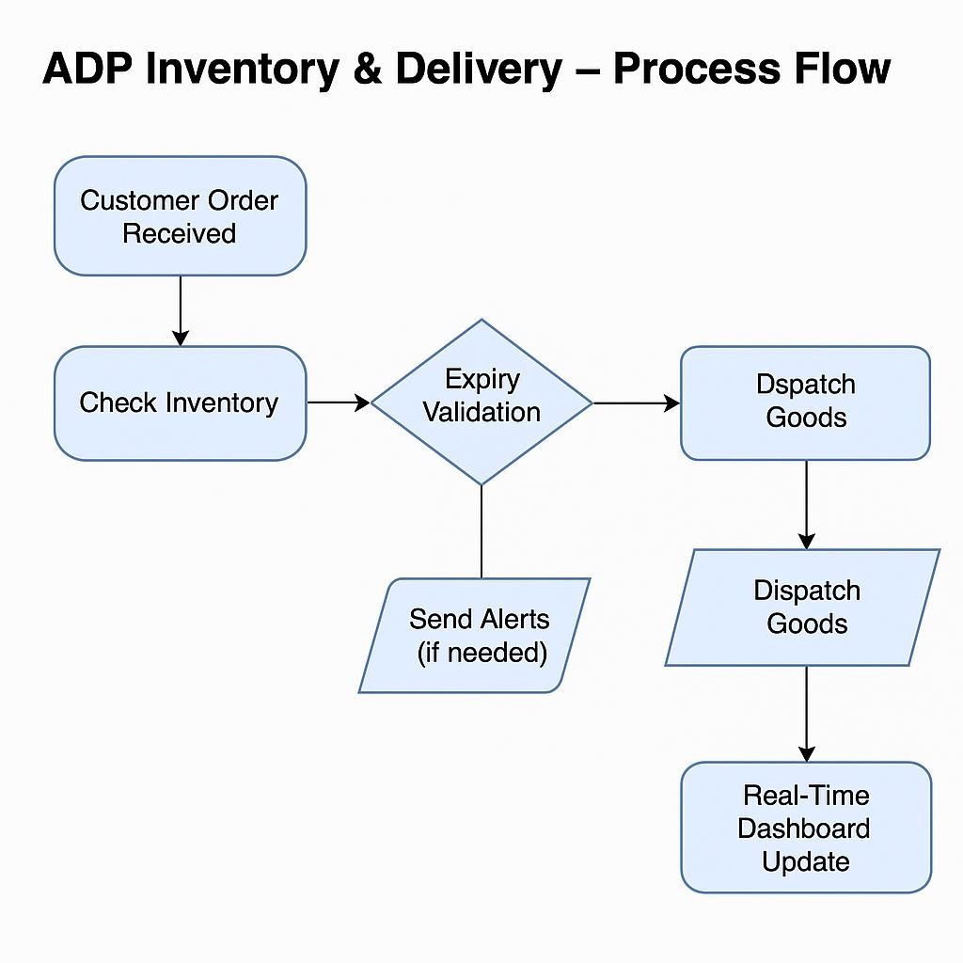

Assignment – 2

- Write an introduction letter to a client introducing yourself as a business analyst in charge of working with the client and his team to start the business understanding process.

Subject: Introduction as Your Business Analyst Partner DDoll,

I hope this message finds you well. My name is Srividya, and I am delighted to introduce myself as the Business Analyst assigned to collaborate with you and your team on this exciting project. Understanding the challenges and opportunities within the manufacturing and logistics sectors, particularly in delivering exceptional customer service, is a domain I am passionate about. With your vision of managing inventory and ensuring the quickest delivery of your ice-cream and milk products, my role will be to work closely with you to transform these goals into a robust, tailor-made software solution. To begin, I aim to thoroughly understand your current processes, challenges, and aspirations. Together, we will explore your operational workflows, identify key requirements, and map out a strategic plan that aligns with your business objectives. Your insights will be invaluable in ensuring the solution we design is practical, scalable, and optimized for your unique needs.
I look forward to discussing your expectations and gathering inputs from your team during our initial meetings. In the meantime, please feel free to share any documents, current processes, or initial thoughts that could help us hit the ground running. Thank you for the opportunity to collaborate on this project. I am confident that, together, we will develop a solution that adds significant value to your business operations. Please let me know a convenient time for us to connect further. Looking forward to working with you.
Warm regards, Srividya Business Analyst
+91 7400194330

- Prepare a brief BRD and SRS for a project- Ticketing system.

Business Requirements Document (BRD) Project Name: Ticketing System Prepared By: Srividya Murugan
Date: 6th July 2025

- Executive Summary
The objective of the Ticketing System project is to implement a comprehensive solution for managing customer support tickets effectively. The system will streamline the process of ticket creation, tracking, resolution, and closure. It will be designed to ensure seamless communication between users, support agents, and managers, improving the overall efficiency of customer support operations. Additionally, the system will include advanced features for monitoring service level agreement (SLA) compliance, enhancing reporting capabilities, and integrating with a knowledge base for faster problem resolution.
- Business Objectives
- Improve response and resolution times for customer issues.
- Centralize and standardize ticket tracking.
- Ensure SLA adherence with alert mechanisms.
- Provide actionable insights through reporting and analytics.
- Enhance user satisfaction and operational transparency.
- Business Process Overview
  - AS-IS Process Diagram

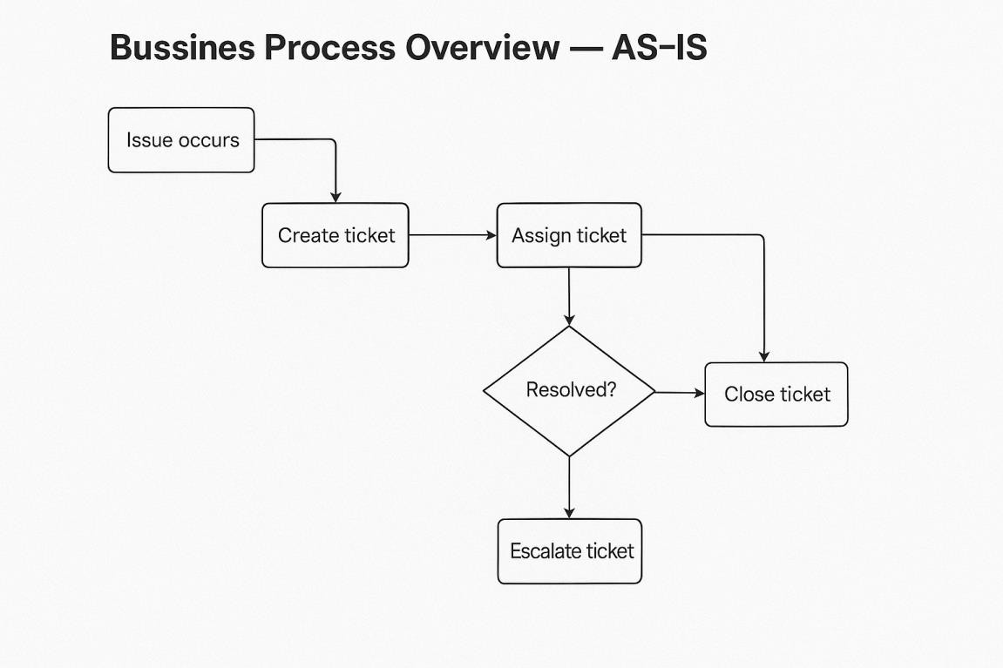

  - TO-BE Process Diagram

    - 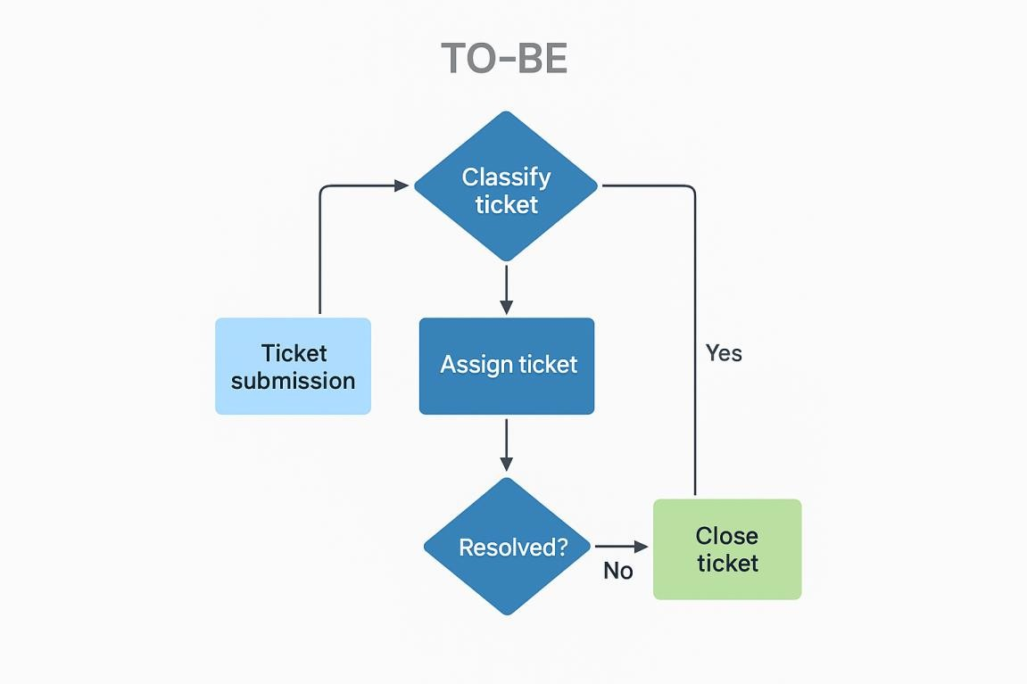

Business Risks

RISK NO.
RISK DESCRIPTION LIKELIHOOD IMPACT MITIGATION
STRATEGY

  - Resistance to new system adoption by support agents

  - Integration failure with existing CRM or Email systems

  - SLA breach due to technical issues

  - Data loss during migration from old system
Medium High Conduct training and offer
ongoing support

Low High Conduct compatibility tests before deployment

Medium High Set up automated alerts
and escalation workflows

Low Critical Ensure full back up and run migration dry tests

RISK NO.
RISK DESCRIPTION LIKELIHOOD IMPACT MITIGATION
STRATEGY

  - Security breach or ticket data exposure
Low Critical Implement encryption, access controls, and audits

- Stakeholder Matrix

STAKEHOLDER ROLE RESPONSIBILITY
Project Sponsor IT Head Overall funding and project support
Project Manager Srividya Murugan Delivery, coordination and
implementation

Customer Support End User Daily system usage and feedback

Admin/IT Support System Admin System configuration, maintenance

QA Team In-house QA Testing and defect rep

- User Stories

User Story ID | User Story | Customer Value (CV) | Business Priority (BP) | Priority Level
US01 | As a user, I want to create a support ticket so that I can get help with my issue. | 5 | 5 | High
US02 | As a user, I want to view the status of my tickets so that I can track progress. | 4 | 5 | High
US03 | As an admin, I want to assign tickets to agents based on workload and priority. | 5 | 5 | High
US04 | As an agent, I want to update ticket status so that users know what is happening. | 5 | 4 | High
US05 | As an agent or system, I want to close a resolved ticket so that records are up to date. | 4 | 4 | Medium
US06 | As a user or agent, I want to upload attachments to tickets so that I can provide supporting evidence or relevant documents. | 2 | 4 | High
US07 | As a support agent, I want to escalate unresolved tickets so that complex issues receive timely attention. | 3 | 5 | Medium
US08 | As a user, I want to filter tickets by priority so that I can focus on the most important issues. | 4 | 1 | Medium
US09 | As an admin, I want to generate performance reports so that I can assess agent productivity. | 5 | 2 | High
US10 | As a user, I want to receive email notifications for ticket updates so that I stay informed. | 1 | 3 | Medium
US11 | As a support agent, I want to add internal notes so that I can track progress privately. | 2 | 4 | Medium
US12 | As a user, I want to reopen closed tickets so that unresolved issues can be addressed. | 3 | 5 | High
US13 | As an admin, I want to manage agent availability so that workload is balanced. | 4 | 1 | Medium
US14 | As a user, I want to change the priority of my ticket so that urgent matters are addressed quickly. | 5 | 2 | Medium
US15 | As a system, I want to auto-close inactive tickets so that system remains efficient. | 1 | 3 | High
US16 | As a support agent, I want to view ticket history so that I understand past interactions. | 2 | 4 | Medium
US17 | As a user, I want to chat with support agents in real-time so that I get faster help. | 3 | 5 | Medium
US18 | As a system, I want to tag similar tickets so that agents can identify recurring issues. | 4 | 1 | High
US19 | As a user, I want to delete my account so that I can opt out of the service. | 5 | 2 | Medium
US20 | As a system, I want to log all ticket changes so that there is audit traceability. | 1 | 3 | Medium
US21 | As a user, I want to rate my ticket experience so that I can give feedback. | 2 | 4 | High
US22 | As a support agent, I want to assign tags to tickets so that they are easy to categorize. | 3 | 5 | Medium
US23 | As a user, I want to export my ticket history so that I can keep personal records. | 4 | 1 | Medium
US24 | As an admin, I want to customize ticket forms so that relevant details are collected. | 5 | 2 | High
US25 | As a user, I want to merge duplicate tickets so that all communication is streamlined. | 1 | 3 | Medium

Use Case Specifications – Ticketing System Create Ticket
USE CASE NAME | CREATE TICKET
Description | Allows a user to create a new support ticket with issue details.
Actors | User, System
Business Rules | Each ticket must have a unique ID. Mandatory fields must be filled before submission.
Basic Flow | - User logs in  - Navigates to 'Create Ticket'  - Enters issue details  - Submits ticket  - System stores and confirms ticket ID
Alternative Flow | If required fields are empty, system prompts user to complete them before proceeding.
Non-Functional Requirements | Form should load in under 3 seconds. Data must be validated in real time.
Precondition | User must be authenticated and logged in.
Postcondition | A new ticket is created and logged in the system with a unique ID.

View Ticket Status

USE CASE NAME | VIEW TICKET STATUS
Description | Enables users to view the status of submitted tickets.
Actors | User, System
Business Rules | Only logged-in users can view their own tickets.
Basic Flow | - User logs in  - Navigates to 'My Tickets'  - System displays list of tickets with statuses
Alternative Flow | If no tickets exist, system displays appropriate message.
Non-Functional Requirements | Ticket list must load within 2 seconds.
Precondition | User must have created at least one ticket.
Postcondition | User can see real-time updates on their tickets.
Assign Ticket to Agent

USE CASE NAME | ASSIGN TICKET TO AGENT
Description | Allows admin/system to assign a ticket to an available agent based on priority and availability.
Actors | System, Admin, Support Agent
Business Rules | Tickets should be assigned within 5 minutes of creation. Priority tickets get auto assigned.
Basic Flow | - New ticket created  - System checks available agents  - Assigns based on workload  - Notifies agent
Alternative Flow | If no agents are available, system adds to queue and notifies admin.
Non-Functional Requirements | Assignment should occur within 1 minute of creation.

Precondition | Ticket must exist and agent pool must be configured.
Postcondition | Ticket is assigned and agent notified.
Update Ticket Status

USE CASE NAME | UPDATE TICKET STATUS
Description | Support agents can update ticket status as they work on resolving issues.
Actors | Support Agent, System
Business Rules | Only agents assigned to a ticket can update its status.
Basic Flow | - Agent logs in  - Navigates to assigned tickets  - Selects ticket  - Updates status and adds notes
Alternative Flow | If agent tries to update unassigned ticket, system shows error.
Non-Functional Requirements | Update operation must complete within 2 seconds.
Precondition | Ticket must be assigned to the agent.
Postcondition | Ticket status is updated and logged in system history.
Close Ticket

USE CASE NAME | CLOSE TICKET
Description | Allows agent or system to close a ticket once issue is resolved.
Actors | Support Agent, System, User
Business Rules | Ticket can only be closed if marked as resolved and user has confirmed.
Basic Flow | - Agent resolves issue  - User confirms resolution  - Agent/system marks ticket closed

Alternative Flow | If user doesn't confirm, system sends reminder. Auto close after 48 hrs if no response.
Non-Functional Requirements | Closure process should be audit-logged.
Precondition | Ticket must be resolved and resolution confirmed.
Postcondition | Ticket status is marked 'Closed' and archived.

Use Case 6

USE CASE NAME | PERFORM TASK 6
Description | This use case describes the ability to perform task 6 in the ticketing system.
Actors | User, Support Agent
Business Rules | The user must be authenticated before performing this task.
Basic Flow | - User logs in  - Navigates to Task 6  - Performs the task  - System confirms action
Alternative Flow | If validation fails, show error and prompt correction.
Non-Functional Requirements | System should respond within 2 seconds.
Preconditions | User is logged in and has required permissions.
Postconditions | Task 6 is completed and logged.
Use Case 7

USE CASE NAME | PERFORM TASK 7
Description | This use case describes the ability to perform task 7 in the ticketing system.
Actors | User, Support Agent

Business Rules | The user must be authenticated before performing this task.
Basic Flow | - User logs in  - Navigates to Task 7  - Performs the task  - System confirms action
Alternative Flow | If validation fails, show error and prompt correction.
Non-Functional Requirements | System should respond within 2 seconds.
Preconditions | User is logged in and has required permissions.
Postconditions | Task 7 is completed and logged.
Use Case 8

USE CASE NAME | PERFORM TASK 8
Description | This use case describes the ability to perform task 8 in the ticketing system.
Actors | User, Support Agent
Business Rules | The user must be authenticated before performing this task.
Basic Flow | - User logs in  - Navigates to Task 8  - Performs the task  - System confirms action
Alternative Flow | If validation fails, show error and prompt correction.
Non-Functional Requirements | System should respond within 2 seconds.
Preconditions | User is logged in and has required permissions.
Postconditions | Task 8 is completed and logged.
Use Case 9

USE CASE NAME | PERFORM TASK 9
Description | This use case describes the ability to perform task 9 in the ticketing system.

Actors | User, Support Agent
Business Rules | The user must be authenticated before performing this task.
Basic Flow | - User logs in  - Navigates to Task 9  - Performs the task  - System confirms action
Alternative Flow | If validation fails, show error and prompt correction.
Non-Functional Requirements | System should respond within 2 seconds.
Preconditions | User is logged in and has required permissions.
Postconditions | Task 9 is completed and logged.
Use Case 10

USE CASE NAME | PERFORM TASK 10
Description | This use case describes the ability to perform task 10 in the ticketing system.
Actors | User, Support Agent
Business Rules | The user must be authenticated before performing this task.
Basic Flow | - User logs in  - Navigates to Task 10  - Performs the task  - System confirms action
Alternative Flow | If validation fails, show error and prompt correction.
Non-Functional Requirements | System should respond within 2 seconds.
Preconditions | User is logged in and has required permissions.
Postconditions | Task 10 is completed and logged.
Use Case 11

USE CASE NAME | PERFORM TASK 11

Description | This use case describes the ability to perform task 11 in the ticketing system.
Actors | User, Support Agent
Business Rules | The user must be authenticated before performing this task.
Basic Flow | - User logs in  - Navigates to Task 11  - Performs the task  - System confirms action
Alternative Flow | If validation fails, show error and prompt correction.
Non-Functional Requirements | System should respond within 2 seconds.
Preconditions | User is logged in and has required permissions.
Postconditions | Task 11 is completed and logged.
Use Case 12

USE CASE NAME | PERFORM TASK 12
Description | This use case describes the ability to perform task 12 in the ticketing system.
Actors | User, Support Agent
Business Rules | The user must be authenticated before performing this task.
Basic Flow | - User logs in  - Navigates to Task 12  - Performs the task  - System confirms action
Alternative Flow | If validation fails, show error and prompt correction.
Non-Functional Requirements | System should respond within 2 seconds.
Preconditions | User is logged in and has required permissions.
Postconditions | Task 12 is completed and logged.

Use Case 13

USE CASE NAME | PERFORM TASK 13
Description | This use case describes the ability to perform task 13 in the ticketing system.
Actors | User, Support Agent
Business Rules | The user must be authenticated before performing this task.
Basic Flow | - User logs in  - Navigates to Task 13  - Performs the task  - System confirms action
Alternative Flow | If validation fails, show error and prompt correction.
Non-Functional Requirements | System should respond within 2 seconds.
Preconditions | User is logged in and has required permissions.
Postconditions | Task 13 is completed and logged.
Use Case 14

USE CASE NAME | PERFORM TASK 14
Description | This use case describes the ability to perform task 14 in the ticketing system.
Actors | User, Support Agent
Business Rules | The user must be authenticated before performing this task.
Basic Flow | - User logs in  - Navigates to Task 14  - Performs the task  - System confirms action
Alternative Flow | If validation fails, show error and prompt correction.
Non-Functional Requirements | System should respond within 2 seconds.
Preconditions | User is logged in and has required permissions.

Postconditions | Task 14 is completed and logged.
Use Case 15

USE CASE NAME | PERFORM TASK 15
Description | This use case describes the ability to perform task 15 in the ticketing system.
Actors | User, Support Agent
Business Rules | The user must be authenticated before performing this task.
Basic Flow | - User logs in  - Navigates to Task 15  - Performs the task  - System confirms action
Alternative Flow | If validation fails, show error and prompt correction.
Non-Functional Requirements | System should respond within 2 seconds.
Preconditions | User is logged in and has required permissions.
Postconditions | Task 15 is completed and logged.
Use Case 16

USE CASE NAME | PERFORM TASK 16
Description | This use case describes the ability to perform task 16 in the ticketing system.
Actors | User, Support Agent
Business Rules | The user must be authenticated before performing this task.
Basic Flow | - User logs in  - Navigates to Task 16  - Performs the task  - System confirms action
Alternative Flow | If validation fails, show error and prompt correction.
Non-Functional Requirements | System should respond within 2 seconds.

Preconditions | User is logged in and has required permissions.
Postconditions | Task 16 is completed and logged.
Use Case 17

USE CASE NAME | PERFORM TASK 17
Description | This use case describes the ability to perform task 17 in the ticketing system.
Actors | User, Support Agent
Business Rules | The user must be authenticated before performing this task.
Basic Flow | - User logs in  - Navigates to Task 17  - Performs the task  - System confirms action
Alternative Flow | If validation fails, show error and prompt correction.
Non-Functional Requirements | System should respond within 2 seconds.
Preconditions | User is logged in and has required permissions.
Postconditions | Task 17 is completed and logged.
Use Case 18

USE CASE NAME | PERFORM TASK 18
Description | This use case describes the ability to perform task 18 in the ticketing system.
Actors | User, Support Agent
Business Rules | The user must be authenticated before performing this task.
Basic Flow | - User logs in  - Navigates to Task 18  - Performs the task  - System confirms action
Alternative Flow | If validation fails, show error and prompt correction.

Non-Functional Requirements | System should respond within 2 seconds.
Preconditions | User is logged in and has required permissions.
Postconditions | Task 18 is completed and logged.
Use Case 19

USE CASE NAME | PERFORM TASK 19
Description | This use case describes the ability to perform task 19 in the ticketing system.
Actors | User, Support Agent
Business Rules | The user must be authenticated before performing this task.
Basic Flow | - User logs in  - Navigates to Task 19  - Performs the task  - System confirms action
Alternative Flow | If validation fails, show error and prompt correction.
Non-Functional Requirements | System should respond within 2 seconds.
Preconditions | User is logged in and has required permissions.
Postconditions | Task 19 is completed and logged.
Use Case 20

USE CASE NAME | PERFORM TASK 20
Description | This use case describes the ability to perform task 20 in the ticketing system.
Actors | User, Support Agent
Business Rules | The user must be authenticated before performing this task.
Basic Flow | - User logs in  - Navigates to Task 20  - Performs the task  - System confirms action

Alternative Flow | If validation fails, show error and prompt correction.
Non-Functional Requirements | System should respond within 2 seconds.
Preconditions | User is logged in and has required permissions.
Postconditions | Task 20 is completed and logged.
Use Case 21

USE CASE NAME | PERFORM TASK 21
Description | This use case describes the ability to perform task 21 in the ticketing system.
Actors | User, Support Agent
Business Rules | The user must be authenticated before performing this task.
Basic Flow | - User logs in  - Navigates to Task 21  - Performs the task  - System confirms action
Alternative Flow | If validation fails, show error and prompt correction.
Non-Functional Requirements | System should respond within 2 seconds.
Preconditions | User is logged in and has required permissions.
Postconditions | Task 21 is completed and logged.
Use Case 22

USE CASE NAME | PERFORM TASK 22
Description | This use case describes the ability to perform task 22 in the ticketing system.
Actors | User, Support Agent
Business Rules | The user must be authenticated before performing this task.
Basic Flow | - User logs in  - Navigates to Task 22

- Performs the task
- System confirms action
Alternative Flow | If validation fails, show error and prompt correction.
Non-Functional Requirements | System should respond within 2 seconds.
Preconditions | User is logged in and has required permissions.
Postconditions | Task 22 is completed and logged.
Use Case 23

USE CASE NAME | PERFORM TASK 23
Description | This use case describes the ability to perform task 23 in the ticketing system.
Actors | User, Support Agent
Business Rules | The user must be authenticated before performing this task.
Basic Flow | - User logs in  - Navigates to Task 23  - Performs the task  - System confirms action
Alternative Flow | If validation fails, show error and prompt correction.
Non-Functional Requirements | System should respond within 2 seconds.
Preconditions | User is logged in and has required permissions.
Postconditions | Task 23 is completed and logged.
Use Case 24

USE CASE NAME | PERFORM TASK 24
Description | This use case describes the ability to perform task 24 in the ticketing system.
Actors | User, Support Agent
Business Rules | The user must be authenticated before performing this task.

Basic Flow | - User logs in  - Navigates to Task 24  - Performs the task  - System confirms action
Alternative Flow | If validation fails, show error and prompt correction.
Non-Functional Requirements | System should respond within 2 seconds.
Preconditions | User is logged in and has required permissions.
Postconditions | Task 24 is completed and logged.
Use Case 25

USE CASE NAME | PERFORM TASK 25
Description | This use case describes the ability to perform task 25 in the ticketing system.
Actors | User, Support Agent
Business Rules | The user must be authenticated before performing this task.
Basic Flow | - User logs in  - Navigates to Task 25  - Performs the task  - System confirms action
Alternative Flow | If validation fails, show error and prompt correction.
Non-Functional Requirements | System should respond within 2 seconds.
Preconditions | User is logged in and has required permissions.
Postconditions | Task 25 is completed and logged.

Essential Use Case Diagram

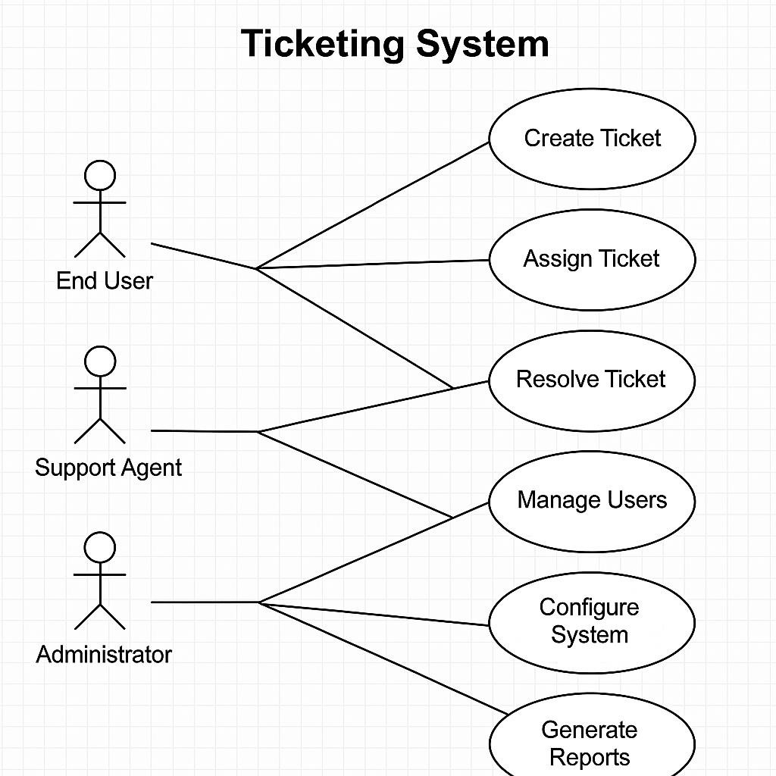

- Functional Requirements
- Support ticket creation with category, priority, and description fields.
- Automated ticket routing based on team availability and workload.
- Track ticket status: Open, In Progress, Resolved, Closed.
- Integration with knowledge base for suggested solutions.
- Support for internal notes and attachments in tickets.
- Notifications and alerts for pending or SLA-breaching tickets.
- Role-based access for customers, agents, and admins.
- Bulk update and merging of tickets.

- Analytics dashboard showing resolution time and volume metrics.
- Audit log for all ticket actions.

Business Rules

RULE NO.
RULE DESCRIPTION

BR-01 Each ticket must be assigned a unique Ticket ID at the time of creation.

BR-02 Tickets must be assigned to an available agent within 2 minutes of submission. BR-03 High-priority tickets must be acknowledged within 15 minutes.
BR-04 SLAs must be defined and tracked for each ticket based on category and priority. BR-05 Only Admins can modify ticket status once marked “Closed.”
BR-06 Users can escalate tickets if not responded to within SLA timeframes.

BR-07 Ticket categories must be predefined in the system and cannot be edited by agents.

BR-08 A ticket can only be reopened once after being closed.

BR-09 Agents cannot resolve tickets without selecting a resolution type from the dropdown.

BR-10 All actions on a ticket must be timestamped and recorded in the audit trail.

- Non-Functional Requirements
  - Security Requirements
The system will use HTTPS for secure communication, implement role-based access, log every login attempt, and have password policies.
  - Availability Requirements
System will be available 99.9% of the time with failover support and routine backups.

  - Usability Requirements
User interface must be mobile responsive, accessible to screen readers, and have intuitive navigation.
  - System Help Requirements

COMPONENT | HELP SUPPORT PROVIDED
Login Page | Tooltip on username/password rules
Ticket Dashboard | Embedded FAQs and support guide
Reports | Tooltips and export guide
Settings | Inline documentation
  - Performance Requirements
Typical response time must be under 3 seconds for common operations under normal load.
  - Scalability Requirements
System should support growing ticket volume and concurrent users through horizontal scaling.

- Data Requirements
This section outlines the data architecture, class diagram, entity-relationship diagram, and definitions required for the Ticketing System project.
  - Data Architecture
The data architecture includes structured storage and retrieval of ticket records, user profiles, SLA configurations, and interaction logs. Data will be stored in relational tables for scalability and ease of access.
  - Domain Class Diagram

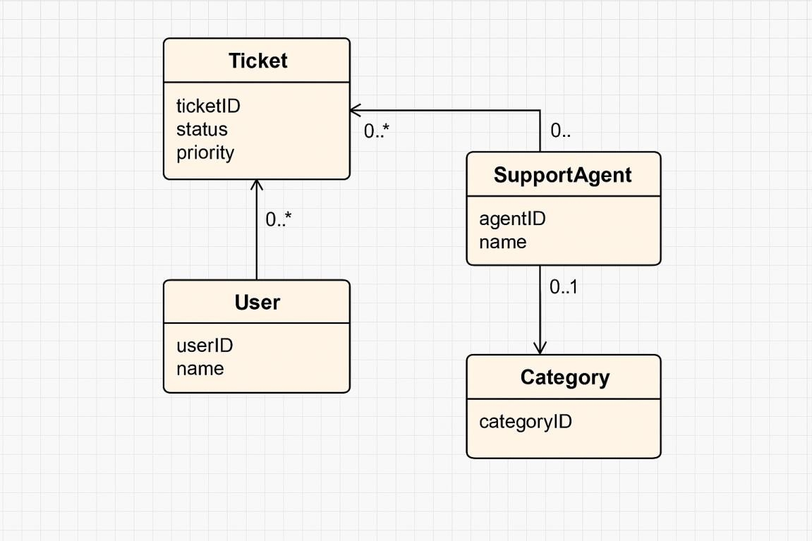
  - Entity Relationship Diagram

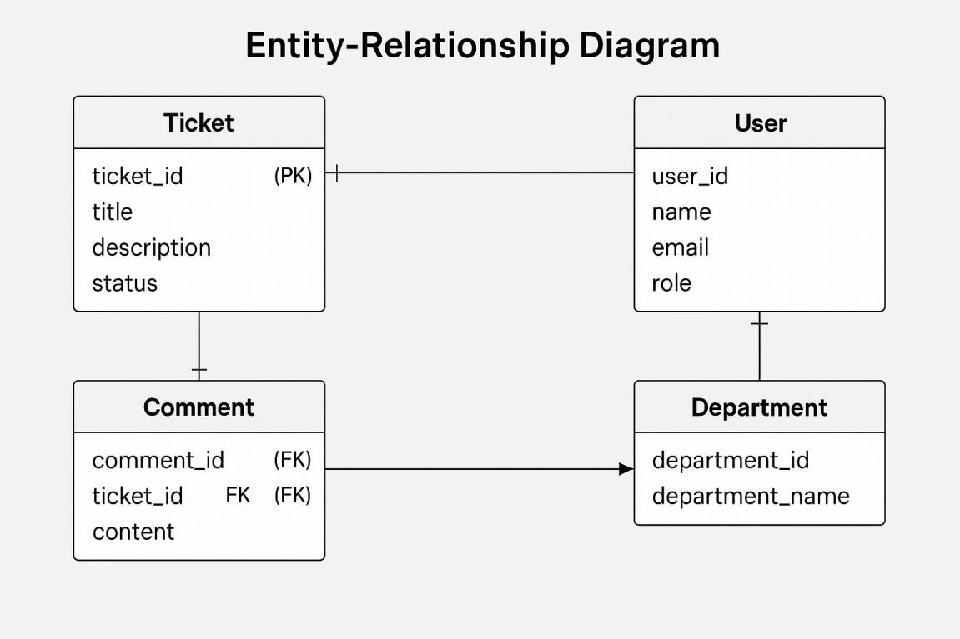

  - Data Sensitivity Table

DATA ELEMENT | SENSITIVITY LEVEL | SECURITY MEASURES
User Credentials | High | Encryption, Role-based Access
Ticket Details | Medium | Access Control, Audit Trail
SLA Configuration | Low | Standard Authentication

  - Data Definition Reports

FIELD NAME | DATA TYPE | DESCRIPTION
Ticket_ID | Integer | Unique identifier for each ticket
User_ID | Integer | References the user raising the ticket
Created_At | Timestamp | Date and time the ticket was created
Status | Varchar | Status of the ticket

- Interface Requirements
  - User Interface Requirements
The system shall feature an intuitive and responsive user interface that enables users to create and manage support tickets easily. Components include dashboard, ticket list, detailed view, search, and filters.
  - System Interface Requirements
The system must integrate with the following external/internal systems:
    - Email Service for ticket creation via email
    - Knowledge Base for suggested solutions
    - Reporting Engine for analytics
    - Authentication Service (LDAP or SSO)

- Glossary
TERM DEFINITION
SLA Service Level Agreement – a contract that defines performance metrics
Ticket A recorded issue/incident reported by a user
Agent Support personnel handling user issues
Knowledge Base Centralized repository of common solutions

- Appendices
  - Ticket Lifecycle Flow
  - SLA Breach Matrix
  - User Permission Matrix

- Approval
PREPARED BY SIGNATURE DATE
Srividya Murugan 06-Jun-2025
Client Acceptor’s Name [To be filled]

- . Make an ERD of creating a support ticket/Ticketing life cycle.

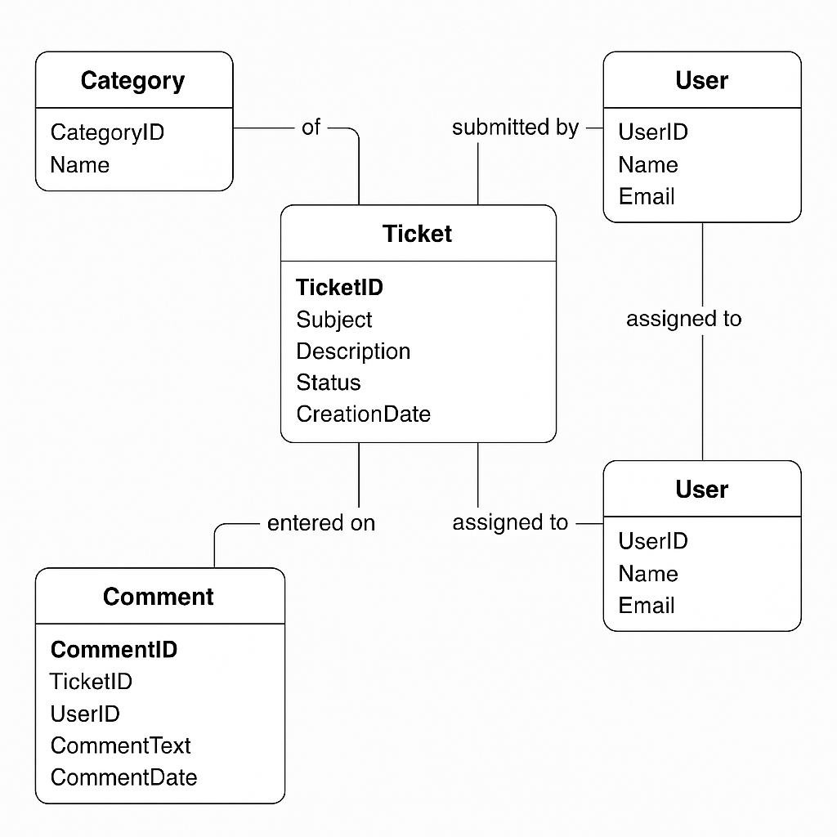

The ERD illustrates the lifecycle of a support ticket, including key entities such as User, Ticket, Agent, and Status, along with their relationships. Diagram created in Visio-style format.

- User story of shopping from ecommerce.

USER STORY ID | USER STORY | CV | BP | PRIORITY
US_ECOM_001 | As a user, I want to perform eCommerce task | 2 | 4 | Medium

 | 1 so that I can achieve a specific goal related to online shopping.
US_ECOM_002 | As a user, I want to perform eCommerce task 2 so that I can achieve a specific goal related to online shopping. | 3 | 5 | Low
US_ECOM_003 | As a user, I want to perform eCommerce task 3 so that I can achieve a specific goal related to online shopping. | 4 | 1 | High
US_ECOM_004 | As a user, I want to perform eCommerce task 4 so that I can achieve a specific goal related to online shopping. | 5 | 2 | Medium
US_ECOM_005 | As a user, I want to perform eCommerce task 5 so that I can achieve a specific goal related to online shopping. | 1 | 3 | Low
US_ECOM_006 | As a user, I want to perform eCommerce task 6 so that I can achieve a  specific goal | 2 | 4 | High

 | related to online shopping.
US_ECOM_007 | As a user, I want to perform eCommerce task 7 so that I can achieve a specific goal related to online shopping. | 3 | 5 | Medium
US_ECOM_008 | As a user, I want to perform eCommerce task 8 so that I can achieve a specific goal related to online shopping. | 4 | 1 | Low
US_ECOM_009 | As a user, I want to perform eCommerce task 9 so that I can achieve a specific goal related to online shopping. | 5 | 2 | High
US_ECOM_010 | As a user, I want to perform eCommerce task 10 so that I can achieve a specific goal related to online shopping. | 1 | 3 | Medium
US_ECOM_011 | As a user, I want to perform eCommerce task 11 so that I can achieve a specific goal related to online shopping. | 2 | 4 | Low
US_ECOM_012 | As a user, I want to perform | 3 | 5 | High

 | eCommerce task 12 so that I can achieve a specific goal related to online shopping.
US_ECOM_013 | As a user, I want to perform eCommerce task 13 so that I can achieve a specific goal related to online shopping. | 4 | 1 | Medium
US_ECOM_014 | As a user, I want to perform eCommerce task 14 so that I can achieve a specific goal related to online shopping. | 5 | 2 | Low
US_ECOM_015 | As a user, I want to perform eCommerce task 15 so that I can achieve a specific goal related to online shopping. | 1 | 3 | High
US_ECOM_016 | As a user, I want to perform eCommerce task 16 so that I can achieve a specific goal related to online shopping. | 2 | 4 | Medium
US_ECOM_017 | As a user, I want to perform eCommerce task 17 so that I can  achieve a | 3 | 5 | Low

 | specific goal related to online shopping.
US_ECOM_018 | As a user, I want to perform eCommerce task 18 so that I can achieve a specific goal related to online shopping. | 4 | 1 | High
US_ECOM_019 | As a user, I want to perform eCommerce task 19 so that I can achieve a specific goal related to online shopping. | 5 | 2 | Medium
US_ECOM_020 | As a user, I want to perform eCommerce task 20 so that I can achieve a specific goal related to online shopping. | 1 | 3 | Low
US_ECOM_021 | As a user, I want to perform eCommerce task 21 so that I can achieve a specific goal related to online shopping. | 2 | 4 | High
US_ECOM_022 | As a user, I want to perform eCommerce task 22 so that I can achieve a specific goal related to online shopping. | 3 | 5 | Medium

US_ECOM_023 | As a user, I want to perform eCommerce task 23 so that I can achieve a specific goal related to online shopping. | 4 | 1 | Low
US_ECOM_024 | As a user, I want to perform eCommerce task 24 so that I can achieve a specific goal related to online shopping. | 5 | 2 | High
US_ECOM_025 | As a user, I want to perform eCommerce task 25 so that I can achieve a specific goal related to online shopping. | 1 | 3 | Medium

