Agile- scrum – PREP 2
1Q.
Agile Light weight
Can be implement where faster delivery is required.
No documentations
Customer retention – since there is no documentation.
The code in itself forms as documentation.
Not support stability and extendibility
SDLC life cycle cut down by employing season developers.

Four main Values:

Individuals and interactions over processes and tools
Working software over comprehensive documentation
Customer collaboration over contract negotiation
Responding to change over following a plan.

Twelve Principles of Agile Software:

1 satisfy the customer through early and continues delivery of valuable software.
2 welcome changing requirements, even late in development. Agile process harness change for the customer’s competitive customers.
3 Deliver working software frequently, from a couple of weeks to a couple of months with a preference to the shorter timescale.
4 Business peoples and developer’s must work together daily throughout the project.
5 Build projects around motivated individuals. Give them the environment and support they need and trust them to get the job done.
6The most efficient and effective method of conveying information to and with a development tram is face to face conversation
7 working king software is the primary measure to progress.
8 agile process promote sustainable development,
The sponsors development and users should be able to maintain constant pace indefinitely.
9 continuous attentions to technical excellence and good design enhances ability.
10 simplicities the art of maximizing the amount of work done is essential.
11the best architectures requirements, and designs emerge from self-organization team.
12 At regular intervals, the team reflects an hoe to become more effective then, tunes and adjusts its behavior accordingly.

2Q.
User story is a short, simple and informal description of a feature or functionality, written from the perspective of the end user or customer.
Format of user story is:
As a -------------
I want to -----------------
So that ----------------------

User Story : 13 | Task : | Priority:
AS A RESTAURENT CUSTOMER

I WANT TO RATE MY ORDER
BV : 500 |  | CP:2
ACCEPTENCE CRITERIA
Order page
Rating option
Rating successful

User Story : 14 | Task :2 | Priority: low
AS A RESTAURENT CUSTOMER

I WANT TO CANCEL MY ORER
SO THAT I CAN CANCEL THE ORDER
BV :50 |  | CP:1
ACCEPTENCE CRITERIA
Order page
Cancel order
Order cancelled

User Story : 15 | Task :2 | Priority: Medium
AS A RESTAURENT CUSTOMER

I WANT TO RAISE A COMPLAINT

SO THAT CAN I CAN PLACE MY COMLAINT ON FOOD
BV : 200 |  | CP: 3
ACCEPTENCE CRITERIA

User account page

Customer support

Raise issue, submit

Complaint registered successfully

User Story : 16 | Task : 2 | Priority: MEDIUM
AS A RESTAURENT CUSTOMER
I WANT TO SEE PAYMENT METHOD
SO THAT I CAN CHOOSE THEY TYPE OF PAYMENT WANTED
BV : 300 |  | CP: 3
ACCEPTENCE CRITERIA
Order page
Payment option
Payment types
Payment done
Order placed

User Story : 17 | Task : 2 | Priority: low
AS A CUSTOMER

I WANT TO VIEW THE CONTACT NUMBER OF DELIVERY BOY

SO THAT I CAN CO NTACT DELIVERY BOY FOR THE STATUS
BV : 50 |  | CP: 1
ACCEPTENCE CRITERIA

Display delivery boy mobile number

Display delivery boy name in tracking field

User Story : 18 | Task : 2 | Priority: HIGHEST
AS A CUSTOMER

I WANT TO ADD THE ADRESS

SO THAT I CAN GET ORDER TO MY ADRESS
BV : 500 |  | CP: 2
ACCPTENCE CRITERIA

Text box to enter.

Business rules: within the radius of 5 km

User Story : 19 | Task :2 | Priority: Highest
AS A CUSTOMER
I WANT TO CHAT TO REG. ADMIN
SO JAT I CAN REQUEST FOR REFUND
BV : 200 |  | CP: 2
ACCEPTENCE CRITERIA

Display order id

Text box for description

Submit button

Generate issue id

User Story : 20 | Task : 2 | Priority: highest
AS AN ADMIN

I WANT TO VIEW THE RESTAURENTS

SO THAT CAN I APPROVE THEIR REGESTRATION
BV : 500 |  | CP: 2
ACCEPTEBCE CRITERIA

List of restaurant
Select restaurants
Verify restaurants details
Approve button,
Reject button
Notification to the restaurant

User Story : 21 | Task :2 | Priority: highest
AS AN ADMIN

I WANT SEE DELIVERY BOY DETAILS
SO THAT I CAN APPROVE THEIR REGESTRATION
BV : 500 |  | CP:2
ACCEPTENCE CRITERIA

List of delivery boy, select of delivery boy
Verify delivery boy details,,
Reject button, notification to the restaurant.

User Story : 22 | Task : 2 | Priority: HIGHEST
AS AN ADMIN

I WANT VIEW RE VIEW RESTUAURANT
SO THAT I CAN MANAGE RESTAURANT FOR THE APP
BV :500 |  | CP:2
ACCEPTENCE CRITERIA

Review list of restaurants, select the restaurants, check review, send review to restaurant button notification to the restaurants

User Story : 23 | Task : 2 | Priority: highest
AS AN ADMIN

I WANT TO VIEW CUSTOMERS SUPPORT SECTION
SO THAT I CAN MANAGE CUSTOMER ISSUE
BV :500 |  | CP:2
ACCEPTANCE CRITERIA
Customer support page

Review the customer satisfaction

Review the rating

User Story : 24 | Task : 2 | Priority: highest
AS ADMIN
I WANT TO SEE THE REGIONAL REVENUE REPORTS
SO THAT I CAN VIEW THE REGIONAL PERFORMANCE
BV :100 |  | CP:3
ACCEPTANCE CRITERIA
Select regional dropdown
View performance of each rest of that region in tabular form which
Includes rest name, revenue generated
Download in excel pdf

User Story : 25 | Task :2 | Priority: medium
AS A RESTAURANT OWNER
I WANT TO PROVIDE TIME SLOTS

SO THAT CUSTOMER CAN CHECK OPENING AND CLOSING HOURS
BV :100 |  | CP:2
ACCEPTANCE CRITERIA

Click on restaurant dash board
Add from time to time
Click on submit
Display updated successfully

User Story : 26 | Task : 2 | Priority: medium
AS A RESTAURANT OWNER
I WANT TO READ CUSTOMER FEEDBACK

SO THAT I CAN CHECK AND SOLVE CUSTOMER ISSUES
BV :100 |  | CP: 2
ACCEPTANCE CRITERIA
Dropdown restaurant page
Customer review
Reply to customer using comment session

User Story : 27 | Task :2 | Priority: highest
AS A RESTAURANT OWNER

I WANT TO CHECK OFFER AVALIABLE

SO THAT I CAN SEE OFFER AVAILABLE FROM THE RESTAURANT
BV : 500 |  | CP: 2
ACCEPTENCE CRITERIA

Customer page

Offer zone

Check offer

Item selected

Order placed

User Story : 28 | Task :2 | Priority: medium
AS A RESTAURANT OWNER

I WANT TO CHECK PAYMENT DETAILS

SO THAT I CAN FIND THE AMOUNT RECEIVED
BV :200 |  | CP: 2
ACCEPTANCE CRITERIA

Restaurant page

Drop down box

Payment option

Download pdf statement

User Story : 29 | Task : 2 | Priority: medium
AS A RESTAURANT CUSTOMER

I WANT TO CHECK THE

SO THAT I CAN CHECK AND SOLVE CUSTOMER ISSUES
BV : 300 |  | CP: 2
ACCEPTANCE CRITERIA
Drop down restaurant page
Customer review
Reply to customer using comment session

User Story : 30 | Task : 2 | Priority: high
AS A REG ADMIN

I WANT TO MANAGE REGIONAL RESTAURANTS,
SO THAT, I CAN TRACK THE PERFORMANCE OF REGIONAL RESTAURANTS,
BV : 200 |  | CP: 3
ACCEPTANCE CRITERIA
Click on performance of restaurants
Select from date to date
Click on generate report which includes restaurants id,
Revenue
Click on download report should be in excel

User Story : 31 | Task : 2 | Priority: highest
AS A BUSINESS OWNER
I WANT TO VIEW RESTAURANT REVENUE REPORT
SO THAT I CAN VIEW THE RESTAURANT REVENUE
BV : 200 |  | CP:3
ACCEPTANCE CRITERIA

Select report

Select revenue reports

Select from and to date
Select region(can select all)
Generate report
Download report in EXCEL

User Story : 32 | Task :2 | Priority: HIGHEST
AS A REG ADMIN

I WANT TO INTIATE REFUND TO CUSTOMER

SO THAT I CAN GIVE BACKTHE FERUND TO CUSTOMERS
BV : 300 |  | CP: 3
ACCEPTANCE CRITERIA

Select customer id

Refund option

Initiated refund

Refund initiated

User Story : 33 | Task :2 | Priority: medium
AS A Admin

I WANT TO CHECK REVENUE OF RESTAURANT

SO THAT I CAN CHECK REVENUE OF RESTAURANT
BV : 200 |  | CP: 3
ACCEPTANCE CRITERIA

Restaurant option

Revenue status

Download the pdf EXCEL

User Story : 34 | Task :2 | Priority: highest
AS A REG ADMIN

I WANT TO CHECK CUSTOMER FEEDBACK

SO THAT I CAN RESOLVE THEIR ISSUES
BV : 500 |  | CP:3
ACCEPTANCE CRITERIA

Customer review

Reply customer

Understand issue

Resolve issue

User Story : 35 | Task : 2 | Priority: medium
AS A REG ADMIN

I WANT TRACK TO DELIVERY BOY

SO THAT I CAN TRACK AND INFORM CUSTOMER
BV : 200 |  | CP:3
ACCEPTANCE CRITERIA

Delivery boy details

Live track option
Track delivery boy

User Story : 36 | Task :2 | Priority: medium
AS A REG ADMIN

I WANT TO TRACK INVOICE OF RESTAURANT

SO THAT I CAN TRACK AMUOUT IF CUSTOMER NEEDS REFUND
BV : 150 |  | CP: 3
ACCEPTANCE CRITERIA
RESTAURANT DETAILS \
Order items
Invoice details
Open invoice

User Story : 38 | Task : 2 | Priority: medium
AS A ADMIN

I WANT TO PAYMENT FOR DELIVERY BOY

SO THAT I CAN INITIATE DELIVERY BOY PAYMENT
BV : 200 |  | CP:3
ACCEPTANCE CRITERIA
Delivery boy details
Delivery completed details
Initiate payment
Payment completed

User Story : 39 | Task :2 | Priority: medium
AS A RESTAURANT OWNER

I WANT TO GIVE OFFER FOR CUSTOMERS

SO THAT I CAN GIVE OFFER TO CUSTOMERS
BV : 200 |  | CP:3
ACCEPTENCE CRITERIA

Restaurant page

Dropdown

Offer details

Initiate offer details

Offer updated

User Story : 40 | Task : | Priority:
AS A ADMIN
I WANT TO GIVE BANK OFFER
SO THAT I GIVE BANK OFFER TO CUSTOMERS
BV :500 |  | CP: 3
ACCEPTANCE CRITERIA

Offer page

Initiated offer from bank

Display on customer page

Offer initiated

3Q. EPIC:
An epic is a large user user story or collection related user stories that represents a significant feature or functionality. Epic are high level after spanning multiple sprints are literation’s and they provide a way organizing and prioritizing work in a product backlog text review
Example of 2 epics:
1 Registration
2 Login

4Q. Difference between BV and CP
BV:
BV stands for business value; business value assesses the potential benefits of a feature or initiative.
For example, a feature that significantly improves user experience and needs to increase sales would have highway business value
Business value is important feature of the business.
This is estimated by scrum currency notes.
The denominations are RS1000, Rs100, Rs500, Rs 50, Rs10.
CP:
CP stands for complexity points;
Reflects the effort and difficulty required to implement a feature or initiative, considering factors like technical challenges, risk, uncertainty.
For example; a feature requiring integration with multiple systems or dealing with complex data structures would likely have higher complexity points
CP is the effort required by the scrum developers to develop this feature (user story) using technology
Efforts include time taken to solve the complexity and right the code
CP is estimated by scrum developers by using poker cards. We provide pokers with values “?”,1,2,3,5,8,13,20,40,100, and big

5Q. SPRINT:
Sprints are time boxed iteration where a defined amount of work is completed and made ready for review.
Sprints typically last between one and four weeks and involve planning, daily stand up meetings, and review and retrospective at the end
This is the time that the team decides to deliver their objectives. It is an approach that takes large, complex product development projects and breaks them down into smaller, more manageable pieces.
Scrum is a subunit of sprint.
PBI: product backlog item, Task: unit of work done by one developer, WIP: work in progress.

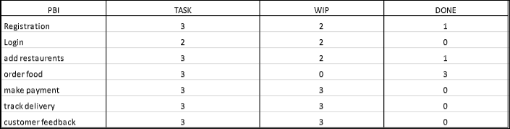

6Q.
Product backlog and sprint back log:
Product back log:
The product backlog is a list that complies all the tasks and user stories that must be done first to complete the whole project.
But it is not just simple task list an effective product backlog breakdown each if the backlog items into a series of steps that help the development the team,
The product backlog shows project tasks and user stories as well as their deadlines, who’s assign to completed them, their priority level and percent completed.

Sprint Backlog:
The sprint backlog is a subset of product backlog. A sprint backlog is list of work items your team plans complete during a project sprint. These items are usually pulled from the product backlog during the sprint planning session. A clear sprint backlog prevents scope creep.
In short the product backlog is ‘’what’’ the project requirements is, while the sprint backlog is the ‘’how’’ specific task for a sprint

7Q what is impediments log? Write 2 impediments

Impediments are barricades, hurdles or obstacles, in terms of scrum, they are blocker that prevent the scrum team from completing work, which in return impact velocity. Anything that prohibits the team from doing work is considered an impediment, examples of scrum impediments are listed in.
The scrum master is responsible for tracking, motoring and ensuring that impediments are removed. All scrum team members are responsible for continually identifying impediments for discussion during the daily standup meeting. If for some reason an impediment does not disappear in a timely manner,
This would indicate that the root cause has not been identified. The sprint retrospective is another place for impediments that reoccur. It is important to understand that the scrum master is not solely responsible for the removal of impediments. The team should work together to remove impediments that can be easily resolved and provide assistance with any additional support that may be required.
Eg: a sick team member, lack of system knowledge.

8Q. Velocity of a team:

Team velocity is a measure of the amount of work a team can handle during a single sprint and is the key metric in scrum. Which means how many complexity points that are completed in a sprint.

9Q. Sprint burn down chart:
The sprint burn down chart makes the work of the team visible. It’s a graphic representation that shows the rate at which work was completed and how much work remains to be done. The chart slopes downward over sprint duration and across story points completed. What makes that completed what makes the chart effective reporting tool is that shows team progress towards the sprint Goal not in terms of time spent but in terms of how much work remains.
If the burn down lines is not tracking downwards by mid-sprint, the team needed quickly implement the emergency procedure pattern. Check- out the slide show below to see an array of burn down warning signs.it is important from the scum scrum master help the team to act early rather than drifting towards sprint failure.

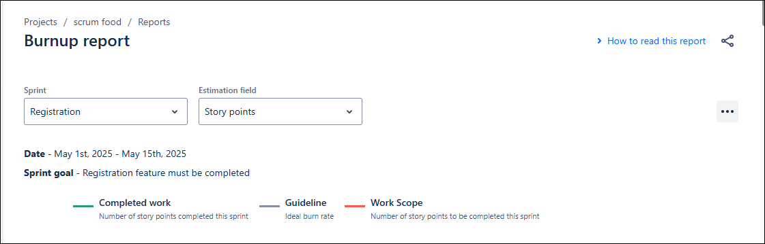
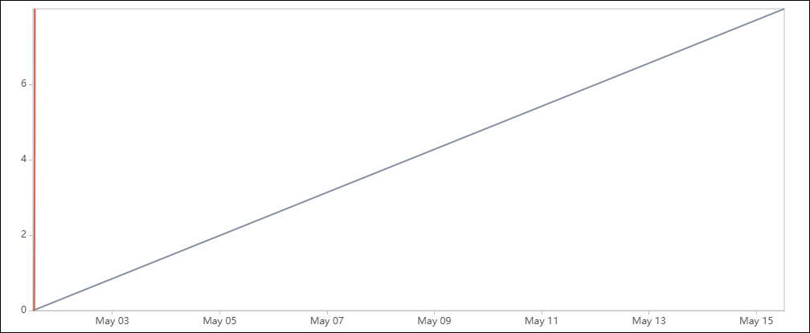
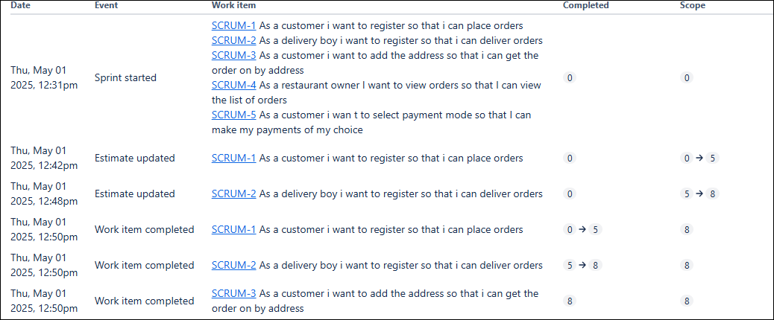

Product Burn down chart:
A product burns down chart collects large amount of data. It represents everything that needs to be completed a product during the specific time requirement agreed upon at the begging of the project.

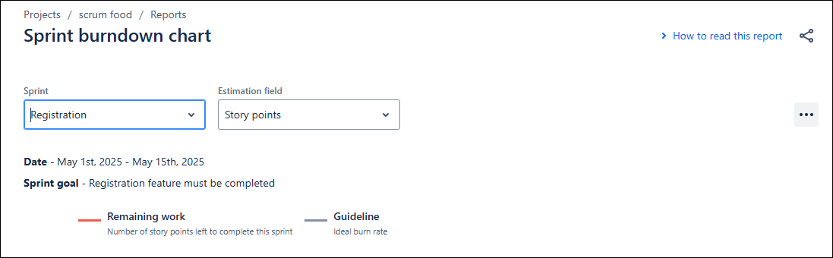
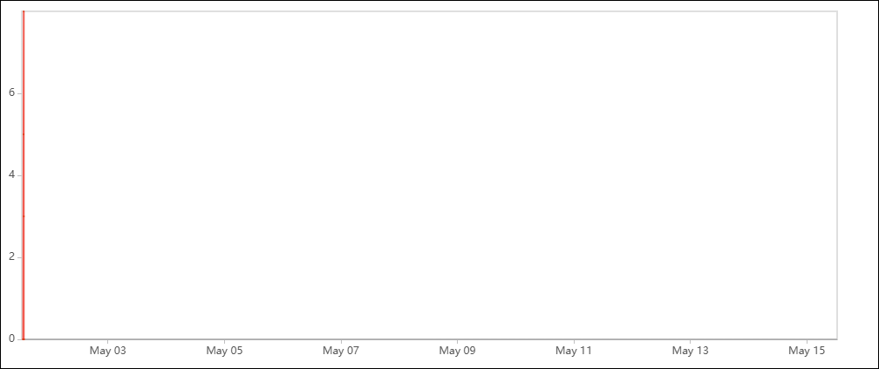
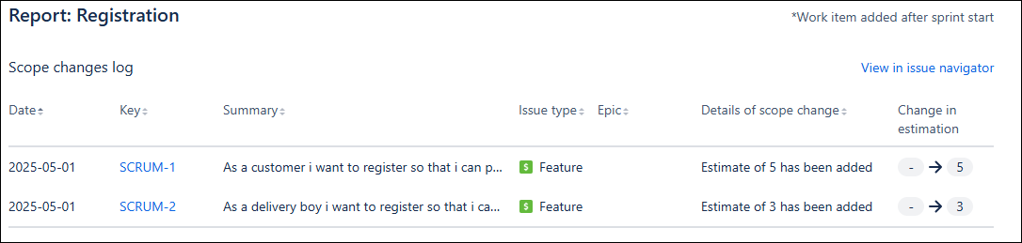

10Q. Product grooming:
Product grooming is the session in which vision or goal of the project is discussed and who will be your target group in which market segment does then product address what are the needs and solutions does the project required. Also what is the benefit that the client will get.

11Q The role of scrum master and product owner:
Scrum master:
The scrum master is the leader of a scrum team and is responsible for championing a project, providing guidance to the development team and product owner, and ensuring all agile practices are followed by team members the scrum master not only addresses all facts of the agile development process but also serves the business, product owner, team and individuals and facilitates communication and collaboration between all these elements.
Scrum Master Responsibilities
1. Leading and coaching the organization in its scrum adoption
2. Planning scrum implementations within the organization
3. Helping employees and stakeholders understand and enact scrum and empirical product development.
4. Causing change that increases the productivity of the scrum team.
Product Owner:
Is a role on a scrum team that is responsible for the project outcome the product owner seeks to maximize a product value by managing and optimizing the product backlog? scrum is an agile software development framework that enables a team to communicate and self-organize
Product Owner Role and Responsibilities:
1 Defining and prioritizing the product backlog (features requirements tasks)
2 ensuring the backlog is up to day refined and aligned with customer needs
3 making decision about product features requirement and trade offs
4 collaborating with stakeholders, customers, and the development team
5 providing clear product vision and goals.

12Q There are four types of scrum meetings held during the scrum process which are as follows.
1. Sprint Planning Meeting
2. Daily Scrum Meeting
3. Sprint Review Meeting
4. Sprint Retrospective Meeting
Sprint Planning Meeting: All the Scrum team will gather before the sprint starts and understand how many user stories, they can develop in 1 sprint (2 weeks), and move them from the product Backlog to the sprint Backlog. They take inputs from Sprint Retrospective meeting.
Daily Scrum Meeting: End of every Scrum, Scrum Developers will participate in Scrum meeting. Here they must answer 3Questions.
a. What task did you work in this scrum?
b. What task will you work on next scrum?
c. Any Challenges/impediments?
When you will complete the user story.
Sprint Review meeting: In Agile project management, a sprint review is an informal meeting held at the end of a sprint, in which the Scrum team shows what was accomplished during this period.
Sprint Retrospective meeting: Only the Scrum Developers will participate and will discuss about Challenges faced and come up with lessons learnt. We can use these lessons learnt in Sprint Planning Meeting to select user stories for the next sprint.

13Q Sprint size and scrum size:
Scrum is a framework that helps teams work together.;
A Scrum team should consist of less than 9 people.
For large enterprise projects, the ideal Scrum team size is 7 people (product owner, scrum master, and 5 developers).
Smaller projects typically consist of four team members (product owner, scrum master, and 2 developers).

Sprint Size
Sprint Length is the defined interval within which the team delivers an incremental workable solution that meets the definition of done. It mostly depends upon user stories.
A Sprint must be long enough to actually complete user stories. It shouldn’t exceed 4 weeks and it is ideal to have 2-week sprints.

14Q Explain DOR or DOD:

The definition of Ready DOR:
The product owner could work together with the team to define an artefact called “the Definition of Ready” (DOR) for ensuring that items at the top of the backlog are ready to be moved into a sprint so that the development team can confidently commit and complete them by the end of a sprint.

Definition of Done: DOD The definition of Done is structured as a list of items, each one used to validate a user story or PBI, which exists to ensure that the Development Team agree about the quality of work they’re attempting to produce. It serves as a checklist that is used to check each Product Backlog Item (aka PBI) or User Story for completeness. Items in the definition of “Done” are intended to be applicable to all items in the Product Backlog, not just a single User Story.

It can be summarized as following:
DOR and DOD are practices that are needed while improving a product. To ensure that the product meets customer expectations, certain features and ideas have to be added to it from time to time, and defining the criteria for the features to be added is absolutely necessary and that's when the DOR and DOD come into play

15Q Prioritization techniques and MVP:

Prioritization of requirements is an important aspect of all software development approaches, but it is especially important in Agile software development.
In essence, we are attempting to discover the user’s priority tasks and rank them accordingly, while also taking into account certain additional characteristics.
For example, we may utilize five priority factors to rank user stories, such as the importance users place on product vision, urgency, time restrictions, technical difficulty, and stakeholder interests. Projects must be correctly prioritized for both the overall project objectives and the individual activities that will fulfil the objectives in order to be successful.
As a result, we address the prioritizing issue on two levels.
Product level: Evaluate which elements of the product might contribute more to the project's major aims.
Tasks level: Specify which work items must be completed and in what sequence during the software product development cycle.
Types of Agile Prioritisation Techniques:
Moscow Agile Prioritization Techniques:
Moscow analysis is a business analyst prioritizing approach. According to this strategy, a collection of needs or user stories should be divided into four categories:
M: Must. Describes a criterion that must be met in the final solution for it to be judged successful.
S: Should. Represents a high-priority component that, if feasible, should be included in the solution. This is frequently a vital criterion, but it can be met in other ways if absolutely required.
C: Could. Describes a criterion that is desirable but not required. If time and resources allow, this will be added.
W: Will not. Represents a demand that stakeholders have decided will not be executed in a particular release but will be addressed in the future.
After categorizing the needs into four groups, they are rated in order of priority within each category.
MVP
(Minimum Viable Product), the Core of the Agile Methodology. An MVP is a concept from agile scrum that refers to a product that has just enough features to satisfy the needs of early customers and, more importantly, give them something to provide feedback on to shape the future of the product.

16Q Difference between Business Analyst and Product Owner
Business Analyst:
- Focus on business needs and requirements
- Analyse business problems and identifies solutions
- 3 work with stakeholders to gather and document requirements
- Often involved project initiation, planning and implementation
- May work on multiple project simultaneously

Product Owner;
1 Focus on product vision, strategy and backlog
2 Responsible for prioritizing and refining product requirements
3 works closely with development team to ensure product delivery
4 Typically dedicated to a single product or team
5 Make decision about product features, requirements, and trade-offs.

BA focuses on business needs while to focuses on product specific requirements.

G.HJKIUYTG
asdfgtyhuj@gmail.com
9897654565

Objective
Motivated and forward-thinking product owner with 3+ years of experience. Eager to support team with leadership and guidance over a wide range of product development efforts. In previous roles reduced the delivery time by20% and was able to coordinate 95% of product completion in line with the company roadmap.

Work Experience
Agile Product, deloitte, Hyderabad 2022
Acted as liaison between business, sales and IT teams to refine the product and incorporate features based on market demands.
Partnered with IT and product leadership to drive and manage the solution development process and ensure the product team understands the direction and vision.
Collaborated with teams to discover and deliver the best solution to the market presented by the product team lead and the business.
Created and maintained the solution vision, roadmap, and backlog of work through the project's life cycle.
Translated features into user stories within the team’s backlog while managing, ranking, and prioritizing this backlog to reflect stakeholder’s requirements.
Key achievement:
Effectively negotiated sprint goals with the team, which resulted in slashing delivery time by 20% in a single quarter.

Scrum Product Owner
Collaborated with stakeholders to understand business problem
Statements and convert them into user stories.
Articulated product vision and user stories in a way clearly understandable to development teams.
Managed backlog of user stories for 2 products simultaneously.
Established user story acceptance criteria and refined stories with Scrum teams.
Created Sprint Release Plans with input from development teams.
Applied Agile methods and processes to promote a disciplined and transparent project management process
Planned and estimated 2-week sprints in a realistic yet time-efficient manner that allowed the teams to deliver 97% of the MVP according to the company roadmap.

Education
B-Tech Computer Science Hyderabad.

Key Skills
Conceptual skill
User-cantered design processed
Design quality standards
Service and product design methodologies
Agile and Scrum
Conducting design sprints
User validation
Analytical skill
Collaboration and teamwork
Communication

