Client Relationship Management & Retention Framework

Prepared by: Nikhil H. Mali
Date: 01 August 2025

Table of Contents
Document Revisions 5
Approvals 5
1. Executive Summary 5
2. Business Goals & Objectives 5
3. Project Scope 6
3.1 In-Scope 6
3.2 Out-of-Scope 6
4. Business Rules, Assumptions & Constraints 6
4.1 Business Rules 6
4.2 Assumptions 6
4.3 Constraints 6
4.4 Risks & Dependencies 7
5. Stakeholder Analysis 7
6. Requirements 7
6.1 Business Requirements (High-level) 7
6.2 Functional Requirements (Summary) 8
7. Non-Functional Requirements (NFRs) 8
8. System Architecture 9
9. Business Process & Onboarding Flow 10
10. Data Model & ERD 11
10.1 Sample Data Dictionary (selected fields) 11
11. UI Wireframes and Key Screens 12
12. User Stories (Selected) 12
13. Test Strategy & QA 12
14. Deployment, Operations & Support 12
15. Acceptance Criteria & Sign-off 12
Appendices 13
A. Acronyms 13
B. Glossary 13
Change Request / Enhancement Backlog 13

Quick Links
Jump to key sections:
Table of Contents
Quick Links
Document Revisions
Approvals
1. Executive Summary
2. Business Goals & Objectives
3. Project Scope
4. Business Rules, Assumptions & Constraints
5. Stakeholder Analysis
6. Requirements
7. Non-Functional Requirements (NFRs)
8. System Architecture
9. Business Process & Onboarding Flow
10. Data Model & ERD
11. UI Wireframes and Key Screens
12. User Stories (Selected)
13. Test Strategy & QA
14. Deployment, Operations & Support
15. Acceptance Criteria & Sign-off
Appendices
Change Request / Enhancement Backlog (Excerpt)

Document Revisions
Date | Version | Change Description
01/08/2025 | 1.0 | Initial consolidated draft integrating BRD and Project Document Package.

Approvals
Project Sponsor: ____________________________________ Date: ____________
Business Owner: ____________________________________ Date: ____________
Project Manager: ____________________________________ Date: ____________

1. Executive Summary
This consolidated document integrates the Business Requirements Document (BRD) and the Project Document Package for the Client Relationship Management & Retention Framework. It captures business goals, scope, requirements (business and functional), non-functional requirements, architecture, data model, processes, UI guidance, testing considerations, deployment and operational guidance.

2. Business Goals & Objectives
Business Goal:
- Implement an end-to-end CRM system to streamline onboarding, automate routine interactions, ensure data integrity, and empower the organisation to retain and grow client relationships with measurable efficiency and satisfaction gains.
Objectives:
- Automate certificate creation and email routing.
- Guarantee data accuracy via validation.
- Reduce turnaround time by ≥ 50%.
- Enhance monitoring/tracking with dashboards and alerts.
- Improve client communication with templated follow-ups.
- Deliver a stable, scalable architecture.
- Execute robust testing (unit, integration, UAT).
- Conduct training and change-management sessions.

3. Project Scope
3.1 In-Scope
- Automated client record creation and certificate issuance.
- Email routing, templated follow-ups and centralized task management.
- Dashboards, alerts and basic analytics for client interactions.
- Data validation rules and migration of existing client data.
- User roles: Admin, Staff, CRM User, Viewer, Support Agent.
- Testing (unit, integration, UAT), training, and change management.
3.2 Out-of-Scope
- Mass marketing campaigns (SMS/Email blasts) - not part of initial delivery.
- Major AI personalization features beyond templated communication.
- Replacing core billing or ERP systems (unless later agreed).

4. Business Rules, Assumptions & Constraints
4.1 Business Rules
- Only validated staff can reserve or modify client records on behalf of a client.
- Administrator roles are permitted to add, modify, or delete certificate templates and client segments.
- System must capture and retain audit logs for all client-related changes.
4.2 Assumptions
- Stakeholders will be available for planned workshops and reviews.
- Existing client data can be exported for migration in acceptable quality.
- Licenses for selected CRM will be procured prior to deployment.
- Client-facing templates and certificate formats are provided by business SMEs.
4.3 Constraints
- Waterfall methodology (phase-gate, minimal overlap).
- Estimated timeline: 6-8 months.
- Budget includes licensing, infra, training and staff costs.
- Dependency on third-party integrations and compliance sign-offs.
4.4 Risks & Dependencies
Key risks and mitigations:
- Potential shifting requirements late in the project — Mitigation: Schedule early data assessment, robust change management, contingency in timeline.
- Data migration complexity and data quality issues — Mitigation: Schedule early data assessment, robust change management, contingency in timeline.
- User resistance to change — Mitigation: Schedule early data assessment, robust change management, contingency in timeline.
- Availability of SME input when needed — Mitigation: Schedule early data assessment, robust change management, contingency in timeline.

5. Stakeholder Analysis
A summary of stakeholders, roles, influence and communication needs (detailed contact list to be appended separately):
- Project Sponsor (Executive Sponsor) — Influence: High — Communication: Monthly steering updates, decision points
- Project Manager (PM) — Influence: High — Communication: Weekly status reports, issue escalation
- Business Analyst (BA) — Influence: High — Communication: Requirements workshops, detailed walkthroughs
- Business Owner (Client Ops Owner) — Influence: High — Communication: Weekly reviews, approvals for business rules
- Developers (Dev Team) — Influence: Medium — Communication: Technical specifications, sprint handovers
- QA Lead (Quality Lead) — Influence: Medium — Communication: Test plans, defect reports
- Change Management Lead (Change Lead) — Influence: Medium — Communication: Training schedules, adoption metrics
- Support Staff / End Users (Customer Service / Support) — Influence: Medium — Communication: Training, user manuals, go-live support

6. Requirements
6.1 Business Requirements (High-level)
BR-001 (High): Automate certificate creation and email routing for client onboarding and renewals.
BR-002 (High): Guarantee client data accuracy via validation rules and duplicate checks.
BR-003 (High): Reduce turnaround time for onboarding and certification issuance by ≥50%.
BR-004 (High): Centralised email and task management with reminders and ticketing.
BR-005 (Medium): Dashboards and alerts for monitoring client status and SLA breaches.
BR-006 (Medium): Support 2x current client volume without performance degradation.
BR-007 (Medium): Conduct training and change management for users.
6.2 Functional Requirements (Summary)
FR-001: Certificate Automation — System shall generate certificates automatically when onboarding completed or renewal triggered.
FR-002: Data Validation & Duplicate Detection — System shall validate mandatory fields and run duplicate checks during record creation/migration.
FR-003: Workflow & Task Management — System shall create tasks and reminders for follow-ups and SLA events.
FR-004: Email Routing & Templates — Incoming/outgoing client emails shall be stored in CRM and associated with client record.
FR-005: Dashboards & Alerts — Provide dashboards for SLAs, outstanding tasks, and certificate status.

7. Non-Functional Requirements (NFRs)
- Availability: 99.0% uptime (monthly).
- Performance: Page load times under 2 seconds for 95% of transactions; API latency under 500ms under normal load.
- Scalability: System must scale horizontally for web tier and vertically for DB as needed; support 2x current client volume.
- Security: Encryption at rest (AES-256) and in transit (TLS 1.2+). RBAC and audit logging.
- Backup & Recovery: Daily backups. RTO = 4 hours, RPO = 1 hour.
- Compliance & Audit: Audit log retention 7 years.
- Usability & Accessibility: WCAG 2.1 AA where applicable.

8. System Architecture
The architecture follows a web frontend connecting to a backend API that orchestrates workflows, template engine, database, and integrations (Email Gateway, SSO, 3rd-party cert service, BI/Reporting). Refer to the included architecture diagram for details.
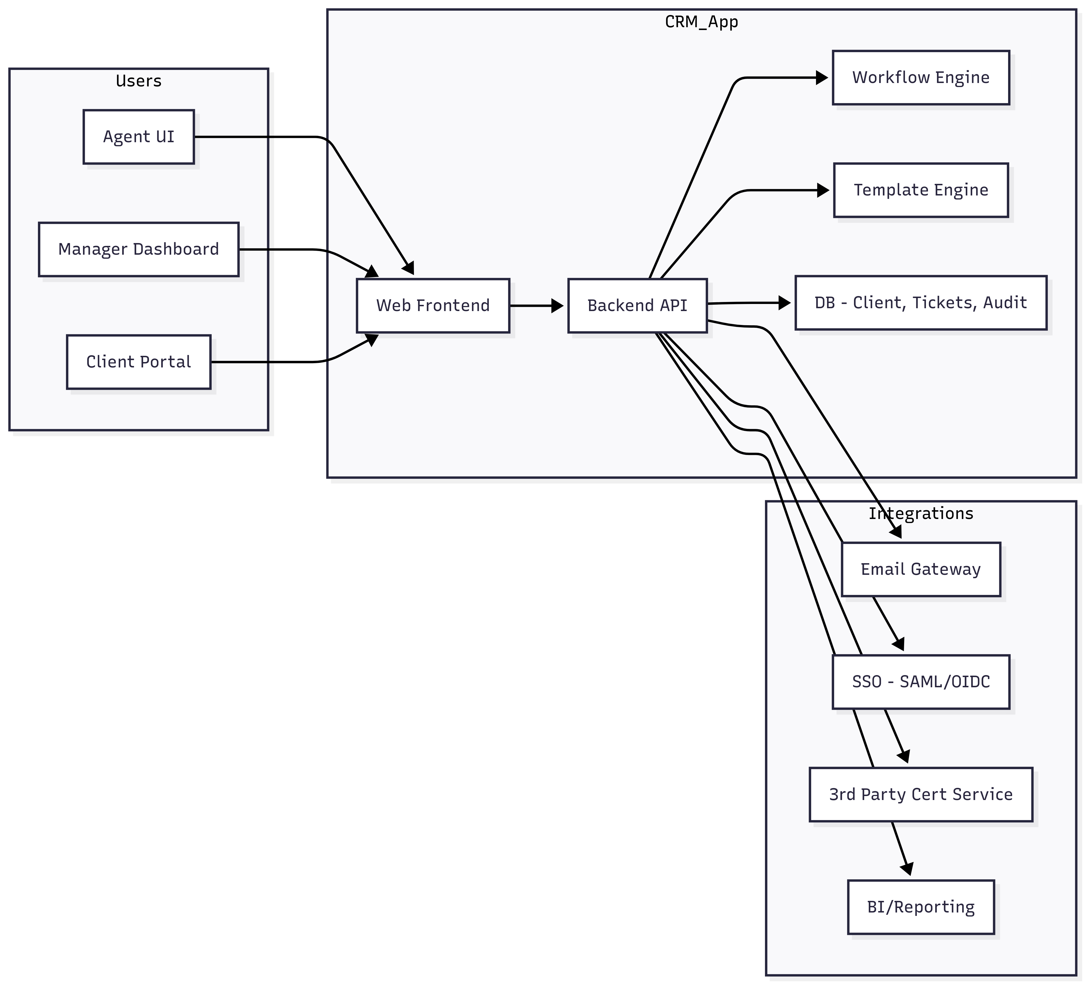
Figure: High-level system architecture (Web Frontend, Backend API, Integrations).

9. Business Process & Onboarding Flow
This section documents the client onboarding process (AS-IS and TO-BE). The TO-BE automated flow includes intake, validation, verification (manual or automatic), certificate generation via template engine, delivery via email & portal, record updates, SLA task generation and ticket closure.
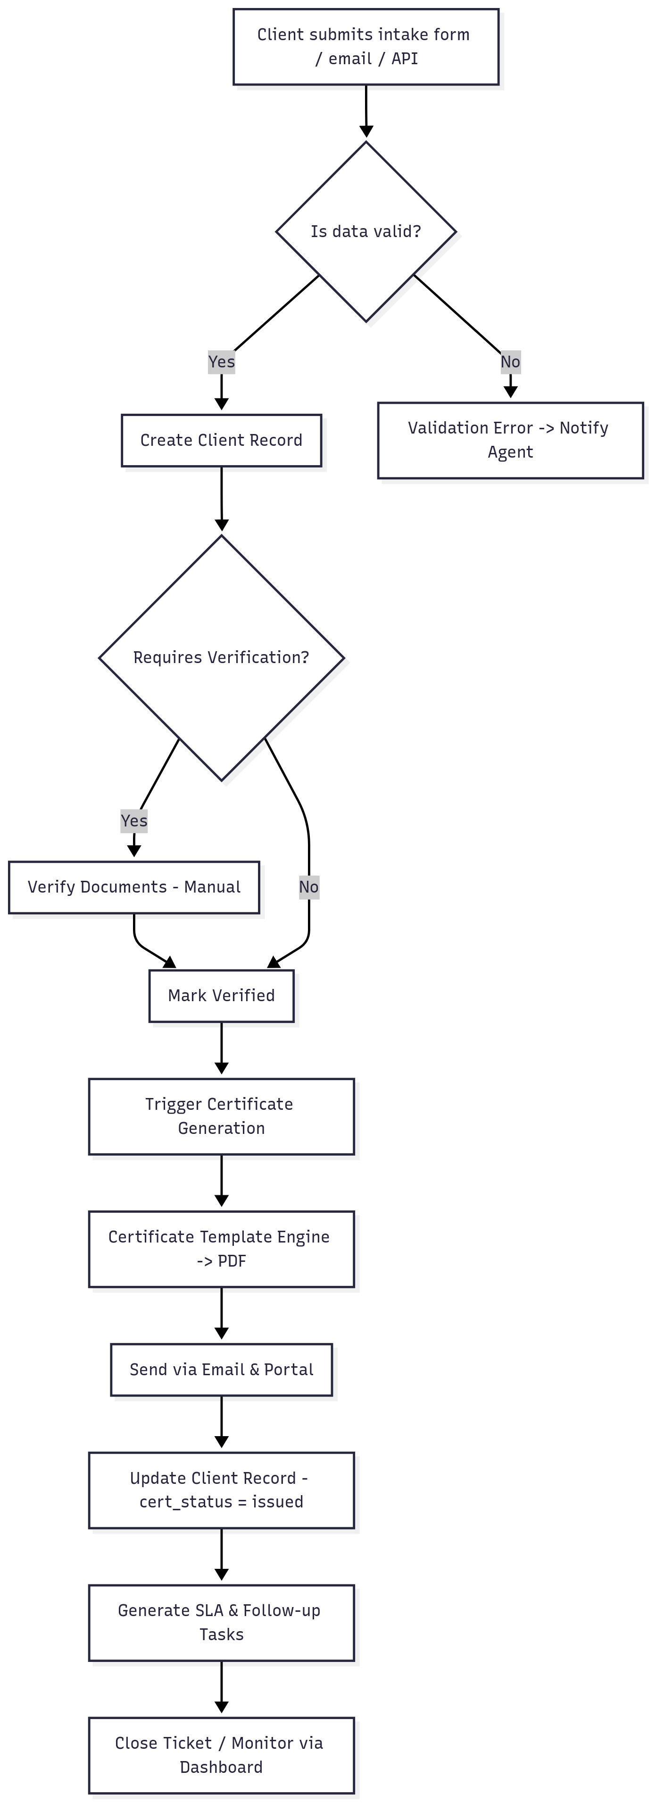
Figure: Client Onboarding Flow (decision points, verification, certificate generation, delivery and closure).

10. Data Model & ERD
Core entities: Client, Ticket, Certificate, User, Template, AuditLog, EmailThread, Task.
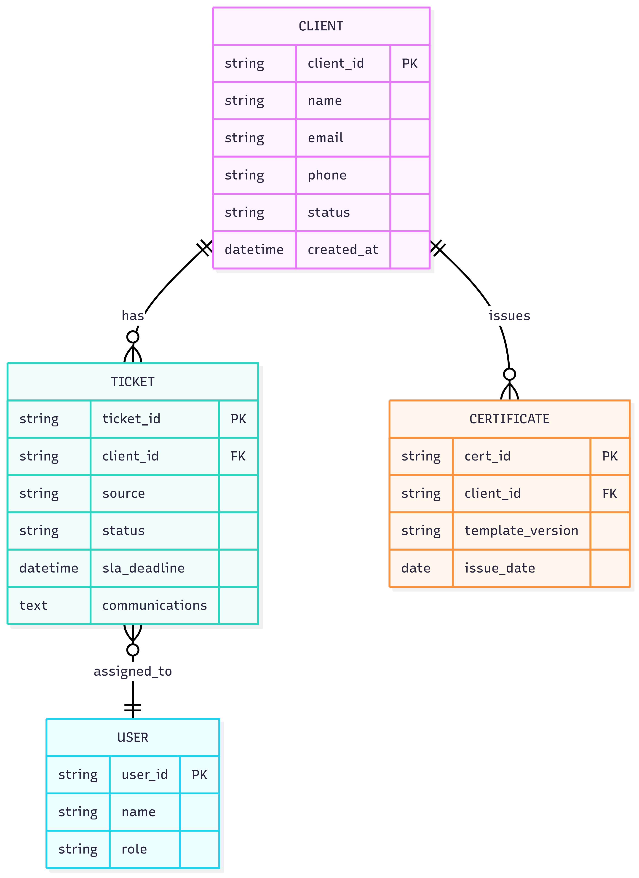
Key data model notes and sample attributes (see data dictionary below).

Figure: Entity Relationship Diagram—Client, Ticket, Certificate and User relationships.

10.1 Sample Data Dictionary (selected fields)
Entity | Field | Type | Notes
Client | client_id | string/uuid | PK — primary customer record
Client | name | string
Client | email | string | Indexed; unique constraint
Ticket | ticket_id | string/uuid | PK
Ticket | client_id | string/uuid | FK -> Client
Certificate | cert_id | string/uuid | PK
Certificate | client_id | string/uuid | FK -> Client
User | user_id | string/uuid | PK
AuditLog | event_id | string/uuid | PK — immutable audit trail

11. UI Wireframes and Key Screens
- Dashboard: Widgets for SLA summary, pending tasks, expiring certificates, recent interactions; Quick actions for Create Client, Issue Certificate, Search.
- Client Onboarding Form: Sections for Basic info, Address, Identification, Document upload, Validation messages; buttons for Save Draft, Submit, Run Duplicate Check.
- Certificate Issuance Screen: Select client, template, preview, issue & email options, history log.
- Email & Task Center: Inbox view, ticket creation, client timeline, quick replies using templates.
- Admin - Template Management: Create/Edit templates, versioning, preview, assign permissions.

12. User Stories (Selected)
US-001: As a staff user I want to create a new client record so that I can register a client. Acceptance: Mandatory fields validated; duplicate check runs.
US-010: As a system I want to auto-generate certificates on onboarding completion so that issuance is automated. Acceptance: PDF generated, emailed, audit log entry created.
US-020: As a support agent I want to view all client emails in context so I can respond accurately. Acceptance: Email threads associated with client.

13. Test Strategy & QA
Testing approach: Unit, Integration, System, UAT and Regression testing. Key test artifacts include test cases, test summary report and QA sign-off.
Sample test cases map to BR and FR IDs. See attached Test Case repository for full details.

14. Deployment, Operations & Support
Deployment model and runbook: CI/CD pipelines for application code, DB migration scripts, backup and rollback procedures. Monitor availability, performance and SLAs using APM and monitoring tools.
Support model: Tiered support; incident templates and problem reports included in the project package.

15. Acceptance Criteria & Sign-off
Key acceptance criteria: Functional coverage per SRS, NFR thresholds met (availability, performance), training completion and UAT sign-off by Business Owner. Sign-off template included in the package.
Appendices

A. Acronyms
- CRM: Client Relationship Management
- SLA: Service Level Agreement
- UAT: User Acceptance Testing
- RBAC: Role Based Access Control
- NFR: Non-Functional Requirement

B. Glossary
- Client: Primary customer record used in the system.
- Certificate: Issued PDF artifacts associated with a client that may be delivered by email or portal.
Change Request / Enhancement Backlog
CR-001: Add bulk import templates — CSV import wizard for bulk client upload with mapping.
CR-002: Additional certificate fields — Add metadata fields to certificate for regulatory tracking.

