Q1: Minimum 20 functional requirements

Ans: Functional requirements: Functional requirements specify what the system should do, the tasks it should perform, or the services it should provide

Functional Requirements

Req ID | Req Name | Req Description
FR0001 | Farmer Registration | Farmers should be able to register with the application by providing personal, contact, and farm details.
FR0002 | Farmer Login/Authentication | Farmers must be able to securely log in using username/password or OTP.
FR0003 | Company Registration | Fertilizer, seed, and pesticide companies should be able to register and create their company profiles.
FR0004 | Company Product Management | Companies should be able to add, edit, or delete their products (fertilizers, seeds, pesticides).
FR0005 | Product Categorization | Products should be categorized by type (fertilizer, seed, pesticide) and sub-category (organic, hybrid, etc.).
FR0006 | Product Search | Farmers should be able to search for products using keywords, category, or brand.
FR0007 | Product Filtering & Sorting | Farmers should be able to filter products by price, rating, brand, and location, and sort results accordingly.
FR0008 | Product Details View | Farmers should be able to view detailed product information such as price, description, quantity, and reviews.
FR0009 | Add to Cart | Farmers can add selected products to a virtual shopping cart.
FR0010 | Order Placement | Farmers should be able to place orders and choose a payment method (online, COD, UPI).
FR0011 | Order Tracking | Farmers should be able to track the status of their orders (Processing, Shipped, Delivered).
FR0012 | Order History | Farmers should be able to view their previous orders and invoices.
FR0013 | Payment Gateway Integration | The system should integrate with secure payment gateways for online transactions.
FR0014 | Communication Module | Farmers and Companies can exchange messages or queries related to products or orders.
FR0015 | Review & Rating System | Farmers can rate and review purchased products and sellers.
FR0017 | Inventory Management | Companies should be able to manage and update product stock levels in real-time.
FR0018 | Notification System | The system shall send notifications (email/SMS) to users for registration, order updates, and promotions.
FR0019 | Report Generation | Admin can generate reports (sales, top products, farmer activity).
FR0020 | Multi-language Support | The application should support multiple regional languages for farmers in remote areas.

Non functional requirements: Non-functional requirements describe the system’s quality, performance, and operational characteristics.

Req ID | Req Name | Req Description | Priority
NFR0101 | Page Loading Time | Each page should load within 2 seconds under standard network conditions. | 9
NFR0102 | WCAG 2.1 Compliance | The system must meet Web Content Accessibility Guidelines WCAG 2.1 for accessibility. | 9
NFR0103 | Security & Data Privacy | All sensitive user data must be encrypted during storage and transmission. | 9
NFR0104 | Availability | The system should maintain 99.5% uptime during business hours. | 8
NFR0105 | Scalability | The system should support up to 100,000 concurrent users without performance degradation. | 8
NFR0106 | Browser & Device Compatibility | The application must be compatible with major browsers and Android/iOS mobile devices. | 8
NFR0107 | Backup & Recovery | Data backup should occur daily, and recovery should be possible within 2 hours of a system failure. | 8
NFR0108 | Localization | The system must support multiple regional languages and currencies. | 7

Question 2–Minimum 5 page designs

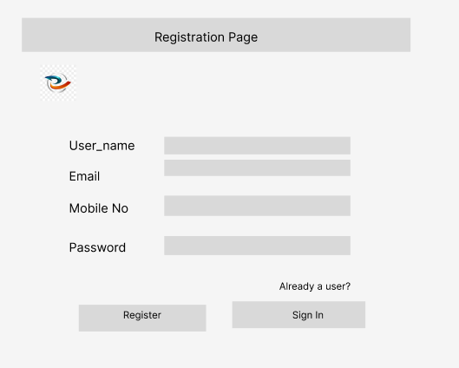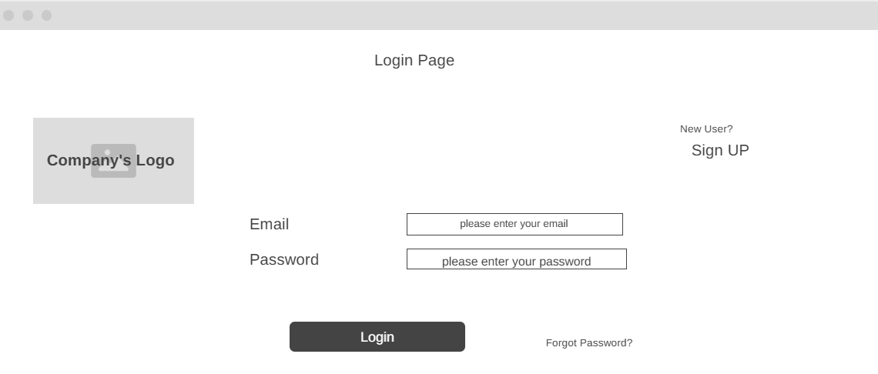

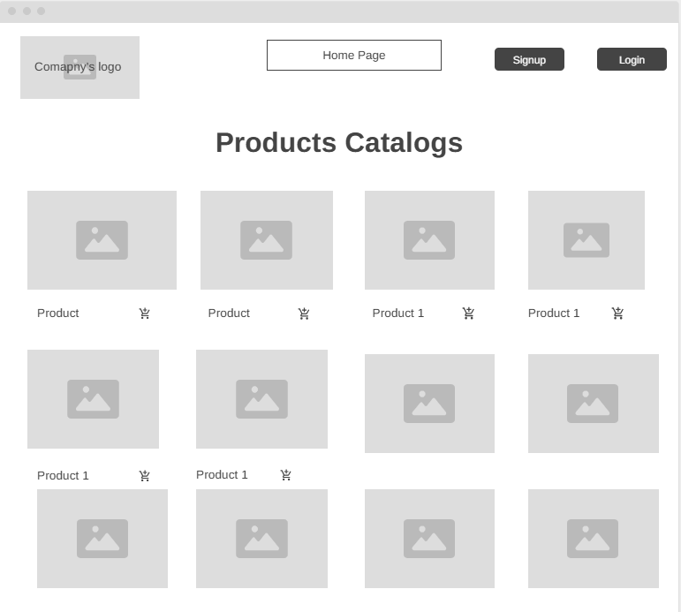

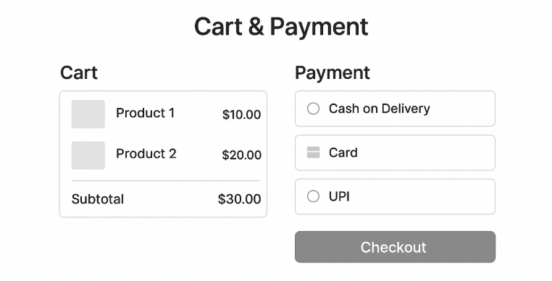

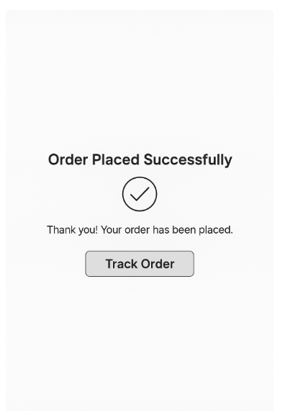

Q3: Tools Used (MS Visio, Balasmiq)

Ans: Microsoft Visio:
MS Visio was used to create all UML diagrams such as Use Case Diagrams, Activity Diagrams, and Sequence Diagrams. It provides professional templates and standardized UML notations, making it easier to visually represent system interactions, user flows, and functional relationships in a structured way.
Balsamiq:
Balsamiq was used for designing low-fidelity wireframes and mockups. It helped in quickly sketching the layout and structure of the web application pages such as the homepage, product catalog, and payment page. The simple, hand-drawn style made it ideal for early-stage brainstorming and stakeholder discussions.
Draw.io:
Draw.io was utilized for creating process-related diagrams like Data Flow Diagrams (DFDs) and Activity Diagrams. It is a versatile online tool that allows collaborative diagramming and helps in representing data movement, workflows, and logical processes effectively.
Figma:
Figma was used to develop high-fidelity, realistic UI prototypes for the web application. It allowed creating visually appealing, interactive screen designs that closely resembled the final product. Figma’s collaborative interface made it easy to share prototypes with stakeholders and gather feedback efficiently.
dbdraw.io:
dbdraw.io was employed for designing the Database Schema and Entity-Relationship (ER) Diagrams. It is specifically built for database modeling, allowing clear representation of entities, attributes, and relationships. This helped in understanding data flow and storage structure within the application.

Q4: RTM

Ans: It is a document or tool used to track the requirements throughout the project lifecycle, ensuring that all requirements defined for a system are implemented and tested.

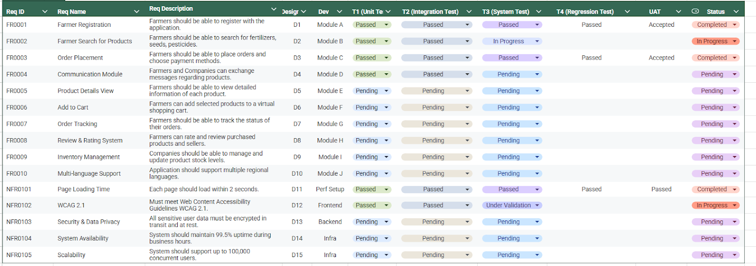

Q5: Test Documents:

Ans:
Test Case 1 – Farmer Registration

Test Case ID: TC001
Requirement ID: FR0001
Description: Verify successful farmer registration in the application.
Pre-Conditions: User has internet access; Registration page is loaded.
Test Steps:
- Navigate to the registration page.
- Enter valid personal details (name, contact, farm details).
- Enter valid email and password.
- Click "Register."
Expected Result: Farmer account created; confirmation email sent.
Actual Result:
Status:
Remarks:
Test Case 2 – Farmer Login

Test Case ID: TC002
Requirement ID: FR0001
Description: Verify that a registered farmer can successfully log in.
Pre-Conditions: Farmer is already registered.
Test Steps:
- Navigate to the login page.
- Enter registered email and password.
- Click "Login."
Expected Result: Farmer redirected to the dashboard.
Actual Result:
Status:
Remarks:
Test Case 3 – Search Products

Test Case ID: TC003
Requirement ID: FR0002
Description: Verify farmers can search for fertilizers, seeds, and pesticides.
Pre-Conditions: Farmer is logged in; Products exist in the system.
Test Steps:
- Navigate to the "Search Products" page.
- Enter a keyword (e.g., "fertilizer").
- Click "Search."
Expected Result: Relevant product list displayed.
Actual Result:
Status:
Remarks:
Test Case 4 – Product Details View

Test Case ID: TC004
Requirement ID: FR0005
Description: Verify that the farmer can view detailed product information.
Pre-Conditions: Product exists in the system; Farmer is logged in.
Test Steps:
- Click on a product from search results.
- Check for product details: price, description, stock, reviews.
Expected Result: All product details display correctly.
Actual Result:
Status:
Remarks:
Test Case 5 – Add to Cart

Test Case ID: TC005
Requirement ID: FR0006
Description: Verify that the farmer can add a product to the cart.
Pre-Conditions: Farmer is logged in and product exists.
Test Steps:
- Navigate to a product page.
- Click "Add to Cart."
- Check the cart for the added item.
Expected Result: Product successfully added to the cart.
Actual Result:
Status:
Remarks:
Test Case 6 – Order Placement

Test Case ID: TC006
Requirement ID: FR0003
Description: Verify that the farmer can place an order using a valid payment method.
Pre-Conditions: Items are in the cart; Payment gateway is functional.
Test Steps:
- Navigate to the cart.
- Click "Checkout."
- Enter payment details.
- Click "Place Order."
Expected Result: Order successfully placed; confirmation displayed.
Actual Result:
Status:
Remarks:
Test Case 7 – Order Tracking

Test Case ID: TC007
Requirement ID: FR0007
Description: Verify that the farmer can track the status of their order.
Pre-Conditions: Farmer has placed an order.
Test Steps:
- Go to "My Orders."
- Click "Track Order" for a specific order.
Expected Result: Current order status displayed (Processing/Shipped/Delivered).
Actual Result:
Status:
Remarks:
Test Case 8 – Page Loading Time

Test Case ID: TC008
Requirement ID: NFR0101
Description: Verify pages load within 2 seconds under standard network conditions.
Pre-Conditions: Application deployed; standard internet connection.
Test Steps:
- Navigate to the homepage.
- Measure page load time using browser tools.
Expected Result: Page loads in ≤2 seconds.
Actual Result:
Status:
Remarks:
Test Case 9 – WCAG 2.1 Compliance

Test Case ID: TC009
Requirement ID: NFR0102
Description: Verify that the system meets WCAG 2.1 accessibility standards.
Pre-Conditions: Application is accessible.
Test Steps:
- Check text contrast, alt text for images, and tab navigation.
- Use a screen reader to navigate pages.
Expected Result: All accessibility criteria pass.
Actual Result:
Status:
Remarks:
Test Case 10 – Multi-language Support

Test Case ID: TC010
Requirement ID: FR0010
Description: Verify that the application supports multiple regional languages.
Pre-Conditions: Language files exist for supported languages.
Test Steps:
- Navigate to settings.
- Change the application language.
- Verify all pages reflect the selected language.
Expected Result: All pages display correctly in the chosen language.
Actual Result:
Status:
Remarks:
Roles in the Testing Process

This document outlines the responsibilities of various roles involved in the software testing lifecycle.

1. Business Analyst (BA)
- Responsibilities:
  - Clearly understand and document both functional and non-functional requirements.
  - Develop a Requirements Traceability Matrix (RTM) to link requirements with corresponding test cases.
  - Ensure Quality Assurance (QA) teams have a clear understanding of requirements to facilitate comprehensive test case coverage.
- Test Case Involvement: BAs may create high-level or functional test scenarios but typically do not write detailed, step-by-step test cases.
2. QA/Test Analysts / QA Engineers
- Responsibilities:
  - Develop detailed Test Case Documents, which include:
    - Test Case ID
    - Requirement ID
    - Test Steps
    - Expected Result
    - Pre-Conditions
    - Post-Conditions
  - Execute test cases and accurately record actual results.
  - Report any identified defects to the development team.
- Primary Contributor: QA/Test Analysts are primarily responsible for the preparation, execution, and maintenance of test cases.
3. Developers
- Test Case Involvement: Developers generally do not prepare test cases. However, they are responsible for writing unit tests and may develop automated test scripts for their own code.
4. UAT (User Acceptance Testing)
- Participants: Business Users / Stakeholders
- Responsibilities:
  - Verify that the system effectively meets all defined business requirements.
  - Execute UAT test cases, which are based on scenarios prepared by the BA or QA team.
-----Summary of Roles:
- BA: Provides clarity on requirements; may draft high-level test scenarios.
- QA/Test Analysts: Create detailed test cases, execute tests, and report defects.
- Developers: Conduct unit testing.
- Business Users: Perform User Acceptance Testing.

Q6 – DB Design and ER Diagrams

Ans: DB Schema Diagram:

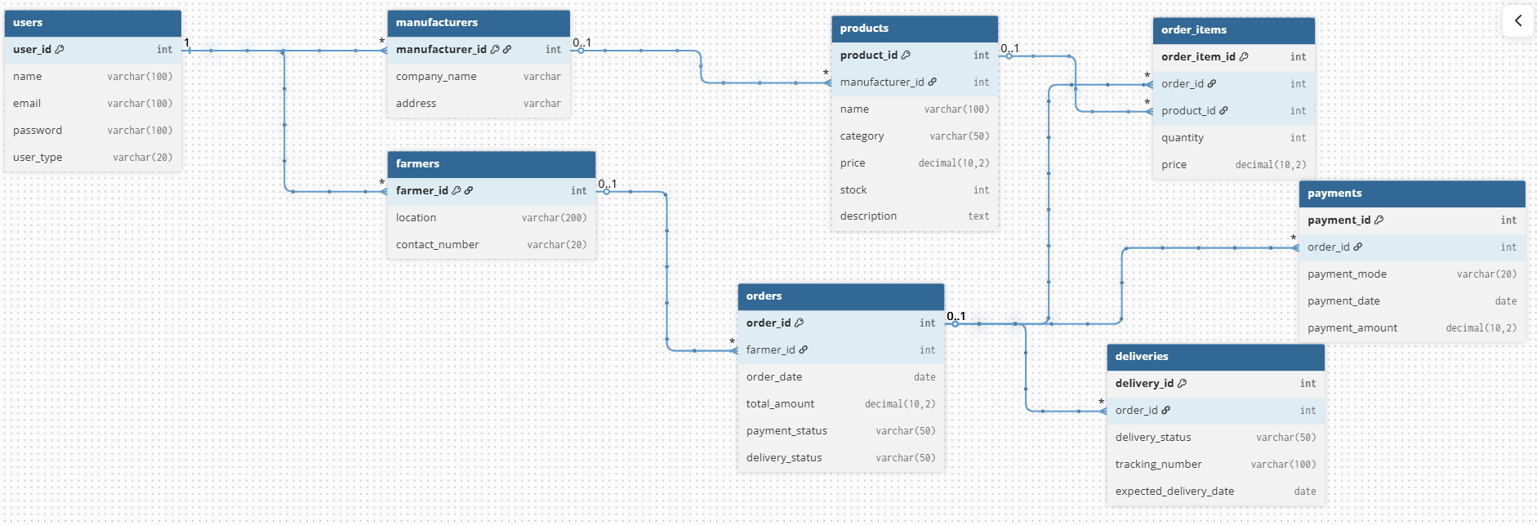

ER Diagrams:
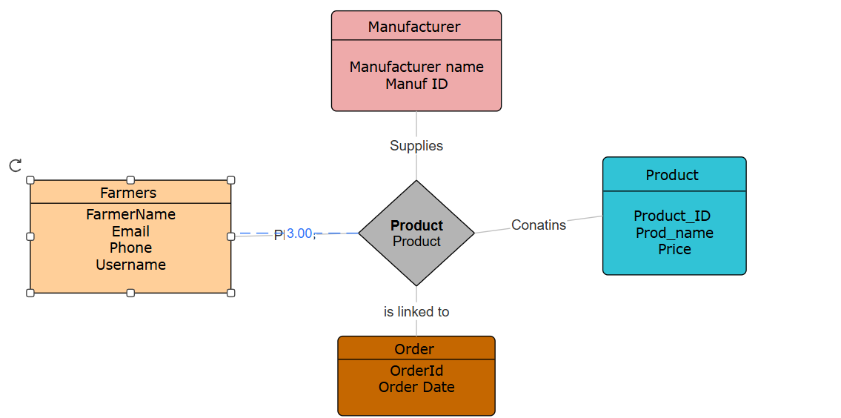

Q6 – Data Flow Diagram
Ans:
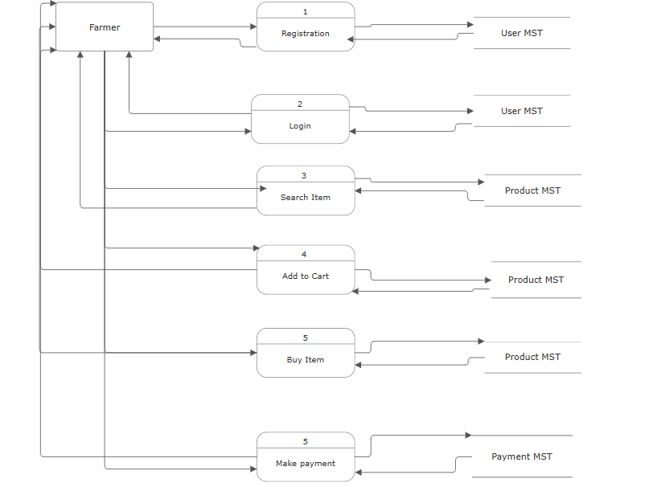

Q8: Change Request management
Ans::
1. Identify the Change
- Trigger: Government announces new taxation rules that affect product pricing or invoices.
- Impact: All modules related to orders, payments, billing, reports may be affected.
- Action: Document the exact change requested. For example: “Update the tax calculation logic to comply with the new GST rates effective from [date].”
2. Submit a Formal Change Request
- Prepare a Change Request Form (CRF):
  - Change ID: Unique identifier (e.g., CR001)
  - Description: Explain the tax change and affected modules
  - Reason: Government mandate / compliance
  - Priority: High (mandatory compliance)
  - Requested By: Stakeholder or business owner (Mr. Henry)
  - Impact Assessment: Preliminary impact on timeline, cost, resources
3. Impact Analysis
- Conduct an impact analysis with the project team:
  - Functional Impact: Update tax calculation, order summary, invoice generation
  - Non-Functional Impact: Database changes, performance (calculation speed)
  - Stakeholders Impacted: Farmers, Companies, Accounting team, QA, Delivery team
  - Timeline Impact: Additional development and testing time
4. Review and Approval
- Present the CR to the Change Control Board (CCB) or project governance:
  - Discuss risks, benefits, timeline, cost, and resource allocation
  - Decide approve / reject / defer
5. Update Requirements
- Once approved, update:
  - Requirements Document: Add new or updated tax rules
  - RTM (Requirements Traceability Matrix): Link the change to impacted modules/test cases
  - Test Cases: Add scenarios for new tax calculation, invoice validation
6. Plan Implementation
- Assign tasks to developers:
  - Update backend tax calculation logic
  - Update frontend invoice display
  - Modify reporting module to reflect new taxes
- Update project timeline and resources in the project plan
7. Testing
- QA team executes test cases for tax calculation changes
- Perform regression testing to ensure no other features are broken
- UAT: Farmers and companies can verify invoices and reports
8. Deployment and Communication
- Deploy changes to production
- Communicate the new taxation structure to all users (farmers, companies) via:
  - Notification in the app
  - Email or SMS alerts
  - Updated documentation/manuals
9. Document Lessons Learned
- Record:
  - How the change was handled
  - Risks encountered
  - Time and cost impact
  - Recommendations for future government-related changes
Tips for Managing Change Requests Effectively
- Always formalize change requests — don’t implement ad-hoc.
- Use a Change Log to track all requests and their status.
- Prioritize changes based on business impact and compliance needs.
- Maintain clear communication with all stakeholders.
- Ensure testing and validation before deploying critical changes.

Change Request Form (CRF)
Field | Details / Instructions
Change Request ID | CR001 (Unique ID for each request)
Date Submitted | [DD/MM/YYYY]
Submitted By | [Name of stakeholder, e.g., Mr. Henry]
Project Name | Online Agriculture Product Store
Description of Change | Clearly describe the change requested. Example: “Update tax calculation logic in the application to comply with the new government taxation structure effective from [date].”
Reason for Change | Explain why the change is required. Example: “Mandatory compliance with new government tax regulations.”
Priority | High / Medium / Low (e.g., High for compliance-related changes)
Modules / Areas Impacted | List affected modules. Example: Orders, Invoice Generation, Reporting, Payment Processing
Impact on Timeline | Estimated additional time required (e.g., 2 weeks for development and testing)
Impact on Cost | Estimated additional cost, if any
Impact on Resources | List additional resources required (developers, QA, etc.)
Functional Impact | Describe what functionalities will be updated or added
Non-Functional Impact | Performance, security, or usability changes (if any)
Risk Assessment | Identify risks if the change is not implemented or if implemented incorrectly
Proposed Solution / Implementation | Describe how the change can be implemented. Example: “Update tax calculation module, modify invoice template, and update reporting queries.”
Testing Required | QA / Regression / UAT
Approval Status | Pending / Approved / Rejected
Approved By | [Name of Change Control Board / Project Manager]
Date of Approval | [DD/MM/YYYY]
Comments / Notes | Any additional remarks

Q9: Change Request Vs Enhancement

Ans: . Definition
Change Request
- A change request is a modification to the project scope, requirements, or deliverables that is typically required due to external factors, errors, or compliance.
- Examples:
  - Government tax structure changes.
  - Fixing a critical bug that affects compliance.
  - Correcting a requirement that was misunderstood or missing.
Enhancement
- An enhancement is an improvement or addition to the product that was not part of the original scope.
- It is generally optional and aimed at adding value or new features for users.
- Examples:
  - Adding a rating system for products.
  - Introducing a crop auction system for farmers.
  - Adding advanced analytics to the dashboard.
2. Analyze Ben and Kevin’s Request

Request Details:
- Farmers should be able to sell their crop yields through the application.
- Introduce an Auction system for crop yields.
Observation:
- These functionalities were not part of the original project scope, which was focused on farmers buying fertilizers, seeds, and pesticides.
- There is no regulatory requirement or error correction driving this request; it’s a new value-added feature.
Conclusion:

This request is an Enhancement, not a Change Request.3. How to Respond as a BA
- Acknowledge the request:
  - “Thank you for your suggestion. This is a valuable feature to increase farmer engagement and revenue.”
- Document it formally:
  - Create an Enhancement Request Document (ERD) with details of the feature:
    - Functional Description: Farmers can list crops, buyers can purchase via auction.
    - Potential impact on UI, database, payments, notifications, etc.
- Assess impact:
  - Resources: Development, testing, database changes.
  - Timeline: Likely an extension of project delivery.
  - Cost: Additional development cost.
- Communicate with stakeholders:
  - Since this is an enhancement, it may need approval from the steering committee or Mr. Henry for inclusion in the current project.
  - Decide whether to:
    - Include in current project phase (if budget/time allows)
    - Move to next phase or future release
- Update documentation:
  - Maintain a separate Enhancement Log.
  - Update Requirements Traceability Matrix (RTM) if approved.

✅ Key Point:

Criteria | Change Request | Enhancement
Driven by | External mandate / error correction | Optional improvement / new feature
Scope impact | Usually critical | Usually optional or value-added
Approval urgency | High | Medium / business priority
Example | Tax structure change | Farmers selling crops, auction system

Q10: Estimations
Ans: The total effort estimation for developing the Online Agriculture Products Store is based on standard SDLC (Software Development Life Cycle) phases — considering scope, team size, and an 18-month project duration as per the case study.

Assumptions:
- Project Duration: 18 months (78 weeks)
- Working Days per Month: 22
- Working Hours per Day: 8
- Total Team Members (Active Core Team): 8 members
  - 1 Project Manager
  - 1 Business Analyst
  - 1 Senior Developer
  - 3 Developers
  - 1 Tester
  - 1 Database Administrator

Summary
- Total Estimated Effort: ~4200 Manhours
- Duration: 18 Months
- Average Team Size: 8 Members
- Estimated Budget: ₹2 Crores (as per CSR allocation)
Q11: UAT
Ans:
Handling Client Testing (UAT – User Acceptance Testing)
As a BA, my role is to coordinate, facilitate, and document the UAT process. Steps

Step 1: Prepare for UAT
- Review Requirements: Make sure all functional and non-functional requirements are captured in the RTM (Requirements Traceability Matrix).
- Prepare UAT Plan:
  - Define scope of UAT.
  - List all features and enhancements (e.g., farmer registration, product search, crop listing, auction system).
  - Prepare UAT schedule with client.
  - Identify resources (client users, internal support team).
- Prepare Test Scenarios & Scripts: Ensure all scenarios are derived from the RTM.
Step 2: Facilitate UAT
- Kick-off Meeting: Introduce the client to UAT process, objectives, and timelines.
- Provide Access: Give client access to the application in a UAT environment.
- Support Client Testing:
  - Guide them on how to execute test cases.
  - Take feedback on defects, usability issues, or missing functionality.
- Document Results: Maintain a UAT defect log for all issues reported.
Step 3: Handle Feedback
- Categorize issues as:
  - Critical / Blocker: Must be fixed before go-live.
  - Minor / Cosmetic: Can be fixed post-launch if agreed.
- Coordinate with development and testing teams to fix defects.
- Retesting: Ensure defects are resolved and verified by the client.
Step 4: Obtain Sign-off
- Once client confirms that all requirements are met and the system is working as expected:
  - Prepare UAT sign-off document.
  - Get formal approval/signature from the client.
- This acts as confirmation that the system is ready for production.

Q12: Project Closure Document
Ans::
Purpose of Project Closure Document
- Confirms the project is complete.
- Records lessons learned for future projects.
- Provides formal acceptance from the client.
- Ensures all deliverables, documentation, and resources are accounted for.
- Acts as a reference for audits or organizational knowledge.

2. Key Components of a Project Closure Document
Section | Description
Project Summary | Brief overview of the project, including objectives, scope, and key milestones.
Deliverables | List of completed deliverables (e.g., Online Agriculture Product Store, crop listing module, auction system, UAT reports).
Achievements | Highlights of project successes, key metrics (on-time delivery, requirements fulfilled, client satisfaction).
Pending Issues / Open Items | Any unresolved issues, defects, or enhancements deferred to future releases.
Lessons Learned | Insights from the project that can improve future projects (e.g., challenges in remote user testing, enhancements suggested).
Client Acceptance | Formal confirmation from the client that the system meets requirements (UAT sign-off).
Financial Closure | Summary of project budget, expenses, and approvals if applicable.
Resource Release | Confirmation that team members and other resources have been released.
Supporting Documents | References to RTM, design docs, test cases, deployment manuals, training material, and UAT reports.
Approval Signatures | Signatures from Project Manager, Business Analyst, Client, and other key stakeholders to formalize closure.
3. Benefits of a Project Closure Document
- Formal Acceptance: Confirms that the client agrees the project is complete.
- Accountability: Ensures all team members and stakeholders acknowledge deliverables.
- Knowledge Management: Captures lessons learned for future projects.
- Audit Trail: Acts as proof for compliance, audits, or legal requirements.
- Smooth Transition: Helps transition to maintenance/support teams with all relevant information.

