- Agile Manifesto
Ans There are four mail values and twelve principles of Agile software
- Individual and interactions over processes and tools
- Working software over comprehensive documentation
- Customer collaboration over contract negotiation
- Responding to change over following a plan
Twelve principles
- Satisfy the customer through early and continuous delivery of valuable software.
- Welcome changing requirements, even late in development. Agile processes harmless change for the customer’s competitive advantage.
- Deliver working software frequently, from a couple of weeks to a couple of months, with a preference to the shorter timescale.
- Business people and developers must work together daily throughout the project.
- Build projects around motivated individuals. Give them the environment and support they need, and trust them to get the job done.
- The most efficient and effective method of conveying information to and within a development team is face to face conversion.
- Working software is the primary measure of progress.
- Agile processes promote suitable development. The sponsors, developers and user should be able to maintain a constant pace indefinitely.
- Continuous attention to technical excellence and good design enhances agility.
- Simplicity—the art of maximizing the amount of work not done – is essential.
- The best architectures, requirements, and design emerge from self-organizing teams.
- At regular intervals, the team reflects on how to become more effective, then tunes and adjusts its behaviour accordingly.

- Write 40 User Story
Ans User story is s short or simple description of future from the end user point of view. There is particular format to write the User story. AS A, I WANT TO, SO THAT.
User Story No: 1 | Tasks: 2 | Priority: HIGH
AS A CUSTOMER

I WANT TO REGISTER TO THE APP

SO THAT I CAN ORDER THE FOOD

BV: 500 | CP: 1
Acceptance Criteria:

Registration screen
Text boxes for User name, Password, Mobile number, Email address, Phone number
Click on Register Button.
Send successful Notification to the user

User Story No: 2 | Tasks: 1 | Priority: HIGH
AS A RESTAURANT OWNER

I WANT TO VIEW THE ORDERS

SO THAT I CAN PREPARE FOOD AND SEND TO THE CUSTOMERS

BV: 1000 | CP: 2
Acceptance Criteria :

Registration screen
Text boxes for User name, Password, Mobile number, Email address, Phone number
Click on Register Button.
Send successful Notification to the user

View Order and List will be displayed.

User Story No: 3 | Tasks: 3 | Priority: LOW
AS A CUSTOMER

I WANT TO SEE THE LIST OF COUPONS ADDED TO MY ACCOUNT

SO THAT I CAN GET THE DISCOUNTS WHILE ORDERING.

BV: 50 | CP: 3
Acceptance Criteria:

Log in to the account, go to vouchers and coupons section, List of coupons added to your accounts will be displayed.

User Story No: 4 | Tasks: 2 | Priority: 1
AS A CUSTOMER

I WANT TO MAKE A PAYMENT

SO THAT I CAN GET MY ORDER AT A DOOR STEP

BV: 1000 | CP: 100
Acceptance Criteria :

Select the items and go to payment gateway, there will be all modes of payment will be displayed, select any one of them and make the payment.

User Story No: 5 | Tasks: 1 | Priority: HIGHEST
AS A DELIVERY BOY

I WANT TO REGISTER TO THE APP

SO THAT I CAN VIEW THE ORDER LISTS

BV: 1000 | CP: 5
Acceptance Criteria :

Registration screen
Text boxes for User name, Password, Mobile number, Email address, Phone number
Click on Register Button.
Send successful Notification to the user

User Story No: 6 | Tasks:2 | Priority: MEDIUM
AS A DELIVERY BOY

I WANT TO VIEW THE RESTAURANT ADDRESS

SO THAT I CAN ACCEPT THE ORDER AND MAKE THE DELIVERY

BV: 20 | CP: 1
Acceptance Criteria:

Go to orders, click on view restaurant details

User Story No: 7 | Tasks:3 | Priority: MEDIUM
AS A DELIVER BOY

I WANT TO KNOW THE CUSTOMERS ADDRESS

SO THAT I CAN DELIVER THE FOOD TO THE CORRECT LOCATION

BV: 50 | CP: 5
Acceptance Criteria:

Go to orders, click on customers details

User Story No: 8 | Tasks:1 | Priority: MEDIUM
AS A CUSTOMER

I WANT TO TRACK AN ORDER

SO THAT I CAN EXPECT AT WHAT TIME I CAN GET THE FOOD

BV: 100 | CP: 3
Acceptance Criteria:

Go to order details, track order

User Story No: 9 | Tasks:2 | Priority: HIGH
AS A CUSTOMER

I WANT TO KNOW THE DELIVERY BOY DETAILS

SO THAT I CAN CONNECT WITH HIM AT ANY POINT OF TIME

BV: 500 | CP: 2
Acceptance Criteria:

Go to orders, go to order details, track order details: Name, phone number

User Story No: 10 | Tasks: 1 | Priority: LOW
AS A DELIVERY BOY

I WANT TO KNOW HOW MANY AMOUNT/ POINTS ADDED TO MY ACCOUNT

SO THAT I CAN ESTIMATE MONTHLY INCOME
BV: 200 | CP: 1
Acceptance Criteria:

Account details, monthly income or points gained displayed

User Story No: 11 | Tasks: 4 | Priority: LOW
AS A DELIVERY BOY

I WANT TO VIEW FEEDBACK

SO THAT I CAN IMPROVE MORE
BV: 10 | CP: 1
Acceptance Criteria:

Account, view feedback

User Story No: 12 | Tasks: 2 | Priority: MEDIUM
AS A CUSTOMER

I WANT TO LOGOUT THE APP

SO THAT I CAN LOGIN WHENEVER NEEDED
BV: 10 | CP: 2
Acceptance Criteria:

Go to settings, logout

User Story No: 13 | Tasks: 3 | Priority: HIGH
AS A BUSINESS OWNER

I WANT TO VIEW ISSUES

SO THAT I CAN SATISFY THE OWNERS AND CUSTOMERS

BV: 50 | CP: 6
Acceptance Criteria:

Go to account, setting, issues. List of issues will be displayed.

User Story No: 14 | Tasks: 1 | Priority: HIGHEST
AS A BUSINESS OWNER

I WANT TO MAKE PAYMENT TO RESTAURANT OWNERS AND DELIVERY BOYS

SO THAT THEY WILL GET THE PAYMENT ON TIME
BV: 1000 | CP: 100
Acceptance Criteria:

Settings, account, payments- Owners and delivery boys, view the total amount and make the payment

User Story No: 15 | Tasks: 2 | Priority: MEDIUM
AS A ADMIN

I WANT TO VIEW CUSTOMER FEEDBACK

SO THAT I CAN GET WHETHER THEY ARE SATISFIED WITH THE SERVICE.
BV: 200 | CP: 7
Acceptance Criteria:

Settings, feedbacks, customers feedback will be viewed

User Story No: 16 | Tasks: 3 | Priority: MEDIUM
AS A CUSTOMER

I WANT TO CANCEL ORDER

SO THAT I CAN GET MY MONEY BACK

BV: 50 | CP: 10
Acceptance Criteria:

Orders, cancel order, notification will be received

User Story No: 17 | Tasks: 4 | Priority: LOWER
AS A CUSTOMER

I WANT TO VIEW THE LIST OF ORDER HISTORY

SO THAT I CAN GET IDEA ON RESTAURANT

BV: 10 | CP: 1
Acceptance Criteria:

Settings, account, orders history

User Story No: 18 | Tasks: 2 | Priority: MEDIUM
AS A CUSTOMER

I WANT TO GIVE THE RATING TO THE RESTAURANT

SO THAT PEOPLE WILL GET AN IDEA ON THEIR SERVICE

BV: 50 | CP: 5
Acceptance Criteria:

Once the order is delivered, go to restaurant and give the rating on the foods and submit.

User Story No: 20 | Tasks: 3 | Priority: LOW
AS A CUSTOMER

I WANT TO GIVE RATING TO THE DELIVERY BOY

SO THAT HE GETS GOOD REVENUE

BV: 10 | CP: 5
Acceptance Criteria:

Once the order is delivered, go to orders, give rating to delivery boy, you will get to see 5 starts, give the starts and submit

User Story No: 21 | Tasks: 2 | Priority: LOW
AS A RESTAURANT OWNER

I WANT TO ADD TIMINGS AND CLOSE TIMING IN THE APP

SO THAT CUSTOMERS WILL GET TO KNOW THE ITEMS WHICH ARE OUT OF STOCK

BV: 100 | CP: 4
Acceptance Criteria:

Settings, add timings on particular menu then save

User Story No: 22 | Tasks: 2 | Priority: LOW
AS A RESTAURANT OWNER

I WANT TO ADD RESTAURANT CLOSE TIMINGS

SO THAT CUSTOMERS WILL GET TO KNOW BEFORE ORDERING
BV: 100 | CP: 4
Acceptance Criteria:

Setting, account, timings, update restaurant close timing

User Story No: 23 | Tasks: 3 | Priority: MEDIUM
AS A RESTAURANT OWNER

I WANT TO VIEW ORDER

SO THAT I WILL PACK THE ITEMS AND GIVE TO DELIVERY BOY

BV: 20 | CP: 2
Acceptance Criteria:

Go to orders, items ordered

User Story No: 24 | Tasks: 1 | Priority: HIGH
AS A RESTAURANT OWNER

I WANT TO VIEW REVENUE GENERATED FROM SCRUM FOODS

SO THAT I CAN GET HOW MUCH MONEY EARNED FROM THIS APP

BV: 10 | CP: 1
Acceptance Criteria:

Setting, Account, list of revenue generated, view the total amount

User Story No: 25 | Tasks: 3 | Priority: MEDIUM
AS A RESTAURANT OWNER

I WANT TO KNOW LIST OF DELIVERIES DONE FOR THE DAY

SO THAT I CAN CALCULATE THE REVENUE FOR THE DAY

BV: 100 | CP: 2
Acceptance Criteria:

Settings, account, deliveries done.

User Story No: 26 | Tasks: 2 | Priority: LOWER
AS A RESTAURANT OWER

I WANT TO KNOW HOW TO RAISE ISSUES

SO THAT GOING FORWARD IF I GET ANY ISSUES I CAN RAISE AND TAKE THE SOLUATION

BV: 10 | CP: 2
Acceptance Criteria:

Go to settings, raise issue, write the issue and submit

User Story No: 27 | Tasks: 3 | Priority: MEDIUM
AS A REGIONAL ADMIN

I WANT TO KNOW HOW MANY REFUNDS HAPPENED

SO THAT I CAN MAKE THE NECESSARY PAYMENTS

BV: 200 | CP: 7
Acceptance Criteria:

Go to settings, accounts, refunds, total amount of refunds.

User Story No: 28 | Tasks: 4 | Priority: MEDIUM
AS A RESTAURANT OWNER

I WANT TO APPROVE/REJECT ONCE THE ORDER IS PLACED

SO THAT I CAN UPDATE THE CUSTOMER WHETHER IT IS ACCEPTED OR NOT

BV: 50 | CP: 3
Acceptance Criteria:

Notification will appear, click on that and if you want to accept- accept it or else reject.

User Story No: 29 | Tasks: 5 | Priority: LOW
AS A REGIONAL ADMIN

I WANT TO KNOW THE PAYMENT MADE TO REGIONAL RESTAURANT
SO THAT I CAN GUESS THE REVENUE

BV: 5 | CP: 2
Acceptance Criteria:

Go to settings, Revenue generated to regional restaurants.

User Story No: 30 | Tasks: 2 | Priority: MEDIUM
AS A DELIVERY BOY

I WANT TO LOGOUT

SO THAT THE ADMINS GET TO KNOW THAT HE LOGGED OUT FOR THE DAY

BV: 100 | CP: 4
Acceptance Criteria:

Go to settings, account, logout

User Story No: 31 | Tasks: 3 | Priority: MEDIUM
AS A DELIVERY BOY

I WANT TO RAISE ISSUES

SO THAT IF I GET ANY CHALLENGES, I CAN RAISE ISSUE

BV: 50 | CP: 3
Acceptance Criteria:

Go to account, settings, Raise Issue save

User Story No: 32 | Tasks: 4 | Priority: LOW
AS A REGIONAL ADMIN

I WANT TO LOGOUT

SO THAT I CAN USE THE APP EFFECTIVELY

BV: 20 | CP: 1
Acceptance Criteria:

Go to settings, logout

User Story No: 33 | Tasks: 1 | Priority: HIGH
AS A DELIVERY BOY

I WANT TO CANCEL THE ORDER

SO THAT I CAN AVOIDE MORE TRAVELLING

BV: 200 | CP: 100
Acceptance Criteria:

Setting, cancel order, cancel

User Story No: 34 | Tasks: 3 | Priority: HIGH
AS A CUSTOMER

I WANT TO VIEW RESTAURANT MENU

SO THAT I CAN ORDER WHATEVER I WANT

BV: 500 | CP: 100
Acceptance Criteria:

Click on the required restaurant name, to go menu, View the menu from there

User Story No: 35 | Tasks: 1 | Priority: HIGH
AS A REGIONAL ADMIN

I WANT TO LOGIN

SO THAT I CAN TRACK THE STATUS, CUSTOMER FEEDBACK ETC

BV: 1000 | CP: 50
Acceptance Criteria:

Registration screen
Text boxes for User name, Password, Mobile number, Email address, Phone number
Click on Register Button.
Send successful Notification to the user

User Story No: 36 | Tasks: 4 | Priority: MEDIUM
AS A REGIONAL ADMIN

I WANT TO VIEW REGIONAL REVENUE

SO THAT I CAN ALLOCATE THE REVENUE TO THE MEMBERS

BV: 500 | CP: 5
Acceptance Criteria:

Application screen, settings, Allocation, revenue allocation

User Story No: 37 | Tasks: 2 | Priority: HIGH
AS A BUSINESS OWNER

I WANT TO VIEW REPORTS

SO THAT I CAN TAKE ACTION AND MAKE EASY APPLICATION
BV: 500 | CP: 7
Acceptance Criteria:

Go to settings, reports, list of reports will be viewed

User Story No: 38 | Tasks: 1 | Priority: HIGH
AS A BUSINESS OWNER

I WANT TO UPDATE PAYMENT FOR RESTAURANT OWNERS AND DELIVERY BOY

SO THAT THEY GET THEIR SALARY ON TIME

BV: 1000 | CP: 8
Acceptance Criteria:

Settings make payments, make payments to restaurant owners , make payment to delivery boy, search by their name and restaurant names, total the amount, make the payment.

User Story No: 39 | Tasks: 5 | Priority: MEDIUM
AS A BUSINESS OWNER

I WANT TO LOGOUT

SO THAT I CAN USE THE APP WHENEVER NEEDED

BV: 200 | CP: 2
Acceptance Criteria:

Settings, logout

User Story No: 40 | Tasks: 1 | Priority: HIGH
AS A RESTAURANT OWNER

I WANT TO VERIFY DELIVERY BOY

SO THAT I CAN DELIVER THE FOOD TO CORRECT PERSON

BV: 200 | CP: 1
Acceptance Criteria:

Setting, list of delivery boys, allotted delivery boy, verify, if verification successfully done, send the food.

- What is epic?
Ans Epic is a large requirement that is too big to complete in as single sprint. Epic will be broken down into multiple user stories and those related user stories we call it as Epic.
As a Customer, I want to browse restaurants, select food items, place an order and get it delivered to my location so that I can enjoy food conveniently without visiting the restaurant.
As a delivery boy, I want to receive delivery request, navigate to restaurants and customers and update delivery status so that I can efficiently deliver orders and earn income.

- What is the Difference between BV and CP.
Ans
BV | CP/ Story points
BV is how important is this feature to the business | CP effort or technical challenge involved in implementing that feature.
Why are we doing it – return on investment | How hard is it to do – the amount of work or risk involved
Measured by currency notes (10,20,50,100,500) | Measured by Fibonacci series (default two numbers 0 and 1)

- Explain about Sprint
Ans It is a fixed period of time usually 1 to 4 weeks during which scrum team works to complete a specific set of tasks or user story from the product backlog. Sprint will have a sub unit known as Scrum Day= 1 day.
- Explain product backlog and sprint backlog
Ans Product Backlog-
A product backlog is a list of everything that needs to be done to make the final product successful for the entire project like, new features, bug fixing, technical work, research work etc. It is managed by the Product owner. These items are prioritised, so that the important features are done first.
Sprint Backlog-
The sprint back log is a smaller list taken from the product backlog. It includes only the items that the team plans to complete in the current sprint. It is done by the development team. The team selects items from the product backlog at the start of each sprint and then breaks them into smaller tasks to work on every day.

- What is impediments log? Write 2 impediments.
Ans It is list of where the scrum master records all the issues, obstacles that stops the them from the making progress, that is known as an impedimental log. The scrum master is responsible for this impedimental log.
Ex- Login is not responsible
After selecting all items from the restaurant payment is not happening

- Explain Velocity of the Team
Ans Velocity is a measure of how much work a scrum team can complete during a single sprint. It is calculated based on the number of story points completed in a sprint.
Velocity= Total Story points completed in a sprint

9.Draw sprint burn down chart and product burn down chart
Ans 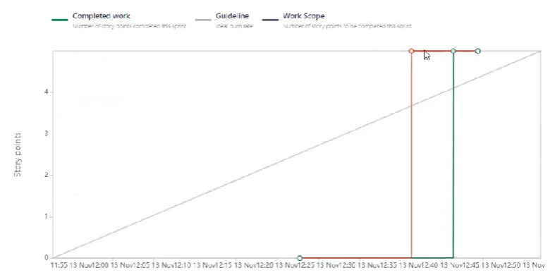
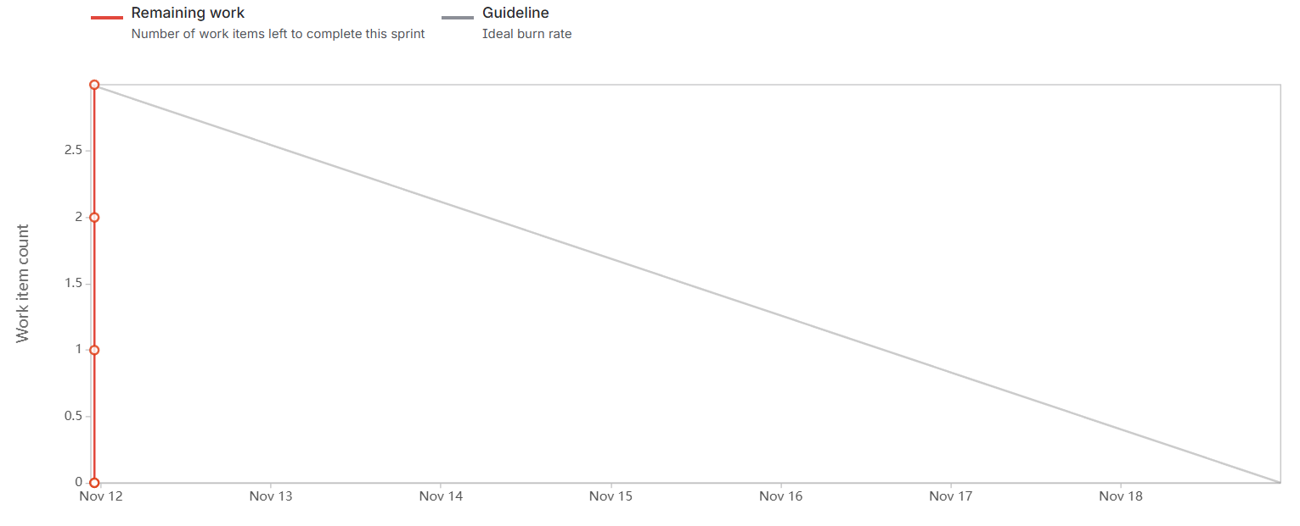

10. What is product grooming
Ans Product Grooming is where the product owner and Scrum team review and update the product backlog to keep it clean, organized and ready for future sprints.

11. Explain the role of scrum master and product owner
Ans Scrum master- Scrum master is the one who understands and apply the scrum principles. He is the one who identifies the impediments and resolve the impediments. He facilitates sprint planning, daily scrum, sprints review and sprint retrospective.
Product Owner- Product owner defines the product vision clearly to the scrum team and manages the product backlog, prioritize tasks based on the business needs. He will write user stories and define acceptance criteria.

- Explain all meeting conducted in the scrum project
Ans Sprint planning- Held at the start of each sprint. The team plains what work will be done in the upcoming sprint and tells the sprint goal.
Daily scrum- A short meeting usually 15 mins held every day to discuss progress, plans for the day and any problems faced.
Sprint Review- Conducted at the end of the sprint. The team shows what they have built to the product owner and stakeholders to get feedback.
Sprint Retrospective- Held after sprint review. The tell discuss on what went well, what didn’t and how to improve in the next sprint.
Product grooming- Product Grooming is where the product owner and Scrum team review and update the product backlog to keep it clean, organized and ready for future sprints.

- Explain sprint size and scrum size.
Ans Sprint size will be usually between 1 to 4 weeks. It is a time period in which the scrum team works to complete a set of tasks or user stories.
Scrum size means number of members in the scrum team. And they are, 1 Product Owner, 1 Scrum Master, 8 Developers.

- Explain DOR and DOD.
Ans DOR- Definition Of Ready- It means the set of conditions that a user story must meet before the team starts working on it.
DOD- Definition Of Done- It ensures that the work is fully finished, tested and meets quality standards before it is delivered.
- Explain Prioritization technique and MVP.
Ans Prioritization means deciding which features or a task should be done first based on their importance, value and urgency.
MVP- Minimum Viable Product- It is the simplest version of a product that has just enough features to be usable by customers and to collect real feedback for improvement.

16.Difference between Business Analyst and Product owner.
Ans
Product Owner | Business analyst
He owns product vision and decides what to do build | He analysis the requirements and defines how to build it
Manages and prioritize the product backlog | Gather documents and analyse requirement
He is involved throughout the product lifecycle | He will be present mostly in planning and analysis stages.
He deliveries product backlog, sprint goals, product vision | He delivers, requirement documents, use cases etc
What and Why to build | How to build it clearly

- Prepare a sample resume of 3 year’s experience Product Owner
Ans
XYZ
xyz@gmail.com
9876543290
Career Objective
I have 3 years of experience in scrum. I can manage product backlogs, product vision and deliver valuable solutions. I can work with different teams to match business goals with customer needs and I ensure timely and high quality delivery.
Professional Summary
3 years of experience as a product owner in software company.
Strong understanding of scrum
Experience in user story creation
Skilled in tools like Jira, Azure
Professional Experience
ABC technologies pvt.ltd.
Responsibilities
Manage product backlog Worked with scrum master and development team
Conducted sprint review meeting and gathered feedback
Personal Details
Language English, Hindi, Kannada
DOB 09/11/1995
Declaration
I here by declare that the above information is true to the best of my knowledge.
Signature
xyz

