BA Mock – 04
Assignment – 01

- Business requirement document



Contents:
1.Document Revisions……………………………………………………………………………………………………1
2.Approvals……………………………………………………………………………………………………………………1
3.RACI Chart…………………………………………………………………………………………………………………...2
Codes used for RACI Chart…………………………………………………………………………………………...2
4.Introduction………………………………………………………………………………………………………………...3
4.1 Business Goals……………………………………………………………………………………………………….3
4.2 Business Objective………………………………………………………………………………………………….3
4.3 Business Rules………………………………………………………………………………………………………...3
4.4 Background……………………………………………………………………………………………………………...3
4.5 Project Objective………………………………………………………………………………………………………3
4.6 Project Scope……………………………………………………………………………………………………………4
4.6.1 In-Scope Functionality……………………………………………………………………………………...4
4.6.2 Out-Scope Functionality…………………………………………………………………………………...5
5.Business Process Overview……………………………………………………………………………………………...5
5.1 Current State Analysis (As-Is) ………………………………………………………………………………5
5.2 Future State / Proposed Solution (To-Be) ……………………………………………………………5
6.Business Requirement……………………………………………………………………………………………………….6
7.Assumptioms…………………………………………………………………………………………………………………….7
8. Constraints……………………………………………………………………………………………………………………….7
9.Risks…………………………………………………………………………………………………………………………………8
Technological risks……………………………………………………………………………………………………………8
Skill risk……………………………………………………………………………………………………………………………8
requirement risk………………………………………………………………………………………………………………8
Business risk……………………………………………………………………………………………………………………8
Other risk………………………………………………………………………………………………………………………8
10.Business rules…………………………………………………………………………………………………………………9
11.Appendices………………………………………………………………………………………………………………………9
1. Document Revisions

Date | Version Number | Document Changes
08/02/2025 | 0.1 | Initial Draft
16/02/2025 | 1.1 | Updated targeted dates

- Approvals
Role | Name | Title | Signature | Date
Project Sponsor | Mr. Jackson | Executive Stakeholder
Business Owner | Mr. Amo | Strategic Business Lead
Project Manager | Miss. Emily | Delivery & Operations Manager
System Architect | Mr. Mario | Technical Architecture Lead
Development Lead | Mr. Lucky | Software Engineering Manager
User Experience Lead | Miss. Lucy | UX/UI Design Head
Quality Lead | Mr. Sam | QA & Testing Manager
Content Lead | Mr. Max | Content Strategy Manager

- RACI Chart for This Document

RACI Chart:

Name | Position | * | R | A | S | C | I
Miss. Emily | Project Manager |  | * | * |  |  | *
Mr. Yash | Business Analyst |  | * |  | * | * | *
Miss. Mindy | Senior Developer |  |  | * | * |  | *
Mr. Jack | Sponsor |  |  | * |  |  | *

Codes Used in RACI Chart
* Authorize document. | Has ultimate signing authority for any changes to the
R Responsible | Responsible for creating this document.
A Accountable | Accountable for accuracy of this document  (for example, the project manager)
S Supports  document | Provides supporting services in the production of this
C Consulted | Provides input (such as an interviewee).
I Informed | Must be informed of any changes.

4. Introduction / Overview
4.1 Business Goals

- Ensure real-time tracking and management of inventory across all manufacturing plants and warehouses.

- Enable the fastest and most cost-efficient delivery of ice-cream and milk products to customers.

- Reduce wastage due to product expiry by maintaining optimum stock levels.

- Provide actionable insights through data analytics and reporting.

4.2 Business Objectives

- Automate manual inventory processes to minimize errors and delays.

- Integrate order management with warehouse and logistics operations.

- Implement route optimization to guarantee quickest delivery to end customers.

- Build a scalable platform that supports future expansion to new regions.

4.3 Business Rules

- All perishable items must be dispatched based on FIFO (First In, First Out).

- Stock levels must always meet the minimum safety threshold defined for each product.

- Orders should be assigned to the nearest warehouse with available stock.

- Delivery commitments must adhere to agreed SLAs (e.g., same-day delivery for metro areas, 2-day delivery for non-metro).

4.4 Background

- The company currently manages inventory and deliveries through semi-manual processes involving spreadsheets and phone-based coordination. This has led to inefficiencies, delayed deliveries, stockouts, and higher operational costs. With increasing demand and geographic expansion, a centralized digital platform is needed to streamline inventory management and optimize logistics.

4.5 Project Objectives
- Efficient Inventory Management – Implement a centralized system to track raw materials, finished goods, and stock levels across all manufacturing plants and warehouses in real-time.
- Optimized Delivery Operations – Enable route planning and order allocation to ensure the fastest possible delivery of ice-cream and milk products to customers.
- Demand Forecasting & Reporting – Provide analytics and reporting tools to predict demand patterns, reduce wastage of perishable goods, and support business decisions.
- Seamless Integration & Scalability – Develop a scalable solution that integrates with existing ERP/CRM systems and can expand as the company grows across new regions.
4.6 Project Scope
4.6.1 In-Scope Functionality
- Inventory Management – Real-time stock tracking at plants and warehouses.
- Order Management – Capture, process, and track customer orders.
- Delivery Optimization – Route planning for quickest delivery to customers.
- Warehouse Operations – Stock transfer, replenishment, and warehouse-level reporting.
- Dashboard & Reporting – Sales, stock, and delivery performance reports.
- User Management – Role-based access for Admin, Plant Manager, Warehouse Manager, and Delivery Staff.

4.6.2 Out-of-Scope Functionality
- Integration with Third-party ERPs – Not included in initial release.
- Mobile Application for Customers – Limited to internal users only for Phase 1.
- Payment Gateway Integration – Only delivery tracking, no online payments.
- Predictive Analytics/AI Forecasting – Advanced analytics excluded from scope.
- International Operations – System limited to domestic plants and warehouses.
- Marketing/CRM Features – Customer engagement campaigns not part of the scope.
5.Business Process Overview
5.1 Current State Analysis (As-Is)
- Manual Inventory Tracking – Inventory across plants and warehouses is tracked through spreadsheets or legacy systems, leading to errors and delays.
- Lack of Real-Time Visibility – Stock levels, expiry dates, and production outputs are not updated in real-time, making it hard to plan supply and demand.
- Delayed Deliveries – Delivery planning is manual, often not optimized for the fastest routes or nearest warehouses, resulting in longer delivery times.
- Poor Demand Forecasting – No integrated system to analyze seasonal or regional demand patterns, causing stock-outs or overstocking.
- Limited Integration – Manufacturing plants, warehouses, and distribution channels work in silos with minimal data sharing.
- Customer Dissatisfaction – Inconsistent delivery timelines and unavailability of products negatively impact customer satisfaction.

5.2 Future State / Proposed Solution (To-Be)
- Centralized Inventory Management System – Implement software to track real-time inventory across all plants and warehouses.
- Automated Stock Updates – Enable automated updates on production, dispatch, and consumption to reduce errors and improve accuracy.
- AI-Powered Demand Forecasting – Use analytics to predict product demand by region, season, and past trends.
- Optimized Delivery System – Integrate route optimization and nearest-warehouse mapping for quickest deliveries.
- End-to-End Integration – Seamlessly connect manufacturing, warehouses, logistics, and customer orders into a single system.
- Mobile & Web Accessibility – Provide dashboards and mobile apps for managers, warehouse staff, and delivery agents for real-time updates.
- Improved Customer Experience – Faster deliveries, product availability, and order tracking improve customer satisfaction and retention.
6. Business Requirements
BR ID | Requirement Name | Business Requirement Description | Priority
BR0001 | Inventory Tracking | System must track stock levels of raw materials and finished products across all plants and warehouses. | High
BR0002 | Real-Time Stock Update | Automatic update of stock after production, dispatch, and sales. | High
BR0003 | Order Management | Allow customers/retailers to place, modify, and cancel orders. | High
BR0004 |  | Suggest the quickest delivery route/warehouse based on customer location and stock availability. | High
  Delivery Optimization
BR0005 | Demand Forecasting | Predict demand using historical sales and seasonal trends. | Medium
BR0006 | Alerts & Notifications | Low stock, delayed delivery, or expired products should trigger alerts. | High
BR0007 | User Management | Role-based access (Admin, Warehouse Manager, Delivery Staff, Customer). | High
BR0008 | Reporting Dashboard | Provide reports on inventory, sales, deliveries, and wastage. | Medium
BR0009 | Integration with ERP/CRM |  | Low
  Sync with existing enterprise or CRM tools if applicable.

6.1 Non-Functional Requirements
- Performance
  - System should handle 10,000+ concurrent transactions.
  - Inventory updates must reflect in <2 seconds.
- Security
  - Role-based authentication and authorization.
  - Data encryption (at rest and in transit).
  - Regular audit logging.
- Usability
  - Simple and intuitive UI for non-technical users.
  - Mobile-friendly interface for warehouse and delivery staff.
- Compliance
  - Adhere to FSSAI / Food Safety standards for expiry tracking.
  - GDPR/Local Data Privacy compliance for customer data.

- Assumptions
- All manufacturing plants and warehouses will have reliable internet connectivity for real-time data sync.
- Customers will place orders through a centralized platform (web/mobile).
- Inventory data will be updated automatically from plants and warehouses without manual intervention.
- Delivery partners or logistics providers will integrate with the system for tracking delivery timelines.
- Users (admin, warehouse staff, delivery staff, customers) will have role-based access to the system.

- Constraints
- Budget and timeline restrictions may limit advanced features in the initial release.
- System performance may depend on the speed and reliability of third-party logistics integration.
- Data security and compliance with food industry regulations must be ensured.
- The application must support scalability as business expands to more locations.
- Deliveries are subject to real-world conditions (traffic, weather, etc.) beyond system control.
- Hardware availability (barcode scanners, IoT sensors, etc.) in warehouses may limit automation.

- Risks

1. Technological Risks
- System integration challenges with existing ERP/legacy systems.
- Scalability issues during peak seasons (summer demand surge for ice-cream).
- Potential downtime or data loss due to server/network failures.

2. Skill Risks
- Limited availability of skilled developers familiar with supply chain/inventory systems.
- Lack of domain knowledge among the development team (perishables, cold chain logistics).
- Insufficient training for end-users on new software.

3. Requirement Risks
- Changing requirements from stakeholders during development.
- Ambiguity in delivery priority logic (fastest vs. cost-effective).
- Incomplete or delayed requirement gathering from multiple departments.

4. Business Risks
- High dependency on accurate demand forecasting—risk of over/understocking.
- Financial impact if delivery delays occur despite system implementation.
- Resistance to change from employees used to manual processes.

5. Other Risks (External/Operational)
- Supply chain disruptions due to external factors (weather, transport strikes).
- Compliance issues with food safety and government regulations.
- Cybersecurity risks like data breaches or ransomware attacks.

- Business Rules:

1. Inventory Update Rule – All manufacturing plants and warehouses must update stock levels in real-time whenever products are manufactured, dispatched, or received.
2.Fulfillment Rule – Customer orders must be automatically routed to the nearest warehouse with available stock to ensure the quickest delivery.
3.Expiry Management Rule – Perishable products (ice-cream and milk) must be tracked by batch and expiry date, and the system should restrict dispatch of expired or near-expiry stock.

11. Appendices
11.1 List of Acronyms
- BRD - Business Requirements Document
- RTM - Requirement Traceability Matrix

11.2 Glossary of Terms
- UAT: User Acceptance Testing

11.3 Related Documents
- Requirement Traceability Matrix (RTM)
- Functional Specification Document

Que.2 Process Flow Diagram

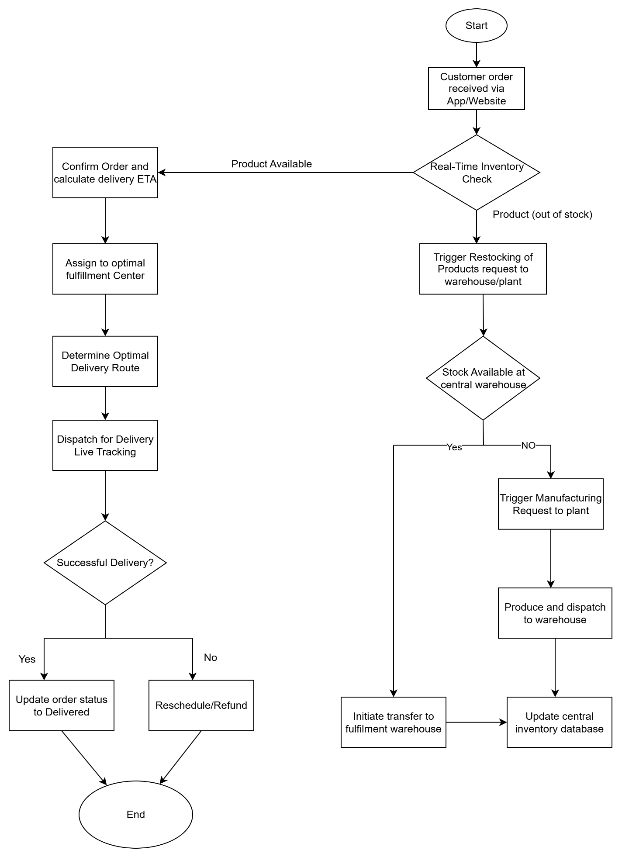
Assignment No – 2

Que.1 - Introduction letter

Subject: – Business Analyst for e-commerce Project/SPP Enterprises
Dear, Max.pvt.ltd
I hope this message finds you well. My name is Yash Patil, and I have been assigned as the Business Analyst for E-commerce Project. I will be working closely with you and your team to initiate the business understanding process, gather requirements, and ensure that we have a clear and shared vision of the project objectives.
My role is to facilitate communication between your team and our development team, document requirements accurately, and help translate business needs into actionable solutions. I look forward to collaborating with you, understanding your goals in depth, and supporting the successful delivery of this project.
Please feel free to reach out to me at any time for discussions or clarifications. I am excited to begin this journey with you and your team.
Thank you for your time and cooperation.
Best regards,
Yash Patil
Business Analyst
Mob.no-8625926xxx /Email – yp0643305@gmail.com

Que.2 – BRD and SRS for Online Store

1.Business Requirement Document



Contents:
1.Document Revisions……………………………………………………………………………………………………1
2.Approvals……………………………………………………………………………………………………………………1
3.RACI Chart…………………………………………………………………………………………………………………...2
Codes used for RACI Chart…………………………………………………………………………………………...2
4.Introduction………………………………………………………………………………………………………………...3
4.1 Business Goals……………………………………………………………………………………………………….3
4.2 Business Objective………………………………………………………………………………………………….3
4.3 Business Rules………………………………………………………………………………………………………...3
4.4 Background……………………………………………………………………………………………………………...3
4.5 Project Objective………………………………………………………………………………………………………3
4.6 Project Scope……………………………………………………………………………………………………………4
4.6.1 In-Scope Functionality……………………………………………………………………………………...4
4.6.2 Out-Scope Functionality…………………………………………………………………………………...5
5.Business Process Overview……………………………………………………………………………………………...5
5.1 Current State Analysis (As-Is) …………………………………………………………………………….…5
5.2 Future State / Proposed Solution (To-Be) ……………………………………………………………..5
6.Business Requirement……………………………………………………………………………………………………….6
7.Assumptioms…………………………………………………………………………………………………………………….7
8. Constraints……………………………………………………………………………………………………………………….7
9.Risks…………………………………………………………………………………………………………………………………8
Technological risks……………………………………………………………………………………………………………8
Skill risk……………………………………………………………………………………………………………………………8
requirement risk………………………………………………………………………………………………………………8
Business risk……………………………………………………………………………………………………………………8
Other risk………………………………………………………………………………………………………………………8
10.Business rules…………………………………………………………………………………………………………………9
11.Appendices………………………………………………………………………………………………………………………9

1. Document Revisions

Date | Version Number | Document Changes
08/02/2025 | 0.1 | Initial Draft
16/02/2025 | 1.1 | Updated targeted dates

- Approvals
Role | Name | Title | Signature | Date
Project Sponsor | Mr. Jackson | Executive Stakeholder
Business Owner | Mr. Amo | Strategic Business Lead
Project Manager | Miss. Emily | Delivery & Operations Manager
System Architect | Mr. Mario | Technical Architecture Lead
Development Lead | Mr. Lucky | Software Engineering Manager
User Experience Lead | Miss. Lucy | UX/UI Design Head
Quality Lead | Mr. Sam | QA & Testing Manager
Content Lead | Mr. Max | Content Strategy Manager

- RACI Chart for This Document

RACI Chart:

Name | Position | * | R | A | S | C | I
Miss. Emily | Project Manager |  | * | * |  |  | *
Mr. Yash | Business Analyst |  | * |  | * | * | *
Miss. Mindy | Senior Developer |  |  | * | * |  | *
Mr. Jack | Sponsor |  |  | * |  |  | *

Codes Used in RACI Chart
* Authorize document. | Has ultimate signing authority for any changes to the
R Responsible | Responsible for creating this document.
A Accountable | Accountable for accuracy of this document  (for example, the project manager)
S Supports  document | Provides supporting services in the production of this
C Consulted | Provides input (such as an interviewee).
I Informed | Must be informed of any changes.

4. Introduction / Overview
4.1 Business Goals
- Increase online sales revenue through digital channels.
- Improve customer experience with a user-friendly and personalized platform.
- Expand market presence beyond physical boundaries.
- Streamline order management, payment, and delivery processes.

4.2 Business Objectives
- Provide customers with 24/7 online shopping access.
- Enable multiple secure payment options.
- Improve operational efficiency by automating order and inventory management.
- Reduce cart abandonment through improved checkout flow and customer engagement.

4.3 Business Rules
- Customers must create an account to place an order.
- Payments must be processed only through authorized gateways.
- Return and refund policies will be limited to specific time frames (e.g., 7–10 days).
- Discounts and promotional codes cannot be combined unless explicitly stated.

4.4 Background
With the increasing demand for online shopping, businesses need a robust e-commerce platform to remain competitive. Currently, sales rely heavily on physical stores, limiting market reach and reducing potential revenue.

4.5 Project Objectives
To design and implement an e-commerce solution that provides customers with a seamless digital shopping experience while integrating backend processes like inventory, logistics, and payment.
4.6 Project Scope
4.6.1 In-Scope Functionality
1. Product catalogue management.
2. User registration and account management.
3. Secure online payment and checkout.
4. Shopping cart and wish list functionality.
5. Order tracking and delivery management.
6. Customer reviews and feedback system.
7. Admin panel for managing products, inventory, and promotions.

4.6.2 Out-of-Scope Functionality
5.Business Process Overview
1. In-store POS integration.
2. Voice-based shopping assistant.
3. AR/VR product visualization.
4. Blockchain-based payment processing.
5. Third-party marketplace integration (e.g., Amazon, eBay).
6. Social media in-app purchasing.
7.Offline retail operations automation.

5.1 Current State Analysis (As-Is)
1. Customers can only purchase products from physical stores.
2.Product availability information is not real-time.
3. Manual order processing increases operational delays.
4. Customer engagement is limited to offline interactions.
5. Payments are primarily cash or card-based at counters.
6. Limited visibility into customer buying behaviour.
7. Returns and refunds managed manually, causing delays.

5.2 Future State / Proposed Solution (To-Be)
1.Customers can shop 24/7 from anywhere via web or mobile app.
2. Real-time inventory updates and product availability tracking.
3. Automated order management system.
4. Integrated multiple payment gateways (credit card, UPI, wallets).
5. Personalized recommendations and promotions.
6. Seamless order tracking and delivery notifications.
7. Digital-first return and refund process.

6. Business Requirements
BR ID | Requirement Name | Business Requirement Description | Priority
BR0001 | User registration and login | Customers must be able to register, log in, and manage their profiles using email, phone, or social media. | High
BR0002 | Product catalog management | The system must display products with details (name, price, description, images, stock availability). | High
BR0003 | Search and filter | Customers must be able to search for products and apply filters (price, category, brand, rating). | High
BR0004 |  | Customers can add/remove products to a shopping cart and save items to a wishlist for later purchase. | High
  Shopping cart and wishlist
BR0005 | Secure checkout and payment | The system must support multiple payment methods (credit/debit card, UPI, wallets) with secure processing. | High
BR0006 | Order management and tracking | Customers must view order history, track order status, and receive delivery updates. | High
BR0007 | Inventory Management | The system must update product availability in real-time after purchases or stock updates. | Medium
BR0008 | Customer Reviews and ratings | Customers should be able to provide product reviews and ratings after purchase. | Medium
BR0009 | Return and refund Processing |  | Medium
  The system must support return requests and process refunds according to business rules..

6.1 Non-Functional Requirements
- Performance
  - The system should load product pages within 3 seconds under normal load.
  - The platform must support up to 10,000 concurrent users without performance degradation.
- Security
  - Customer data (personal, financial) must be stored in encrypted format
  - All payments must follow PCI DSS compliance with SSL/TLS encryption.

- Usability
  - The platform must provide an intuitive interface accessible on desktop & mobile.
  - The system should allow switching between multiple languages and currencies.
- Compliance
  - Terms of Service, Privacy Policy, and Return Policy must be displayed clearly.
  - The platform must comply with GDPR for handling customer data in applicable regions.

- Assumptions

- Customers will have access to the internet and smartphones/computers.
- Vendors will provide accurate product details and stock information.
- Payment gateways will provide uptime and integration support.
- Delivery partners will ensure timely shipment.
- The project will follow Agile methodology for development.

- Constraints

- Budget limitations for advanced AI/AR integrations.
- Fixed timeline for initial release (MVP within 6 months).
- Data security and compliance with GDPR/PCI DSS.
- Dependency on third-party logistics and payment gateways.
- Limited internal technical resources for initial deployment.

- Risks

- Technological Risks
- Integration failures with third-party payment gateways.
- System downtime during peak traffic.

- Skill Risks
- Lack of in-house technical expertise for advanced integrations.
- Training gaps for admin and support staff.

- Requirement Risks
1. Scope creep due to continuous feature requests.
2. Ambiguity in product catalog classification.

4. Business Risks
1. High competition in the e-commerce market.
2. Customer reluctance to adopt online purchases.

5. Other Risks (External/Operational)
1.Cybersecurity threats like fraud and data breaches.
2.Dependency on stable internet connectivity.
3. Delays from logistics partners affecting delivery SLAs.

- Business Rules:
1.Customers must log in to place an order.
2. Refunds will be processed only through the original payment method.
3. Inventory must auto-update after every transaction.
4. Orders cannot be modified after confirmation.
- Discounts are applicable only within their defined validity.

11. Appendices
11.1 List of Acronyms
- BRD - Business Requirements Document
- RTM - Requirement Traceability Matrix

11.2 Glossary of Terms
- UAT: User Acceptance Testing

11.3 Related Documents
- Requirement Traceability Matrix (RTM)
- Software requirement specification (SRS)

- Software Requirement Specification (SRS)

1. Introduction
1.1 Purpose
The purpose of this document is to define the software requirements for the development of an Online Store E-commerce application. It serves as a reference for stakeholders, developers, testers, and project managers to ensure a common understanding of the system’s functionalities and constraints.
1.2 Scope
The system will provide a platform for customers to browse products, add them to a cart, make secure payments, and receive order confirmations. It will also provide administrators and sellers with tools for product management, inventory updates, and sales tracking.
Key features include:
- User registration and authentication
- Product catalogue management
- Shopping cart and checkout
- Payment gateway integration
- Order management and tracking
- Customer support and feedback system
1.3 Overview
The application will be web-based, accessible via desktops and mobile devices. It will include a customer-facing storefront, an admin panel, and secure payment integrations.

2. Overall Description
2.1 Product Perspective
The Online Store will act as a standalone web application, integrated with third-party payment gateways, shipping services, and email/SMS notification systems.
2.2 User Classes and Characteristics
- Customers: Browse products, purchase, track orders. Basic technical knowledge.
- Admin: Manage products, categories, inventory, users, and orders. Moderate technical knowledge.
- Sellers (optional): Manage their own product listings and stock.
- Support Staff: Handle customer queries, returns, and complaints.
2.3 Operating Environment
- Frontend: Responsive web application (HTML, CSS, JavaScript, React/Angular/Vue).
- Backend: REST API / Microservices (Java, .NET, Python, or Node.js).
- Database: SQL/NoSQL database (MySQL, PostgreSQL, MongoDB).
- Payment: Integrated with payment gateways (PayPal, Stripe, Razorpay, etc.).
- Deployment: Cloud environment (AWS, Azure, GCP).
- Devices: Desktop, tablet, mobile browsers.
2.4 Design and Implementation Constraints
- Compliance with data privacy regulations (GDPR, PCI DSS for payments).
- Secure handling of sensitive customer data.
- Performance must support at least 10,000 concurrent users.
- Multi-language and multi-currency support.
2.5 Assumptions and Dependencies
- Users have stable internet connections.
- Third-party APIs (payment, shipping, SMS/email) are reliable.
- System updates and maintenance will be handled periodically.

3. Functional Requirements
FR-1: User Registration and Login (with social login options).
FR-2: Product Catalog Browsing with search and filtering.
FR-3: Shopping Cart (add, update, remove items).
FR-4: Checkout process with multiple payment options.
FR-5: Order placement, confirmation, and tracking.
FR-6: Admin panel for product, category, and inventory management.
FR-7: Review and rating system for products.
FR-8: Discount coupons and promotional codes.
FR-9: Notifications via email/SMS (order updates, promotions).
FR-10: Return, refund, and cancellation management.

4. Non-Functional Requirements
- Performance: System should handle 10,000 concurrent users with <3s response time.
- Security: Data encryption (SSL/TLS), secure authentication (OAuth2/JWT).
- Usability: Simple, intuitive UI with responsive design.
- Availability: 99.9% uptime with cloud deployment.
- Scalability: Ability to scale horizontally to support traffic growth.
- Maintainability: Modular codebase for easy updates.
- Compliance: GDPR, PCI DSS for payments.

5. External Interface Requirements
5.1 User Interface
- Web-based responsive UI (desktop, tablet, mobile).
- Dashboard for admin and sellers.
5.2 Hardware Interfaces
- Compatible with standard desktop and mobile devices.

5.3 Software Interfaces

- Payment gateways (Stripe, PayPal, Razor pay).
- Email/SMS APIs (SendGrid, Twilio).
- Shipping APIs (FedEx, UPS, DHL).

5.4 Communication Interfaces
- HTTPS protocol for secure transactions.
- REST API for integration with third-party systems.

6. Other Requirements
- Multi-language and multi-currency support.
- Accessibility compliance (WCAG 2.1).
- Integration with analytics tools (Google Analytics, custom BI dashboards).

7. System Architecture Information
- Client Tier: Web/Mobile application (React/Flutter).
- Application Tier: RESTful API services (Node.js/Java/Spring Boot).
- Data Tier: Relational database (PostgreSQL/MySQL), NoSQL for caching (Redis/MongoDB).
- External Integrations: Payment gateway, logistics tracking, notification service.

8. Appendices
8.1 Glossary of Terms
- SKU: Stock Keeping Unit
- API: Application Programming Interface
- SSL: Secure Sockets Layer
- GDPR: General Data Protection Regulation
8.2 Acronyms
- UI: User Interface
- DBMS: Database Management System
- PCI DSS: Payment Card Industry Data Security Standard
8.3 Supporting Documents
- Payment gateway integration guides.
- Shipping service API documentation.
- UI mock-ups (to be provided separately).

- ERD For Ticketing life cycle.

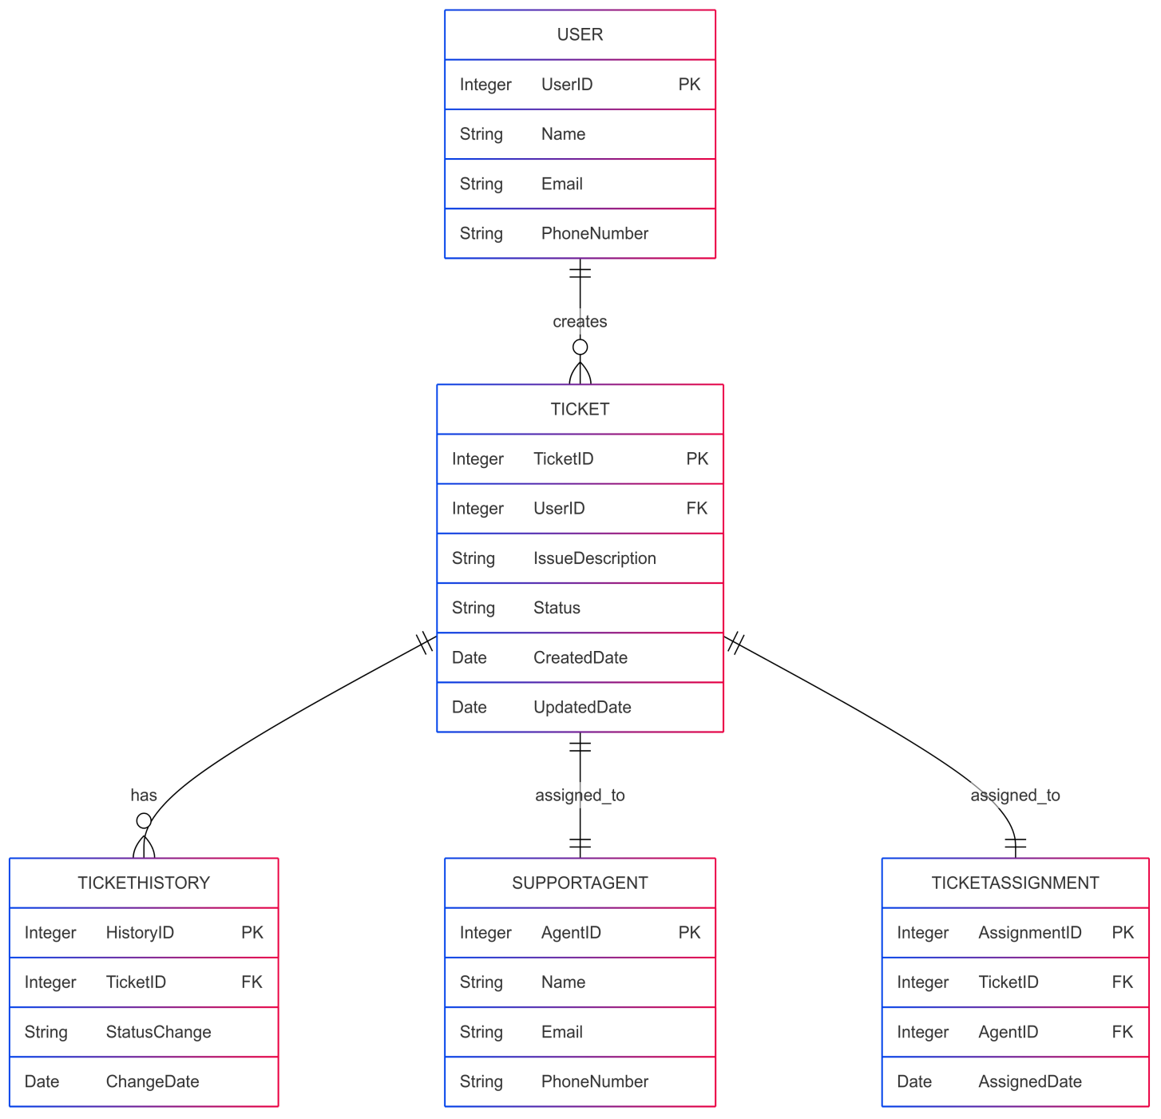

4.User story for shopping from e commerce

User story No: 01 | Tasks: User Registration & Login |  | Priority: High
Value statement:
As a customer,
I want to create an account and log in securely,
so I can personalize my shopping experience and track my orders.
BV: 500 |  | CP: 05
Acceptance criteria:
- User can register with email/mobile.
- User can log in with credentials/social login.
- Invalid login attempts are restricted.

User story No: 02 | Tasks: Product Browsing & Search |  | Priority: High
Value statement:
As a customer,
I want to browse and search products by category,
so I can quickly find the items I need.
BV: 500 |  | CP: 8
Acceptance criteria:
- Search bar returns relevant results.
- Filters by price, category, brand are available.
- Products load under 2 seconds.

User story No: 03 | Tasks: Shopping Cart Management |  | Priority: High
Value statement:
As a customer,
I want to add/remove items to a cart,
so I can review products before purchasing.
BV: 500 |  | CP: 05
Acceptance criteria:
- User can add products to the cart.
- User can remove/update quantity.
- Cart persists during the session.
User story No: 04 | Tasks: Checkout and Payment |  | Priority: High
Value statement:
As a customer,
I want to checkout and pay securely,
so I can complete my purchase safely.
BV: 500 |  | CP: 08
Acceptance criteria:
- Multiple payment methods (card, UPI, wallet).
- Payment gateway is PCI-DSS compliant.
- Confirmation message & invoice sent after purchase.

User story No: 05 | Tasks: Wishlist Feature |  | Priority: Medium
Value statement:
As a customer,
I want to save items to my wishlist,
so I can purchase them later.
BV: 200 |  | CP: 05
Acceptance criteria:
- User can add/remove products to wishlist.
- Wishlist persists after logout.
- Products in wishlist can be moved to cart.

User story No: 06 | Tasks: User registration |  | Priority: High
Value statement: As a new user,
I want to register using email/phone,
so I can create my account.
BV: 500 |  | CP:06
Acceptance criteria:
User can sign up with valid details; confirmation email/SMS is sent.

User story No: 07 | Tasks: Social Login (Google/Facebook) |  | Priority: High
Value statement:
As a user,
I want to log in via Google/Facebook,
so I can sign in quickly.

BV: 500 |  | CP: 12
Acceptance criteria:
Login via social accounts is successful.

User story No: 08 | Tasks: Password reset |  | Priority: High
Value statement:
As a user,
I want to reset my password,
so I can regain account access.

BV: 500 |  | CP: 06
Acceptance criteria:
Reset link sent; New password updates successfully.

User story No: 09 | Tasks: Browse Products |  | Priority: High
Value statement:
As a user,
I want to browse product categories,
so I can explore items.

BV: 500 |  | CP: o3
Acceptance criteria:
Categories displayed; Products load correctly.

User story No: 10 | Tasks: Product Search |  | Priority: High
Value statement:
As a user,
I want to search products by name/keyword,
so I can find what I need quickly.

BV: 500 |  | CP: 05
Acceptance criteria:
Search results display relevant products.

User story No: 11 | Tasks: Filter Products |  | Priority: High
Value statement:

As a user,
I want to filter products by price/brand,
so I can narrow my choices.

BV: 500 |  | CP: 08
Acceptance criteria:
Filters apply correctly; Reset option available.

User story No: 12 | Tasks: Sort Products |  | Priority: Medium
Value statement:
As a user,
I want to sort products by price/popularity,
so I can view in my preferred order.
BV: 250 |  | CP: 03
Acceptance criteria:
Sorting changes order instantly.
User story No: 13 | Tasks: View Products Details |  | Priority: High
Value statement:

As a user,
I want to see detailed product info,
so I can make an informed decision.

BV: 500 |  | CP: 08
Acceptance criteria:
Product name, price, description, images visible.

User story No: 14 | Tasks: Products Reviews |  | Priority: Medium
Value statement:

As a user,
I want to read reviews,
so I can assess product quality.

BV: 500 |  | CP: 03
Acceptance criteria:
Reviews display with ratings.

User story No: 15 | Tasks: Add to Cart |  | Priority: High
Value statement:

As a user,
I want to add items to my cart,
so I can prepare for purchase.

BV: 500 |  | CP: 12
Acceptance criteria:
Item added; Cart updates instantly.
User story No: 16 | Tasks: View Cart |  | Priority: High
Value statement:

As a user,
I want to view my cart,
so I can see all selected items.

BV: 500 |  | CP: 08
Acceptance criteria:
Cart shows all items with quantity & total.

User story No: 17 | Tasks: Update cart |  | Priority: High
Value statement:

As a user,
I want to update quantity/remove items,
so I can adjust my order.

BV: 500 |  | CP: 05
Acceptance criteria:
Quantity updates; Items removable.

User story No: 18 | Tasks: Save cart |  | Priority: High
Value statement:

As a user,
I want my cart to persist,
so I don’t lose items if I leave.

BV: 500 |  | CP: 12
Acceptance criteria:
Cart items saved until checkout or removal.
User story No: 18 | Tasks: Wishlist |  | Priority: Medium
Value statement:

As a user,
I want to add items to a wishlist,
so I can save them for later.

BV: 250 |  | CP: 05
Acceptance criteria:
Items added to wishlist and retrievable.

User story No: 19 | Tasks: Checkout |  | Priority: High
Value statement:

As a user,
I want a seamless checkout,
so I can complete purchase easily.

BV: 500 |  | CP: 08
Acceptance criteria:
Checkout works with valid inputs.

User story No: 20 | Tasks: Address Management |  | Priority: High
Value statement:
As a user,
I want to save/edit addresses,
so I can reuse them at checkout.
BV: 500 |  | CP: 05
Acceptance criteria:
Multiple addresses can be added/edited.

User story No: 21 | Tasks: Apply coupens |  | Priority: Medium
Value statement:

As a user,
I want to apply coupons,
so I can get discounts.

BV: 250 |  | CP: 05
Acceptance criteria:
Valid coupon applies discount; Invalid rejected.

User story No: 22 | Tasks: Multiple Payment options |  | Priority: High
Value statement:
As a user,
I want to pay via card, UPI, wallet,
so I can use my preferred method.

BV: 500 |  | CP:03
Acceptance criteria:
Payment processes successfully

User story No: 23 | Tasks: Order Confirmation |  | Priority: High
Value statement:

As a user,
I want to receive confirmation,
so I know my order was placed.

BV: 500 |  | CP: 12
Acceptance criteria:
Confirmation screen & email sent.

User story No: 24 | Tasks: Track Order |  | Priority: High
Value statement:

As a user,
I want to track my order status,
so I know when it will arrive.

BV: 500 |  | CP: 08
Acceptance criteria:
Status updates: Processing, Shipped, Delivered.

User story No: 25 | Tasks: Cancel order |  | Priority: High
Value statement:

As a user,
I want to cancel before shipment,
so I avoid unwanted purchases.

BV: 500 |  | CP: 12
Acceptance criteria:
Cancel option available before dispatch.

User story No: 26 | Tasks: Return request |  | Priority: High
Value statement:
As a user,
I want to request returns,
so I can send back defective items.

BV: 500 |  | CP: 03
Acceptance criteria:
Return initiated with reason selection.

User story No: 27 | Tasks: Refund processing |  | Priority: High
Value statement:
As a user,
I want refunds processed,
so I get my money back.
BV: 500 |  | CP:08
Acceptance criteria:
Refund confirmation received.

User story No: 28 | Tasks: Review order history |  | Priority: Medium
Value statement:
As a user,
I want to see past orders,
so I can reorder or track purchases.
BV: 250 |  | CP:08
Acceptance criteria:
Order history displayed correctly.
User story No: 29 | Tasks: Push notification |  | Priority: Medium
Value statement:

As a user,
I want alerts for offers/orders,
so I don’t miss updates.

BV: 250 |  | CP: 05
Acceptance criteria:
Notifications triggered correctly.

User story No: 30 | Tasks: Profile Managment |  | Priority: Medium
Value statement:

As a user,
I want to update my profile,
so I can keep info accurate.

BV: 250 |  | CP: 03
Acceptance criteria:
Profile updated successfully.

User story No: 31 | Tasks: Loyalty Points |  | Priority: Low
Value statement:
As a user,
I want loyalty points,
so I can save money on future orders.
BV: 100 |  | CP: 03
Acceptance criteria:
Points displayed & applied at checkout.

User story No: 32 | Tasks: Guest Checkout |  | Priority: High
Value statement:

As a guest,
I want to checkout without an account,
so I can order quickly.

BV: 500 |  | CP: 08
Acceptance criteria:
Checkout works without login.

User story No: 33 | Tasks: Multi Language support |  | Priority: Medium
Value statement:

As a user,
I want to view the app in my language,
so I can understand easily.

BV: 100 |  | CP: 03
Acceptance criteria:
Language switch works.

User story No: 34 | Tasks: Multi Currency Support |  | Priority: Medium
Value statement:

As a global user,
I want to pay in my currency,
so I know exact costs.

BV: 200 |  | CP: 03
Acceptance criteria:
Price conversion accurate.

User story No: 35 | Tasks: Admin Product Managment |  | Priority: High
Value statement:

As an admin,
I want to add/edit/delete products,
so I can manage catalog.

BV: 500 |  | CP: 05
Acceptance criteria:
Product changes reflect instantly.

User story No: 36 | Tasks. Admin order management |  | Priority: High
Value statement:
As an admin,
I want to update order statuses,
so customers stay informed.
BV: 500 |  | CP: 12
Acceptance criteria:
Status updates correctly.

User story No: 37 | Tasks: Admin user management |  | Priority: medium
Value statement:
As an admin,
I want to manage user accounts
, so I can block/unblock users.

BV: 250 |  | CP: 03
Acceptance criteria:
User updates reflected instantly.

User story No: 38 | Tasks: Inventory Management |  | Priority: High
Value statement:
As an admin,
I want stock to update automatically,
so I avoid overselling.
BV: 500 |  | CP: 08
Acceptance criteria:
Stock decreases after order.

User story No: 39 | Tasks: Reports analytics |  | Priority: Medium
Value statement:

As an admin,
I want sales reports,
so I can track performance.

BV: 250 |  | CP: 03
Acceptance criteria:
Reports generated with filters.

User story No: 40 | Tasks: Fraud detection |  | Priority: High
Value statement:
As a system,
I want to detect fraudulent activity,
so I can protect users.

BV: 500 |  | CP: 08
Acceptance criteria:
Suspicious activity flagged.

