Q.1. Document 6- Please prepare a use case diagram, activity diagram and a use case specification document.
Use case diagram:
Activity diagram:

Section | Details
Use Case Name | Event Registration by Student
Use Case Description | Enables students to register for college events using an online portal
Primary Actor | Student
Secondary Actors | Faculty Coordinator, Admin
Basic Flow | 1. Student logs in → 2. Selects event → 3. Submits form → 4. Coordinator reviews → 5. Admin finalizes approval
Alternate Flow | Coordinator rejects → notification sent to student
Exceptional Flow | System error during submission; form saved in draft
Pre-conditions | Student must be registered and logged in
Post-conditions | Registration status visible on dashboard
Assumptions | Events are listed accurately; roles are assigned
Constraints | Form must be submitted before deadline; single entry per student
Dependencies | Active event list; working approval workflow
Inputs | Student ID, Event ID, Reason
Outputs | Registration record, confirmation message
Business Rules | Approved events only shown; suggestion box open post-event
Miscellaneous Information | Registration date auto-captured; dropdown filtered by class level
Use case specification document:

Q.2. Document 7- Screens and pages
Home Page:
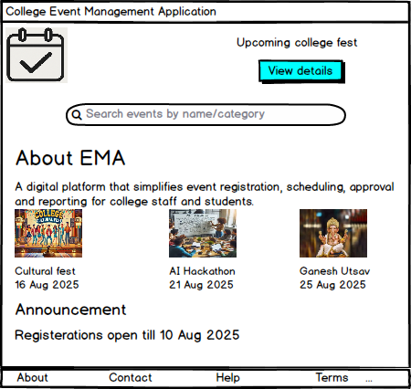
Login Page:
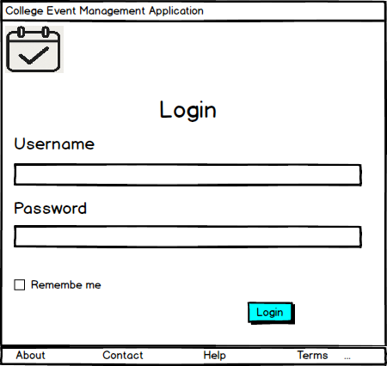
Student Event Registration Page:
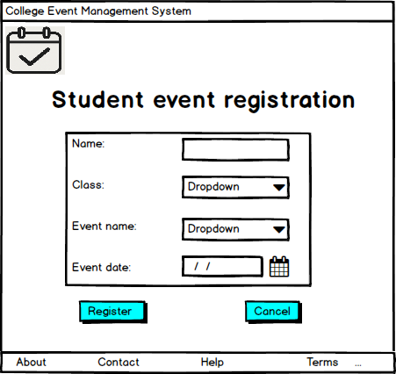
Faculty Registration Form Page:
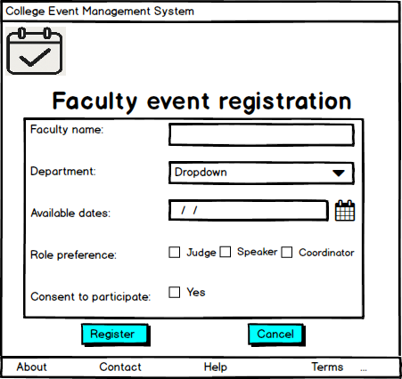
Admin Event Approval Panel:
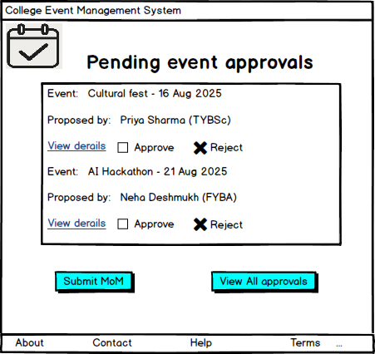
Event Calendar Dashboard:
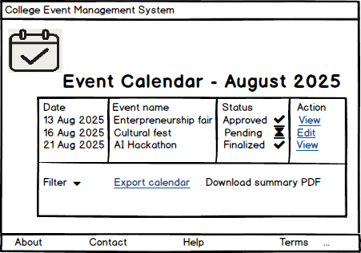

Suggestion Portal:
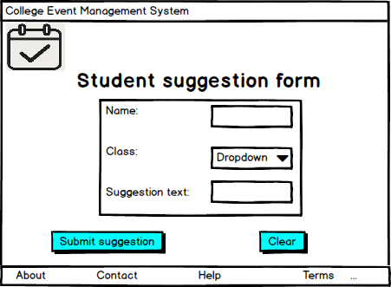
Reports Generator Page:
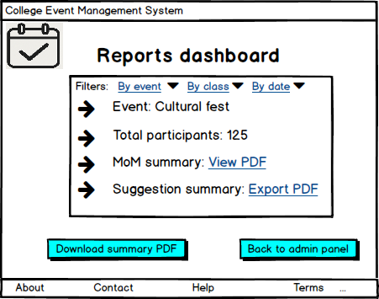
Q.3. Document 8- Tools-Visio and Axure:
Write a paragraph on your experience using Visio and Axure for the project.
During this project, I used MS Visio to create flowcharts, use case diagrams and activity diagrams that mapped the current and proposed business processes. It helped stakeholders visualize changes clearly. For UI prototyping, I used Axure RP to design medium-fidelity mockups showcasing real interactions like dropdowns and pop-ups. Axure helped simulate use cases before development started.
Q.4. Document 9- BA experience
My experience as BA in following phases:
- Requirement gathering:
- Used MoSCoW to prioritize features
- Validated the requirements via FURPS technique for quality dimensions
- Client is not available for some period of time during this phase. So, as a BA I sourced info from alternate POCs during client absence
- Removed duplicates during review
- Created prototypes for event modules and dashboard views

- Requirement Analysis:
- Created UML diagrams (use case, activity) to visually describe the requirements and to describe the process flow
- Developed BRS/SRS documents
- Modified diagrams collaboratively with team as some team members might not agree with them and might make changes. As a BA we need to consider the points and make modifications
- Ensured clarity before sign-off
- Design:
- Derived test cases from use cases
- Communicated with client on design and solution documents
- Did not miss a single test case as it might have created a huge impact on project development in later stages
- Wrote both positive and negative cases
- Prepared test data for each student flow
- Updated RTM to ensure coverage
- Development:
- Organized JAD sessions
- Resolved developer queries with diagrams
- Some team members did not agree with the concept and did not cooperate during JAD sessions. As a BA I handled the resistance gently via one-on-one mentoring
- Referred diagrams to code the unit
- Conducting regular meetings with technical team and client was challenging. However, I kept the team aligned with recordings and recap meetings for those who missed one
- Testing:
- Performed high-level testing based on RTM
- Collected test data and client sign-off
- Prepared client teams for UAT walkthroughs
- Deployment:
- Shared RTM, project closure documents and end-user manuals to client
- Organized training sessions for students and staff
- Tracked attendance and feedback for session success

