Question 1- Use Case Diagram
Answer -
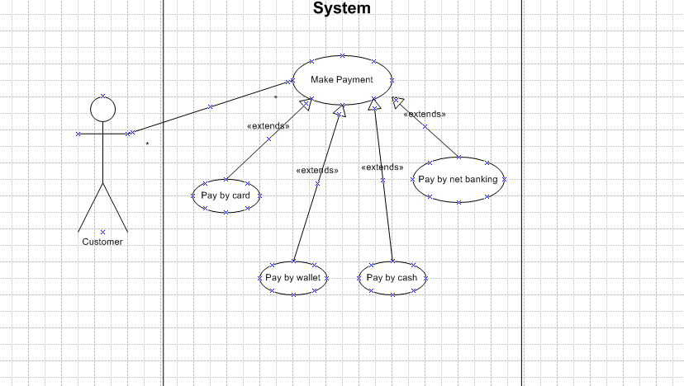

Question 2 - . Derive Boundary Classes, Controller classes, Entity Classes

Answer - 1. Boundary Classes

These interact with the actors (usually the UI components or system interfaces).
Class Name | Responsibility
PaymentUI | Interface to initiate and confirm payment.
CardPaymentUI | Captures card details (number, CVV, expiry).
WalletPaymentUI | Captures wallet provider and credentials.
CashPaymentUI | Accepts or confirms cash payment.
NetBankingUI | Takes bank details and login.

2. Controller Classes
These coordinate between UI (boundary) and data (entity) – handle logic and workflow.
Class Name | Responsibility
PaymentController | Main class to handle payment logic and route to methods.
CardPaymentController | Validate and process card payments.
WalletPaymentController | Handle wallet payment logic.
CashPaymentController | Confirm cash received and generate receipt.
NetBankingController | Interface with bank API and confirm transaction.

3. Entity Classes
These represent business/domain objects that hold data.
Class Name | Responsibility
Customer | Holds customer data (ID, name, contact, etc.)
Payment | Base class with common attributes (amount, status, date).
Card | Stores card info securely.
Wallet | Holds wallet account info and balance.
BankAccount | Stores net banking info (account number, IFSC).

Question 3 - Place these classes on a three tier Architecture
Answer -
Tier | Classes Placed | Responsibility
1. Presentation Layer | PaymentUI, CardPaymentUI, WalletPaymentUI, CashPaymentUI, NetBankingUI | Interact with customer/user, collect input data for processing
2. Business Logic Layer | PaymentController, CardPaymentController, WalletPaymentController, CashPaymentController, NetBankingController | Handle payment logic, route the request to the correct payment processor
3. Data/Entity Layer | Customer, Payment, Card, Wallet, BankAccount | Store business-related data, represent domain objects

Question 4 - Domain Model for Customer making payment through Net Banking
Answer - A Domain Model is a visual representation of real-world business entities and the relationships between them. It shows classes, attributes, and associations relevant to the problem domain—here, Customer making payment via Net Banking.

Key Domain Objects Involved in Net Banking Payment -
Class | Attributes (example) | Responsibility
Customer | customerId, name, email | Represents the user making the payment
Payment | paymentId, amount, date, status | Abstract class representing a payment
NetBankingPayment | transactionId, bankName, accountNumber, IFSC | Specialized payment method via bank
BankAccount | accountNumber, IFSC, balance | Holds customer’s bank details
Transaction | transactionId, amount, timestamp, status | Records the transaction done

Question 5 - sequence diagram
Answer -
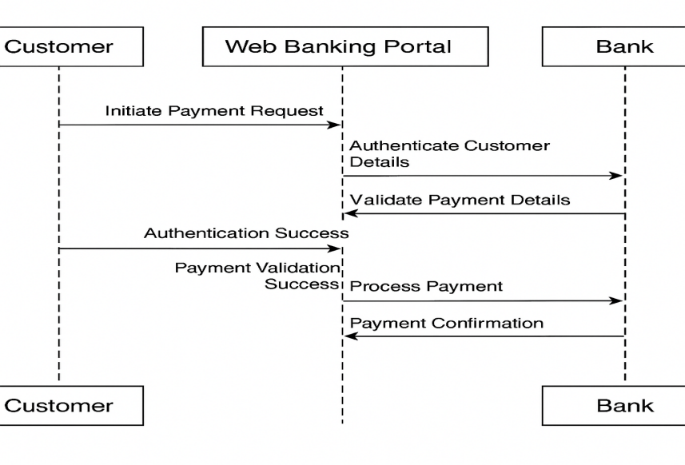

Question 6 - Conceptual Model for this Case
Answer - A Conceptual Model is a high-level representation of key concepts (classes/entities) in the problem domain and their relationships, without technical details like methods, data types, or implementation logic.

Conceptual Model for Customer Payment System (All Modes) -
Class | Description
Customer | A user who makes a payment
Payment | Abstract concept of a financial transaction
PaymentMethod | A general method of payment (Card, Wallet, Cash, NetBanking)
Card | Stores card-specific details (e.g., card number, CVV)
Wallet | Stores wallet provider info
Cash | Represents a physical cash payment
NetBanking | Includes bank account and IFSC info
Transaction | Represents the outcome of a payment (amount, time, status)

Question 7 - What is MVC architecture ?
Answer - MVC stands for Model–View–Controller, a software design pattern commonly used to develop user interfaces and structure object-oriented applications.

MVC Rules to Derive Classes from Use Case Diagram
Use Case Element | Derives | Explanation
Actors | → Boundary Classes (Views) | They interact with the system; hence define input/output interfaces
Use Cases | → Controller Classes | Logic behind a use case is implemented by controller classes
Domain Concepts | → Entity (Model) Classes | Nouns and business objects become data classes

Guidelines to Place Classes in 3-Tier Architecture
Tier | MVC Component | Class Types
Presentation Tier | View (Boundary) | UI classes (e.g., PaymentUI, LoginForm)
Business Logic Tier | Controller | Control logic (e.g., PaymentController)
Data/Entity Tier | Model | Domain entities (e.g., Customer, Payment)

Question 8 - BA contributions in project (Waterfall Model – all Stages)
Answer - The Waterfall Model is a linear, sequential software development methodology that consists of distinct phases. Each phase must be completed before moving on to the next.

Phase | BA Contributions
1. Requirement Gathering & Analysis | Identify stakeholders and conduct requirement elicitation techniques (interviews, surveys, workshops) 🔹 Gather and document Business Requirements Document (BRD), Functional Requirements (FRD), and Non-functional requirements (NFR) 🔹 Validate and get sign-off from stakeholders
2. System Design | Help translate business requirements into technical specifications 🔹 Participate in review of architecture, data flow diagrams (DFDs), and wireframes 🔹 Ensure business logic is accurately captured in the design
3. Implementation (Development) | Act as a bridge between developers and stakeholders 🔹 Clarify requirements, answer queries, and manage requirement traceability 🔹 Review development progress against requirements
4. Testing | Create/review test cases, test scenarios, and ensure coverage of business rules Coordinate User Acceptance Testing (UAT) 🔹 Identify and log defects or mismatches between requirements and implementation
5. Deployment | Ensure all business requirements are delivered and validated 🔹 Help in training users and creating user manuals or SOPs 🔹 Validate production readiness
6. Maintenance | Track and analyze change requests or enhancement needs 🔹 Help in impact analysis of new changes 🔹 Maintain documentation for future reference and audits

Question 9 - conflict management? Explain using Thomas – Kilmann technique

Answer - Conflict management refers to the process of identifying, addressing, and resolving disagreements or disputes between individuals or teams in a constructive manner.

The Thomas–Kilmann Conflict Mode Instrument (TKI) is a well-known model used to analyze how people handle conflict. It is based on two dimensions:
1. Assertiveness – the extent to which a person tries to satisfy their own concerns
2. Cooperativeness – the extent to which a person tries to satisfy others’ concerns
The 5 Conflict Management Styles in Thomas–Kilmann Model
Style | Description | When to Use
1. Competing (High Assertiveness, Low Cooperation) | Forcing one's own viewpoint or decision on others | Useful in emergencies or high-stakes decisions
2. Collaborating (High Assertiveness, High Cooperation) | Working together to find a win–win solution | Best when time allows and relationships matter
3. Compromising (Moderate Assertiveness and Cooperation) | Each party gives up something to reach a middle ground | Effective for temporary or quick resolutions
4. Avoiding (Low Assertiveness and Cooperation) | Ignoring or delaying conflict | Suitable when the issue is minor or emotions are high
5. Accommodating (Low Assertiveness, High Cooperation) | Yielding to others’ viewpoints | Appropriate to preserve harmony or when the issue is more important to the other party

Question 10 - Reasons for project failure
Answer -
Reason | Explanation
Unclear Requirements | Poorly defined or changing requirements lead to misaligned outcomes.
Lack of Stakeholder Engagement | If key stakeholders are not involved, the solution may not meet business needs.
Poor Planning | Inadequate scope, time, or cost planning leads to delays or overspending.
Inadequate Risk Management | Ignoring risks or not planning for them can cause sudden project disruptions.
Communication Gaps | Miscommunication between teams, clients, and vendors leads to confusion and errors.
Weak Leadership or Governance | Lack of direction from project managers or sponsors reduces accountability.
Unrealistic Deadlines | Over-ambitious timelines without capacity analysis often lead to project burnout.
Insufficient Resources | Lack of skilled personnel, tools, or budget can halt progress.
Poor Change Management | Inability to adapt to changes in scope, technology, or market needs causes failure.
Lack of Testing or Quality Control | Inadequate testing can lead to defective or non-functional deliverables.

Question 11 - Challenges faced in projects for BA
Answer -
Challenge | Explanation
Unclear or Evolving Requirements | Stakeholders often struggle to articulate what they need, or they change their minds mid-project, leading to rework.
Lack of Stakeholder Involvement | When business users or decision-makers are not available or engaged, the BA cannot validate or finalize requirements.
Communication Gaps | Miscommunication between business and technical teams can lead to misunderstandings and incorrect implementations.
Scope Creep | Continuous addition of new features without proper impact analysis or approvals leads to delays and cost overruns.
Time Constraints | BAs often have limited time to gather and analyze complex requirements thoroughly.
Conflicting Stakeholder Interests | Different stakeholders may have opposing needs, making it difficult to prioritize and finalize requirements.
Question 12 - Document Naming Standards
Answer - Document Naming Standards are predefined rules and guidelines used to name project documents in a consistent, clear, and organized manner.
Key Elements in Naming Standards
Element | Description
Project Code/Name | Short code for the project (e.g., AGRI, HRM, CRM)
Document Type | Indicates the document purpose (e.g., BRD, SRS, UAT, MOM)
Module/Feature | Specifies the module covered (e.g., Payment, Login)
Version | Indicates document version (e.g., V1.0, V2.3)
Date (optional) | Helps track document timeline (format: YYYYMMDD)
Question 13 - Do’s and Don’ts of a Business analyst
Answer - Do’s of a Business Analyst
Do | Explanation
Actively Listen to Stakeholders | Understand their pain points, goals, and expectations clearly.
Document Clear and Complete Requirements | Ensure all business, functional, and non-functional needs are captured accurately.
Facilitate Effective Communication | Maintain continuous and transparent communication between business and technical teams.
Verify and Validate Requirements | Conduct reviews and walkthroughs to ensure correctness.
Maintain Traceability | Keep track of requirements from initiation to implementation.
Don’ts of a Business Analyst
Don’t | Explanation
Make Assumptions | Always clarify requirements instead of guessing.
Ignore Stakeholder Conflicts | Address and resolve conflicting interests promptly.
Overcomplicate Requirements | Avoid using technical jargon or unnecessary complexity.
Delay Feedback or Approvals | Timely reviews are critical to avoid rework.
Lose Focus on Business Goals | Stay aligned with business value and objectives.
Question 14 - Difference between packages and sub-systems
Answer -
Aspect | Package | Sub-System
Definition | A logical grouping of related classes, interfaces, and diagrams | A self-contained component that represents a system or part of a system
Purpose | Organize and manage complexity in models | Represent a deployable or functional unit with defined interfaces
Scope | Used mainly for modeling organization | Used for system architecture and design
Content | May contain classes, diagrams, and other packages | Contains multiple packages and offers specific services
UML Representation | Shown as a folder icon in diagrams | Shown as a package with stereotype <>
Example | PaymentModule, UserManagementPackage | BillingSystem, InventorySubsystem

Question 15 - Camel-casing
Answer - Camel-casing is a naming convention in programming and documentation where:
Words are joined together without spaces.
The first word starts in lowercase, and each subsequent word starts with a capital letter.
Where Is Camel-Casing Used
Usage Area | Purpose
Programming Languages (Java, C#, JavaScript) | To define variables, methods, and object names
Database Schema Naming | Table or column names (in modern systems) like orderDate
API Naming Conventions | REST API parameters: getCustomerData(), updateProductList()
Scripting & Automation | Used in tools like PowerShell, Bash scripts, etc.
Documentation Standards | Ensures consistent readability and professionalism
Question 16 - Illustrate Development server and what are the accesses does business analyst has?
Answer - A Development Server is a server environment used by the development team to build, test, and integrate code before deployment to production.
accesses does business analyst has
Access | Description
Read-Only Access to Application | To verify feature implementation against requirements
Access to Test Data/Input | To create, update, and verify business scenarios using sample/test data
Access to Logs/Error Reports | To analyze issues and provide detailed feedback to developers
User Interface Validation | Check if UI matches wireframes, labels, and field validation rules
Postman/API Tool (Optional) | For BAs involved in API testing or validation
No Access to Source Code | BA typically doesn't edit code but may access build versions
Question 17 - Data Mapping
Answer - Data Mapping is the process of matching fields from one data source to another, ensuring that data is accurately transferred, transformed, or integrated between systems.
It acts as a blueprint for:
Data migration
System integration
ETL (Extract, Transform, Load) processes
API connections and report generation

Purpose of Data Mapping
The goal is to ensure:
Data consistency
Correct data format
Accurate data flow across systems (e.g., from frontend to backend or from legacy system to new system)
Best Practices in Data Mapping
· Ensure data types and formats match
· Define transformation rules clearly
· Include default values and error handling
· Maintain a data mapping document for traceability and testing
Question 18 - What is API
Answer - API stands for Application Programming Interface. It is a set of rules and protocols that allows different software systems to communicate with each other.
Types of APIs:
•REST API (most common – uses HTTP)
•SOAP API
•GraphQL API
What is API Integration?
API Integration is the process of connecting your application with another system via API to send, receive, or process data automatically.
Use Case Scenario: Date Format Issue
Context: •Your Application Date Format: dd-mm-yyyy (Indian Standard)
•External US Application Format: mm-dd-yyyy
Steps to Handle API Integration with Date Format Conversion
Step | Description
API Contract Definition | Clearly define in the API documentation the expected date format on both sides
Use Data Mapping / Transformation Layer | When receiving data, use a middleware (e.g., API Gateway, code logic, or integration tool) to convert mm-dd-yyyy into dd-mm-yyyy before saving or displaying
Implement Date Format Conversion | Use programming logic (e.g., in JavaScript, Python, or Java) to parse and reformat dates

