Document 1: Definition of Done
Definition of Done (DoD) in Municipal Data Processing Project
In Agile projects, the Definition of Done is a clear, shared agreement on when a task (like a user story, sprint, or release) can be considered fully completed.
For Municipal Data Processing (MUDP), this means:
👉 Each functionality (like tax calculation, garbage collection scheduling, complaint registration, etc.) must pass certain quality checks, acceptance tests, and documentation updates before the team can mark it as “Done.”
This prevents confusion like “development done” vs. “testing done” vs. “ready for deployment.” Everyone aligns on one common meaning of Done.

📌 Levels of DoD for MUDP
- User Story Level
  - Example: A story like “As a citizen, I want to submit my property tax online so that I don’t need to visit the municipal office.”
  - Done when: the online form works, validations are applied, payment gateway integrated, tested, accepted by Product Owner.
- Sprint Level
  - Example: Sprint goal is “Enable online submission and processing of municipal complaints.”
  - Done when: All stories in the sprint are tested, integrated into the system, free of major bugs, and ready for demo.
- Release Level
  - Example: Release 1.0 = Citizen Portal + Data Upload System.
  - Done when: The portal works end-to-end, deployed in staging/production, documentation completed, and training material provided.

📌 Checklist for DoD in Municipal Data Processing (Customized Explanation)
✅ 1. Produced code for presumed functionalities
- Developers must write code to handle municipal tasks like tax calculation, water bill generation, or waste management data entry.
- Example: If the user story is “Calculate property tax,” the code should calculate taxes correctly based on rates and exemptions.

✅ 2. Assumptions of User Story met
- If the story assumes “the citizen must be logged in,” then the login check must be built.
- Example: Complaint registration should only work when a citizen is authenticated.

✅ 3. Project builds without errors
- Municipal data processing system should compile/deploy without build errors.
- Example: No broken database connection or missing library when deploying.

✅ 4. Unit tests written and passing
- Write unit tests for core logic like tax calculation, late fee application, or citizen ID validation.
- Example: A test case where property value = ₹10,00,000 should calculate correct tax.

✅ 5. Project deployed on the test environment identical to production
- Deploy system on a staging environment that mirrors real municipal infrastructure.
- Example: Citizen portal tested with same database structure as production.

✅ 6. Tests on devices/browsers listed in the project assumptions passed
- Citizens may use Chrome, Firefox, Safari, or mobile browsers.
- The portal must work on all supported browsers.

✅ 7. Feature ok-ed by UX designer
- Municipal portals must be citizen-friendly.
- Example: Complaint form should be simple, accessible, with language options.

✅ 8. QA performed & issues resolved
- QA team verifies correctness of tax receipts, accuracy of citizen complaint status, and reliability of data reports.

✅ 9. Feature is tested against acceptance criteria
- Acceptance criteria are pre-defined by BA/Product Owner.
- Example: For “Download tax receipt,” acceptance criteria: Receipt must include property ID, owner name, payment details, and QR code.

✅ 10. Feature ok-ed by Product Owner
- The Municipal Authority or Product Owner verifies that the feature meets business needs.
- Example: Tax calculation rules align with current government policy.

✅ 11. Refactoring completed
- Code must be cleaned and optimized.
- Example: Instead of duplicate functions for water bill and property tax, create a reusable billing module.

✅ 12. Any configuration or build changes documented
- Database connections, API keys for payment gateway, or GIS map integration details must be documented.

✅ 13. Documentation updated
- User manuals for municipal staff, citizen help guides, API documentation, and system architecture must be updated.

✅ 14. Peer Code Review performed
- Team members review each other’s code to ensure security (e.g., no SQL injection), maintainability, and compliance with coding standards.

📌 Example of a DoD Checklist for MUDP (Summary Table)
Checklist Item | Municipal Data Processing Example
Code produced | Tax, billing, complaint modules implemented
Assumptions met | Login required, correct citizen ID
Build success | No errors in deployment
Unit tests passing | Tax calculation test cases
Test env deployment | Staging matches production
Browser/device tested | Works on Chrome, Firefox, mobile
UX approved | Complaint form is simple & accessible
QA verified | Receipts, reports, workflows tested
Acceptance criteria met | Payment receipt includes all fields
PO approved | Municipal officer validates
Refactoring done | Common billing module reused
Config documented | Payment API, GIS map setup recorded
Documentation updated | User/citizen manuals updated
Peer review | Security & quality checked

Document 2- Product Vision

Product Vision Document – Municipal Data Processing (MUDP)

📌 Scrum Project Details
- Name: Municipal Data Processing System (MUDP)
- Venue: Municipal Corporation Office / Online Scrum Collaboration Tool (e.g., Jira, MS Teams)
- Date: [Fill in actual date]
- Start Time – End Time: [Fill meeting timings]
- Duration: [Fill, e.g., 2 hours]
- Client: Municipal Corporation / Local Government Authority
- Stakeholder List:
  - Municipal Commissioner
  - IT Department Head
  - Tax Department Head
  - Sanitation/Waste Management Department
  - Citizen Representatives
  - Product Owner & Scrum Team

📌 Scrum Team
- Scrum Master: [Assign name]
- Product Owner: Municipal Corporation’s Digital Transformation Head
- Scrum Developer 1: Backend Developer (Database & APIs)
- Scrum Developer 2: Frontend Developer (Citizen Portal UI/UX)
- Scrum Developer 3: QA/Tester
- Scrum Developer 4: Data Analyst (for reports, dashboards)
- Scrum Developer 5: DevOps Engineer (deployment & servers)

1. Vision
👉 The overarching goal of MUDP is to build a digital system that efficiently processes, manages, and analyzes municipal data (tax, billing, complaints, waste management, citizen services) in order to improve transparency, speed of service delivery, and citizen satisfaction.
- Citizens will have a single online platform to interact with municipal services.
- Municipal officers will have real-time data dashboards to take quick decisions.
- The government will improve efficiency, accountability, and revenue collection.

2. Target Group
- Market Segment Addressed: Government digital services (Smart City initiatives, e-Governance).
- Target Users:
  - Citizens (property owners, tenants, business owners, residents).
  - Municipal staff (clerks, officers, administrators).
- Customers:
  - The Municipal Corporation (funding authority).
  - Citizens (end-users who benefit from better service delivery).

3. Needs
- Problems Solved:
  - Manual municipal processes (tax collection, complaint registration) are slow and error-prone.
  - Citizens face long queues and paperwork.
  - Lack of transparency in tax billing, complaint resolution, and waste management.
  - Difficulty for authorities to access accurate, real-time data for decision-making.
- Benefits Provided:
  - Citizens can access services anytime, anywhere online.
  - Reduced human errors in tax calculation and billing.
  - Faster grievance redressal (complaint tracking).
  - Data-driven decision-making for municipal authorities.
  - Improved trust between citizens and government.

4. Product
- What product is it?
A web and mobile-based Municipal Data Processing System that integrates tax collection, billing, complaint management, waste management tracking, and citizen reporting.
- What makes it desirable and special?
  - User-friendly citizen portal (multi-language, mobile-friendly).
  - Integrated dashboards for municipal staff.
  - Real-time data processing for quick decision-making.
  - Secure payments via online gateways.
  - Transparency & accountability through tracking and reporting.
- Feasibility:
  - Yes. The product is feasible as:
    - Municipalities already have IT infrastructure.
    - Similar e-Governance solutions exist (proven models).
    - Agile development allows phased delivery (e.g., start with tax collection, then complaints).

5. Value
- How will the product benefit the company (Municipal Corporation)?
  - Increased revenue collection through accurate and timely billing.
  - Reduced operational costs (less paperwork, fewer staff hours wasted).
  - Enhanced public trust through transparent systems.
  - Data insights for better urban planning (e.g., analyzing complaints by ward).
- Business Goals:
  - Improve citizen satisfaction by 40% in 1 year (via faster service delivery).
  - Reduce complaint resolution time by 30%.
  - Increase property tax collection by 20% through automated reminders and online payments.
  - Enable digital-first governance in line with Smart City initiatives.
- Business Model:
  - Funded by Municipal Corporation (public sector investment).
  - Long-term savings on operational costs.
  - Can be scaled to other municipalities (if product is modular).
  - Potential for PPP (Public Private Partnership) model with IT companies.

📌 Example Product Vision Statement (One-Liner)
"To create a digital Municipal Data Processing System that empowers citizens with easy access to municipal services while enabling municipal authorities with real-time data for efficient governance, transparency, and improved revenue collection.
Document 3: User stories

User Story Structure Explanation (for MUDP)
- User story number – Unique identifier (e.g., US-01).
- Tasks – Technical/functional activities required to complete the story.
- Priority – High (H), Medium (M), Low (L).
- Value statement – “As a [role], I want to [action], so that [benefit].”
- BV (Business Value) – How much business value this adds (1–10).
- CP (Complexity Points / Effort) – Story points for effort (1–10).
- Acceptance Criteria – Measurable conditions to mark story as Done.

- . Higher BV → Higher Priority (must-have).
- Medium BV → Medium Priority (should-have).
- Lower BV → Low Priority (nice-to-have).
Let’s rewrite your 10 user stories with updated BV and Priority:

✅ Revised User Stories with Updated BV & Priority
User Story 1 (MDP-001)
- Tasks: Collect raw municipal datasets (tax records, water bills, citizen complaints)
- BV: 200 (critical for project foundation)
- CP: 5
- Priority: High
- Acceptance: Data from at least 3 departments is ingested.

User Story 2 (MDP-002)
- Tasks: Data cleaning, removing duplicates, handling missing values
- BV: 200 (accuracy is very important)
- CP: 4
- Priority: High
- Acceptance: No duplicates; missing values handled.

User Story 3 (MDP-003)
- Tasks: Develop data validation rules for incoming records
- BV: 100 (important but not core foundation)
- CP: 3
- Priority: Medium
- Acceptance: Invalid records rejected with clear errors.

User Story 4 (MDP-004)
- Tasks: Standardize citizen addresses across datasets
- BV: 200 (enables linking of records across departments)
- CP: 4
- Priority: High
- Acceptance: 95% addresses standardized.

User Story 5 (MDP-005)
- Tasks: Create ETL (Extract, Transform, Load) pipeline for automated data flow
- BV: 500 (highest value – automation & efficiency)
- CP: 6
- Priority: Very High
- Acceptance: ETL runs daily without manual intervention.

User Story 6 (MDP-006)
- Tasks: Integrate data from GIS system (maps, zones, wards)
- BV: 100
- CP: 5
- Priority: Medium
- Acceptance: GIS data linked to municipal datasets.

User Story 7 (MDP-007)
- Tasks: Generate dashboard showing revenue collection (tax, fees, fines)
- BV: 500 (direct impact for finance dept.)
- CP: 6
- Priority: Very High
- Acceptance: Dashboard shows revenue with drill-down.

User Story 8 (MDP-008)
- Tasks: Set role-based access (admin, analyst, officer)
- BV: 100 (important for security but not revenue)
- CP: 3
- Priority: Medium
- Acceptance: Different users get restricted access.

User Story 9 (MDP-009)
- Tasks: Generate reports for citizen service requests (water, garbage, streetlight)
- BV: 200 (improves citizen services → high value)
- CP: 5
- Priority: High
- Acceptance: Reports show requests, volume, resolution time.

User Story 10 (MDP-010)
- Tasks: Backup and archive historical municipal data
- BV: 20 (useful for compliance but less frequent use)
- CP: 4
- Priority: Low
- Acceptance: Data can be retrieved for 5 years.
User Story 11 – Audit Log Tracking
- No: MDP-011
- Value Statement: As a system auditor, I want to track all user activities so that I can ensure accountability and compliance.
- Tasks: Create audit log, store user actions, generate log reports.
- BV: 100
- CP: 4
- Priority: Medium
- Acceptance Criteria: All user actions (login, update, delete) are logged with timestamp.

User Story 12 – Real-Time Alerts
- No: MDP-012
- Value Statement: As a municipal officer, I want to receive real-time alerts for system errors so that I can take immediate corrective action.
- Tasks: Configure alert rules, send email/SMS notifications.
- BV: 200
- CP: 5
- Priority: High
- Acceptance Criteria: Alerts sent to officers within 5 minutes of critical failure.

User Story 13 – Data Encryption
- No: MDP-013
- Value Statement: As a security officer, I want municipal data to be encrypted so that I can protect sensitive citizen information.
- Tasks: Apply encryption standards, secure data in transit and at rest.
- BV: 500
- CP: 6
- Priority: Very High
- Acceptance Criteria: All sensitive data is encrypted as per compliance rules.

User Story 14 – Duplicate Citizen Record Merging
- No: MDP-014
- Value Statement: As a data analyst, I want to merge duplicate citizen records so that I can maintain a single source of truth.
- Tasks: Identify duplicate records, merge rules, maintain history.
- BV: 200
- CP: 5
- Priority: High
- Acceptance Criteria: 95% duplicate citizen records merged successfully.

User Story 15 – Mobile Dashboard Access
- No: MDP-015
- Value Statement: As a municipal officer, I want to access dashboards on mobile so that I can monitor data on the go.
- Tasks: Mobile UI design, responsive dashboard, test on devices.
- BV: 100
- CP: 4
- Priority: Medium
- Acceptance Criteria: Dashboard is viewable on Android/iOS with no layout issues.

User Story 16 – Predictive Analytics for Complaints
- No: MDP-016
- Value Statement: As a city planner, I want predictive analytics on citizen complaints so that I can plan proactive actions.
- Tasks: Build ML model, train with past complaints, visualize predictions.
- BV: 500
- CP: 8
- Priority: Very High
- Acceptance Criteria: Prediction model achieves at least 80% accuracy.

User Story 17 – Citizen Self-Service Portal
- No: MDP-017
- Value Statement: As a citizen, I want to view my tax payments and complaints online so that I can track my requests easily.
- Tasks: Create citizen login, link personal records, provide request history.
- BV: 200
- CP: 7
- Priority: High
- Acceptance Criteria: Citizens can log in and see their tax/complaint records.

User Story 18 – Multi-Language Support
- No: MDP-018
- Value Statement: As a citizen, I want to access the system in my local language so that I can understand the information clearly.
- Tasks: Add language pack, translate UI labels, test with users.
- BV: 100
- CP: 5
- Priority: Medium
- Acceptance Criteria: System available in English + 2 local languages.

User Story 19 – Performance Optimization
- No: MDP-019
- Value Statement: As a system admin, I want faster query performance so that reports and dashboards load within seconds.
- Tasks: Optimize SQL queries, add indexing, cache frequently used data.
- BV: 200
- CP: 6
- Priority: High
- Acceptance Criteria: Reports load in less than 5 seconds for 90% of queries.

User Story 20 – Cloud Data Storage Integration
- No: MDP-020
- Value Statement: As a system admin, I want to integrate municipal data with cloud storage so that I can ensure scalability and disaster recovery.
- Tasks: Connect cloud services, sync municipal datasets, test failover.
- BV: 500
- CP: 7
- Priority: Very High
- Acceptance Criteria: Cloud storage syncs daily and ensures data recovery.

📊 Summary Priority by BV
- Very High (500) → US-005 (ETL), US-007 (Dashboard)
- High (200) → US-001, US-002, US-004, US-009
- Medium (100) → US-003, US-006, US-008
- Low (20) → US-010

Document 4: Agile PO Experience

Document 4: Agile Product Owner (PO) Experience – Municipal Data Processing Project

📌 Product Owner Vision in MUDP
As the Product Owner (PO) of the Municipal Data Processing System, my role was to define a clear vision:
👉 To build a citizen-friendly and efficient municipal data processing system that simplifies tax payments, complaint management, waste management tracking, and reporting for both citizens and municipal officers.
This vision was based on domain experience in e-Governance and the market need for transparent, efficient, and digital-first municipal services.

📌 Responsibilities of PO in MUDP Project

1. Market Analysis
- Analysis of Market Need/Demand:
  - Citizens demand faster, paperless services (online tax payments, complaint registration).
  - Municipal authorities require real-time reporting to improve efficiency.
- Availability of Similar Products:
  - Many cities already use Smart City dashboards, but smaller municipalities lack such integrated systems.
  - Opportunity to adapt best practices from existing e-Governance portals into a localized solution.

2. Enterprise Analysis
- Due diligence on Market Opportunity:
  - Identified gap between citizen expectations (online convenience) vs. municipality’s current systems (manual/slow).
  - Feasible solution as municipalities already have IT infrastructure and digital initiatives under Smart Cities Mission.
- Result: Strong opportunity for digital transformation that improves service quality and citizen trust.

3. Product Vision and Roadmap
- Product Vision:
“A centralized municipal platform that enables digital tax collection, billing, complaint management, waste scheduling, and reporting – accessible anytime, anywhere by citizens and municipal staff.”
- Roadmap (High-level Features):
  - Release 1.0: Citizen registration, tax calculation, online payments.
  - Release 2.0: Complaint management and grievance redressal tracking.
  - Release 3.0: Waste management scheduling and reporting dashboards.
  - Release 4.0: Advanced analytics, mobile app, and citizen feedback features.

4. Managing Product Features
- Stakeholder Management:
  - Regular meetings with municipal commissioner, tax officers, IT department, and citizen representatives.
  - Balanced priorities between revenue goals (tax collection) and citizen service improvements (complaints, waste tracking).
- Feature Prioritization:
  - Used ROI & criticality analysis to decide development order.
  - Example: Online tax payment (high ROI + high citizen value) was prioritized before GPS-based waste tracking (medium ROI, long-term value).

5. Managing Product Backlog
- Created Epics (big features like “Tax Management,” “Complaint Handling”).
- Broke Epics into User Stories (20 created earlier).
- Prioritized stories based on urgency (tax first, complaints second).
- Conducted backlog refinement sessions with BA & Scrum Team.
- Example: Tax Receipt Generation (US-05) was kept in Sprint 1; Citizen Feedback (US-19) was moved to later sprints.

6. Managing Overall Iteration Progress
- Sprint Progress Review: Ensured sprint goals were met (e.g., Sprint 1 delivered online registration + tax calculator).
- Reprioritization: Adjusted backlog when new citizen requirements came (e.g., added multi-language support).
- Sprint Retrospectives: Worked with BA and Scrum Master to improve team communication and reduce bugs.

📌 Sprint Meetings Experience
From this project, I gained hands-on experience in handling Scrum ceremonies:
- Sprint Planning Meeting
  - Defined Sprint Goal: e.g., “Enable online property tax payment.”
  - Selected user stories with BA & Developers.
- Daily Scrum Meeting
  - Monitored daily progress.
  - Removed blockers (e.g., delay in payment gateway API integration).
- Sprint Review Meeting
  - Demonstrated working features to municipal officers (Product Demo).
  - Collected feedback, e.g., “Receipt must include QR code.”
- Sprint Retrospective Meeting
  - Discussed improvements (better testing coverage, clearer acceptance criteria).
- Backlog Refinement Meeting
  - Updated backlog based on new requirements (multi-browser support for citizen portal).

📌 User Story Experience as PO
I also learned how to define and refine user stories for MUDP, including:
- Story No – e.g., US-03 (Tax Calculation).
- Tasks – Development + Testing steps.
- Priority – High (citizen-facing, compliance-driven).
- Acceptance Criteria – Measurable, unambiguous definitions.
- BV & CP values – To balance ROI with team effort.
This ensured all stories were clear, testable, and valuable to both citizens and the municipality.

📌 Liaison Role of PO in MUDP
As the PO, I acted as the bridge between:
- Business Stakeholders (municipal authority, tax dept., sanitation dept., citizens) and
- Scrum Team (developers, QA, DevOps, data analysts)
I ensured that:
- Stakeholders remained informed about development progress.
- The Scrum team clearly understood requirements and priorities.
- Conflicts (e.g., budget vs. scope) were resolved early.

📌 Learnings from PO Role in MUDP
- How to analyze market demand for municipal e-services.
- How to prioritize epics and stories based on ROI and citizen impact.
- Importance of continuous communication with both stakeholders and Scrum team.
- How backlog refinement and sprint reviews directly improve product quality.
- The role of acceptance criteria and DoD in ensuring deliverables are truly “Done.”

✅ In short: Acting as the Product Owner for the Municipal Data Processing Project taught me how to balance business value, technical feasibility, and citizen needs, while managing sprints, backlog, and stakeholder expectations to deliver a transparent and efficient digital governance solution.

Document 5: Product and sprint backlog and product and sprint burndown charts

Product Backlog
- User Story ID
- User Story
- Tasks
- Priority
- BV (Business Value)
- CP (Complexity Points)
- Sprint
Sprint Backlog
- User Story ID
- User Story
- Tasks
- Owner
- Status
- Estimated Effort

📌 Product Backlog (Municipal Data Processing)
User Story ID | User Story | Tasks | Priority | BV | CP | Sprint
MDP-001 | As a data engineer, I want to collect raw datasets to build a repository. | Collect tax, water bill, complaint data from departments. | High | 9 | 5 | Sprint 1
MDP-002 | As a data analyst, I want to clean and preprocess data for accuracy. | Remove duplicates, handle missing values, normalize data. | High | 8 | 4 | Sprint 1
MDP-003 | As a system admin, I want to validate incoming records for accuracy. | Build validation rules, reject bad records with error logs. | Medium | 7 | 3 | Sprint 1
MDP-004 | As a data engineer, I want to standardize addresses across datasets. | Apply formatting, merge duplicates, standardize zones. | High | 9 | 4 | Sprint 2
MDP-005 | As a data engineer, I want to automate ETL pipelines for efficiency. | Build ETL scripts, schedule daily runs, monitor jobs. | High | 10 | 6 | Sprint 2
MDP-006 | As a planner, I want to integrate GIS data with municipal services. | Connect GIS zones, overlay ward-wise data, validate maps. | Medium | 8 | 5 | Sprint 2
MDP-007 | As a finance officer, I want dashboards to monitor revenue collections. | Build dashboard, connect tax/fine data, enable drill-down reports. | High | 10 | 6 | Sprint 3
MDP-008 | As an officer, I want secure role-based access for data security. | Create login system, assign roles (admin, analyst, officer). | Medium | 7 | 3 | Sprint 3
MDP-009 | As a service manager, I want reports on citizen service requests. | Collect complaints, categorize by type, generate resolution report. | High | 8 | 5 | Sprint 3
MDP-010 | As a system admin, I want to archive historical municipal data. | Backup old records, compress, ensure retrieval system. | Medium | 6 | 4 | Sprint 4

📌 Sprint Backlog (Example: Sprint 1 – Data Preparation)
User Story ID | User Story | Tasks | Owner | Status | Estimated Effort
MDP-001 | Collect raw datasets for repository | Fetch tax, water, complaint data | Swapnil | In Progress | 5 days
MDP-002 | Clean and preprocess data | Remove duplicates, handle missing values | Analyst 1 | Not Started | 4 days
MDP-003 | Validate incoming data records | Apply validation rules, log rejected records | Analyst 2 | Not Started | 3 days

📊 How this links to your Burndown/Burnup Charts:
- Product backlog = long-term plan (all sprints).
- Sprint backlog = short-term execution (current sprint only).
- Burndown chart will track the story points (CP) reducing as tasks are completed in Sprint 1.
- Burnup chart will track the cumulative BV delivered across sprints.

Sprint Burndown Chart (Explained with Your Backlog)
📊 What it is:
- A time vs. work remaining graph.
- X-axis = sprint days (e.g., Day 1 → Day 10).
- Y-axis = story points (CP) or estimated effort.
- It shows how much work is left to complete in the sprint.
🔎 From Your Sprint Backlog Example (Sprint 1):
- User Stories: MDP-001, MDP-002, MDP-003.
- Total Complexity Points (CP) = 5 + 4 + 3 = 12.
- On Day 1, burndown starts at 12 points.
- As tasks get completed:
  - If MDP-001 (CP=5) is done → chart drops to 7 points remaining.
  - If MDP-002 (CP=4) is done → chart drops to 3 points remaining.
  - If MDP-003 (CP=3) is done → chart drops to 0 (Sprint Goal achieved).
✅ Ideal line (grey) = steady decline to 0.
✅ Actual line (red) = real progress.
👉 Example Observation: If your red line stayed flat at 12 for several days, then suddenly dropped to 0, it means team finished all work at the end instead of evenly.

2️⃣ Sprint Burnup Chart (Explained with Your Backlog)
📊 What it is:
- A time vs. work completed graph.
- X-axis = sprint days.
- Y-axis = story points completed.
- It shows how much work has been delivered during the sprint.
🔎 From Your Sprint Backlog Example (Sprint 1):
- Total Sprint Scope = 12 points (fixed at the top line).
- On Day 1, burnup starts at 0 points completed.
- As tasks are finished:
  - If MDP-001 is done → chart rises from 0 → 5.
  - If MDP-002 is done → rises from 5 → 9.
  - If MDP-003 is done → rises from 9 → 12 (Sprint Goal achieved).
✅ Scope Line (red/gray) = total sprint points (remains constant).
✅ Completed Line (green) = climbs upward as work is finished.
👉 Example Observation: If completed line meets scope line (12/12), sprint is successful. If it stops below, work remains incomplete.

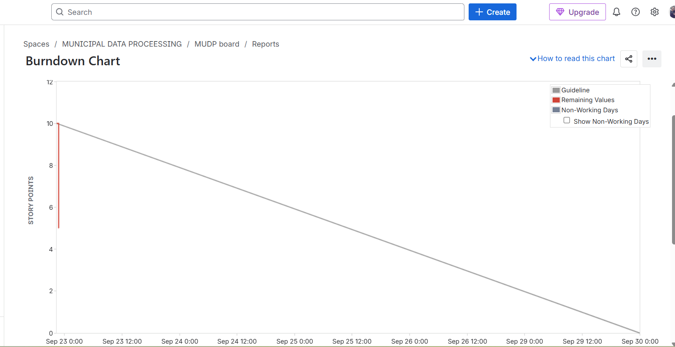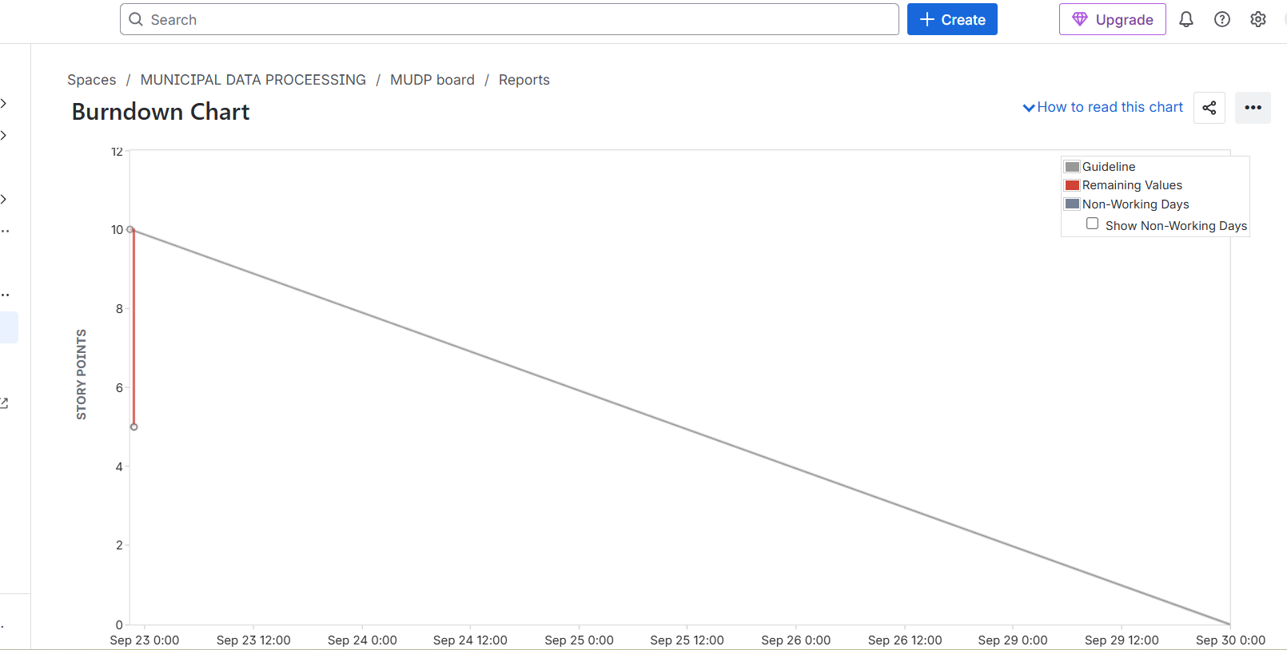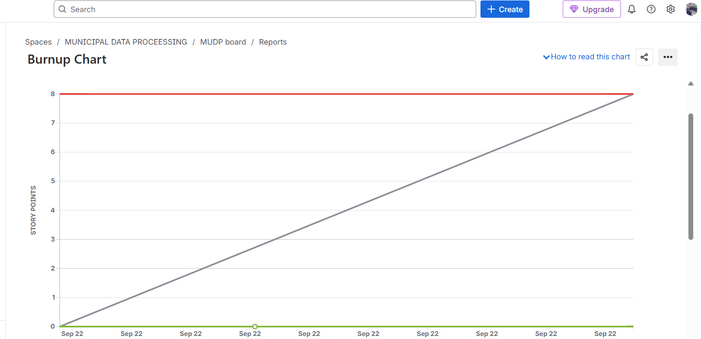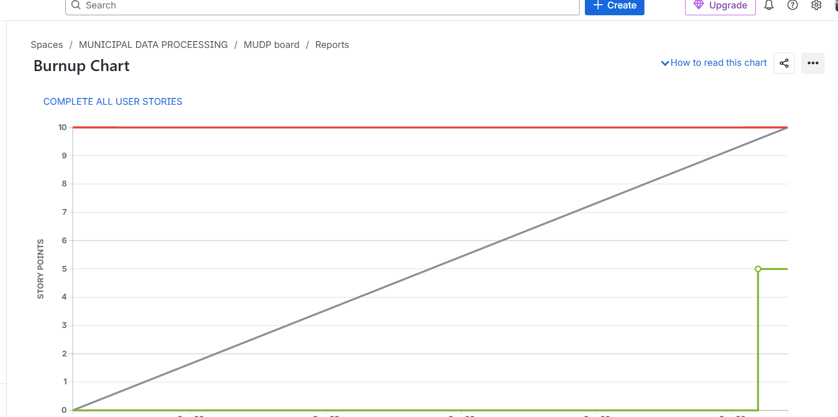

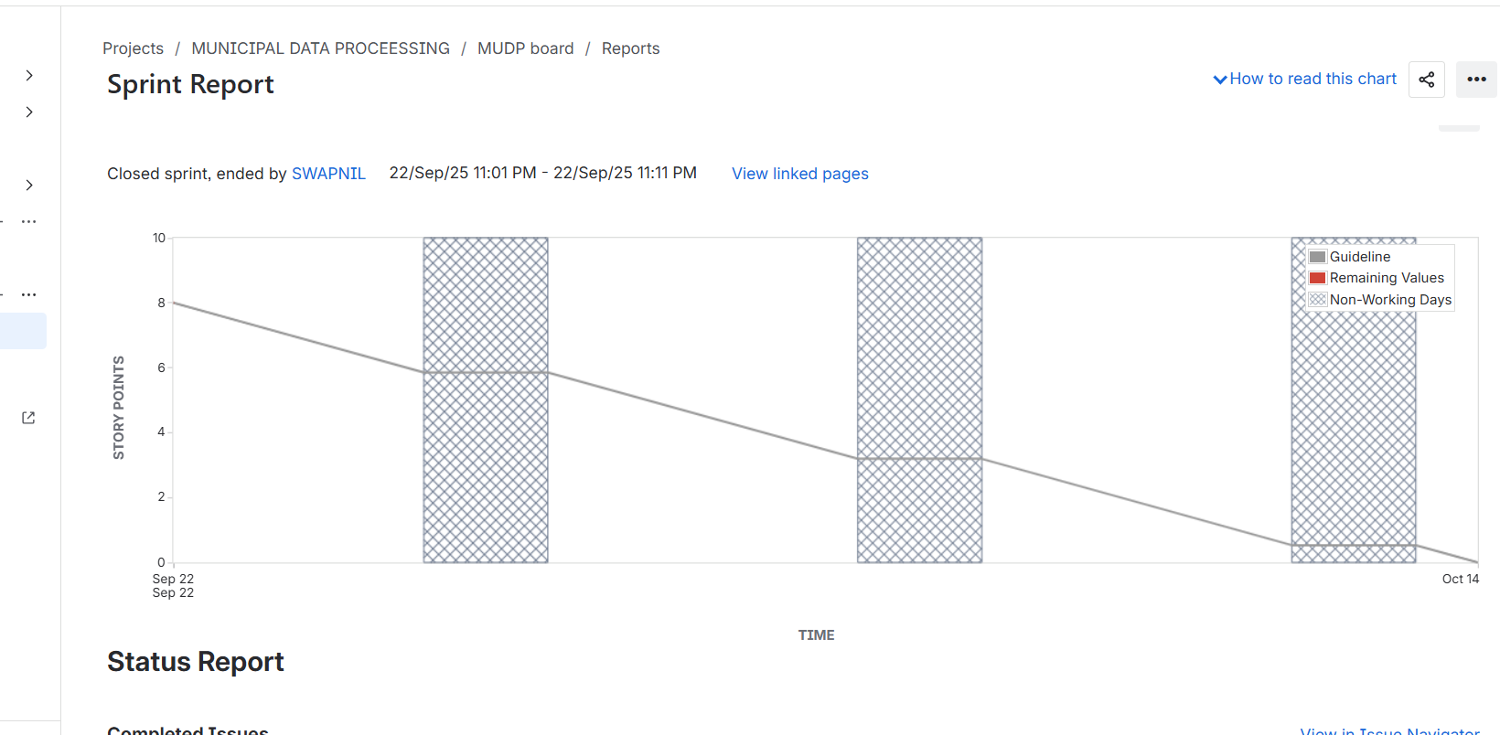

Document 6: Sprint meetings

Sprint Planning Meeting
👉 Purpose: Define what will be delivered in the sprint and how it will be achieved.
Example (Municipal Data Processing – Sprint 1)
- Date: 01-10-2025
- Time: 10:00 AM – 12:00 PM
- Location: Municipal IT Office / Online (MS Teams)
- Prepared By: Scrum Master
- Attendees: Product Owner, Scrum Master, Development Team (5 Devs), Business Analyst
- Agenda Topics:
Topic | Presenter | Time Allotted
Product vision alignment | Product Owner | 15 min
Review of prioritized Product Backlog | BA & PO | 20 min
Selection of user stories for Sprint 1 | Scrum Master & Team | 30 min
Break down stories into tasks | Developers | 30 min
Estimation of efforts | Scrum Team | 15 min
Definition of Done (review) | Scrum Master | 10 min
- Other Information: Sprint length = 2 weeks. Goal = “Enable citizens to register complaints online.”
- Observers: Municipal IT staff (non-participating).
- Resources: Jira, municipal backlog documents, laptops, projector.
- Special Notes: Confirmed backlog priorities with client before sprint.

2. Sprint Review Meeting
👉 Purpose: Demo what was built in the sprint to stakeholders and gather feedback.
Example (Sprint 1 Review – Municipal Data Processing):
- Date: 15-10-2025
- Time: 3:00 PM – 4:30 PM
- Location: Municipal IT Office / Zoom
- Prepared By: Scrum Master
- Attendees: Product Owner, Scrum Master, Development Team, Stakeholders (Municipal Commissioner, Citizen Welfare Officer)
- Sprint Status: 4 user stories delivered out of 5 committed.
- Things to Demo:
  - Citizen complaint submission form (working online)
  - Database storing complaints
  - Dashboard for officers to view complaints
  - Basic assignment workflow
- Quick Updates: SMS notification integration delayed → shifted to Sprint 2.
- What’s Next: Prioritize “Complaint assignment automation” and “SMS/email notifications” in Sprint 2.

3. Sprint Retrospective Meeting
👉 Purpose: Team reflects on how the sprint went and identifies improvements.
Example (Sprint 1 Retrospective – Municipal Data Processing):
- Date: 16-10-2025
- Time: 11:00 AM – 12:00 PM
- Location: Scrum Team Room / Online
- Prepared By: Scrum Master
- Attendees: Development Team, Scrum Master, Product Owner
- Agenda: Review Sprint 1 performance.
- What went well:
  - Citizen complaint form delivered successfully.
  - Stakeholders impressed with demo.
  - Good collaboration among Dev1 & Dev2 for API integration.
- What didn’t go well:
  - SMS gateway integration delayed due to vendor issues.
  - Estimation of complaint assignment module underestimated.
- Questions:
  - How can we manage vendor dependencies better?
  - Should we increase buffer time for external integrations?
- Reference: Jira sprint report, Definition of Done checklist.

4. Daily Stand-up Meeting (15 min daily sync)
👉 Purpose: Each team member answers 3 questions:
- What did you do yesterday?
- What will you do today?
- Any blockers?
Example (Week 1 – Sprint 1, Municipal Data Processing):
Question | Name/Role | Mon | Tue | Wed | Thu | Fri | Sat | Sun
What did you do yesterday? | Dev1 | Completed UI for complaint form | Tested form fields | Fixed DB bug | Worked on API | Tested integration | — | —
 | Dev2 | Set up DB schema | API coding | Linked DB & API | Tested DB storage | Peer review with Dev3 | — | —
 | Dev3 | Defined workflow rules | Set up assignment logic | Debugged workflow | Started notifications | Prepared demo | — | —
What will you do today? | Dev1 | Test submission form | Connect UI with API | Deploy on test env | Fix bugs | Prepare demo | — | —
 | Dev2 | Continue API coding | DB testing | Fix errors | Integration testing | Help with demo | — | —
 | Dev3 | Assignment logic coding | Notifications setup | Debug issues | Sprint demo prep | Demo execution | — | —
What blockers? | Dev1 | None | API errors | DB sync issues | Fixed | None | — | —
 | Dev2 | DB migration delay | None | None | SMS vendor not ready | None | — | —
 | Dev3 | Workflow conflict | None | None | SMS vendor issue | None | — | —

✅ Summary for MDP Project:
- Sprint Planning → Decides what to build in 2 weeks.
- Sprint Review → Shows finished features to stakeholders.
- Sprint Retrospective → Learns what to improve.
- Daily Stand-up → Keeps the team aligned daily.

