COEPD – Prep Exam 3 –Part 1/2

Question 1- Use Case Diagram

Answer -
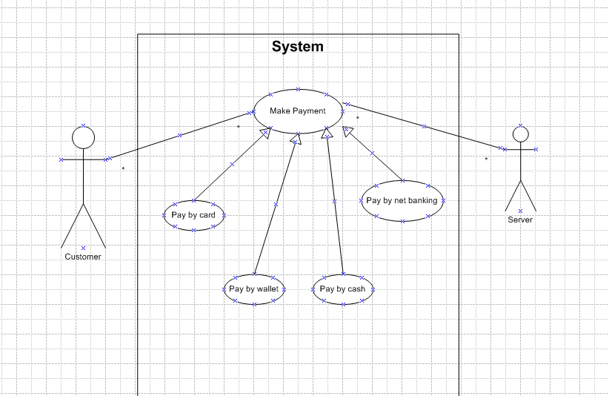

Q2. Derive Boundary Classes, Controller classes, Entity Classes. - 4 Marks

Answer –

Boundary Class: In use case diagram a boundary class represents the parts of a system that interact with actors (Users or eternal systems).It acts as bridge between the system’s internal workings and the outside world, handling communication, user interfaces and external interactions.
Controller Class: A controller class acts as an intermediatory managing the flow of interactions between the user interface (View) and the underlying business logic(Model) within a specific use case. It essentially bridges the gap between what the user sees and what the system does, ensuring proper sequence of actions is executed.
Entity Class: It represents a passive class that stores and manages information related to the system. Its a type of class that is not involved in initiating interactions but rather participates in them and persist data. Typically entity classes are used to model things like: Customer” ‘Product’ or Order in a system.
Boundary Class (All use cases)  [Combination of 1 actor and use case is one boundary class]  [Combination of 2 actors and a use case is 2 boundary class]  And so on  And those actors should be primary actors.  Primary actors mean the actors who initiate the use case and interact with the system | Customer Registration  Customer login  BankServer Login  Customer Logout  BankSererlogout
Controller Class (Handles user input and process the data)  Use case will be considered as the controller Classes. | Registration Controller  Login Controller  Payment Controller  Credentials Controller  Net Banking Controller  Email Controller  Logout Controller
Entity Class(All actors)  Each Actor will be considered as one entity | Customer  Bank Server  Cash  Card  Net banking

Question 3 - Place these classes on a three tier Architecture
Answer -
Tier | Classes Placed | Responsibility
1. Presentation Layer | PaymentUI, CardPaymentUI, WalletPaymentUI, CashPaymentUI, NetBankingUI | Interact with customer/user, collect input data for processing
2. Business Logic Layer | PaymentController, CardPaymentController, WalletPaymentController, CashPaymentController, NetBankingController | Handle payment logic, route the request to the correct payment processor
3. Data/Entity Layer | Customer, Payment, Card, Wallet, BankAccount | Store business-related data, represent domain objects

Question 4 - Domain Model for Customer making payment through Net Banking

Answer - A Domain Model is a visual representation of real-world business entities and the relationships between them. It shows classes, attributes, and associations relevant to the problem domain - here, Customer making payment via Net Banking.

Key Domain Objects Involved in Net Banking Payment -
Class | Attributes (example) | Responsibility
Customer | customerId, name, email | Represents the user making the payment
Payment | paymentId, amount, date, status | Abstract class representing a payment
NetBankingPayment | transactionId, bankName, accountNumber, IFSC | Specialized payment method via bank
BankAccount | accountNumber, IFSC, balance | Holds customer’s bank details
Transaction | transactionId, amount, timestamp, status | Records the transaction done
Q5. Draw a sequence diagram for payment done by Customer Net Banking - 4 Marks

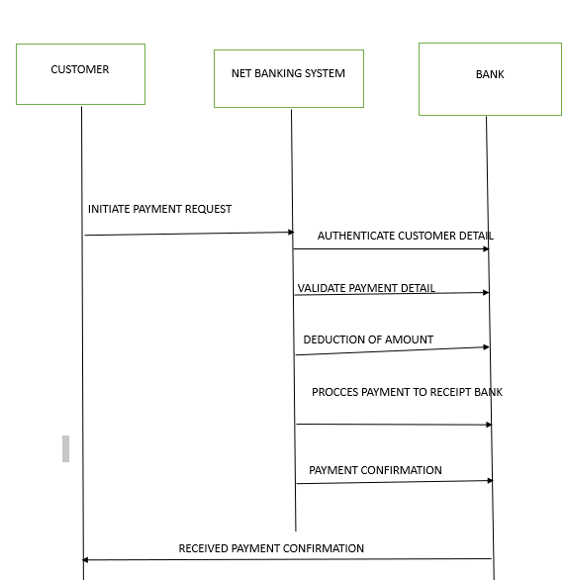

Question 6 - Conceptual Model for this Case

Answer - A Conceptual Model is a high-level representation of key concepts (classes/entities) in the problem domain and their relationships, without technical details like methods, data types, or implementation logic.

Conceptual Model for Customer Payment System (All Modes) -
Class | Description
Customer | A user who makes a payment
Payment | Abstract concept of a financial transaction
PaymentMethod | A general method of payment (Card, Wallet, Cash, NetBanking)
Card | Stores card-specific details (e.g., card number, CVV)
Wallet | Stores wallet provider info
Cash | Represents a physical cash payment
NetBanking | Includes bank account and IFSC info
Transaction | Represents the outcome of a payment (amount, time, status)

Q7. What is MVC architecture? Explain MVC rules to derive classes from use case diagram and guidelines to place classes in 3-tier architecture - 8 Marks
• MVC (Model-View-Controller): Architectural pattern that separates application into three interconnected components:
- Model: Domain data and business logic (entities, validation rules, persistence).
- View: UI layer rendering data and capturing user input (pages, components).
- Controller: Handles user input, invokes model operations, and selects views.
• Benefits: separation of concerns, easier testing, parallel development, reuse.
• MVC rules to derive classes from Use Case Diagram:
- Identify Actors & Interactions → Boundary (View) classes: For each actor/use case interaction, create a boundary class to represent the UI screens/forms.
- Identify Use Cases → Controller classes: For each use case, define one or more controllers to orchestrate the interaction between view and model. Controllers implement the workflow.
- Identify Nouns in Use Case → Entity (Model) classes: Extract nouns that represent persistent information (Customer, Payment, Card) and model them as entities.
- Refine with CRUD and Behavior → Services/Domain logic: For complex operations beyond CRUD, define service classes in the model layer or application services.
• Guidelines for placing classes in 3-tier architecture:
- Presentation Tier (View + thin controllers): All UI/boundary classes and validators for user input. Keep business logic minimal here.
- Application Tier (Controllers + Services): Controllers orchestrate use cases, implement transaction scripts, coordinate domain services and external APIs. Put business rules here if not in domain model.
- Data Tier (Model + Persistence): Entity classes, repositories/DAOs, and DB schema mapping. Ensure entities are persistence-friendly and include versioning/audit as needed.
• Example mapping for payment case: PaymentForm → View, PaymentController & PaymentService → Application, Payment & Customer → Data Tier.

Q8. Explain BA contributions in project (Waterfall Model – all Stages) – 8 Marks
Role of Business Analyst (BA) across Waterfall phases:
- Requirement Gathering / Analysis:
  - Elicit requirements via interviews, workshops, documents.
  - Produce Requirement Specification (SRS/FRD), use cases, functional requirements, and non-functional requirements.
  - Validate and get sign-off from stakeholders.
- System Design (High-Level & Detailed):
  - Convert requirements into system design: data models, interface specs, flow diagrams, UML diagrams (class/use case/sequence).
  - Work with architects to ensure requirements mapping.
- Implementation / Development:
  - Clarify requirements during development, resolve ambiguities.
  - Help developers with acceptance criteria and user stories (if split into smaller waterfall tasks).
- Integration & Testing:
  - Prepare test scenarios, acceptance criteria, and UAT test cases.
  - Assist QA in writing test cases and validating test coverage.
  - Validate fixes and coordinate regression testing.
- Deployment / Release:
  - Prepare deployment checklists, data migration plans, and user manuals.
  - Ensure stakeholders are aware of go-live impacts.
- Maintenance / Support:
  - Triage defects, work on change requests, analyze business impact, and update documentation.
  - Serve as liaison between users and technical teams.
BA contributions include stakeholder management, scope control, documentation, requirement traceability, and acceptance validation.

Q9. What is conflict management? Explain using Thomas – Kilmann technique – 6 Marks

Answers: Conflict is an inevitable part of any workplace and can occur due to various reasons such as difference in views towards goals, values,personalities, resources or communication breakdowns. Its
Its important to resolve it to promote learning and growth.
Conflict management is nothing but the process of identifying and addressing conflict in a healthy and constructive manner. By identifying the conflicts efficiently, it will in turn be helpful to reduce negative impact and increase positive impact.
Thomas Kilman approach is widely used to recognize the approach for conflict management.
COLLABORATING
I WIN: YOU WIN
High Assertive/cooperative
HIGH
COMPETING
I WIN: YOU LOOSE
High assertive Low cooperative

COMPROMISING
I WIN SOME: YOU CAN WIN SOME
Medium Assertive/Cooperative
SOME

AVOIDING
I LOOSE:YOU LOOSE
Low Assertive-Low cooperative

ACCOMMODATINGI LOOSE: YOU WIN,I LOOSE
Low assertive/High Cooperative

LOW
Cooperativeness

Q10. List down the reasons for project failure – 6 Marks
Common reasons:
- Poor requirements definition / scope creep / unclear objectives.
- Lack of stakeholder engagement or sponsor support.
- Inadequate planning and unrealistic schedules.
- Poor communication among teams and stakeholders.
- Insufficient resources or lack of skilled personnel.
- Technical issues: inadequate architecture, integration problems.
- Poor risk management and lack of change control.
- Incomplete testing, resulting in defects at deployment.
- Cost overruns and financial mismanagement.
- Cultural/resistance to change or organizational politics.

Q11. List the Challenges faced in projects for BA – 6 Marks
- Eliciting tacit requirements and dealing with stakeholders who can't articulate needs.
- Managing conflicting stakeholder priorities and expectations.
- Changing requirements (scope creep) and late changes.
- Ambiguous or incomplete documentation.
- Balancing technical constraints with business needs.
- Ensuring proper traceability from requirements to tests.
- Communicating effectively across technical and non-technical audiences.
- Time constraints and tight deadlines.
- Managing vendor/integrations and third-party dependencies.

Q12. Write about Document Naming Standards – 4 Marks
Answer: [ProjectID][Document Type] V[x]D[y].extension.
Example:[PQ777FRDV1D1.docx]or [PQ777FRD1.1docx]

Q13. What are the Do’s and Don’ts of a Business analyst – 6 Marks
Answer:
- Never say ‘NO’ to the client
- There is no word called as “By default’
- Never imagine anything in terms of GUI.
- Question everything in the world.
- Go to the client with plain mind i.e. with no assumptions.
- Listen to the client very carefully and after he is done, then ask question.
- Don’t interrupt the client.
- Never try to give solutions to the client right away.
- Try to concentrate only on important and required things.
- Be like a lotus in mud-if a client comes with a fancy requirement, then talk to the project manager first.
- Requirements hurried project buried.
- Never criticize the Stakeholder.
- Always appreciate the Stakeholder even for small efforts.

Q14. Write the difference between packages and sub-systems – 4 Marks
- Package: A logical grouping of related classes or modules in design (often a namespace or folder-level grouping). It’s primarily for organization, reusability, and modularization within a system. Packages are language-level constructs (e.g., Java packages).
- Sub-system: A higher-level architectural component that may contain multiple packages and defines a distinct area of functionality with its own interfaces and responsibilities. Sub-systems often map to deployment or runtime boundaries (e.g., Payment Subsystem, Authentication Subsystem).
Key differences: scale (sub-system larger than package), architectural role (sub-systems define system decomposition and interfaces; packages are organizational), and deployment (sub-systems may be separately deployable).
Q15. What is camel-casing and explain where it will be used- 6 Marks
Answer: Camel Casing refers to the naming convention of variable,parameters or properties.
Here Multiple words are combined together.
In Camel-Casing the starting letter of first word starts with small letter and other starts with capital letters.
Ex: firstName,lastName.
In Ba camel-casing is used in requirement documentation.
In requirement documentation, BA often use camel-casing to name the entities like use case,features,user stories like ValidateCustomerDeatils etc.
Business rules,which should be satisfied by the system use camel-casing.
While documentiong business process or workflows,camel-casing can be used to individual in steps
The database tables name also uses camel casing.
Requirement Naming: Camel casing is used in requirement document also,to name the functional and non-functional requirements.
By using camel casing in the documents, it helps to maintain consistency in the entire document and also increase readability.

Q16. Illustrate Development server and what accesses does business analyst has? - 6 Marks
- Development Server (dev): Environment where developers deploy builds for development and initial functional testing. It typically has less stringent security, can be reset often, and may contain synthetic or masked data.
- Characteristics:
  - Continuous integration builds deployed frequently.
  - Debugging/logging enabled.
  - May be on internal network only.
  - Not for production data (or data is masked/anonymized).
- BA Access & Activities:
  - Read-only access to validate flows and test use cases on UI.
  - Test accounts and test data provided for simulating scenarios.
  - Access to view logs or error dashboards usually through development team or with limited privileges.
  - Permission to request data setup (create test customers, payment methods).
  - Typically no direct write access to backend production data or admin-level DB access; any schema changes or deep DB queries handled by dev/db team with BA requesting reports.
  - BA may have access to defect tracking, build notes, and deployment logs (not infra-level credentials).
- Security & Governance: BA must follow data privacy rules; if real data used, ensure masking; use test accounts for customer PII.

Question 17 - Data Mapping
Answer - Data Mapping is the process of matching fields from one data source to another, ensuring that data is accurately transferred, transformed, or integrated between systems.
It acts as a blueprint for:
Data migration
System integration
ETL (Extract, Transform, Load) processes
API connections and report generation

Purpose of Data Mapping
The goal is to ensure:
Data consistency
Correct data format
Accurate data flow across systems (e.g., from frontend to backend or from legacy system to new system)
Best Practices in Data Mapping
· Ensure data types and formats match
· Define transformation rules clearly
· Include default values and error handling
· Maintain a data mapping document for traceability and testing
Q18. What is API. Explain how you would use API integration in the case of your application Date format is dd-mm-yyyy and it is accepting some data from Other Application from US whose Date Format is mm-dd-yyyy 10 Marks

Answer:
API stands for Application Programming Software.
It’s a software intermediary that allows the 2 applications to communicate with each other.
It’s the set of rules,protocols,and tools that define how different software application should interact with each other.
API allows sharing of only necessary information and keeps the internal system details hidden, which helps the system securely.
For above Scenario:
Establish API communication: Set up API communication between your application and other application to exchange data.
Do data formatting: while sending the data from one application to other convert the date format from dd-mm-yyyy to mm-dd-yyyy.
While receiving the data from other application, parse the data and extract the date, month and year and rearrange them accordingly.
Perform Data Validation and ensure that the converted date remains in a valid format.

