Capstone Project Prep1 - Part3
Question 1: Identify minimum 20 functional requirements
Answer: Functional Requirements describes the behaviour and information that the solution will manage. They describe capabilities the system will be able to perform in terms of behaviours or operations of specific information technology application actions or responses.
Requirement ID | Requirement Name | Requirement Description | Priority
FR0001 | Product Search | The system should be able to allow farmers to search for available products in fertilizers, seeds and pesticides. | 10
FR0002 | Product picture uploaded | The system should able to allow manufacturers to upload and display products with details including name, description, price and quantity | 9
FR0003 | Account creation | The system should be able to allow farmers to create an account using email ID and secure password to access the application and make purchases. | 10
FR0004 | User Login | The system should be able to log in using email (user Id) and password to view order history and buy products. | 10
FR0005 | Buy Later List | The system should be able to allow farmers to add products to a “Buy Later” list for future purchase. | 6
FR0006 | Payment Gateway | The system should be able to provide a secure payment gateway supporting Cash on Delivery, credit/debit cards and UPI | 10
FR0007 | Order Confirmation Email | Upon successful payment, the system should be able to send an email conformation with order status and estimated delivery time. | 9
FR0008 | Delivery Tracking | The system should be able to allow farmers to track delivery status of their orders. | 9
FR0009 | Product Catalogue navigation | The system should be able to provide an easy to navigate product catalogue with filtering by categories such as fertilizers, seeds, pesticides. | 8
FR0010 | Real-Time Availability Display | The system should be able to display real-time product availability, showing only in stock items. | 9
FR0011 | Product Update by Manufacturer | The system should be able to allow manufacturers to update product details such as inventory, price, product description and quantity in real time. | 9
FR0012 | Mobile Responsiveness | The system should be able to be responsive for mobile devices allowing access with limited internet connectivity. | 8
FR0013 | Product Ratings and Reviews | The system should be able to allow farmers to rate and review purchased products which will be visible to other farmers. | 7
FR0014 | Manufacturer Reports and Analytics | The system should be able to provide manufacturers with downloadable sales reports and product performance analytics. | 6
FR0015 | Multi-Language Support | The system should be able to provide a multi-language interface to ease the language barriers for farmers from different regions. | 7
FR0016 | Notifications | The system shall send SMS or push notification for key updates such as order confirmation and shipping details. | 8
FR0017 | Search Filters | The system should be able to allow use to search products by using filters such as product name, price, manufacturer and ratings. | 7
FR0018 | Role based Access Control | The system should be able to implement role-based access control for farmers, manufacturer and admins with appropriate permissions. | 9
FR0019 | Multiple Delivery addresses | The system should be able to allow farmers to save and select multiple delivery addresses. | 5
FR0020 | Customer Support | The system should be able to provide customer support feature such as chat bot or contact form for assistance. | 7
Non-Functional Requirements captures conditions that do not directly relate to the behaviour or functionality of the solution, but rather describe environmental conditions under which the solution must remain effective or qualities that the systems must have. They are also known as quality or supplementary requirements. These can include requirements related to capacity, speed, security, availability and the information architecture and presentation of the user interface.
Requirement ID | Requirement Name | Requirement Description | Priority
NFR0101 | Performance | The system should be able to handle up to 500 concurrent users without degradation in performance | 9
NFR0102 | Security | The system should be able to user HTTPS encryption and secure authentication mechanisms to protect user data. | 10
NFR0103 | Availability | The system should have an uptime for at least 99.5% annually. | 9
NF0104 | Usability | The system should be able to provide an intuitive and user-friendly interface for users with basic internet knowledge. | 8
NF0105 | Scalability | The system should be scalable to support future addition of more product categories and more user from different regions. | 7

Question 2: Make wireframe and prototypes
Answer:
- Page designs are high-fidelity static visuals that show the final look of a website or app. They include colours, fonts, images, and branding elements, helping communicate the intended visual style before development or prototyping begins.
- A wireframe is a low-fidelity blueprint of a page layout, focusing on structure, content placement, and functionality. It avoids colour or graphics, serving as a visual guide for designers, developers, and stakeholders during early planning stages.
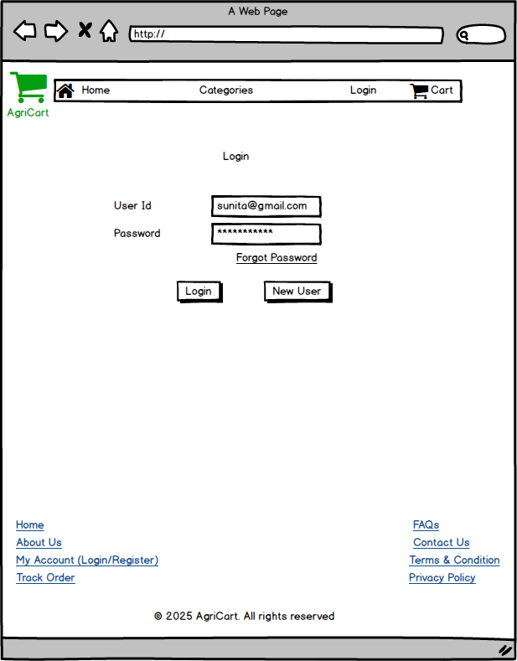
Login
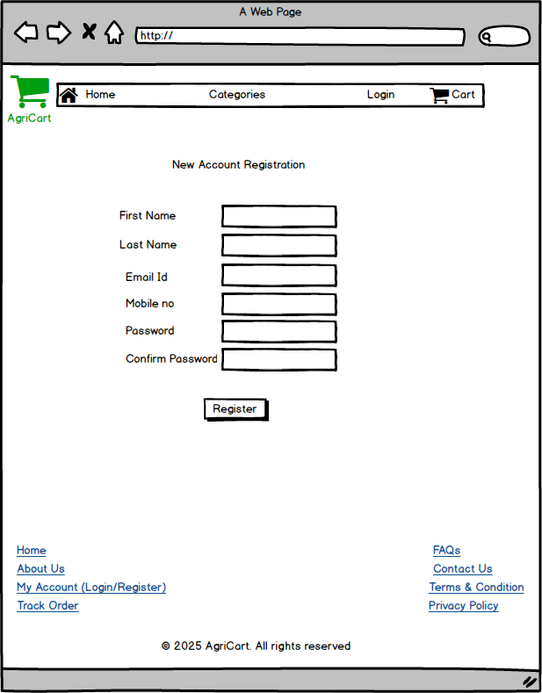
Registration
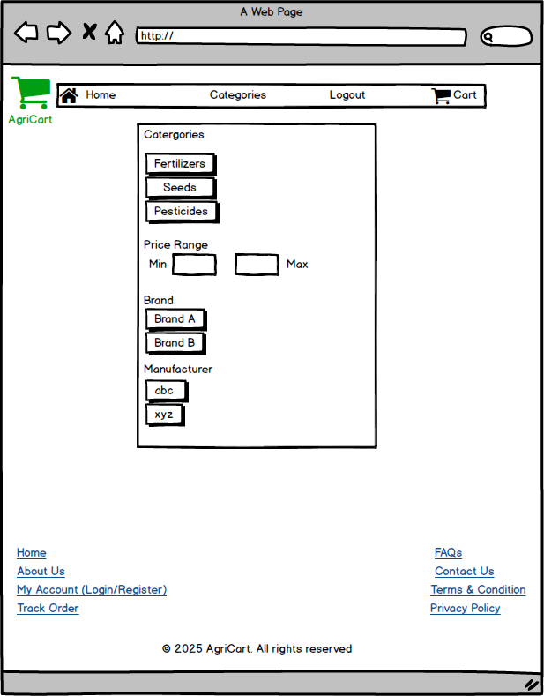
Categories
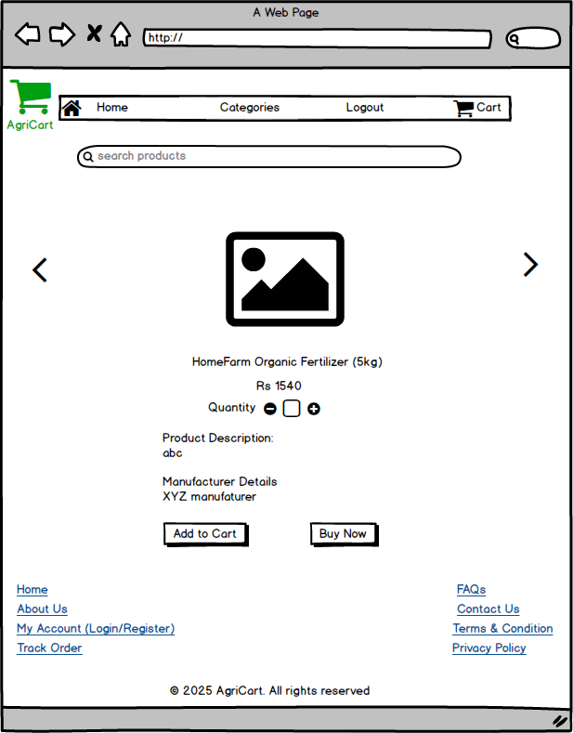
Product Details

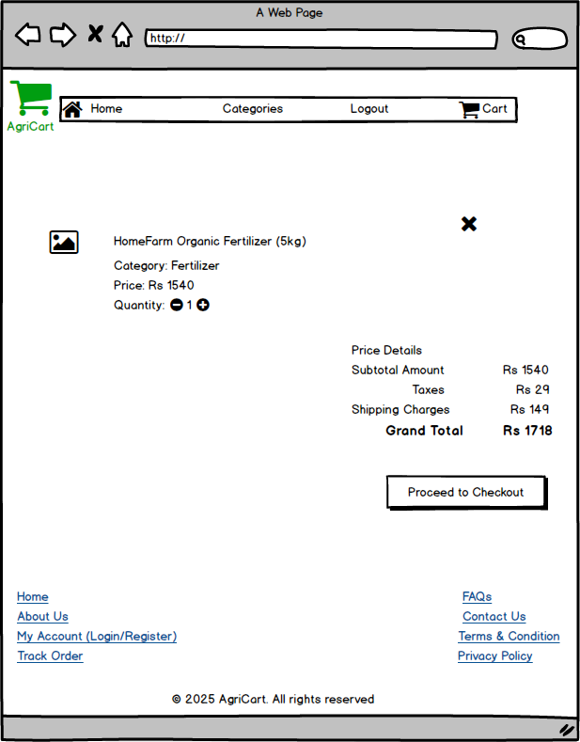
Cart Checkout
- Prototypes are interactive mock-ups that simulate user interactions with an app or website. They demonstrate navigation, transitions, and user flows, allowing teams to test usability, gather feedback, and refine design before development starts.
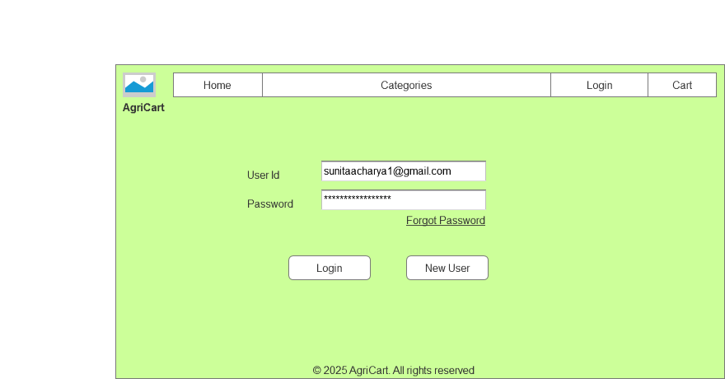
Login
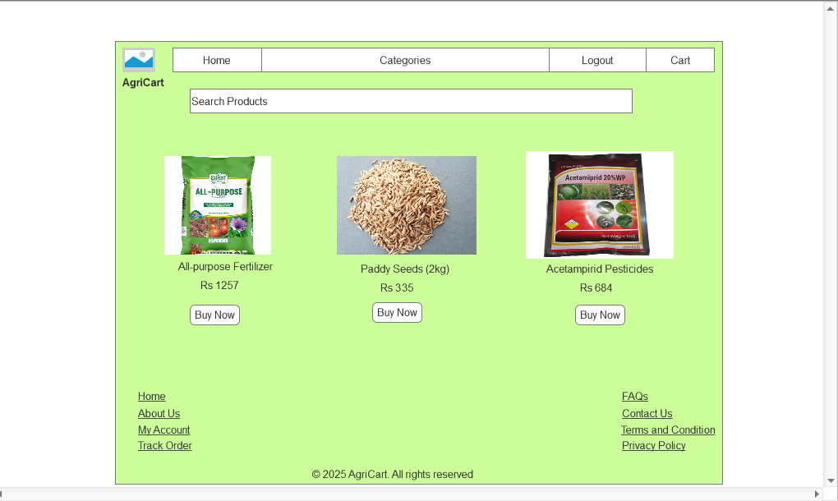
Home Page
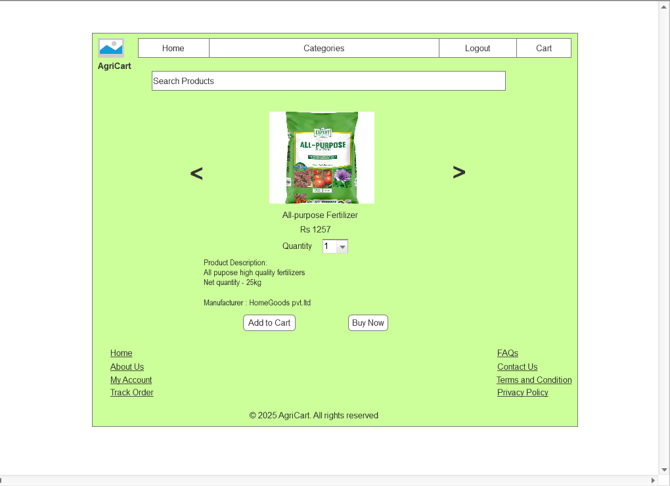
Product Details

Question 3: Make a note of the Tools, which you are using for above concepts
Answer: The tools that are used in this project are MS Visio, Balsamic, Axure, Draw.io.
MS Visio
- Microsoft Visio is a diagramming tool primarily used for creating flowcharts, process maps, organizational charts, and network diagrams. While it offers basic wireframing capabilities, it is not specialized for UI/UX design. It is better suited for planning system architecture or user journeys rather than creating detailed interface mock ups.
- MS Visio integrates well with other Microsoft Office tools, making it convenient for teams already using that ecosystem.
I have used this tool for creating use case diagram, activity diagram, DB Schema diagram and Data Flow Diagram.

Balsamic

- Balsamiq is a wireframing tool focused on low-fidelity UI design. Its sketch-style interface encourages quick layout creation without distractions from visuals like colours or fonts. Ideal for early-stage planning, it helps teams visualize structure and functionality, fostering collaboration and feedback before investing time in detailed design work.
- Balsamiq’s drag-and-drop components and simple interface make it accessible to non-designers, enabling cross-team participation.
I have used this tool for creating wireframes for this project.
Axure
- Axure is a professional prototyping tool for creating high-fidelity, interactive wireframes and prototypes with dynamic content, animations and conditional logic, making it ideal for demonstrating complex user flows and realistic application behaviour.
- It supports collaboration, documentation and version control helping BAs, designers and developers align and test usability before development.
I have used this tool for creating prototypes for this project.

Draw.io
- Draw.io is a free, web-based diagramming tool used to create flowcharts, UML diagrams, network diagrams, wireframes and mind maps making it versatile for both technical and business documentation.
- It integrates with platform like Google Drive, OneDrive allowing easy collaboration, sharing and version control for teams.
I have used this tool for creating Entity-Relationship Diagram.
Question 4: A business analyst’s key responsibilities are to keep track of the requirements and make sure that no requirement is missed Mr. Henry and peter have approached you regarding the current status of the project. How will you tackle this situation? Prepare RTM
Answer:
- To keep track of the requirements and current status of the project can be shown by using RTM (Requirements Traceability Matrix)
- RTM is a document that maps and traces business requirements, functional requirements and test cases to ensure nothing is missed during development and testing.
As a Business Analyst, RTM is used to ensure every requirement has been implemented and testing, track progress, validate scope, support testing and facilitate impact analysis.
Req ID | Req Name | Req Description | Design | Development | T1 | T2 | T3 | T4 | UAT
FR0001 | Product Search | The system should be able to allow farmers to search for available products in fertilizers, seeds and pesticides. | Yes | Yes | Yes | Yes | Yes | Yes | Yes
FR0002 | Product picture uploaded | The system should able to allow manufacturers to upload and display products with details including name, description, price and quantity | Yes | Yes | Yes | No | No | No | No
FR0003 | Account creation | The system should be able to allow farmers to create an account using email ID and secure password to access the application and make purchases. | Yes | Yes | Yes | Yes | Yes | Yes | Yes
FR0004 | User Login | The system should be able to log in using email (user Id) and password to view order history and buy products. | Yes | Yes | Yes | Yes | Yes | Yes | Yes
FR0005 | Buy Later List | The system should be able to allow farmers to add products to a “Buy Later” list for future purchase. | Yes | Yes | No | No | No | No | No
FR0006 | Payment Gateway | The system should be able to provide a secure payment gateway supporting Cash on Delivery, credit/debit cards and UPI | Yes | Yes | Yes | Yes | No | No | No
FR0007 | Order Confirmation Email | Upon successful payment, the system should be able to send an email conformation with order status and estimated delivery time. | Yes | Yes | No | No | No | No | No
FR0008 | Delivery Tracking | The system should be able to allow farmers to track delivery status of their orders. | Yes | No | No | No | No | No | No
FR0009 | Product Catalogue navigation | The system should be able to provide an easy to navigate product catalogue with filtering by categories such as fertilizers, seeds, pesticides. | Yes | Yes | Yes | Yes | Yes | Yes | Yes
FR0010 | Real-Time Availability Display | The system should be able to display real-time product availability, showing only in stock items. | Yes | Yes | Yes | No | No | No | No
FR0011 | Product Update by Manufacturer | The system should be able to allow manufacturers to update product details such as inventory, price, product description and quantity in real time. | Yes | Yes | Yes | Yes | Yes | Yes | Yes
FR0012 | Mobile Responsiveness | The system should be able to be responsive for mobile devices allowing access with limited internet connectivity. | Yes | Yes | Yes | Yes | Yes | Yes | Yes
FR0013 | Product Ratings and Reviews | The system should be able to allow farmers to rate and review purchased products which will be visible to other farmers. | No | No | No | No | No | No | No
FR0014 | Manufacturer Reports and Analytics | The system should be able to provide manufacturers with downloadable sales reports and product performance analytics. | Yes | No | No | No | No | No | No
FR0015 | Multi-Language Support | The system should be able to provide a multi-language interface to ease the language barriers for farmers from different regions. | Yes | No | No | No | No | No | No
FR0016 | Notifications | The system shall send SMS or push notification for key updates such as order confirmation and shipping details. | Yes | Yes | Yes | Yes | Yes | No | No
FR0017 | Search Filters | The system should be able to allow use to search products by using filters such as product name, price, manufacturer and ratings. | Yes | Yes | Yes | Yes | Yes | Yes | Yes
FR0018 | Role based Access Control | The system should be able to implement role-based access control for farmers, manufacturer and admins with appropriate permissions. | Yes | Yes | Yes | Yes | Yes | Yes | Yes
FR0019 | Multiple Delivery addresses | The system should be able to allow farmers to save and select multiple delivery addresses. | Yes | Yes | No | No | No | No | No
FR0020 | Customer Support | The system should be able to provide customer support feature such as chat bot or contact form for assistance. | No | No | No | No | No | No | No

Question 5: Prepare 10 Test Case Documents
Answer: A test case document is a structured file that describes the conditions, inputs, steps and expects outcomes needed to verify that a specific system function works correctly.
It serves as a blueprint for testing helping testers systematically check functionality, avoid missing scenarios, ensure coverage of requirements and provide a record for tracking defects and retesting.
Test Case 1:
Test Case ID | PQ742TC001 | Test Case Name | Product Search
Project ID | PQ742 | Project Name | Online Agriculture Store
PM ID | 1234 | PM Name | Mr Vandanam
Test Strategy ID | PQ742TS001 | Tester ID | EMP1234
Test Plan ID | PQ742TP001 | Tester Name | Mr Jason
Test Schedule ID | PQ742SC001 | Date of Test | 24-07-2025

Scenario | The agriculture e-commerce platform aims to connect farmers with suppliers so that farmers can buy agriculture products from wide range of available products. This test case ensures that farmers can search for products by name, category or keyword and relevant results are displayed quickly and accurately.
Link To page | https://www.agricart.com/search

Input Data | Search by exact and full product name -> “Organic Fertilizer” | Search by partial name -> “Ferti” | Search by category -> Seeds | Search by keyword -> “Pesticide” | Search for a random product which does not exists -> “Vegetable oil”
Expected Behaviour | System displays product named “Organic Fertilizer” in results | Search results show products containing “Ferti” | Products under “Seed” category displayed | All pesticide related items displayed | “No products found” message shown
Actual Behaviour | Product displayed correctly | Matches shown correctly | Correct list displayed | Correct pesticide list displayed | Correct message displayed
Comments | N/A | N/A | N/A | N/A | N/A
Result (Pass/Fail) | Pass | Pass | Pass | Pass | Pass

Test Case 2:
Test Case ID | PQ742TC002 | Test Case Name | Upload Product Image
Project ID | PQ742 | Project Name | Online Agriculture Store
PM ID | 1234 | PM Name | Mr Vandanam
Test Strategy ID | PQ742TS001 | Tester ID | EMP1234
Test Plan ID | PQ742TP001 | Tester Name | Mr Jason
Test Schedule ID | PQ742SC002 | Date of Test | 24-07-2025

Scenario | The platform enables manufacturers to showcase their products with detailed information for farmers. This test case verifies that manufacturers can upload product images with complete details such as name, description, price and quantity, ensuring they display correctly in the product catalogue.
Link To page | https://www.agricart.com/imageupload

Input Data | Upload JPEG image with complete product details | Upload PNG image with complete product details | Upload image exceeding size limit (6MB) | Upload without filling product description | Upload image in unsupported format (e.g., bmp)
Expected Behaviour | JPEG image of the Product uploaded with correct details and image visible in catalogue | PNG image of the Product uploaded with correct details and image visible in catalogue | Uploaded rejected with error message about exceeding size limit | Upload rejected with prompt showing description field required | Upload rejected for unsupported .bmp format
Actual Behaviour | Uploaded successfully | Displayed as expected | Correct error message shown | Correct validation error shown | Correct file type error shown
Comments | N/A | N/A | N/A | N/A | N/A
Result (Pass/Fail) | Pass | Pass | Pass | Pass | Pass

Test Case 3:
Test Case ID | PQ742TC003 | Test Case Name | Create account
Project ID | PQ742 | Project Name | Online Agriculture Store
PM ID | 1234 | PM Name | Mr Vandanam
Test Strategy ID | PQ742TS001 | Tester ID | EMP1234
Test Plan ID | PQ742TP001 | Tester Name | Mr Jason
Test Schedule ID | PQ742SC003 | Date of Test | 24-07-2025

Scenario | To maintain a secure and personalized shopping experience the platform requires farmers to register. This test case checks that farmers can successfully create an account using a valid email and strong password with system confirmation and error handling for invalid inputs.
Link To page | https://www.agricart.com/newregistration

Input Data | Enter valid email & strong password  (jason24@gmail.com, P@ssw0rd!) | Enter valid email & weak password (jason24@gmail.com, password123) | Enter invalid email format (jason24@gml.com) | Leave password field blank | Enter already registered email (jason24@gmail.com)
Expected Behaviour | Account created, user is redirected to dashboard | Password rejected showing message “Password too weak” | Invalid email rejected error message shown | Form validation shows “Password required | Error “Email already registered” displayed
Actual Behaviour | Account created successfully | Password rejected. Correct error message shown | Error displayed as “Invalid email id” | Correct error shown as “Password required” | Correct error shown as “Email already registered”
Comments | N/A | N/A | N/A | N/A | N/A
Result (Pass/Fail) | Pass | Pass | Pass | Pass | Pass
Test Case 4:
Test Case ID | PQ742TC004 | Test Case Name | Login with valid credentials
Project ID | PQ742 | Project Name | Online Agriculture Store
PM ID | 1234 | PM Name | Mr Vandanam
Test Strategy ID | PQ742TS001 | Tester ID | EMP1234
Test Plan ID | PQ742TP001 | Tester Name | Mr Jason
Test Schedule ID | PQ742SC004 | Date of Test | 24-07-2025

Scenario | Secure access ensures that farmer data and purchase history are protected. This test case validates that users can log in with correct credentials to access their accounts and that invalid credentials trigger appropriate error messages without allowing access.
Link To page | https://www.agricart.com/login

Input Data | Login with valid credentials | Login with incorrect password | Login with unregistered email | Leave email field blank | Enter valid email with leading spaces
Expected Behaviour | Login successful redirected to dashboard | Incorrect password shows “Invalid credentials” | Unregistered email shows error message “Register first” | Email required message shown  “Email required” | Spaces trimmed login successful
Actual Behaviour | Logged in successful and redirected to dashboard | “Invalid credentials”  message shown | “Register first” message shown | “Email required”  message shown | Logged in as expected
Comments | N/A | N/A | N/A | N/A | N/A
Result (Pass/Fail) | Pass | Pass | Pass | Pass | Pass
Test Case 5:
Test Case ID | PQ742TC005 | Test Case Name | Add product to buy later list
Project ID | PQ742 | Project Name | Online Agriculture Store
PM ID | 1234 | PM Name | Mr Vandanam
Test Strategy ID | PQ742TS001 | Tester ID | EMP1234
Test Plan ID | PQ742TP001 | Tester Name | Mr Jason
Test Schedule ID | PQ742SC005 | Date of Test | 24-07-2025

Scenario | The platform supports purchase flexibility for farmers who want to buy certain products later. This test case ensures that farmers can add items to a “Buy Later” list, view them in a saved list and use it later for future purchase even after logging out
Link To page | https://www.agricart.com/buyitlater

Input Data | Add a single product to “Buy Later” list | Add multiple products to “Buy Later” list | Remove product from “Buy Later” list | View “Buy Later” list after logging out & in again | Add the same product twice (check for duplicates)
Expected Behaviour | Product added to “Buy Later” list | Multiple products stored in list | Product removed from list | List available after re-login | No duplicates allowed
Actual Behaviour | Product added | Only first product saved | Remove function works | List empty after login | Duplicates appear in list
Comments | N/A | Buy It later list only contains last added product to list. It should show full list of saved products | N/A | Upon page reloading or log out and log in again, the list disappears | Duplicates products appear on Buy it later list, It should not add same product twice.
Result (Pass/Fail) | Pass | Fail | Pass | Fail | Fail
Test Case 6:
Test Case ID | PQ742TC006 | Test Case Name | Make payment
Project ID | PQ742 | Project Name | Online Agriculture Store
PM ID | 1234 | PM Name | Mr Vandanam
Test Strategy ID | PQ742TS001 | Tester ID | EMP7844
Test Plan ID | PQ742TP001 | Tester Name | Ms Alekya
Test Schedule ID | PQ742SC006 | Date of Test | 27-07-2025

Scenario | Secure and flexible payment options are essential for smooth transactions. This test case verifies that the platform must redirect the user to a third-party payment gateway after order confirmation, send correct payment data, and handle the gateway’s response (success, failure, cancellation) correctly without breaking the order flow.
Link To page | https://www.agricart.com/payment

Input Data | Valid order Select -> Credit/Debit Card -> Proceed to Payment | Valid order  -> Select UPI -> Proceed to Payment | Valid order  -> Select COD (Cash on Delivery) | Valid order  -> Select UPI -> Cancel payment midway. | Valid order  -> not selecting any payment method
Expected Behaviour | User redirected to payment gateway page with correct amount | User redirected to payment gateway page with correct amount | COD skips payment gateway and confirms order instantly | Order is cancelled and redirected to payment method page and prompt to pay again | shows message “select payment method”
Actual Behaviour | Redirection successfully with correct order amount | Redirection successfully with correct order amount | Order placed successfully with payment mode as COD. | Cancellation returned to “Pending Payment” | Message shown correctly
Comments | N/A | N/A | N/A | order summary page took 2–3 seconds longer to load. | N/A
Result (Pass/Fail) | Pass | Pass | Pass | Fail | Pass
Test Case 7
Test Case ID | PQ742TC007 | Test Case Name | Order Confirmation Email
Project ID | PQ742 | Project Name | Online Agriculture Store
PM ID | 1234 | PM Name | Mr Vandanam
Test Strategy ID | PQ742TS001 | Tester ID | EMP7844
Test Plan ID | PQ742TP001 | Tester Name | Ms Alekya
Test Schedule ID | PQ742SC007 | Date of Test | 27-07-2025

Scenario | Providing clear purchase confirmation builds trust with farmers. The test case ensures that after successful payment the system sends an accurate email confirmation containing order details, status and estimated delivery date.
Link To page | https://www.agricart.com/OrderConfirmEmail

Input Data | Place order with credit/debit card payment | Place order with UPI payment | Place order with COD payment | Verify confirmation email for correct order details | Verify confirmation email for correct estimated delivery date
Expected Behaviour | Confirmation email sent after credit/debit card payment | Confirmation email sent after UPI payment | Confirmation email sent after COD | Email contains correct order details | Email contains correct delivery date
Actual Behaviour | Email received | Email received | Email received | Email received | Email received
Comments | N/A | N/A | N/A | N/A | N/A
Result (Pass/Fail) | Pass | Pass | Pass | Pass | Pass
Test Case 8:
Test Case ID | PQ742TC008 | Test Case Name | Track order
Project ID | PQ742 | Project Name | Online Agriculture Store
PM ID | 1234 | PM Name | Mr Vandanam
Test Strategy ID | PQ742TS001 | Tester ID | EMP7844
Test Plan ID | PQ742TP001 | Tester Name | Ms Alekya
Test Schedule ID | PQ742SC008 | Date of Test | 28-07-2025

Scenario | Order transparency helps farmers plan better for their agricultural needs. This test case verifies that farmers can track the real-time delivery status of their orders through the platform with updates from dispatch to final delivery.
Link To page | https://www.agricart.com/Trackorder

Input Data | Track Order with correct tracking ID | Track Order with incorrect tracking ID | Track Order with in “Processing” state | Track Order with in “Shipped” state | Track Order after delivery completion
Expected Behaviour | Correct status shown for valid tracking ID | Invalid tracking ID shows error | “Processing” status displayed accurately | “Shipped” status displayed accurately | Delivered orders marked as “Delivered”
Actual Behaviour | Status sometimes not updated | Error message shown correctly “Invalid Order ID” | Delayed in update and shows “Pending” | “Shipped” status displayed accurately | Sometimes it is not updated
Comments | Sometimes No tracking information displayed for selected tracking ID | N/A | Delivery status remains “Pending” even though it is in Processing state | N/A | Delivery status remains “Shipped” even though the parcel has already been delivered.
Result (Pass/Fail) | Fail | Pass | Fail | Pass | Fail
Test Case 9:
Test Case ID | PQ742TC009 | Test Case Name | Browse Catalogue
Project ID | PQ742 | Project Name | Online Agriculture Store
PM ID | 1234 | PM Name | Mr Vandanam
Test Strategy ID | PQ742TS001 | Tester ID | EMP7844
Test Plan ID | PQ742TP001 | Tester Name | Ms Alekya
Test Schedule ID | PQ742SC009 | Date of Test | 28-07-2025

Scenario | A structured product catalogue improves the buying experience. This test case checks that farmers can easily navigate through categories such as fertilizers, seeds and pesticides and apply category filters to quickly locate desired products.
Link To page | https://www.agricart.com/browsecatalogue

Input Data | Browse “Fertilizers” category | Browse “Seeds” category | Browse “Pesticides” category | Apply category filter + price filter | Apply multiple filters and verify navigation
Expected Behaviour | Fertilizers list displayed | Seeds list displayed | Pesticides list displayed | category filter + price filter applied correctly | multiple filters applied correctly
Actual Behaviour | Fertilizers list displayed | Seeds list displayed | Pesticides list displayed | category filter + price filter applied correctly | multiple filters applied correctly
Comments | N/A | N/A | N/A | N/A | N/A
Result (Pass/Fail) | Pass | Pass | Pass | Pass | Pass
Test Case 10:
Test Case ID | PQ742TC010 | Test Case Name | Check stock availability
Project ID | PQ742 | Project Name | Online Agriculture Store
PM ID | 1234 | PM Name | Mr Vandanam
Test Strategy ID | PQ742TS001 | Tester ID | EMP7844
Test Plan ID | PQ742TP001 | Tester Name | Ms Alekya
Test Schedule ID | PQ742SC010 | Date of Test | 28-07-2025

Scenario | Accuracy in inventory display prevents order failures and builds trust. This case test ensures that only in-stock items are shown to farmers, with real-time updates on availability to reflect current warehouse status.
Link To page | https://www.agricart.com/browsecatalogue

Input Data | View Product in stock (quantity > 0) | View Product out of stock (quantity = 0) | Refresh page after stock update | Add product to cart when in stock | Attempt to add out of stock product to cart
Expected Behaviour | In stock product displayed with quantity | Out of stock product marked correctly | Stock updates after refresh | Add to cart works for in stock product | Out of stock product cannot be added to cart
Actual Behaviour | In stock product displayed with quantity | Sometimes shows “Available” incorrectly | Stock update took 5 mins after refresh | Add to cart works for in stock product | Sometimes still added to the cart
Comments | N/A | Some products showed available even though there is no stock present in inventory | It took 5-10 minutes to reload the page and update stock quantities. | N/A | Sometimes out of stock products are added to the cart because stock quantity is not getting updated accurately
Result (Pass/Fail) | Pass | Fail | Fail | Pass | Fail

Question 6: After the requirements are thoroughly explained to the entire project team by business analyst, the Database architects have decided to do the database design and also to represent the in-flow and out-flow of data. Draw database schema and ER diagram
Answer: A DB Schema is the structural design of database that defines tables, columns, data types, relationships and constraints. It acts as a blue print, showing how data is stored, linked and organised.
An Entity-Relationship diagram (ERD) is a visual representation of a database’s structure, showing entities (tables), their attributes (fields) and relationships between them. It helps in understanding how data elements interact and ensures proper database design. ERDs are widely used during database planning to avoid redundancy, maintain integrity and streamline future development.
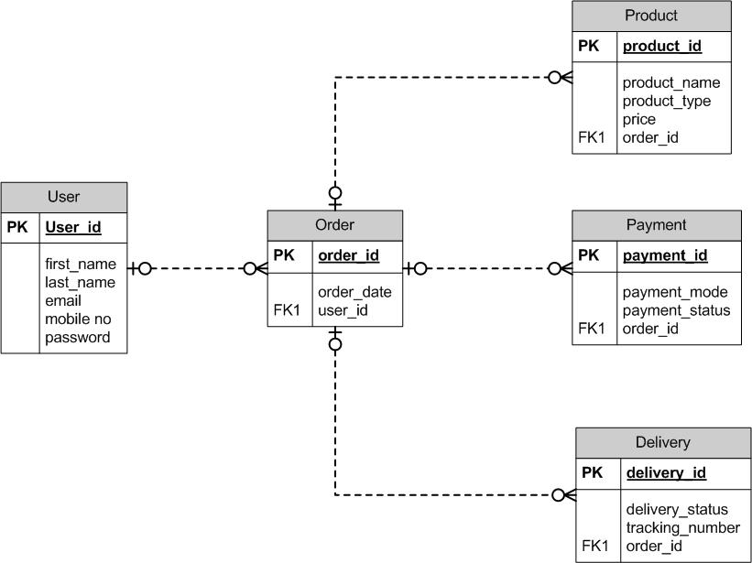DB Schema
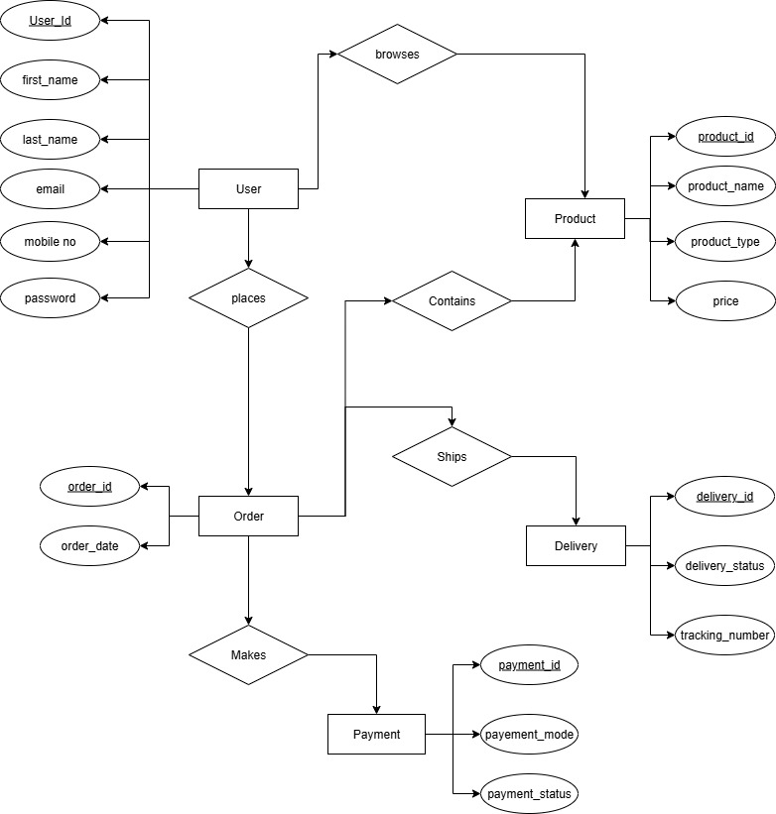
ER- Diagram
Question 7: What is a data flow diagram? Draw a data flow diagram to represent the in-flow and out-flow of data when a Farmer is placing an order for the product
Answer: A Data Flow Diagram (DFD) graphically shows how data moves through a system. It illustrates inputs, processes, data stores and outputs, helping visualize how information flows between users, processes and storage.
DFD helps Business Analyst by making it easier to understand processes, identify gaps or inefficiencies and ensure all requirements are captured. It facilitates clear communication with stakeholders, supports accurate documentation and guides design decisions effectively bridging the gap between needs and technical implementation.
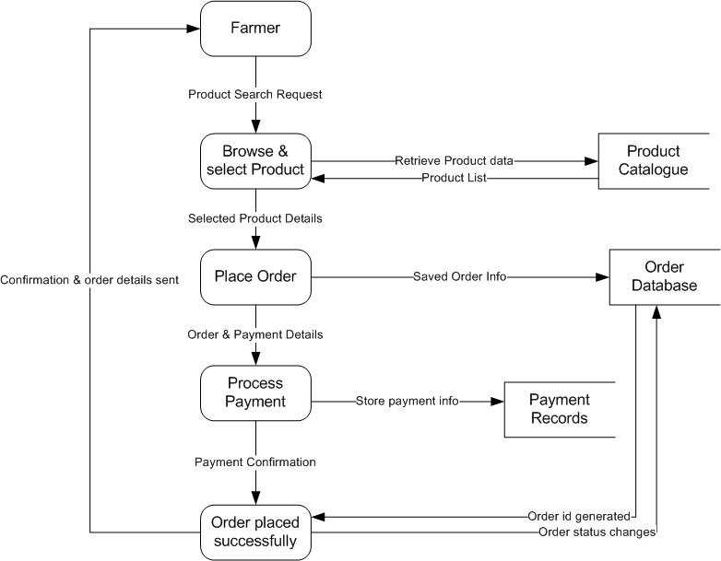
Data Flow Diagram

Question 8: Due to change in the Government Taxation structure. we should change the Tax structure How do you handle change requests in a project?
Answer: When there is a change in the Government Taxation structure requiring an update to the tax structure in this project, I would handle the change request in the following way:
- Understand scope and Document the Change Request:
First, I would meet with the key stakeholders Mr Henry and the Committee, to clearly understand the change in taxation rules and how it affects the current system. I would document the change request formally by capturing the reason for change, expected outcomes and any specific requirements related to the updated tax structure.
- Impact Analysis
Next, I would perform a detailed impact analysis to assess how this change affects the project. This includes examining the which modules or features are affected (project scope), any potential delays due to implementation (schedule), additional cost required (budget), developers, testers and infrastructure needed (resources) a technical, operational and compliance risks (risks).
Area | Impact Details
Scope | Update product catalogue to include revised tax rates, modify payment calculation logic, update order confirmation emails with correct tax amounts
Schedule | Additional 2-3 weeks needed for development, testing and deployment of tax changes
Budget | Estimated additional cost: Rs 4-6 Lakhs for development and testing resources.
Resources | Senior Java Developer (Ms. Juhi) and Java Developers (Mr Teyson, Ms Lucie, Mr Tucker, Mr Bravo) required for coding changes, DB Admin (John) to update tax fields in database, Testers (Mr Jason and Ms Alekya) for testing.
Risks | Potential errors in tax calculation affecting payments, delay in deployment may impact farmer orders; extra workload on team may affect other deliverables.

- Prioritize the change request
Once the impact is understood, I would prioritize the change based on urgency, importance and its overall impact on the project deliverables. Since taxation changes are often regulatory requirements, this would likely to be high-priority change that must be implemented promptly.

- Seek Approval
I would present the documented change request along with impact analysis to the project sponsor (Mt Henry and the committee) for formal approval before proceeding. Approval ensures alignment and commitment from the decision makers.
- Communicate to Stakeholders
After Approval, I would communicate the change request, its implications and the revised plan to all relevant stakeholders, including project team (developers, testers, DB admin. Network Admin) and key stakeholders like Peter, Kevin, Ben. Clear communication ensures everyone is aware of change, their responsibilities, and any adjustments to timelines or deliverables.
Question 9: As the project is in process, Ben and Kevin have contacted you. The reason is to inform you that they want the Farmers to sell their crop yields through this application i.e. Farmers should be able to add their crop yields or products and display to general public and should be able to sell them. They also want to introduce Auction system for their Crop yields. As a BA, what will be your response? Is this a change request or an enhancement???
Answer: When Ben and Kevin approached me with this idea that farmers should able to sell their crop yields through the application and introduce an auction system, I would carefully analyse the situation before responding,
- Understand the Request
Currently the system is designed only to allow farmers to purchase products such as fertilizers, seeds and pesticides from manufacturers. Ben and Kevin are requesting an entirely new functionality which is, farmers will also sell their own products to general public. Additionally, they want an auction mechanism, which involves bidding timers and possibly dynamic pricing.
- Determine if it is a Change request or Enhancement
A change request usually refers to modifications within the existing scope where as Enhancement means adding new functionality beyond approved scope.
Since selling crop yields and implementing an auction system is not a part of the original project scope and represents a significant expansion of the application, this request is classified as a major enhancement rather than a change request.
- Initial BA Response
As a BA, I would respond to Ben and Kevin by saying
- Acknowledge their suggestion and explain that this is a valuable idea to increase the platform’s usability and farmer engagement.
- Inform them that this feature was not part of the original project scope approved by the project scope.
- Advice that we will document this request formally and conduct an impact analysis to assess its implication.

- Requirement Analysis Documentation
Now, after doing requirement analysis, I will document the enhancements clearly and submit it to the project sponsor (Mr. Henry and the Committee) and ensure all stakeholders understand that implementing this enhancement will require formal approval and potentially an updated project plan.

Question 10: Come up with estimations – How many Manhours required
Answer:
- Tasks: Gather and document functional and non-functional requirements from stakeholders and ensure clarity, completeness to serve as a baseline for design and development.
Resources: Sunita Acharya (Business Analyst)
Estimated Manhours: 80-100 hours
- Tasks: System design such as Database design, UI/UX design, integration architecture for application modules and create technical specifications to guide development.
Resources: Senior Java Developer (Ms Juhi), Developers (Mr Teyson, Ms Lucie, Tucker, Bravo), DB Admin (John)
Estimated Manhours: 120-150 hours
- Tasks: Development and coding for overall application modules such as registration/login, product catalogue, shopping cart, payment processing, integration with database and so on.
Resources: Senior Java Developer (Ms Juhi), Developers (Mr Teyson, Ms Lucie, Tucker, Bravo), DB Admin (John)
Estimated Manhours: 400-450 hours
- Tasks: Unit testing for all modules, Integration testing, regression testing and UAT
to ensure all modules works correctly, validate that the application meets requirements.
Resources: Mr Jason and Ms Alekya
Estimated Manhours: 150-180 hours
- Tasks: Deploying modules to production environment & ensure system stability.
Resources: Network Admin (Mr Mike), Business Analyst (Sunita Acharya)
Estimated Manhours: 40-50 hours
- Tasks: Project Management includes progress tracking, risk management, conduct status meetings throughout the project lifecycle.
Resources: Project Manager (Mr Vandanam), Business Analyst (Sunita Acharya)
Estimated Manhours: 60-70 hours
Total Estimated Man Hours: 850-1000 manhours (approx.)
Question 11: Project has finally completed all the stages i.e., design, development, testing etc. Now, it is the role of a business analyst to contact the client for testing of the final product and have to successfully complete it. How are you going to handle this situation? And once it is done, what will be the process to close the project? Explain UAT Acceptance process
Answer:
- User Acceptance Testing (UAT) is the process where the client or end-users test the final product to ensure it meets their business requirements and works as expected in real-world scenarios. It is the final verification step before the product goes live.
- As a Business Analyst, during UAT, we coordinate and facilitate testing with the client. This includes preparing test scenarios based on business requirements, guiding the client on how to execute tests, tracking and documenting defects or issues, ensuring all critical issues are resolved and obtaining formal acceptance/sign off from the client. The Phases of UAT Acceptance are as follows:

- Planning
- Define UAT scope, objectives and success criteria
- Prepare UAT schedule, resources and responsibilities
- Identify with features/modules will be tested and how
- Designing
- Create UAT test cases and scenarios reflecting real-world usage
- Prepare test data that mimics actual farmer and manufacturer transactions
- Ensure the scenarios cover all critical workflows
- UAT Testers
- Identify the client stakeholders who will perform testing (Mr Henry, Peter, Kevin, Ben)
- Provide guidelines and training on executing the test cases
- Monitor progress and assist testers in understanding the workflow
- Bug Fixing
- Track issues reported by UAT testers
- Prioritize defects based on severity and impact on business processes
- Coordinate with development team to resolve defects and perform the testing again.
- Sign-Off
- Once all critical defects are resolved, obtain formal acceptance from the client.
- Document UAT results and approval
- Confirm that the system meets all business requirements and is ready for production deployment to GO-LIVE.
Question 12: Explain Project closure document
Answer: A Project Closure Document formal record that marks the completion of a project. It summarizes the project’s outcomes, confirms that all deliverables are met, and ensures stakeholder approval. This document includes final performance reports, lessons learned, budget and schedule reviews, and any outstanding issues or risks. It provides a clear record for accountability, facilitates knowledge transfer, and helps transition project resources, ensuring a smooth wrap-up and closure of project activities.
Points to be included in the Project closure documents are:
- Project Overview
The Online Agriculture Products Store was initiated by Mr Henry under CSR initiative through SOONY Company and developed by APT IT SOLUTIONS. The project aimed to create a platform for farmers to purchase fertilizers, seeds and pesticides online and facilitate communication with manufacturers. Key features: Login, Product Catalogue, Search, Payment and Delivery tracking.
Duration: 18 months
Budget: 2 Crores INR

- Achievements
  - All planned modules are successfully implemented i.e., Login, Product Catalogue, Search, Payment and Delivery tracking.
  - System is user friendly and improved farmer accessibility enabling farmers to purchase online easily.
  - Delivered the project within budget and timeline with all stakeholder’s satisfaction.
- Lesson Learned
- Early stakeholder engagement (Peter, Kevin, Ben) is crucial for gathering accurate requirements.
- Detailed UAT planning and client involvement helps in identifying real-world usability issues.
- Proper impact analysis for change requests prevents delays and budget overruns.
- Importance of documenting all enhancements and future potential features for phased delivery.
- Quality Assurance
- Internal QA included unit testing, integration testing, regression testing and system testing before UAT.
- UAT with key stakeholders ensured that the system met business requirements and compliance standards.
- Payment gateway and delivery tracking modules were thoroughly tested for reliability and accuracy.

- Resource Utilisation
- Team Include:
Project Manager: Mr. Vandanam,
Senior Java Developer: Ms. Juhi,
Java Developers: Mr. Teyson, Ms. Lucie, Mr. Tucker, Mr. Bravo
DB Admin: John
Network Admin: Mr. Mike
Testers: Mr. Jason, Ms. Alekya
Business Analyst: Sunita Acharya
- Resources were effectively allocated to ensure smooth project cycle with no major delays.

- Risk Management
- Risks identified: changes in government taxation, delays in stakeholder’s approvals, payment integration issues.
- Mitigation strategies included: impact analysis for changes, scheduled client meetings and thorough QA/testing before production.
- Challenges
- Coordinating with stakeholders in remote areas for requirement validation and UAT.
- Ensuring system usability for first time users with limited tech knowledge.
- Adapting to regulatory changes like new tax structured during development.
S No | Points to Include | Details | Reference Link
1 | Did the client signed off on UAT testing
 | Date of signoff | 11th August 2025 | Business.scope.document.docx
 | Name of the resources | Ms. Sunita Acharya
2 | Objectives of the project
 | User friendliness | Achieved
 | Customer Satisfaction | ROI in 6 months
 | More Categories | Achieved
3 | Functionalities worked on
 | Secure Payment processing | Achieved
 | Categories | Achieved
4 | Infrastructure
 | Software installed | Achieved
 | Laptops purchased | Achieved
5 | Funding
 | Amount approved | Rs 2 crore INR
 | Amount used | Rs 1.8 crore INR | Financebreakdown.docx
6 | Overall Project information
 | Escalations | N/A
 | Customer satisfaction | Yet to determine after GO-Live but estimated to be High
7 | Value to the company
 | Positive/ Negative | Positive- 90% (estimated)  Increased in clients (estimated)  Trained employees (estimated)  New project in pipeline (estimated)

