Document 6 – Use Case Diagram, Activity Diagram & Use Case Specification
Project/Domain: ICS Global Proxy Services (Broadridge)
Internal Tool: MOCHA MAINFRAME (Screens 400 & 10)
Primary Use Case: Update Meeting Information (as per client request)
Context & Scope
Problem Statement: Client requests changes to corporate meeting data (e.g., Meeting Date, Record Date, Meeting Type, Location, Meeting Time, Event ID). Operations/BA team updates the details using MOCHA MAINFRAME, with validations, audit logging, and notifications.
In Scope: Editing and saving meeting attributes on MOCHA screens; validation; audit trail; submission for approval (if applicable); notifications.
Out of Scope: Upstream data ingestion, downstream vote processing, external issuer communications.
Use Case Diagram

Activity Diagram
Use Case Specification
1. Use Case Name
ICS Global Proxy Services MOCHA MAINFRAME (Screens 400 & 10), Update meeting information
2. Use Case Description
This use case describes how a Business Analyst (BA) updates meeting-related information (e.g., Meeting Date, Record Date, Meeting Type, Location, Meeting Time, and Event ID) in the MOCHA Mainframe system based on client requirements.
3. Actors
- Primary Actor: BA, Operation Analyst
- Secondary Actors: Client (requestor of changes), Approver
4. Basic Flow
- Client sends a request to update meeting details.
- BA logs into the MOCHA Mainframe system (Screen 400 / Screen 10).
- BA navigates to the meeting information section.
- BA updates the required meeting fields (e.g., Meeting Date, Record Date, Event ID).
- System validates the entered data (format, mandatory fields).
- BA saves the changes.
- System updates the database and confirms success.
- BA notifies the client of the update completion.
- After that any changes are made approver will approve the meeting
5. Alternate Flow
- Partial Update: If the client requests changes to only selected fields (e.g., only RD), BA updates those specific fields while keeping others unchanged.
- Client Cancels Request: If the client cancels before BA updates, the request is closed without any changes
6. Exceptional Flows
- Invalid Data: If the BA enters an invalid format (e.g., incorrect date), the system rejects the input and prompts for correction.
- System Unavailable: If MOCHA Mainframe is down, the BA cannot proceed, It will go to Display errors.
- Missing Mandatory Fields: If Event ID or Meeting Date is missing, the system prevents saving.
7. Pre-Conditions
- BA must have valid login credentials to access MOCHA Mainframe.
- Client request for changes must be documented and approved.
8. Post-Conditions
- Meeting details are successfully updated in MOCHA Mainframe.
- Audit logs are maintained for tracking changes.
- Client is informed of update status.
9. Assumptions
- Client provides accurate and complete meeting details.
- BA has the necessary permissions to update meeting information.
10. Constraints
- Updates must follow regulatory and compliance guidelines.
- Changes are allowed only during the deadline dates.
11. Dependencies
- Availability of MOCHA Mainframe system.
- Dependency on client-provided data (Meeting Date, Record Date, etc.).
- Database connectivity for saving changes.
12. Inputs and Outputs
- Inputs: Meeting Date, Record Date, Meeting Type, Location, Meeting Time, Event ID.
- Outputs: Updated meeting record in MOCHA Mainframe and confirmation notification.
13. Business Rules
- Meeting Date cannot be earlier than Record Date.
- Event ID must be unique and mandatory.
- Location must follow predefined formats (e.g., city/country or virtual mode).
- All updates must be logged for audit and compliance.
14. Miscellaneous Information
- This use case applies to internal BA activities within Broadridge.
- Security policies (password protection, access rights) must be enforced.
- Training may be provided to new BAs for handling MOCHA Mainframe updates.
Document 7- Screens and pages
using balsamic
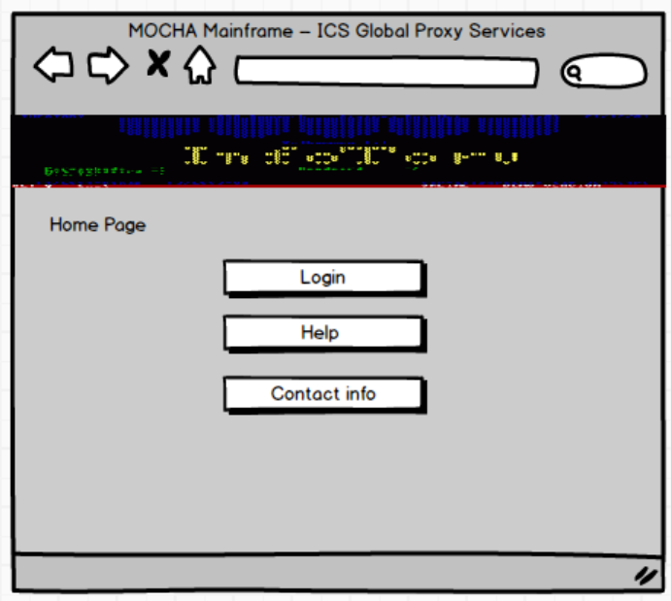
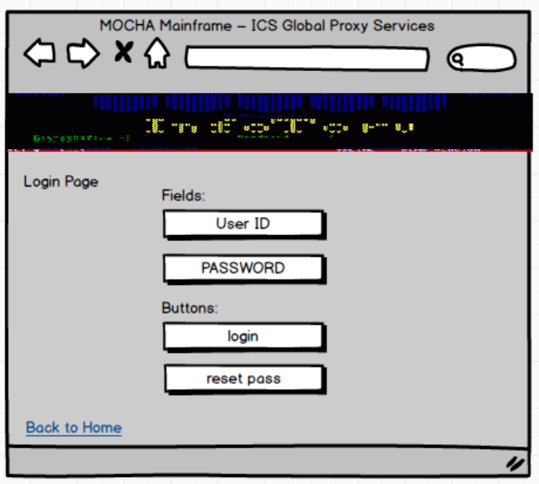
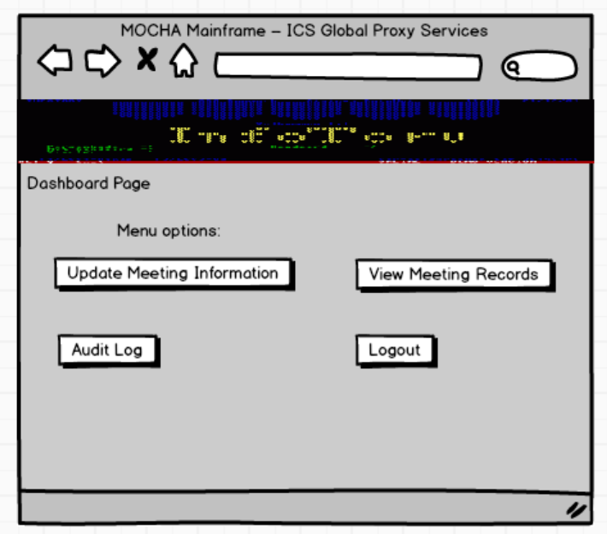
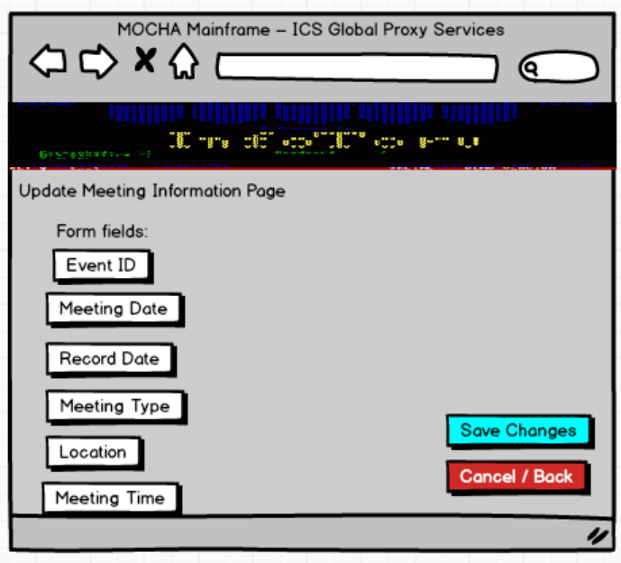
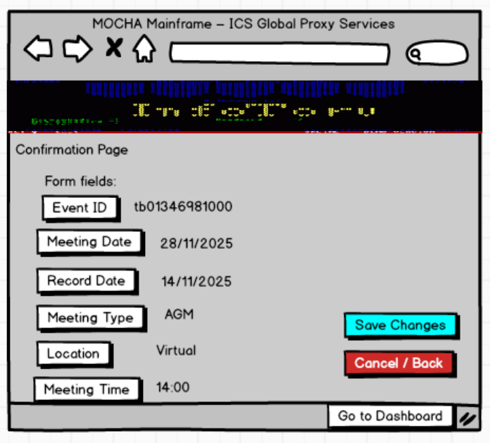
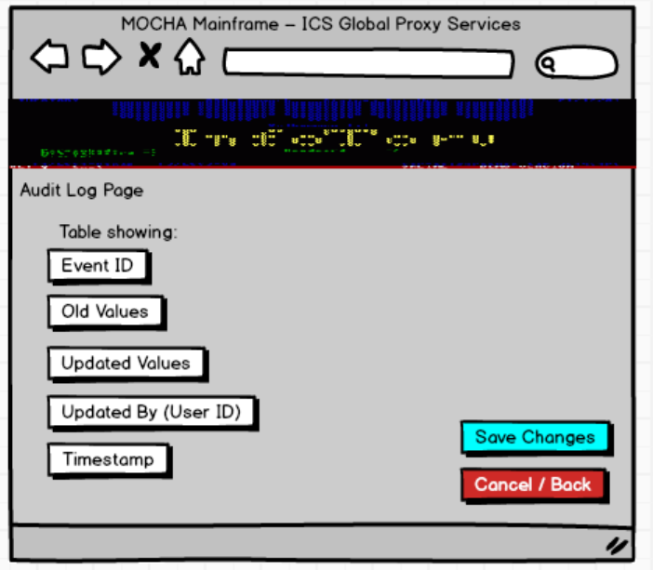
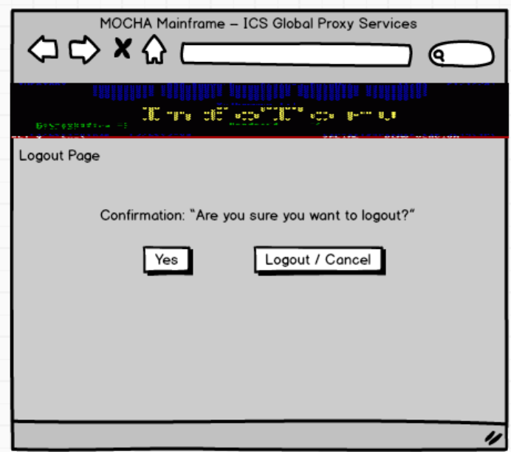
Document 8- Tools-Visio and Axure
Microsoft Visio
- I used Visio mainly for creating process flow diagrams, activity diagrams, and use case diagrams.
- These diagrams helped me represent the “as-is” workflows (current process) and the “to-be” workflows (future process) in the MOCHA Mainframe system.
- The main benefit was that complex processes became easy to visualize and explain to both technical and non-technical stakeholders.
- This ensured everyone was aligned before moving into design and development, and also reduced the chances of misinterpretation.
Axure RP
- I used Axure RP to design wireframes and interactive mock-ups of MOCHA Mainframe screens like login, dashboard, and meeting update forms.
- With Axure, I could simulate user interactions (for example, how a user enters meeting dates or updates records).
- This gave stakeholders a realistic feel of the system before it was actually built, which improved clarity and made feedback quicker.
- As a result, it reduced misunderstandings and helped get faster approvals from business users.
Document 9- BA experience
My experience as BA in following phases:
1. Requirement Gathering Phase
- As a Business Analyst in the ICS Global Proxy Services project, my primary responsibility was to elicit and validate requirements effectively
- For prioritization, we followed the MoSCoW technique (Must have, Should have, Could have, Won’t have), which ensured that critical requirements were captured first
- During this phase, the client was unavailable for certain periods, so I proactively identified and coordinated with alternate points of contact from the client’s side to avoid delays
- Once requirements were collected, I validated them using the FURPS technique (Functionality, Usability, Reliability, Performance, and Supportability) to ensure quality and completeness
- I also identified duplicate or repeated requirements and removed them promptly to maintain a clean and accurate backlog
- To help stakeholders visualize requirements more clearly, I used prototyping techniques, creating mock-ups of MOCHA Mainframe screens (e.g., Meeting Date, Record Date, Event ID fields).
- This gave the client a better understanding of the system behaviour and helped refine requirements before moving to the design stage
2. Requirement Analysis:
- Created UML diagrams (Use Case, Class Diagrams) to visually describe requirements
- Designed Activity Diagrams to capture the end-to-end process flow for meeting information updates
- Communicated diagrams with the development and QA teams for validation and clarity
- Collected feedback from team members; if there were disagreements or suggestions, considered them and updated diagrams accordingly
- Prepared Business Requirements Specification (BRS) to capture high-level business needs
- Prepared System Requirements Specification (SRS) to define detailed functional and non-functional requirements
- Ensured all requirements were clear, unambiguous, and aligned with the business goals
3. Design:
- Derived test cases from use case diagrams to ensure coverage of all functional requirements
- Actively communicated with the client to review design and solution documents for validation
- Prepared both positive and negative test cases to capture all possible system behaviours
- Ensured that no test case was missed, as even a small gap could have a major impact on later stages of development
- Created test data sets to be used during the testing phase
- Maintained and updated the Requirements Traceability Matrix (RTM) to confirm that all requirements were mapped to corresponding test cases and fully covered
4. Development:
- Conducted Joint Application Development (JAD) sessions with the technical team and stakeholders
- Clarified queries raised by the technical team during the coding phase to avoid blockers
- Managed conflicts by addressing non-cooperative team members through one-on-one discussions, explaining the project impact, and maintaining a healthy working environment
- Referred to UML and activity diagrams to guide developers in coding specific units
- Organized regular meetings with the technical team and client to ensure alignment
- Handled challenges such as team members missing meetings by recording sessions and conducting follow-up discussions with the missed participants
5. Testing:
- Prepared test cases based on use case scenarios to ensure full functional coverage
- Performed high-level testing to validate end-to-end business workflows
- Collected or requested test data from the client to simulate real scenarios
- Updated the Requirements Traceability Matrix (RTM) to confirm that all requirements were tested
- Obtained formal sign-off from the client once testing results were validated
- Prepared the client team for User Acceptance Testing (UAT) by explaining processes, test data, and expected outcomes
6. Deployment:
- Forwarded the Requirements Traceability Matrix (RTM) to the client, which was attached to the Project Closure Document
- Coordinated with the team to complete and share End-User Manuals for smooth system adoption
- Planned and organized training sessions for end users to ensure they understood the new system
- Ensured all participants attended training sessions by sending reminders and following up with absentees

