Ans 1 – Quarterly Audits in a project involving a BA, to evaluate progress, compliance, quality of deliverables & Alignment with business goals.
- Ensure requirements Documented
- Verification of documentation
- Track Stakeholder engagement
- Evaluate Process (Agile or SDLC)
- Monitor risks & issue the logs
Ans 2 – As a BA, my approach strategy to complete the project successfully will follow a structured methodology.
- Elicitation Techniques – to gather the requirements from stakeholder I will use the combination of Interview with Mr. Henry & farming stakeholders & questionnaire/survey for wide user inputs.
- Stakeholder mapping – I will perform stakeholder mapping and maintain RACI Matrix to define the role.
- Responsible – Developer, tester (Mr Teyson, Ms Lucie, Mr Tucker, Mr Bravo, Tester - Jason and Ms Alekya)
- Accountable – Project Manager
- Consulted - Client (Mr. Henry & farmer)
- Informed – DB Admin (Mr. John)
- Documents to Prepare like _ Business requirements document (BRD), functional requirement specification (FRS), use case/stories, Meeting Minutes.
- Formal sign off will be taken on the documentation.
- Schedule walkthrough/demo with Mr. Henry.
- Daily stand ups & status reports , Review meetings to establish a communication.
- Support Testers (Mr Jason & Ms. Alekya) in UAT.
- Get formal sign off on UAT & prepare project closure document.
Ans 3 – 3-tier Architecture is widely used software development model that separates an application into 3 layers. It is easy to maintain and update each tier independently. It Improves scalability & Performance and also separation of concerns.

Presentation Tier (UI – Web/Mobible app/Client Layer)
- Farmer Login
- View Products
- Place Order
Application Tier (Business Logic/API)
- Validate order
- Check Inventory
- Manage Approvals
Data Tier (database Server)
- User Data
- Product catalog
- Transactions

Ans 4 – when a BA prepares to frame a questions for stakeholders , like an online agriculture product store, it is crucial to structure the thought process.
- 5W 1H Technique – (Basic Exploration)- who are the users?, what the requirements, when will they use the application, where will this be used as there is limited connectivity, how will it function etc.
- SMART Goal – Specific,Measurable,Achievable,Realistic,Time bound – what feature should be there in app, how will the success measured (procuring), are features feasible in the budget,is internet connectivity realistic, what is the project time line?
- Use cases & specifications- user journey – how does farmer place an order? Pre and post steps for key flows.
- Activity Diagram – Workflow(Farmer login then searches the product – place order), decision( what happens if product is out of stock)
Ans 5- As a BA, I know about below elicitation techniques which is require to understand from the stakeholders what they want to achieve through the given project.
- Requirement workshop - This is a structured meeting attended by multiple stakeholders and the business analyst may work with a group of stakeholders to develop a model. And at the end of meeting BA can discuss what was accomplished, what remains to be done, and what the next steps are and follow up on those points.
- Interview - Interviews involve asking questions, listening to the answers, and asking follow-up questions. Interviews can be done one-on-one, but they can also be done in a small group. It can be an informal or formal setting by asking questions and documenting the responses.
- Observation- observation is an effective means of understanding how a user does their job by assessing (like shadowing)their work environment. This technique can be used to understand requirements.
- Document Analysis - involves actively reading a document, such as a regulation, a standard, a competitive product review, or customer suggestion logs. you need to identify which materials are suitable and relevant for analysis.
- Brainstorming - It’s a way to think out of the box and to get people thinking about ideas and solutions that might not come to mind in a more formal session. It is like spontaneous.
- Prototyping – it is technique where an early version of product from which future versions are developed. A lot of times we work with users who don’t really know what they want and have a lot of trouble expressing their true needs and desires, but they’re very clear when they see something that represents what they don’t want.
- Questionnaires - questionnaires are used to gather information from many people who answer a specific question.
Ans 6 – I would suggest to used the Use case/focus group elicitation technique to build a platform where farmers can search and buy fertilizers, seeds and pesticides and also manufacturers can display their products.
Justification – Ideal for defining and validating functional requirements like farmers search for products, farmers add to cart etc. also it helps to visualize real world usage and define system behavior clearly.
Ans 7 –
- BR001 – Farmers should be able to search for available products in fertilizers, seeds, pesticides.
- BR002 – Manufacturers should be able to upload and display their products in the application.
- BR003 - Farmers must be able to register and log in using their email ID and password.
- BR004 - The app should provide a product catalog with filtering and sorting options (e.g., by type, price).
- BR005 - Buy Later or Wishlist feature should allow users to save products.
- BR006 - The application should have multiple payment modes, including COD, credit/debit cards, and UPI.
- BR007 - A delivery tracking system to help farmers track order status.
- BR008 - An automated email/SMS notification sent after order placement, dispatch, and delivery.
- BR009 - The platform should include support care system for managing users, orders, and resolving disputes.
- BR010 – The application should be mobile-friendly and support regional language.
Ans 8-
Assumption 1 – users include farmers & Manufacturers ( farmers are end user and manufactures are vendors).
Assumption 2 – Platform is web based and mobile friendly interface for rural access.
Assumption 3 – Login and registration is required through mobile number or email id.
Assumption 4 – there is product catalog that includes fertilizer , seeds, and pesticides.
Assumption 5 – Buy Later or Wishlist features for farmers to save product which they can later purchase.
Assumption 6 – security measures like password encryption and secure login.
Ans 9 -
Req ID | Req Name | Req description | Priority
BR001 | Farmer Search for Products | Farmers should be able to search for available products in fertilizers, seeds, pesticides. | 10
BR002 | Manufacturers upload their Products | Manufacturers should be able to upload and display their products in the application. | 9
BR003 | Register & Login in | Farmers must be able to register and log in using their email ID and password. | 9
BR004 | Filtering & sorting of Product catalog | The app should provide a product catalog with filtering and sorting options (e.g., by type, price). | 8
BR005 | Features like buy later & Wish listing of products | Buy Later or Wishlist feature should allow users to save products. | 6
BR006 | Payment modes to make payment | The application should have multiple payment modes, including COD, credit/debit cards, and UPI. | 8
BR007 | Tracking mechanism for farmers | A delivery tracking system to help farmers track order status. | 7
BR008 | Notifications after placing the order | An automated email/SMS notification sent after order placement, dispatch, and delivery. | 6
BR009 | Issue resolving system through customer care or chat | The platform should include support care system for managing users, orders, and resolving disputes. | 7
BR010 | Visual should be friendly & supportive | The application should be mobile-friendly and support regional language. | 8
Ans 10- in separate paper
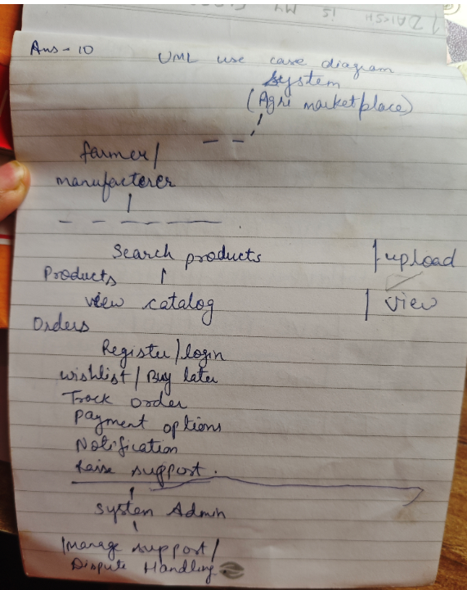

Ans 11 – Use Case Specifications for all the requirements are:
- Search Product – Primary actor would be Farmer and preconditions will be that he must have logged in.
- Upload Product – Primary actor would be Manufacturer where user must logged in and upload the products (Fertilizers, pesticides, Seeds)
- Filter & Sorting – Primary actor would be Farmer and user search results must be available.
- Wishlist/ Buy Later - Primary actor would be Farmer and user must have add to wishlist or product is saved to user list.
- Payment Mode - Primary actor would be Farmer and product is selected by user for purchase and selected the payment mode.
- Order Tracking - Primary actor would be Farmer and Order must be placed and user opens order tracking screen and sees the status.
- Notification - Primary actor would be system and system sends the status update to user.
- Support & Issue - Primary actor would be Farmer/Manufacturer and user can generate the ticket or raise issue.
- Mobile Friendly UI - Primary actor would be Farmer and app should be accessed via Mobile.
Ans 12 – Activity Diagram
[Start]
[Login/ Register]
[Search Product]
[Filter/Sorting]
[Select Product]
[Add to wishlist/ Buy Later]
[Select Payment Method]
[Confirm Order]
[Track delivery]
[Receive Notifications]
[Raise Support if Required]
[End]

